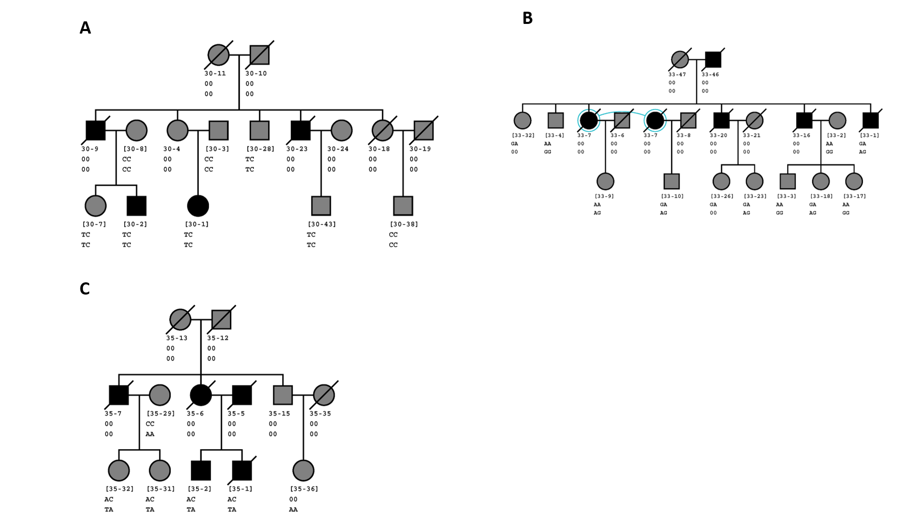

Supplementary Figure S5: Segregation of potential causal variants in UTRN and PHACTR2 in families 30, 33 and 35. In all pedigrees, gray symbols represent non-affected individuals (coded as missing in the analysis) and black symbol represent affected individuals. The diagonal slash through the symbol represents a deceased individual and brackets around an individual’s ID represents individuals who were sequenced. A) Family 30 pedigree with the first two letters underneath the individual ID represents the individual’s genotype at rs186871831 (major allele = C, minor allele = T) and the second two letters underneath the individual ID represents the individual’s genotype at rs966382235 (major allele = C, minor allele = T) B) Family 33 pedigree with the first two letters underneath the individual ID represents the individual’s genotype at rs532363235 (major allele = A, minor allele = G) and the second two letters underneath the individual ID represents the individual’s genotype at rs79313503 (major allele = G, minor allele = A) C) Family 33 pedigree with the first two letters underneath the individual ID represents the individual’s genotype at rs191491353 (major allele = C, minor allele = A) and the second two letters underneath the individual ID represents the individual’s genotype at rs553447284 (major allele = A, minor allele = T).

