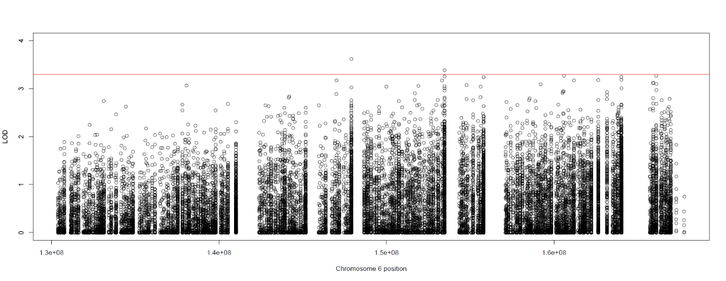
Supplementary Figure S1: Collapsed haplotype pattern (CHP) analysis across all 9 families. The heterogeneity LOD (HLOD) scores of the regional CHP analysis. The line at 3.3 represents the line for genome-wide significance based on Lander and Kruglyak.

