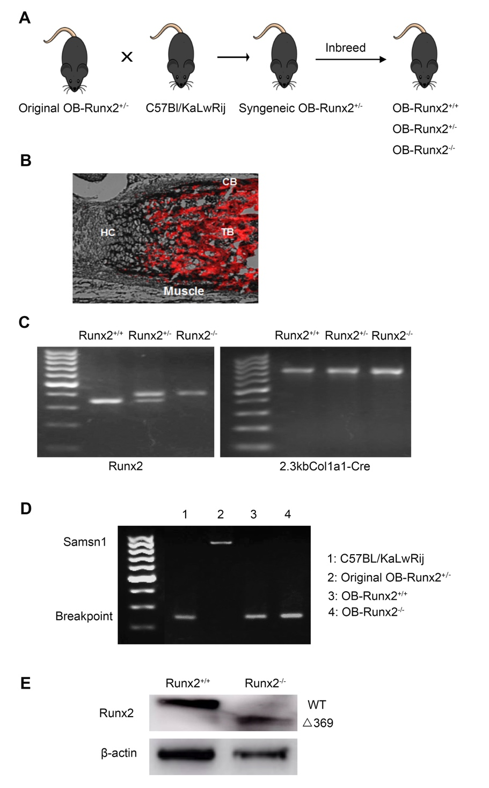

Supplementary Figure S1. Generation of a syngeneic MM model with specific deletion of Runx2 in immature OBs. A, Schematic depicting the generation of a syngeneic murine MM model with Runx2 knockout. B, Tibias were collected from newborn Col1a1-Cre and tdTomato double-transgenic littermates and sectioned. Representative bright field/fluorescence images reflect the overall Cre signal (red) in the developing bone. Col1a1-Cre activity (red) is limited to cortical (CB) and trabecular bone (TB), with no activity in muscle or chondrocytes (HC: hypertrophic chondrocytes). C, PCR confirmation of littermate genotypes. D, PCR amplification detected the Samsn1 gene in the original OB-Runx2^{+/-} mice but not in the original C57BL6/KaLwRij or in the OB-Runx2^{+/+} and OB-Runx2^{-/-} (crossed) mice. Primers flanking the Samsn1 deletion breakpoint amplified a product in C57BL6/KaLwRij, OB-Runx2^{+/+}, and OB-Runx2^{-/-} genomic DNA, confirming Samsn1 deletion in these mice. E, Proteins were isolated from OBs harvested from 5‐week‐old OB-Runx2^{+/+} and OB-Runx2^{-/-} mouse long bones and subjected to SDS-PAGE. Blots were probed with antibodies against Runx2 and β-actin (loading control). Deletion of exon 8 results in a mutant Runx2 protein (Δ369) in OB-Runx2^{-/-} mice that lacks 159 amino acids at the C-terminus. Full-length Runx2 (WT) and mutant proteins (Δ369) are shown.

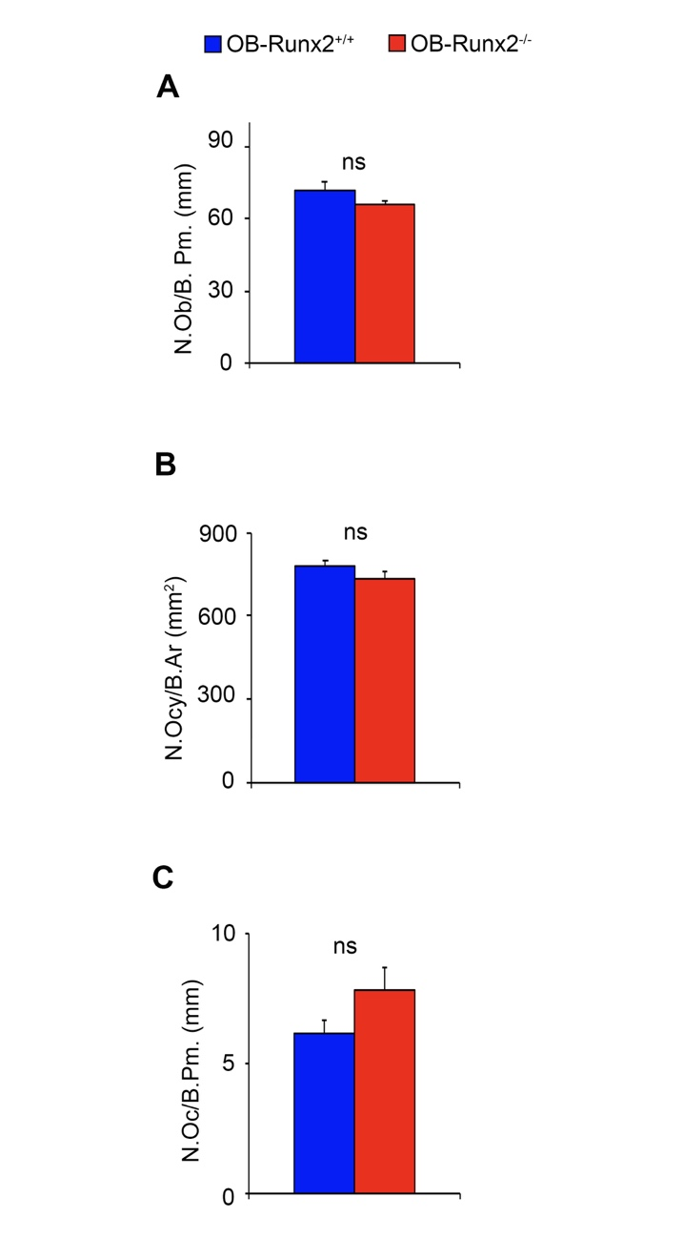

Supplementary Figure S2. Comparison of the number of OBs, osteocytes, and osteoclasts in OB-Runx2^{+/+} and OB-Runx2^{-/-} mice. A, H&E staining was performed on the femurs harvested from OB-Runx2^{+/+} and OB-Runx2 ^{-/-} mice (n=7 mice/group). OBs on the bone surface were counted. No significant change in OB number was observed in OB-Runx2^{-/-} mice. B, The number of osteocytes embedded in bone tissue was determined. No significant change in the number of osteocytes was observed in OB-Runx2^{-/-} mice. C, TRAP staining shows no significant difference in the number of osteoclasts between the genotyping groups. ns, not significant; osteocytes, Ocy; osteoclasts, OC.

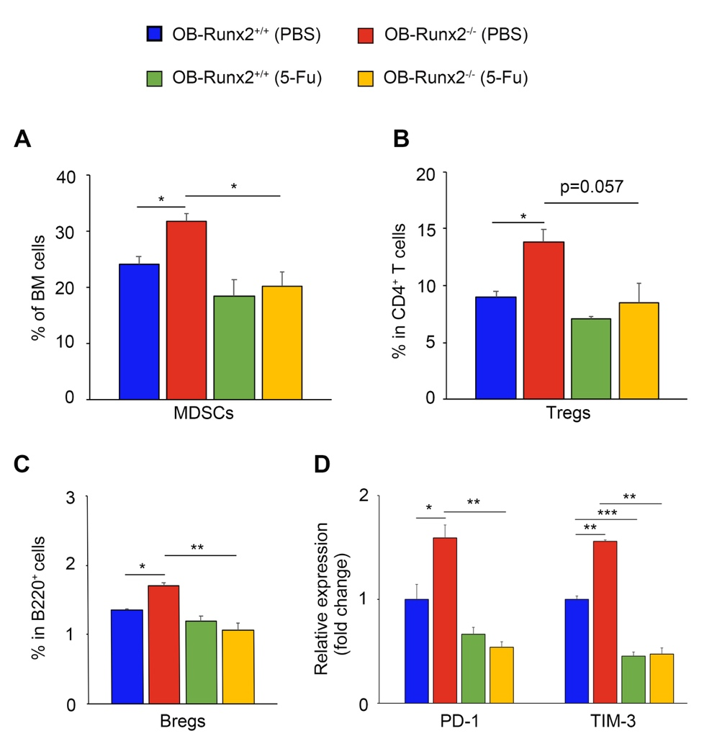

Supplementary Figure S3. Depletion of MDSCs by 5-FU restores the BM immunity in OB-Runx2-deficient mice. Immune cells in the BM of non-tumor-bearing 5-week-old OB-Runx2^{+/+} and OB-Runx2^{-/-} mice were profiled by FACS after i.p. injection of PBS or 5-FU (30 mg/kg body weight/injection) once every 3 days for 4 weeks (n=3 mice/group). A, The percentage of MDSCs (Gr1⁺CD11b^{hi}) among all BM cells. B, The percentage of Tregs (CD25⁺CD127⁻) among CD4⁺ T cells. C, The percentage of Bregs (CD5⁺CD1d⁺) among B220⁺ cells. D, The expression of PD-1 and TIM-3 in CD8⁺ T cells of OB-Runx2^{-/-} mice relative to that in OB-Runx2^{+/+} mice. Data are presented as mean ± SEM. *P < 0.05, **P < 0.01, ***P < 0.001.

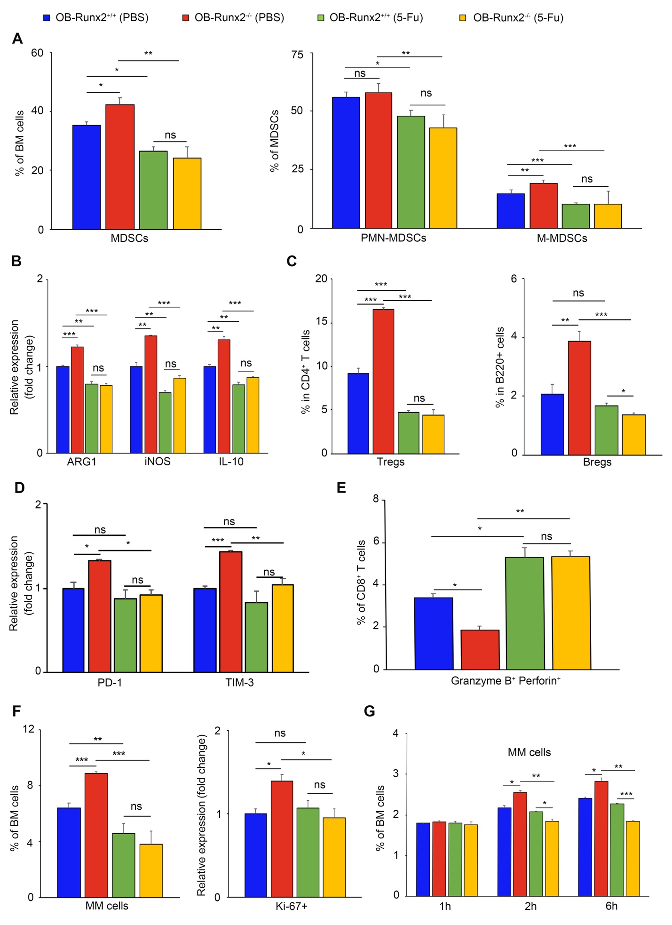
Supplementary Figure S4. 5-FU-mediated MDSC depletion enhances antitumor immunity in OB-Runx2^{-/-} mice. A-F, OB-Runx2^{+/+} and OB-Runx2^{-/-} mice were i.v. injected with 5TGM1 MM cells (10⁶ per mouse). Five days after tumor cell injection, mice began treatment with PBS or 5-FU (30 mg/kg body weight/injection) i.p. injected once every 3 days for 4 weeks (n=5-7 mice/group). FACS analysis of BM cells in tumor-bearing bones was performed after 4 weeks of PBS or 5-FU treatment. A, The percentage of MDSCs among BM cells (left) and proportion of polymorphonuclear MDSCs (PMN-MDSCs, CD11b⁺LY6G⁺LY6C^{low/-}) and monocytic MDSCs (M-MDSCs, CD11b⁺LY6G^{low/-}LY6C^{high}) among MDSCs. B, Expression of ARG1, iNOS, and IL-10 in MDSCs of each group relative to that in PBS-treated OB-Runx2^{+/+} mice. C, The percentage of Tregs among CD4⁺ T cells (left) and of Bregs among B220⁺ cells (right). D, The expression of PD-1 and TIM-3 in CD8⁺ T cells of each group relative to that in PBS-treated OB-Runx2^{+/+} mice. E, Percentage of activated (granzyme B⁺ perforin⁺) cells among CD8⁺ T cells. F, Percentage of MM cells among BM cells (left) and relative expression of Ki-67 among MM cells in each group relative to that in MM cells of PBS-treated OB-Runx2^{+/+} mice (right). G, To determine the effect of MDSC depletion on bone-homing of MM cells in OB-Runx2^{-/-} mice, we treated mice with 5-FU or PBS for 2 weeks and then i.v. injected 5TGM1-GFP MM cells (2×10⁶ cells per mouse, n=12 mice/group). BM cells were harvested 1, 2 and 6 hours after tumor cell injection (n=4 mice/time point/group), and GFP⁺ MM cells homing to bone were counted by FACS. Data are presented as mean ± SEM. ns, not significant, *P < 0.05, **P < 0.01, ***P < 0.001.

