Supplementary Methods
Bioinformatics analyses of RNA sequencing data
Sequences were aligned to mm10 (GRCm38) using TopHat alignment software (1) that mapped reads to 20,743 out of 39,179 genes. The number of reads aligning to genes was counted with HTseq (2). Quantification and statistical inference of systematic changes between samples were computed by DESeq2 (3). Differential gene expression profiles were analyzed with normalized expression values using exon-based model RPKM (reads per kilobase per million) (4) vs. NT or IR only group, respectively. Genes with two-fold upregulation or downregulation vs. NT or IR (log2 fold change ≥1 or ≤-1) with the false discovery rate (FDR) ≤ 0.05 were filtered for analyses with Ingenuity Pathway Analysis (IPA) software (Qiagen) following manufacturer’s instructions.
Bioinformatics analyses of single cell RNA sequencing data
The Cell Ranger Suite version 2.0.2 software was used to perform sample barcode processing and single-cell gene UMI (unique molecular index) counting. Alignment, filtering, barcode counting and unique molecular identifier counting were performed using Cell Ranger 3.1.0 with default parameters. Reads were aligned to the mouse reference mm10. Cell-based QC metrics were calculated with R package scater (scater_1.10.1), outliers identified in PCA space were removed (5). 11,048 and 18,333 cells from GFP and Shh groups were sequenced to a depth of 43,924 mean reads per cell and 1,420 median genes per cell. Cells with UMI<200 and mitochondrial gene percentage > 50% were filtered. After filtering, transcripts were subjected to batch-correction within Seurat v.3 (6). For the datasets, potential confounders (numbers of UMI per cell and the proportion of mitochondrial genes) were regressed out of the data before principal component analysis was performed using variable genes. The JackStraw method was used to determine the statistically significant principal components to be used for graph-based clustering. The Uniform Approximation and Projection method (UMAP) was used to visualize the clusters. Clusters were manually assigned on the basis of differentially expressed genes using the FindAllMarkers function using default settings.
Supplementary data
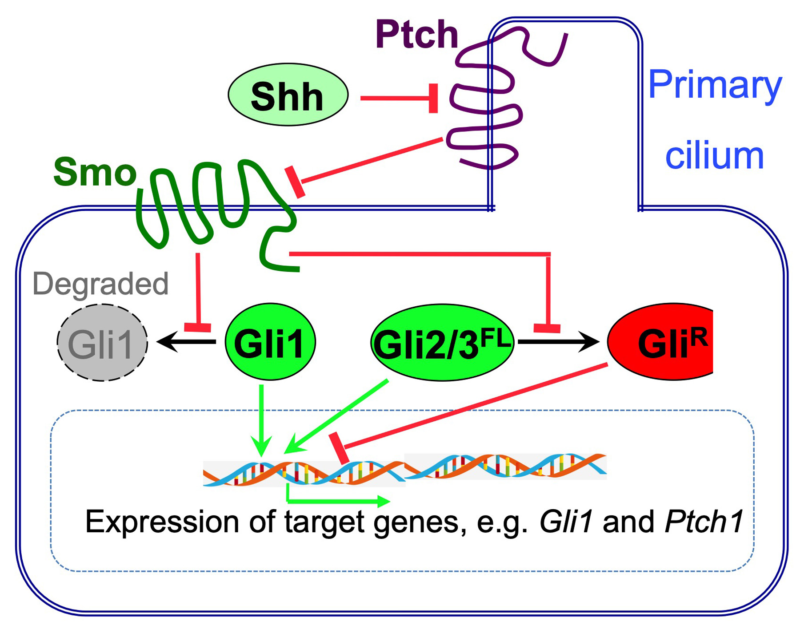
Supplementary Figure S1. Simplified scheme of canonical Hedgehog signaling.
In absence of Hedgehog ligands, Ptch inhibits Smo (Smoothened) by preventing its entry into the primary cilium, hence full-length (FL) Gli1 is completely degraded by the proteasome, while the partial proteasome degradation of Gli2 and Gli3 leads to the formation of repressor forms (Gli^{R}, red). Upon Hedgehog ligand binding, Ptch is displaced from the primary cilium, allowing accumulation and activation of Smo. Active Smo inhibits proteasome degradation of activator forms of full-length Gli factors, which increases the ratio of active to repressive Gli factors and induces the expression of Hedgehog target genes such as Gli1 and Ptch1.

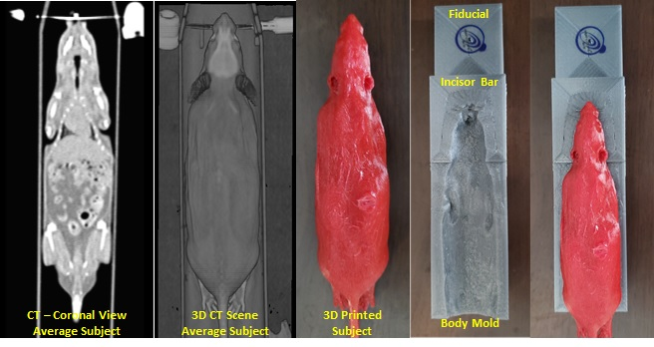
Supplementary Figure S2. 3D full-body immobilizer for planning irradiation of mouse SGs.
A modern clinical radiation oncology patient workflow (immobilize, simulate, treatment plan, quality control, deliver) was adapted and used to irradiate mice salivary glands. To address subject setup accuracy and reproducibility with the radiation therapy plan, a custom full-body immobilizer was 3D fabricated and described below. Prior to the start of the project, a single average representative mouse in volume and weight was sacrificed, ideally positioned on the CT couch, and scanned to generate a full-body image set of the subject. The entire patient was scanned in a large bore (80 cm) CT scanner (Siemens Somatom Definition AS). The image set was transferred to a VelocityAI (Varian Medical Systems Inc., Palo Alto, CA.) workstation for contouring. To generate the initial 3D full-body immobilizer, the subject’s surface was contoured, transformed into a 3D mesh using 3Dslicer, boolean subtracted from a primitive rectangle (with additional modifications made for couch indexing) using Meshmixer (Autodesk, San Rafael, CA.), converted to a stereolithographic file for 3D printing using Simplify3D (Cincinnati, OH.), and printed using a Gigabot 3+ FDM printer (re:3D., Austin, TX.). The immobilizer and the subject’s 3D mesh were fabricated using polylactide (PLA) filament with a mass density of approximately 1.09 g/cm-3 and an infill percentage of 100.
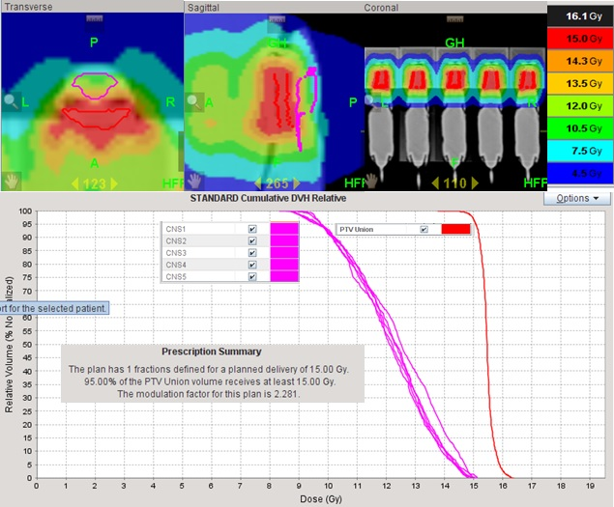

Supplementary Figure S3. Helical tomotherapy planning of SG IR.
For helical tomotherapy treatment planning a new CT image set of five 3D printed subjects positioned side-by-side and immobilized within individual indexed full-body immobilizers was acquired. The image set was transferred to a VelocityAI workstation for target and normal tissue contouring. Brain and spinal cord were contoured as organs at risk (OAR) for each subject. The gross target volume (GTV) was defined as the parotid and submandibular gland regions identified on the CT image set. The clinical targeting volume was set equal to the GTV. To account for imaging uncertainty and setup variability, the GTV was expanded 1mm isotropically to form the planning target volume (PTV). The individual PTVs were unionized into one target volume to uncomplicate optimization. The contours and image set were then transferred to the to the Tomotherapy treatment planning system where fifteen Gray was prescribed to 95% of the PTV Union to be delivered in one fraction to each. The field width, pitch, and modulation factor used for treatment planning optimization were 2.5 cm, 0.1, and 3.0 respectively. The dose rate for an open field is 8.5 Gy per minute.

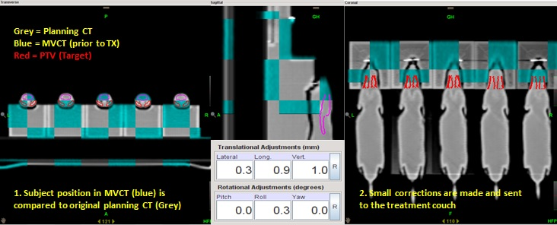

Supplementary Figure S4. Image guidance and delivery of SG IR.
Mice positioning and setup was verified by onboard volumetric megavoltage CT (MVCT) system integrated in the helical tomotherapy machine. MVCT scans (approximately 3 cGy to the area) were performed capturing representative anatomy and fiducials imbedded within immobilizer. Image fusion was evaluated by a veterinary radiation oncologist and any appropriate translational shifts were applied to the subjects’ setup prior to treatment delivery. Shifts had to be within the PTV margin for all five subjects simultaneously to deliver radiation. If shifts for any individual exceeded this requirement, the offending individual setup adjusted and the image guidance process was repeated.

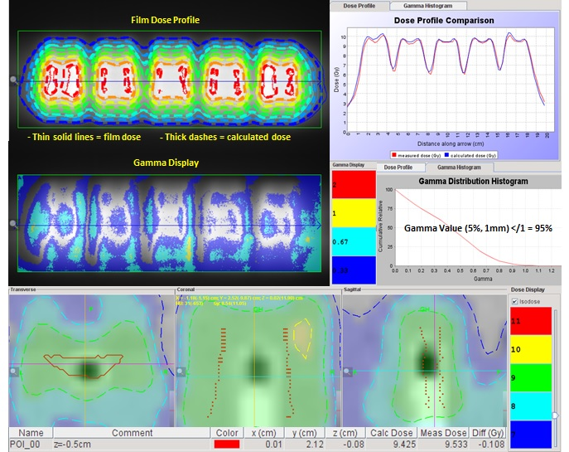

Supplementary Figure S5. The measurement of IR dose.
Plan-specific delivery quality assurance was performed in a solid-water phantom native to the system using Radiochromic EBT3 film (Ashland, Covington, KY.) and ionization chamber measurements to verify the planned fraction delivered dose. Relative planar dose profiles and absolute point dose measurements were compared to calculated planar isodose profiles and point doses. Tolerance for the plan to be deemed acceptable was +/- 3% for measured point doses and gamma value </= 1 for 95 percent of all points lying within the 30% isodose line using search criteria of 5% and 1mm.

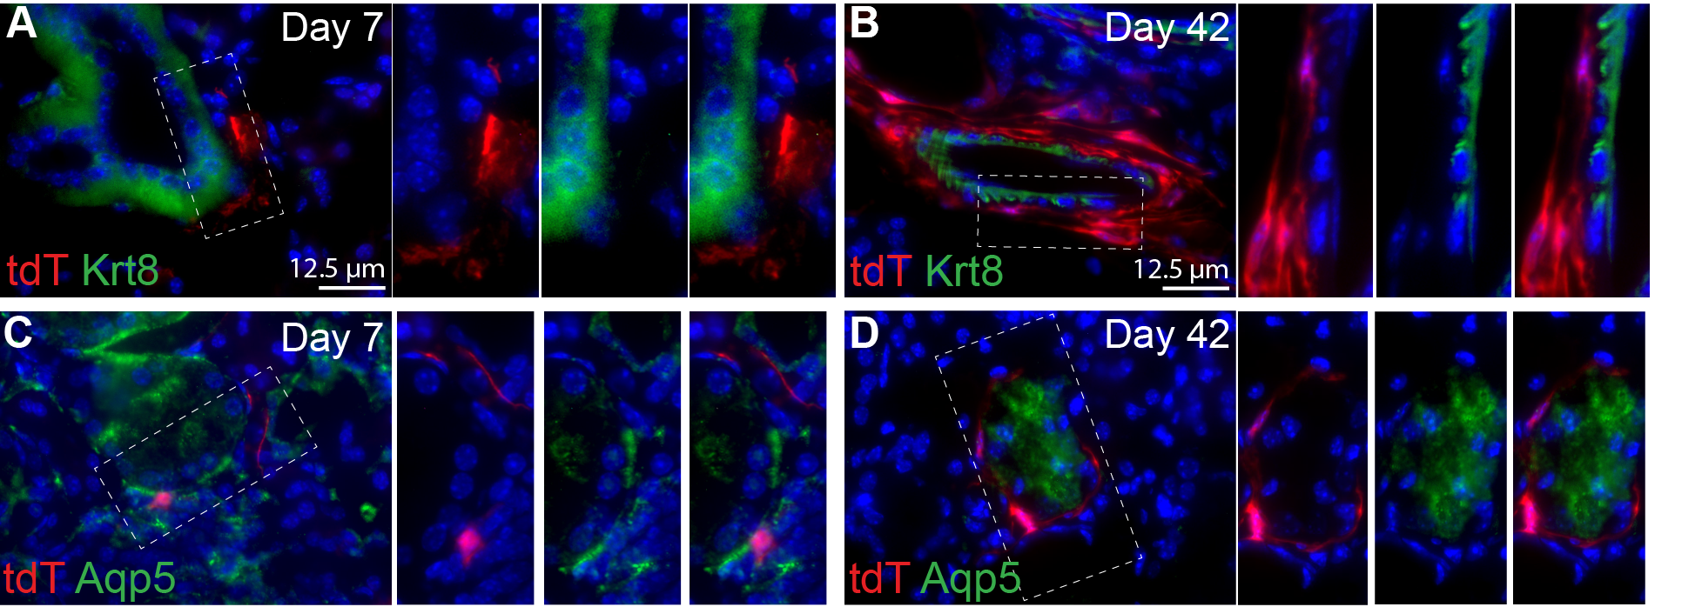

Supplementary Figure S6. Immunoflourescent staining of Krt8 and Aqp5 in SMGs of Gli1-CreER^{T2};Ai9(RCL-tdT) mice.

As mentioned in Figure 2, SMGs were collected at 7 or 42 days after 4-OHT treatment, and sectioned for IF staining of ductal epithelial maker Krt8 (A-B) and acinar epithelial marker Aqp5 (C-D). Dashed boxes are enlarged to show images of tdT alone, marker signal alone, and merged signals of same fields.

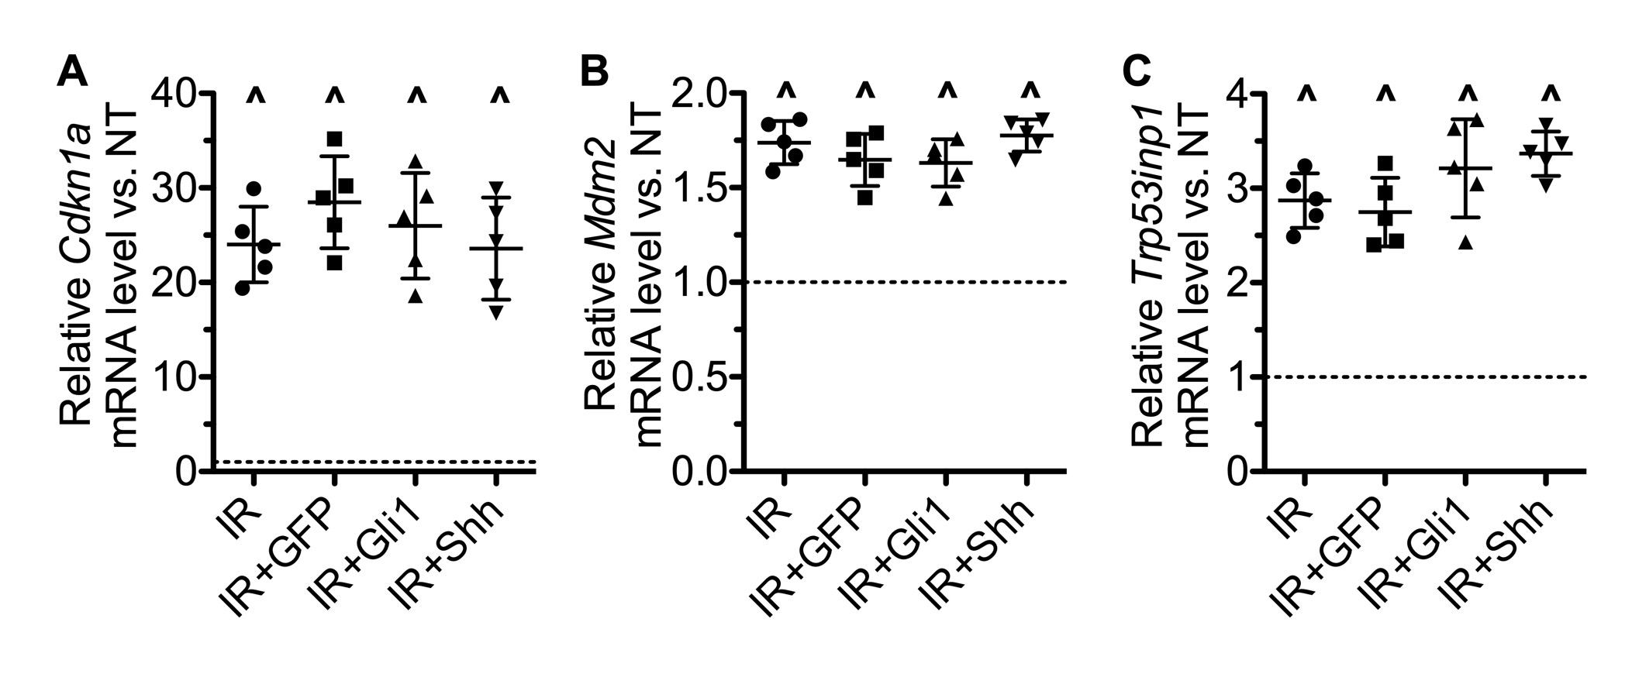
Supplementary Figure S7. Expression of p53 target genes.

The expression of p53 target genes Cdkn1a/p21, Mdm2 and Trp53inp1 was determined by qRT-PCR assays on SMGs collected at 7 days after IR. N = 5. ^: P < 0.05 vs. NT. The differences between all pairs of samples treated with IR are not significant (P > 0.05).
Supplementary Table S1. Marker genes for cell clusters identified by single cell RNA-seq of SMGs at 7 days after transfer of GFP or Shh gene.
Cluster | Upregulated markers | Downregulated markers | Cell identity
1 | Cd83, Cd86, Tlr2, Cd14 | Krt7/8/18, Ly6a (Sca1) | DC: dendritic cells
2 | Aif1, Adgre1(F4/80), Fcgr1, Csf1r, Cx3cr1, C1qa/b/c, | Ccr2, Krt7/8/18, Ly6a, Vim | rMp: resident macrophages
3 | Aif1, Hmgb1, Pcna | Cx3cr1, Krt18, Ly6a | iMp: infiltrating macrophages
4 | Ncr1, Klrb1c, Eomes, Tbx21, Tnfsf10, Ltb | Aif1, Krt7/8/18, Ly6a | ILCs: innate lymphoid cells
5 | Aqp5, Prol1, Elf5, Krt8/18, Epcam, Sox2/9, Kit | Aif1, Ly6a, Pecam1, Krt7, Csf1r | ADP: acinar/ductal progenitors
6 | Krt7, Krt8, Krt18 | Aif1, Ly6a, Prol1, Csf1r | Ductal cells
7 | Krt7/8/18, Epcam, Ascl3 or Sox9, Elf5 | Aif1, Vim, Csf1r | DP: ductal progenitors
8 | Krt14, Myl9, Csf1 | Krt7/8/18, Aif1, Csf1r | Basal: basal/myo-epithelial cells
9 | Pecam1, Aqp1, Mcam, Ly6a, Cd93, Csf1 | Aif1, Csf1r, Krt7/8/18, C1qa/b/c, Prol1 | Endothelia
10 | S100a4, Vim | Krt7/8/18, Adgre1, Fcgr1, Csf1r, Ly6a | Fibroblasts
11 | S100a4, Vim, Kit, Ly6a | Krt7/8/18, Aif1, Csf1r, Epcam | MSC: mesenchymal stem cells

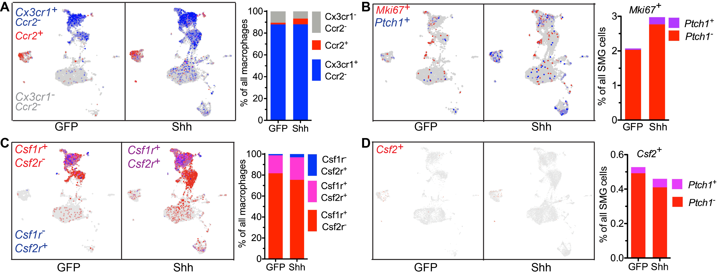

Supplementary Figure S8. Expression of other related genes in scRNA-seq data.
A and C: The expression of resident macrophage marker Cx3cr1 vs. infiltrating macrophage marker Ccr2 (A) and Csf1r vs. Csf2r (Csf2ra and Csfr2b) was plotted, and the percentages of each subpopulation in all macrophages quantified.
B and D: The expression of proliferation marker Mki67 vs. Ptch1 (B) and Csf2 was plotted, and the percentages of each subpopulation in all SMG cells quantified.

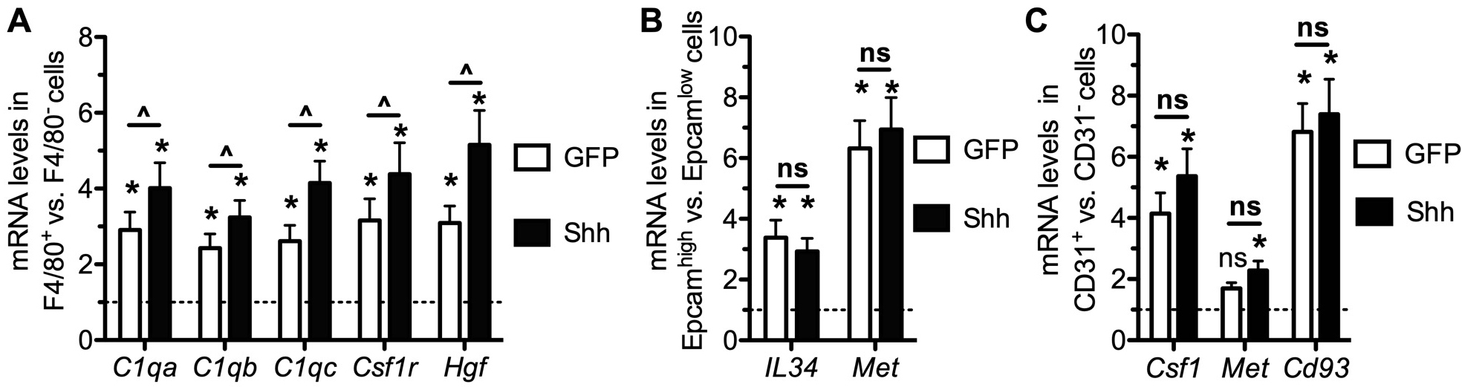
Supplementary Figure S9. Expression of paracrine factors in sorted subpopulations of SMGs cells with or without Hedgehog activation.

A-C: From SMGs at 7 days after intra-SMG transfer of GFP or Shh gene, macrophages, putative epithelial progenitor cells and endothelial cells were isolated by their expression of F4/80, Epcam (high level), and Cd31 resepectively with fluorescence-activated cell sorting (FACS). The expression of paracrine factors and their receptors identified in Figure 5 in these cells were examinded by qRT-PCR in comparsion to SMG cells negative for corresponding markers. N = 5. ^: P < 0.05 between GFP and Shh groups; ns: not significant (P > 0.05); *: P < 0.05 vs. cells negative or low for the corresponding marker.

References:
1. Trapnell C, Pachter L, Salzberg SL. TopHat: discovering splice junctions with RNA-Seq. Bioinformatics 2009;25:1105-11
2. Anders S, Pyl PT, Huber W. HTSeq--a Python framework to work with high-throughput sequencing data. Bioinformatics 2015;31:166-9
3. Love MI, Huber W, Anders S. Moderated estimation of fold change and dispersion for RNA-seq data with DESeq2. Genome Biol 2014;15:550
4. Mortazavi A, Williams BA, McCue K, Schaeffer L, Wold B. Mapping and quantifying mammalian transcriptomes by RNA-Seq. Nature methods 2008;5:621-8
5. McCarthy DJ, Campbell KR, Lun AT, Wills QF. Scater: pre-processing, quality control, normalization and visualization of single-cell RNA-seq data in R. Bioinformatics 2017;33:1179-86
6. Butler A, Hoffman P, Smibert P, Papalexi E, Satija R. Integrating single-cell transcriptomic data across different conditions, technologies, and species. Nat Biotechnol 2018;36:411-20

