SUPPLEMENTARY MATERIALS AND METHODS
Spheroid assay
Cells were seeded, maintained and cultured as described previously (1). HCT116 and SW620 cells were cultured and treated with 20 µg/ml control IgG or EpAb2-6. Final data are presented as fold increase in colony number compared to IgG controls. Data are expressed as mean ± standard deviation (SD) from three independent experiments.
Soft agar assay
A 0.8% base agar layer was prepared and sterilized, followed by storage at room temperature in conical flasks. The agar was melted and kept in a water bath at 50°C. To make the bottom layer, one part of the melted 0.8% agar (500 μl) was mixed with 500 μl 2× DMEM serum free medium, and the mixture (0.4% agar) was then added to wells at 100 μl/well and allowed to solidify at room temperature. To prepare the top layer (0.3% soft agar), 500 μl of 0.6% agar was mixed with 500 μl 2× DMEM containing cells (500 cells/well). This mixture was then added to the bottom layer (100 μl/well) and allowed to solidify at RT before culturing as described. HCT116 and SW620 cells were cultured and treated with 20 µg/ml control IgG or EpAb2-6. Colonies were photographed after three weeks of growth.
TACE activity assay
The enzyme activity of ADAM17 was quantified by fluorometric analysis using the InnoZyme™ TACE Activity Kit (Calbiochem #CBA042). To assess activity, 500 μg of a total lysate of HCT116 cells were incubated with anti-ADAM17 antibody-coated well before following the activity kit protocol.
γ-secretase activity assay
The enzyme activity of γ-secretase was quantified by fluorometric analysis using the fluorogenic γ-secretase substrate (Calbiochem #565764). The cell lysate was extracted with 0.5% CHAPSO to avoid breaking the structure of γ-secretase subunits. Each well contained 1 mg total lysate from HCT116 cells and 32.5 mM substrate; the reaction was carried out at 37°C in Corning® 96 well plates (black flat bottom). Fluorescence was determined with a microplate reader (Molecular Devices, SpectraMax M5) at an excitation wavelength of 355 nm and an emission wavelength of 440 nm under kinetic mode for 3 h, with a 3 min interval time.

Reference
1. Lin CW, Liao MY, Lin WW, Wang YP, Lu TY, Wu HC. Epithelial cell adhesion molecule regulates tumor initiation and tumorigenesis via activating reprogramming factors and epithelial-mesenchymal transition gene expression in colon cancer. The Journal of biological chemistry 2012;287:39449-59

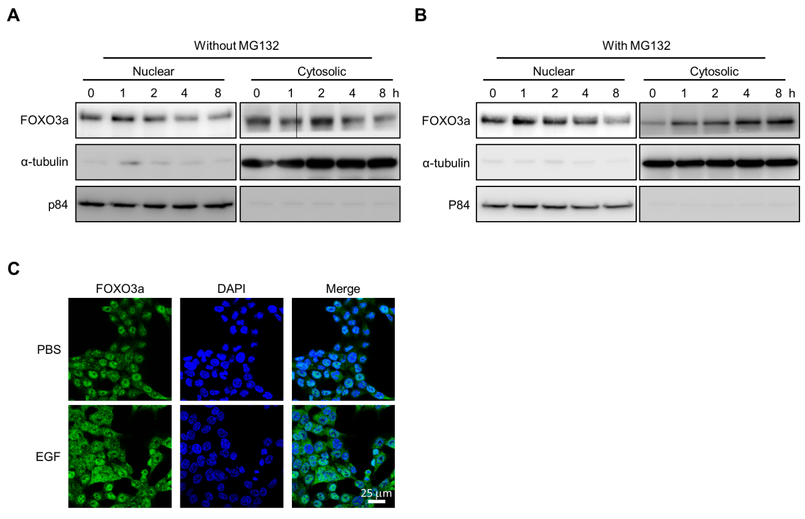
Figure S1. EGFR-AKT signaling pathway decreases nuclear localization of FOXO3a
(A, B) HCT116 cells were serum starved then pre-treated with or without 10 μM MG132 for 1 h before being treated with EGF (100 ng/ml) and extracted at the indicated times. Nuclear and cytoplasmic fractions were analyzed by immunoblotting with the indicated antibodies. (C) HCT116 cells were treated with EGF for 2 h, and the subcellular localization of FOXO3a was assessed by immunofluorescence staining.
.

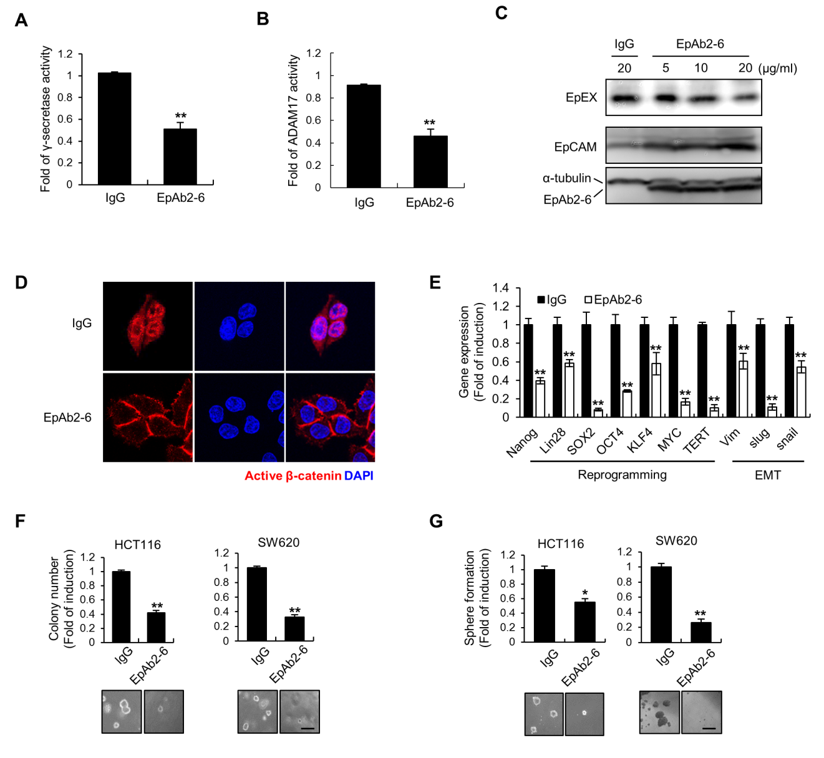
Figure S2. EpAb2-6 decreases EpICD shedding and β-catenin nuclear translocation
HCT116 cells were treated with either control IgG (20 µg/ml) or EpAb2-6 (20 µg/ml) for 24 h. Cell proteins were subsequently examined using (A) γ-secretase and (B) TACE activity assay kits. (C) HCT116 cells were treated with EpAb2-6 (0-20 µg/ml) for 24 h, and the culture supernatants were immunoblotted with anti-EpEX antibody. (D) HCT116 cells were treated with EpAb2-6 (20 µg/ml) for 6 h, and the subcellular localization of active β-catenin was assessed by immunofluorescence staining. (E) Real-time qPCR analysis mRNA levels of reprogramming and EMT genes in EpAb2-6 treated HCT116 cells. (F) The effect of EpAb2-6 on colon cancer cells was examined by the anchorage-independence assay. Results from one representative field in each group are shown. Quantification of results of colony formation data is presented. (G) The effect of EpAb2-6 on colon cancer cells was examined by spheroid formation. Spheroid formation from colon cancer cells was counted in triplicate. Representative images of tumorspheres after treatment with IgG or EpAb2-6 are shown. Bar, 5 mm. N = 3 independent experiments. Error bars indicate ± SD. *p < 0.05, **p < 0.01.

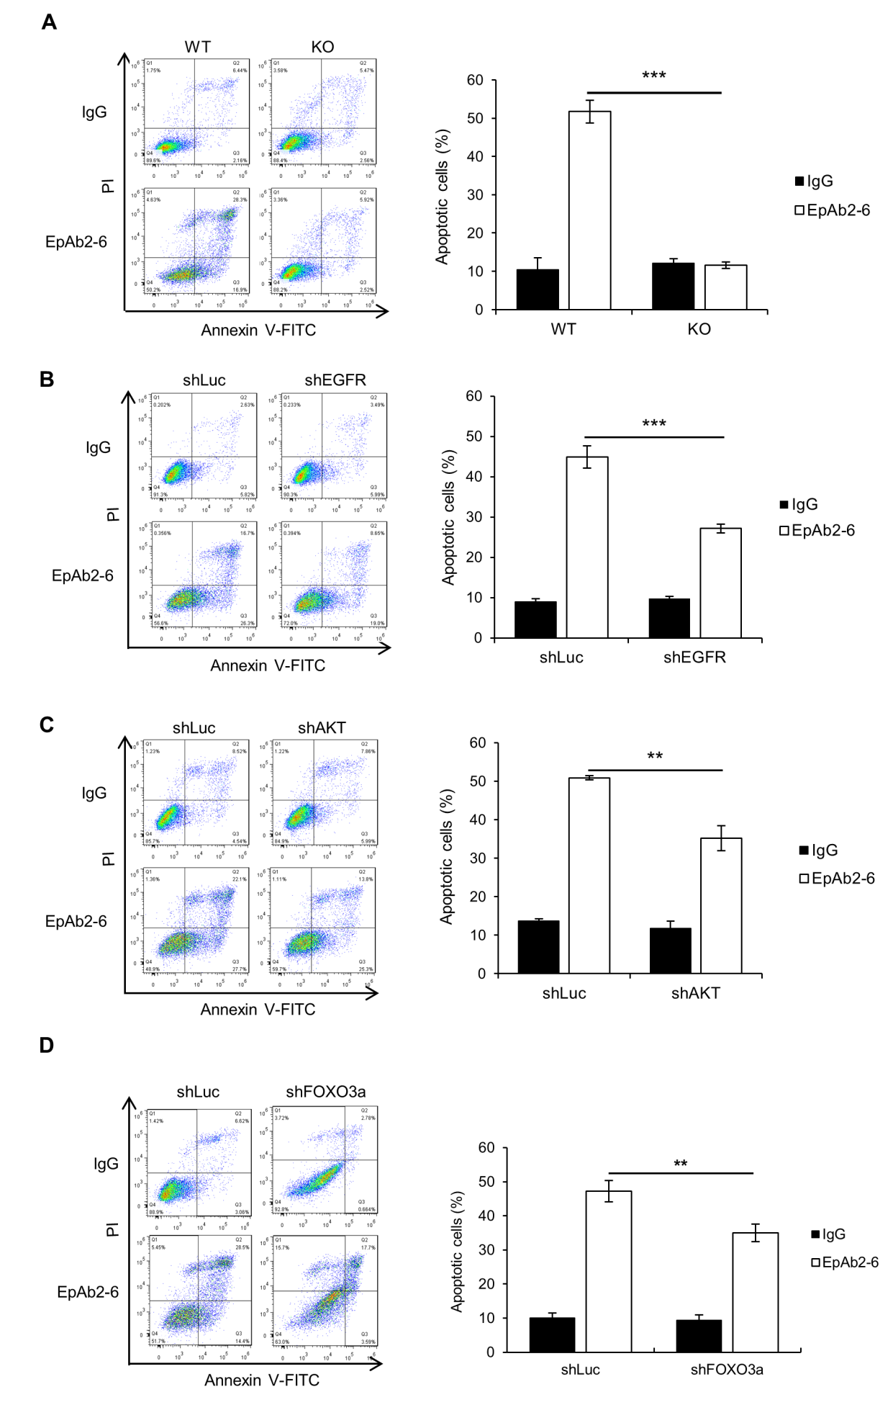
Figure S3. EGFR, AKT or FOXO3a knockdown and EpCAM knockout decrease EpAb2-6-induced apoptosis
(A) EpCAM-knockout (KO), (B) EGFR-, (C) AKT-, (D) FOXO3a-knockdown HCT116 cells were treated with EpAb2-6, and the apoptotic cells were quantified by fluorescein-conjugated annexin V-FITC/PI double labeling. N = 3 independent experiments. Bar graphs show mean ± SEM. *p < 0.05, **p < 0.01.

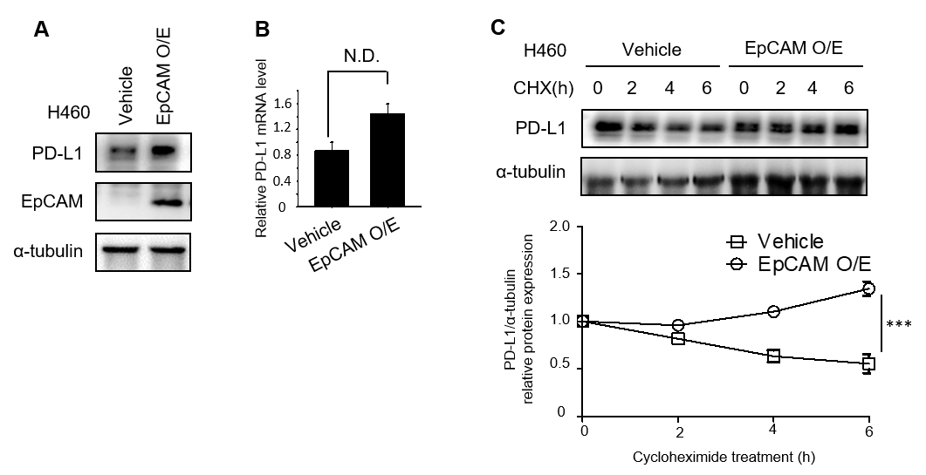
Figure S4. EpCAM expression stabilizes PD-L1 protein in H460 cells.
After transfection with vehicle or EpCAM expression vector, the PD-L1 protein and mRNA expression levels were analyzed by (A) Western blotting or (B) qRT-PCR. (C) H460 cells were treated with 50 μM CHX for the indicated intervals, and PD-L1 expression was analyzed by Western blotting. Protein expression over time is shown in the graph.

Figure S5. Expression of EpCAM and PD-L1 in a colon tumor tissue array
Immunohistochemical staining for (A) EpCAM and (B) PD-L1 was performed on a colon tumor tissue array.

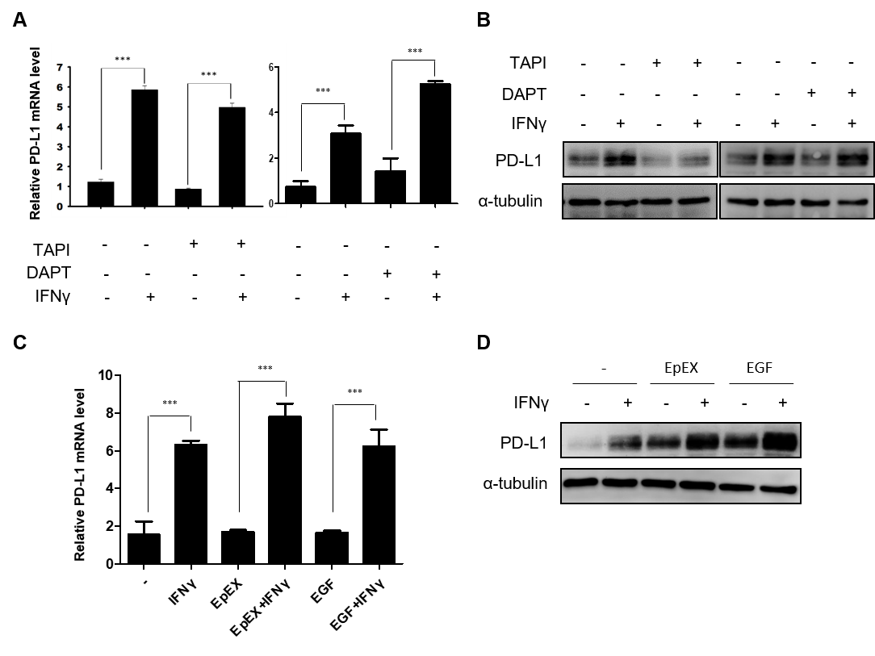
Figure S6. EpCAM is crucial for PD-L1 protein expression
(A, B) After starvation and treatment with IFNγ for 16 h, H441 cells were treated with EpEX or EGF for 1 h and the PD-L1 expression was analyzed by (A) qRT-PCR and (B) Western blotting. (C, D) H441 were treated with or without TAPI, DAPT and IFNγ for 24 h, and PD-L1 expression was analyzed by (C) qRT-PCR and (D) Western blotting.

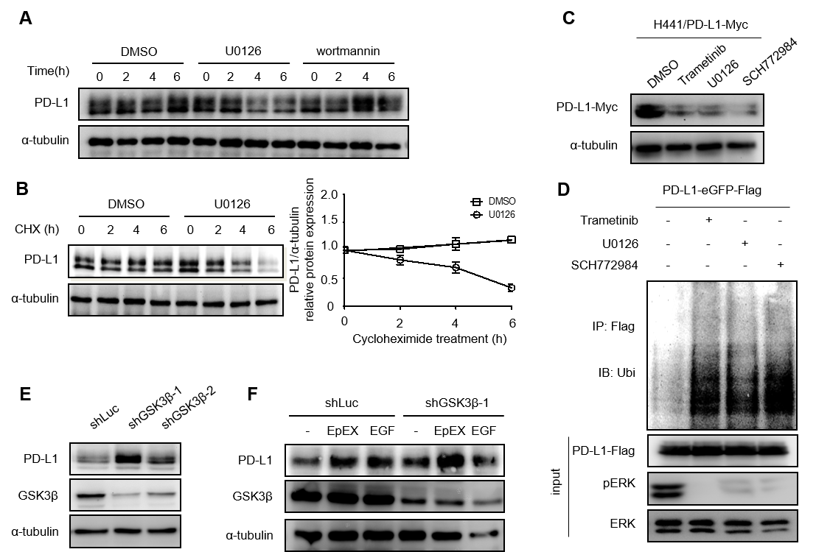

Figure S7. MAPK pathway increases PD-L1 protein stability
(A) H441 cells were treated with DMSO, U1026 or wortmannin for the indicated intervals, and PD-L1 expression was analyzed by Western blotting. (B) H441 cells were treated with U0126 for 6 h, and CHX for the indicated intervals, and PD-L1 expression was analyzed by Western blotting. (C) H441 cells expressing PD-L1-Myc were treated with trametinib, U0126 or SCH772984 for 6 h, and total cell lysate was subjected to Western blotting. (D) H441 cells expressing PD-L1-eGFP-Flag were treated with MG132 for 5 h. Total cell lysate was immunoprecipitated with anti-Flag antibody and the polyubiquitin of PD-L1-eGFP-Flag analyzed by Western blotting. (E) PD-L1 expression was analyzed in shLuc- or shGSK3β-expressing cells by Western blotting. (F) shLuc or shGSK3β cells were starved for 16 h and then treated with EpEX or EGF for 1 h. The total cell lysate was subjected to Western blotting.
Figure S8. EpAb2-6 treatment shows no significant body weight change in the orthotopic model with HCT116-Luc tumors
Average body weight of each group is shown on the indicated days. Error bars show mean ± SD.

Table S1. Primers for quantitative real-time PCR
Genes | Sequence
Nanog | Forward: 5'-ATGCCTCACACGGAGACTGT-3'  Reverse: 5'-AGGGCTGTCCTGAATAAGCA-3'
Sox2 | Forward: 5'-TATTTGAATCAGTCTGCCGAG-3'  Reverse: 5'ATGTACCTGTTATAAGGATGATATTAGT-3'
Oct4 | Forward: 5'-AGCAAAACCCGGAGGAGT-3'  Reverse: 5'-CCACATCGGCCTGTGTATATC-3'
Lin28 | Forward: 5'-CCAGTGGATGTCTTTGTGCACC-3'  Reverse: 5'-GTGACACGGATGGATTCCAGAC-3'
Klf4 | Forward: 5'- GCGAACTCACACAGGCGAGAAACC-3'  Reverse: 5'- TCGCTTCCTCTTCCTCCGACACA-3'
Myc | Forward: 5'-AAACACAAACTTGAACAGCTAC-3'  Reverse: 5'-ATTTGAGGCAGTTTACATTATGG-3'
Slug | Forward: 5'-TGGTTGCTTCAAGGACACAT-3'  Reverse: 5'-GTTGCAGTGAGGGCAAGAA-3'
Snail | Forward: 5'-CTTCGGCTCCAGGAGAGTC-3'  Reverse: 5'-TTCCCACTGTCCTCATCTGAC-3'
Vimentin | Forward: 5'-GTTTCCCCTAAACCGCTAGG-3'  Reverse: 5'-AGCGAGAGTGGCAGAGGA-3'
TERT | Forward: 5'-CCTGCTCAAGCTGACTCGACACCGTG-3'  Reverse: 5'-GGAAAAGCTGGCCCTGGGGTGGAGC-3'
BIM | Forward: 5'-GAGCCACAAGACAGGAGC-3'  Reverse: 5'-AAGGGCAATTCTGAGGGA-3'
p21 | Forward: 5'-CACAGCTCAGTGGACTGGAA-3'  Reverse: 5'-ACCCTAGACCCACAATGCAG-3'
FasL | Forward: 5'-AGCAAATAGGCCACCCCAGTCC-3'  Reverse: 5'-TGGCTCAGGGGCAGGTTGTTG-3'
HtrA2 | Forward: 5'-GTGGCAGACATCGCAACGCT-3'  Reverse: 5'-ACCCACTGATTCCGGAGGAG-3'
GAPDH | Forward: 5'-CTTCACCACCATGGAGGAGGC-3'  Reverse: 5'-GGCATGGACTGTGGTCATGAG-3'

Table S2. Primers for ChIP assay
Name | Sequence
FOXO3a | Forward: 5'-TGCAAAGAAACAATCC-3'  Reverse: 5'-TATATCAAGGTTCTACC-3'

Table S3. Primers for HtrA2 promoter cloning
Name | Sequence
pGL4.18-HtrA2-1 | Forward: 5'-AAAGAGCTCTGCTCTGCTTTGTCAGCTGG-3'  Reverse: 5'-AAACTCGAGACTGCTTCCTACTGCTCGTGC-3'
pGL4.18-HtrA2-2 | Forward: 5'-AAAGAGCTCCTTGACCACCTACCCAGCTGG-3'  Reverse: 5'-AAACTCGAGACTGCTTCCTACTGCTCGTGC-3'

Table S4. The effect of gene knockdown on EpAb2-6-induced apoptosis
 | A | B | A-B | C (A-B/A)
shEGFR | 35.9 | 17.4 | 18.5 | 51.5
shc-Met | 37.1 | 28.2 | 8.9 | 24.0
shAKT | 37.1 | 23.4 | 13.7 | 36.9
shFOXO3a | 37.2 | 25.7 | 11.5 | 30.9
shHtrA2 | 47.7 | 29.3 | 18.4 | 38.6
A: EpAb2-6-induced apoptosis in control knockdown cells (%)
B: EpAb2-6-induced apoptosis in indicated knockdown cells (%)
A-B: The decrease of EpAb2-6-induced apoptosis in indicated knockdown cells (%)
C: The decrease of EpAb2-6-induced apoptosis in indicated knockdown cells compared to apoptosis in control knockdown cells (%), (A-B/A)

