Supplementary Materials
Supplementary Materials and Methods
Supplementary Figure S1. Characterizations of established lymphoma mice and survival curve for λ-Myc mice.
Supplementary Figure S2. Histopathology of lymphomas derived from MYC–transduced B cells expressing shRNAs and in vivo depletion of CD8 T cells after administration of an anti-CD8 antibody.
Supplementary Figure S3. Flow cytometric analyses of Fas restoration by several inhibitors or activators and Fas-mediated apoptosis by CD40 activation in mouse lymphoma cells.
Supplementary Figure S4. Flow cytometric analyses of Fas-mediated apoptosis with or without CD40 activation and CD40 expression in human lymphoma cell lines.
Supplementary Figure S5. The effect of several inhibitors and shRNA for BRD4 and BRD2 on Livin expression in human lymphoma cell lines.
Supplementary Figure S6. The analysis of combination treatment with FasL and JQ1, ABT737, or shRNA for cIAP1, cIAP2 and Flip, and the expression of Livin and Fas in mouse lymphoma cells.
Supplementary Figure S7. The proposed model in this study.
Supplementary Table 1. The 10 genes altered with the highest frequency in DLBCL samples.
Supplementary Table 2. Summary of Fas expression status, FAS genotype, up-regulation of Fas expression by CD40L, and sensitivity to FasL-induced apoptosis in human lymphoma cell lines.
Supplementary Table 3. The lists of antibodies used for flowcytometry.

Supplementary Materials and Methods
Viral vectors and viral infection
Both pMXs retroviral vectors and Plat-E packaging cells (1) were kindly provided by T. Kitamura (Institute of Medical Science, University of Tokyo, Japan). Human MYC cDNA was cloned into the retroviral vector pMXs-IRES-GFP as described previously (2). Mouse Fas and Cd40lg as well as human BIRC7 and BIRC3 cDNAs were cloned into the pMXs-IRES-puro vector. All retroviral vectors were introduced into Plat-E packaging cells by transfection for 24 h with the use of the Fugene HD reagent (Roche, Mannheim, Germany). The virus-containing culture supernatants were passed through a 0.45-µm cellulose acetate filter (Iwaki, Tokyo, Japan), and the filtrate was collected for cell infection. RetroNectin-coated dishes (Takara Bio, Tokyo, Japan) were used for infection of mouse lymphoma cells, which were subsequently subjected to selection with puromycin (InvivoGen) at 0.4 µg/ml. For infection of NIH3T3 cells, the virus-containing supernatant derived from the retroviral vector encoding CD40L was added to the cells together with protamine (Sigma-Aldrich) at 0.8 µg/ml for 48 h, and the infected cells were then subjected to selection with puromycin (2 µg/ml). The lentiviral vector pLenti6/UbC/V5-DEST encoding the mouse ecotropic receptor Slc7a1 (kindly provided by S. Yamanaka, Kyoto University, Japan) was introduced into human lymphoma cell lines before retroviral infection, as previously described (3). In brief, Lenti-X 293 packaging cells (Takara Bio) were transfected with the lentiviral vector with the use of Fugene HD (Roche) for 24 h, and the filtered virus-containing culture supernatant was collected for infection of human lymphoma cells in RetroNectin-coated dishes (Takara Bio). The lentivirus-infected cells were then infected with retroviruses and subjected to selection with puromycin. For expression of shRNAs, shFas #1 (TRCN0000012328), shFas #2 (TRCN0000012329), shLivin #1 (TRCN0000033929), shLivin #2 (TRCN0000033933), shBRD4 #1 (TRCN0000199427), and shBRD4 #2 (TRCN0000196576), shBRD3 #1 (TRCN0000021376), shBRD3 #2 (TRCN0000021378), shBRD2 #1 (TRCN0000006308), shBRD2 #2 (TRCN0000006311), shcIAP1 #1 (TRCN0000378682) , shcIAP1 #2 (TRCN0000320867), shcIAP2 #1 (TRCN0000355769), shcIAP2 #2 (TRCN0000355806), shFlip #1 (TRCN0000007229) and shFlip#2 (TRCN0000364099) in pLKO-puro were obtained from Dharmacon (Lafayette, CO). The empty pLKO-puro vector was used as shCtrl. Transfection and infection for the pLKO vectors and subsequent puromycin selection were performed as described above.

Establishment of the mouse B cell lymphoma model
B cells were isolated from the spleen of Cdkn2a–/– or C57BL/6 mice with the use of an EasySep Mouse B Cell Isolation Kit (StemCell Technologies, Vancouver, British Columbia, Canada). The separated cells were cultured for 2 days in RPMI 1640 supplemented with 10% FBS, penicillin (100 U/ml), streptomycin (100 U/ml), American hamster mAbs to CD40 (HM40-3; Biolegend, San Diego, CA) at 1 µg/ml, IL-4 (25 ng/ml), and 2-mercaptoethanol (55 µM). They were then isolated by centrifugation at 2000 × g for 1 h at room temperature for infection with a retrovirus encoding human c-Myc and GFP for 2 days in the presence of protamine (Sigma-Aldrich) at 0.8 µg/ml. Infected cells (10⁵ GFP+ cells) were then injected i.v. or i.p. into x-irradiated (4 Gy) recipient C57BL/6 mice.

Analysis of lymphoma clonality
Genomic DNA isolated from LNs of lymphoma-bearing mice was subjected to PCR with primers that detect VDJ regions of Ig heavy chain genes as described previously (4,5)

Flow cytometry
All labeled antibodies for flow cytometry are listed in Supplementary table 3. Cells were exposed to antibodies specific for CD16/32 (Biolegend) for 10 min before incubation with labeled antibodies for 20 min on ice. They were then either sorted with a MoFlo flow cytometer (Beckman Coulter, Miami, FL) or analyzed with Gallios (Beckman Coulter) or Attune Acoustic Focusing (Thermo Fisher Scientific, Rockford, IL) flow cytometers.

Depletion of CD8 T or NK cells
Rat mAbs to CD8 (2.43), NK1.1(PK136) and rat isotype control antibodies (LTF-2) were obtained from BioXCell (West Lebanon, NH). The antibodies (400 µg) were injected i.p. into recipient mice 1 day before transplantation of Fas-transduced lymphoma cells. They (200 µg) were then administered every 3 or 4 days.

Cell viability assays, Annexin V–based assay of apoptosis, and detection of caspase-3 activity
Human lymphoma cell lines were cultured for 48 h on NIH3T3 cells transduced with CD40L. The cells were then treated with FasL (50 ng/ml) for 24 h, after which cells expressing the B cell marker CD19 were measured as a viable cell population by flow cytometry. Mouse cells were treated with American hamster mAbs to CD40 (HM40-3, Biolegend) at 2 µg/ml or isotype control antibodies (2 µg/ml) for 48 h and then exposed to FasL (50 ng/ml) for 24 h. The cells were then stained with 0.05% trypan blue and counted with a TC10 Automated Cell Counter (Bio-Rad, Hercules, CA). For quantitation of Annexin V+ apoptotic cells, cell samples were washed with ice-cold PBS, suspended in Annexin V Binding Buffer (BD Biosciences, San Jose, CA), and then treated with allophycocyanin-conjugated Annexin V (BD Biosciences) and propidium iodide (Sigma-Aldrich). For quantitation of caspase-3 activation, cell samples were treated with NucView 530 substrate (Biotium, Fremont, CA) and then analyzed by flow cytometry.

RT-qPCR analysis
Total RNA was extracted from cells with the use of the Trizol reagent (Thermo Fisher Scientific) and was subjected to reverse transcription (RT) with ReverTra Ace qPCR RT Master Mix (Toyobo, Osaka, Japan). The resulting cDNA was subjected to real-time PCR analysis with the use of SYBR Green and a Thermal Cycler Dice Real Time System (Takara Bio). The PCR conditions were as follows: 95°C for 2 min, followed by 40 cycles of 95°C for 30 s and 60°C for 30 s. Expression data were normalized on the basis of GAPDH mRNA abundance. The sequences of the PCR primers (forward and reverse, respectively) were 5'-TGCAGAAGATGTAGATTGTGTGATGA-3' and 5'-GGGTCCGGGTGCAGTTTATT-3' for mouse Fas, 5'-TTCACCACCATGGAGAAGGC-3' and 5'-CCCTTTTGGCTCCACCCT-3' for mouse Gapdh, 5'-ACAGTGTGCAGGAGACTCAC-3' and 5'-CTGGACTGACCCCTCCTGG-3' for human BIRC7, and 5'-GCACCGTCAAGGCTGAGAAC-3' and 5'- TGGTGAAGACGCCAGTGGA -3' for human GAPDH.

Immunoblot analysis
Cells were lysed and denatured as previously described (6). Proteins were fractionated by SDS-PAGE on Mini-Protean TGX Precast Gels (Bio-Rad) and were then transferred to a PVDF membrane (Bio-Rad). Membranes were incubated for 1 h at room temperature in PBS containing 5% dried nonfat milk and 0.05% Tween 20 before exposure overnight at 4°C to appropriate dilutions of primary antibodies. The antibodies included those to Flip (ab8421), Bcl-xL (E18), Bcl2A1 (ab45413), MCL1 (Y37), and c-Myc (Y69) from Abcam (Cambridge, UK); those to Survivin (71G4B7), Livin (D51D1), cIAP1 (D5G9), cIAP2 (58C7), XIAP (3B6), BRD4 (E2A7X) from Cell Signaling Technology (Danvers, MA); those to BRD2 (A302-583A) and BRD3 (A302-368A) from Bethyl Laboratories (Montgomery, TX); those to α-tubulin (DM1A) from Sigma-Aldrich; and those to Bcl2 (C-2) from Santa Cruz Biotechnology (Santa Cruz, CA). Immune complexes were detected by incubation with horseradish peroxidase–conjugated secondary antibodies (GE Healthcare, Little Chalfont, UK) for 45 min at room temperature. Peroxidase activity was detected with Western Lightning Plus-ECL reagents (Perkin Elmer, Boston, MA).

Sequence analysis of the Fas gene
Total RNA was extracted from human lymphoma cell lines and was subjected to RT as described above. The PCR product for human FAS was directly sequenced by Fasmac (Kanagawa, Japan).

Bisulfite Genomic Sequencing
Bisulfite treatment of DNA from mouse lymphoma cells was performed using the EZ DNA Methylation-lightning kit (ZymoResearch, Irvine, CA) according to the manufacturer's protocol. The sequence of PCR primers (forward and reverse, respectively) are 5'-TGTGTTTGGTTTTTTAAAAGAAAAA-3' and 5'-AACCCAAATCCACAACATATCTAC-3'. Amplified products were cloned into pMD20-T (Takara Bio). Ten clones were randomly selected and sequenced with the M13 reverse primer for mouse Fas gene.

ChIP-qPCR analysis
ChIP using antibodies to BRD4 (91301, Activemotif, Carlsbad, CA), BRD2 (A302-583A, Bethyl Laboratories), H3K27ac (39133, Activemotif), or Rabbit Isotype IgG (Cell Signaling Technology) in DB cells treated with 0.5 µM of JQ1 or DMSO for 24 h was performed with ChIP-IT PBMC and ChIP-IT High Sensitivity kit (Active motif) according to the manufacture's protocols. The isolated DNA was subjected to qPCR analysis as described above. The sequences of the PCR primers (forward and reverse, respectively) were 5'-CGAGACGTTTATTTTGCCAAG-3' and 5'-GAGAAAGGCACAGACCACAGA-3' for -10742, 5'-CACCACACCTGGCTAATTTTG-3' and 5'-CACCTGAGGTCAGGAGTTCG-3' for -7920, 5'-GTCCGTAGGTGGCTTGTGTT-3' and 5'-CAGAAAGCCCTCTGTCCTTG-3' for -5168, 5'-CATATGGGTTTTCCCAGCTT-3' and 5'-AGGGTGCATGGACACCTCTA-3' for -2601, 5'-CTTCTGGGCTCTATCCTCAGC-3' and 5'-AAATCAAAGTGAAGGGTGTGG-3' for -1345 and, 5'-AGCACAGCTCACATGTCCTTC-3' and 5'-GAGATGATGGCTCCAAGGTC-3' for -255.

Immunohistochemistry
LN, liver, or BM tissue was fixed with 4% paraformaldehyde, embedded in paraffin, and sectioned at a thickness of 4 µm. The sections were depleted of paraffin, rehydrated, subjected to antigen retrieval by heating for 15 min at 100°C in 0.01 M sodium citrate (pH 6.0), and exposed to 3% H2O2. They were then incubated first overnight at 4°C with antibodies to GFP (FL, Santa Cruz Biotechnology) and then for 30 min at room temperature with Histofine Simple Stain MAX-PO (Multi) secondary antibodies (Nichirei, Tokyo, Japan). Immune complexes were detected with ImmPACT DAB (Vector Laboratories, Burlingame, CA), and the sections were counterstained with hematoxylin.

Histological analysis
LN, spleen, or liver tissue was fixed in 15% neutral buffered formalin (Muto Kagaku, Tokyo, Japan), embedded in paraffin, and sectioned at a thickness of 4 µm. The sections were depleted of paraffin, rehydrated in a graded series of ethanol solutions, and then stained with H&E.

1. Morita S, Kojima T, Kitamura T. Plat-E: an efficient and stable system for transient packaging of retroviruses. Gene Ther 2000;7:1063-6
2. Kitamura T, Koshino Y, Shibata F, Oki T, Nakajima H, Nosaka T, et al. Retrovirus-mediated gene transfer and expression cloning: powerful tools in functional genomics. Experimental Hematology 2003;31:1007-14
3. Nakagawa M, Koyanagi M, Tanabe K, Takahashi K, Ichisaka T, Aoi T, et al. Generation of induced pluripotent stem cells without Myc from mouse and human fibroblasts. Nat Biotechnol 2008;26:101-6
4. Ehlich A, Martin V, Muller W, Rajewsky K. Analysis of the B-cell progenitor compartment at the level of single cells. Curr Biol 1994;4:573-83
5. Li YS, Hayakawa K, Hardy RR. The regulated expression of B lineage associated genes during B cell differentiation in bone marrow and fetal liver. J Exp Med 1993;178:951-60
6. Sugihara E, Shimizu T, Kojima K, Onishi N, Kai K, Ishizawa J, et al. Ink4a and Arf are crucial factors in the determination of the cell of origin and the therapeutic sensitivity of Myc-induced mouse lymphoid tumor. Oncogene 2012;31:2849-61

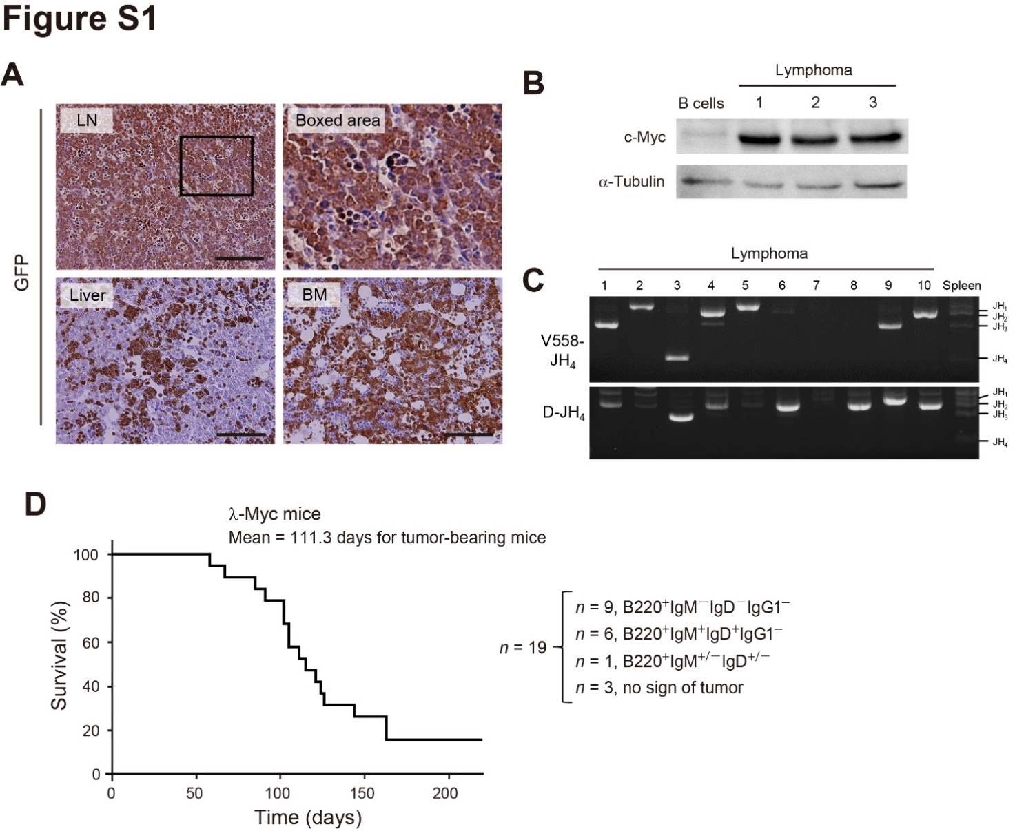

Figure S1
(A) Immunohistochemical analysis of GFP expression in LN, liver, and BM tissue of lymphoma-bearing model mice. GFP expression is indicative of lymphoma cells. The boxed area of the LN section is shown at higher magnification on the right. Scale bars, 100 µm. (B) Immunoblot analysis of c-Myc in isolated B cells and in three clones of lymphoma isolated from LNs of model mice. α-Tubulin was examined as a loading control. (C) VDJ rearrangement of Ig heavy chain genes of lymphoma cells from 10 model mice as well as of the WT spleen analyzed by PCR with primers for V558-JH₄ or D-JH₄ genomic regions. (D) Survival curve for λ-Myc mice (n = 19). Lymphoma cells in each mouse were classified as B220⁺IgM⁻IgD⁻IgG1⁻, B220⁺IgM⁺IgD⁺IgG1⁻, or B220^{+/+} IgM^{+/−}IgD^{+/−} based on flow cytometry.

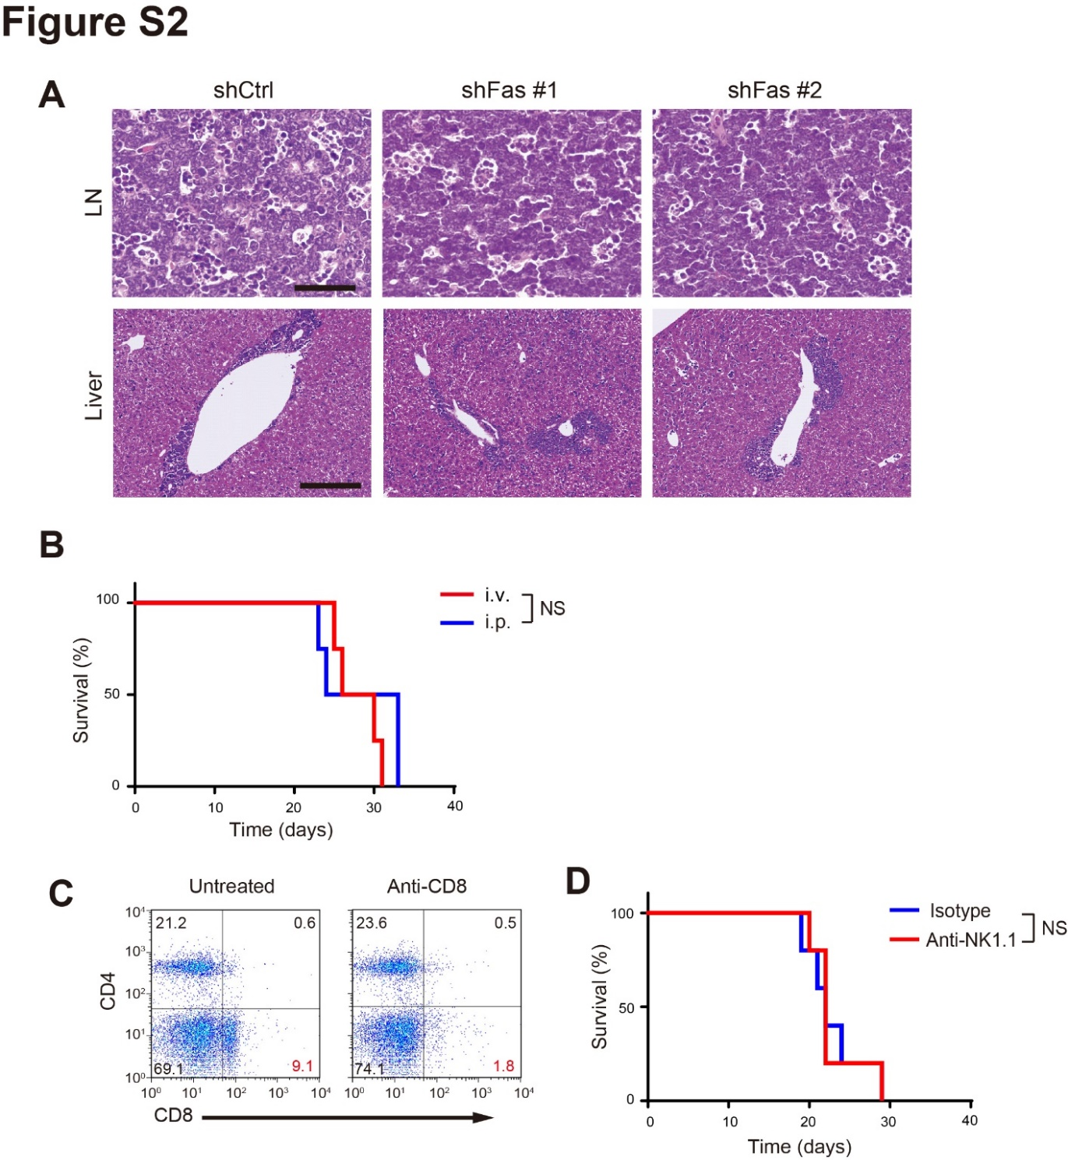
Figure S2
(A) Representative histopathology of LN and liver tissue (stained with H&E) from mice bearing lymphomas derived from MYC–transduced B cells expressing control or Fas shRNAs. Scale bars, 100 µm for LNs and 200 µm for liver. (B) Survival curves for recipient mice injected i.v. or i.p. with mouse lymphoma cells. Data are for five mice per group. NS, not significant (log rank test). (C) Flow cytometric analysis of CD4 and CD8 expression in the spleen of representative mice 48 h after a single intraperitoneal injection of anti-CD8 or left untreated. (D) Survival curves for recipient mice treated with a mAb to NK1.1 or an isotype control (ctrl) antibody before and after transplantation with Fas-transduced lymphoma cells. Data are for five mice per group. NS, not significant (log rank test).
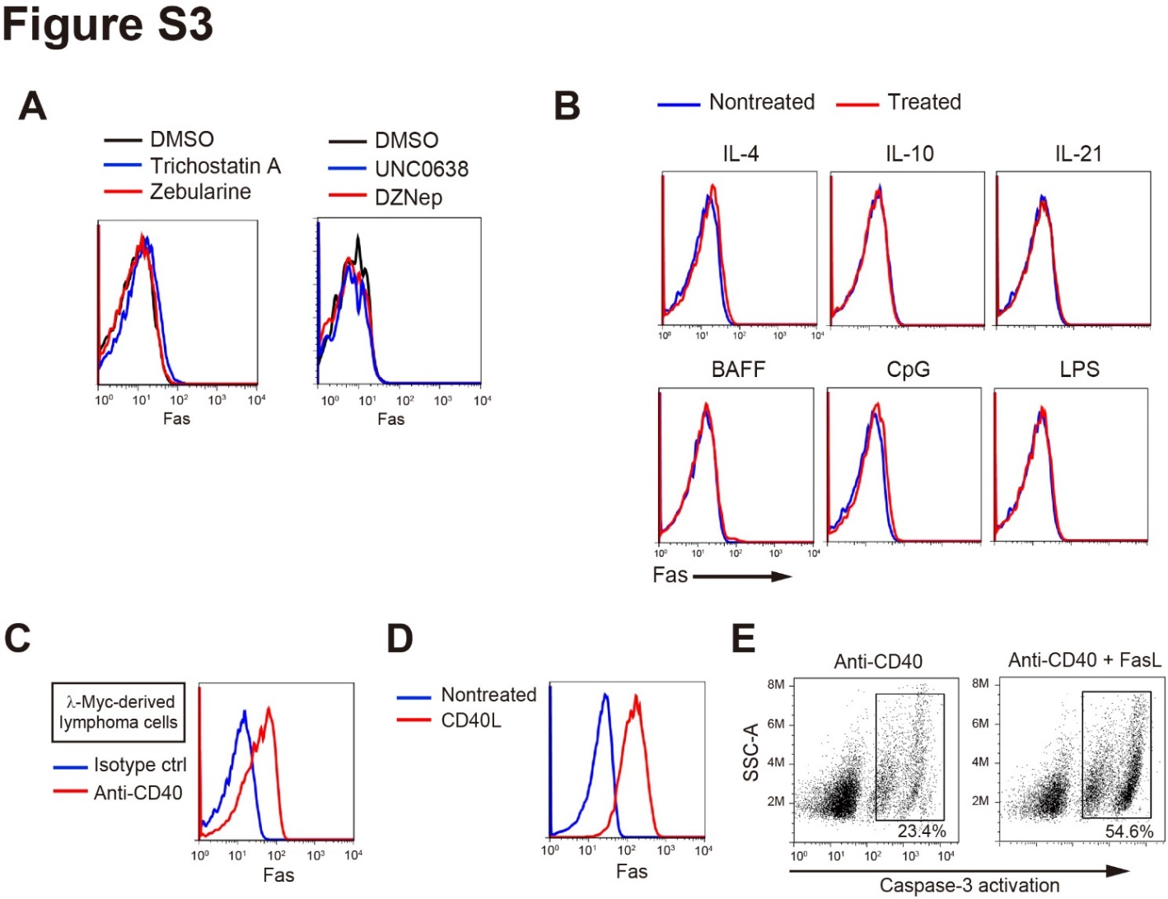
Figure S3
(A) Primary lymphoma cells were incubated for 48 h in the absence or presence of trichostatin A (5 nM), zebularine (5 µM), DzNep (0.1 µM) or UNC0638 (1 µM) then analyzed for Fas expression by flow cytometry. (B) Lymphoma cells were treated (or not) with IL-4 (50 ng/ml), IL-10 (50 ng/ml), IL-21 (50 ng/ml), BAFF (50 ng/ml), CpG (10 µM), or LPS (10 ng/ml) for 48 h. Fas expression was then analyzed by flow cytometry. (C) Fas expression in lymphoma cells derived from λ-Myc mice and incubated for 48 h with anti-CD40 (2 µg/ml) or an isotype control (ctrl) antibody. (D) Fas expression in primary lymphoma cells derived from MYC–transduced B cells were incubated for 48 h with or without CD40L-expressing NIH3T3 cells. (E) Flow cytometric analysis of caspase-3 activation in MYC–transduced B cells-derived lymphoma cells treated with anti-CD40 (2 µg/ml) for 48 h and then incubated in the additional absence or presence of FasL (50 ng/ml) for 6 h. SSC-A, side scatter area; M, million.

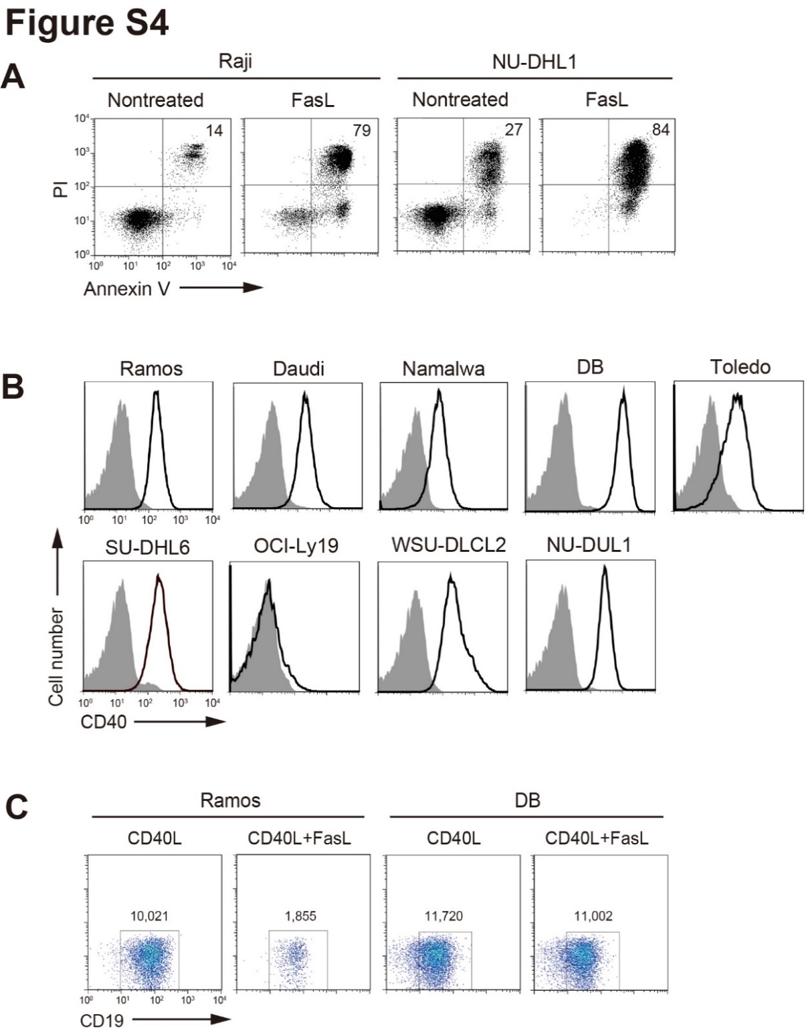

Figure S4
(A) Raji or NU-DHL1 cells were incubated with or without FasL (50 ng/ml) for 24 h and then assayed for apoptosis by staining with Annexin V and propidium iodide (PI) followed by flow cytometry. (B) Flow cytometric analysis of CD40 expression in human lymphoma cell lines. Shaded histograms indicate nonstained cells. (C) Ramos or DB cells cultured on CD40L-expressing NIH3T3 cells for 48 h were incubated in the absence or presence of FasL (50 ng/ml) for 24 h, after which the proportion of CD19⁺ (viable) cells was determined by flow cytometry.

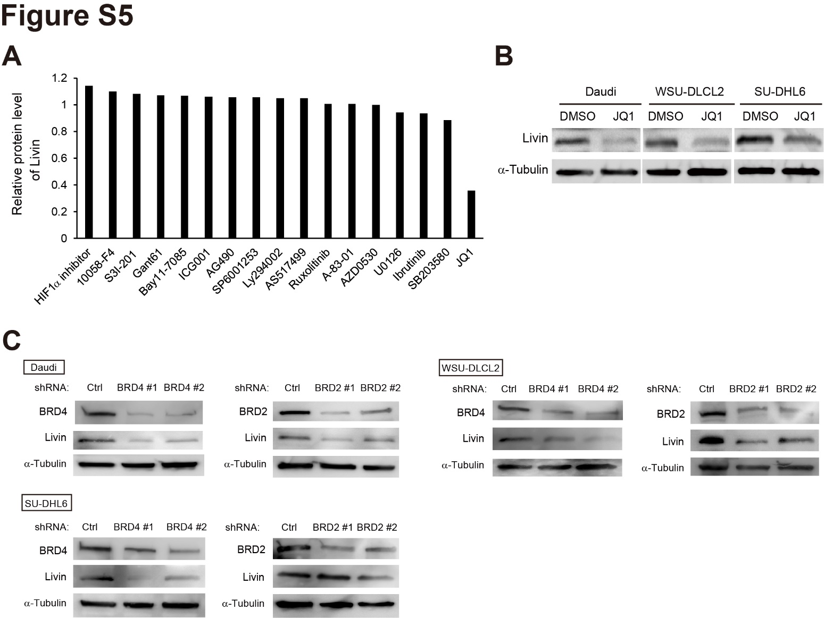

Figure S5
(A) Relative protein level of Livin in DB cells treated with inhibitors of HIF1α (10 µM), Myc (10058-F4, 10 µM), Stat3 (S3I-201, 3 µM), GLI1/2 (Gant61, 10 µM), NFκB (Bay11-7085, µM), β-catenin/TCF (ICG001, 10 µM), EGFR (AG490, 10 µM), JNK/SAPK (SP6001253, 3 µM), PI3K (Ly294002, 10 µM), Stat6 (AS1517499, 3 µM), Jak2 (Ruxolitinib, 3 µM ), TGFβRI (A-83-01, 3 µM), Src/Abl (AZD0530, 10 µM), MEK1/2 (U0126, 3 µM), BTK (Ibrutinib, 0.01 µM), p38 (SB203580, 10 µM), and BET (JQ1, 0.3 µM) for 24 h. Amounts of Livin protein on immunoblot analysis were assessed by Image J. Relative protein levels were normalized on the basis of Livin amount in DMSO-treated DB cells. (B) Immunoblot analysis of Livin in Daudi, WSU-DLCL2, and SU-DHL6 cells treated with DMSO vehicle or JQ1 (0.25 µM) for 24 h. α-Tubulin was examined as a loading control. (C) Immunoblot analysis of BRD4, BRD2 and Livin in lymphoma cell lines lentivirally transduced with shCtrl, BRD4, or shBRD2. α-Tubulin was examined as a loading control.

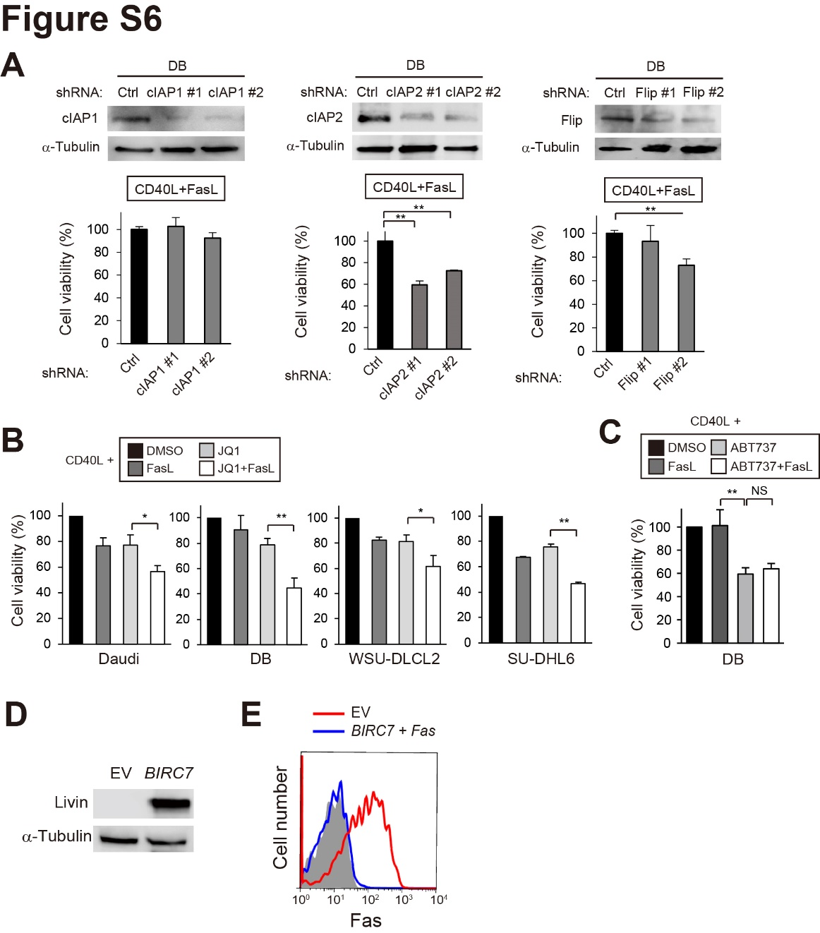
Figure S6
(A) Immunoblot analysis of cIAP1, cIAP2 and Flip in DB cells infected with lentiviruses for control (shCtrl), cIAP1 (shcIAP1 #1 or #2), cIAP2 (shcIAP2 #1 or #2), or Flip (shFlip #1 or #2) shRNAs. Infected cells were cultured on CD40L-expressing cells for 48 h and then were exposed to FasL (50 ng/ml) for 24 h, after which cell viability was measured by flow cytometric analysis of CD19. (B) Lymphoma cell lines were cultured on CD40L-expressing cells for 48 h and then exposed to DMSO, FasL (50 ng/ml), JQ1 (0.5 µM), or FasL (50 ng/ml) and JQ1 (0.5 µM) as indicated, for 24 h, after which cell viability was measured as in (A). (C) DB cells were cultured on CD40L-expressing cells for 48 h and then exposed to DMSO, FasL (50 ng/ml), ABT737 (0.5 µM), or FasL (50 ng/ml) and ABT737 (0.5 µM) as indicated, for 24 h, after which cell viability was measured as in (A). (D) Immunoblot analysis of Livin in mouse lymphoma cells transduced with BIRC7 or the empty virus (EV). (E) Flow cytometric analysis of Fas expression in mouse lymphoma cells transduced with BIRC7 and Fas or with the empty viruses. Shaded histogram corresponds to nonstained cells. All data are means ± SD for three independent experiments. *p < 0.05, **p < 0.01 (unpaired Student’s t test). NS, not significant.
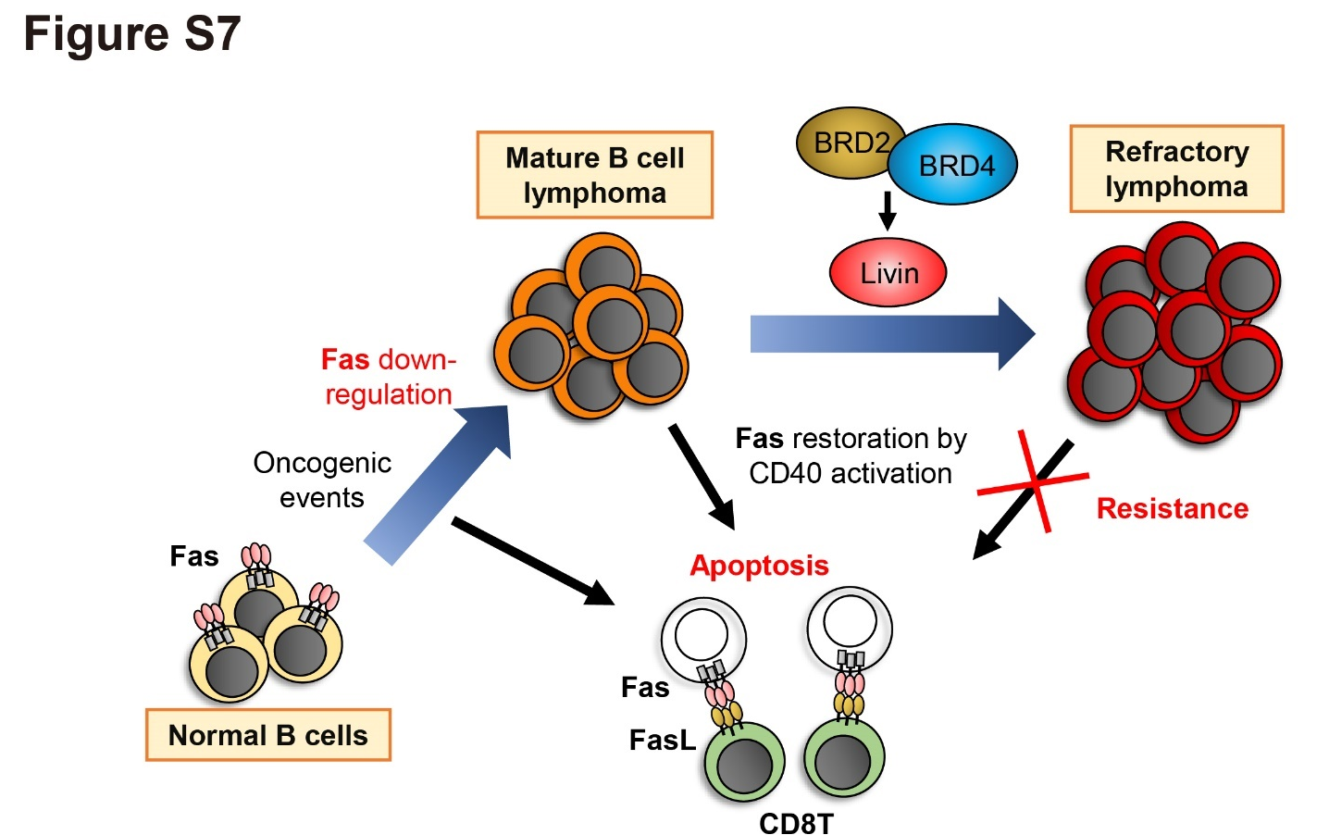

Figure S7
Proposed model for the development of resistant lymphoma. Lymphomagenesis from normal B cells including GG B cells requires down-regulation of Fas expression in order to overcome immune surveillance. Further acquisition of BRD4 and BRD2-driven Livin expression by established lymphoma confers resistance to apoptosis triggered by restoration of Fas expression.

Supplementary Table 1. Antibodies used for flow cytometry.
Antigen | Reactivity | Fluorescent label | Clone |  | Company
B220 | Mouse | Alexa Fluor 647 | RA3-6B2 | Biolegend
IgM | Mouse | APC | RMM-1 | Biolegend
IgD | Mouse | PE | 11-26c.2a | Biolegend
IgG1 | Mouse | APC | M1-14D12 | Thermo Fisher eBioscience
IgE | Mouse | PE | 23G3 | Thermo Fisher eBioscience
GL7 | Mouse | Alexa Fluor 647 | GL7 | BD Pharmingen
Fas | Mouse | PE | Jo2 | Biolegend
CD4 | Mouse | PE | GK1.5 | TONBO Biosciences
CD8a | Mouse | APC/Cy7 | 53-6.7 | Biolegend
Fas | Human | FITC | DX2 | Biolegend
CD19 | Human | FITC | HIB19 | Biolegend
CD40 | Human | PE | 5C3 | Biolegend
APC, allophycocyanin; PE, phycoerythrin; FITC, fluorescein isothiocyanate.

Supplementary Table 2. The 10 genes altered with the highest frequency in DLBCL samples from a study of The Cancer Genome Atlas (TCGA) accessed by the cBio Cancer Genomics Portal.
Study | Rank | Gene | CNA | No. of samples | Frequency
DLBCL (TCGA, PanCancer Atlas,  n = 48 | 1 | CDKN2A | DEL | 13 | 27.08%
 | 2 | CDKN2B | DEL | 12 | 25.00%
 | 3 | REL | AMP | 10 | 20.83%
 | 4 | XPO1 | AMP | 9 | 18.75%
 | 5 | BCL11A | AMP | 8 | 16.67%
 | 6 | MTAP | DEL | 7 | 14.58%
 | 7 | CD58 | DEL | 6 | 12.50%
 | 8 | TNFAIP3 | DEL | 6 | 12.50%
 | 9 | RHOA | DEL | 5 | 10.42%
 | 10 | PRDM1 | DEL | 5 | 10.42%
CNA, copy number alteration; DEL, deletion; AMP, amplification.

Supplementary Table 3. Summary of Fas expression status, FAS genotype, up-regulation of Fas expression by CD40L, and sensitivity to FasL-induced apoptosis in human lymphoma cell lines.
Cell line | Subtype | Fas expression | FAS genotype | Fas up-regulation by CD40L | Sensitivity to FasL
Ramos | Burkitt | Low | WT | + | ++
Raji | Burkitt | High | WT | ND | +++
Daudi | Burkitt | Low | WT | + | –
Namalwa | Burkitt | Low | WT | + | ++
DB | DLBCL | Low | WT | + | –
Toledo | DLBCL | Low | WT | + | ++
NU-DHL1 | DLBCL | High | WT | ND | +++
SU-DHL6 | DLBCL | Low | WT | + | +
WSU-DLCL2 | DLBCL | Low | WT | + | +
OCI-Ly19 | DLBCL | Low | WT | – | –
NU-DUL1 | DLBCL | Low | WT | + | ++
ND, not determined.

