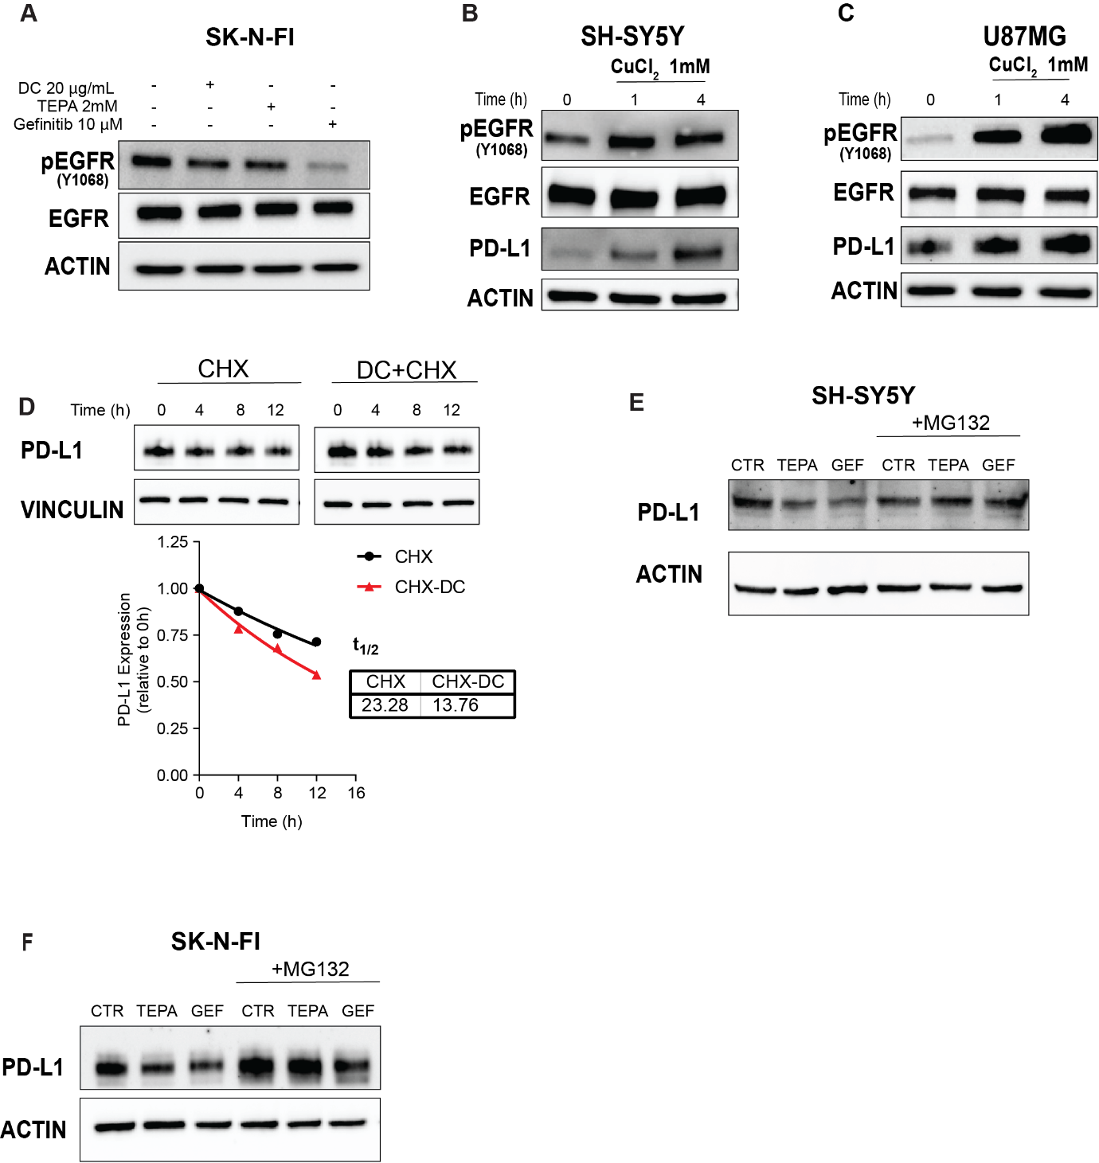

Supplementary Figure S3. A, Western blot of phospho-EGFR (Y1068) and EGFR in SK-N-FI treated with DC, TEPA or Gefitinib at 24h. B, and C, Expression of phospho-EGFR (Y1068), EGFR and PD-L1 in SH-SY5Y and U87MG cells treated with CuCl2 (1mM) for 1h or 4h. D, PD-L1 half-life in cells pre-treated with DC 20µg/ml for 12 h and with 200 µg/ml of cycloheximide (CHX) for 2, 4, 8 and 12 h. E, and F, PD-L1 rescue experiments: 2h pre-treatment with the proteasome inhibitor MG132 blocked the degradation of PD-L1 induced by TEPA and Gefitinib.

