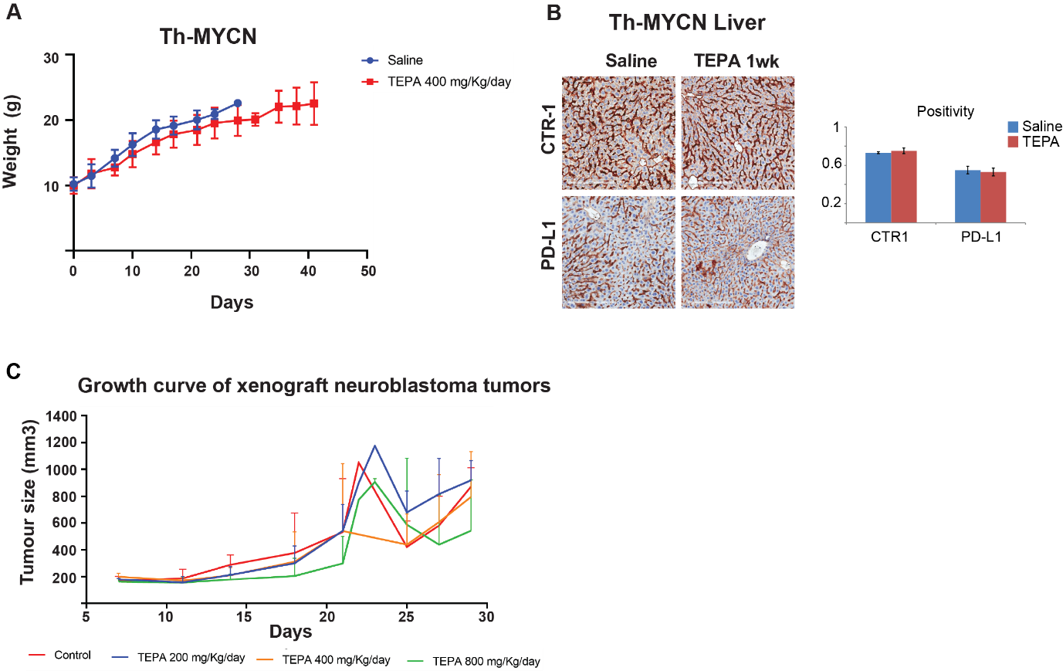

Supplementary Figure S7. A, Mouse weight in Th-MYCN mouse model (n=7, used for mouse survival) treated with saline control (blue line) or with TEPA 400mg/kg/day (red line). B, Immunohistochemistry staining for CTR-1 and PD-L1 in the liver of neuroblastoma Th-MYCN mice treated with the copper chelation agents TEPA. C, Growth of NB SK-N-BE(2)-C tumors xenografted into immunocompromised BALB/c-Fox1nu/Ausb (n=4 mice per group) treated with saline control (red line), or TEPA at doses of 200mg/kg/day (blue line), 400mg/kg/day (orange line) or 800mg/kg/day (green line).

