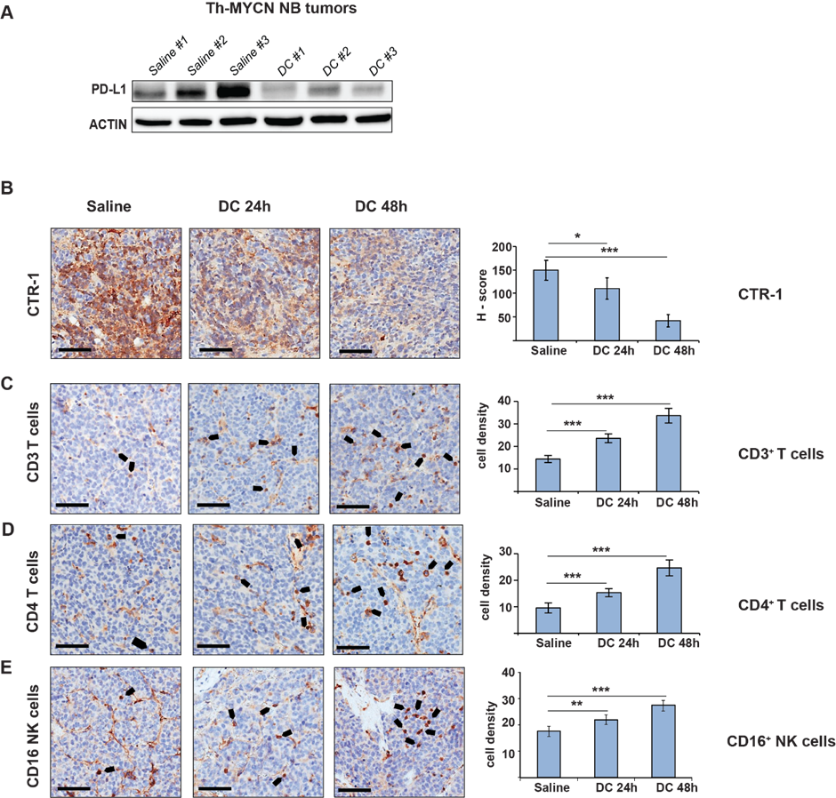

Supplementary Figure S5. A, Ex vivo analysis for PD-L1 expression from tumors dissected from Th-MYCN mice (n=3 each group) treated with DC (300 µg/mL) for 48h. B, Immunohistochemistry staining in NB tumor slices for CTR-1, C, CD3, D, CD4, E, CD16 dissected from Th-MYCN mice treated with DC (300 µg/mL) for 24h or 48h. Images are representative of 4 mice for saline control group and 6 mice for each treatment time-point. Black bars represent 60µm. The bar graphs (on the right) show CTR-1 H-score or CD3/CD4/CD16 cell density (* p<0.05; ** p<0.01; *** p<0.001). Cell density expressed as number of cells/field, with a field size of 0.1mm².

