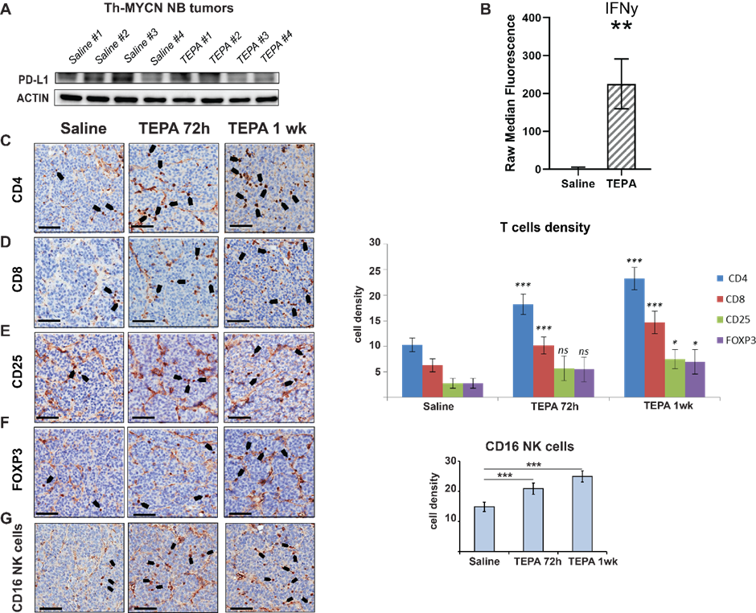

Supplementary Figure S4. A, Ex vivo analysis for PD-L1 expression from tumors dissected from Th-MYCN mice (n=4 per group) treated with TEPA (400mg/kg/day) for seven days. B, Level of IFNγ in the sera of mice treated with TEPA for one week expressed as raw median fluorescence (n=4). Immunohistochemistry staining in NB tumor slices for C, CD4, D, CD8, E, CD25, F, FOXP3, G, CD16 dissected from Th-MYCN mice treated with TEPA (400mg/kg/day) for 72h and seven days. Images are representative of 4 mice for saline control group and 6 mice for each treatment time-point. Black bars represent 60µm. Cell density bar graphs (on the right) of CD4/CD8/CD16/ and T-reg CD25/FOXP3 positive cells expressed as number of cells/field with a field size of 0.1mm². (* p<0.05; ** p<0.01; *** p<0.001).

