Calibration of pathogenicity due to variant-induced leaky splicing defects
by using BRCA2 exon 3 as model system

Supplementary Data (Table of contents)
Supplementary Materials and Methods

Supplementary Figures
Supplementary Figure S1. Human BRCA2 mRNA and protein.
Supplementary Figure S2. Selection strategy of 100 variants located BRCA2e3 and its flanking intronic regions for calibration of variant-induced splicing defects.
Supplementary Figure S3. Selection of the 13 variants that were designed to gradually weaken the 5’/3’ss strength of BRCA2 exon 3.
Supplementary Figure S4. Selection of 40 synonymous BRCA2e3 variants predicted as the most susceptible to affect splicing by disrupting putative SREs.
Supplementary Figure S5. Structure of the pCAS2.BRCA2e3 minigenes used in the splicing reporter assay.
Supplementary Figure S6. Bioinformatics predictions of an intronic variant leading to the usage of a de novo 3’splice site.
Supplementary Figure S7. Impact on splicing of variations predicted to decrease the strength of BRCA2e3 splice sites.
Supplementary Figure S8. Comparison of the variant-associated splicing effects observed in the context of BRCA2e3 minigenes with in silico data obtained with SRE-dedicated approaches.
Supplementary Figure S9. Correlation between variant-associated exon skipping levels observed in the context of pCAS2-BRCA2e3 minigene assay and in silico data obtained with SRE-dedicated approaches.
Supplementary Figure S10. Sanger sequencing of the FL RT-PCR products of patients carrying variations within BRCA2e3.
Supplementary Figure S11. Correlation analysis between BRCA2 exon 3 inclusion levels observed in different systems.
Supplementary Figure S12. Expression of human BRCA2 protein in selected mESC clones.
Supplementary Figure S13. Complementation phenotypes of BRCA2e3 variants expressed in mESCs.
Supplementary Figure S14. Sensitivity of BRCA2e3 variants to different DNA-damaging agents as determined in the mESC-based assay.
Supplementary Figure S15. Correlation analysis between BRCA2 exon 3 inclusion levels observed in minigene- and mESC-based assays.
Supplementary Figure S16. Bioinformatics predictions of an exonic variant leading to the usage of a de novo 3’splice site.
Supplementary Figure S17. Protein sequence alignment between twelve BRCA2 orthologs.

Supplementary Tables
Supplementary Table S1. Overview of bioinformatics predictions and experimental data obtained for the 100 selected BRCA2 exon 3 variants. (excel file)
Supplementary Table S2. Description of primers used in this study (excel file)
Supplementary Table S3. Comparison of experimental results obtained with pCAS2-BRCA2e3 minigenes carrying natural variants mapping to BRCA2 exon 3 splice sites or to flanking intronic positions with in silico data obtained with splice site-dedicated bioinformatics approaches. (excel file)
Supplementary Table S4. Comparison of the experimental results obtained with pCAS2-BRCA2e3 minigenes carrying natural BRCA2 exon 3 variants with in silico data obtained with SRE-dedicated bioinformatics approaches. (excel file)
Supplementary Table S5. Statistical analyses conducted in this study. (excel file)
Supplementary Table S6. Clinical and family data of patients carrying BRCA2 exon 3 spliceogenic variants. (excel file)

Supplementary Note
Supplementary References

Supplementary Materials and Methods
Minigene-based splicing reporter assays. In order to evaluate the impact of the selected BRCA2e3 variants on RNA splicing, we performed a functional assay based on the comparative analysis of the splicing pattern of wild-type (WT) and mutant reporter minigenes by using the pCAS2 vector (1), as previously described (2). Briefly, the WT genomic fragments containing BRCA2e3 and 202 bp and 225 bp of upstream and downstream intronic sequence [c.68-202_ 316+225] were PCR amplified from patient genomic DNA by using a combination of forward B2Ex3_InFus_Bam-F and reverse B2Ex3_InFus_Mlu-R primers (Supplementary Table S2) and then inserted into the BamHI and MluI cloning sites of the reporter plasmid pCAS2, yielding the three-exon hybrid minigenes pCAS2-BRCA2e3 (Supplementary Figure S5). When patient genomic DNA was not available, the variants of interest were introduced by site-directed mutagenesis by using the two-stage overlap extension PCR method (3) and a combination of specific primers indicated in Supplementary Table S2 and the WT constructs as template. Then, the mutant amplicons were introduced by into the previously linearized pCAS2 vector at BamHI and MluI cloning sites by homologous recombination using the SLICE method (4). The integrity of all constructs was confirmed by sequencing. Next, WT and mutant minigenes (400 ng/well) were transfected in parallel into HeLa cells grown at ~70% confluency in 12-well plates using the FuGENE 6 transfection reagent (Roche Applied Science). HeLa cells obtained from ATCC were tested negative for mycoplasma contamination and cultured in Dulbecco’s modified Eagle medium (Life Technologies) supplemented with 10% fetal calf serum in a 5% CO₂ at 37°C. Twenty-four hours later, total RNA was extracted using the NucleoSpin RNA II kit (Macherey Nagel) according to the manufacturer’s instructions, and the transcripts encoded by the minigenes were analyzed by semi-quantitative fluorescent RT-PCR (30 cycles of amplification) in a 25 μl reaction volume by using the OneStep RT-PCR kit (Qiagen), 200 ng total RNA and the 6FAM-pCASKO1F forward and reverse pCAS-2R minigene primers (Supplementary Table S2). RT-PCR products were separated by electrophoresis on 2.5% agarose gels containing ethidium bromide and visualized by exposure to ultraviolet light under saturating conditions using the Gel Doc XR image acquisition system (Bio-RAD), followed by gel-purification and sanger sequencing for proper identification of the minigene’s transcripts. In parallel, splicing events were quantitated by performing capillary electrophoresis on an automated sequencer (Applied Biosystems) using 500 ROX™ Size Standard (Applied Biosystems) followed by a computational analysis by using the GeneMapper v5.0 software (Applied Biosystems). Results are presented as the mean of three independent experiments and represent the proportion (%) of transcripts containing exon 3 (FL) relative to the total amount of detected transcripts (FL + other isoforms such as Δ3).
Analysis of the BRCA2e3 splicing pattern in RNA samples from patient and control individuals. Informed written consent was obtained from each subject Peripheral blood samples were directly collected into PAXgene Blood RNA Tubes (Qiagen) from which total RNA was extracted by using the PAXgene Blood RNA kit, according to the manufacturer’s instructions. EBV-immortalized lymphoblastoid cell lines (LCLs) (Genethon, France) were cultured in RPMI medium (Life Technologies) supplemented with 2 mM of L-glutamine and 10% fetal calf serum, at 37°C in a 5% CO2 atmosphere. They all tested negative for mycoplasma contamination. Before RNA extraction, LCLs were transferred into 6-well plates, at 2.5x10⁶ cells/well, and incubated for 5.5 hours with/without 200 μg/ml puromycin prior to harvest. Total RNA was extracted by using the NucleoSpin RNA II kit (Macherey Nagel). The splicing patterns of BRCA2 transcripts expressed in peripheral blood and in LCLs were analyzed by semi-quantitative fluorescent RT-PCR (40 and 26 cycles of amplification for PAXgene and LCL samples, respectively) in a 25 μl reaction volume by using the OneStep RT-PCR kit (Qiagen), 200 ng of total RNA and a combination of forward and reverse primers located in BRCA2 exons 2 and exon 5, respectively (Supplementary Table S2). Then, RT-PCR products were separated by electrophoresis on a 2% agarose gel, gel-purified and sequenced. In parallel, splicing events were quantitated by performing capillary electrophoresis on an automated sequencer (Applied Biosystems) using 500 ROX™ Size Standard (Applied Biosystems) and analyzed by using the GeneMapper v5.0 software (Applied Biosystems). Results are presented as the mean of three independent experiments.
Allele-specific expression analysis. Allele-specific expression (ASE) of BRCA2e3-containing transcripts (+E3) was measured by performing a SNaPshot quantitative primer extension assay (SNaPshot MultiplexKit, Applied Biosystem), as previously described (1). Briefly, RT-PCR products spanning BRCA2 exons 2 to 5 were obtained from patients’ RNA sample (PAXgenes and LCLs), by using a combination of forward RT-BRCA2Ex2-F and reverse RT-BRCA2Ex5-R primers (Supplementary Table S2). In parallel, the genomic segment encompassing BRCA2e3 was amplified by PCR from the genomic DNA of the same patient by using a combination of forward BRCA2Ex3_InFus_Bam-F and reverse BRCA2Ex3_InFus_Mlu-R (Supplementary Table 3). Then, primer extension reactions were performed by using the RT-PCR and PCR products as template and variant-specific primers indicated in Supplementary Table S2. Purified extension products along with 120 LIZ Size Standard (Applied Biosystems) were separated by capillary electrophoresis on an automated 3500 Genetic Analyzer (Applied Biosystems) and analyzed by using the GeneMapper v5.0 software (Applied Biosystems). SNaPshot results obtained from patient cDNA were normalized by those obtained from corresponding patient gDNA in order to correct possible differences in fluorescent yield and terminator dye incorporation.
Mouse embryonic stem cells (mESC)-based complementation assay. PL2F7 cells (5,6) were cultured on mitotically inactive SNL feeder cells in M15 media, which is Knockout DMEM media (Life Technologies) supplemented with 15% fetal bovine serum (FBS; Hyclone), 0.00072% beta-mercaptoethanol, 100 U/ml penicillin, 100 mg/ml streptomycin and 0.292 mg/ml L-glutamine at 37 C, in a 5% CO₂ atmosphere.
Genomic fragments containing the variant of interest were PCR-amplified from mutant pCAS2-BRCA2e3 minigenes by using specific primers carrying BAC homology arms (Supplementary Table S2). These fragments were subsequently introduced into BAC constructs containing the full-length human BRCA2 gene (BAC RPCI-11 777 19I) by recombineering in SW102 bacteria using the galK-based counter selection method as previously described (6–8).
BAC DNA (25 µg) was then electroporated into 1.10⁷ mESC per ml suspended in 0.9 ml PBS by setting a Gene Pulser (Bio-Rad) at 300 V, 500 mF. Twenty-four hours after electroporation, G418 (180 µg/ml) selection was performed for 5 days, after which cells were transferred to normal M15 medium until colonies became visible. Forty-eight individual colonies were picked into 96-well plates and hBRCA2 expression was verified by RT-PCR and Western blot analyses.
For RT-PCR analysis, total RNA was extracted from mESC pellets by using RNeasy 96 kit (Qiagen), according to the manufacturer instruction and RT-PCR (30 cycles of amplification) was carried out in a 25 µl reaction volume by using the OneStep RT-PCR kit (ABM), ~100 ng total RNA and B2ex11FRT and B2ex14R RT primers, located in exons 11 and 14, respectively (Supplementary Table S2). RT-PCR products were separated by electrophoresis on 1.2% agarose gels containing ethidium bromide and visualized by exposure to ultraviolet light. For Western blot, cells were lysed in lysis buffer (20 mM HEPES, 100 mM NaCl, 1mM EDTA, 1mM NaF, 1mM EGTA, 1 mM DTT and 0,1% Triton X, including one tablet of complete mini protease inhibitor cocktail tablets per 10 ml of lysis buffer added immediately before use). Protein extracts were resolved by SDS PAGE by using NuPAGETM 3-8% Tris-Acetate protein gels (Invitrogen) and subsequently transferred to nitrocellulose membranes. Blots were blocked with milk and incubated with rabbit polyclonal anti-BRCA2 (BETHYL Laboratories, A303-434A-T-1) and mouse monoclonal anti-vinculin (Santa Cruz Biotechnology, sc25336) primary antibodies overnight at 4°C, washed with PBST and probed with horseradish peroxidase-conjugated secondary antibodies at room temperature for 1 h and subjected to ECL (Amersham). Finally, immunoreactive bands were detected by incubating immunoblots with ECL reagent and exposing for 30 sec to 10 min in a luminescence image analyser (Syngene GeneGenome) (Supplementary Figure S12).
After confirmation of hBRCA2 expression, G418-resistant (G418^{R}) clones (2 clones/variant) expressing equivalent levels of hBRCA2, as determined by RT-PCR and Western blot, were electroporated with PGK-Cre plasmid DNA (25 µg) into 1.10⁷ mESC G418^{R} per ml suspended in 0.9 ml PBS. Electroporation was performed by setting a Gene Pulser (Bio-Rad) at 230 V, 500 mF. Thrirty-six hours after electroporation,recombinant clones were selected for the deletion of the conditional allele in HAT (Hypoxanthine-Aminopterin-Thymidine) media for 5 days, after which cells were switched to HT (Hypoxanthine-Thymidine) media for 2 days and then transferred to M15 medium until colonies became visible.
HAT-resistant (HAT^{R}) colonies were counted after methylene blue staining by using ImageJ and the number of colonies was then compared to that of no-HAT control to determine the rescue rate (HATx100/no-HAT). In parallel, 24 individual colonies were picked into 96-well plates and genotyped by Southern blotting as previous described (6,9). After confirmation of BRCA2 recue, HAT^{R} clones (2 clones/variant) were selected for genotoxic and irradiation sensitivity assays. For this purpose, HAT^{R} clones were seeded in triplicate in 96-well plates at 8,000 mESC HAT^{R} per well. Next, drug treatment (with cisplatin, Mitomycin C (MMC), methyl methanesulfonate (MMS), olaparib or camptothecin) was performed for 72 hours, 18 hours after seeding, whereas ionizing irradiation (¹³⁷Cs source, γ-irradiator) was performed 24 hours after seeding. Finally, cells were cultured in fresh M15 media for 72 hours, after which the relative number of living cells was measured using XTT assay (Sigma) (6,10). Drug treatment concentrations as well as irradiation doses are indicated in Supplementary Figure S13
In addition, the splicing pattern of hBRCA2 transcripts expressed in HAT^{r} mESC was analyzed by semi-quantitative fluorescent RT-PCR (24 cycles of amplification) in a 25 μl reaction volume by using the OneStep RT-PCR kit (Qiagen), 200 ng of total RNA and a combination of specific primers located in BRCA2 exons 2 and exon 5 (Supplementary Table S2). Then, RT-PCR products were separated by electrophoresis on a 2% agarose gel, gel-purified and sequenced and splicing events were quantitated by performing capillary electrophoresis on an automated sequencer (Applied Biosystems) using 500 ROX™ Size Standard (Applied Biosystems) and computational analysis by using the GeneMapper v5.0 software (Applied Biosystems). The relative level of FL transcripts was determined by calculating the percentage of transcripts containing BRCA2e3 (FL) relative to the total amount of transcripts with and without BRCA2e3 (FL + Δ3). All the cell lines were tested negative for mycoplasma contamination.
Performance assessment of splicing-dedicated algorithms. The evaluation of the predictive power of splicing-dedicated bioinformatics methods was performed by measuring three parameters defined as follows: sensitivity (Sen) = [TPx100/(TP+FN)], specificity (Spe) = [TNx100/(TN+FP)] and accuracy (Acc) = [(TN+TP)x100/(TN+TP+FN+FP), where TP (true positive) and FN (false negative) are the numbers of positive samples that are predicted/called to be positive and negative, respectively. Analogously, TN (true negative) and FP (false positive) values are the numbers of negative samples that are predicted to be negative and positive respectively. TP, TN, FP, FN were determined by taking into account previously determined generic thresholds (11) as indicated under Supplementary Figure S3.
Statistical analyses. Data derived from comparison of experimental and in silico analyses were compared by using (i) Student test or Mann-Whitney for assessing the performance of the bioinformatics tools in discriminating variants that induced exon skipping versus those that did not) and (ii) Spearman or Pearson correlation for measuring the correlation between exon inclusion levels and in silico predictions, as detailed in Supplementary Table S6. All statistical analyses were performed by using GraphPad Prism software (Version 5.0). Results are expressed as two sided p-values (* p-value<0.05, ** p-value<0.01, *** p-value<0.001) and were considered significant when p-value <0.05.

Supplementary Figures
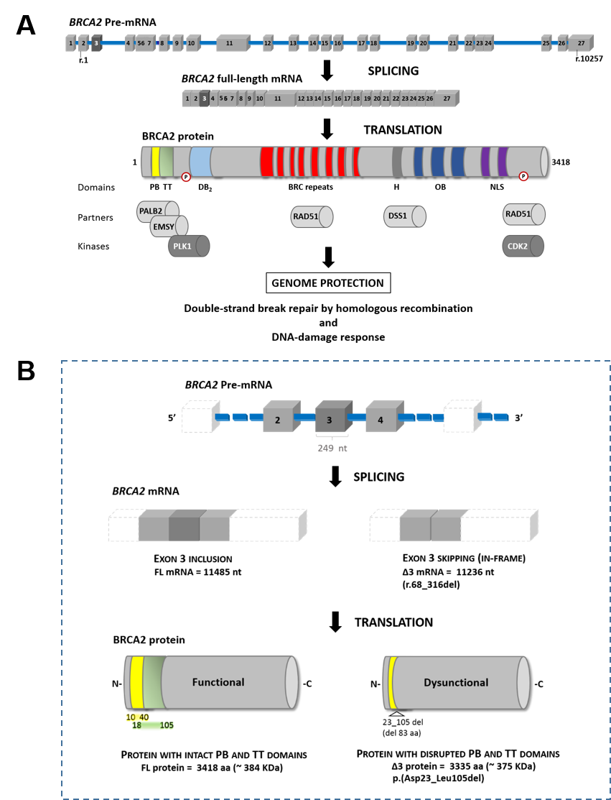

Supplementary Figure S1. Human BRCA2 mRNA and protein. (A) Main features of full-length BRCA2 mRNA and protein (adapted from (12)). The diagrams, which are not drawn to scale, are based on BRCA2 reference sequences NM_000059.3 (transcript) and NP_000050.2 (protein). The full-length BRCA2 transcript contains 27 exons and a protein coding sequence from r.1 (exon 2) to r.10257 (exon 27). BRCA2 exon 3 (r.68-r.316), the focus of this study, is highlighted in dark grey. This exon codes for a BRCA2 segment (p.Asp23-p.Leu105) that includes the major part of the critical PALB2 binding domain (PB) and the transcriptional transactivation domain (TT). The interaction of BRCA2 with PALB2 via PB is important for its nuclear localization and stability, chromatin binding, recruitment to DNA damage sites, checkpoint maintenance, and for functionally connecting to BRCA1 (13–17), The minimal region of PB (represented in yellow) spans BRCA2 positions p.Thr10 to p.Pro40 (15). One third of this region is encoded by the 3’-terminal portion of BRCA2 exon 2 (r.28-r.67), whereas the remaining two thirds are encoded by the 5’-proximal portion of exon 3 (r.68-r.120). The TT domain (shown in green), which physiological role remains uncertain, interacts with the transcriptional repressor EMSY and is implicated in transcriptional regulation, namely of androgen receptor-regulated genes (18,19). The primary and auxiliary activating regions of the TT domain correspond to p.Arg18-p.Asn60 (partially overlapping PB) and p.Asn60-p.Leu105, respectively (20,21). (B) Impact of BRCA2 exon 3 skipping on the functional integrity of BRCA2. Yellow and green represent the PB and TT BRCA2 protein domains described in (A). PB, PALB2 binding domain; TT, transcriptional transactivation domain; DB₂, DNA binding domain 2; H, helical domain; OB, oligonucleotide binding folds (H and OB are portions of the DNA binding domain 1); NLS, nuclear localization signal; P, phosphorylation site; nt, nucleotides; Δ3, skipping of exon 3; aa, amino acids.

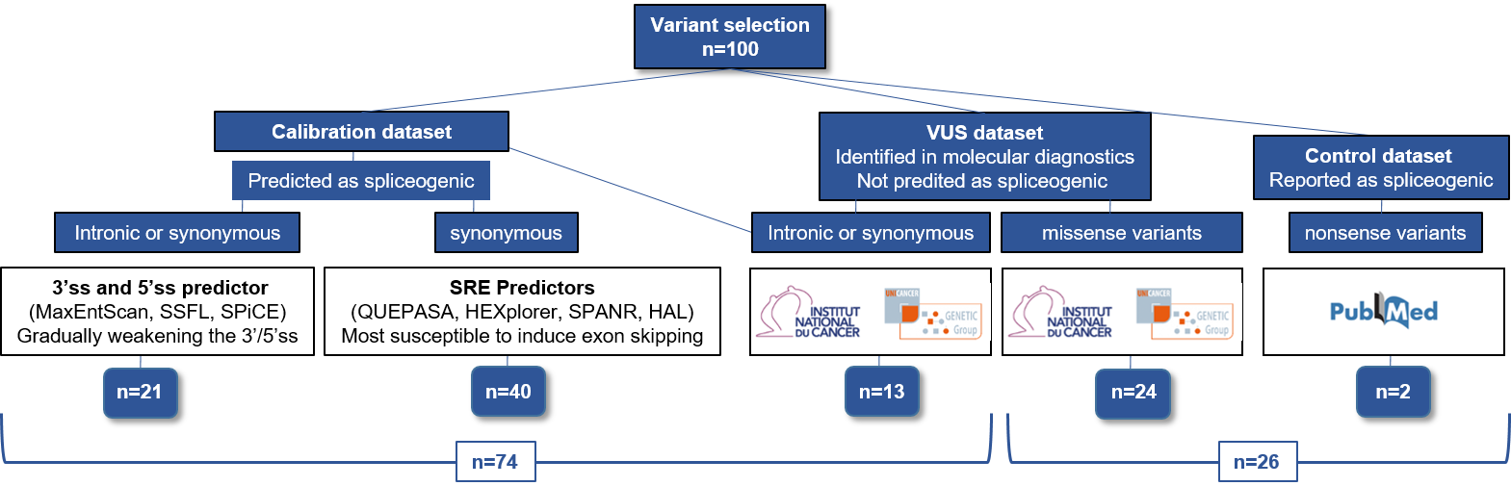

Supplementary Figure S2. Selection strategy of 100 variants mapping to BRCA2e3 and its flanking intronic regions for calibration of variant-induced splicing defects. To calibrate the severity of variant-induced BRCA2e3 splicing defects, we selected translationally silent variants (intronic or synonymous) bioinformatically predicted to affect BRCA2e3 splicing by either weakening the strength of 5’ or 3’ splice sites (5’/3’ss, n=21) or by disrupting putative splicing regulatory elements (SREs, n=40) as further detailed in Supplementary Figures S2-S3. In addition, we also retained those detected in probands selected from families undergoing genetic counselling in one of the BRCA diagnostic laboratories from the French GGC-Unicancer (n=13). Functional analyses were also performed for a set of missense variants (n=24) identified in probands undergoing genetic counselling in one of the BRCA diagnostic laboratories, including c.316G>A (p.Gly106Arg) that was identified in a child who died at age 5 yo of malignancy associated with Fanconi anemia (FA). Two pathogenic variants, c.92G>A (p.Trp31*) and c.145G>T (p.Glu49*) that were previously described for their impact on splicing (35, 36) were also retained as controls. 3’ss, 3’ splice site; 5’ss, 5’ splice site; SSFL, SpliceSiteFinder-like; SRE, splicing regulatory element.

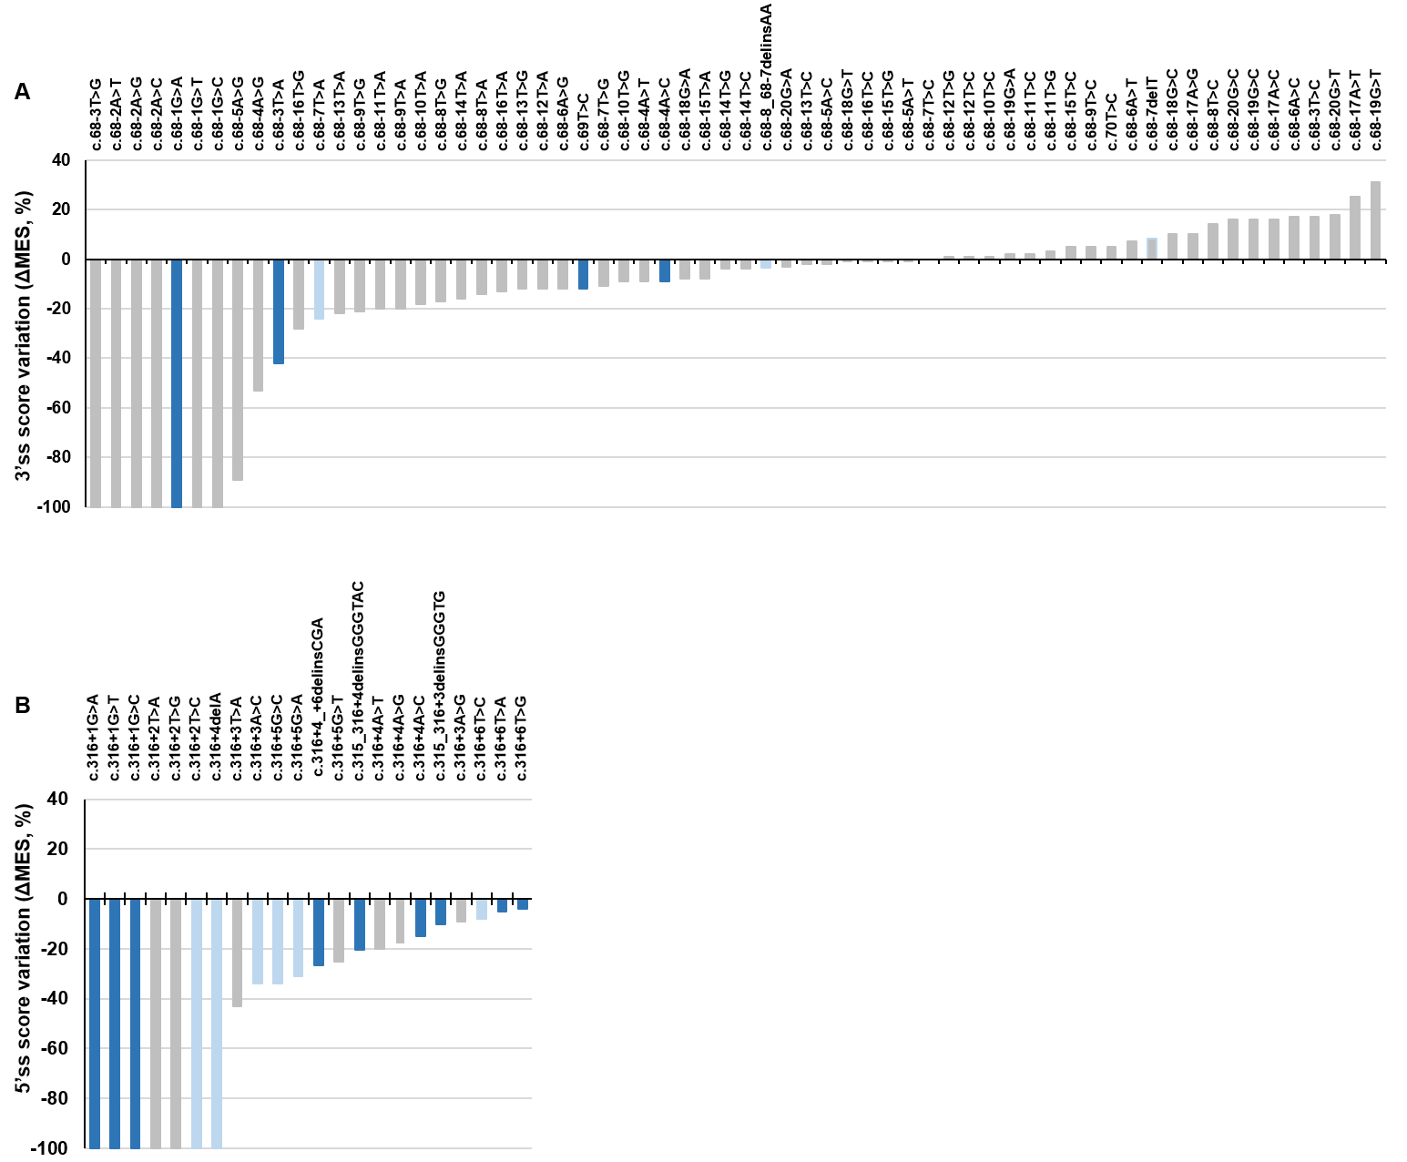

Supplementary Figure S3. Selection of the 13 variants that were designed to gradually weaken the 5’/3’ss strength of BRCA2 exon 3. After performing in silico predictions of variant-induced alterations of the strength of BRCA2e3 5’/3’ss by using the MaxEntScan algorithm (ΔMES values relative to WT), we selected 21 variants at the exon-intron borders that were predicted to gradually weaken the strength of BRCA2e3 3’ss (A) or 5’ss (B). This selection encompassed 8 variants previously identified within the BRCA2e3 splice sites in the context of HBOC genetic testing by the French GGC network as described in the BRCA-Share database (light blue bars, Supplementary Table S1; 3’ss, n=2 and 5’ss, n=6) and 13 other variants designed to gradually weaken the 3’ss or the 5’ss of exon 3 (dark blue bars; n=4 or n=9, respectively). Out of these 13 variants, 8 were artificially created and 5 are naturally occurring variants described in the ClinVar database (Supplementary Table S1). A total of 21 variants expected to directly affect the definition of BRCA2e3 splice sites were thus integrated into our calibration set and experimentally tested in the minigene splicing assay. The grey color indicates variants that were not retained for experimental analysis. ΔMES, changes in MaxEntScan scores relative to WT.

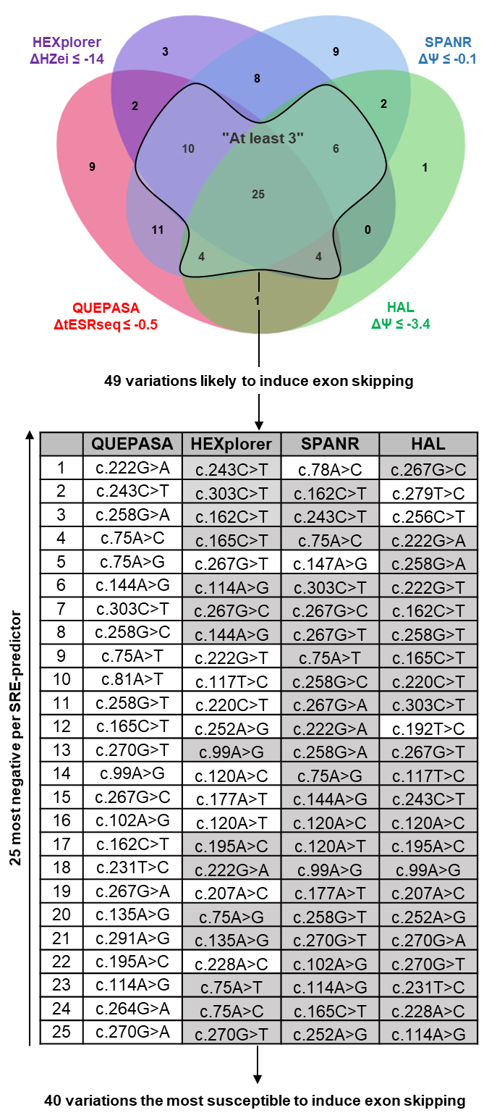

Supplementary Figure S4. Selection of 40 synonymous BRCA2e3 variants predicted as the most susceptible to affect splicing by disrupting putative SREs. First, we simulated all possible single nucleotide changes in BRCA2e3 (n=747, the majority being “artificial”, i.e. currently absent from human variation databases). Then, only synonymous variants (n=161) were retained for an exploratory SRE-dedicated in silico analysis with QUEPASA, HEXplorer, SPANR and HAL. We then applied the “at least 3” decision rule with the thresholds indicated in the top panel inferred by Tubeuf and co-workers (11) to predict which variants were more likely to induce exon skipping (n=49). Next, a number of 40 variants were selected by taking into account the 25 SNVs with the most extreme negative scores produced by each SRE-dedicated approach as indicated in the table at the bottom. The grey background indicates variants present in a precedent column in the same table. Variants in the white background thus represent all those selected for experimental analyses and integration into our dataset. Twenty-eight out of the selected 40 single nucleotide changes correspond to artificial variations not yet described in human variation databases, whereas the following 12 variants are naturally occurring changes: c.75A>G, c.99A>G, c.102A>G, c.114>G, c.165C>T, c.195A>C, c.222G>A, c.243C>T and c.256C>T, c.267G>T, c.267G>A, and c.303C>T (Supplementary Table S1).

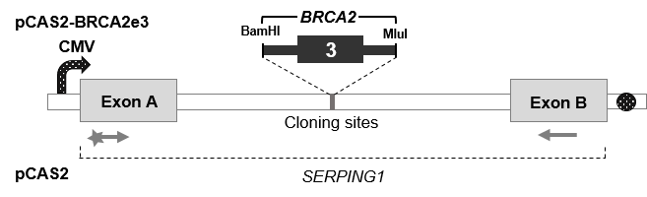
Supplementary Figure S5. Structure of the pCAS2-BRCA2e3 minigenes used in the splicing reporter assay. The pCAS2-BRCA2e3 minigenes were generated by inserting a genomic fragment containing BRCA2e3 as well as upstream/downstream flanking intronic sequences (165 and 225 nucleotides, respectively) into the intron of the pCAS2 vector, as indicated. The pCAS2 vector carries two exons (A and B) with a sequence derived from the human SERPING1/C1NH gene, separated by an intron containing BamHI and MluI cloning sites. Boxes represent exons, and lines in between indicate introns, whereas the bent arrow specifies the cytomegalovirus (CMV) promoter and the black circle indicates the polyadenylation signal (Poly A). Arrows below the exons represent primers used in RT-PCR reactions. The star in the forward primer symbolizes a 6-FAM 5’ fluorescent modification for detection of the RT-PCR products upon capillary electrophoresis.

Supplementary Figure S6. Bioinformatics predictions of an intronic variant leading to the usage of a de novo 3’ splice site. Predictive 3’ss scores were obtained with SpliceSiteFinder-like (SSFL) and MaxEntScan (MES) algorithms for both reference (WT) and mutant (c.68-1G>A) sequences, as indicated. The image consists of a screen shot of the intron 2-exon 3 junction obtained with the Alamut Visual v2.11 software tool (Interactive Biosoftware). The intronic and exonic sequence are indicated by the white and grey backgrounds, respectively.
As observed in the minigene assay (Supplementary Table S1), BRCA2 c.68-1G>A leads to the production of transcripts containing BRCA2e3 deleted of its first 6 nucleotides (E3Δp(6nt)) due to the creation of a de novo 3’ss (MES = 8.3) concomitant to the destruction of the natural 3’ss (MES = 6.1 and 0; SSFL = 87.9 and 0, in the WT and mutated contexts, respectively), as predicted by both MES and SSFL algorithms.

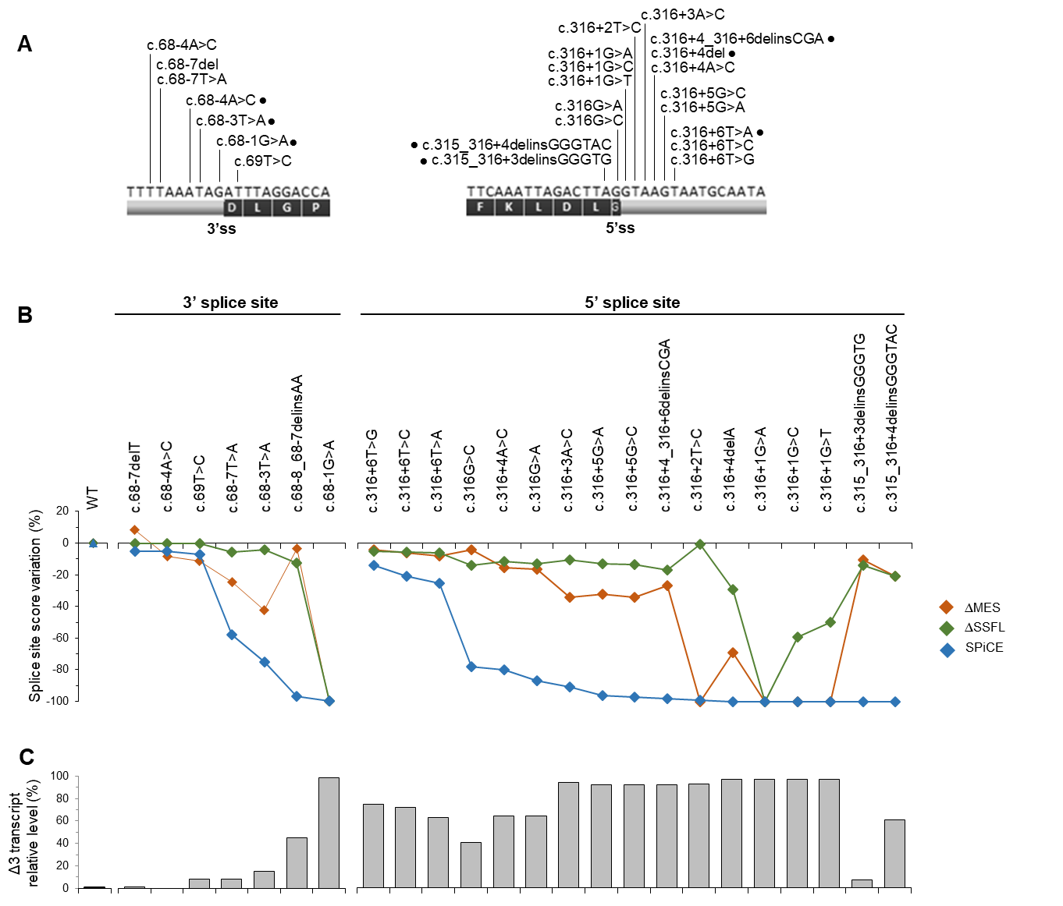

Supplementary Figure S7. Impact on splicing of variations mapping to BRCA2e3 splice sites. (A) Distribution of 24 variations mapping to the 3’ss or the 5’ss of BRCA2e3. The diagram shows the nucleotide composition in the vicinity of BRCA2e3 splice sites, the amino acid sequence encoded by the exon (1-letter code), as well as the relative position and identity of the variants of interest. Artificial variants are indicated by a dot. (B) Variant-induced alterations in the strength of BRCA2e3 splice sites as predicted by the MES, SSFL (ΔMES and ΔSSFL values relative to WT) and SPiCE in silico tools. (C) RT-PCR analysis of the splicing pattern of pCAS2-BRCA2e3 minigenes carrying the variants of interest. Wild-type (WT) and mutant pCAS2-BRCA2e3 minigene constructs were transiently expressed in HeLa cells. The splicing patterns of the RNA produced from the different minigenes were then analyzed by semi-quantitative fluorescent RT-PCR followed by capillary electrophoresis. Results represent the mean of BRCA2e3 skipping level (Δ3) of three independent transfection experiments. Error bars indicate standard error of mean values. E3, exon 3; MES, MaxEntScan; SSFL, SpliceSiteFinder-like.

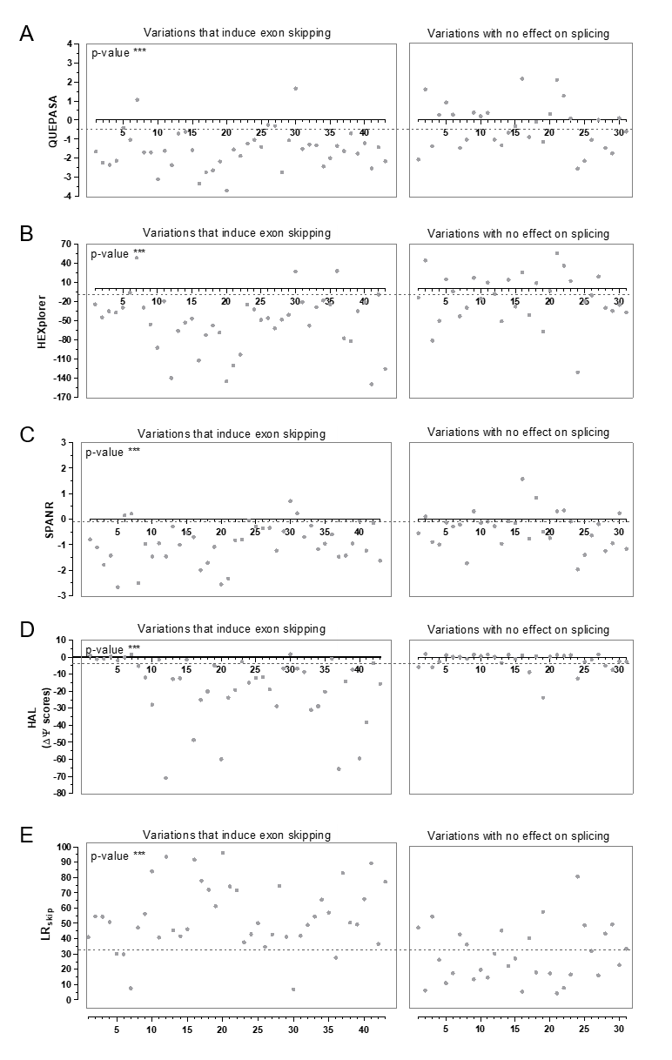

Supplementary Figure S8. Comparison of the variant-associated splicing effects observed in the context of BRCA2e3 minigenes with in silico data obtained with SRE-dedicated approaches. The 73 exonic variations outside the reference splice sites were separated into 2 groups according to their impact on splicing as experimentally determined by performing pCAS2-BRCA2e3 minigene-based splicing assays (Figure 1 and Supplementary Table S1). Panels A to E compare these data with the corresponding in silico results obtained with QUEPASA, HEXplorer, SPANR, HAL, LR_{skip} and LR_{inc}, respectively (Supplementary Table S5). The dashed lines indicate the thresholds used in this study as shown in Supplementary Table S5. Two-sided p-values were calculated by using ANOVA or Kruskal-Wallis, as indicated in Supplementary Table S6. *, p<0.05; **, p<0.01; ***, p<0.001.

Supplementary Figure S9. Correlation between variant-associated exon skipping levels observed in the context of pCAS2-BRCA2e3 minigene assay and in silico data obtained with SRE-dedicated approaches. Exon skipping levels refer to semi-quantitative data obtained from the pCAS2-BRCA2e3 minigene assay (Supplementary Table S1). Panels A to E compare these data with the corresponding in silico results obtained with QUEPASA, HEXplorer, SPANR, HAL and LR_{skip} and LR_{inc}, respectively (Supplementary Table S1). Determination coefficients (R²) and two-sided p-values were determined by performing a Pearson or Spearman correlation analysis, as indicated in Supplementary Table S6. *, p<0.05; **, p<0.01; ***, p<0.001.

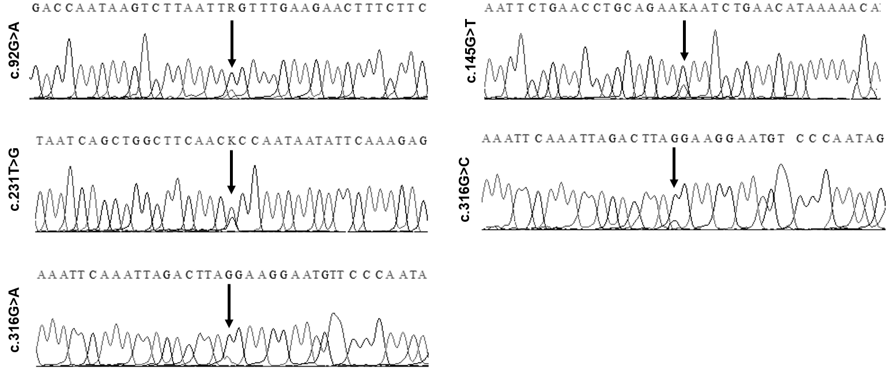

Supplementary Figure S10. Sanger sequencing of the FL RT-PCR products of patients carrying variations within BRCA2e3. Partial sequence chromatograms of FL cDNA fragments amplified from RNA samples of heterozygous patients carrying the following BRCA2e3 variants: c.92G>A, c.145G>T, c.231T>G, c.316G>C and c.316G>A, as indicated. The electropherograms show the presence of both alleles in the FL BRCA2e3 RT-PCR products (overlapping wild-type and mutant peaks indicated by the arrows).

Supplementary Figure S11. Correlation analysis between BRCA2 exon 3 inclusion levels observed in the minigene assay and in patient RNA samples.
(A) Comparison of BRCA2 exon 3 splicing patterns observed in patient-derived samples and minigene assay. The impact on splicing of BRCA2e3 variants was determined in the context of the pCAS2-BRCA2e3 minigene (mono-allelic) and compared with those observed in equivalent patient-derived RNA samples (bi-allelic). The precise correspondence between the levels of exon skipping observed in the pCAS2-BRCA2e3 minigene assays and patient-derived RNA samples (LCLs untreated with puromycin, and PAXgene) and the identity of the corresponding BRCA2e3 variant, is indicated on Supplementary Table S1. R², coefficient of determination.
(B) Comparison of BRCA2 exon 3 splicing patterns observed in minigene assay and allele-specific expression monitored in patient-derived RNA samples. The impact on splicing of BRCA2e3 variants was determined in the context of the pCAS2-BRCA2e3 minigene and compared with allele-specific expression (ASE) assessed in equivalent patient-derived RNA samples. The correspondence between the levels of exon 3 skipping observed in the pCAS2-BRCA2e3 minigene assays and the relative contribution of the variant allele to the expression of full-length BRCA2 transcripts observed in patient-derived RNA samples (mean values per variant) and the identity of the corresponding BRCA2e3 variant, is indicated on Supplementary Table S1. R², coefficient of determination.

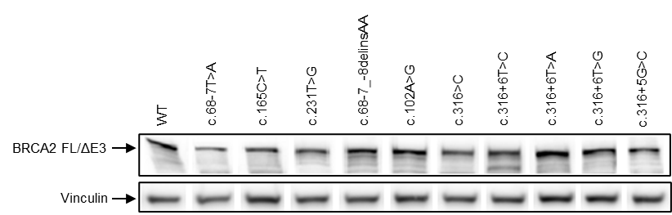

Supplementary Figure S12. Expression of human BRCA2 protein in selected mESC clones. Human BRCA2 and mouse vinculin proteins from WT and variant mESC clones were detected by Western blot analysis before Cre-mediated deletion of the conditional mouse allele, as described under Supplementary Materials and Methods. The anti-BRCA2 antibody is specific for the human protein as it does not recognize the mouse orthologue. Vinculin (~120 kDa) was used as loading control. Due to the small molecular weight difference between FL and Δ3 BRCA2 proteins (~384 kDa and ~375 kDa, respectively), these large protein isoforms are indistinguishable by Western blot analysis. The figure consists of a composite image corresponding to different experiments. FL, full-length; Δ3, skipping of exon 3 (corresponding to an internal protein deletion of 83 amino acids, i.e. ~11 kDa, Supplementary Figure S1).

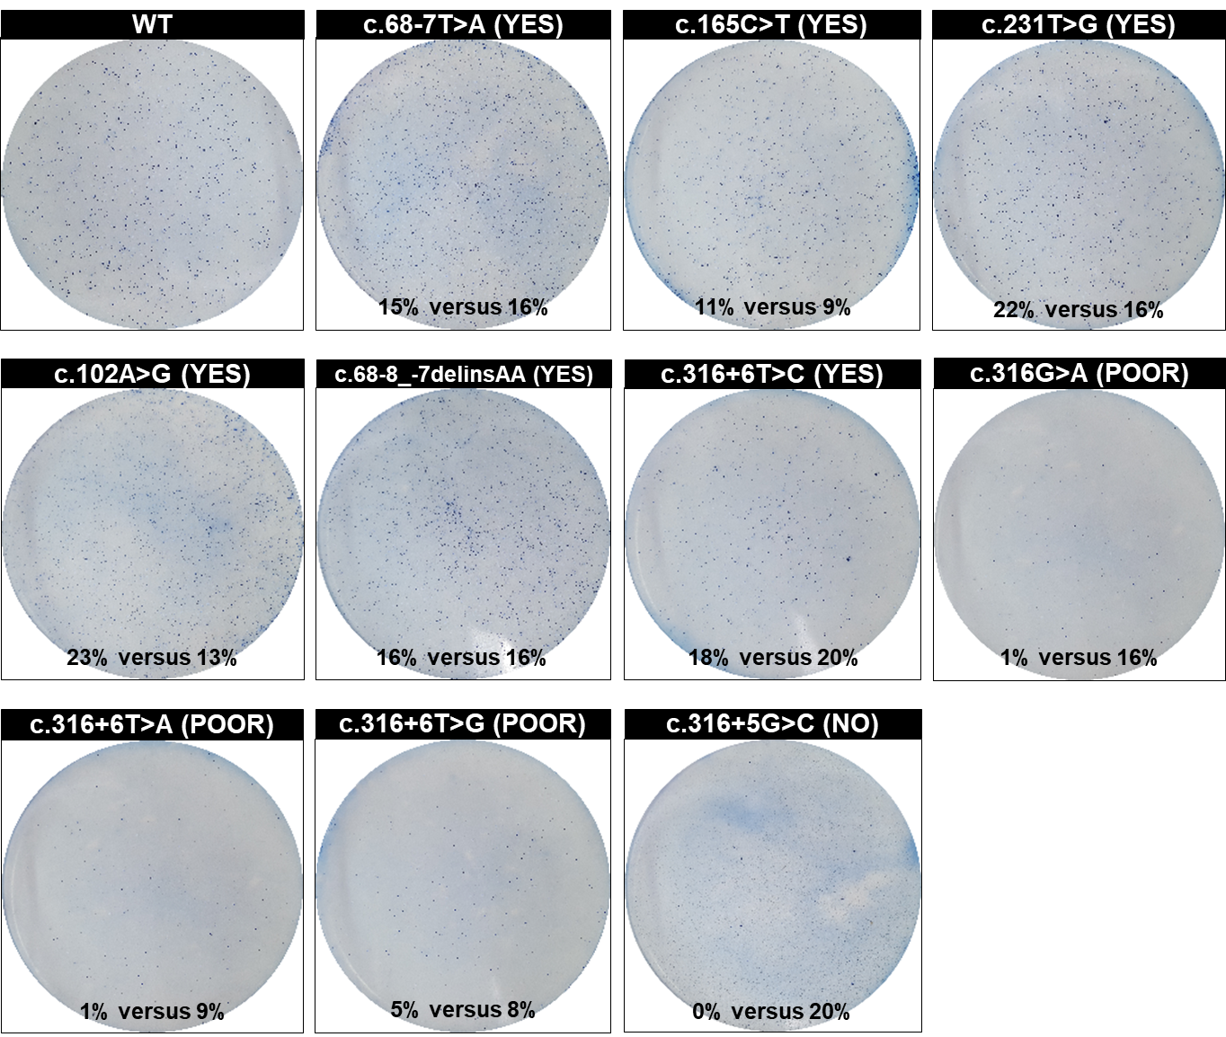

Supplementary Figure S13. Complementation phenotypes of BRCA2e3 variants expressed in mESCs. Mouse ES cells expressing either WT or mutant BRCA2 from a genomic copy of the human gene were electroporated with a pGKCre expression plasmid to induce loss of the conditional mBrca2 allele and restore the HPRT gene. Upon Cre-recombinase expression cells become mBrca2 deficient, a lethal condition unless complemented by the expression of a (full or partially) functional hBRCA2 variant. Seven days post pGKCre transfection, colonies were counted after methylene blue staining by using ImageJ and the number of colonies was compared to that of no-HAT control to determine the rescue rate (HATx100/no-HAT). The rescue rate of each variant was then compared to that of the WT-expressing cells, as indicated below each plate. The qualitative nature of the complementation output is indicated between parenthesis (Yes, complementation equivalent to WT; Poor, partial complementation; No, failed complementation
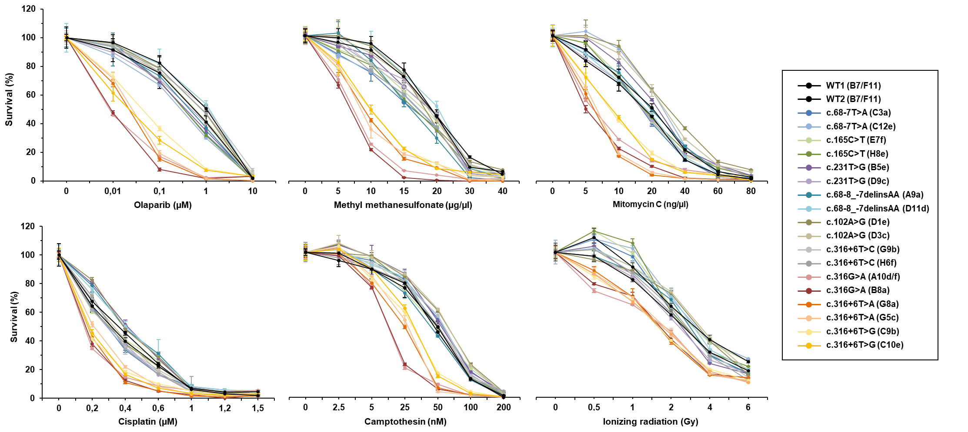
Supplementary Figure S14. Sensitivity of BRCA2e3 variants to different DNA-damaging agents as determined in the mESC-based assay. After loss of the conditional mBRCA2 allele, mESC colonies expressing either WT or mutant hBRCA2 (two colonies per mutant, as indicated) were exposed to DNA-damaging agents (olaparib, methyl methanesulfonate, Mitomycin C, cisplatin, camptothecin, or ionizing radiation) as described under Supplementary Materials and Methods. Survival of mESCs expressing hBRCA2 variants was then measured by the XTT assay and compared to that of mESC expressing wild-type hBRCA2. Values represent the percentage of surviving cells compared with untreated cultures. Error bars indicate standard deviation.

Supplementary Figure S15. Correlation analysis between BRCA2 exon 3 inclusion levels observed in minigene- and mESC-based assays. The impact on splicing of BRCA2e3 variants was determined in the context of the pCAS2-BRCA2e3 minigene (mono-allelic) and compared with those observed in mESC (mono-allelic). The precise correspondence between the levels of exon skipping observed in the pCAS2-BRCA2e3 minigene assays and mESC and the identity of the corresponding BRCA2e3 variant, is indicated on Supplementary Table S1. R², coefficient of determination.

Supplementary Figure S16. Bioinformatics predictions of an exonic variant leading to the usage of a de novo 3’ splice site. Predictive 3’ss scores were obtained with SpliceSiteFinder-like (SSFL) and MaxEntScan (MES) algorithms for both reference (WT) and mutant (c.100G>A) sequences, as indicated. The image consists of a screen shot of the BRCA2 intron 2-exon 3 junction obtained with the Alamut Visual v2.11 software tool (Interactive Biosoftware). The intronic and exonic sequences are indicated by the white and grey backgrounds, respectively.
In the minigene assay (Supplementary Table S1), BRCA2 c.100G>A is responsible of a partial splicing defect with the production of three transcripts: (i) one containing the entire exon 3 (FL= 77%), (ii) one lacking exon 3 (∆3 = 14%) and (iii) one with inclusion of exon 3 deleted from its first 45 nucleotides ([E3Δp(45nt)] = 9%), due to the creation of a de novo 3’ splice site at the position c.112 (MES = 3.2 and SSFL = 77.3) in competition with the natural 3’ splice site (MES = 6.1 and SSFL = 87.9).

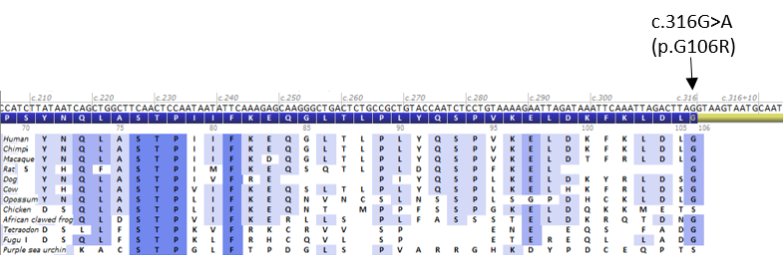

Supplementary Figure S17. Protein sequence alignment between twelve BRCA2 orthologs. This alignment was generated by the Alamut Visual v2.11 interface (Interactive Biosoftware) and focuses on the region corresponding to the end of BRCA2e3. The black arrow points to the position of a missense variation (BRCA2 p.Gly106Arg), located at the end of exon 3, and identified in a Fanconi anemia patient as mentioned in the main text. Amino acids are indicated in a single-letter code.

Supplementary Note
GGC-Unicancer consortium
French HBOC diagnostic laboratories within the “Genetic and Cancer Group” (GGC)
(http://www.unicancer.fr/)

Françoise Bonnet, Natalie Jones, Virginie Bubien, Michel Longy, Nicolas Sevenet: Institut Bergonie - Bordeaux; Sophie Krieger, Laurent Castera, Dominique Vaur: Centre François Baclesse - Caen; Maud Privat, Nancy Uhrhammer, Yves Jean Bignon: Centre Jean Perrin - Clermont-Ferrand; Sarab Lizard, Vincent Goussot: CHU de Dijon, Hôpital d'Enfants, Service de Génétique Médicale - Dijon; Aurélie Dumont, Françoise Revillion: Centre Oscar Lambret - Lille; Mélanie Léone, Nadia Boutry-Kryza, Olga Sinilnikova (deceased): Hospices Civils de Lyon and Centre Léon Bérard - Lyon; Audrey Remenieras, Violaine Bourdon, Tetsuro Noguchi, Hagay Sobol: Institut Paoli Calmettes – Marseille, France; Pierre-Olivier Harmand, Paul Vilquin, Pascal Pujol: Laboratoire de Biologie Cellulaire et Hormonale (CHU Arnaud de Villeneuve) - Montpellier; Philippe Jonveaux, Myriam Bronner, Joanna Sokolowska, Sarab Lizard: CHU de Nancy-Brabois - Vandoeuvre-les-Nancy; Capucine Delnatte, Virginie Guibert, Céline Garrec, Stéphane Bezieau: CHU - Institut de Biologie - Hôtel Dieu - Nantes; Erell Guillerm, Florence Coulet: Groupe hospitalier Pitié-Salpétriere, Assistance Publique-Hôpitaux de Paris, Université Pierre et Marie Curie, Laboratoire d'Oncogénétique et Angiogénétique moléculaire - Paris; Virginie Caux-Moncoutier, Lisa Golmard, Claude Houdayer, Dominique Stoppa-Lyonnet: Institut Curie - Paris; Fanny Barotel: Institut Jean Godinot - Reims; Danièle Muller: Centre Paul Strauss - Strasbourg; Christine Toulas: Institut Claudius Regaud - Toulouse; Etienne Rouleau, Marine Guillaud-Bataille, Brigitte Bressac-De Paillerets: Institut Gustave Roussy - Villejuif.

COVAR Group (COsegregation of VARiants in the BRCA1/2 and PALB2 genes)
(https://clinicaltrials.gov/ct2/show/NCT01689584)

Town (France) | Center | Members
Amiens | CHU Amiens | Florence Amram, Michèle Mathieu-Dramard, Gilles Morin, Bénédicte Demeer
Angers | ICO - Centre Paul Papin  Service de Génétique Médicale | Claire Le Hetet, Olivier Ingster, Marie-Emmanuelle Morin-Meschin
Angoulême | Centre Hospitalier d'Angoulême  Oncogénétique | Paul Gesta, Stéphanie Chieze-Valero
Avignon | Institut Sainte-Catherine  Oncogénétique | Julie Mestre, Hélène Dreyfus
Besançon | CHU Besançon ; Hôpital Saint-Jacques ; Service de Génétique Biologique | Céline Populaire, Marie-Agnès Collonge-Rame, Jean-Luc Bresson,
Bordeaux | Institut Bergonié | Michel Longy; Emmanuelle Barouk-Simonet, Virginie Bubien; Anais Dupre, Henri Margot, Françoise Bonnet, Virginie Bubien, Natalie Jones, Nicolas Sévenet
Bordeaux | CHU- Groupe Hospitalier Pellegrin | Cécile Gaudebout, Julie Tinat
Bourges | CH Jacques Coeur | Isabelle Mortemousque
Brest | CHU de Brest | Julie Ménard, Séverine Audebert-Bellanger
Caen | Centre François Baclesse | Pascaline Berthet; Agathe Ricou, Sophie Krieger, Laurent Castéra, Dominique Vaur
Chambery | Centre Hospitalier  Hôtel Dieu  Laboratoire de Génétique | Sandra Ferrer
Clermont-Ferrand | Centre Jean Perrin - Département d'Oncogénétique | Nancy Uhrhammer, Maud Privat, Mathilde Gay-Bellile, Yves-Jean Bignon,
Dijon | CHU de Dijon  Hôpital d'Enfants  Service de Génétique Médicale | Vincent Goussot,Sophie Nambot, Salima El Chehadeh; Laurence Faivre-Olivier
Fort de France, Martinique | CHU de Fort de France  Unité d'Oncogénétique | Odile Béra
Grenoble | CHU de Grenoble | Helene Dreyfus, Clémentine LEGRAND, Anne Béchet, Marie Bidard, Dominique Leroux
pLa Réunion | CHU Sud Réunion | Hanitra Ranjatoelina
La Rochelle | Centre Hospitalier Saint-Louis  Oncogénétique | Paul Gesta
Le Havre | Hôpital Flaubert  Unité de Génétique | Valérie LAYET
Lille | Centre Oscar Lambret, Departement de cancérologie Générale | Audrey Mailliez, Berengere Legendre, Françoise Revillion
Lille | CHRU LILLE  Hôpital Jeanne de Flandre  Service de Génétique Clinique | Sophie Lejeune, Laurence Bellengier, Sylvie Manouvrier-Hanu
Limoges | CHU Dupuytren  Oncogénétique | Laurence Vénat-Bouvet, Anais Grangier, Sandrine Lavau-Denes
Lyon | Centre Léon Bérard Lyon | Valérie Bonadona; Sylvie Mazoyer ; Olga Sininilkova, Mélanie Léone, Adrien Buisson, Nadia Boutry-Kryza, Christine Lasset
Lyon | Hospices civils de Lyon | Sophie Giraud
Marseille | Institut Paoli-Calmettes  Département d'Oncologie Génétique | Hagay Sobol, Tetsuro Noguchi, Violaine Bourdon, Audrey Remenieras, François Eisinger, Catherine Noguès
Marseille | CHU La Timone, Département de Génétique | Hélène Zattara
Montpellier | CHU Arnaud de Villeneuve - Service de Génétique | Jean-Marc Rey, Laurence Lode, Pierre-Olivier Harmand, Paul Vilquin, Virginie Galibert, Isabelle Coupier
Nancy | Centre Alexis Vautrin; Oncogénétique | Elisabeth Luporsi
Nancy | CHU Nancy ; Hôpital Brabois ; Service de Génétique | Myriam Bronner, Joanna Sokolowska-Gillois, Christophe Philippe, Sarab Lizard, Philippe Jonveaux
Nantes | ICO - Centre René Gauducheau  Unité d'Oncogénétique | Capucine Delnatte, Virginie Guibert, Céline Garrec, Stéphane Bézieau, Estelle Cauchin, Caroline Abadie
Nantes | Centre Catherine de Sienne  Oncogénétique | Alain Lortholary, Alica Yvard
Nice | Centre Antoine Lacassagne - Nice | Véronique Mari; Marc Frenay
Nimes | CHRU Caremeau, Oncogénétique | Jean Chiesa, Audrey Combes
Niort | Centre Hospitalier de Niort  Oncogénétique | Paul Gesta, Jeanne Triquard
Orléans | Hôpital de la Source  Génétique | Isabelle Mortemousque, Edouard Cottereau
Paris | Institut Curie site Paris  Génétique Oncologique | Virginie Caux-Moncoutier, Lisa Golmard, Claude Houdayer, Muriel Belotti, Antoine Depauw, Jessica Le Gall, Maud Blanluet, Mathias Schwartz, Caroline Lecerf, Marine Lementec, Anais Dupre, Mathilde Warcoin, Chrystelle Colas, Bruno Buecher, Marion Gauthier-Villars, Dominique Stoppa-Lyonnet
Paris | Groupe Hospitalier Pitié-Salpêtrière - Laboratoire d'Oncogénétique et d'Angiogénétique | Florence Coulet, Mathilde Warcoin, Erell Guillerm, Noemie Basset, Florent Soubrier, Veronica CUSIN, Patrick BENUSIGLIO
Paris | Hôpital Tenon  Oncogénétique Clinique | Anne Fajac, Florent Soubrier, Patrick BENUSIGLIO, Nathalie Chabbert Buffet
Paris | HEGP | Diane Molière, Anne-Marie Birot, Pierre-Laurent Puig
Paris | Hôpital Saint-Antoine, Département de génétique | Jeanne NETTER-COTI, Patrick BENUSIGLIO
Paris | Hôpital Saint-Louis – Oncogénétique | Odile Cohen-Haguenauer, Daniel Toledano
Pointe à Pitre, Guadeloupe | CHU de Pointe à Pitre | Marilyn Lackmy-Port-Lis
Poitiers | CHU La Milétrie  Oncogénétique | Paul Gesta, Stéphanie Chieze-Valero, Brigitte Gilbert-Dussardier
Reims | Polyclinique de Courlancy | Nathalie Heil, Frédérique Carré-Pigeon
Reims | Institut Jean Godinot ; Service de Génétique et Biologie de la Reproduction | Tan Dat Nguyen; Helene Larbre, Fanny Brayotel, David Bonnerave; Aude-Marie Savoye, Philippe Guilbert
Reims | CHU de Reims ; Service de Génétique | Dominique Gaillard ; Céline Poirsier ; Mozelle-Nivoix Monique, Anne Durlach
Rennes | Centre Eugène Marquis | Louise Crivelli, Vanessa Colombert, Enora Lejeune, Caroline Abadie
Rouen | CHU de Rouen  Unité de Génétique Clinique | Annick Rossi, Isabelle Thevenet, Thierry Frebourg
Saint-Etienne | CHU Saint-Etienne Hôpital Nord | Marine Lebrun, Fabienne Prieur
Saint-Cloud | Institut Curie  site Hôpital René Huguenin  Epidémiologie Clinique | Emmanuelle Fourme, Claire Saule, Ophélie Bertrand, Helene Delhommel, Chrystelle Colas
Strasbourg | Centre Paul Strauss ; Laboratoire de Biologie Tumorale | Laurène Rebattu, Danièle Muller, Hélène Nehme-Schuster
Strasbourg | Hopital Universitaire de Strasbourg | Chistine Maugard
Toulouse | Institut Claudius Regaud  Laboratoire d’Oncogénétique | Viviane Feillel; Norbert Lignon, Christine Toulas, Laurence Gladieff
Tours | CHU Bretonneau ; Service de Génétique ; Génétique | Isabelle Mortemousque
Troyes | CHG Troyes | Monique Mozelle
Valence | Centre Hospitalier de Valence | Marie-Noelle Bonnet-Dupeyron
Villejuif | Institut Gustave Roussy | Marine Guillaud-Bataille, Marina Dimaria, Sophie Villebasse, Odile Cabaret, Alice Fievet, Etienne Rouleau, Brigitte Bressac-De Paillerets, Olivier Caron

Supplementary References

1. Soukarieh O, Gaildrat P, Hamieh M, Drouet A, Baert-Desurmont S, Frébourg T, et al. Exonic Splicing Mutations Are More Prevalent than Currently Estimated and Can Be Predicted by Using In Silico Tools. PLoS Genet. 2016;12:e1005756.
2. Gaildrat P, Killian A, Martins A, Tournier I, Frébourg T, Tosi M. Use of splicing reporter minigene assay to evaluate the effect on splicing of unclassified genetic variants. Methods Mol Biol. 2010;653:249–57.
3. Ho SN, Hunt HD, Horton RM, Pullen JK, Pease LR. Site-directed mutagenesis by overlap extension using the polymerase chain reaction. Gene. 1989;77:51–9.
4. Motohashi K. A simple and efficient seamless DNA cloning method using SLiCE from Escherichia coli laboratory strains and its application to SLiP site-directed mutagenesis. BMC Biotechnol. 2015;15:47.
5. Kuznetsov SG, Liu P, Sharan SK. Mouse embryonic stem cell-based functional assay to evaluate mutations in BRCA2. Nat Med. 2008;14:875–81.
6. Kuznetsov SG, Chang S, Sharan SK. Functional analysis of human BRCA2 variants using a mouse embryonic stem cell-based assay. Methods Mol Biol. 2010;653:259–80.
7. Chang S, Stauffer S, Sharan SK. Using recombineering to generate point mutations: the oligonucleotide-based “hit and fix” method. Methods Mol Biol. 2012;852:111–20.
8. Sharan SK, Thomason LC, Kuznetsov SG, Court DL. Recombineering: a homologous recombination-based method of genetic engineering. Nat Protoc. 2009;4:206–23.
9. Ding X, Ray Chaudhuri A, Callen E, Pang Y, Biswas K, Klarmann KD, et al. Synthetic viability by BRCA2 and PARP1/ARTD1 deficiencies. Nat Commun. 2016;7:12425.
10. Scudiero DA, Shoemaker RH, Paull KD, Monks A, Tierney S, Nofziger TH, et al. Evaluation of a soluble tetrazolium/formazan assay for cell growth and drug sensitivity in culture using human and other tumor cell lines. Cancer Res. 1988;48:4827–33.
11. Tubeuf, H, Charbonnier, C, Soukarieh, O, Blavier, A, Lefebvre, A, Dauchel, H, et al. Large-scale comparative evaluation of user-friendly tools for predicting variant-induced alterations of splicing regulatory elements.
12. Martins, A. Functional assays for evaluating the biological impact of variants of unknown significance in BRCA1 and BRCA2. La Lettre du Sénologue. 2017;76:30–1.
13. Zhang F, Fan Q, Ren K, Andreassen PR. PALB2 functionally connects the breast cancer susceptibility proteins BRCA1 and BRCA2. Mol Cancer Res. 2009;7:1110–8.
14. Zhang F, Ma J, Wu J, Ye L, Cai H, Xia B, et al. PALB2 links BRCA1 and BRCA2 in the DNA-damage response. Curr Biol. 2009;19:524–9.
15. Xia B, Sheng Q, Nakanishi K, Ohashi A, Wu J, Christ N, et al. Control of BRCA2 cellular and clinical functions by a nuclear partner, PALB2. Mol Cell. 2006;22:719–29.
16. Sy SMH, Huen MSY, Chen J. PALB2 is an integral component of the BRCA complex required for homologous recombination repair. Proc Natl Acad Sci USA. 2009;106:7155–60.
17. Simhadri S, Vincelli G, Huo Y, Misenko S, Foo TK, Ahlskog J, et al. PALB2 connects BRCA1 and BRCA2 in the G2/M checkpoint response. Oncogene. 2019;38:1585–96.
18. Hughes-Davies L, Huntsman D, Ruas M, Fuks F, Bye J, Chin S-F, et al. EMSY links the BRCA2 pathway to sporadic breast and ovarian cancer. Cell. 2003;115:523–35.
19. Shin S, Verma IM. BRCA2 cooperates with histone acetyltransferases in androgen receptor-mediated transcription. Proc Natl Acad Sci USA. 2003;100:7201–6.
20. Milner J, Fuks F, Hughes-Davies L, Kouzarides T. The BRCA2 activation domain associates with and is phosphorylated by a cellular protein kinase. Oncogene. 2000;19:4441–5.
21. Milner J, Ponder B, Hughes-Davies L, Seltmann M, Kouzarides T. Transcriptional activation functions in BRCA2. Nature. 1997;386:772–3.
22. Caputo SM, Léone M, Damiola F, Ehlen A, Carreira A, Gaidrat P, et al. Full in-frame exon 3 skipping of BRCA2 confers high risk of breast and/or ovarian cancer. Oncotarget. 2018;9:17334–48.
23. Machado PM, Brandão RD, Cavaco BM, Eugénio J, Bento S, Nave M, et al. Screening for a Rearrangement in High-Risk Breast/Ovarian Cancer Families: Evidence for a Founder Effect and Analysis of the Associated Phenotypes. Journal of Clinical Oncology. 2007;25:2027–34.
24. Théry JC, Krieger S, Gaildrat P, Révillion F, Buisine M-P, Killian A, et al. Contribution of bioinformatics predictions and functional splicing assays to the interpretation of unclassified variants of the BRCA genes. Eur J Hum Genet. 2011;19:1052–8.
25. Colombo M, Lòpez-Perolio I, Meeks HD, Caleca L, Parsons MT, Li H, et al. The BRCA2 c.68-7T > A variant is not pathogenic: A model for clinical calibration of spliceogenicity. Hum Mutat. 2018;39:729–41.
26. Fraile-Bethencourt E, Valenzuela-Palomo A, Díez-Gómez B, Goina E, Acedo A, Buratti E, et al. Mis-splicing in breast cancer: identification of pathogenic BRCA2 variants by systematic minigene assays. J Pathol. 2019; 248: 409-20.
27. Sanz DJ, Acedo A, Infante M, Durán M, Pérez-Cabornero L, Esteban-Cardeñosa E, et al. A high proportion of DNA variants of BRCA1 and BRCA2 is associated with aberrant splicing in breast/ovarian cancer patients. Clin Cancer Res. 2010;16:1957–67.
28. Thomassen M, Blanco A, Montagna M, Hansen TVO, Pedersen IS, Gutiérrez-Enríquez S, et al. Characterization of BRCA1 and BRCA2 splicing variants: a collaborative report by ENIGMA consortium members. Breast Cancer Res Treat. 2012;132:1009–23.
29. Bonnet C, Krieger S, Vezain M, Rousselin A, Tournier I, Martins A, et al. Screening BRCA1 and BRCA2 unclassified variants for splicing mutations using reverse transcription PCR on patient RNA and an ex vivo assay based on a splicing reporter minigene. J Med Genet. 2008;45:438–46.
30. Houdayer C, Caux-Moncoutier V, Krieger S, Barrois M, Bonnet F, Bourdon V, et al. Guidelines for splicing analysis in molecular diagnosis derived from a set of 327 combined in silico/in vitro studies on BRCA1 and BRCA2 variants. Hum Mutat. 2012;33:1228–38.
31. Leman R, Gaildrat P, Gac GL, Ka C, Fichou Y, Audrezet M-P, et al. Novel diagnostic tool for prediction of variant spliceogenicity derived from a set of 395 combined in silico/in vitro studies: an international collaborative effort. Nucleic Acids Res. 2020; 46: 7913-23.

