**Supplementary information**

**Supplementary Methods.**

*Retrospective analysis of the relationship between T1 and R2* in genetically-engineered models of neuroblastoma.*The significant correlation between native T1 and R2* identified in this study encouraged the retrospective analysis of these measurements often routinely acquired as part of the evaluation of novel therapies in genetically-engineered mouse models of neuroblastoma, including Th-*MYCN*, Th-*MYCN*/*Trp*53*KI/KI* (1) and Th-ALKF1174L/*MYCN* mice (2,3). Here we collated datasets acquired either in control mice or before enrollment into a drug trial (n=71 mice).

*Cleaved caspase-3 immunohistochemistry and quantification.*Cleaved caspase-3 (CC3) (Asp175) (Cell Signalling, #9661) antibodies were used. Cleaved caspase 3 expression was quantified as the percentage of stained area on digitized whole-slide histopathological images (10x) by applying color deconvolution to extract the brown color channel followed by the application of a manual threshold using Fiji. Computational analysis of Cleaved caspase 3 expression was conducted on digitized whole-slide histopathological images (20x) using the free software QuPath-version 0.1.2 (<https://qupath.github.io/>). CC3 staining for each cell was quantified as the mean optical density of nuclear DAB staining using the *Positive Cell Detection* module (4-8). Results of detected CC3 positive cells were exported and processed to produce maps of equivalent MRI-resolution in Matlab as described in the Materials and Methods section of the manuscript.

**Supplementary Table 1.** Summary of the MRI sequences and parameters used in this study

|  |  |  |  |  |  |  |  |  |  |
| --- | --- | --- | --- | --- | --- | --- | --- | --- | --- |
| Sequence | Parameters | TE  (ms) | TR  (ms) | NS | FOV  (cm2) | Matrix size | Slices | Slice thickness | Sequence specific parameters |
| T2-weighted RARE | Tumour volume (mm3) | 36 | 4500 | 4 | 3x3 | 128x128 | 20 | 1 mm | RARE factor = 8, TT=3min40s |
| IR- TrueFISP | T1 (ms), T2 (ms) | 1.2 | 2.5 | 8 | 3x3 | 128x128 | 1 | 1 mm | 8 segments, scan TR= 10s,  50 TI = 28-1930ms), TT=10min 40s |
| Diffusion-weighted MRI | ADC  (10-6 mm2.s-1) | 32 | 1500 | 4 | 3x3 | 128x128 | 3 | 1 mm | EPI readout  5b-values = 200 to 1000 s.mm−2, TT= 4min |
| MGRE | R2* (s-1) | 6 | 200 | 4 | 3x3 | 128x128 | 3 | 1 mm | 8 echoes, 3ms apart, TT= 3min 20s |
| MT-RARE | MTR (%) | 7.5 | 1600 | 4 | 3x3 | 128x128 | 1 | 1 mm | RARE factor=8, Saturation pulse length= 1.3s, strength B1= 8 μT,  offset frequency= +25ppm (MT effects “on”) and +100ppm (MT effects “off”), TT= 1min 36s |

*RARE*: rapid acquisition with refocused echoes, *FISP*: fast imaging with steady-state precession, *ADC*: apparent diffusion coefficient, *MGRE*: Multi-gradient recalled echo,*MT*: magnetization transfer, *MTR*: magnetization transfer ratio, *TE*: echo time, TR: repetition time, NS: number of scan, *FOV*: field of view, *EPI*: echo-planar imaging, *TI*: inversion time, *TT*: total scan time.

**Supplementary Table 2.** Summary of sub-regional analysis for the comparison of T1 with segmented cell density and classified undifferentiated neuroblasts density.

|  |  |  |  |  |  |  |
| --- | --- | --- | --- | --- | --- | --- |
| Thresholds on  density values | T1 values from segmented cells  density thresholds | | | T1 values from classified undifferentiated neuroblasts density thresholds | | |
|  | **High** | **Low** | **p-value** | **High** | **Low** | **p-value** |
| Median | 1753±18 | 1742±19 | **0.01** | 1763±17 | 1736±20 | **0.0005** |
| Otsu | 1761±17 | 1721±21 | **0.0005** | 1786±17 | 1737±18 | **0.003** |
| 85th percentile | 1769±22 | 1761±16 | 0.38 | 1778±18 | 1752±17 | **0.008** |
|  | | | | | | |
| Thresholds on T1 values | **Segmented cells density** | | | **Classified undifferentiated neuroblasts density** | | |
|  | **High** | **Low** | **p-value** | **High** | **Low** | **p-value** |
| Median | 0.58±0.02 | 0.50±0.02 | **0.0002** | 0.48±0.03 | 0.33±0.03 | **0.0002** |
| Otsu | 0.57±0.02 | 0.33±0.02 | **0.0002** | 0.47±0.03 | 0.17±0.02 | **0.0002** |
| T1 > 1900 | 0.57±0.02 | 0.52±0.02 | **0.0002** | 0.49±0.03 | 0.37±0.03 | **0.0002** |

**Supplementary Table 3.** Confusion matrix of the classification results for the neuroblastoma cell classifier

|  |  |  |  |  |  |
| --- | --- | --- | --- | --- | --- |
| (%) | Apoptotic cells | Undifferentiated NB | Differentiating NB | Lymphocytes | Stromal cells |
| Apoptotic cells | **95.41** | 2.83 | 0.12 | 0.06 | 1.58 |
| Undifferentiated NB | 0.63 | **98.61** | 0 | 0 | 0.76 |
| Differentiated NB | 0.41 | 1.29 | **96.79** | 0 | 1.51 |
| Lymphocytes | 3.7 | 0 | 0 | **96.15** | 0.15 |
| Stromal cells | 7.23 | 6.47 | 1.76 | 0 | **84.54** |

*NB*, neuroblasts



**Supplementary Figure 1.** Summary of the tumor volumes quantified using T2-weighted MRI at the time of enrollment (D0). There was no significant difference in tumor volume at D0 between the different treatment cohorts (p>0.01, one-way ANOVA with a 5% level of significance).

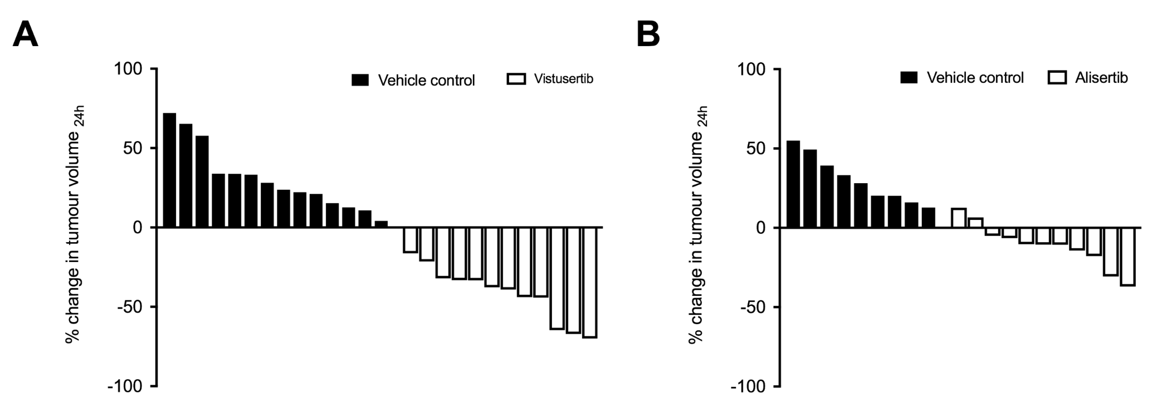

**Supplementary Figure 2.** Waterfall plots documenting relative changes in tumor volume in the Th-*MYCN* mouse model of neuroblastoma 24 hours following treatment with **A.** 25mg/kg vistusertib, **B.** 30mg/kg alisertib, or their respective vehicle.

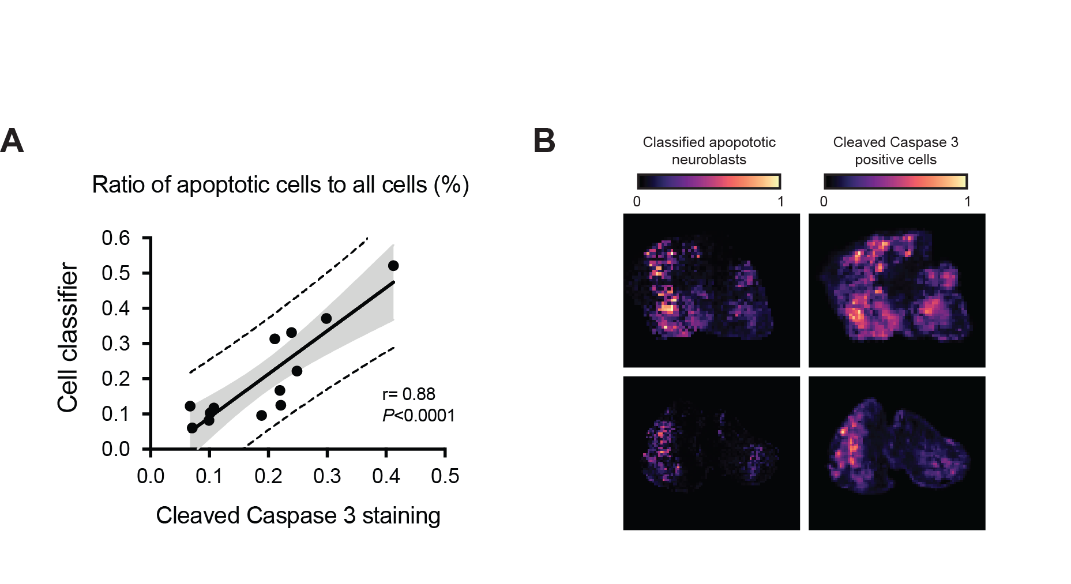

**Supplementary Figure 3.** **A.** Scatter graph showing that the proportion of apoptotic cells in tumors arising in the Th-*MYCN* mouse model of neuroblastoma 24h after treatment with 30mg/kg alisertib or vehicle and quantified using the cell classification algorithm significantly correlated (r= 0.88, *P*<0.0001) with the proportion of cells staining positively for cleaved caspase 3 on adjacent IHC slides. The grey shaded area indicates the 95% confidence intervals while the dashed lines indicate 95% prediction confidence **B.** Histopathology-derived parametric maps showing apoptotic cells density determined using the cell classification algorithm and the density of cells staining positively for cleaved caspase 3 in Th-*MYCN* tumors­.

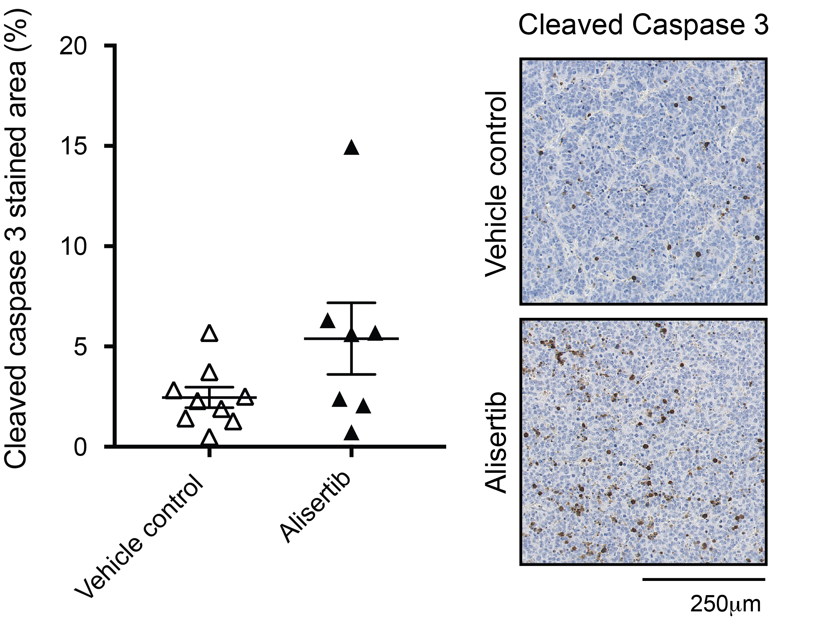

**Supplementary Figure 4.** Quantification of cleaved caspase-3 staining in tumors arising in the Th-*MYCN* mouse model of neuroblastoma 24h after treatment with 30mg/kg alisertib or vehicle.

**References**

1. Yogev O, Barker K, Sikka A, Almeida GS, Hallsworth A, Smith LM*, et al.* p53 Loss in MYC-Driven Neuroblastoma Leads to Metabolic Adaptations Supporting Radioresistance. Cancer Res **2016**;76:3025-35

2. Berry T, Luther W, Bhatnagar N, Jamin Y, Poon E, Sanda T*, et al.* The ALK(F1174L) mutation potentiates the oncogenic activity of MYCN in neuroblastoma. Cancer Cell **2012**;22:117-30

3. Jamin Y, Glass L, Hallsworth A, George R, Koh DM, Pearson AD*, et al.* Intrinsic susceptibility MRI identifies tumors with ALKF1174L mutation in genetically-engineered murine models of high-risk neuroblastoma. PLoS One **2014**;9:e92886

4. Caruana D, Wei W, Martinez-Morilla S, Rimm DL, Reisenbichler ES. Association between low estrogen receptor positive breast cancer and staining performance. NPJ Breast Cancer **2020**;6:5

5. Michael IP, Saghafinia S, Tichet M, Zangger N, Marinoni I, Perren A*, et al.* ALK7 Signaling Manifests a Homeostatic Tissue Barrier That Is Abrogated during Tumorigenesis and Metastasis. Dev Cell **2019**;49:409-24 e6

6. Ribeiro GP, Endringer DC, De Andrade TU, Lenz D. Comparison between two programs for image analysis, machine learning and subsequent classification. Tissue Cell **2019**;58:12-6

7. Loughrey MB, Bankhead P, Coleman HG, Hagan RS, Craig S, McCorry AMB*, et al.* Validation of the systematic scoring of immunohistochemically stained tumour tissue microarrays using QuPath digital image analysis. Histopathology **2018**;73:327-38

8. Bankhead P, Loughrey MB, Fernández JA, Dombrowski Y, McArt DG, Dunne PD*, et al.* QuPath: Open source software for digital pathology image analysis. Scientific reports **2017**;7:1-7