Allosteric inhibition of SHP2 Unleashes Anti-Tumor Immunity by Transforming the Immunosuppressive Environment

Supplementary data file:
Supplementary methods
Supplementary Figures

Supplementary Methods

Immunogenicity studies following chronic lymphocytic choriomeningitis virus (LCMV) infection in mice. In vivo studies were compliant with all relevant ethical regulations regarding animal research. These animal studies were conducted in accordance with approved institutional animal care and use committee IACUC from Canadian Council protocols at PAIRimmune Inc, Laval, Qc, Canada. C57BL/6J mice from Jackson Laboratories (Bar Harbor, ME) were used. This study included: LCMV clone 13 (Cl13) infection (2E+06 ffu, intravenous), CD4 blockade (anti-CD4 antibody, clone GK1.5, BioXcell, 500 μg, intraperitoneal administration at day -1 and day 0 to ensure establishment of viral chronicity) and treatment with vehicle (2% HPMC in 50mM sodium citrate buffer), RMC-4550 (30 mg kg−1, by daily oral administration), anti-PD-L1 (10F.9G2, BioXcell, 200 ug per mouse, intraperitoneal, days 40, 43, 46, 49 and 52) or isotype control (LFT-2, BioXcell) from day 40 to day 52 after viral challenge. Mouse body weight and clinical signs were monitored throughout the study. Partial bleeds were done on days 0 and 31. Mice were randomized based on serum viral titers at day 31. On day 54 mice were euthanized and terminal serum, spleen, kidney and lung were collected for analysis. LCMV viral load estimation in serum, kidney, spleen and lung was performed by focus assay using standard procedures. For kidney, spleen and lung tissue processing, collection tubes were weighted (with culture media) before and after sample collection, mechanically disrupted using a Precellys 24-Dual Tissue Homogenizer (Bertin Technologies). Flow cytometry analysis of T cell populations was performed on splenocytes on day 54. Detection of LCMV antigenic-specific CD8+T cells included: Live/dead fixable Aqua dead cell stain dye (Invitrogen), gp33- or gp276-tetramer (Fred Hutchinson Institute), CD3 (17A2, BD Biosciences), CD8a (53-6.7 BD Biosciences), PD-1 (29F1A12, Biolegend), BTLA (HMBT-6B2, BD Biosciences), TIM-3 (RMT3-23, Biolegend), CD44 (IM7, BD Biosciences) and Ki67 (B56, BD Biosciences). Intracellular cytokine detection was used using standard procedures: One hour after PMA/ionomycin stimulation, GolgiPlug (BD, Cat. 554724) was added to prevent intracellular protein transport, and stimulation was pursued for 4 hours; antibody cocktail included: Live/dead fixable Aqua dead cell stain dye (Invitrogen), CD3 (17A2, BD Biosciences), CD8a (53-6.7 BD Biosciences), CD44 (IM7, BD Biosciences), IFNγ (XMG1.2 (BD Biosciences) and TNFα (MP6-XT22, Biolegend). Samples were acquired on a BD LSR II instrument (BD Biosciences), using BD FACs Diva software (BD Biosciences). Analysis was performed using the same software.

Analysis of ERK1/2 Phosphorylation. ERK1/2 phosphorylation at Thr202/Tyr204 of was assayed using the AlphaLISA SureFire Ultra HV pERK Assay Kit (Perkin Elmer). Cells were seeded 24 hours prior to the assay in clear 96-well plates. Serial dilutions of RMC-4550 were added (final DMSO concentration equivalent to 0.1%) and cells were incubated for one hour at 37 °C in 5% CO2. Cellular lysates were prepared and pERK levels determined according to the manufacturer’s protocol. Samples were read using an EnVision Multilabel Plate Reader (Perkin Elmer) using standard AlphaLISA settings. IC50 values were determined using four-parameter concentration response model in GraphPad Prism 7.

Spheroid Formation and Proliferation. Cells were seeded in polystyrene Microplates (Cat# 655096, Greiner bio-one) and allowed to form spheroids at 37°C in 5% CO2. Serial dilutions of RMC-4550 were incubated for six days(final DMSO concentration equivalent to 0.1%). Cell viability in spheroids was determined using CellTiter-Glo assay kit (Promega), following the manufacturer’s instructions. Luminescence was read in a SpectraMax M5 Plate Reader (Molecular Devices). Assay data was normalized to DMSO values, and EC₅₀ values were determined using a four-parameter concentration-response model in GraphPad Prism 7.

Intracellular detection of IFN-γ in tumors by Flow cytometry. Tumors were processed as stated in general methods. The population of cytokine (IFN-γ) producing cells in the tumor was measured by stimulating the single cell suspensions for 5 hours with PMA (Sigma 8139, 40 ng/ml) and Ionomycin (Millipore 407952, 500 ng/ml) in vitro in the presence of Brefeldin A (Biolegend 420601, 1X), followed by intracellular staining with the cytokine flow cytometry panel. Samples were run in an Attune NxT flow cytometer.

Immunohistochemistry detection for Ki67 and CD31 in mouse paraffin embedded tumors. Anti-Ki67 rabbit monoclonal antibody (Biocare, Cat#CRM325/PRM325, 1:100) was used with citrate-based pH 6.2 Heat-Induced Epitope Retrieval; an isotype control (rabbit IgG) was used under the same conditions. FFPE sections (5 µm) were stained on the Biocare intelliPATH automated staining platform using the manufacturer’s recommended settings. The sections were incubated with Peroxidase Blocker and Background Punisher. Antibody binding was detected with MACH4 HRP-polymer Detection System followed by the chromogenic detection and counterstaining kits IntelliPATH FLX DAB chromogen and IntelliPATH Hematoxylin were used. Anti-mouse CD31 antibody (Dianova Cat#DIA-310, 1:50) was used with pH 9 Heat-Induced Epitope Retrieval; Antibody binding was detected using a rabbit anti-rat secondary antibody (Vector Laboratories BA-4001), followed by an anti-rabbit HRP-conjugated secondary polymer and chromogenic visualization with diaminobenzidine (DAB). A Hematoxylin counterstain was used to visualize nuclei. All reagents were from Biocare Medical, Pacheco CA unless stated otherwise. Stained slides were scanned using an Aperio AT2 whole slide scanner. Whole slide images were annotated to delineate regions of interest (ROI) of the tumor samples. Core, and edge areas of each tumor were identified with oversight from a board-certified veterinary pathologist. Exclusions were applied to remove debris and tissue artifact from the analysis. An algorithm was applied to the immunohistochemically-stained samples using Visiopharm (VIS) image analysis software. Ki67 count-based thresholding was utilized to determine positivity of each pixel on the slide. CD31 positive staining were analyzed using area-based thresholding. The output images underwent a quality control check after analysis was complete. Tumor samples that lacked edge or core ROI’s were excluded from that analysis.

Activation of SHP2 by PD1 ITIM/ITSM peptide. PD1 ITIM/ITSM peptide (sequence H₂N-SVDpYGELDFQWREKTPEPPVPAVPEQTEpYATIVF-NH₂ was synthesized by New England Peptide (Gardner, MA). This sequence corresponds to residues 220 to 253 of human PD1, with cysteine 242 replaced with alanine. The catalytic activity of SHP2 was monitored using the fluorogenic small molecule substrate DiFMUP (ThermoFisher) in 96-well, black polystyrene plates (Corning). The final reaction volume was 100 µl, and the final assay conditions were 55 mM HEPES pH 7.2, 100 mM NaCl, 0.5 mM EDTA, 1 mM DTT, 0.001% Brij35, 0.002% BSA, 0.1% DMSO, 20 µM DiFMUP, 0.0078 to 4.0 nM enzyme, and 0 to 100 nM PD1 peptide. SHP2 activity was determined in triplicate at 8 different [enzyme] and 12 different [peptide]. PD1 peptide was prepared at 10X final concentration and serial 2-fold dilutions prepared in 50 mM HEPES pH 7.2 with 0.02% BSA. Enzyme was prepared at 2X final concentration and serial 2-fold dilutions were prepared in 2X assay buffer. Peptide (10 µl) was mixed with enzyme (50 µl) and 50 µM DifMUP (40 µl) immediately prior to reading plate in kinetic mode on a SpectraMax M5 plate reader (Molecular Devices) for 6 minutes using excitation and emission wavelengths of 340 nm and 450 nm. Plots of initial velocity vs. [SHP2] were fit to determine specific activity. To avoid deviations from linearity due to peptide depletion, points with less than 5-fold excess of peptide to SHP2 were eliminated from the analysis. Plots of specific activity vs. [PD1 ITIM/ITSM peptide] were fit using a 4 parameter concentration-response model in GraphPad Prism 7.01, with the lower baseline constrained to the specific activity of SHP2 with no peptide added. Inhibition of SHP2 by RMC-4550: Assay conditions were similar to peptide activation experiments, except that [SHP2] was constant at 0.2 nM, [PD1 ITIM/ITSM peptide] was constant at 10 nM, and RMC-4550 was present in concentrations ranging from 1 µM to 5.6 pM. RMC-4550 was prepared at 1 mM and serial 3-fold dilutions were prepared in DMSO. DMSO solutions were then diluted 1:100 in 50 mM HEPES pH 7.2 with 0.02% BSA. Enzyme was mixed with activating peptide in 2X buffer 10 minutes before starting the experiment. Diluted compound (10 µL) was mixed with activated enzyme (50 µl) and incubated for 30 minutes at room temperature. A 50 µM aqueous DifMUP solution (40 µl) was added and the plate was read in kinetic mode on a SpectraMax M5 plate reader (Molecular Devices) for 6 minutes using excitation and emission wavelengths of 340 nm and 450 nm. Plots of fluorescence units vs. time were fit with linear regression to determine initial velocity. Plots of initial velocity vs. inhibitor concentration were fit using a 4 parameter concentration-response model in GraphPad Prism 7.01.

MDSC suppression assay. Human buffy coat was obtained from San Diego Blood Bank. Monocytes were isolated from fresh PBMC from healthy donors by using EasySep human monocyte enrichment kit (Stemcell). MDSC induction was done with 1000U/ml GM-CSF (R&D Systems), 1000U/ml IL-4 (R&D Systems), and 1µM PGE2 (Sigma Aldrich) treatment for 7 days. Cells were confirmed to be MDSC by staining with CD11b, CD14, CD33 and HLA-DR and the purity was confirmed to be >90%. CD8+T cells were isolated from the same donor by using EasySep human CD8 T-cell Isolation kit (Stemcell), labelled with 3 µM CSFE (Invitrogen) and activated with Dynabeads (1:1 bead to cell ratio) for 1h. MDSC and CD8+T cells were co-cultured into a U-bottom 96-well plate at ratio indicated. 5 days after co-culture, supernatant was analyzed for IFNγ cytokine content by MSD. Cells were treated with vehicle of RMC-4550 during differentiation and co-culture. MDSC viability was not affected by RMC-4550. The remaining cells were stained with FVD 506 (viability dye, Invitrogen) and anti-CD8 antibody (Invitrogen). CD8+ T cell proliferation was analyzed in Attune NxT Flow Cytometer.

In vitro studies with human derived monocytes. Human buffy coat was obtained from San Diego Blood Bank. Monocytes were isolated from fresh PBMC from healthy donors by using EasySep human monocyte enrichment kit (Stemcell). Cells were pre-treated for 30 minutes with vehicle, 1µM RMC-4550 or 300nM BLZ-945 and then treated with 100ng/ml CSF-1 (Invitrogen, human recombinant) for 0 or 5 minutes. Cells were then collected and lysed in lysis RIPA buffer (Sigma) with protease and phosphatase inhibitor cocktail (ThermoFisher), proteins were separated on an SDS-PAGE gel and transferred utilizing a fast-transfer system (Bio-Rad Trans Blot Turbo) before analyzed with a chemiluminescent detection kit (ThermoFisher). Antibodies used from Cell Signaling Technologies: pAKT (ser473) rabbit mAb, pERK1/2 (Thr202/Tyr204) rabbit mAb, Erk1/2 rabbit mAb, m-CSF rabbit mAb. Direct blot HRP anti-actin antibody (Biolegend). For cell proliferation assay, human derived monocytes were treated with increasing concentrations of compounds in the presence of 100 ng/ml CSF-1 (Invitrogen, human recombinant). Cell proliferation was measured 7 days after treatment using the CellTiterGlo reagent (Promega).

In vitro studies with CSF-1R/SRE reporter cells. CSF-1R/SRE Reporter-HEK293 cells (BPS Bioscience # 79380) were seeded at 30,000 cells per well into white clear-bottom 96-well microplate in 100 μL of assay medium (MEM medium (Hyclone #SH30024.01) without Geneticin and Puromycin). Cells were incubated at 37°C and 5% CO2 overnight. The following day cells were switched to media containing 0.5% FBS and incubated with the indicated concentrations of test article for 1 hour. After compound pre-incubation, human CSF-1 in assay medium containing 0.5% FBS was added to wells to a final concentration of 10 ng/ml. Cells were then incubated at 37°C and 5% CO2 for 5-6 hours. After treatment, cells were lysed and the luciferase assay was performed using ONE-Step luciferase assay system (BPS Bioscience # 60690). Luminescence was measured using a luminometer (BioTek SynergyTM 2 microplate reader).

qPCR of CSF-1 in CT26 cells. CT26 cells were cultured in RPMI 1640 (Gibco) supplemented with 10% heat-inactivated FBS (VWR) and 1% Penicillin Streptomycin L-Glutamine (Corning). For the CSF-1 qPCR experiment, CT26 cells were cultured with combinations of IFNγ (222 U/mL, Peprotech), TNFα (50 ng/mL, Peprotech), and RMC-4550 (1 µM), as indicated in a 12-well plate. RNA was collected at 24 h post-treatment using RNeasy Mini Kit (Qiagen) according to kit instructions. RNA was quantified using Nanodrop. All qPCR reactions were performed using the Taqman RNA-to-C_{T} 1-Step Kit (Applied Biosystems) and the following TaqMan gene probes: Hprt (Mm03024075_m1), Csf-1 (Mm00432686_m1). qPCR reactions were done in two technical replicates and 100 ng RNA per reaction.

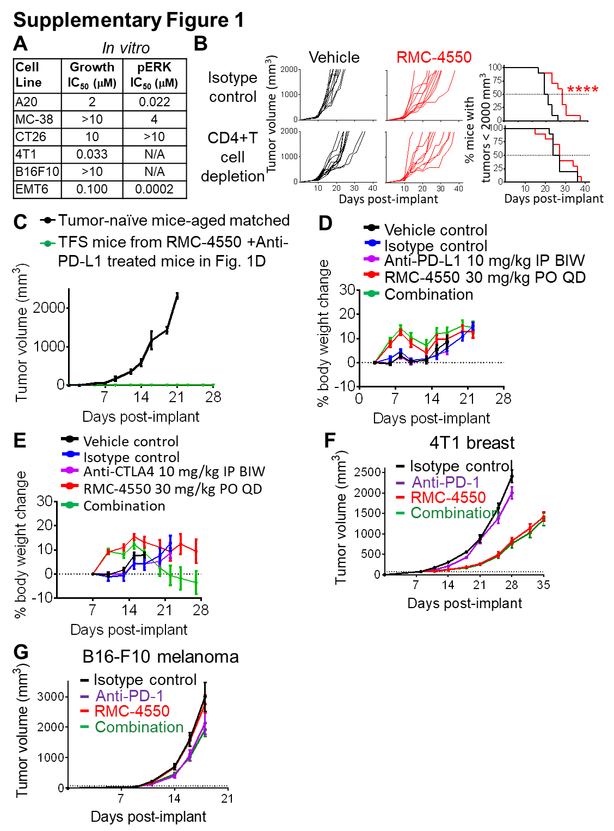
Fig. S1. (A), In vitro effect of RMC-4550 on cell growth (in vitro 3D) or pERK levels in syngeneic cell lines used in this study; representative data (mean ± s.d.) from 2 independent experiments. N/A not available. (B) Activity of RMC-4550 (oral daily administration of 30 mg/kg) in CT26 tumor bearing immunocompetent mice depleted of CD4+ T-cells alone by intraperitoneal injection (IP) of depleting antibody. Left two panels show tumor growth of individual mice for each experimental group described, right panel shows Kaplan-Meier plot displaying percentage of animals with tumor burden below 2000 mm³ in each treatment. Data from the same experiment shown in figure 1C. Kaplan–Meier curves were compared using the Mantel-Cox Log-Rank test; n=10 animals per group (****P < 0.0001). (C), Four tumor free survival mice derived from combination group in experiment shown in figure 1D were re-challenged with CT26 cancer cells (green). Tumor-naïve control mice show tumor growth at typical rate for CT26 cells (black). TFS = Tumor-free survivors. (D, E), Body weight change in mice from experiment shown in figure 1D and E, respectively. Data represents mean ± s.e.m. (F-G), Activity of RMC-4550 (oral daily administration of 30 mg/kg, for the duration of the study starting at day 8 or 9 post-implant), anti-PD-1 (10 mg/kg, IP every three days, for a total of 7 doses starting at day 8 or 9 post-implant) or combination of both in 4T1 (F) or B16-F10 (G) -tumor bearing immunocompetent mice. Graphs show mean tumor volume ± s.e.m. n=10 animals per group.

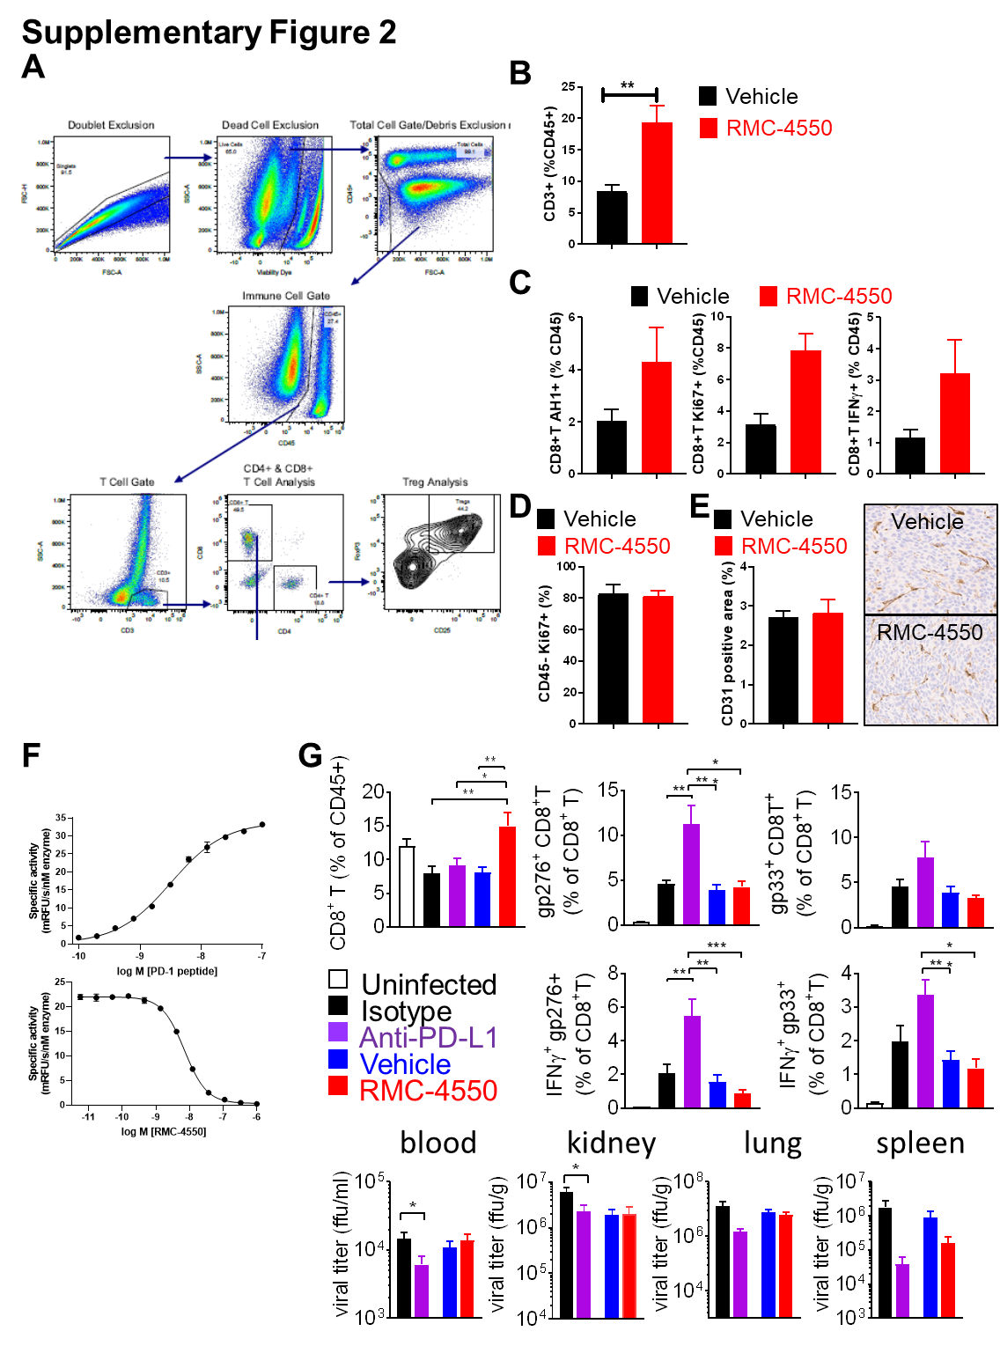
Fig. S2. (A), Representative dot-plots depicting gating strategy during flow cytometry analysis of tumor infiltrating leukocytes as shown in figure 2. Quantification by flow cytometry of (B), CD3+, (C), AH1+ antigen specific CD8+T cells (left), Ki67+ CD8+T cells (right) or IFNg+ specific CD8+T cells (middle), represented as frequency of CD45+ TILs. (D), Frequency of Ki67+ CT26 tumor cells analyzed by flow cytometry (gated as live, CD45 negative cells). (E) Analysis of CD31 expression in CT26 tumors analyzed by immunohistochemistry, representative images included (F), Biochemical activation of SHP2 by PD1 ITIM/ITSM peptide and inhibition by RMC-4550. Purified full length SHP2 enzyme was titrated with a synthetic phosphopeptide derived from the PD1 ITIM/ITSM and activity was determined using the fluorogenic small molecule substrate DiFMUP. The synthetic peptide increased specific activity of SHP2 by 270-fold, with an EC₅₀ of 3.2 nM (N = 3, 95% confidence interval 2.9 nM to 3.5 nM). RMC-4550 inhibits SHP2 activated with 10 nM PD1 ITIM/ITSM peptide (65% maximum activation) with an IC50 of 7.1 nM (N = 8, 95% confidence interval 6.8 nM to 7.3 nM). (G) Flow cytometry analysis in splenocytes derived from uninfected mice (white bars) or mice challenged with LCMV clone 13 for 54 days (colored bars). Mice were treated with isotype control antibody, anti-PD-L1 (10 mg/kg, IP every three days), vehicle of RMC-4550 (oral daily administration of 30 mg/kg) for a total of 13 days (during chronic viral phase, from day 40 to day 53 after viral challenge). Splenic total and antigen-specific gp276+ or gp33+ CD8+T cells (top row, tetramer analysis) and intracellular IFNγ release upon ex vivo re-stimulation (middle row) were analyzed. LCMV viral load was estimated in peripheral blood or organs indicated (bottom row) by focus assay. Data represents mean ± s.e.m. n=5-10 animals per group. One-Way ANOVA followed by Tukey (*P < 0.05; **P < 0.01; ***P < 0.001; ****P < 0.0001).

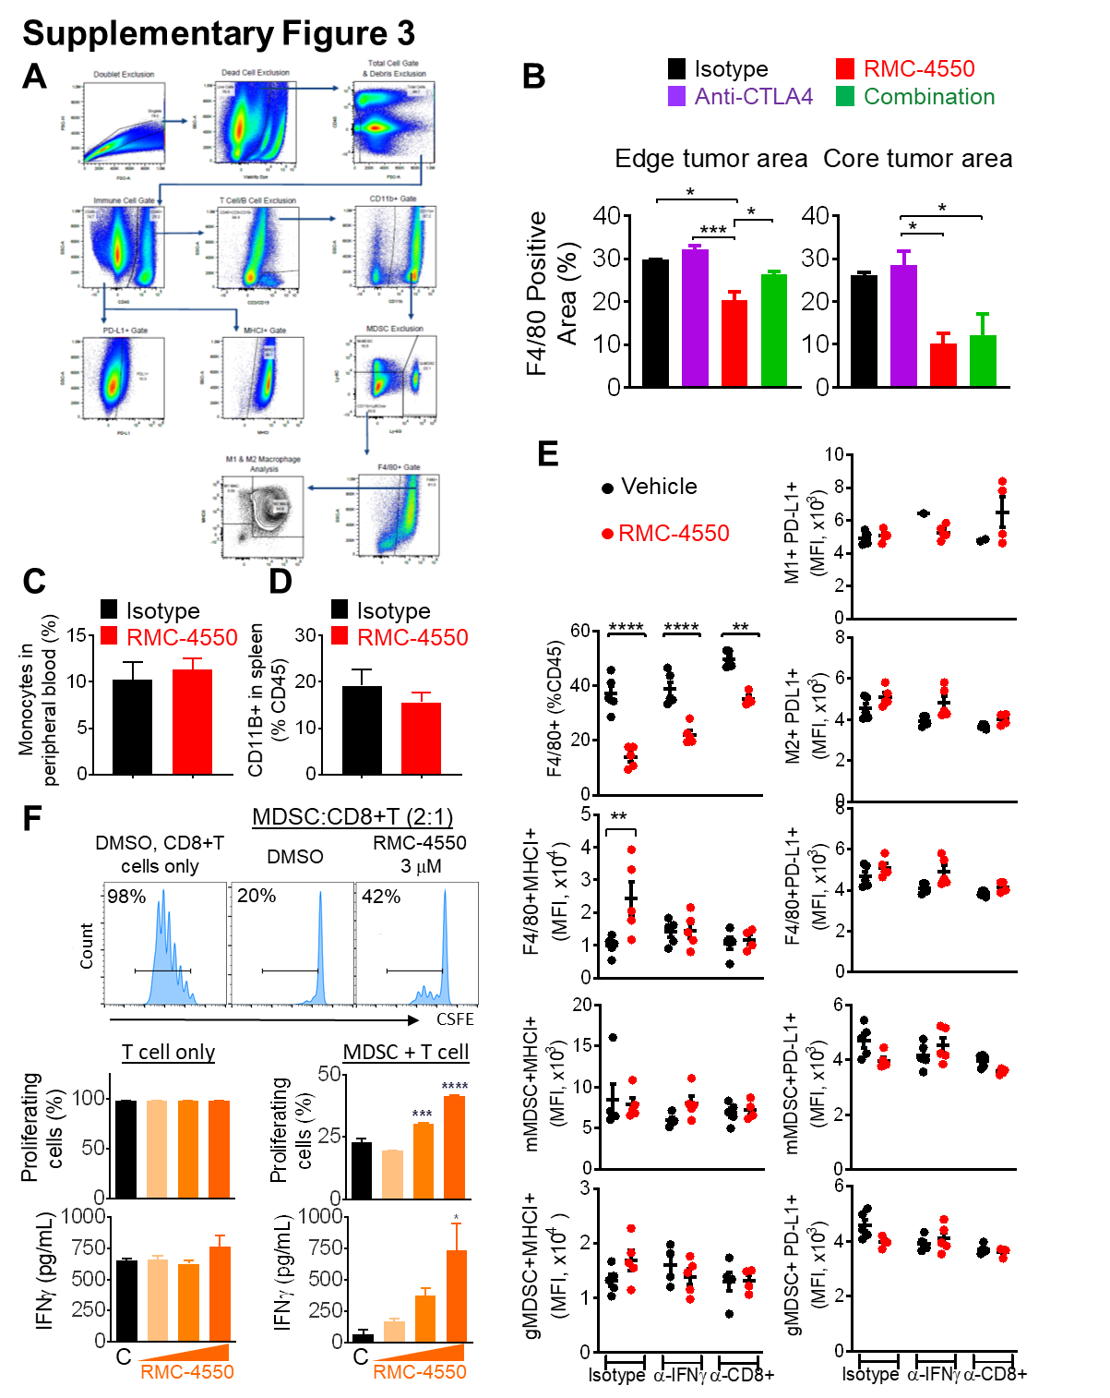

Fig. S3. (A), Representative dot-plots depicting gating strategy during flow cytometry analysis of tumor infiltrating leukocytes as shown in figure 3. (B), Immunohistochemistry analysis for F4/80+ cells of images shown in Figure 3D, quantification of F4/80+ area, as percentage of edge or core tumor area in each section. (C), Frequency of monocytes in peripheral blood (complete blood count analysis) from CT26-tumor bearing mice as shown in figure 3D. (D), Frequency of myeloid cells in spleens from EMT6 tumor bearing mice. (E), Analysis by flow cytometry of the frequency of F4/80+ cells (top left) and MHCI MFI (left) or PD-L1 MFI (right) of total, M1+ or M2+ like tumor associated macrophages upon in vivo depletion of IFNγ or CD8+T cells in CT26 tumors derived from the same experiment as in Figure 2D and 3E,F. (F), MDSC in vitro suppression assay from human cells derived from healthy donors. Upper plots show cell proliferation (CSFE content determined by flow cytometry with corresponding quantification of % CFSE dilution bar graph below); bottom bar graph shows IFNγ release analyzed by ELISA. 30 nM, 300 nM and 3 μM RMC-4550 (orange) were used and compared with DMSO control (black). T cell viability and proliferation were not affected by RMC-4550 when not in co-culture with MDSC (left bar graph). (B-F), Data represents mean ± s.e.m. One-Way ANOVA followed by Tukey (*P < 0.05; **P < 0.01; ***P < 0.001; ****P < 0.0001). (B-E), n=2-5 animals per group.

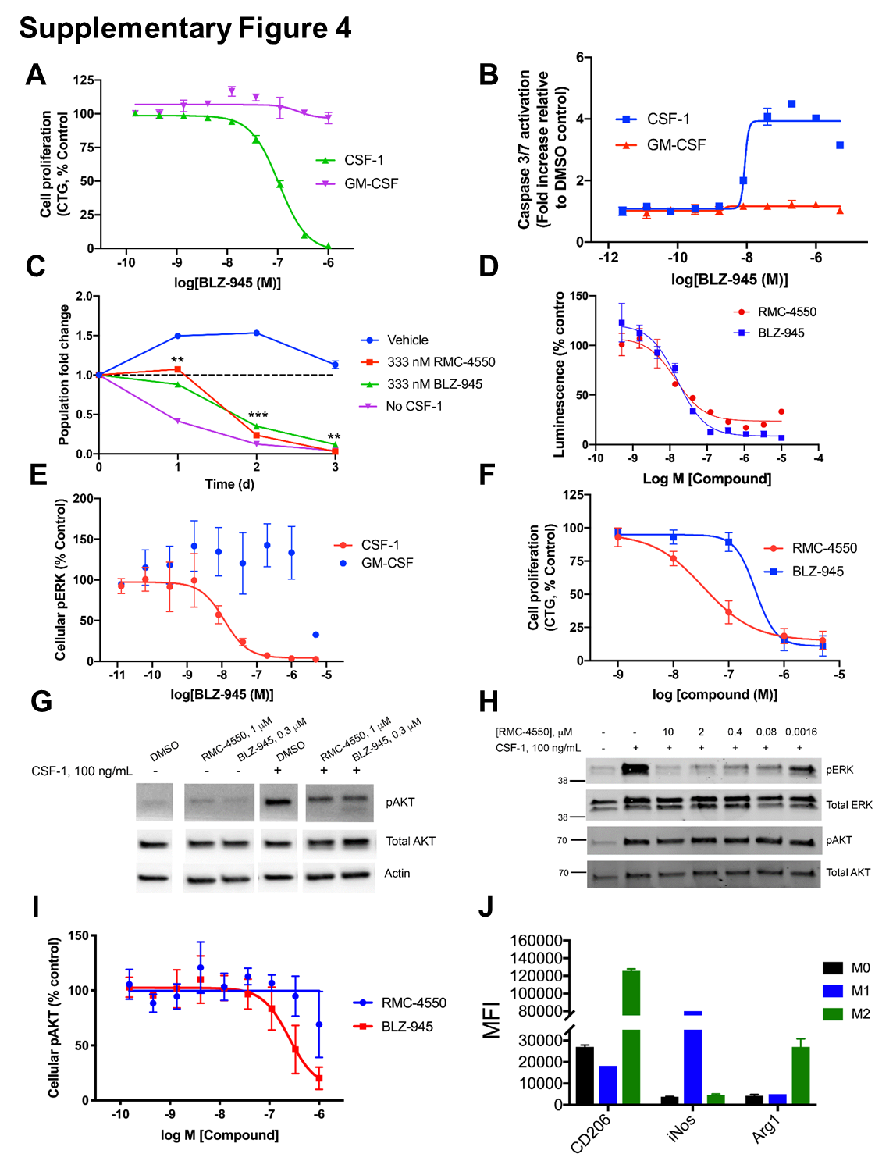

Fig. S4. (A) The effect of BLZ-945 treatment on proliferation (CTG) murine BM cells cultured in either CSF-1 or GM-CSF. Cells were incubated with the appropriate cytokine for 7 days, followed by 72 h of treatment of RMC-4550. The IC₅₀ value for CSF-1 treated BMDMs is 172 nM. The data represent the mean ± s.d. for n= 2 independent biological experiments performed in technical duplicate. (B) Murine BM cells were grown in either CSF-1 or GM-CSF and assayed for caspase 3/7 activation after 48 h of treatment with BLZ-945. Data are plotted as the mean ± s.d. of a representative example of n=2 independent biological experiments performed in technical duplicate. The EC₅₀ value for CSF-1 treated BMMs is 9 nM. (C) Effects of RMC-4550 and the CSF-1R inhibitor BLZ-945 on BMDM survival as compared to CSF-1 deprivation. Data are normalized to initial seeding density (dashed line). Data are plotted as the mean ± s.d. of a representative example of n=2 independent biological experiments performed in technical duplicate. Statistical significance of RMC-4550 and BLZ-945 treatment was calculated by unpaired t-test.**P < .01, ***P < .001 (D) Inhibitory effects of RMC-4550 and BLZ-945 on MAPK signaling downstream of CSF1R in HEK293 CSF1R/SRE reporter cells. Both compounds potently inhibit signaling after stimulation with human CSF1 (RMC-4550 EC₅₀- 14.3 nM ; BLZ-945 EC₅₀- 15.9 nM).(E) Effects of BLZ945 treatment on murine BM-derived cultured in CSF-1 (IC₅₀ = 12 nM) and GM-CSF (no effect). The data represent the mean ± s.d. for n= 2 independent biological experiments performed in technical duplicate. (F) Cell proliferation of human monocytes treated with RMC-4550 and BLZ-945. Data represent the mean ± s.d. of n=3 independent biological experiments performed in technical triplicate. (G) Representative Western blots showing the effects of RMC-4550 and BLZ-945 on phosphorylation of AKT in human monocytes and (H) murine BMDMs. Lanes in G are reordered to include only relevant treatments. (I) Effects of RMC-4550 and BLZ945 treatment on Akt phosphorylation in murine BM-derived cells cultured in CSF-1. The data represent the mean ± s.d. for n= 2 independent biological experiments performed in technical duplicate. (J) The expression levels of CD206, iNOS, and arginase in murine BMDMs polarized to either M1 or M2 assessed by flow cytometry.

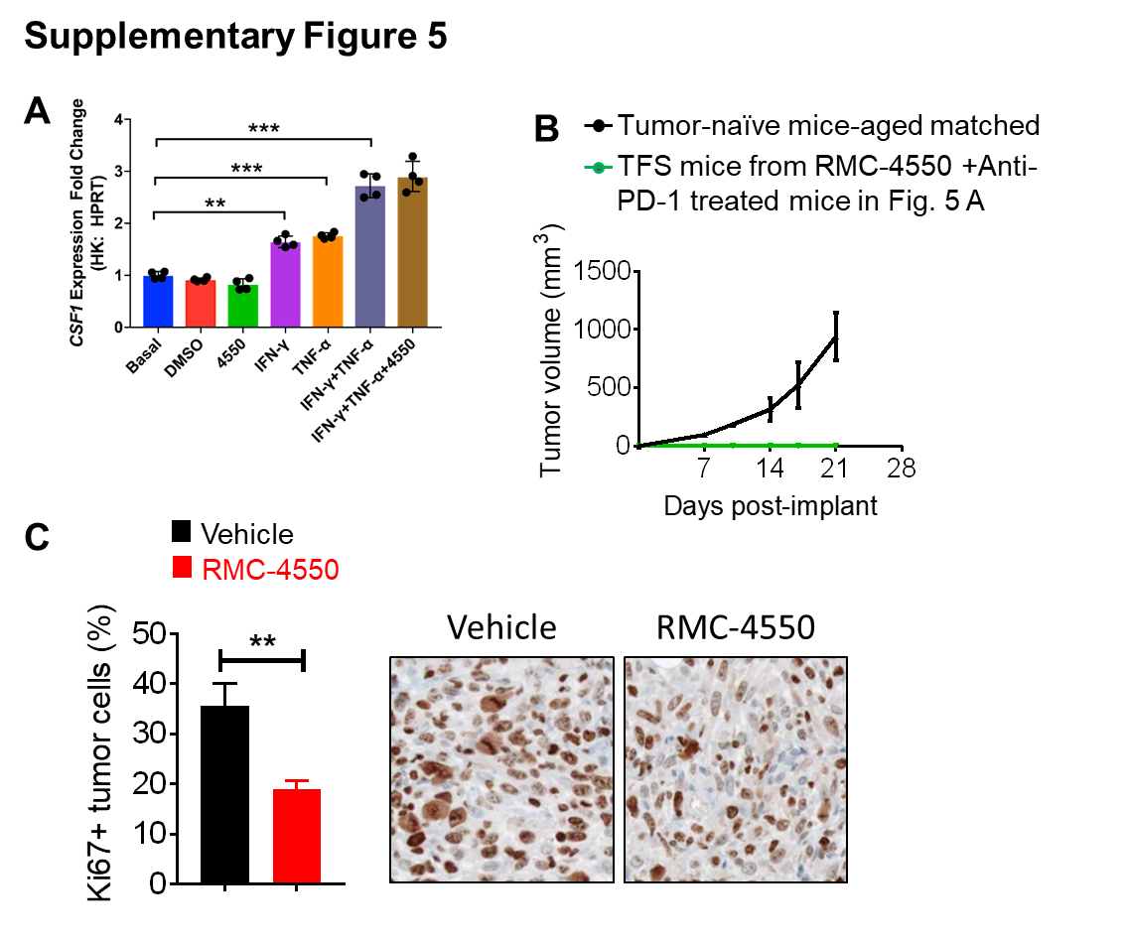

Fig. S5. (A), Expression of CSF in CT26 cells is induced by treatment with IFN-γ and TNF-α as assessed by qPCR. (B), Two tumor free survival mice derived from combination group in experiment shown in figure 5A were re-challenged with EMT6 cancer cells (green). Aged-matched tumor-naïve control mice show tumor growth at typical rate for EMT6 cells (black). TFS = Tumor-free survivors. (C) Frequency of Ki67+ tumor cells from EMT6 tumor bearing mice treated with RMC-4550 (30 mg/kg, po qd) or vehicle for 9 days, analyzed by immunohistochemistry, representative images shown on right. Data represents mean ± s.e.m. n=5 animals per group. Unpaired t-Test (**P < 0.01).

