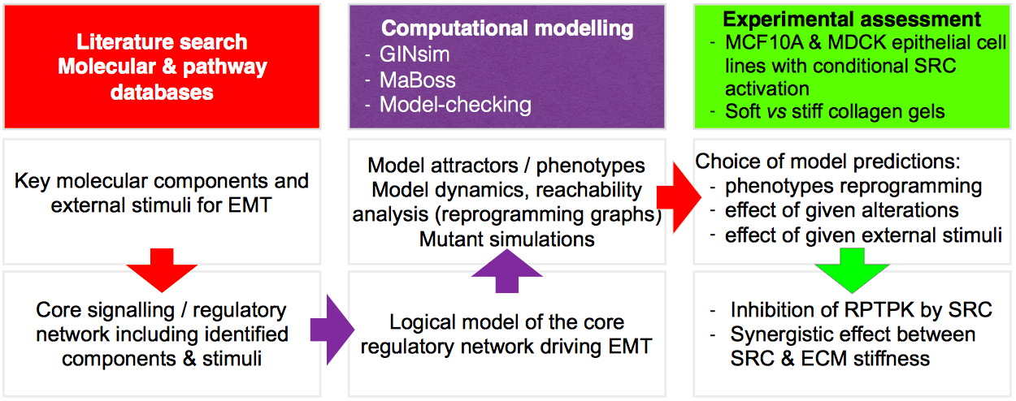

Supplementary Figure S1: Summary of the general workflow of our study. Color code: reading, curating tasks in red, computational tasks in purple, experimental tasks in green.

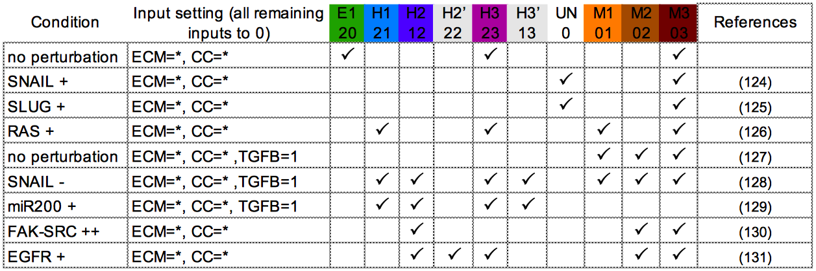

Supplementary Figure S2: Quality assessment of the logical model, which compare the phenotypes displayed by the model upon perturbations with observations reported in the literature. The first column indicates the condition: knock-out/inhibition (-) or ectopic expression/activation (+). The second column provides the considered input configurations; all inputs are considered absent but ECM stiffening (ECM), cell-cell contact (CC) and possibly TGFB (1 for activated/present, * for any state). The remaining 10 columns correspond to phenotypes, those marked with a tick symbol are retrieved by the model under the specified condition and input configuration.
(1st row) no perturbation.
(2nd to 5th row) Consistent with experimental observations showing that cells expressing SNAIL or SLUG ectopically, or an activated form of RAS, or exposed to TGFB, lose their epithelial characteristics and gain mesenchymal traits (124–127), fixing SNAIL, SLUG, RAS or the input TGFB to 1 in the model promoted the conversion of E1 and H3 into M phenotypes.
(6th and 7th row) TGFB-induced EMT requires SNAIL upregulation and miR200 downregulation, as silencing SNAIL or forcing miR200 expression in cells exposed to TGFB prevents ECad loss (128,129). According to these experimental observations, model perturbations showed that setting TGFB and miR200 at 1 or TGFB at 1 and SNAIL at 0, promoted the appearance of hybrid phenotypes, characterized by the presence of ECad.
(8th row) conversely, the model with a gain of FAK_SRC activity (FAK_SRC=2) was sufficient to induce phenotypes that lack AJs (H2, M2 and M3), reminiscent of the effect of FAK or SRC in promoting AJ disassembly (130).
(9th row) phenotypes reached by the model with an EGFR gain of function (EGFR=1) exhibited all migrating abilities, reminiscent of the behavior of carcinoma cells overexpressing EGFR and treated with EGF (131).

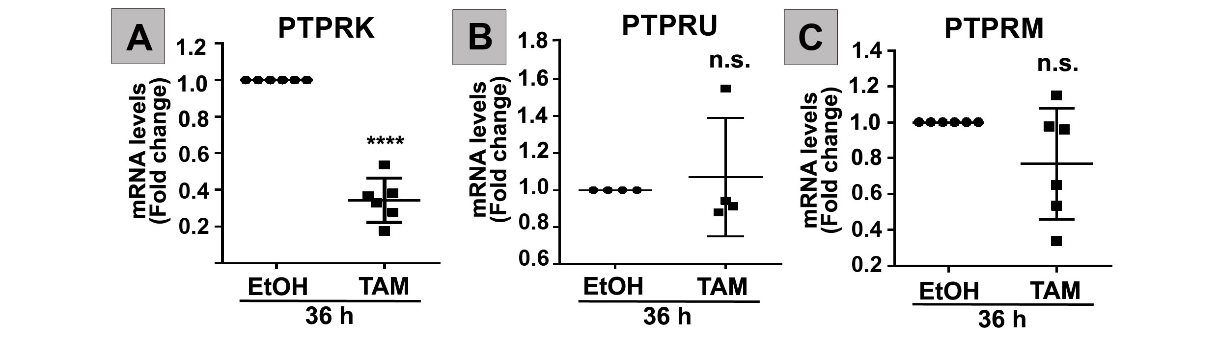

Supplementary Figure S3: PTPRK, but not PTPRU or PTPRM, is downregulated by SRC (A) PTPRK or (B) PTPRU or (C) PTPRM mRNA levels normalized to GAPDH on extracts from MCF10A-ER-SRC cells treated with EtOH or TAM for 36 hours. Statistical significance was calculated using unpaired t-test. Data are presented as mean ± SD. n.s. indicate non-significant; **** indicates P<0.000 (unpaired t-test).

Supplementary Figure S4: SRC and ECM stiffening synergize to induce SLUG and ZEB expression. Simulation of SLUG (A) or ZEB (D) expression when FAK_SRC is overactivated (FAK_SRC⁺), starting from an E1 phenotype in condition of a soft (ECM=0) or a stiff (ECM=1) ECM.

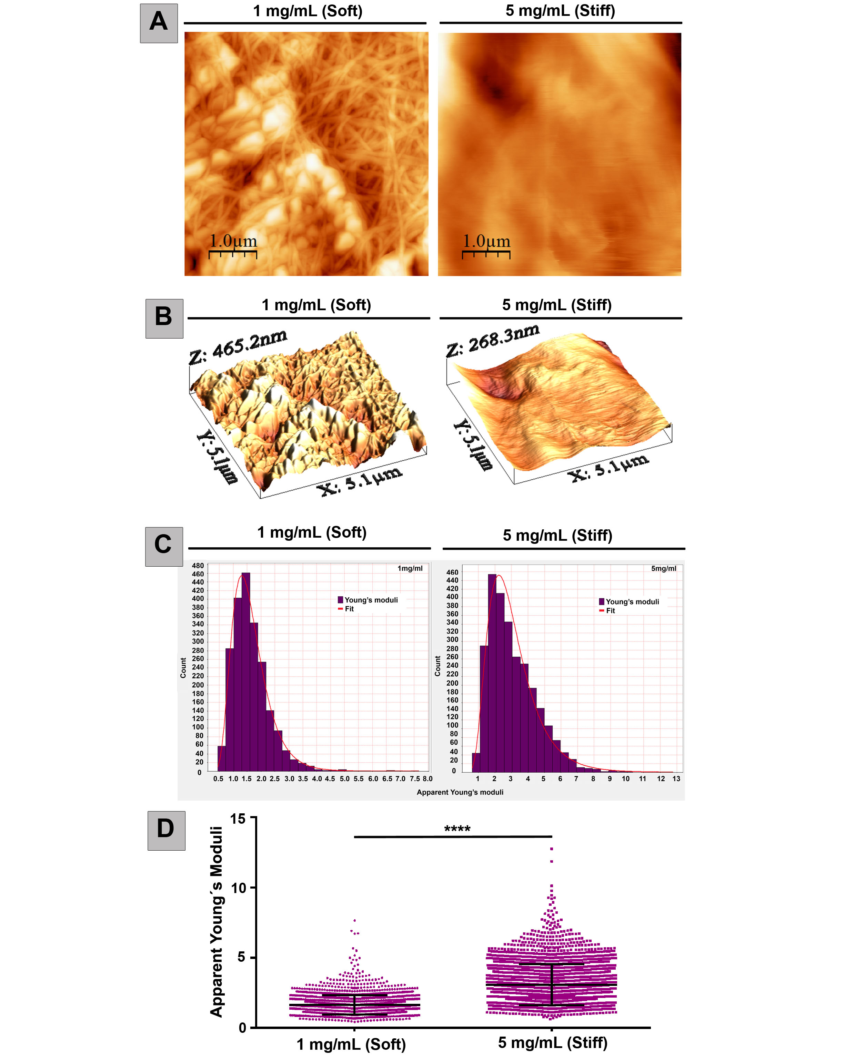

Supplementary Figure S5: Stiffness measurement of 1 and 5 mg/mL collagen I gels by nanoindentation using AFM.
(A-B) 2D (A) and 3D (B) topography of the nanosurfaces of 1 or 5 mg/mL collagen I gels.
(C) Histograms representing the Apparent Young’s moduli of 1 or 5 mg/mL collagen gels.
(D) Apparent Young’s moduli from 1 or 5 mg/mL collagen gels. Measurements are from three biological replicates with a total of 2166 or 2691 force curves for 1 or 5 mg/mL collagen gels, respectively. Values represent mean ± SD. **** P<0.0001 (unpaired t test with Welch’s correction).

Supplementary Figure S6: SRC and the presence of a stiff collagen gel do not synergize to induce SLUG, ZEB1 or ZEB2 expression in MCF10A cells but cooperate to upregulate SLUG in MDCK cells.
(A and B) ZEB1 (A) or ZEB2 (B) mRNA levels, normalized to GAPDH on extracts from MCF10A-ER-SRC cells plated on soft (1 mg/mL) or stiff (5 mg/mL) collagen gels and treated with EtOH or TAM for 24 hours.
(C, D) SLUG mRNA levels, normalized to GAPDH on extracts from (C) MCF10A-ER-SRC or (D) MDCK-pTR cSRC^{Y527F}-GFP cells plated on soft (1 mg/mL) or stiff (5 mg/mL) collagen gels and treated with EtOH or TAM for 24 hours or with EtOH or tet for 48 hours.
Quantifications are presented as mean ± SD. n.s. indicate non-significant; ** indicates P<0.005; **** indicates P<0.000 (one-way ANOVA).

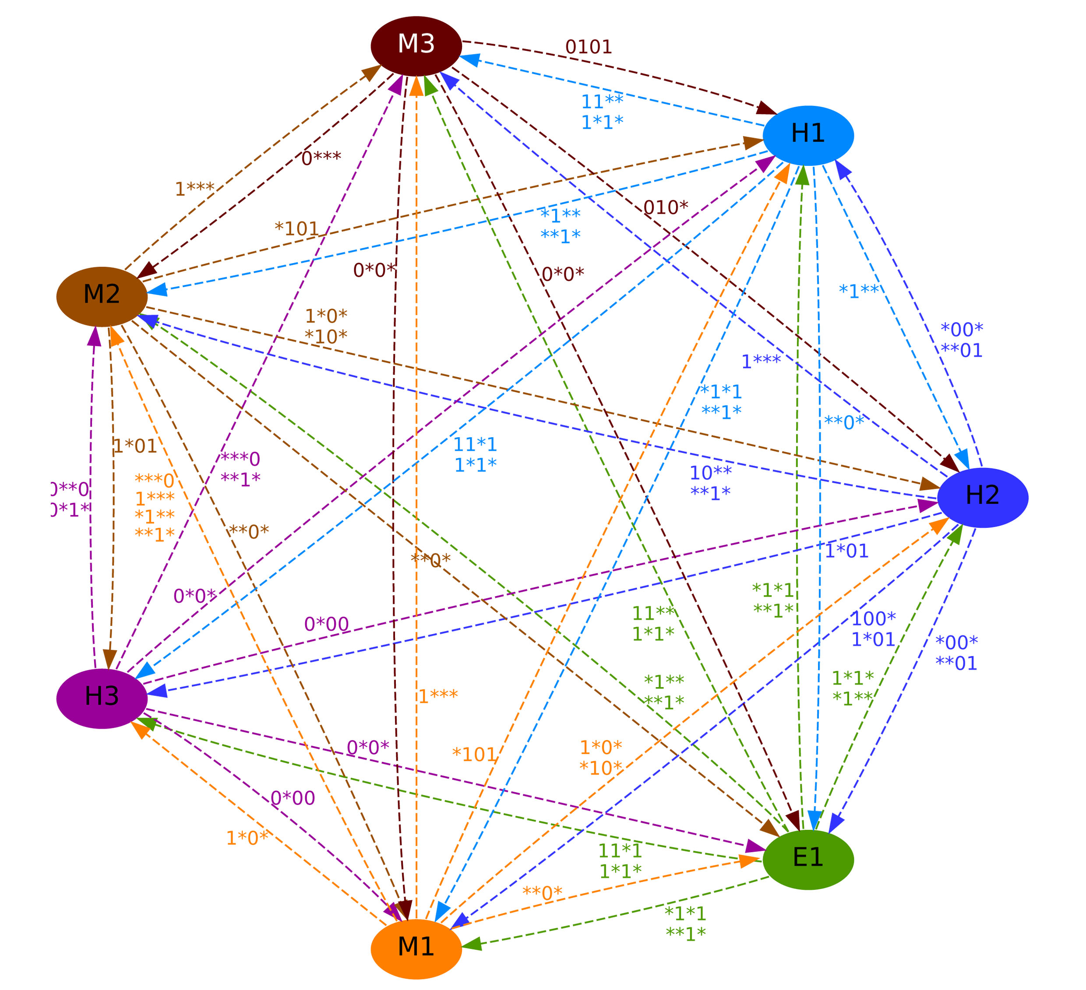

Supplementary Figure S7: “Weak” reprogramming graph displaying potential reprogramming trajectories between phenotypes, under specific input combinations (edge labels). Here, an edge means that there is a trajectory from at least one state of the source phenotype towards a state of the target phenotype without passing through a state of a third phenotype.

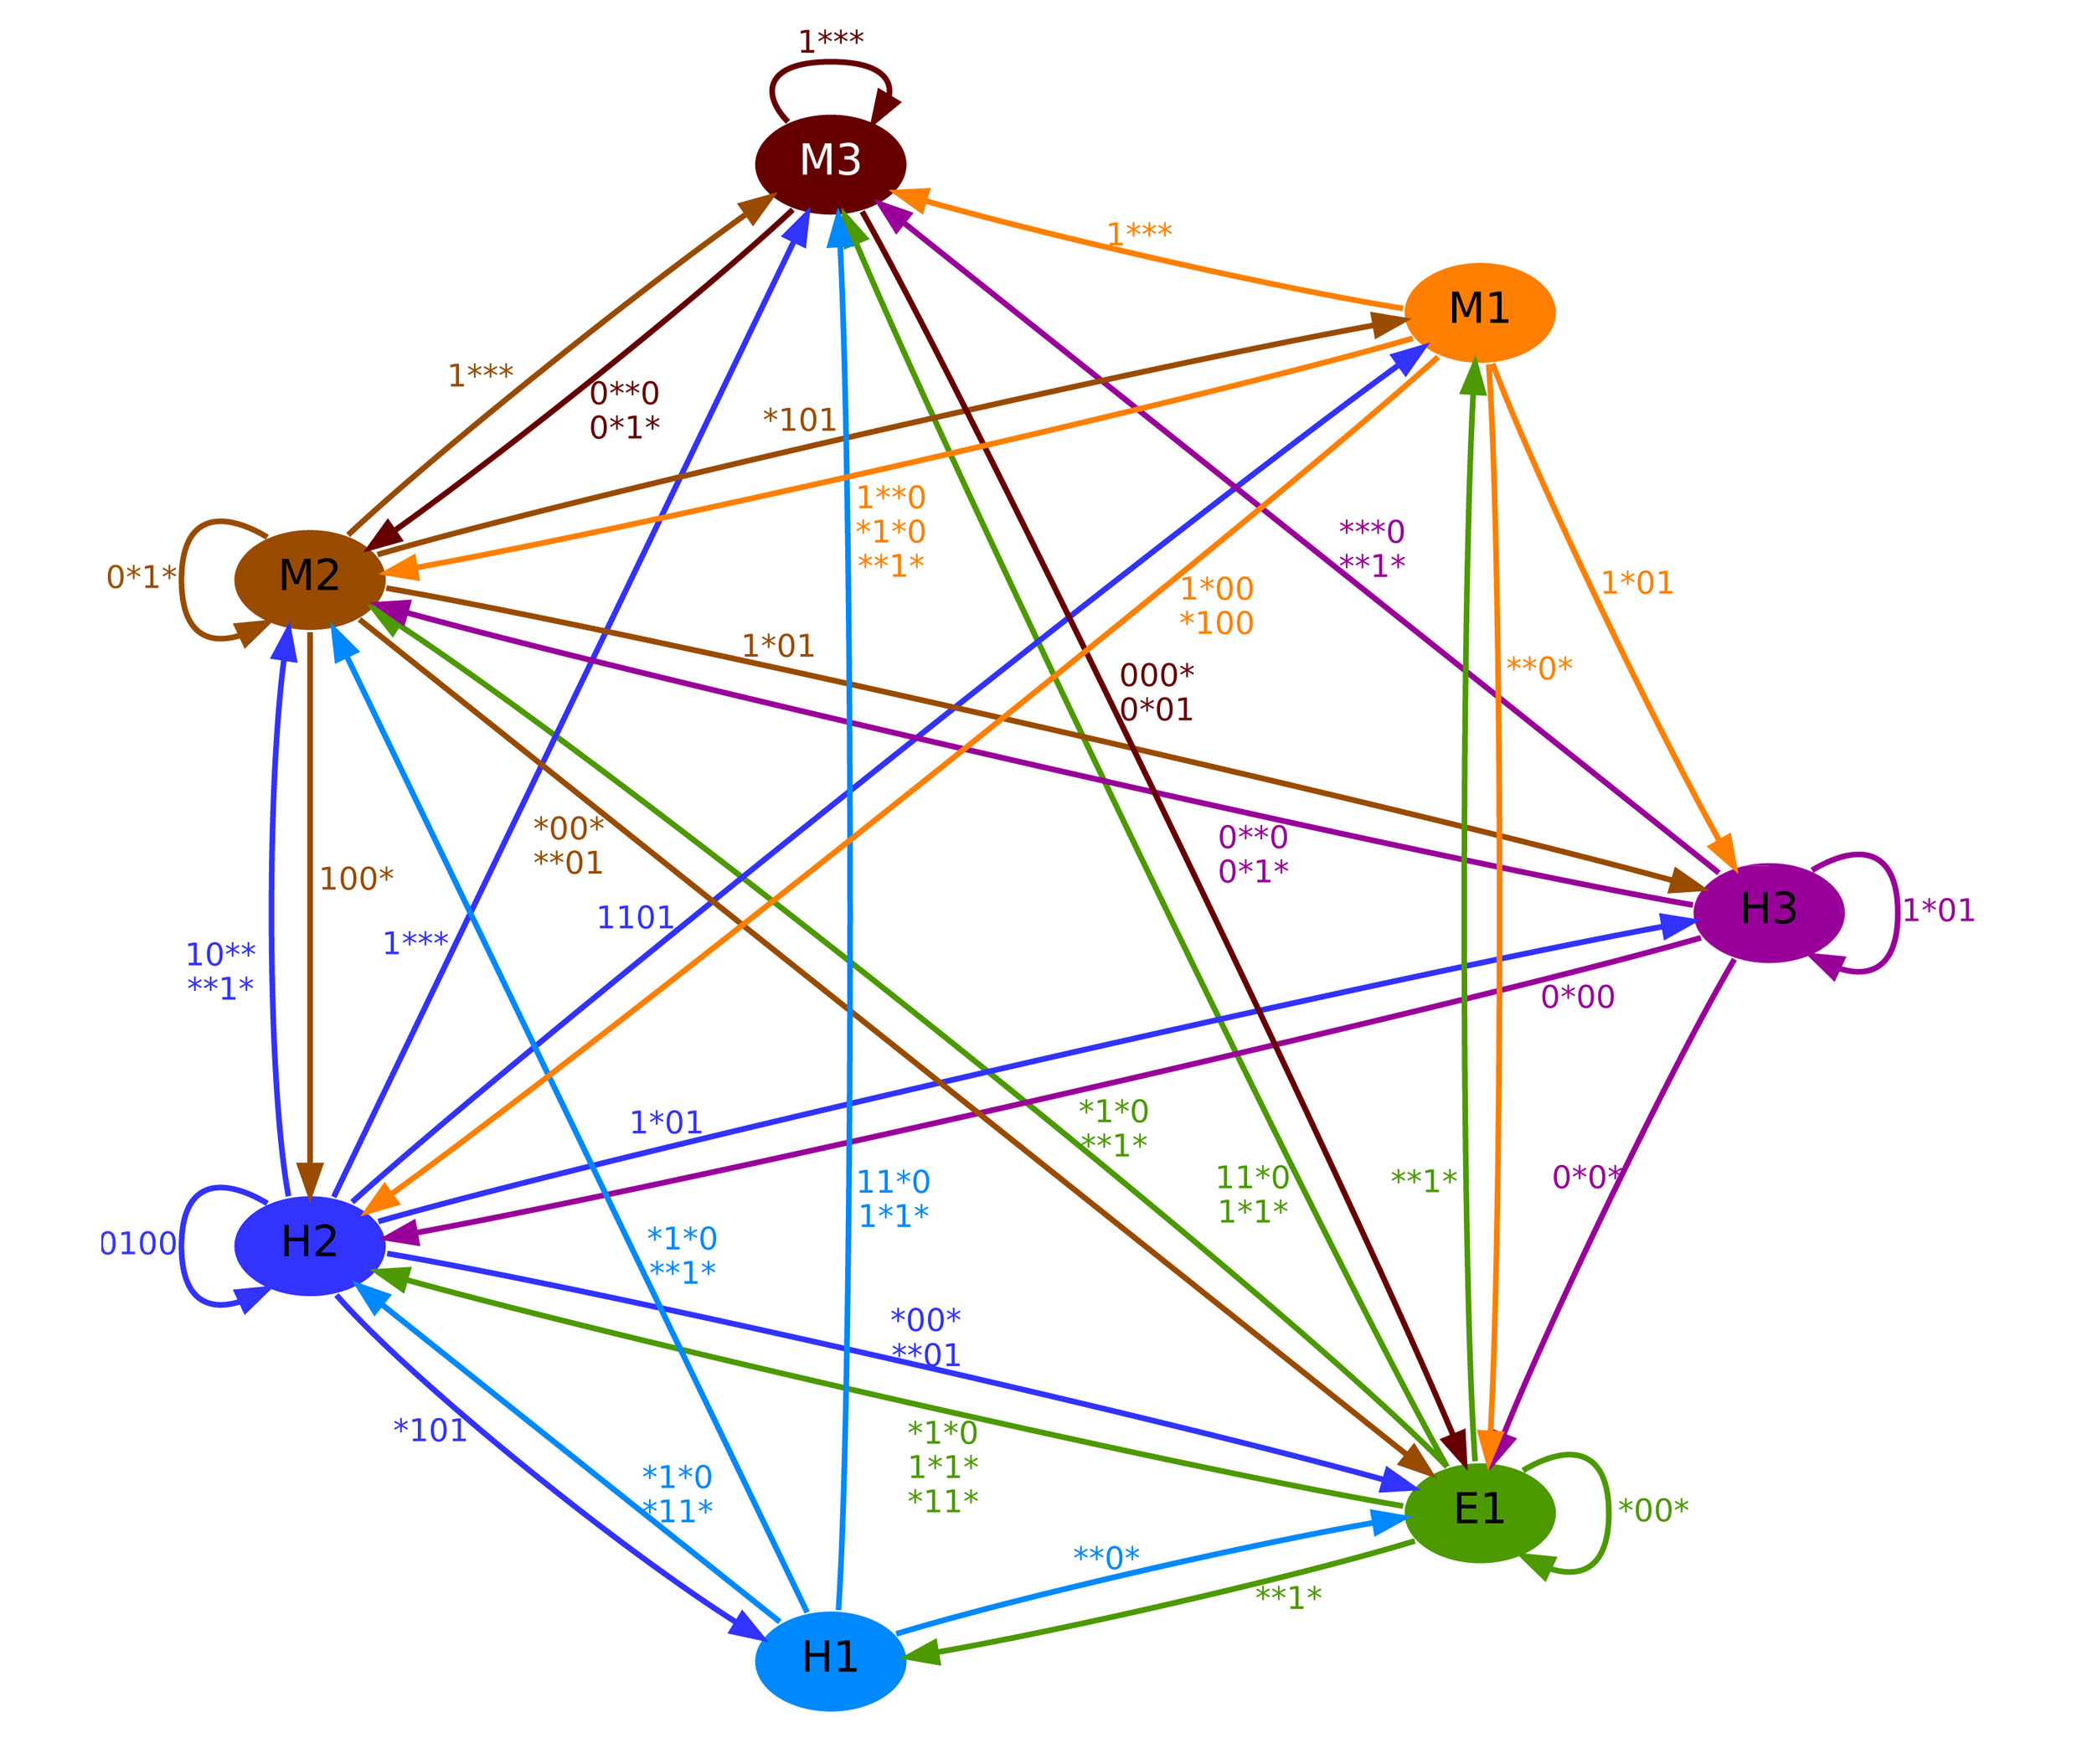

Supplementary Figure S8: “Strong” reprogramming graph displaying potential reprogramming trajectories between phenotypes, under specific input combinations (edge labels). Here, an edge means that there is a trajectory from every state of the source phenotype towards a state of the target phenotype without passing through a state of a third phenotype. Self-loops indicate that under the input indicated by the edge label, the phenotype is stable.

