**Supplementary information**

**Optical Radiomic Signatures Derived from OCT Images to Improve Identification of Melanoma**

Zahra Turani1,2, Emad Fatemizadeh 1, Tatiana Blumetti3, Steven Daveluy4, Ana Flavia Moraes3, Wei Chen5, Darius Mehregan3, Peter Andersen6, and Mohammadreza Nasiriavanaki2,5\*

1 Department of Biomedical Engineering, Wayne State University, Detroit, MI

2 Department of Electrical Engineering, Sharif University of Technology, Tehran, Iran

3 Cutaneous Oncology Department, AC Camargo Cancer Center, São Paulo, Brazil

4 Department of Dermatology, School of Medicine Wayne State University

5 Department of Oncology, Karmanos Cancer Institute, Detroit, MI

6 Department of Photonics engineering, Technical University of Denmark, Denmark

\*Corresponding author: [mrn.avanaki@wayne.edu](mailto:mrn.avanaki@wayne.edu)

**Preprocessing.** One of the main steps in the optical properties extraction (OPE) algorithm is choosing an appropriate size for the region of interest (ROI), for which the optical properties are calculated. Different ways of choosing the ROI were investigated on optical coherence tomography (OCT) images of milk phantoms: (1) a median filter was initially applied on a stack of 170 OCT images acquired from the same cross section, the extracted optical properties were averaged over several ROIs chosen in the resultant image; (2) the same ROI was chosen in 170 images and the extracted optical properties were averaged; (3) a single B-scan was randomly selected from 170 images and the optical properties were extracted from several ROIs and averaged; for strategies (1) and (3), 24 ROIs were considered in the OCT image, each included 100 A-scans. Running equivalence test on the results, the statistical difference between the optical properties obtained from strategy #3 with those from strategies #1 and #2 were insignificant (*p* < 0.05 with of the scattering coefficient = 0.5[mm-1], of the absorption coefficient = 0.03[mm-1], and of the anisotropy factor = 0.01), therefore the optical properties extracted from a single B-scan image can be as accurate as the ones extracted from the average of several images (see Supplementary Figure 12). Since the OPE methodology will be used on OCT images of skin, due to the layered structure of the skin tissue, an optimum size of the ROI needs to be determined to generate robust results. A stack of 60 OCT images were acquired from different transverse cross-sections of the forearm of a 30-year-old male who had no skin condition. The variation of the scattering coefficient, absorption coefficient and anisotropy factor with different sized ROIs, when they were overlapped, and with different overlap spans were explored. Initially, ROIs with different widths 20, 50, 80, 110, and 140 pixels (89, 223, 357, 490, and 624 µm), and with overlap widths of 10, 20, 40 and 50 pixels were tested. The results in supplementary Figure 13 shows that the optical properties obtained from these conditions are similar (*p* < 0.05 with = for scattering coefficient, = for absorption coefficient, and = for anisotropy factor). The analysis suggests that the OPE algorithm generates statistically similar results in different size ROIs in a single OCT image. Considering a slight difference between the results, the optimum width for the ROI is 80 pixels with an overlap of 20 pixels. To optimize the length of the ROI, ROIs with varying lengths were considered. The best length of the ROI was obtained 180 pixels based on two considerations: i) a few number of pixels cannot provide a sufficient number of samples for fitting, ii) considering low signal-to-noise ratio (SNR) pixels in fitting process generates a larger error. In total, 24 ROIs were selected in each image. The average and standard deviation of optical properties over all ROIs of the image are calculated and reported as mean and standard deviation of the optical properties of that image.

We used the optimum ROI size obtained from the previous experiments to compare the optical properties of the skin of the forearm of three healthy individuals. The subjects chosen for this experiment were 25 and 30-year-old males and a 30-year-old female, none of whom had any skin conditions. We imaged 3 regions (R1, R2 and R3) on each subject’s forearm with a 10 mm distance between them. The images were collected from 6 mm by 6 mm transverse areas. The average and standard deviation of the scattering coefficients, absorption coefficients, and anisotropy factor for each subject for the R1, R2, and R3 were compared. The results indicated an insignificant difference between the optical properties extracted from the same individual (see Supplementary Figure 14). This was to make sure that the difference between the optical properties extracted from adjacent regions were statistically insignificant. An equivalence test was performed between every pair of regions in each subject and resulted *p*<0.001 with = for scattering coefficient, *p*<0.05 with = for absorption coefficient, and *p*<0.001 with = for anisotropy factor. In this test, the null hypothesis was the absolute difference between the average of two experimental settings (i.e., ) is higher than a threshold value,. Different values of delta were chosen for different settings and the values were based on our preliminary results for clinical importance. re the text? mentionedesults ervision,i of this beautiful knowledge to my studnets and hopefully inspire them to become thThe rejection of the null hypothesis indicates the equivalence of the two conditions. All the other statistical tests were two sided at the 5% level of significance

**Mie simulations.** When light interacts with a spherical particle with geometrical cross-section area , an effective scattering cross-section, , is calculated as , where s [dimensionless] is the scattering efficiency. For a volume where many such particles are homogeneously distributed, the scattering coefficient is defined as , whererepresents the density of particles per volume and has a unit of . The scattering coefficient can also be thought of as the reciprocal of the average distance a photon travels between scattering events. Note that while the scattering cross-section, , is a microscopic property of a particle, the scattering coefficient, , is a macroscopic average of a medium. Analogous to the scattering coefficient, for the absorption coefficient an effective absorption cross-section is calculated which is related to the geometrical cross-section by the absorption efficiency [dimensionless]. Likewise, in the macroscopic case, the absorption coefficient, , can be defined as , where is the density of absorbers in the medium [[1](#_ENREF_1), [2](#_ENREF_2)]. Following these relationships, therefore, there is a direct relation between and with the density of scatterers/absorbers in a volume, which explains why the scattering coefficient and absorption coefficients increase with the concentration of scatterers and absorbers (i.e., melanocytes in the skin tissue). To demonstrate this, we performed a simulation using Mie theory principles. We used the online Mie calculator, which works based on solving Maxwell’s equations for the interaction of light with tissue [[3](#_ENREF_3)]. The input to the simulator was as follows: scatterer structure was simplified and considered as a sphere, central wavelength of the OCT light source was set to 1305 nm and the refractive index of scatterers as 1.3, the average refractive index of skin. In Supplementary Tables 6-8, the scattering and absorption coefficients, as well as the anisotropy factors are reported.

**Figures**

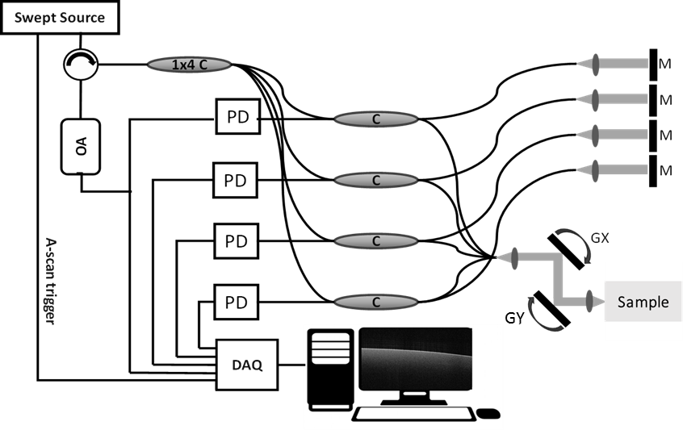

**Supplementary Figure 1.** Schematic diagram of the Michelson Diagnostics TM multi-beam SS-OCT; SS-OCT: swept-source OCT, M: mirror, C: optical coupler, PD: photodetector, OA: optical attenuator, DAQ: data acquisition, GX: x-axis galvanometer, GY: y-axis galvanometer.

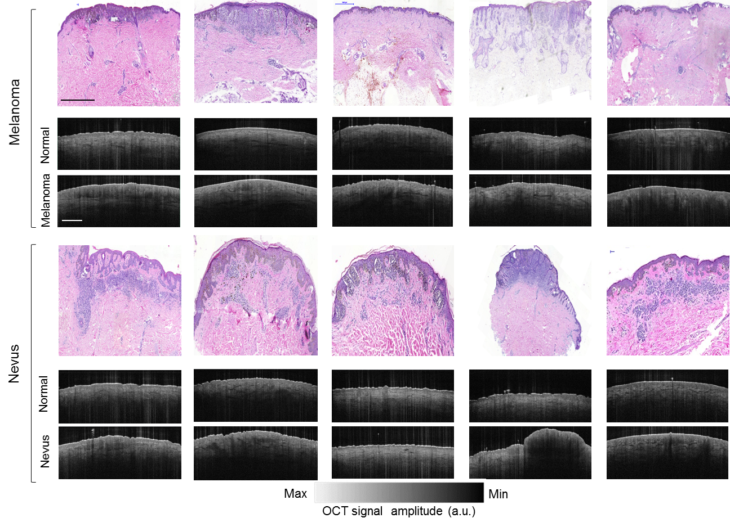

**Supplementary Figure 2.** Histologic photographs and OCT images of five selected melanoma cases and five nevus cases. All of these datasets contain both normal and abnormal parts. The scale bar shown in the histology images and the OCT images is 1 mm.

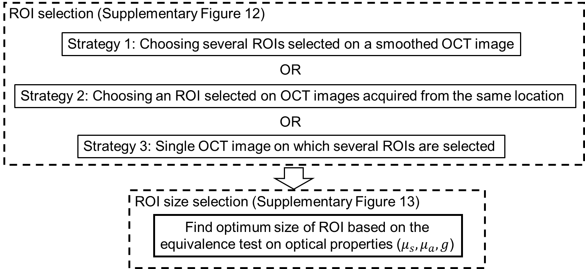

**Supplementary Figure 3.** Pre-processing procedure optimization.

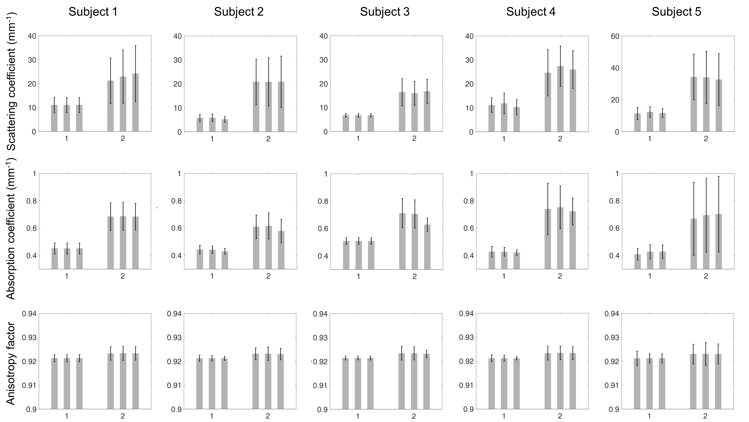

**Supplementary Figure 4.** Scattering coefficients, absorption coefficients, and anisotropy factors of five melanoma (“2”) cases and their nearby healthy (“1”) skin (calculated from 3 consecutive OCT slices).

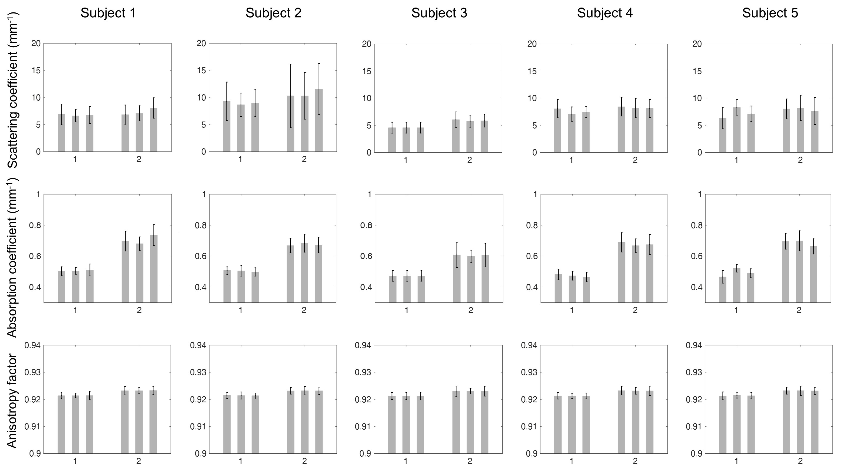

**Supplementary Figure 5.** Scattering coefficients, absorption coefficients, and anisotropy factors of five benign nevi (“2”) cases and their nearby normal (“1”) skins (calculated from 3 consecutive OCT slices).

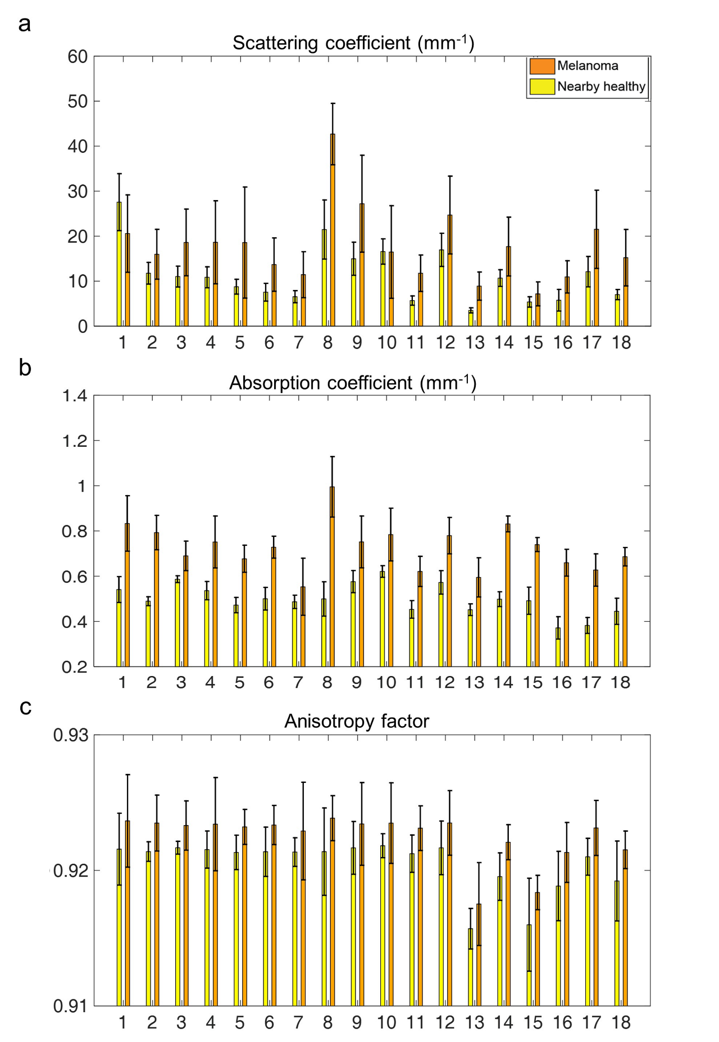

**Supplementary Figure 6.** Scattering coefficients, absorption coefficients and anisotropy factors of melanoma cases and their nearby normal skin for the remaining 18 cases not shown in Figure 3. (a) Scattering coefficients, (b) absorption coefficients, (c) anisotropy factor.

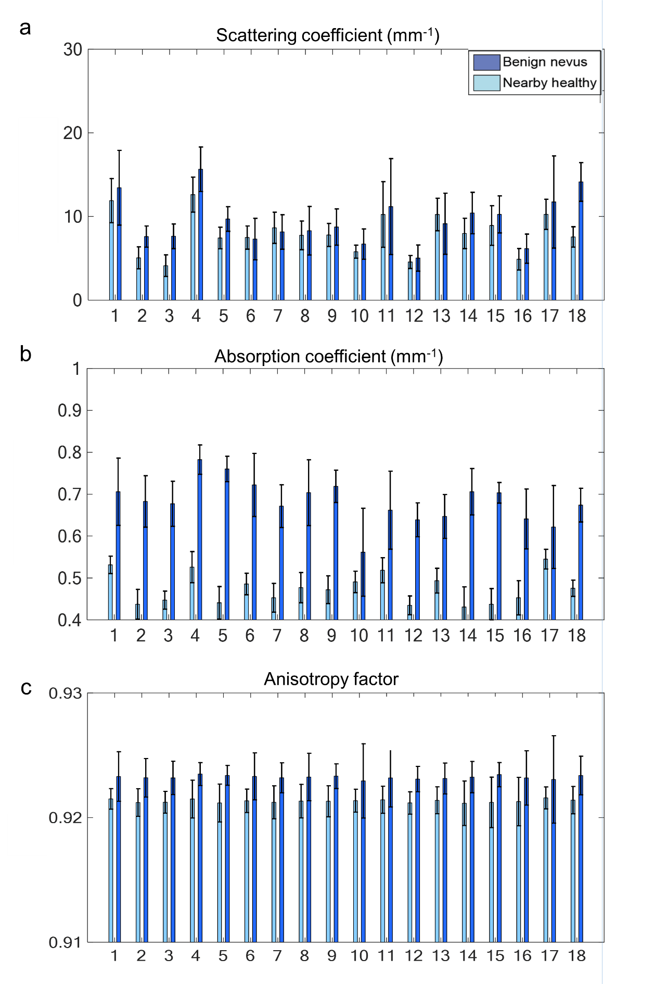

**Supplementary Figure 7.** Scattering coefficients, absorption coefficients and anisotropy factors of benign nevi cases and their nearby normal skin for the remaining 18 cases not shown in Figure 3. (a) Scattering coefficients, (b) absorption coefficients, (c) anisotropy factor.

**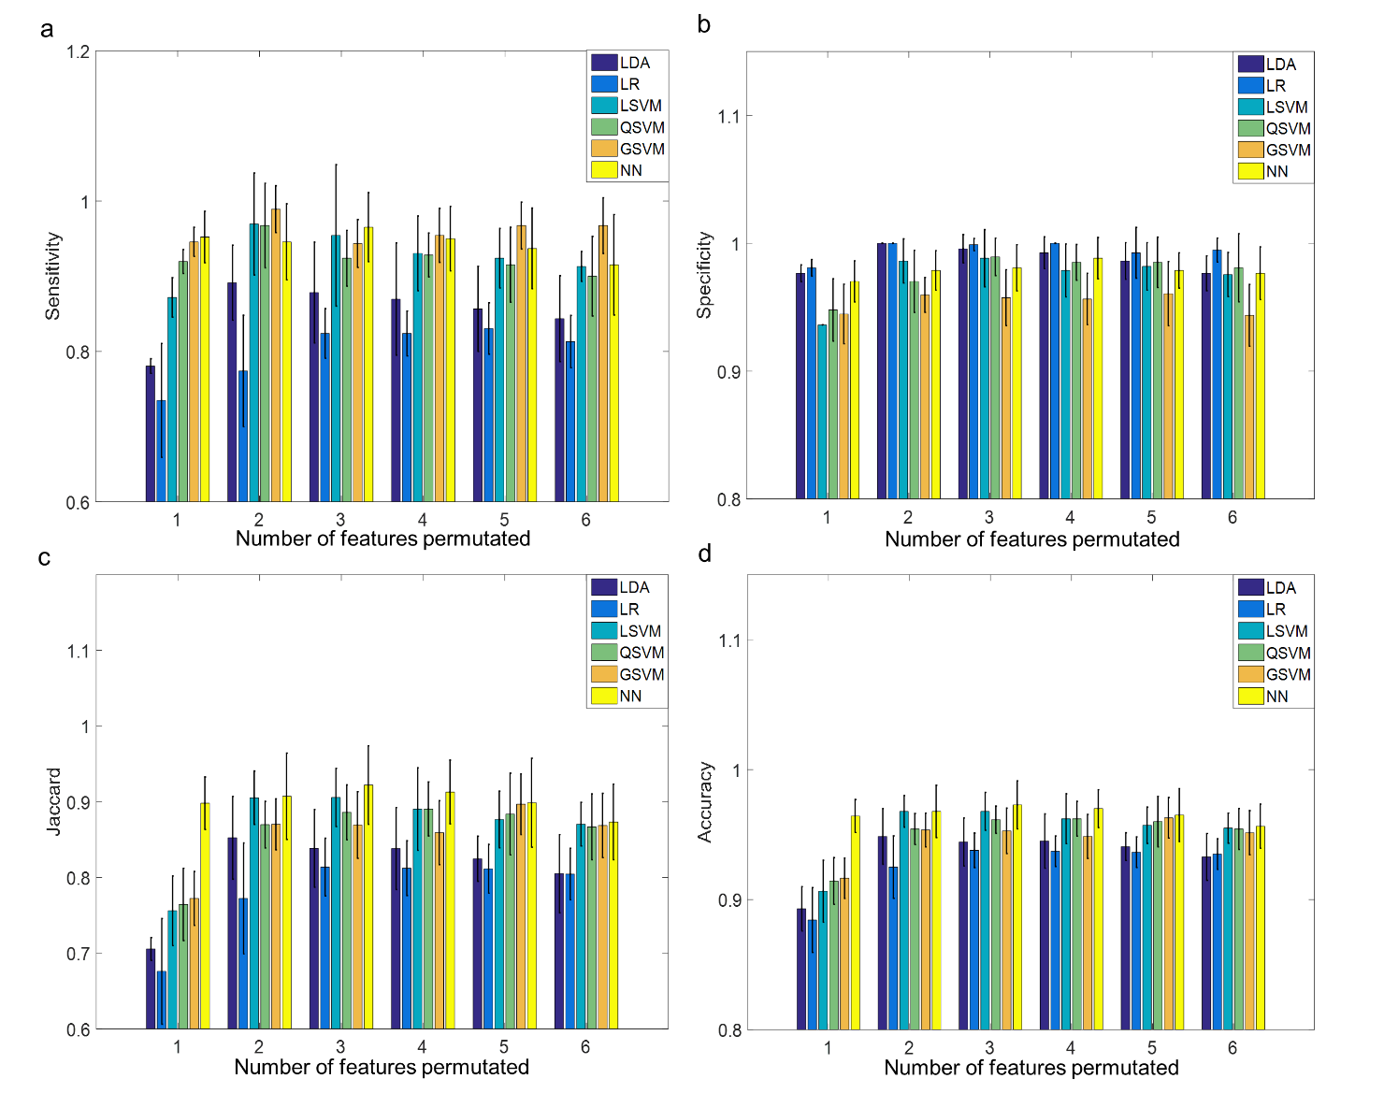**

**Supplementary Figure 8.** Classifier and feature selection optimization. The best (a) sensitivity, (b) specificity, (c) Jaccard index, and (d) accuracy for various feature combinations using each classifier. LDA: linear discriminant analysis, LR: linear regression, LSVM: linear support vector machine, QSVM: quadratic support vector machine, GSVM: Gaussian support vector machine, and NN: nearest neighbor.

**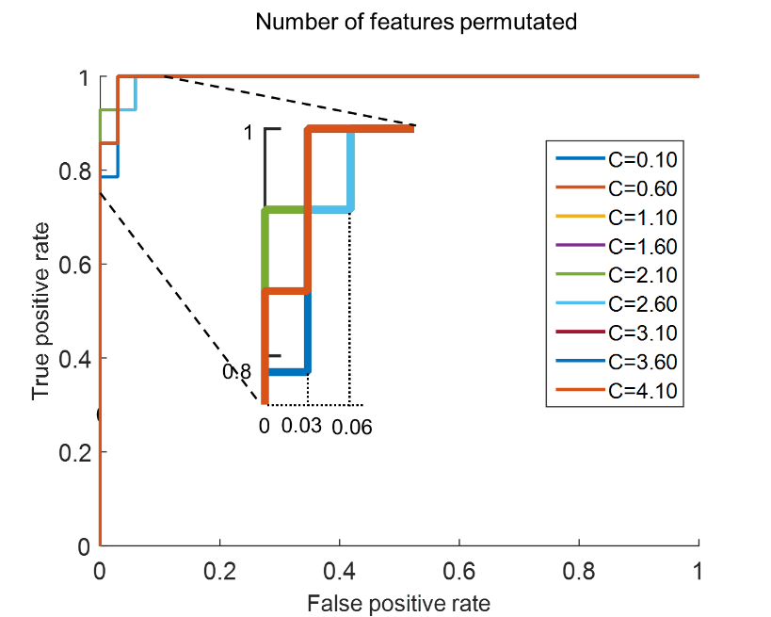**

**Supplementary Figure 9.** ROC curve for sample margin factors in GSVM. Margin factors from 0 to 4 with steps 0.1 have been evaluated. ROC: receiver operating characteristic, GSVM: Gaussian support vector machine.

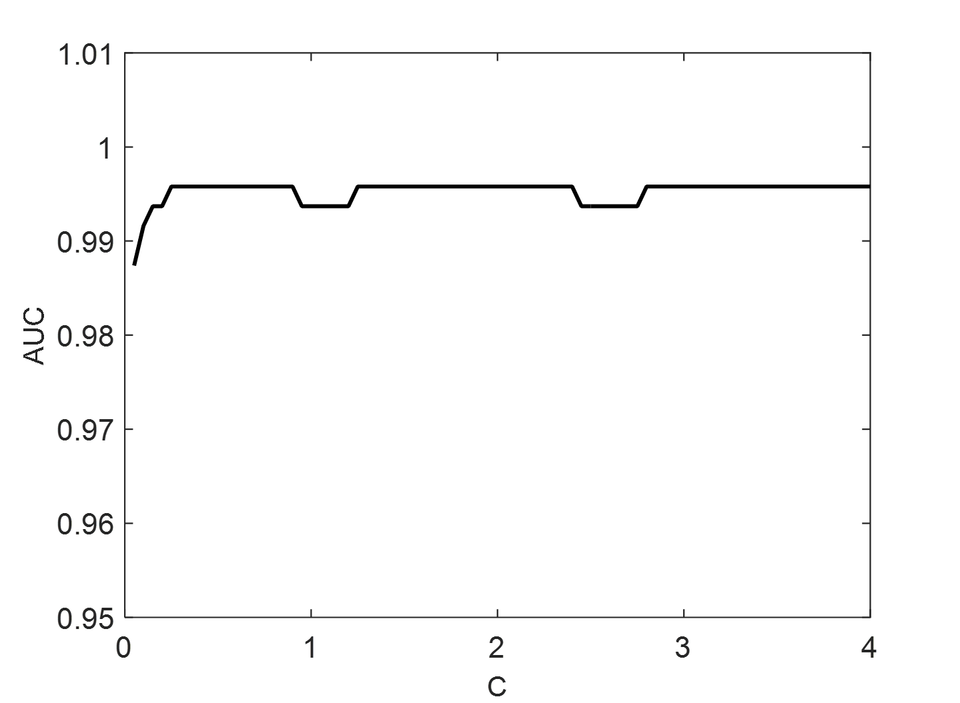

**Supplementary Figure 10.** AUC for selected margin factors when GSVM classifier was used. AUC: area under the curve, GSVM: Gaussian support vector machine.



**Supplementary Figure 11.** Absorption coefficients with linearized X-axis (presented in Figure 2 (g) in the main text). The concentration of milk in all these experiments was 5%.

C:\Users\mrn.avanaki\Downloads\fig2_1.tif

**Supplementary Figure 12.** Evaluation of three pre-processing methodologies using by a series of OCT images of the milk phantom. X-axis shows the concentration of milk diluted by water. (a) Smoothed OCT image on which several ROIs are specified, (b) an ROI located at the same place in all the images collected from the same place in the sample, (c) an OCT image of the milk phantom on which several ROIs are specified. (d), (g), (j) and (m) scattering coefficient, absorption coefficient, anisotropy factor and corresponding fitting error for the preprocessing Strategy #1. (e), (h), (k) and (n) scattering coefficient, absorption coefficient, anisotropy factor and corresponding fitting error for the preprocessing Strategy #2. (f), (i), (l) and (o) scattering coefficient, absorption coefficient, anisotropy factor and corresponding fitting error for the preprocessing Strategy #3. The equivalence test resulted *p* <0.05 for all corresponding pairs of optical properties for all three strategies.

*C:\Users\mrn.avanaki\Dropbox\Rayyan Manwar\Radiomic signatures\Figure 3\fig3.tif*

**Supplementary Figure 13.** Optimization of the size of the ROI. (a) An OCT image of a dorsal hand sample on which five example scenarios are depicted in each white box, (b) scattering coefficients, (c) absorption coefficients, and (d) anisotropy factor, of ROIs of various widths and overlaps. W: width, O: overlap.

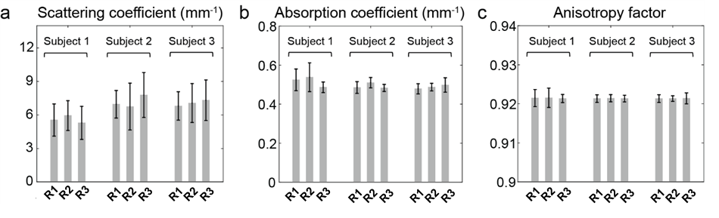

**Supplementary Figure 14.** (a) Scattering coefficients, (b) absorption coefficients, and (c) anisotropy factors of three adjacent regions (R1, R2 and R3) on the forearm of three subjects (10 mm distant).

.

**Tables**

**Supplementary Table 1.** Percentages of milk, ink and water in milk and milk-ink phantoms. The information in the table correspond to the phantoms in Figure 2 from left to right.

|  |  |  |  |  |  |  |  |  |  |  |  |
| --- | --- | --- | --- | --- | --- | --- | --- | --- | --- | --- | --- |
| Milk (%) | 100 | 80 | 60 | 40 | 20 | 5 | 5 | 5 | 5 | 5 | 5 |
| Ink (%) | 0 | 0 | 0 | 0 | 0 | 0 | 0.1 | 0.5 | 1 | 2 | 3 |
| Distilled Water (%) | 0 | 20 | 40 | 60 | 80 | 95 | 94.9 | 94.5 | 94 | 93 | 92 |

**Supplementary Table 2.** List of melanoma and benign nevus cases used in this study. The images were obtained at the AC Camargo Cancer Center in Brazil. F: Female, M: Male, UL: Upper limbs, LL: Lower limbs, HN: Head and Neck, and T: Trunk.

|  |  |  |  |  |  |
| --- | --- | --- | --- | --- | --- |
| **Type** | **Case number** | **gender** | **age** | **Location** | **Details** |
| **Melanoma** | 1 | M | 78 | UL | Melanoma *in situ* |
| 2 | F | 52 | UL | Melanoma *in situ* |
| 3 | M | 61 | LL | Superficial Spreading melanoma, Breslow 0.49 mm - no mitoses, no ulceration |
| 4 | F | 72 | UL | Superficial spreading melanoma, Breslow 1.00 mm, 1 mitose, no ulceration |
| 5 | M | 45 | LL | Superficial spreading melanoma, Breslow 0.25, no mitoses, no ulceration |
| 6 | M | 48 | LL | Melanoma *in situ* |
| 7 | F | 33 | T | Superficial spreading melanoma, Breslow 1.30 mm, 1 mitose, no ulceration |
| 8 | M | 86 | HN | Superficial Spreading Melanoma, Breslow 5.50 mm, 10 mitoses, no ulceration |
| 9 | M | 26 | T | Superficial Spreading Melanoma, Breslow 2.49mm, 8 mitoses. Associated Nevi, no ulceration |
| 10 | F | 26 | T | Superficial Spreading Melanoma, Breslow 0.20 mm, no mitoses, no ulceration |
| 11 | M | 96 | T | Superficial Spreading Melanoma, Breslow 1.42, no mitoses, no ulceration |
| 12 | F | 42 | T | Superficial Spreading Melanoma, Breslow 2.15mm, 7 mitoses, no ulceration |
| 13 | F | 60 | UL | Amelanotic melanoma, superficial spreading, Breslow 1.80 mm, 2 mitoses, ulceration present |
| 14 | F | 62 | HN | Melanoma *in situ* |
| 15 | M | 66 | LL | Superficial Spreading Melanoma, Breslow 2.20 mm, 23 mitoses, ulceration present |
| 16 | M | 65 | T | Melanoma *in situ* |
| 17 | M | 71 | LL | Superficial Spreading Melanoma, Breslow 0.56, 1 mitose, no ulceration |
| 18 | F | 59 | LL | Melanoma *in situ* |
| 19 | M | 43 | LL | Melanoma *in situ* |
| 20 | F | 50 | LL | Melanoma *in situ* |
| 21 | M | 32 | HN | Melanoma *in situ* |
| 22 | F | 59 | HN | Superficial Spreading Melanoma, Breslow 0.48mm 1 mitose, no ulceration |
| 23 | F | 41 | T | Superficial Spreading melanoma, Breslow 1.00 mm, 1 mitose, no ulceration |
| **Nevi** | 1 | M | 46 | UL |  |
| 2 | F | 24 | LL |  |
| 3 | M | 26 | LL |  |
| 4 | F | 25 | LL |  |
| 5 | M | 26 | LL |  |
| 6 | M | 67 | LL |  |
| 7 | F | 49 | LL |  |
| 8 | M | 38 | LL |  |
| 9 | F | 55 | LL |  |
| 10 | M | 53 | LL |  |
| 11 | M | 29 | LL |  |
| 12 | M | 43 | LL |  |
| 13 | M | 26 | LL |  |
| 14 | F | 48 | LL |  |
| 15 | F | 30 | LL |  |
| 16 | F | 61 | LL |  |
| 17 | F | 62 | LL |  |
| 18 | F | 40 | LL |  |
| 19 | M | 60 | LL |  |
| 20 | M | 45 | T |  |
| 21 | F | 78 | LL |  |
| 22 | F | 30 | LL |  |
| 23 | M | 48 | LL |  |
| **Normal** | 1 | M | 20-35 | UL |  |
| 2 | F | 20-35 | UL |  |
| 3 | F | 20-35 | UL |  |
| 4 | F | 20-35 | UL |  |
| 5 | M | 20-35 | UL |  |
| 6 | F | 20-35 | UL |  |
| 7 | M | 20-35 | UL |  |
| 8 | M | 20-35 | UL |  |
| 9 | F | 20-35 | UL |  |
| 10 | M | 20-35 | UL |  |
| 11 | F | 20-35 | UL |  |
| 12 | M | 20-35 | UL |  |
| 13 | F | 20-35 | UL |  |
| 14 | F | 20-35 | UL |  |
| 15 | M | 20-35 | UL |  |
| 16 | M | 20-35 | UL |  |
| 17 | F | 20-35 | UL |  |
| 18 | F | 20-35 | UL |  |
| 19 | F | 20-35 | UL |  |
| 20 | M | 65-75 | UL |  |
| 21 | M | 20-35 | UL |  |
| 22 | M | 20-35 | UL |  |
| 23 | M | 20-35 | UL |  |

**Supplementary Table 3.** Definitions of diagnostic statistics including sensitivity, specificity, Jaccard index and accuracy. TP: true positive, TN: true negative, FP: false positive and FN: false negative

|  |  |
| --- | --- |
| Statistic | Formula |
| Sensitivity |  |
| Specificity |  |
| Jaccard index |  |
| Accuracy |  |

**Supplementary Table 4.** An example of the best sensitivity, specificity, Jaccard index and accuracy for combinations of four features.

|  |  |  |  |  |  |
| --- | --- | --- | --- | --- | --- |
| Feature combination | Classifier | Sensitivity | Specificity | Jaccard Index | Accuracy |
| [010111] | LDA | 0.87±0.07 |  |  |  |
| [011110] | LDA |  | 0.99±0.01 |  |  |
| [101110] | LDA |  |  | 0.84±0.05 |  |
| [101101] | LR | 0.82±0.03 |  | 0.81±0.04 |  |
| [011110] | LR |  | 1.0±0.0 |  | 0.94±0.01 |
| [111100] | LSVM | 0.93±0.05 |  | 0.89±0.05 | 0.96±0.02 |
| [001111] | LSVM |  | 0.98±0.02 |  |  |
| [111100] | QSVM | 0.93±0.03 | 0.98±0.02 |  | 0.96±0.01 |
| [011101] | QSVM |  | 0.99±0.01 | 0.85±0.07 | 0.95±0.03 |
| [101110] | GSVM | 0.95±0.04 |  |  |  |
| [110110] | GSVM |  | 0.96±0.02 |  |  |
| [101101] | GSVM |  |  | 0.86±0.04 | 0.95±0.02 |
| [101101] | NN | 0.95±0.04 |  | 0.91±0.04 | 0.97±0.01 |
| [110101] | NN |  | 0.99±0.02 |  |  |

**Supplementary Table 5.** Optimum selection of classifier and feature combinations to achieve the optimum sensitivity, specificity, Jaccard index and accuracy, individually; the best sensitivity (row 1); the best specificity (row 2); the best Jaccard index (row 3); the best accuracy (row 4); statistical results when GSVM with a margin factor of 1 (row 5) and 2.1 (row 6) was used. The binary numbers in “Feature combination” column show if that feature has been used, “1” or not, “0”.

|  |  |  |  |  |  |  |
| --- | --- | --- | --- | --- | --- | --- |
| Row | Feature combination | Classifier | Sensitivity | Specificity | Jaccard Index | Accuracy |
| 1 | [011000] | GSVM (C=1) | 0.99±0.03 |  |  |  |
| 2 | [001100] | LDA |  | 1±0.0 |  |  |
| 3 | [110100] | NN |  |  | 0.92±0.05 |  |
| 4 | [110100] | NN |  |  |  |  |
| 5 | [111110] | GSVM (C=1) |  |  |  |  |
| 6 | [111110] | GSVM (C=2.1) |  |  |  |  |

**Supplementary Table 6.** Relation between the concentration of scatterers and their scattering coefficients.

|  |  |  |  |
| --- | --- | --- | --- |
| **Concentration (spheres per cubic micron)** | **Cell size (micron)** | **Scattering coefficient (mm-1)** | **Anisotropy factor** |
| 0.0001 | 6 | 5.8555 | 0.74169 |
| 0.0002 | 6 | 11.711 | 0.74169 |
| 0.0003 | 6 | 17.566 | 0.74169 |

**Supplementary Table 7.** Relation between the particle size and their anisotropy factor.

|  |  |  |  |
| --- | --- | --- | --- |
| **Concentration (spheres per cubic micron)** | **Cell size (micron)** | **Scattering coefficient (mm-1)** | **Anisotropy factor** |
| 0.0001 | 6 | 5.8555 | 0.74169 |
| 0.0001 | 16 | 48.095 | 0.85191 |
| 0.0001 | 26 | 114.82 | 0.85669 |

**Supplementary Table 8.** Relation between the concentration of absorbers and absorption coefficient.

|  |  |  |
| --- | --- | --- |
| **Concentration (spheres per cubic micron)** | **Cell size (micron)** | **Absorption coefficient (mm-1)** |
| 0.0001 | 6 | 0.0123 |
| 0.0002 | 6 | 0.0246 |
| 0.0003 | 6 | 0.0369 |

**References:**

[1] *Oregon medical laser center website*. Available: https://omlc.org/

[2] C. F. Bohren and D. R. Huffman, *Absorption and scattering of light by small particles*: John Wiley & Sons, 2008.

[3] *Oregon medical laser center website*. Available: <http://omlc.org/calc/mie_calc.html>