Supporting Information
Label-free Raman spectroscopy reveals signatures of radiation resistance in the tumor microenvironment
Santosh K. Paidi,^{a,}* Paola Monterroso Diaz,^{b,}* Sina Dadgar,^{b,}* Samir V. Jenkins,^{c} Charles M. Quick,^{d} Robert J. Griffin,^{c} Ruud P.M. Dings,^{c} Narasimhan Rajaram,^{b} and Ishan Barman^{a,e, f}
ªDepartment of Mechanical Engineering, Johns Hopkins University, Baltimore, MD, 21218
^{b}Department of Biomedical Engineering, University of Arkansas, Fayetteville, AR, 72701
^{c}Division of Radiation Oncology, University of Arkansas for Medical Sciences, Little Rock, AR, 72205
^{d}Division of Pathology, University of Arkansas for Medical Sciences, Little Rock, AR, 72205
^{e}Department of Oncology, The Johns Hopkins University School of Medicine, Baltimore, MD, 21287
^{f}The Russell H. Morgan Department of Radiology and Radiological Science, The Johns Hopkins University School of Medicine, Baltimore, Maryland, 21287
*These authors contributed equally to this work.
Running title: Decoding radiation resistance with Raman spectroscopy
Corresponding authors:
Narasimhan Rajaram, Email: nrajaram@uark.edu
University of Arkansas, Department of Biomedical Engineering, 700 W. Research Center Blvd., Fayetteville, AR 72701, USA
Ishan Barman, Email: ibarman@jhu.edu
Mailing address: Johns Hopkins University, Department of Mechanical Engineering, 3400 N Charles St, Latrobe 103, Baltimore, MD 21218, USA
Conflict of interest: The authors disclose no potential conflicts of interest.
Fig. SF1: Tumor growth assays in response to radiation therapy for the A. HNSCC tumors and B. Lung tumors. Tumors in the XT group were radiated using the radiation schedule described in the methods section (4 x 2 Gy) at tumor volumes between 100 – 200 mm³. NT groups received sham radiation. There were significant differences in tumor volume between NT and XT groups in the UM-SCC-22B and A549 tumors. Differences in tumor volume were evaluated 35-50 days post-treatment. * indicates significant differences at p < 0.05.

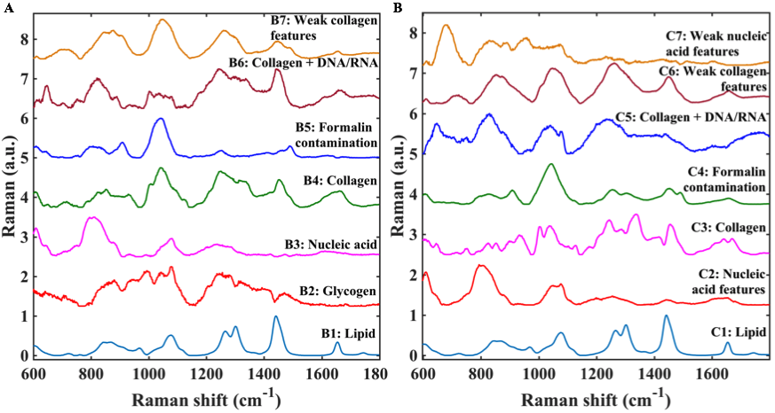
Figure SF2. The complete set of MCR-derived pure component spectra are provided here for – (A) lung tumor, and (B) head and neck tumor datasets. The biological components of interest, whose pure spectra resembles those obtained through MCR-ALS analysis, are identified and marked alongside the spectra.
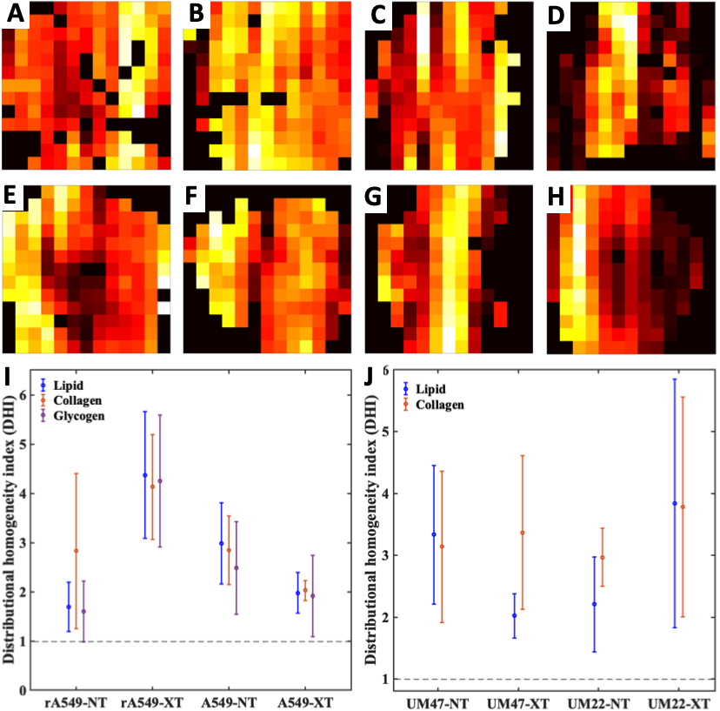

Figure SF3. Heterogeneity in biochemical composition of tumors. Top (A–D) and middle (E–H) panels display representative MCR-ALS score maps of glycogen-rich and lipid-rich loadings respectively in lung and HN tumors. The columns of panels from left to right - (A and E), (B and F), (C and G) and (D and H), respectively, represent fields of view from tumors belonging to the treatment groups - RR-NT, RR-XT, RS-NT and RS-XT, where RR and RS are the radiation resistant and radiation sensitive groups respectively. Each pixel in the images in panels A-F spans an area of 1mm x 1mm. The bottom (I and J) panels show distributional homogeneity index plots calculated using relevant MCR-ALS loading score maps for tumors in lung and HN tumor datasets, respectively.
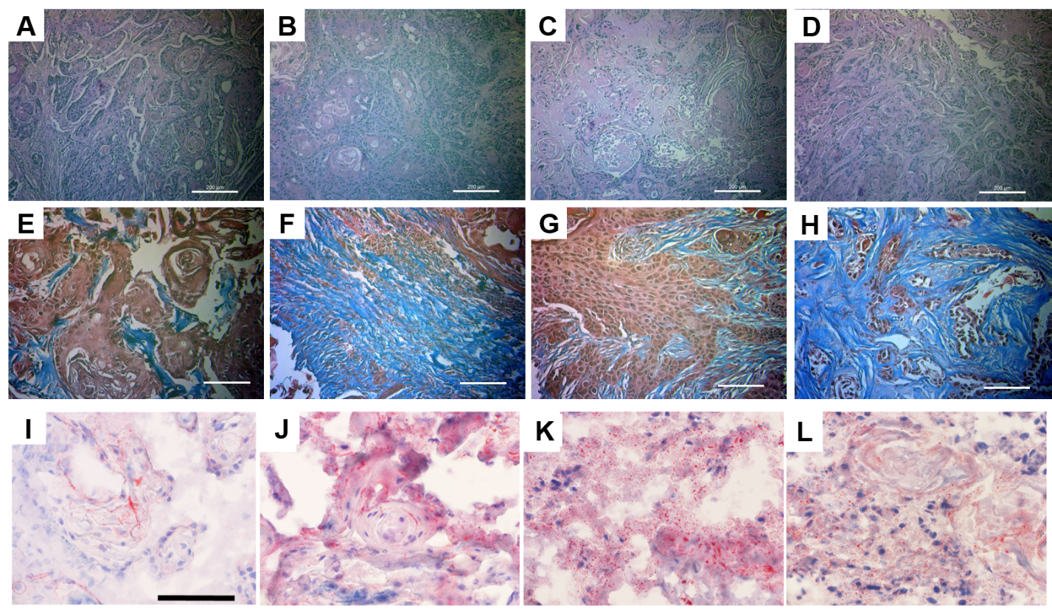
Figure SF4. Histologic assessment for head and neck tumor dataset. Top (A–D), middle (E–H) and bottom (I–L) panels display representative microscopic images of H&E, Masson's trichrome, and Oil Red O stained slides, respectively. The columns of panels from left to right - (A and I), (B and F), (C and G) and (D and H), respectively, represent fields of view from tumors belonging to the treatment groups – UM22-NT, UM22-XT, UM47-NT and UM47-XT. The scale bars in panels A-D represent 200 µm and panels E-L represent 100 µm.

Table TS1. Table listing the peak assignments for all the MCR-derived component spectra derived from lung tumor dataset.

Observed Raman peaks in the MCR loadings (cm⁻¹) |  |  |  |  |  |  | Raman band assignment from literature
B1 | B2 | B3 | B4 | B5 | B6 | B7
 | 708 |  |  |  |  |  | Glycogen
 |  | 790 |  |  |  |  | O-P-O stretching in DNA
 |  | 812 |  |  | 816 |  | O-P-O stretching in DNA and RNA
 |  |  | 851 |  |  |  | C-C stretch of proline in collagen
 |  |  |  |  |  | 878 | C-C stretch of hydroxyproline in collagen
 |  |  |  | 908 |  |  | Formalin contamination during tissue fixation
 |  |  | 928 |  |  |  | C-C vibration in collagen backbone
 | 940 |  |  |  |  |  | Glycogen
 |  |  | 1040 |  |  |  | Proline in collagen
 |  |  |  | 1042 |  |  | Formalin contamination during tissue fixation
 | 1044 |  |  |  |  |  | Glycogen
 |  |  |  |  |  | 1047 | Proline in collagen
 | 1078 |  |  |  |  |  | Glycogen
1078 |  |  |  |  |  |  | C-C stretch
 |  | 1082 |  |  | 1080 |  | PO₂⁻ symmetric stretching in DNA
 |  | 1237 |  |  |  |  | PO₂⁻ asymmetric stretching in DNA
 |  |  |  |  | 1242 |  | Amide III in collagen
 |  |  | 1251 |  |  |  | Amide III in collagen
 |  |  |  | 1251 |  |  | Formalin contamination during tissue fixation
 | 1256 |  |  |  |  |  | Glycogen
 |  |  |  |  |  | 1259 | Amide III in collagen
1266 |  |  |  |  |  |  | CH₂ in-plane deformation (Triglyceride)
1301 |  |  |  |  |  |  | CH vibration (Triglyceride)
 | 1320 |  |  |  |  |  | Glycogen
 |  |  | 1315 |  |  |  | CH₃CH₂ twisting modes of collagen
 |  |  |  |  | 1337 |  | CH₃CH₂ wagging modes of collagen and nucleic acids
1442 |  |  |  |  |  |  | CH₂ bending mode (Triglyceride)
 |  |  | 1453 |  |  | 1448 | CH₂ bending mode in collagen
 |  |  |  | 1489 |  |  | Formalin contamination during tissue fixation
1654 |  |  |  |  |  |  | C=C lipid stretch
 |  |  | 1661 |  | 1657 | 1656 | α-helical structure of amide I in collagen

Table TS2. Table listing the peak assignments for all the MCR-derived component spectra derived from head and neck tumor dataset.
Observed Raman peaks in the MCR loadings (cm⁻¹) |  |  |  |  |  |  | Raman band assignment from literature
C1 | C2 | C3 | C4 | C5 | C6 | C7
 | 790 |  |  |  |  |  | O-P-O stretching in DNA
 | 806 |  |  |  |  |  | O-P-O stretching in DNA and RNA
 |  |  |  | 820 |  |  | O-P-O stretching in DNA and RNA
 |  | 852 |  |  |  |  | C-C stretch of proline in collagen
 |  |  |  |  | 873 |  | C-C stretch of hydroxyproline in collagen
 |  |  | 906 |  |  |  | Formalin contamination during tissue fixation
 |  | 932 |  |  |  |  | C-C vibration in collagen backbone
 |  | 1038 |  |  |  |  | Proline in collagen
 |  |  | 1042 |  |  |  | Formalin contamination during tissue fixation
 |  |  |  |  | 1047 |  | Proline in collagen
1078 |  |  |  |  |  |  | C-C stretch
 | 1076 |  |  | 1076 |  | 1074 | PO₂⁻ symmetric stretching in DNA
 |  |  |  | 1235 |  |  | Amide III in collagen
 |  | 1245 |  |  |  |  | Amide III in collagen
 |  |  | 1256 |  |  |  | Formalin contamination during tissue fixation
 |  |  |  | 1259 | 1262 |  | Amide III in collagen
1266 |  |  |  |  |  |  | CH₂ in-plane deformation (Triglyceride)
1302 |  |  |  |  |  |  | CH vibration (Triglyceride)
 |  |  | 1304 |  |  |  | Formalin contamination during tissue fixation
 |  |  |  |  |  |  | CH₃CH₂ twisting modes of collagen
 |  | 1338 |  |  |  | 1335 | CH₃CH₂ wagging modes of collagen and nucleic acids
1442 |  |  |  |  |  |  | CH₂ bending mode (Triglyceride)
 |  | 1454 |  |  | 1448 |  | CH₂ bending mode in collagen
 |  |  | 1451 |  |  |  | Formalin contamination during tissue fixation
 |  |  | 1491 |  |  |  | Formalin contamination during tissue fixation
1654 |  |  |  |  |  |  | C=C lipid stretch
 |  | 1668 |  |  | 1657 |  | α-helical structure of amide I in collagen

Table TS3. Results of binary leave-one-mouse-out SVM analysis for lung tumor dataset.
 |  | Number of mice classified accurately, unclassified and misclassified
 |  | A549-NT | A549-XT | rA549-NT | rA549-XT
Binary SVM comparisons | A549-NT  vs  A549-XT | (5+0+0)/5 | (1+2+1)/4 | - | -
 | rA549-NT  vs  rA549-XT | - | - | (5+0+0)/5 | (4+0+1)/5
 | A549-NT  vs  rA549-NT | (5+0+0)/5 | - | (3+2+0)/5 | -
 | A549-XT  vs  rA549-XT |  | (3+0+1)/4 |  | (4+1+0)/5

Table TS4. Results of binary leave-one-mouse-out SVM analysis for head and neck tumor dataset.
 |  | Number of mice classified accurately, unclassified and misclassified
 |  | UM22-NT | UM22-XT | UM47-NT | UM47-XT
Binary SVM comparisons | UM22-NT  vs  UM22-XT | (6+0+0)/6 | (7+0+0)/7 | - | -
 | UM47-NT  vs  UM47-XT | - | - | (4+5+0)/9 | (8+2+0)/10
 | UM22-NT  vs  UM47-NT | (5+1+0)/6 | - | (9+0+0)/9 | -
 | UM22-XT  vs  UM47-XT |  | (7+0+0)/7 |  | (10+0+0)/10

