Supplemental Materials:

Supplementary Figure 1.

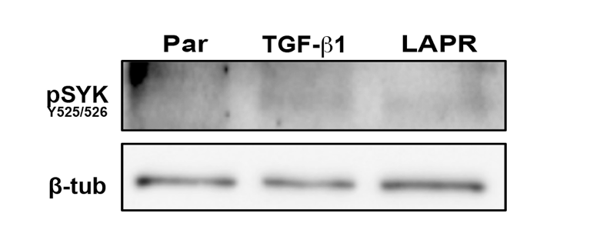
Supplementary Figure 1. Immunoblot analysis of phosphorylated SYK (pSYK) in HME2 parental, lapatinib resistant (LAPR) and TGF-β treated cells. β-tubulin was assessed as a loading control.

Supplementary Figure 2.

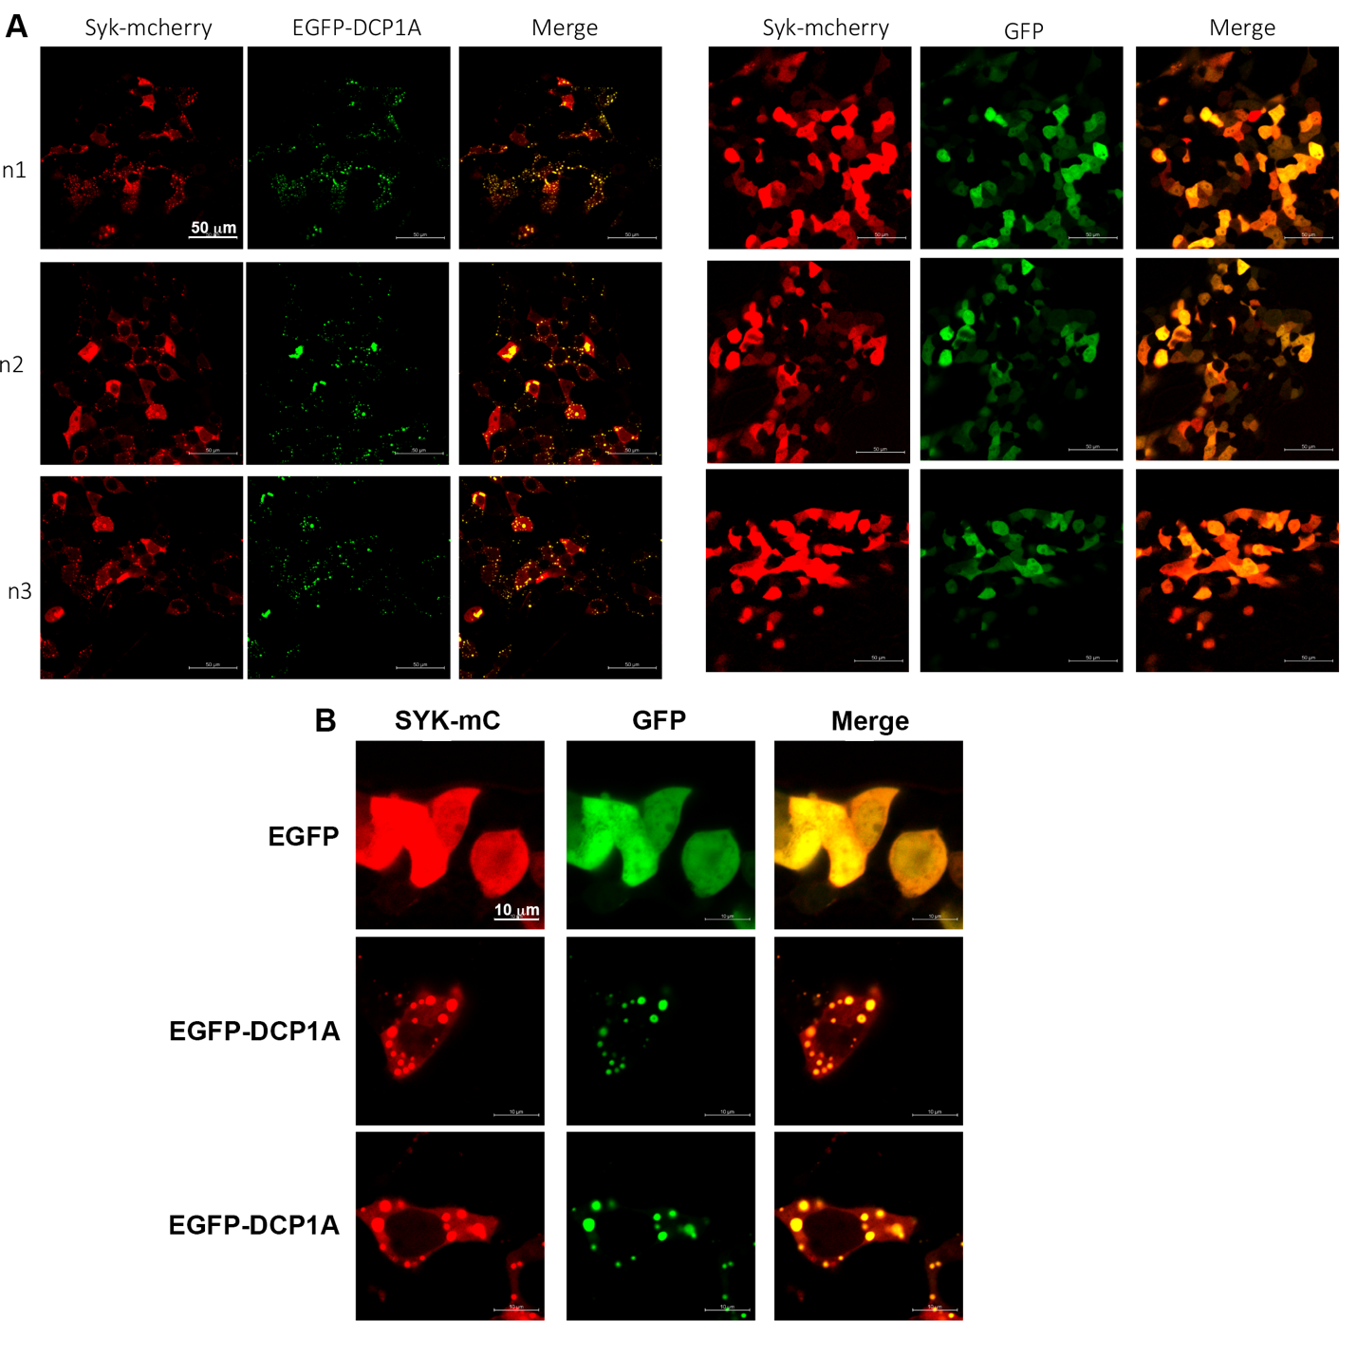
Supplementary Figure 2. SYK colocalizes with DCP1A into P-bodies. HEK293 cells were transiently transfected with SYK-mCherry (SYK-mC) and EGFP as a control or EGFP-DCP1A to induce P-body formation. Localization of SYK into P-bodies was examined by fluorescence microscopy at 60x (A) with no digital zoom (B) and with a 5x digital zoom. Several fields for each condition are shown.
Supplementary Figure 3.
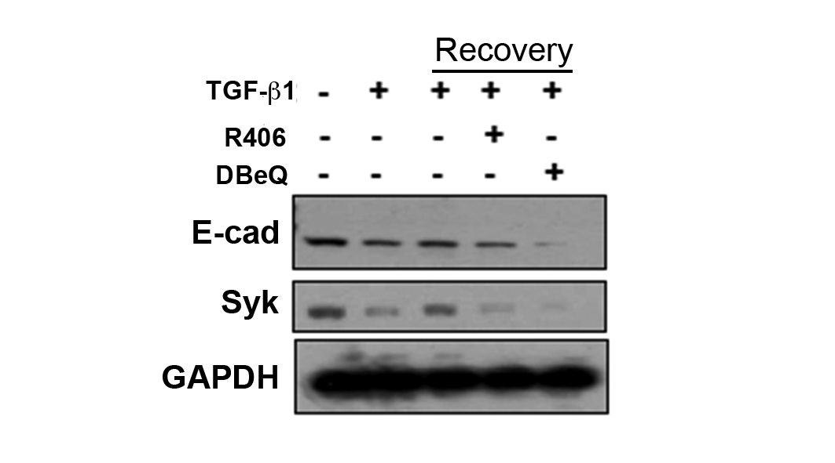
Supplementary Figure 3. HMLE cells were treated without (-) or with (+) TGF-β for 120 hours. TGF-β was removed and cells were allowed to recover (Recovery) in the presence (+) or absence (-) of R406 (2 μM) or the autophagy inhibitor DBeQ (1.25 μM) for an additional 120 hours. Cell lysates were examined by immunoblotting using antibodies against E-cadherin (E-cad) and SYK. Analysis of GAPDH served as a loading control.

Supplementary Figure 4.

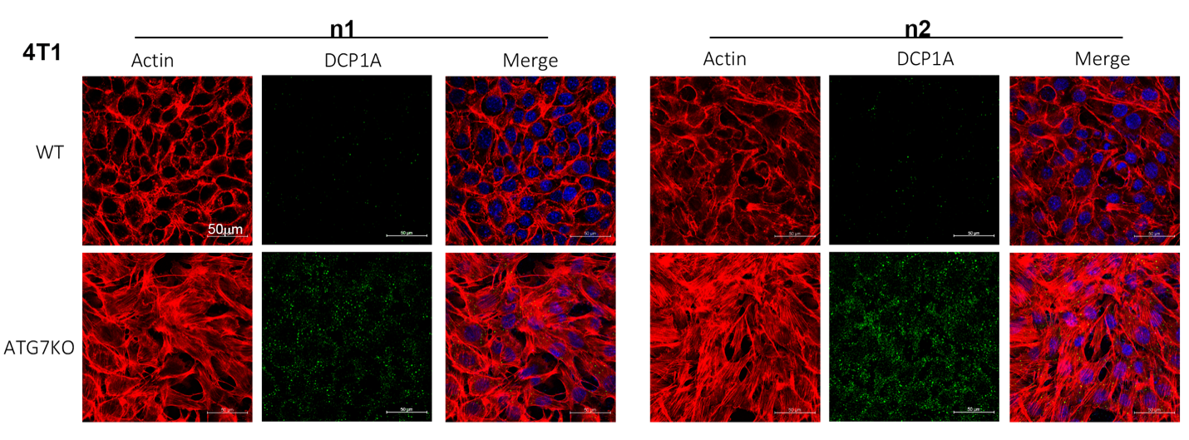
Supplementary Figure 4. Deletion of ATG7 promotes P-body accumulation and a mesenchymal phenotype. Control (WT) and ATG7 deleted (ATG7KO) 4T1 cells were stained with phalloidin to visualize differential organization of the actin cytoskeleton and DCP1A to visualize P-bodies. These cells were counterstained with DAPI to visualize the nucleus. Two separate fields for each cell condition are shown.

