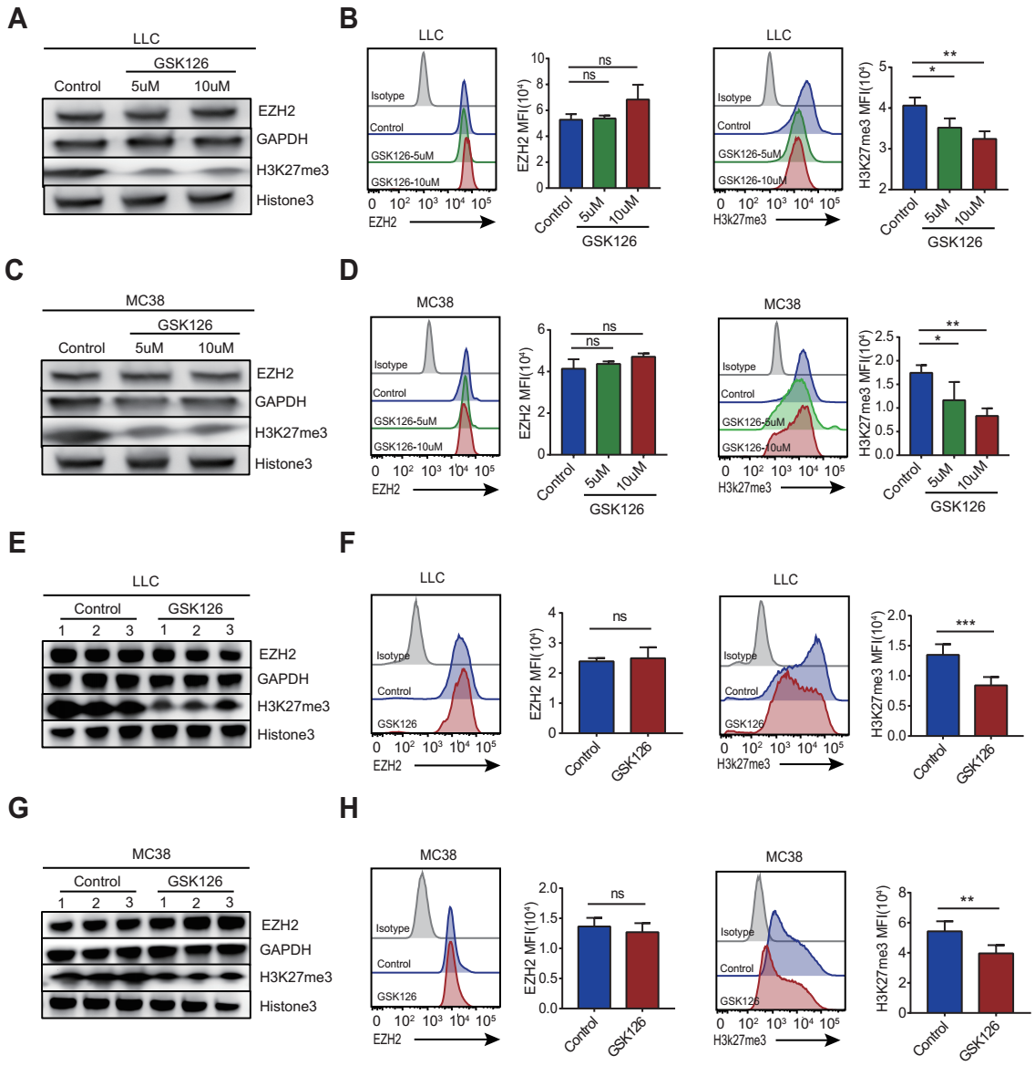

Supplementary Figure S1.
GSK126 treatment does not affect EZH2 protein levels but decreases H3K27 trimethylation in LLC and MC38 cells in vitro and in vivo. A,C, EZH2, H3K27me3, Histone3, and GAPDH levels were analyzed by immunoblotting of LLC and MC38 cells in vitro. B,D, EZH2 and H3K27me3 were analyzed by flow cytometry of LLC and MC38 cells in vitro (n=3). E,G, EZH2, H3K27me3, Histone3, GAPDH levels were analyzed by immunoblotting of tumor tissues from LLC and MC38 tumor-bearing mice (n=3). F,H, EZH2 and H3K27me3 were analyzed by flow cytometry in tumor tissues from LLC and MC38 tumor-bearing mice (n=5). One-way ANOVA with Turkey’s multiple comparison post-test (B,D) and a two-tailed unpaired Student’s t-test(F,H) was used to evaluate statistical significance (*p<0.05, **p<0.01, ***p<0.001).

