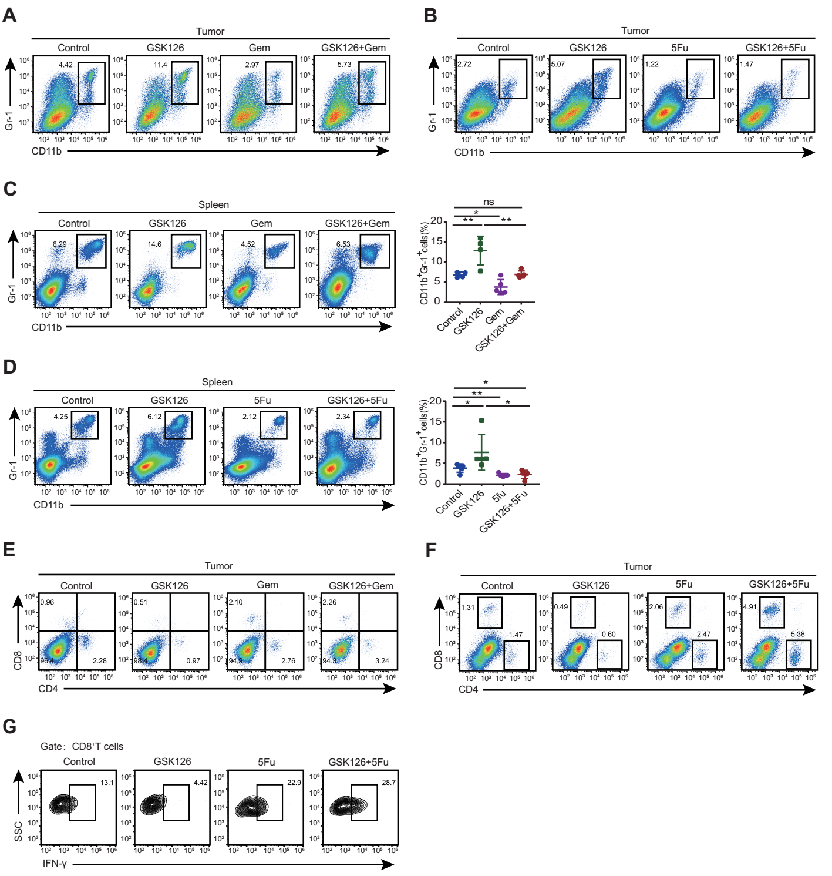

Supplementary Figure S6.
GSK126+gemcitabine/5Fu treatment leads to reduced myeloid derived suppressor cell (MDSC) numbers and increased T cell numbers and activity. A–D, Percentage of MDSCs in tumor tissues and spleen. E, F, Percentage of intratumoral CD4⁺ and CD8⁺ T cells. G, IFN-γ expression by intratumoral CD8⁺T cells. Two-way ANOVA with Turkey’s multiple comparison post-test (C,D) was used to evaluate statistical significance (*p<0.05, **p<0.01, ***p<0.001).

