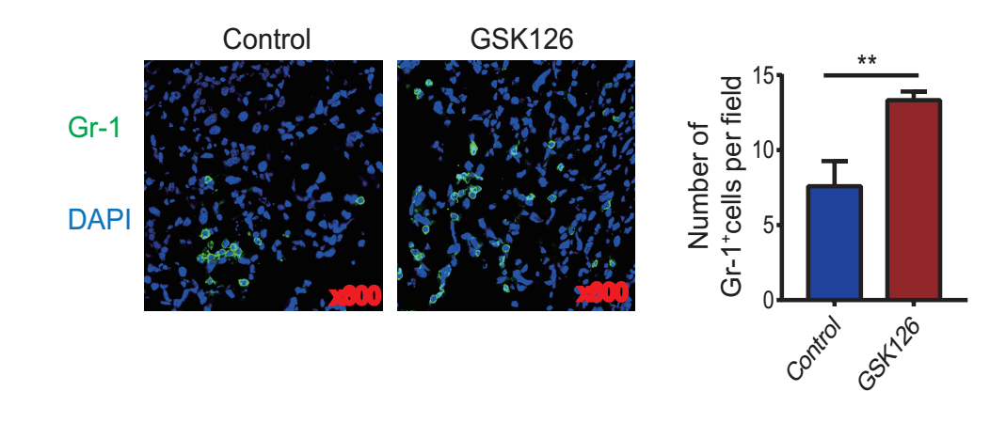

Supplementary Figure S4.
GSK126 results in accumulation of MDSCs in the TME. Immunofluorescence staining of Gr-1 in tumor tissue. Significance was assessed by two-tailed unpaired Student’s t-test, *p < 0.05, **p < 0.01, ***p < 0.001.

