SUPPLEMENTAL DATA

Assessment of tumor redox status through (S)-4-(3-[¹⁸F]fluoropropyl)-L-glutamic acid positron emission tomography imaging of system x_{c}⁻ activity

Patrick N. McCormick¹, Hannah E. Greenwood¹, Matthias Glaser², Oliver D.K. Maddocks³, Thibault Gendron², Kerstin Sander², Gayatri Gowrishankar⁴, Aileen Hoehne⁴, Tong Zhang³, Adam J. Shuhendler⁴, David Y. Lewis⁴, Mathias Berndt⁵, Norman Koglin⁵, Mark F. Lythgoe¹, Sanjiv S. Gambhir^{4,6}, Erik Årstad², Timothy H. Witney^{1,*}

SUPPLEMENTARY MATERIALS AND METHODS

Experimental reagents
All cell culture reagents, reagents for Western blot analysis, HPLC grade methanol and HPLC grade acetonitrile were purchased from ThermoFisher Scientific (UK). Sources of drugs and other experimental compounds were as follows: TBHP was purchased from Fisher Scientific; N-acetyl cysteine, diethyl maleate, rotenone, and antimycin A from Sigma-Aldrich (UK); butein and auranofin from Cambridge Bioscience (Cambridge, UK); N-ethylmaleimide, CellROX Orange, CellROX Green, and Annexin V-Alexafluor 488 from ThermoFisher Scientific (UK). The GSH/GSSG-Glo Assay, Biovision Glutamate Colorimetric Assay, and Pierce BCA Protein Assay kits were purchased from Promega (USA), Generon Ltd. (UK), and Thermofisher Scientific (UK), respectively. [¹⁸F]FDG was obtained from PETNET Solutions (UK) and [¹⁸F]fluoride for radiosynthesis from Alliance Medical (UK). Monoclonal antibodies against human p53, Casp-3, ΔCasp-3, Nrf2, system x_{c}⁻, GCL, KGA, and β-actin were purchased from Cell Signaling Technology (Netherlands).

Metabolomics measurements using liquid chromatography-mass spectrometry (LC-MS)
Cells were seeded at a density of 10.6 x10⁴ cells/cm² in 6-well plates. 24 h after seeding, fresh RPMI media was provided and the cells were either left untreated or treated with TBHP, NAC, or BOTH as described above. Following treatment, the media was aspirated and the cells were rapidly washed with PBS warmed to 37 °C (3 x 2 mL). The media was replaced with cystine-free RPMI supplemented with 200 µM [U-¹³C₆, U-¹⁵N₂]cystine in addition to TBHP, NAC or the combined treatment. Fifteen, 30 or 60 min following addition of the [U-¹³C₆, U-¹⁵N₂]cystine, media and cell samples were taken and processed for liquid chromatography-mass spectrometry (LC-MS). Cells were placed on ice and washed with ice-cold PBS (3 x 2 mL). To extract intracellular metabolites, cells were lysed (2 x10⁶ cells per ml) by scraping into a solution of 50% methanol/30% acetonitrile/20% water (v/v). For analysis of media samples 10 µL of media was diluted into 490 µL of the same lysis solution. The samples were thoroughly vortexed and centrifuged at 15,000 g, 1 °C for 10 min. The cleared supernatants were subjected to LC-MS analysis as follows: 20 µL of supernatant was injected into an Accela 600 LC system coupled to an Exactive mass spectrometer (Thermo Fisher Scientific). Chromatographic separation was performed on a Sequant ZIC-HILIC column (150 × 4.6 mm, 3.5 µm; Merck) with mobile phase A (water) and B (acetonitrile) both containing 0.1% formic acid (v/v) at a flow rate of 0.3 mL/min. A gradient elution program was used: mobile phase A increasing from 20 to 80% in 30 min, then holding A at 92% for 5 min, followed by 10 min re-equilibration with 20% A. The Exactive mass spectrometer was equipped with a heated electrospray ionization source and operated in an electrospray ionization–positive and –negative switching mode with a scan range of 70–1200 m/z at a resolution of 50,000. The obtained LC-MS raw data were converted into .mzML files with ProteoWizard and imported into MZMine 2.10 to conduct peak extraction, sample alignment, and metabolite identification. The LC-MS signals of NEM and NAC conjugates were manually extracted in MZMine 2.10. Together with the metabolites identified in our in-house database, the outcome data were exported as a .CSV file for statistical analysis using Microsoft Office Excel 2010.

Radiotracer synthesis
[¹⁸F]FSPG radiosynthesis was done in four steps and is based on solid phase extraction for purification. Briefly, [¹⁸F]fluoride (1-2 GBq, Alliance Medical UK) was extracted from target water (2 mL) using a conditioned QMA light SepPak cartridge (WAT186004051, Waters UK) and eluted with a solution of Kryptofix (8.0 mg, 21.2 µmol), potassium carbonate (1.1 mg, 8.0 µmol), acetonitrile (0.644 mL), and water (0.195 mL) into the reactor vial. After azeotropic removal of water using anhydrous acetonitrile (2× 0.5 mL), the precursor PI-021 (6.0 mg, 12.2 µmol, ABX GmbH, Radeberg, Germany) was added as solution in anhydrous acetonitrile (0.6 mL). Following heating at 80 °C for 10 minutes, a solution of sulfuric acid (2.0 mL, 1 mol/L) was added and the mixture kept at 130 °C for 4 min. The reaction temperature was lowered to 70 °C, and a solution of sodium hydroxide (1.5 mL, 4 mol/L) added. After 5 min the reaction mixture was transferred into a quenching vessel containing a solution of sulfuric acid (34 mL, 0.12 mol/L). The crude product was extracted on two MCX SepPak cartridges (WAT186003516, Waters, UK), washed with water (60 mL) and eluted with PBS (10 mL) through an Alumina light SepPak cartridge (WAT023561, Waters UK) and a Hypercarb cartridge (#10233313, Thermo Fisher UK). The product was analyzed by a radio-HPLC system [Agilent 1260 series with a variable wavelength detector and a GABI Star NaI(Tl) scintillation detector. Column: Chromolith C18 (100x4.6 mm, Merck Millipore; solvent A: H₂O (0.1 % TFA), solvent B: MeOH (0.1 % TFA), flow rate: 3 mL/min, UV detector: 314 nm, gradient: 10-90 % B in 10 min]. For UV detection, OPA reagent (10 µL, #5061-3335, Agilent UK) was incubated with the [¹⁸F]FSPG solution (40 µL) for 1 min prior to the HPLC analysis.

SUPPLEMENTARY FIGURES

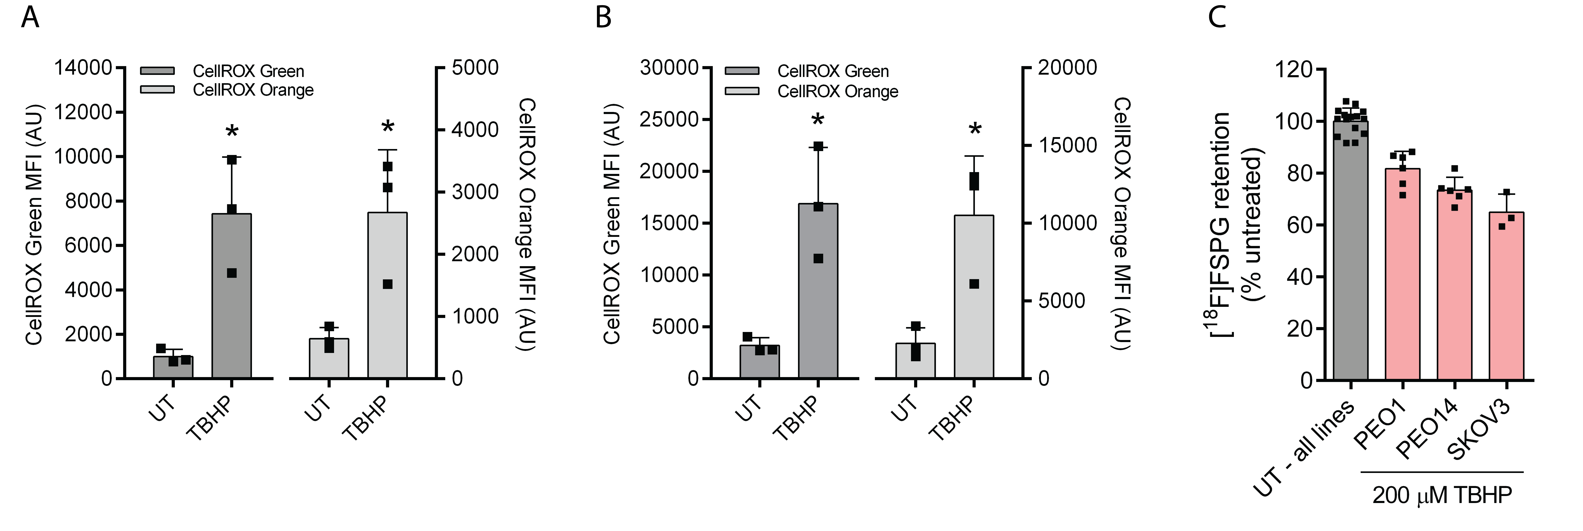
Figure S1. [¹⁸F]FSPG retention is decreased by oxidative stress in several ovarian cancer cell lines. (A-B) Flow cytometric measurement of ROS in (A) PEO1 and (B) PEO14 ovarian cancer cells using CellROX Orange and CellROX Green, following treatment with TBHP (200 μM, 1 h). Scatter plot points represent independent experiments, each performed as a single measurement. * p < 0.05, t test. (C) Effect of TBHP treatment on [¹⁸F]FSPG retention in PEO1, PEO14 and SKOV3 ovarian cancer cells. Scatter plot points represent replicate wells collected in one (SKOV3) or two (PEO1 and PEO14) independent experiments.
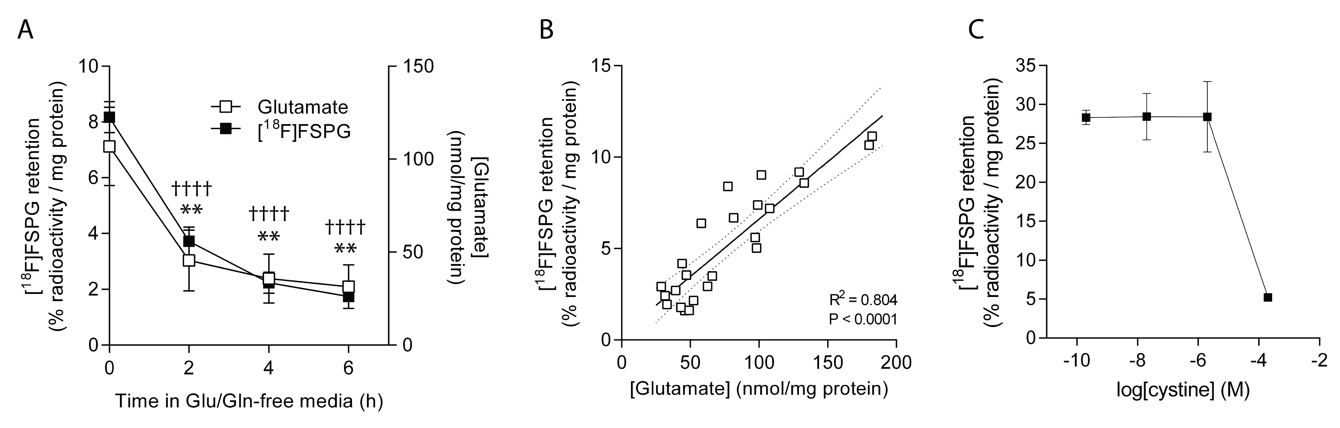
Figure S2. [¹⁸F]FSPG retention is influenced by levels of glutamate and cystine. (A) Cell-associated [¹⁸F]FSPG radioactivity after various durations of exposure to glutamine-free media, with intracellular glutamate levels determined in the same cells. Data represent the mean ± SD of three independent determinations. †††† p < 0.0001, ** p < 0.01, Bonferroni multiple comparison-corrected t test versus cells grown in glutamine-containing media. (B) Correlation between [¹⁸F]FSPG accumulation and intracellular glutamate concentration. (C) Reduction of [¹⁸F]FSPG cell retention at high concentrations of extracellular cystine. Data represent mean ± SD of three replicate wells.

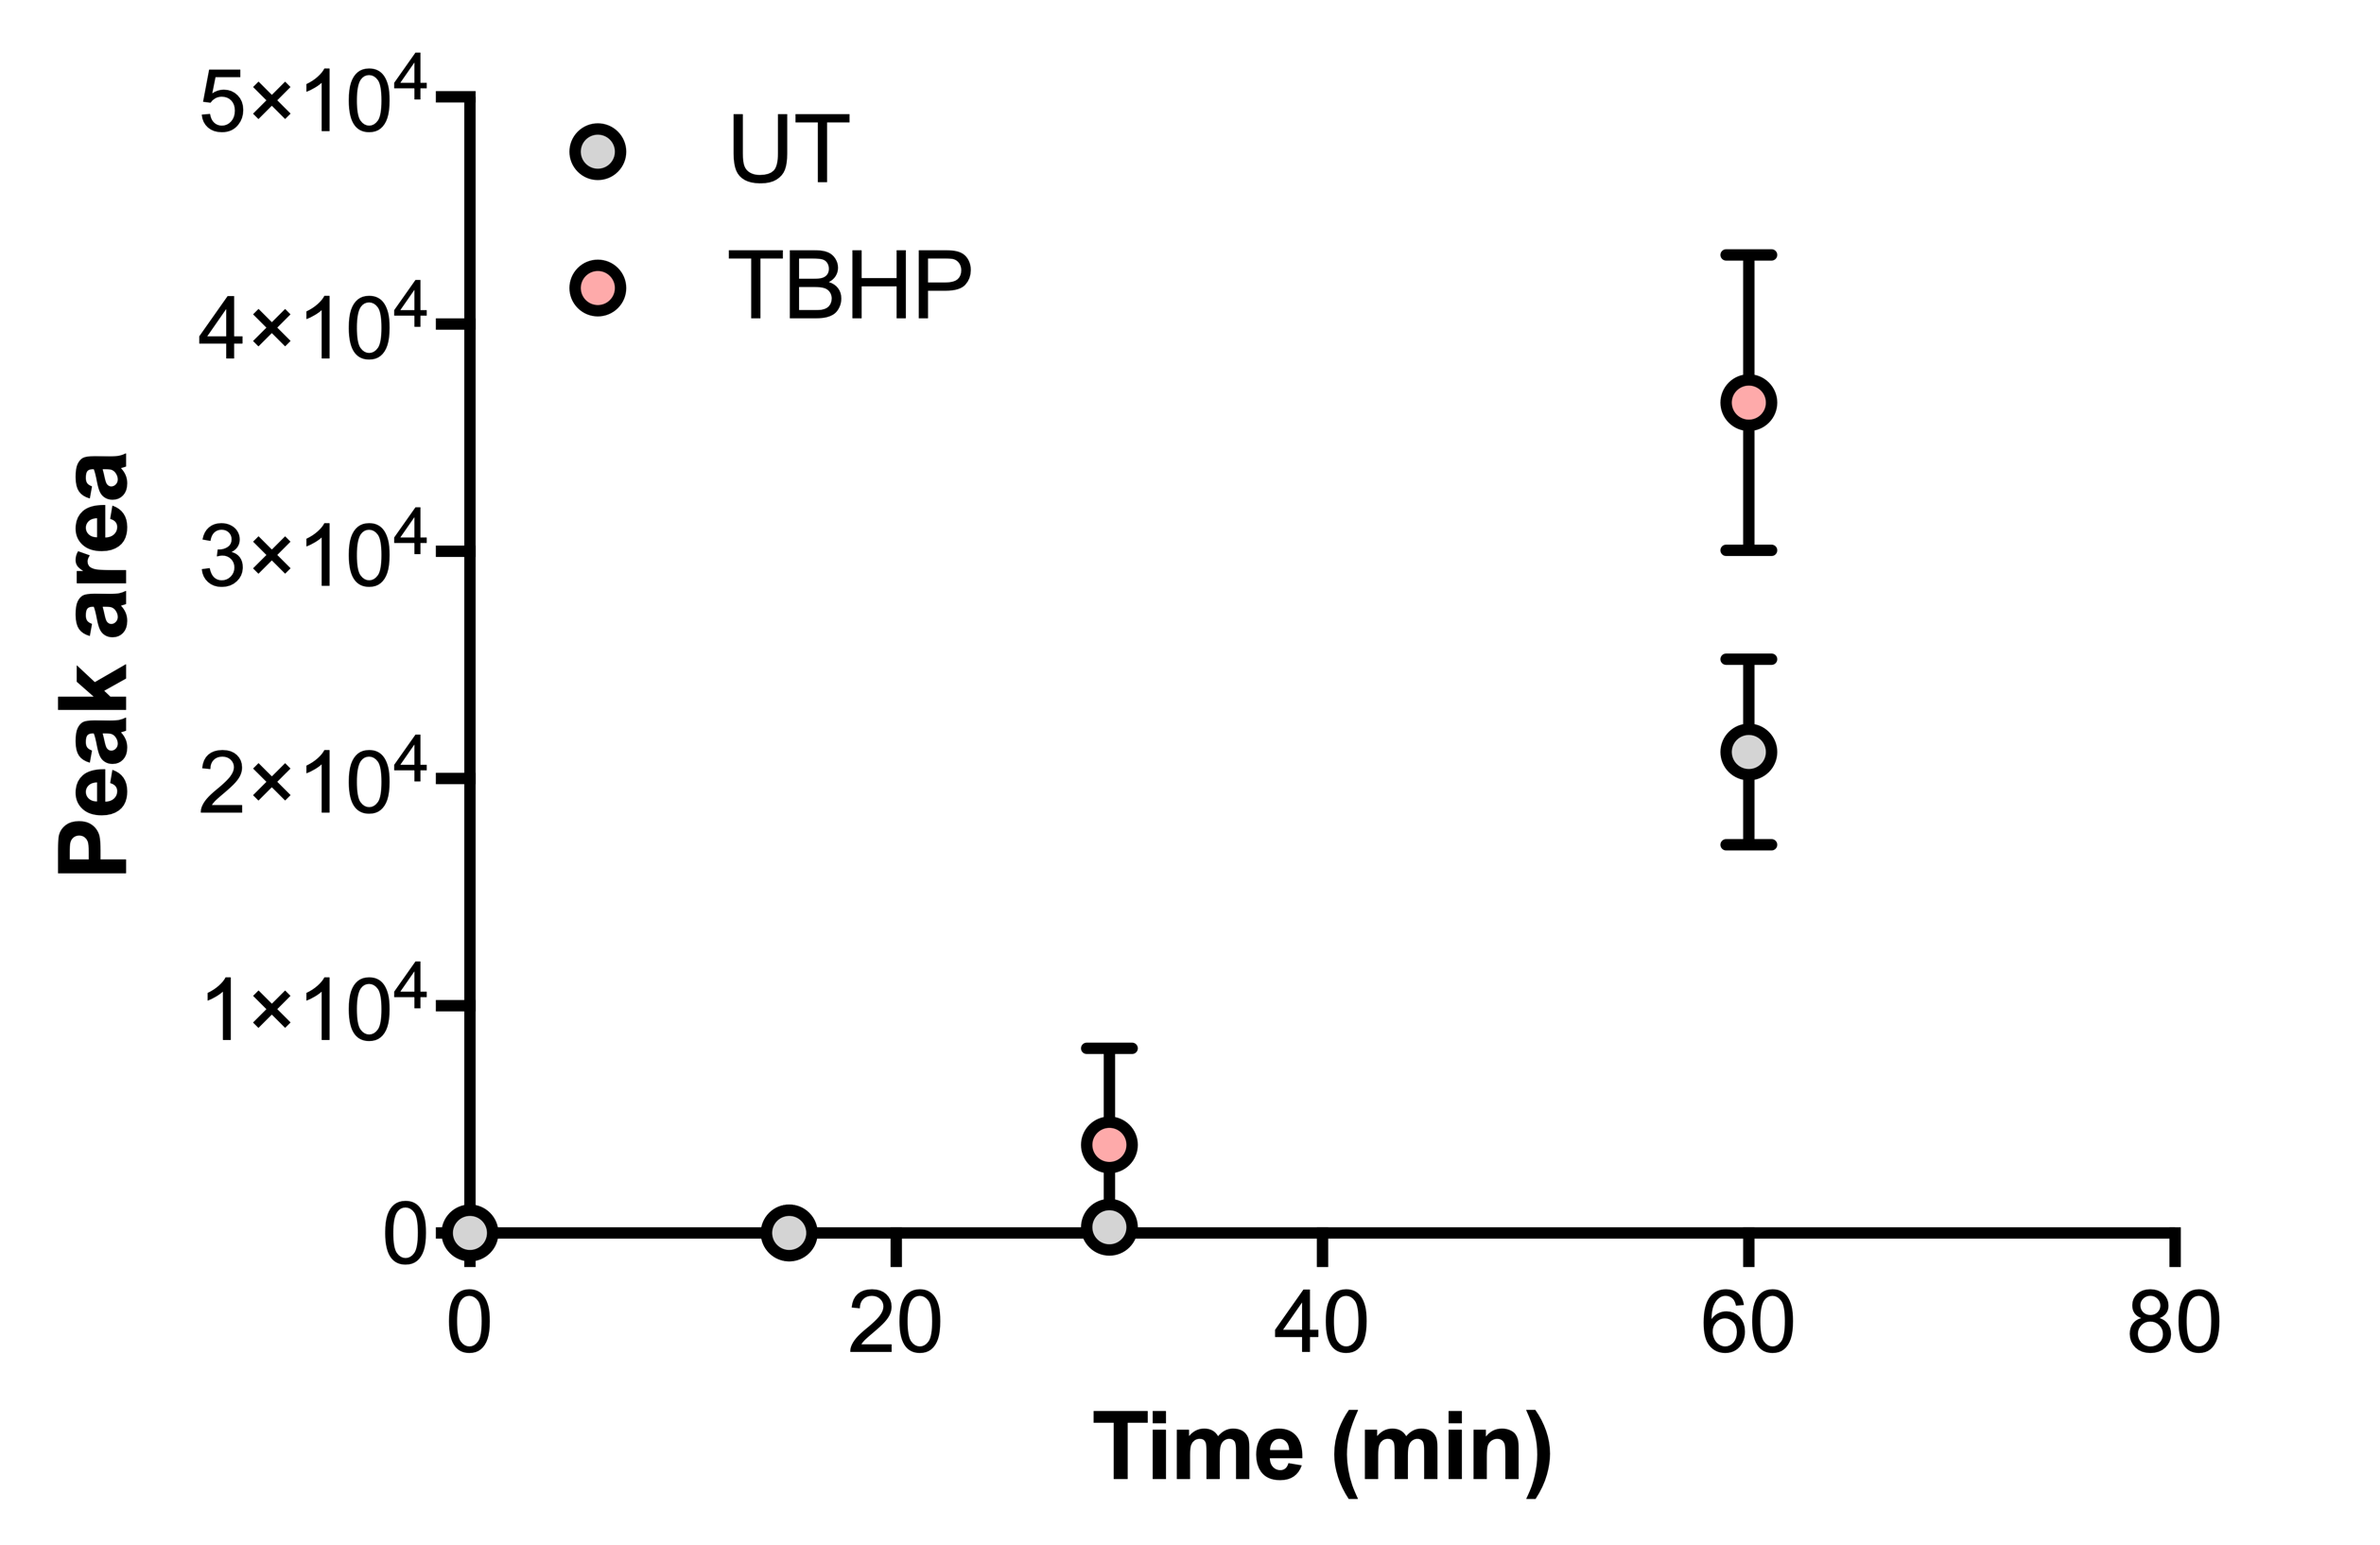
Figure S3. Incorporation of [U-¹³C₆, U-¹⁵N₂]cystine into dual-labeled (M+8) GSSG. Cells were fed with [U-¹³C₆, U-¹⁵N₂]cystine (200 µM) and the flux of two heavy-labeled cystines into GSSG was followed in cell lysates using LC-MS. Data are presented as mean ± SD of three replicate wells.

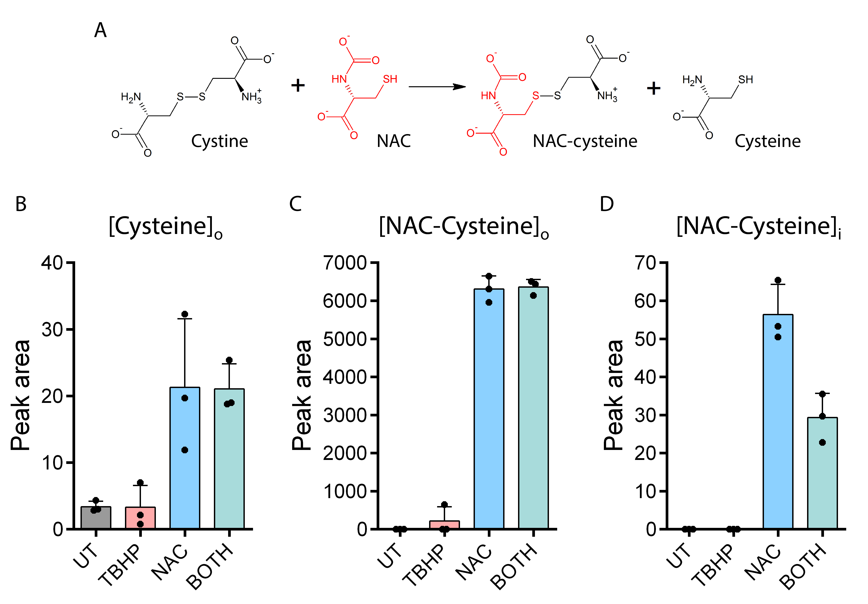
Figure S4. Extensive disulfide exchange between cystine and N-acetylcysteine occurs in both cells and culture media. (A) Proposed disulfide exchange reaction between cystine and NAC, forming cysteine and the mixed NAC-cysteine disulfide species. (B) Free cysteine in media after addition of NAC (NAC and BOTH conditions) relative to the untreated (UT) and TBHP-treated conditions. (C) Appearance of NAC-cysteine disulfide species in media following NAC treatment compared to near-undetectable levels in non-NAC treated conditions. (D) Intracellular appearance of NAC-cysteine disulfide following NAC treatment, compared to undetectable levels in the absence of NAC treatment. Data represent mean ± SD, and individual points represent replicate wells. [Cysteine]_{o}, extracellular cysteine; [NAC-cysteine]_{o}, extracellular NAC-cysteine conjugate; [NAC-cysteine]_{i}, intracellular NAC-cysteine conjugate.

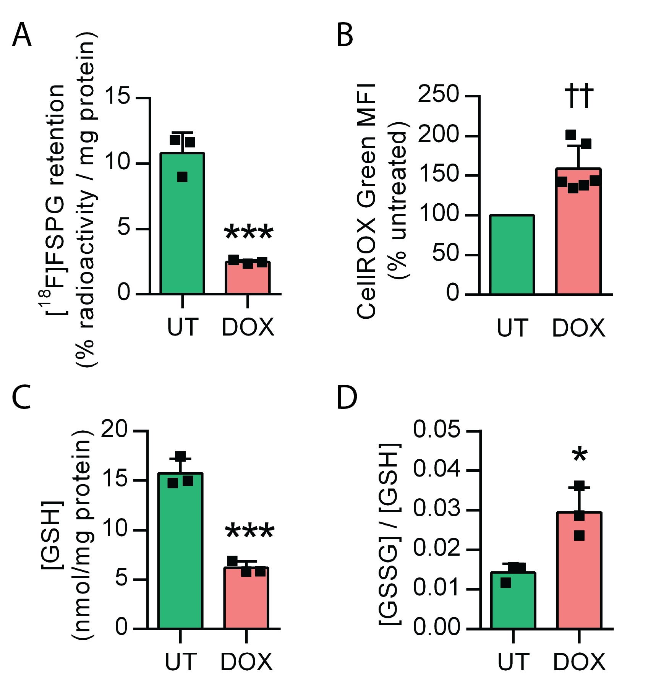

Figure S5. Doxil treatment results in oxidative stress and decreased [¹⁸F]FSPG accumulation in A2780 cells. (A) Intracellular [¹⁸F]FSPG retention, (B) Intracellular fluorescence of the ROS-sensitive fluorophore CellROX Green, (C) intracellular total GSH, and (D) intracellular ratio of GSSG to GSH, following treatment of A2780 cells with Doxil (200 nM, 72 h). Data are presented as mean ± SD. Scatter plot points represent independent experiments performed as single measurements (B) or in duplicate/triplicate (B-D). * p < 0.05, *** p < 0.001, t test versus UT; †† p < 0.01, single sample t test (versus unity).

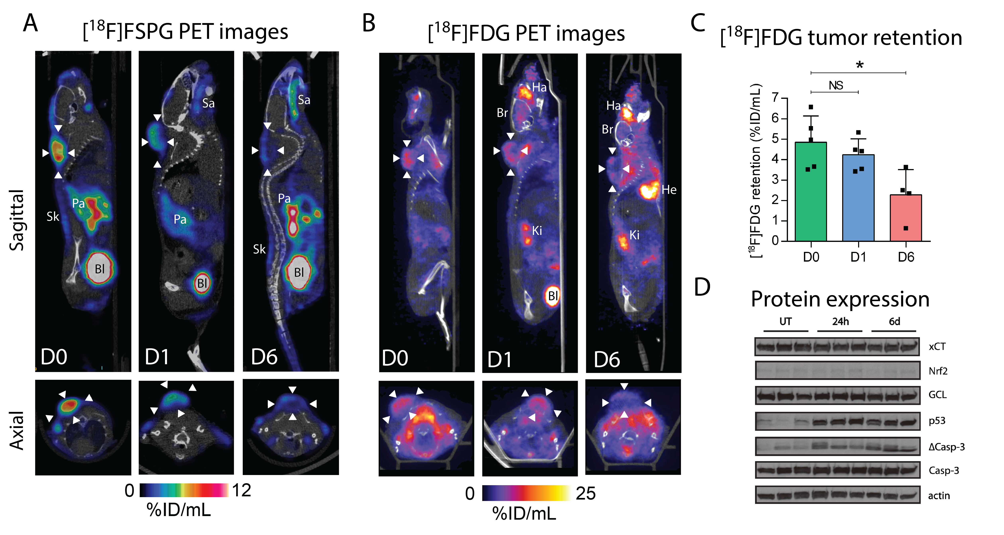
Figure S6. Doxil-induced changes in tumor retention of [¹⁸F]FSPG and [¹⁸F]FDG, and expression of key proteins. (A-B) Representative sagittal and axial (A) [¹⁸F]FSPG and (B) [¹⁸F]FDG PET images in untreated (D0) and mice treated with Doxil for 24 h (D1) or 6 days with Doxil (D6). Tumor margins are indicated by white arrow heads. Abbreviations: Bl, bladder; Br, brain; Ha, harderian glands; He, heart; Ki, kidney; Pa, pancreas; Sa, salivary glands; Sk, skin. (C) Quantified [¹⁸F]FDG tumor uptake in the above treatment groups. Scatter plot points represent determinations from individual animals. NS, not statistically significant; * p < 0.05; Bonferroni multiple comparison-corrected t test versus D0. (D) Western blot indicating protein expression from tumor lysates taken from untreated mice, mice treated with Doxil (10 mg/kg) for 24h or following 6 days of treatment (3 × 10 mg/kg). Separate bands represent tumors taken from individual animals, with 3 tumors evaluated per treatment group. Nrf2, Nuclear factor (erythroid-derived 2)-like 2; Casp-3, inactive form of caspase 3; ΔCasp-3, active (cleaved) form of Casp-3; GCL, glutamate-cysteine ligase, catalytic subunit. Actin was used as a loading control.

Movie S1. Overlaid [¹⁸F]FSPG PET/CT 3D VRT movie of a drug-naïve mouse bearing a subcutaneous A2780 ovarian cancer xenograft
Movie S2: Overlaid [¹⁸F]FSPG PET/CT 3D VRT movie of a mouse bearing a subcutaneous A2780 ovarian cancer xenograft after 24 h of Doxil treatment
Movie S3: Overlaid [¹⁸F]FSPG PET/CT 3D VRT movie of a mouse bearing a subcutaneous A2780 ovarian cancer xenograft after 6 d of Doxil treatment

