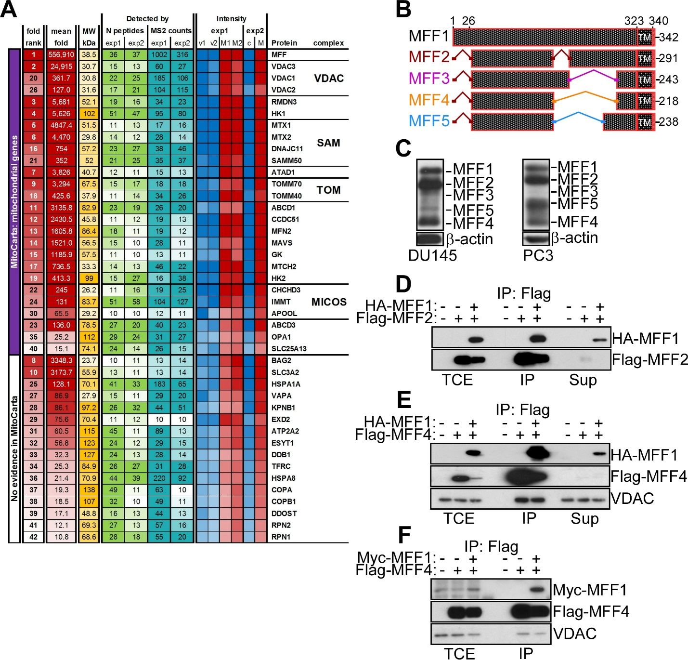
Supplementary Fig. S2. MFF-VDAC1 complex in cancer. A, Heat map of MFF-associated proteins identified by a 1D proteomics screening in PC3 cells. The mean fold, number of peptides and MS counts in two independent experiments are shown. The four main categories of MFF-associated proteins by pathway analysis (VDAC, SAM, TOM, MICOS) are shown on the right. B, Schematic diagram of predicted human MFF isoforms generated by alternative splicing of a single MFF locus. TM, transmembrane domain. The nomenclature of MFF isoforms by numbers is indicated. C, Total extracts from DU145 (left) or PC3 (right) cells were analyzed by Western blotting. The position of individual MFF isoforms is indicated. D-F, PC3 cells transfected with vector or the indicated HA- or Flag-tagged MFF cDNAs were immunoprecipitated (IP) with an antibody to Flag and analyzed by Western blotting. TCE, total cell extracts; Sup, supernatant.

