MFF REGULATION OF MITOCHONDRIAL CELL DEATH IS A THERAPEUTIC TARGET IN CANCER

Jae Ho Seo, Young Chan Chae, Andrew V. Kossenkov, Yu Geon Lee, Hsin-Yao Tang, Ekta Agarwal, Dmitry I. Gabrilovich, Lucia R. Languino, David W. Speicher, Prashanth K. Shastrula, Alessandra M. Storaci, Stefano Ferrero, Gabriella Gaudioso, Manuela Caroli, Davide Tosi, Massimo Giroda, Valentina Vaira, Vito W. Rebecca, Meenhard Herlyn, Min Xiao, Dylan Fingerman, Alessandra Martorella, Emmanuel Skordalakes and Dario C. Altieri

SUPPLEMENTARY MATERIAL
Supplementary Table S1-S3
Supplementary Figs. S1-S6

Supplementary Table S1. MFF1 synthetic peptides used in this study.
Peptide # | Sequence | Amino acid range
1 | AEMAEISRIQYEMEYTEGISQRMRVP | 25-50
2 | VPEKLKVAPPNADLEQGFQEGVPNASVIMQ | 49-78
3 | MQVPERIVVAGNNEDVSFSRPADLDLIQST | 77-106
4 | STPFKPLALKTPPRVLTLSERPLDFLDLER | 105-134
5 | ERPPTTPQNEEIRAVGRLKRERSMSENAVR | 133-162
6 | VRQNGQLVRNDSLWHRSDSAPRNKISRFQA | 161-190
7 | QAPISAPEYTVTPSPQQARVCPPHMLPEDG | 189-218
8 | DGANLSSARGILSLIQSSTRRAYQQILDVL | 217-246
9 | VLDENRRPVLRGGSAAATSNPHHDNVRYGI | 245-274
10 | GISNIDTTIEGTSDDLTV | 273-290
11 | VVDAASLRRQIIKLNRRLQLLEEENKERAKREM | 290-322

Supplementary Table S2. Mutant peptides derived from MFF1 peptide #8 used in this study.
Peptide # | Sequence
8-1 | NLSSARGILSLIQSSTRRAYQQILDVL
8-2 | SARGILSLIQSSTRRAYQQILDVL
8-3 | GILSLIQSSTRRAYQQILDVL
8-4 | SLIQSSTRRAYQQILDVL
8-5 | QSSTRRAYQQILDVL
8-6 | DGANLSSARGILSLIQSSTRRAYQQIL
8-7 | DGANLSSARGILSLIQSSTRRAYQ
8-8 | DGANLSSARGILSLIQSSTRR
8-9 | DGANLSSARGILSLIQSS
8-10 | DGANLSSARGILSLI

Supplementary Table S3. Clinico-pathological characteristics of non-small cell lung cancer (NSCLC) patient series used in this study (n=72)*.
 | Feature | n
Histotype | Adenocarcinoma (AdCa)  Squamous Cell Carcinoma (SCC) | 57  15
pN | N0  N1,2 | 45  26
pT | pT1a,b  pT2a,b  pT3,4 | 24  30  18
Grade | na  Grade 1  Grade 2  Grade 3 | 2  4  36  30
 | ALK-R** | 15

*67 out of 72 samples were evaluable for MFF expression by immunohistochemistry.
** ALK-R, ALK rearrangement.

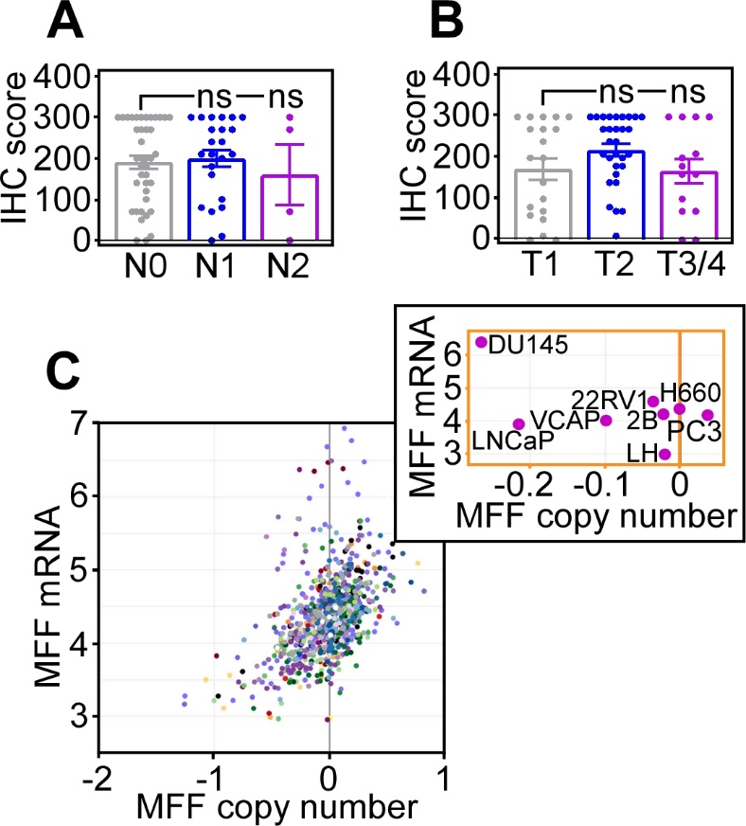
SUPPLEMENTARY FIGURE LEGENDS

Supplementary Fig. S1. MFF expression in cancer. A and B, MFF expression quantified in a cohort of non-small cell lung cancer (NSLC) patients by immunohistochemistry was correlated to lymph node status (A) or tumor size (B). C, MFF mRNA expression and copy number in the Cancer Cell Line Encyclopedia. Inset, MFF mRNA expression in prostate cancer cell lines.

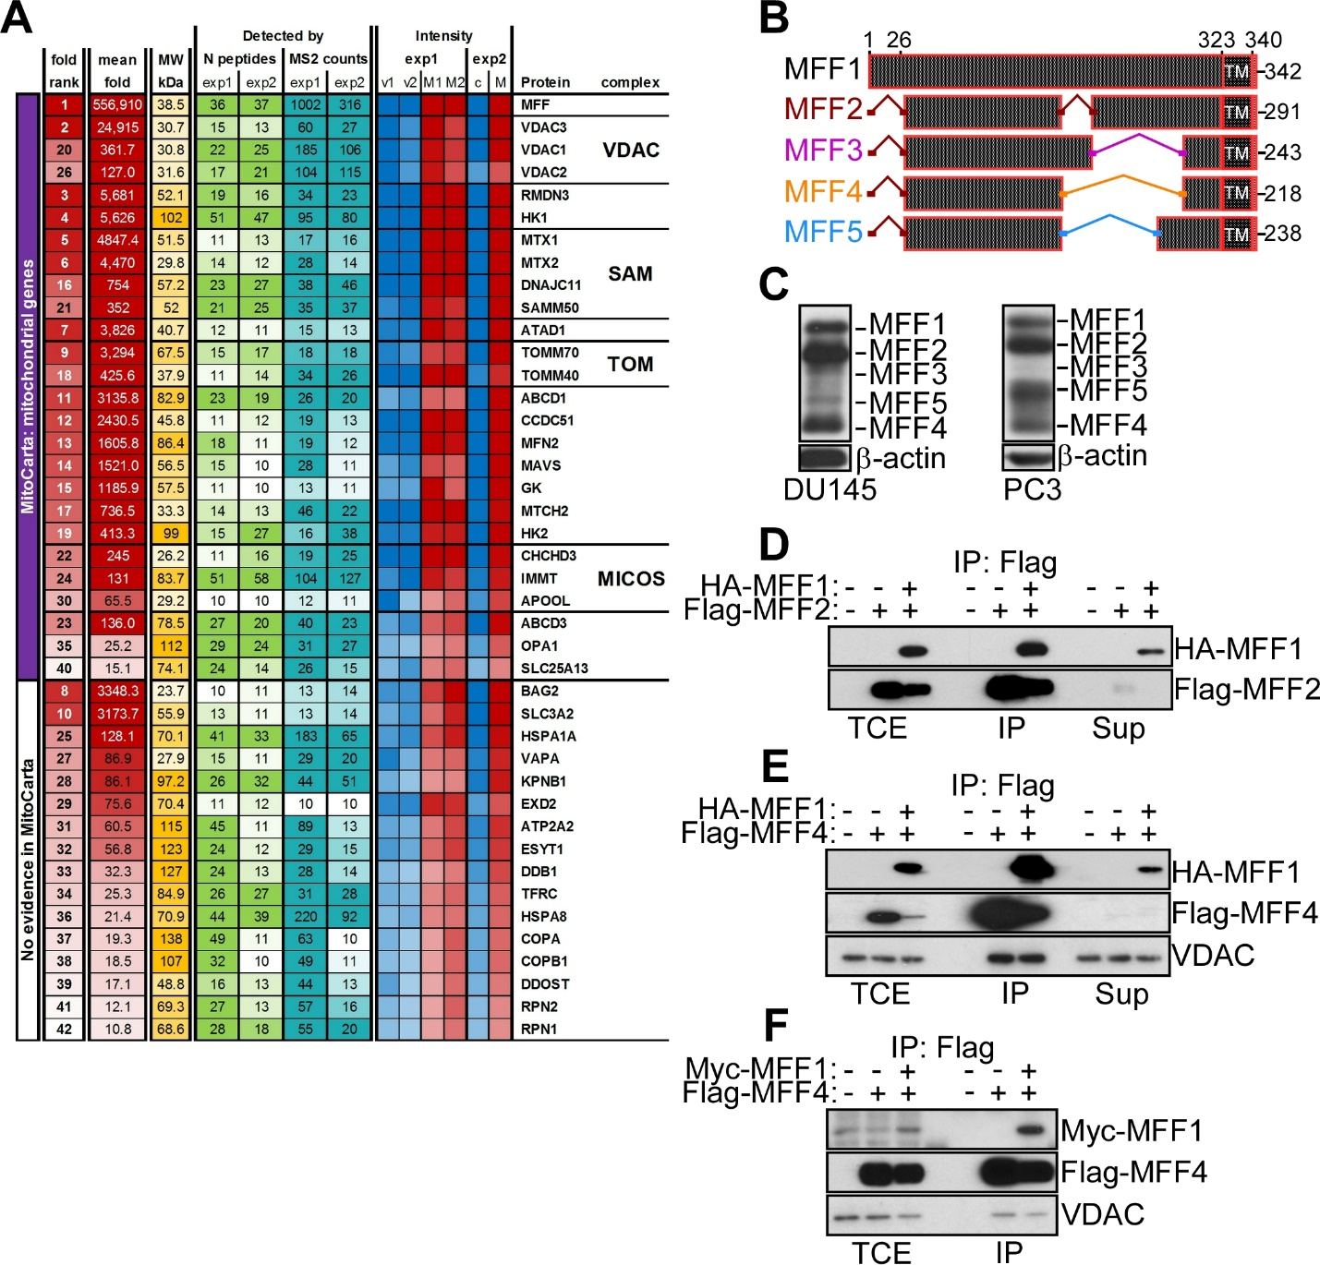
Supplementary Fig. S2. MFF-VDAC1 complex in cancer. A, Heat map of MFF-associated proteins identified by a 1D proteomics screening in PC3 cells. The mean fold, number of peptides and MS counts in two independent experiments are shown. The four main categories of MFF-associated proteins by pathway analysis (VDAC, SAM, TOM, MICOS) are shown on the right. B, Schematic diagram of predicted human MFF isoforms generated by alternative splicing of a single MFF locus. TM, transmembrane domain. The nomenclature of MFF isoforms by numbers is indicated. C, Total extracts from DU145 (left) or PC3 (right) cells were analyzed by Western blotting. The position of individual MFF isoforms is indicated. D-F, PC3 cells transfected with vector or the indicated HA- or Flag-tagged MFF cDNAs were immunoprecipitated (IP) with an antibody to Flag and analyzed by Western blotting. TCE, total cell extracts; Sup, supernatant.

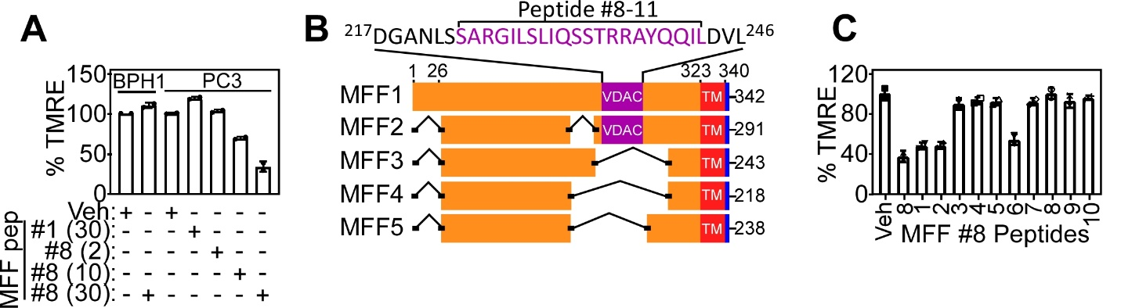
Supplementary Fig. S3. Peptidyl mimicry of MFF-VDAC1 complex. A, Mitochondrial extracts from PC3 or BPH-1 cells were incubated with MFF peptide #1 (30 μM) or MFF peptide #8 (10-30 μM) and analyzed for changes in mitochondrial inner membrane potential by TMRE staining and flow cytometry. Mean±SD (n=3). B, Schematic diagram of MFF isoforms (MFF1-MFF5) and position of a VDAC binding site in MFF1 and MFF2. The minimal MFF-VDAC1 interacting region (peptide #8-11) is indicated. TM, transmembrane domain. C, Mitochondrial extracts from PC3 cells were incubated with MFF peptide #8 variants as in Supplementary Table S2 and analyzed for changes in TMRE fluorescence by flow cytometry. Mean±SD (n=2).

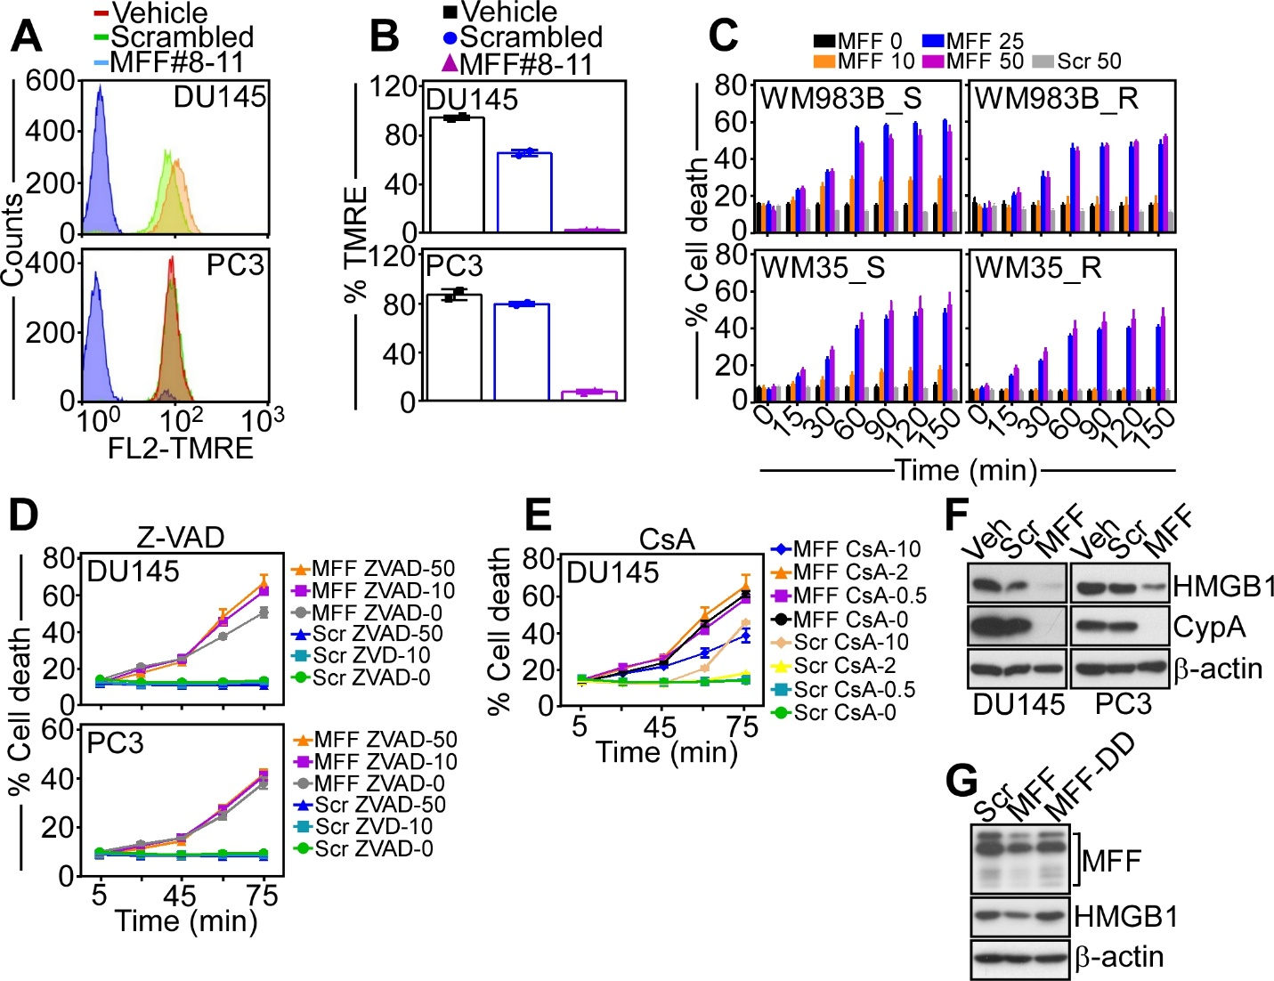
Supplementary Fig. S4. Requirements of MFF regulation of tumor cell death. A and B, DU145 or PC3 cells were incubated with vehicle, cell-permeable scrambled peptide (Scrambled) or cell-permeable MFF peptide #8-11 (MFF #8-11), and TMRE staining determined by flow cytometry (A) was quantified (B). Mean±SD. C, Isogenic pairs of melanoma cell lines sensitive (WM983B_S, WM35_S) or resistant (WM983B_R, WM35_R) to the combination of Debrafenib plus Trametinib were incubated with increasing concentrations of the cell-permeable MFF peptide #8-11 or cell-permeable scrambled peptide (50 μM) and analyzed for cell death by CellTox reactivity at the indicated time intervals. Mean±SD (n=2). D and E, DU145 or PC3 cells were incubated with cell-permeable scrambled peptide or cell-permeable MFF peptide #8-11 (0-50 μM), mixed with the indicated concentrations of Z-VAD-fmk (0-50 μM for 75 min, D) or cyclosporine A (CsA, 0-10 μM for 75 min, E), and analyzed for cell death at the indicated time intervals. Mean±SD (n=2). (F) DU145 or PC3 cells were incubated with cell-permeable scrambled (Scr) or MFF peptide #8-11 and analyzed by Western blotting. Veh, vehicle. G, PC3 cells were incubated with cell-permeable scrambled peptide, MFF peptide #8-11 or MFF peptide #8-11 containing the double mutation R225D/R236D (DD) and analyzed by Western blotting.

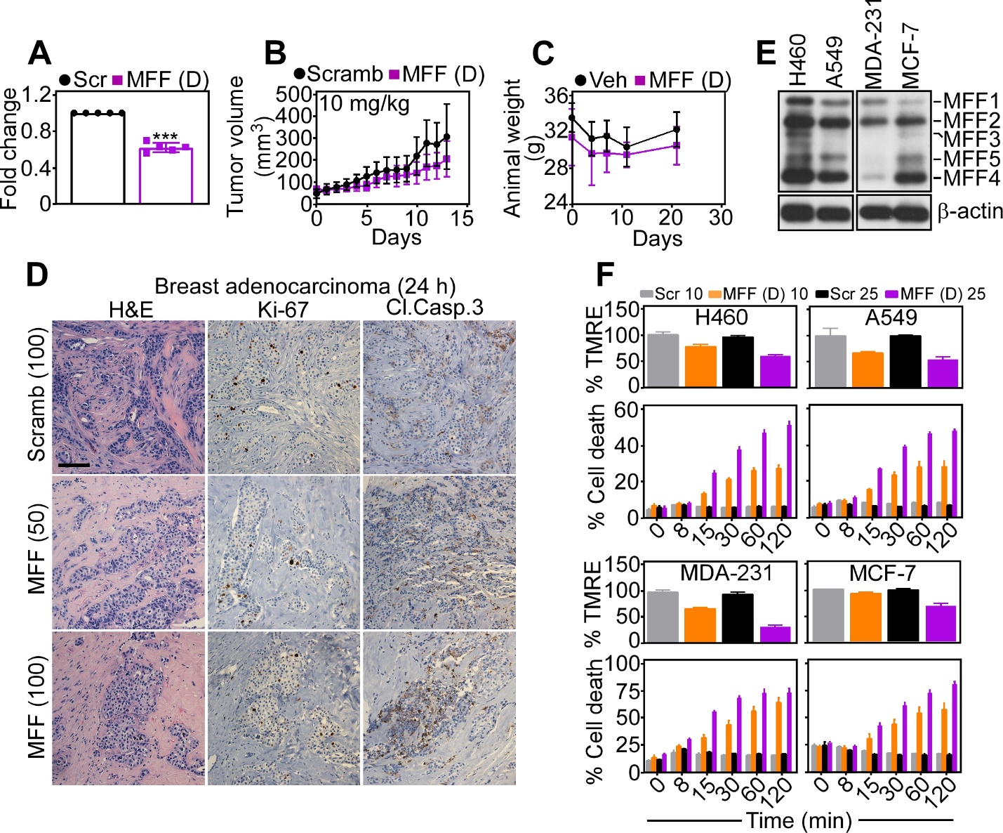
Supplementary Fig. S5. Preclinical activity of MFF targeting. A, PC3 cells were treated with cell-permeable biotin-conjugated MFF (D) 8-11 peptidomimetic (MFF (D), 10 μM) or cell-permeable scrambled peptide (Scr) and biotinylated mitochondrial extracts were treated with HABA (2-(4-Hydroxyphenylazo) benzoic acid)/avidin, followed by quantification of absorbance at 500 nm. Biotin accumulation in the mitochondrial samples displaces HABA from the HABA/Avidin complex, thus leading to reduction in absorbance. Mean±SD. ***, p<0.0001 by unpaired two-tailed t test. B, PC3 cells (5x10⁶ in 50% Matrigel) were engrafted onto the flanks of immunocompromised athymic mice, and animals randomized in two groups were treated with cell-permeable scrambled peptide or MFF (D) 8-11 peptidomimetic (10 mg/kg, daily i.p.) with quantification of tumor growth at the indicated time intervals. Mean±SD (n=8-10). C, Tumor-bearing immunocompromised mice were treated with vehicle (Veh) or MFF (D) 8-11 peptidomimetic and animal weight was measured at the indicated time intervals. Mean±SD (n=5). D, Primary, patient-derived 3D organoids from cases of breast adenocarcinoma were treated with cell permeable scrambled peptide (100 μM) or MFF (D) 8-11 peptidomimetic (50-100 μM) for 24 h and stained for hematoxylin-eosin (H&E), Ki-67 or cleaved caspase-3 (Cl. Casp.3), by immunohistochemistry. Scale bar, 100 μm. E, Extracts from the indicated NSCLC (A549, H460) or breast adenocarcinoma (MDA-231, MCF-7) cell lines were analyzed by Western blotting. The position of MFF isoforms is indicated. F, The indicated NSCLC and breast adenocarcinoma cell lines were incubated with increasing concentrations (10-25 μM) of cell-permeable scrambled peptide (Scr) or MFF (D) 8-11 peptidomimetic and analyzed for mitochondrial membrane potential by TMRE staining and flow cytometry (top) or cell death by CellTox reactivity (bottom) at the indicated time intervals. Mean±SD (n=2).

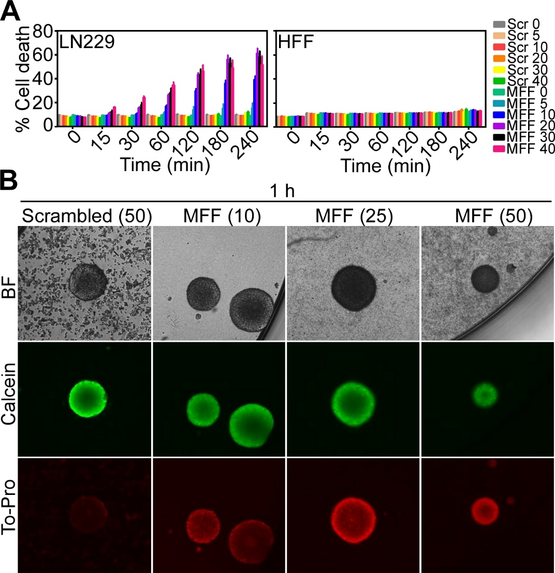
Supplementary Fig. S6. Anti-glioma activity of MFF peptidomimetic. A, Glioblastoma (GBM) LN229 cells or normal HFF were treated with increasing concentrations of cell-permeable scrambled peptide or cell-permeable MFF peptide #8-11 (0-40 μM) and analyzed for cell death at the indicated time intervals. Mean±SD (n=3). B, Primary, patient-derived human GBM neurospheres were treated with cell-permeable scrambled peptide (50 μM) or the indicated increasing concentrations of MFF (D) 8-11 peptidomimetic (10-50 μM) for 1 h, stained with calcein (live cells) or To-Pro (dead cells) and analyzed for fluorescence expression. FU, fluorescence units; BF, bright field.

