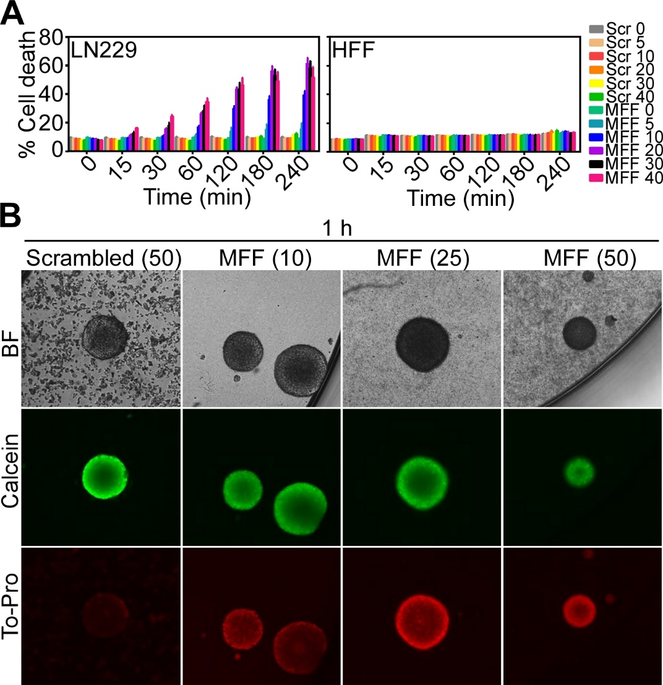
Supplementary Fig. S6. Anti-glioma activity of MFF peptidomimetic. A, Glioblastoma (GBM) LN229 cells or normal HFF were treated with increasing concentrations of cell-permeable scrambled peptide or cell-permeable MFF peptide #8-11 (0-40 μM) and analyzed for cell death at the indicated time intervals. Mean±SD (n=3). B, Primary, patient-derived human GBM neurospheres were treated with cell-permeable scrambled peptide (50 μM) or the indicated increasing concentrations of MFF (D) 8-11 peptidomimetic (10-50 μM) for 1 h, stained with calcein (live cells) or To-Pro (dead cells) and analyzed for fluorescence expression. FU, fluorescence units; BF, bright field.

