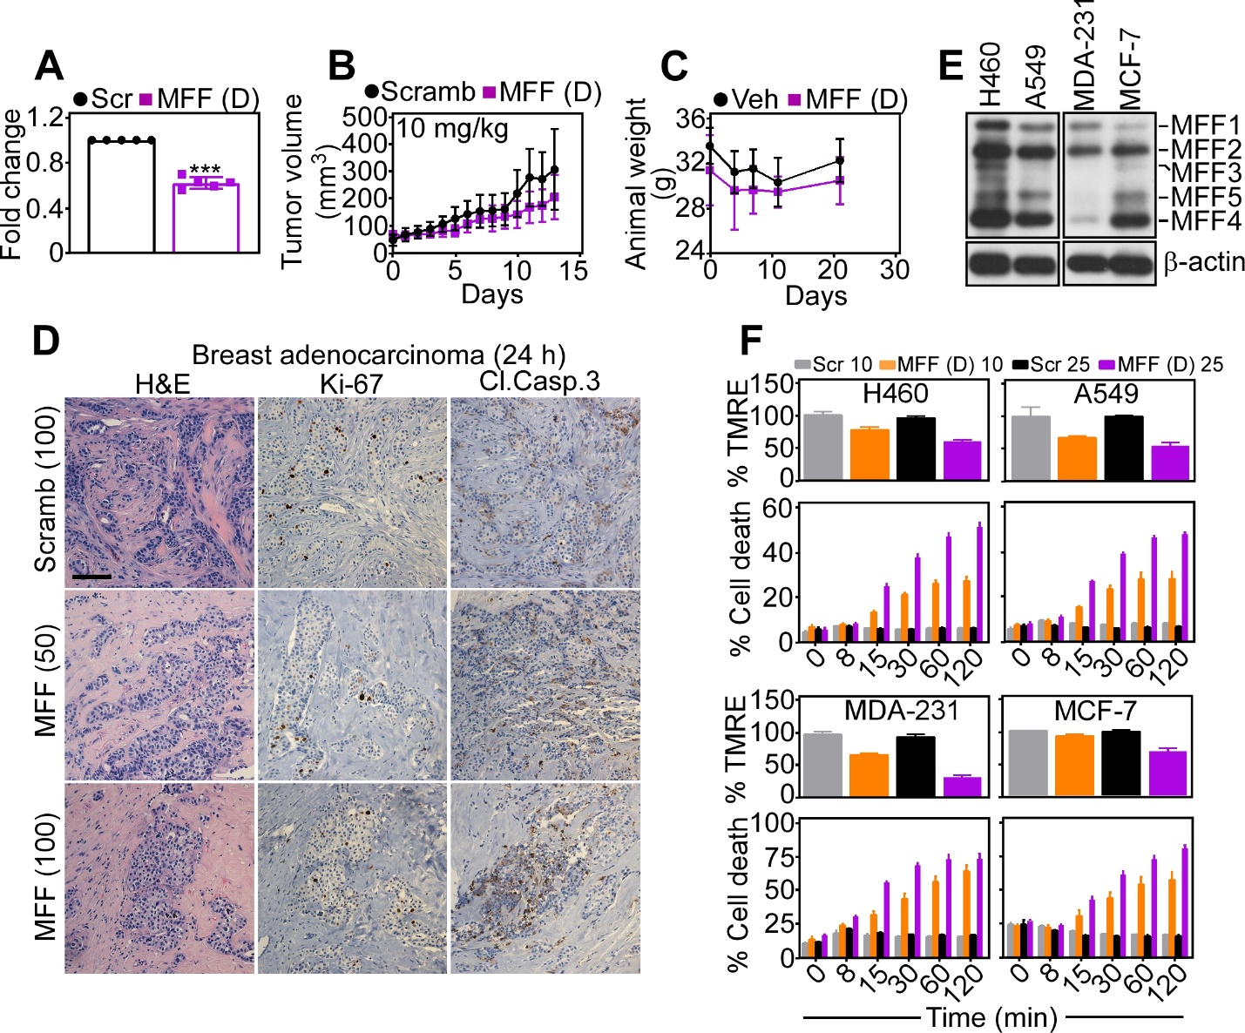
Supplementary Fig. S5. Preclinical activity of MFF targeting. A, PC3 cells were treated with cell-permeable biotin-conjugated MFF (D) 8-11 peptidomimetic (MFF (D), 10 μM) or cell-permeable scrambled peptide (Scr) and biotinylated mitochondrial extracts were treated with HABA (2-(4-Hydroxyphenylazo) benzoic acid)/avidin, followed by quantification of absorbance at 500 nm. Biotin accumulation in the mitochondrial samples displaces HABA from the HABA/Avidin complex, thus leading to reduction in absorbance. Mean±SD. ***, p<0.0001 by unpaired two-tailed t test. B, PC3 cells (5x10⁶ in 50% Matrigel) were engrafted onto the flanks of immunocompromised athymic mice, and animals randomized in two groups were treated with cell-permeable scrambled peptide or MFF (D) 8-11 peptidomimetic (10 mg/kg, daily i.p.) with quantification of tumor growth at the indicated time intervals. Mean±SD (n=8-10). C, Tumor-bearing immunocompromised mice were treated with vehicle (Veh) or MFF (D) 8-11 peptidomimetic and animal weight was measured at the indicated time intervals. Mean±SD (n=5). D, Primary, patient-derived 3D organoids from cases of breast adenocarcinoma were treated with cell permeable scrambled peptide (100 μM) or MFF (D) 8-11 peptidomimetic (50-100 μM) for 24 h and stained for hematoxylin-eosin (H&E), Ki-67 or cleaved caspase-3 (Cl. Casp.3), by immunohistochemistry. Scale bar, 100 μm. E, Extracts from the indicated NSCLC (A549, H460) or breast adenocarcinoma (MDA-231, MCF-7) cell lines were analyzed by Western blotting. The position of MFF isoforms is indicated. F, The indicated NSCLC and breast adenocarcinoma cell lines were incubated with increasing concentrations (10-25 μM) of cell-permeable scrambled peptide (Scr) or MFF (D) 8-11 peptidomimetic and analyzed for mitochondrial membrane potential by TMRE staining and flow cytometry (top) or cell death by CellTox reactivity (bottom) at the indicated time intervals. Mean±SD (n=2).

