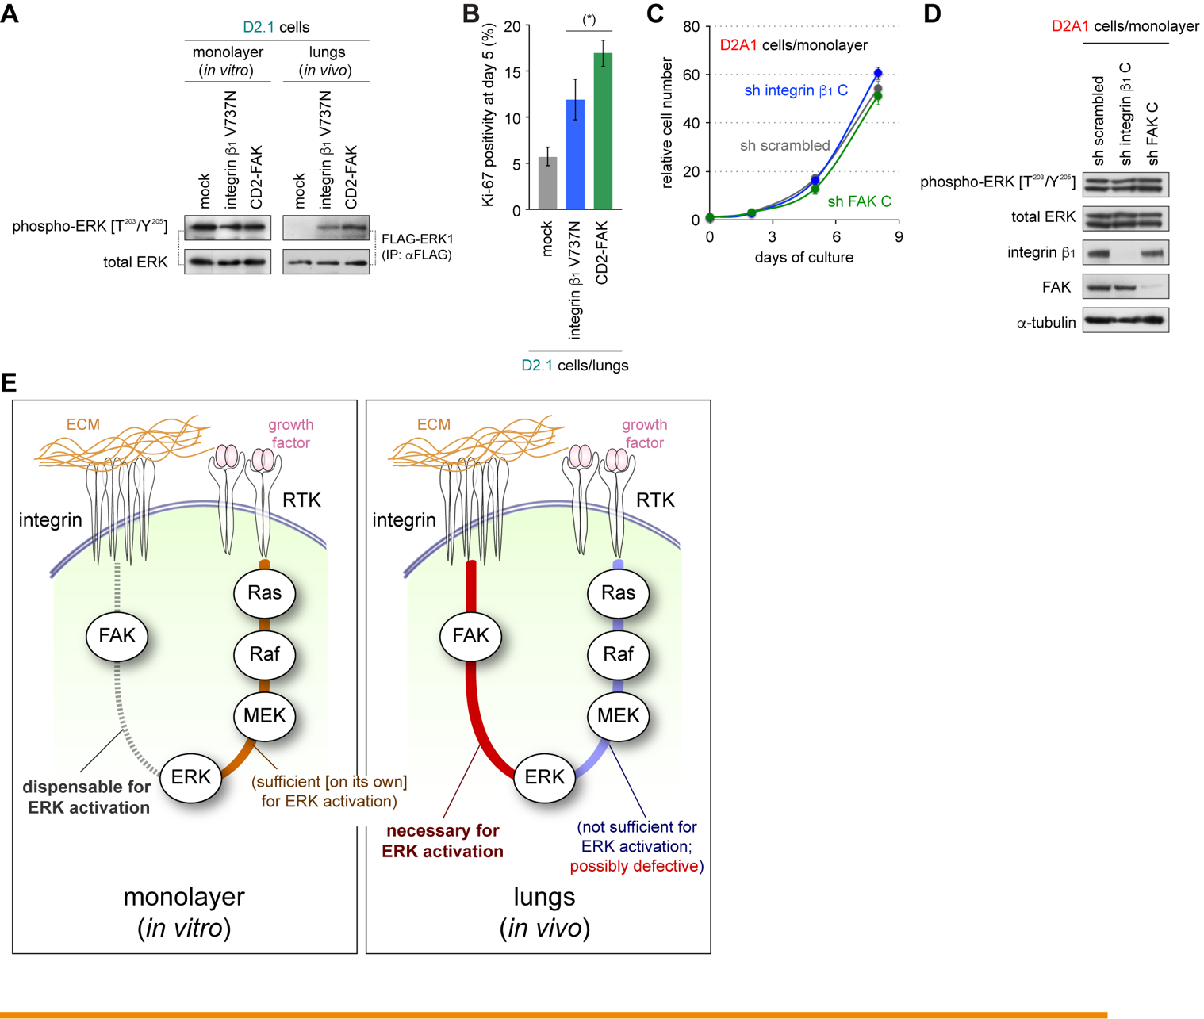

Supplementary Figure S1. Involvement of integrin:FAK-signaling in driving ERK activation and proliferation in vivo, related to Figure 1

(A, B) Forced activation of integrin β₁/FAK signaling in the naturally nonaggressive D2.1 cells. D2.1 cells were engineered to express either the autoclustering integrin β₁ V737N mutant (Paszek et al. [2005], Cancer Cell 8:241) or the constitutively active CD2-FAK fusion protein (Shibue & Weinberg [2009], Proc Natl Aca Sci U S A 106:10290), both of which cause potent activation of the integrin β₁/FAK signaling. In A, these and the control cells were manipulated further to express FLAG-tagged ERK1 (FLAG-ERK1), and then either propagated under monolayer culture or injected into Balb/c mice via the tail-vein. Five days later, cells (or lungs) were harvested, lysed and subsequently, FLAG-ERK1 was collected by anti-FLAG immunoprecipitation (IP) and analyzed by immunoblotting (IB). In B, control D2.1 cells and D2.1 cells expressing either integrin β₁ V737N or CD2-FAK were manipulated further to express the tdTomato-mem fluorescent plasma membrane marker; these various cells were then injected into Balb/c mice via the tail-vein. 5 days later, lungs were harvested, sectioned, and stained for the proliferation marker Ki-67. The positivity of Ki-67 staining within the population of tdTomato-mem-positive cells (i.e., D2.1 cells) was scored under fluorescence microscope. This revealed that experimental activation of integrin β₁/FAK signaling sufficed to drive ERK activation and stimulate proliferation in the otherwise-dormant D2.1 cells following their extravasation into the parenchyma of the lung tissue.
(C, D) Blockade of integrin β₁:FAK signaling in the naturally aggressive D2A1 cells. D2A1 cells were engineered to express short-hairpin RNA (shRNA) targeting either integrin β₁ (sh integrin β₁ C) or FAK (sh FAK C) (Shibue & Weinberg [2009], Proc Natl Aca Sci U S A 106:10290). These and the control (sh scrambled) cells were then propagated under monolayer culture conditions. In C, the cell numbers were scored on days 0, 2, 5 and 8. In D, cells were harvested on day 5 and their lysates were analyzed by IB. This revealed that neither ERK activation nor proliferation was noticeably impaired by the knockdown of integrin β₁ or FAK expression when D2A1 cells were propagated as a monolayer in vitro. Hence, integrin β₁:FAK signaling is dispensable for driving ERK activation and proliferation when D2A1 cells were growing under such conditions of two-dimensional (2D) culture.
(E) Relative roles of extracellular matrix (ECM):integrin signaling and growth factor:receptor tyrosine kinase (RTK) signaling in driving ERK activation. In the carcinoma cells that were propagated in an in vitro monolayer culture, the blockade of ECM:integrin signaling did not noticeably affect ERK activation (left panel, gray dotted line; see also C and D). This suggests that the growth factor:RTK signaling, a major driver of the MAP kinase signaling cascade in many cell types (Johnson & Lapidat [2002], Science 298:1911), suffices by itself to drive ERK activation, obviating ECM:integrin signaling in these cells (left panel, orange line). In contrast, upon extravasation of carcinoma cells into the parenchyma of the lungs in vivo, ERK activation becomes dependent critically on the ECM:integrin signaling (right panel, red line; also see A and B) (Shibue & Weinberg [2009], Proc Natl Aca Sci U S A 106:10290; Shibue et al. [2012], Cancer Discov 2:706). This indicates, in turn, that various growth factors present in the lung parenchyma, to which these carcinoma cells should have access, do not suffice, on their own, to trigger the activation of ERK when these cells were growing under this in vivo condition (right panel, blue line). Based on this thinking, we speculated that growth factor:RTK signaling is rendered defective in the disseminated tumor cells (DTCs) that have extravasated into the lung parenchyma in vivo (see Fig. 1C). Detailed understanding of the mechanism that controls Ras/ERK signaling specifically in DTCs is critical for the following reason. Thus, while previous studies by us and others have already demonstrated the central role of Ras/ERK signaling in governing the proliferation of DTCs (Shibue et al. [2012], Cancer Discov 2:706; Aguirre Ghiso et al. [1999], J Cell Biol 147:89), these studies, on their own, did not suffice to guide the eventual development of therapeutic strategies to control DTC proliferation. Indeed, given the important role of Ras/ERK signaling in a wide range of physiological processes, direct targeting of this signaling pathway for therapeutic purposes compromises a number of other important physiological processes, presumably yielding unacceptable side-effect toxicity. Hence, uncovering a molecular mechanism that controls Ras/ERK signaling specifically in the DTCs is necessary for the better therapeutic management of these cells. Values = means ± SD (n = 3: B, C).

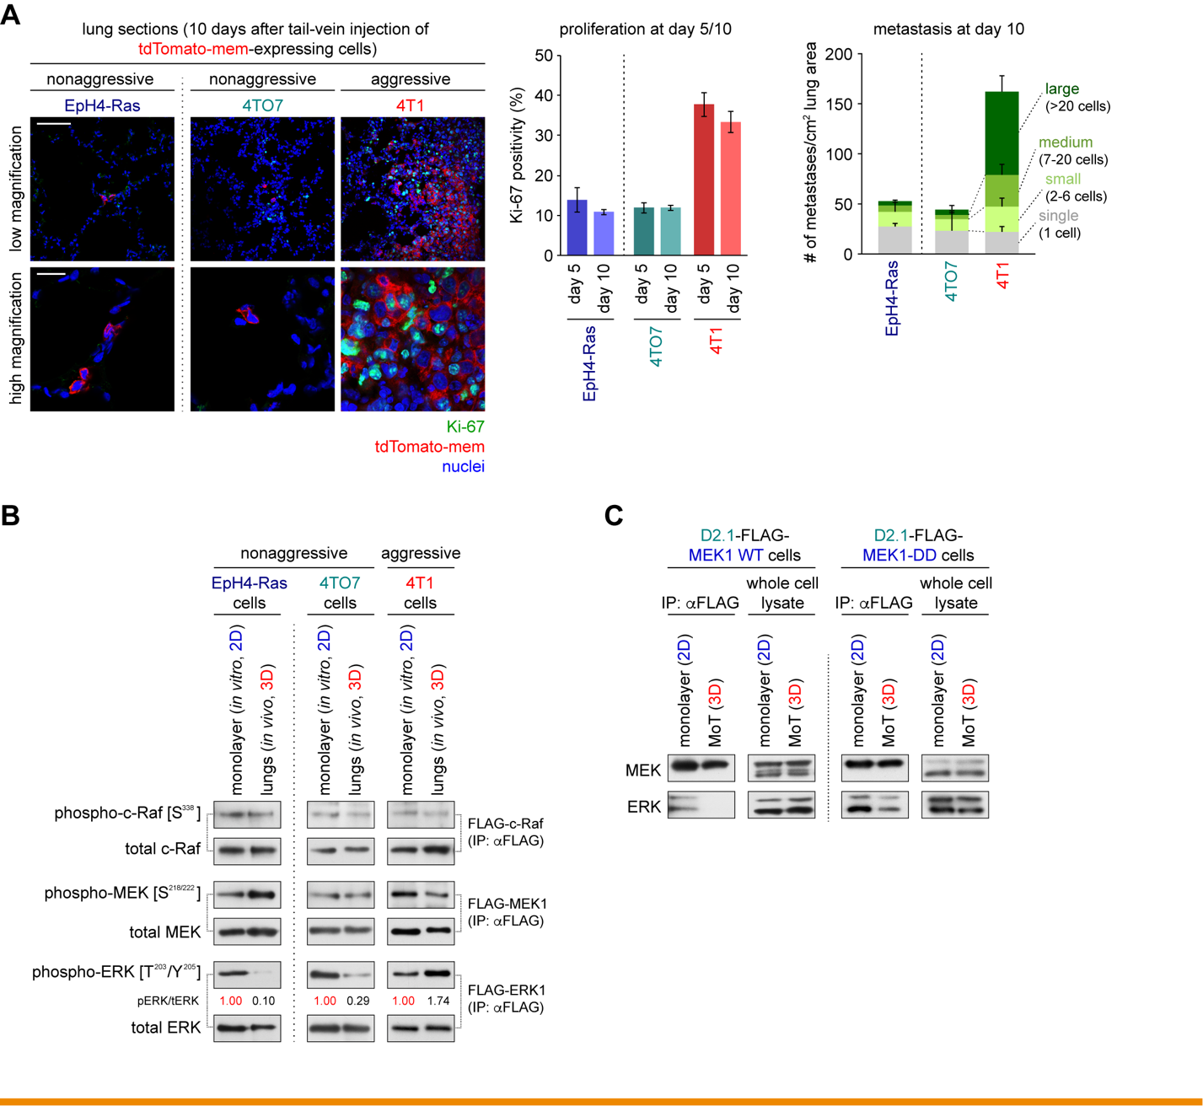

Supplementary Figure S2. In vitro and in vivo behaviors of various mammary carcinoma cell types, related to Figure 1

(A) Post-extravasation behavior of various mouse mammary carcinoma cell types in the lungs. Two nonaggressive cell types, EpH4-Ras and 4TO7, as well as one aggressive cell type, 4T1, all expressing the tdTomato-mem plasma membrane marker, were injected into Balb/c mice via the tail-vein. Subsequently, lungs were harvested, sectioned, and stained for the proliferation marker Ki-67 (green) and nuclei (with DAPI; blue). Presented are representative low magnification (15x) and high magnification (63x) images of the sections prepared 10 days after the injection (left). Bar = 100 μm (low magnification), 20 μm (high magnification). The positivity of Ki-67-staining at days 5 and 10 was also scored (middle). The size of the metastatic colonies at day 10 was classified into four ranks: single cell, small colony (2-6 cells), medium colony (7-20 cells), and large colony (> 20 cells), and the number of colonies in each of these ranks was plotted (right). Values = means ± SD (n = 3: center) or means + SD (n = 4: right).
(B) In vivo activity of the Ras/ERK signaling cascade components in various mouse mammary carcinoma cell types. EpH4-Ras, 4TO7 and 4T1 cells were engineered to express a FLAG-tagged version of a kinase component of the Ras/ERK cascade (FLAG-c-Raf, FLAG-MEK1 or FLAG-ERK1). These various cells were then either propagated under monolayer culture or injected into Balb/c mice via the tail-vein. Five days later, cells (or lungs) were harvested, lysed and subsequently, FLAG-tagged kinases were collected by anti-FLAG IP and analyzed by IB. Relative band intensities (phospho-ERK [pERK]/total ERK [tERK]) are also presented.
(C) Differing potentials between the wild-type (WT) version of MEK1 and its MEK1-DD mutant in binding to their ERK substrate. Nonaggressive D2.1 cells were engineered to express a FLAG-tagged version of either MEK1 WT or MEK1-DD mutant. These cells were subsequently propagated under either 2D monolayer or 3D MoT conditions of culture. Five days later, cells were harvested, lysed and subsequently, FLAG-tagged kinases were collected by anti-FLAG IP and analyzed by IB. FLAG-tagged MEK1 WT did not coprecipitate with ERK noticeably from the lysate of the D2.1 cells growing under the 3D MoT condition of culture. In stark contrast, FLAG-tagged MEK1-DD mutant was found to coprecipitate with ERK even from the lysate of the MoT-cultured D2.1 cells. Hence, MEK1 WT fails to interact with its ERK substrate under conditions where KSR scaffolding proteins are functionally inactivated (i.e., under the 3D MoT condition), while the MEK1-DD mutant can interact strongly with ERK even under this 3D condition, doing so for mechanistic reasons that remain unexplored. This appears to account for the differing effects distinguishing MEK1 WT from the MEK1-DD mutant in driving ERK activation in the naturally dormant cells.

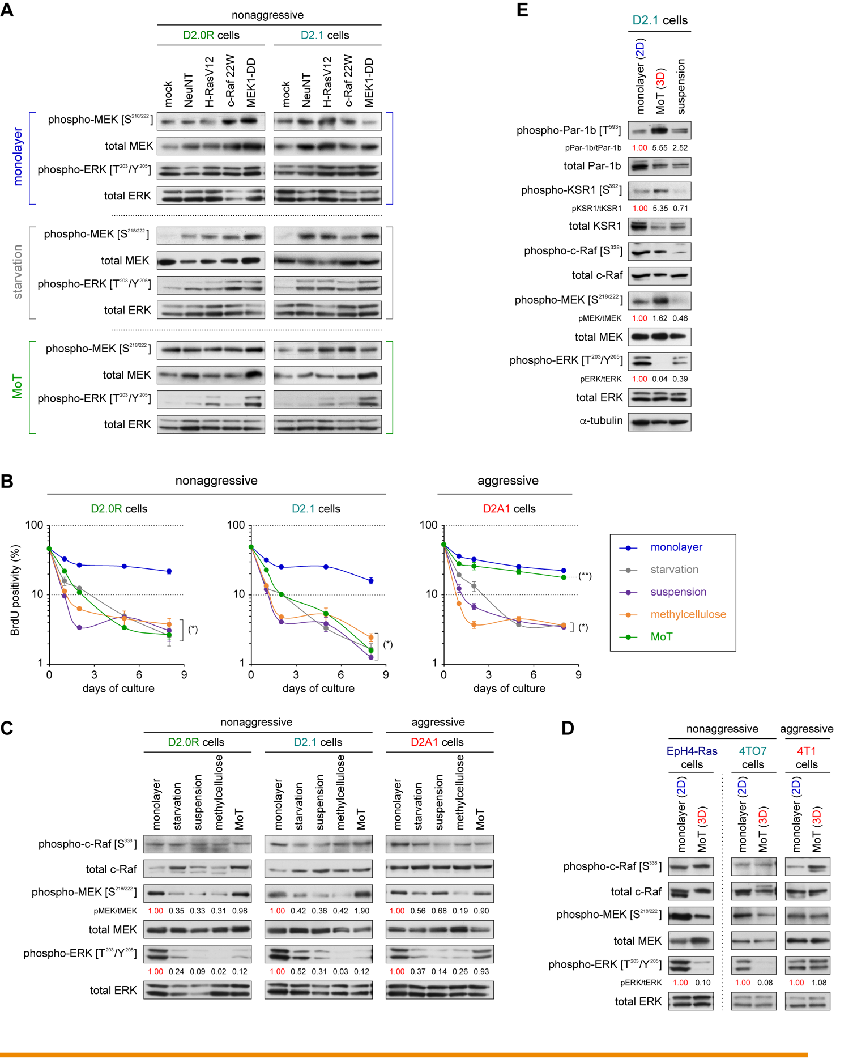

Supplementary Figure S3. MoT culture as an in vitro model system to study signaling in DTCs, related to Figures 1 and 2

(A) Attempts at experimentally forced activation of the Ras/ERK cascade under starvation and MoT conditions of culture. The nonaggressive D2.0R and D2.1 cells were engineered to express one of the constitutively active mutants of Ras/ERK cascade components. These included: (i) NeuNT, a mutant (V664E) of the HER2/Neu receptor tyrosine kinase; (ii) H-RasV12, a mutant (C12V) of H-Ras; (iii) c-Raf 22W, a truncated C-terminal kinase domain of c-Raf; and (iv) MEK1-DD, a phospho-mimetic mutant (S218D, S222D) of MEK1. These and the control (mock) cells were then propagated under either monolayer, starvation conditions or MoT conditions of culture for 5 days. Subsequently, cells were harvested and their lysates were analyzed by IB. This revealed that reduced ERK phosphorylation, observed in the D2.0R and D2.1 cells growing under the starvation conditions, was restored by any of the four constitutively active mutants of the Ras/ERK cascade components tested here. In contrast, only MEK1-DD, but not the other three constitutively active mutants, stimulated ERK phosphorylation when these nonaggressive cells were growing in the MoT conditions of culture. These differing effects between MEK1-DD and the other three constitutively active mutants of the Ras/ERK cascade components (i.e., NeuNT, H-RasV12 and c-Raf 22W) observed in MoT culture mirrored the observations made in vivo following the extravasation of these nonaggressive cells into the parenchyma of the lungs (see Fig. 1D). The results presented in A-C collectively provided a strong support for the utility of the MoT culture system for studying the signaling and behavior of carcinoma cells that have recently infiltrated the parenchyma of the lungs.
(B) Proliferation of three different D2 cell types under various conditions of in vitro culture. The three different D2 cell types were propagated under the monolayer culture conditions (DME/F12 with 2% horse serum) as well as in the four different model systems that may mimic the microenvironment of the lung parenchyma (starvation, suspension, methylcellulose, and Matrigel on-top [MoT]; see Supplementary Methods for the detailed conditions of these culture systems). The proliferation rates of these cells were measured by a BrdU incorporation assay at days 0, 1, 2, 5 and 8. This revealed that while all the four model systems tested here induced proliferative arrest of the nonaggressive D2.0R and D2.1 cells, only the MoT culture, but not the other three model systems, permitted rapid proliferation of the aggressive D2A1 cells while limiting the proliferation of the nonaggressive cells. Hence, differing proliferation rates of the aggressive and nonaggressive D2 cell types, observed upon extravasation of these various cell types into the parenchyma of the lungs in vivo (see Fig. 1B), were reproduced only in the MoT culture. (*) p < 0.005, (**) p = 0.02 (vs monolayer). Values = means ± SD (n = 3).
(C) Activation of kinase components of the Ras/ERK signaling cascade under various conditions of in vitro culture. The three different D2 cell types were propagated under various in vitro culture conditions as in A. Five days later, cells were harvested and their lysates were analyzed by IB. This revealed that all four conditions that induced proliferative arrest of the D2.0R and D2.1 cells – namely starvation, suspension, methylcellulose and MoT cultures, reduced the level of ERK phosphorylation in the D2.0R and D2.1 cells relative to the level observed when they were growing as a monolayer. However, with the exception of the MoT culture, the other three model systems also reduced the level of MEK phosphorylation in these nonaggressive cells. Hence, the discrepancy between MEK activity and ERK activity – i.e., “MEK active but ERK inactive” state, which was observed when these nonaggressive cells were residing in the lung parenchyma in vivo (see Fig. 1A), was reproduced only in the MoT culture. In addition, only the MoT culture, but not the other three culture systems, permitted the aggressive D2A1 cells to maintain a high level of ERK phosphorylation, again mirroring the observation made with these aggressive cells in vivo (see Fig. 1A). Hence, among the four strategies tested here, only the MoT culture successfully reproduced the activation patterns of various signaling proteins within the Ras/ERK cascade that were observed after the infiltration of the various D2 cell types into the parenchyma of the lungs in vivo.
(D) In vitro activity of the Ras/ERK signaling cascade components in various mouse mammary carcinoma cell types. The nonaggressive EpH4-Ras and 4TO7 cells, as well as the aggressive 4T1 cells, were propagated either under 2D monolayer or 3D MoT conditions of culture for 5 days. Subsequently, cells were harvested and their lysates were analyzed by IB. This revealed that the nonaggressive EpH4-Ras and 4TO7 cells, but not the aggressive 4T1 cells, exhibited reduced ERK phosphorylation specifically under the 3D MoT conditions of culture; this echoed the observation made when these cells were residing in the lung parenchyma in vivo (see Supplementary Fig. S2B).
(E) Differing phosphorylation levels of various signaling proteins between 3D MoT and suspension conditions of culture. The nonaggressive D2.1 cells were propagated in 2D monolayer, 3D MoT, or suspension conditions of culture for 5 days and their lysates were analyzed by IB. This revealed that the level of ERK phosphorylation was reduced in both 3D MoT culture and suspension culture, relative to the level observed in the 2D monolayer culture of the D2.1 cells. Intriguingly, however, this impaired ERK phosphorylation was accompanied by reduced phosphorylation of MEK only in suspension culture, but not in 3D MoT culture. In addition, the phosphorylation levels of KSR1 (on the S392 residue) and Par-1b (on the T593 residue) were much higher when these cells were growing under the 3D MoT condition of culture relative to the levels of phosphorylation observed in the suspension culture. These observations indicated that reduced ERK phosphorylation, observed both in 3D MoT culture and suspension culture, is caused by distinct mechanisms in these two culture conditions.

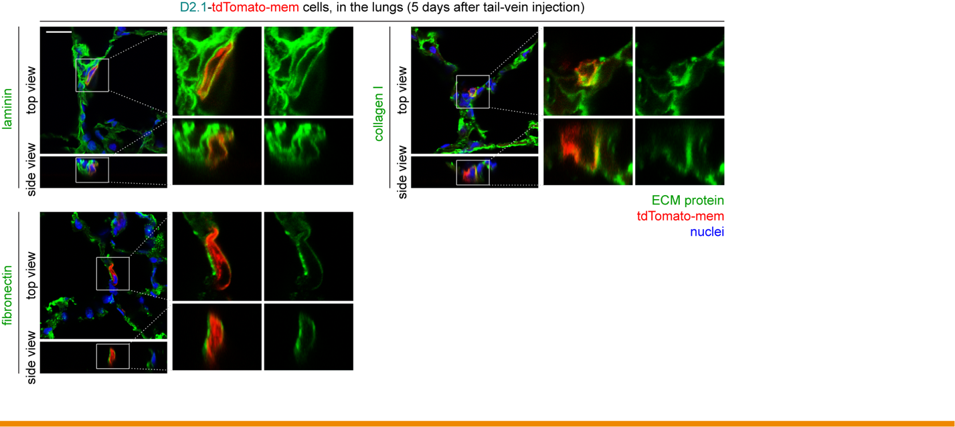

Supplementary Figure S4. ECM proteins in the lungs that surround recently-extravasated solitary DTCs, related to Figures 1 and 2

The D2.1-tdTomato-mem cells were injected into mice via the tail-vein. Five days later, lungs were harvested, frozen sectioned and stained for various ECM proteins (green) and the nuclei (blue). This revealed that the solitary D2.1-tdTomato-mem cells that were residing in the parenchyma of the lungs appeared to be surrounded, on all sides, by multiple different types of ECM proteins, including laminin, collagen I and fibronectin. Bar = 20 μm.

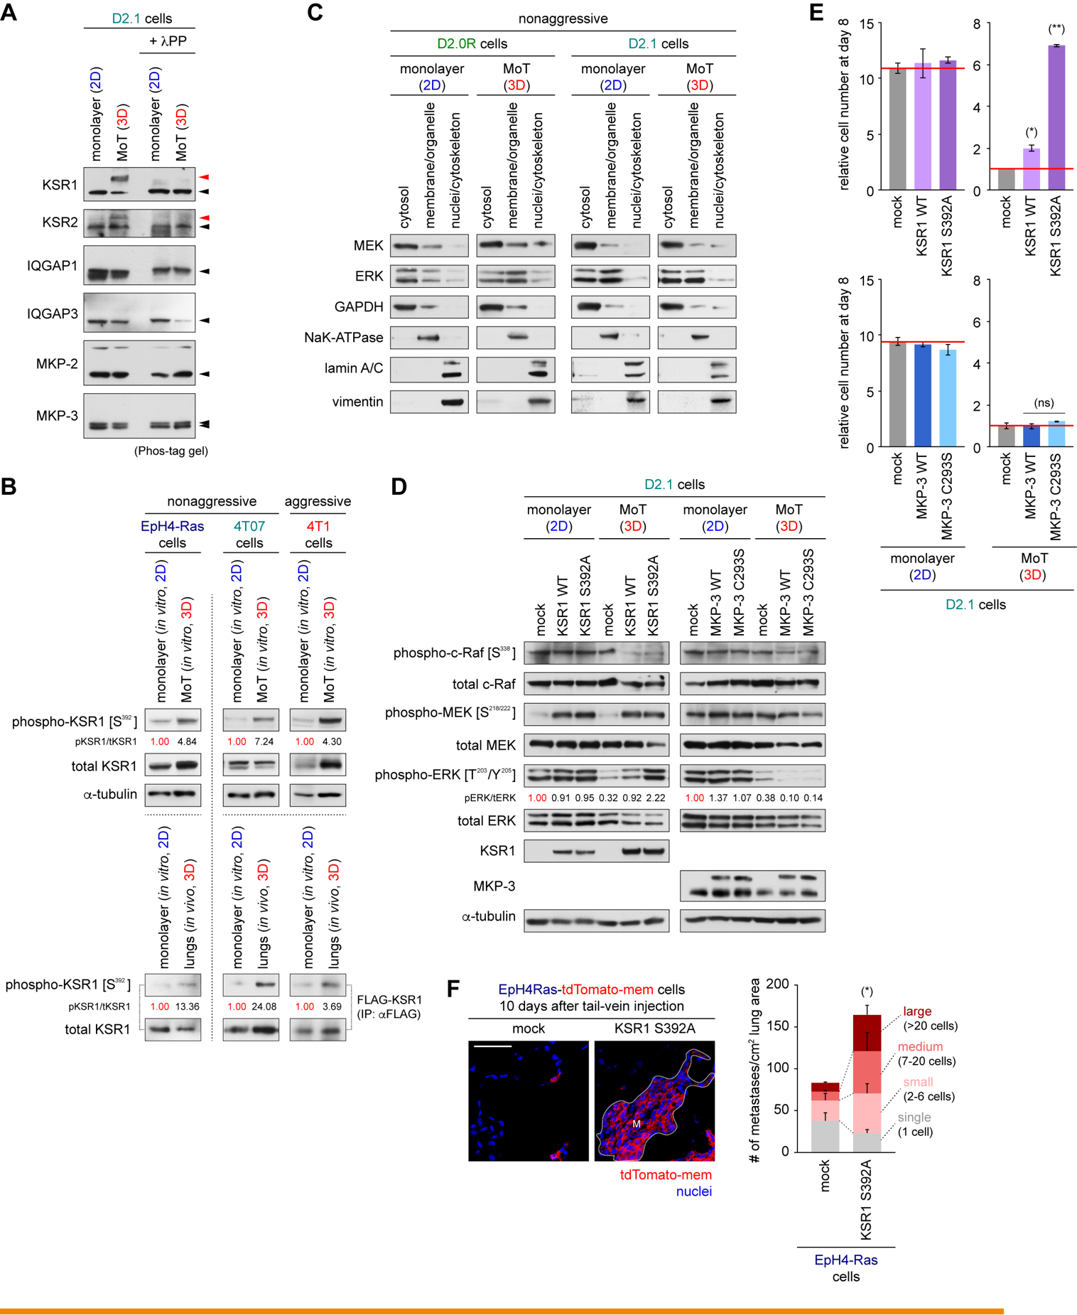

Supplementary Figure S5. KSR phosphorylation in nonaggressive/aggressive cancer cell types, related to Figure 2

(A) Phosphorylation of the potential controllers of the Ras/ERK signaling cascade. The nonaggressive D2.1 cells were propagated under either 2D monolayer or 3D MoT conditions of culture for 5 days, harvested and lysed. Aliquots of these lysates were treated with lambda protein phosphatase (+ λPP). Subsequently, both phosphatase-treated and -nontreated samples were analyzed by IB using a Phos-tag gel, which selectively retards phosphorylated proteins and thus separates them from their respective unmodified forms (Kinoshita et al. [2006], Mol Cell Proteomics 5:749). A slower migrating band (red arrowheads), corresponding to a phosphorylated form of the protein, was detected for both KSR1 and KSR2, specifically in the lysate of MoT-cultured cells but not in the lysate of monolayer-cultured cells. In contrast, slower migrating bands were not detectable for any of the IQGAP and MKP isoforms tested here. Black arrowheads indicate the bands corresponding to (a) nonphosphorylated form(s) of each protein.
(B) KSR1 phosphorylation in various mouse mammary carcinoma cell types. Top: The nonaggressive EpH4-Ras and 4TO7 cells and the aggressive 4T1 cells were propagated either under 2D monolayer or 3D MoT conditions of culture. Five days later, cells were harvested and their lysates were analyzed by IB. Bottom: The EpH4-Ras, 4TO7 and 4T1 cells, all expressing the FLAG-tagged KSR1 protein (FLAG-KSR1), were either propagated under monolayer culture or injected into Balb/c mice via the tail-vein. Five days later, cells (or lungs) were harvested, lysed and subsequently, FLAG-KSR1 was collected by anti-FLAG IP and analyzed by IB. This revealed that in all the three cell types tested here, the level of KSR1 S392 phosphorylation was elevated both while these cells were propagated under 3D MoT culture conditions in vitro and following their extravasation into the parenchyma of the lungs in vivo relative to the level observed when the respective cells were growing under the 2D monolayer culture in vitro.
(C) Subcellular distribution of marker proteins representing individual fractions in the experiment presented in Figs. 2E and 3E. The nonaggressive D2.0R and D2.1 cells were propagated either under 2D monolayer or 3D MoT conditions of culture. Five days later, these cells were fractionated into cytosol, membrane/organelle, and nuclei/cytoskeleton fractions and analyzed by IB.
(D, E) Effects of manipulating the functions of KSR1 and MKP-3 on ERK activation and proliferation of the D2.1 cells. D2.1 cells were engineered to express either the WT version of KSR1, a constitutively active mutant (S392A) of KSR1 (Muller et al. [2001], Mol Cell 8:983), the WT version of MKP-3, or a dominant-negative (C293S) mutant of MKP-3 (Muda et al. [1998], J Biol Chem 273:9323). In D, these and the control cells were propagated as indicated. Five days later, cells were harvested and their lysates were analyzed by IB. The expression of the KSR1 S392A mutant, but not the expression of MKP-3 C293S mutant, restored ERK phosphorylation in the D2.1 cells growing under the 3D MoT conditions of culture. In E, the same cell types were propagated as indicated for 8 days before the measurement of cell numbers. (*) p = 0.01, (**) p < 0.0001, (ns) p > 0.05 (vs mock).
(F) Effect of manipulating KSR1 function on metastatic colony formation by the EpH4-Ras cells. The EpH4-Ras-tdTomato-mem cells expressing the S392A mutant of KSR1, as well as control cells (mock), were injected into Balb/c mice through the tail-vein. The numbers and sizes of lung metastases formed by these cells at day 10 were scored as in Supplementary Fig. S2A. Bar = 50 μm. (*) p < 0.006 (vs mock; for combined abundance of medium and large metastases). M, large colony. Values = means ± SD (n = 3: E) or means + SD (n = 4: F).

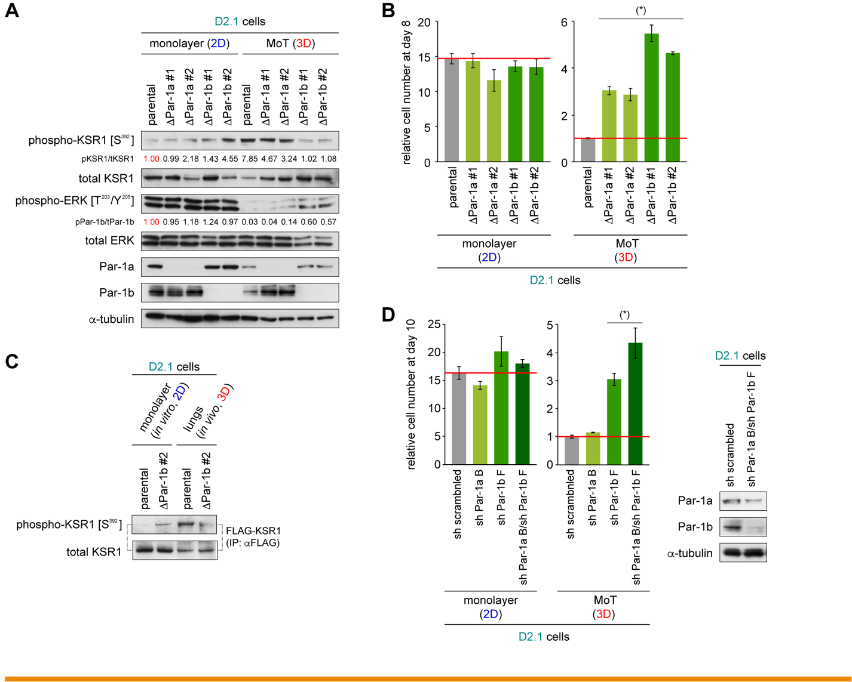

Supplementary Figure S6. Restoration of ERK activation and proliferation by genetic depletion of Par-1, related to Figure 3

(A, B) Effects of CRISPR/Cas9-mediated Par-1a or Par-1b knockout on intracellular signaling and cell proliferation. The parental D2.1 cells and the two independent knockout clones of the D2.1 cells for each the Par-1a (ΔPar-1a #1, 2) and Par-1b (ΔPar-1b #1, 2) were propagated under either 2D monolayer or 3D MoT conditions of culture. Five days later, cells were harvested and their lysates were analyzed by IB (A). This revealed that when growing under the 3D MoT conditions of culture, the D2.1-ΔPar-1a #1, 2 cells and D2.1-ΔPar-1b #1, 2 cells all exhibited reduced phosphorylation of KSR1 on the S392 residue – as represented by 41%, 59%, 87% and 86% reduction, respectively, in the phospho-KSR1 [S³⁹²] band intensity (following normalization against the respective band intensity of total KSR1) – relative to the level of phosphorylation observed in the parental D2.1 cells. The cell numbers were also measured after 8 days of culture (B). (*) p < 0.01 (vs parental).
(C) Functional contribution of Par-1b in enabling KSR1 S392 phosphorylation in vivo. The parental and ΔPar-1b #2 clone of the D2.1 cells were engineered to express the FLAG-Par-1b fusion protein. These cells were either propagated under monolayer cultures in vitro or injected into Balb/c mice via the tail-vein. Five days later, FLAG-par1b was collected from the lysate of the cells (or t7he lungs) by IP and subsequently analyzed by IB. This indicated the critical role of Par-1b in enabling elevated phosphorylation of KSR1 on its S392 residue when the nonaggressive D2.1 cells were residing in the parenchyma of the lungs.
(D) Effects of short-hairpin RNA (shRNA)-mediated Par-1a and Par-1b knockdown on cell proliferation. The D2.1 cells expressing shRNA against Par-1a (sh Par-1a B), Par-1b (sh Par-1b F), both of these Par-1a/Par-1b shRNAs (sh Par-1a B/sh Par-1b F), or control shRNA (sh scrambled) were propagated under either 2D monolayer or 3D MoT conditions of culture. The cell numbers were measured after 10 days of culture (left). The levels of Par-1a/Par-1b knockdown were measured by IB (right). This observation, together with the result shown in B, indicated that multiple genetic strategies to deplete Par-1b (and Par-1a) result in enhanced proliferation of the otherwise-nonaggressive D2.1 cells specifically when they are propagated under the 3D MoT conditions of culture. (*) p < 0.002 (vs sh scrambled). Values = means ± SD (n = 3: B, D).

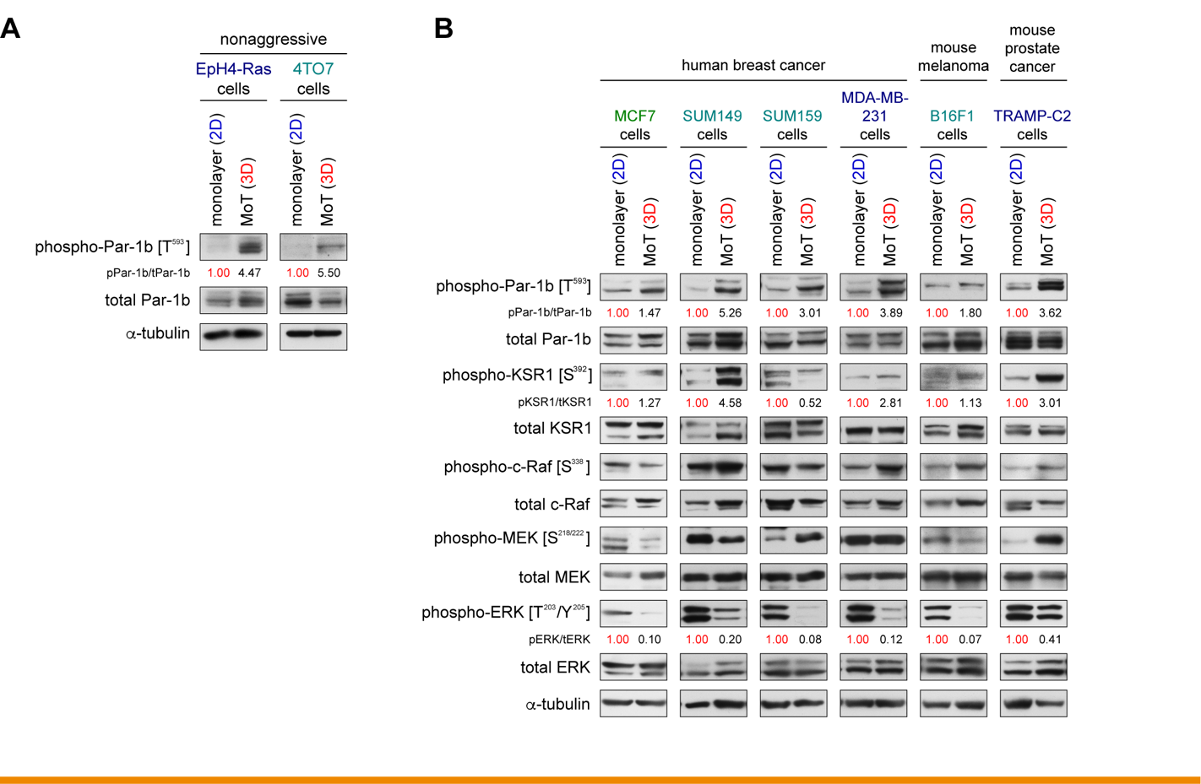

Supplementary Figure S7. Par-1:KSR:Ras/ERK signaling in various cell line models, related to Figure 3

(A) Phosphorylation of Par-1b in two nonaggressive mouse mammary carcinoma cell types. The nonaggressive 4TO7 and EpH4-Ras cells were propagated either under 2D monolayer or 3D MoT conditions of culture. Five days later, cells were harvested and their lysates were analyzed by IB. This revealed that both cell types exhibited a higher level of Par-1b T593 phosphorylation when growing under the 3D MoT conditions of culture than they did under 2D monolayer culture.
(B) Phosphorylation of Par-1b, KSR1, and the kinase components of the Ras/ERK signaling cascade in various cell line models. The human breast cancer cell lines MCF7, SUM149, SUM159, MDA-MB-231, mouse melanoma cell line B16F1, as well as mouse prostate cancer cell line TRAMP-C2, were propagated either under 2D monolayer or 3D MoT conditions of culture. Five days later, cells were harvested and their lysates were analyzed by IB. Elevated phosphorylation of Par-1b (on T593 [T595 for human cells]; > 2-fold increase in 4 out of 6 cell lines) and KSR-1 (on S392 [S406 for human cells]; > 2-fold increase in 3 out of 6 cell lines) as well as reduced phosphorylation of ERK (> 2-fold decrease in 6 out of 6 cell lines) were commonly observed specifically when these cells were growing under the 3D MoT conditions of culture, relative to the phosphorylation levels of respective proteins observed in 2D monolayer culture.

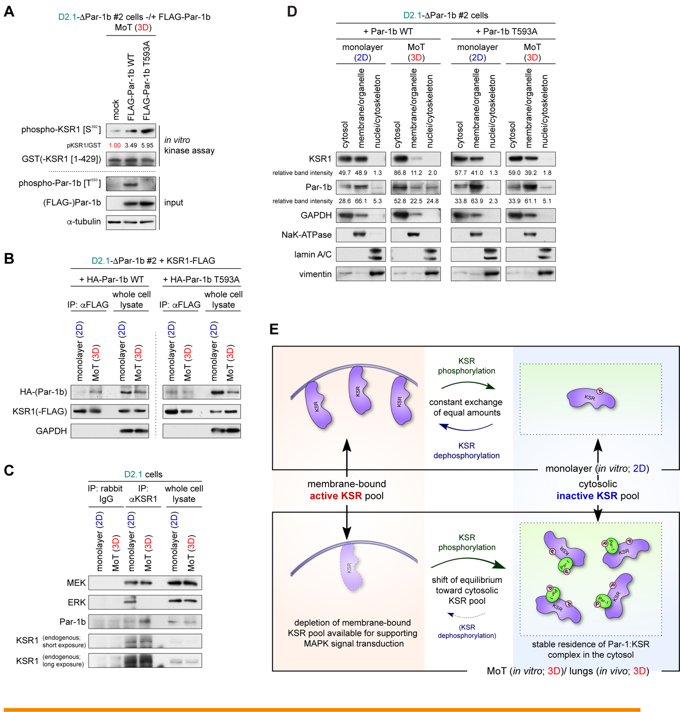

Supplementary Figure S8. Par-1b phosphorylation and its effect on KSR:Ras/ERK signaling, related to Figure 3

(A) Effect of Par-1b T593A mutation on the activity of the Par-1b kinase to phosphorylate its KSR1 substrate. One of the Par-1b knockout clones of the D2.1 cells (ΔPar-1b #2) was engineered to express either the WT version or nonphosphorylatable mutant (T593A) of Par-1b, both of which were FLAG-tagged. These and the empty vector-expressing cells (mock) were then propagated under the 3D MoT conditions of culture. Five days later, cells were harvested, lysed and the FLAG-Par-1b protein was collected by anti-FLAG IP. Subsequently, the ability of the precipitates to phosphorylate a GST-tagged, N-terminal fragment of KSR1 (GST-KSR1 [1-429]) was assessed by an in vitro kinase assay (top). This revealed that the nonphosphorylatable T593A mutant was even more competent than its WT counterpart in phosphorylating the S392 residue of GST-KSR1 [1-429] (1.7-fold increase in phospho-KSR1 [S³⁹²] band intensity). Hence, the T593 mutation of Par-1b does not impair the intrinsic kinase activity of Par-1b to phosphorylate KSR1. The expression of FLAG-Par-1b protein and the phosphorylation on the T593 residue of this fusion protein were also examined by an IB analysis of the input lysates (bottom).
(B) Effect of Par-1b T593A mutation on the physical interactions between Par-1b and KSR1. The D2.1-ΔPar-1b #2 cells were engineered to express FLAG-tagged KSR1 protein (KSR1-FLAG). Subsequently, these cells were manipulated further to express either WT version or the T593A mutant of HA-tagged Par-1b (HA-Par-1b). These cells were then propagated under either 2D monolayer or 3D MoT conditions of culture. Five days later, cells were harvested and the lysates were subjected to anti-FLAG IP. The abundance of HA-Par-1b protein coprecipitated with KSR1-FLAG, as well as the abundance of HA-Par-1b protein within the input lysates (whole cell lysate), was analyzed by anti-HA IB. Whole cell lysate represents 10% of the amount of lysate used for the IP reaction.
(C) Interactions between endogenous KSR1 and its binding partners. The D2.1 cells were propagated as indicated for 5 days. Lysates of these cells were subjected to IP with an anti-KSR1 antibody or a rabbit IgG negative control and both the precipitates and whole cell lysates were analyzed by IB. This revealed that when the D2.1 cells were growing under the 3D MoT condition of culture, endogenously expressed KSR1 protein bound strongly with Par-1b but not detectably with ERK. In contrast, in the D2.1 cells that were propagated as a 2D monolayer, the endogenous KSR1 protein attached strongly to ERK and only weakly to Par-1b. These results mirrored the observations made with exogenously expressed FLAG-tagged KSR1 (see Fig. 3C)
(D) Effect of Par-1b T593 phosphorylation on its subcellular localization. A clone of Par-1b-knockout D2.1 cells (D2.1-ΔPar-1b #2 cells) were engineered to express either WT version or nonphosphorylatable T593A mutant of Par-1b. These engineered cells were propagated as indicated for 5 days and then subjected to subcellular fractionation as in Supplementary Fig. S5C. Relative band intensities of Par-1b and KSR1 in individual fractions are also indicated. This revealed that, when the D2.1 cells were growing under the 3D MoT condition of culture, the WT version of Par-1b primarily relocated to the cytosol while the Par-1b T593A mutant failed to do so, being predominantly present in the membrane/organelle fraction. In contrast, when the D2.1 cells were growing under the 2D monolayer culture condition, both WT version and T593A mutant of Par-1b were distributed mainly in the membrane/organelle fraction. Hence, only WT Par-1b, but not the non-phosphorylatable T593A mutant of Par-1b, undergoes eviction from the plasma membrane into the cytosol in the D2.1 cells growing under the 3D MoT culture condition.
(E) Hypothetical model on the shift of the equilibrium between the plasma membrane-bound, active pool of KSR proteins and the cytosolic, inactive pool of KSR proteins that is formulated on the basis of present and previously published experimental evidence. When the nonaggressive carcinoma cells were growing under the 2D monolayer culture conditions, the KSR scaffolding proteins are phosphorylated and dephosphorylated at equal rates, resulting in an equilibrium between plasma membrane-bound pool of non-phosphorylated (and active) KSR proteins and cytosolic pool of phosphorylated (and inactive) KSR proteins (Lavoie et al. [2015], Nat Rev Mol Cell Biol 16:281) (top). However, when propagated in 3D MoT culture or upon extravasation into the parenchyma of the lungs, the Par-1 kinase is evicted from the plasma membrane into the cytosol and subsequently binds strongly to its KSR substrate in the cytosol (see B-D). This in turn causes the phosphorylation of KSR and the stable residence of Par-1:KSR complex in the cytosol, shifting the equilibrium between these two pools of KSR proteins toward the cytosolic (with phosphorylated, inactive KSR proteins) pool (bottom). This shift of equilibrium in the KSR protein pools results in the depletion of the KSR proteins that are available at the plasma membrane for supporting the flow of signaling through the Ras/ERK cascade, ultimately causing defects in ERK activation and proliferation.

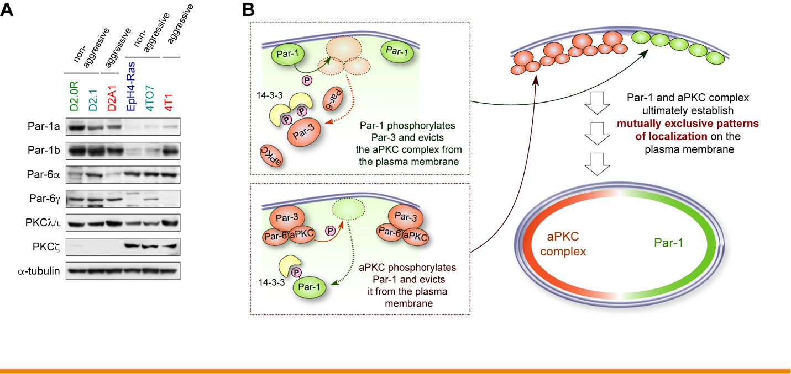

Supplementary Figure S9. Function and expression of polarity-regulating proteins, related to Figure 4

(A) Expression levels of the regulators of cell polarity in various mouse mammary carcinoma cell types. The lysates of the three different D2 cell types, as well as those of EpH4-Ras, 4TO7 and 4T1 cells were analyzed by IB. PKCλ/ι is the major aPKC isoform expressed in the nonaggressive D2.1 cells.
(B) Schematic of the reported molecular controls of cell polarity. Multiple different types of cell polarity are governed by the mutually exclusive localization patterns on the plasma membrane of Par-1 and the aPKC complex. This scheme is based on previously-reported observations (St Johnston and Ahringer [2010], Cell 141:757).

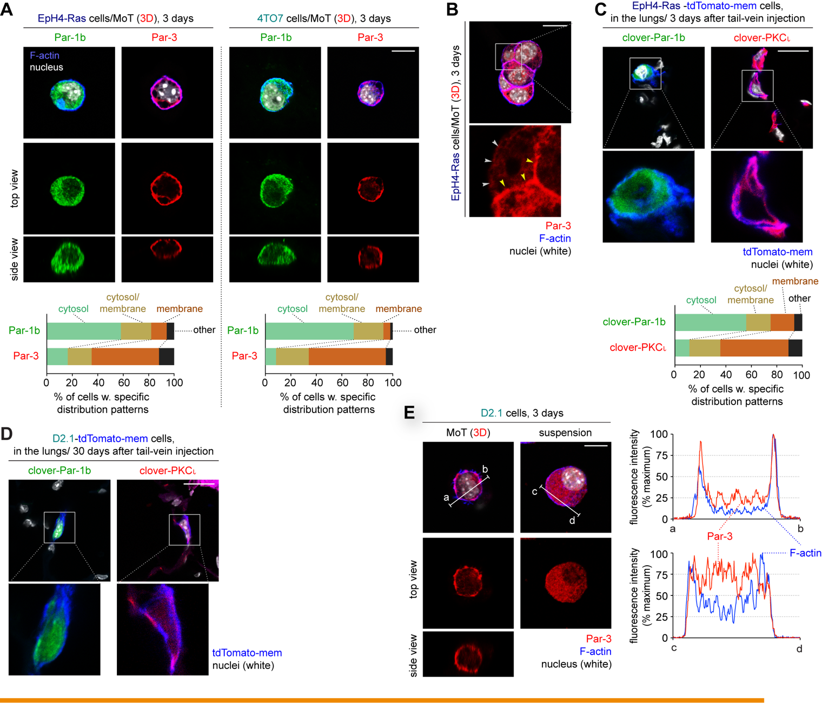

Supplementary Figure S10. Distribution of polarity-regulating proteins in 3D conditions, related to Figure 4

(A-D) Subcellular localization of Par-1b and Par-3 in the nonaggressive mouse mammary carcinoma cells. In A, the nonaggressive EpH4-Ras and 4TO7 cells were propagated under the 3D MoT conditions of culture for 3 days and immunostained for Par-1b (green) and Par-3 (red). The actin cytoskeleton (F-actin; blue) and the nuclei (white) were also visualized. In addition, the patterns of Par-1b and Par-3 localization were classified into four different classes (“cytosol”, “cytosol/membrane”, “membrane” and “other”; see ‘Supplementary Methods’) and plotted (bottom). n ≒ 300. Note that a small fraction of the cells that developed multicellular clumps within the 3 days of culture exhibited enrichment of Par-3 staining only at the cell-cell junctions (B, yellow arrowheads) without detectably displaying Par-3 accumulation on the side of the plasma membrane region facing the outer side of the clump (B, gray arrowheads). These cells were classified into the “other” category. This pattern was more evident in the EpH4-Ras cells than in the 4TO7 and D2.1 cells, and represented 10.0%, 3.6%, 3.4% of the total cells scored for EpH4-Ras, 4TO7, and D2.1 cells, respectively, in Fig. 4C and Supplementary Fig. S10A. In C and D, the EpH4-Ras-tdTomato-mem cells (C) and the D2.1-td-Tomato-mem cells (D) were engineered to express either clover-Par-1b or clover-PKCι fluorescent fusion protein. These cells were then injected into Balb/c mice via the tail-vein. Three (C) and 30 (D) days later, lungs were harvested, sectioned and stained for the nuclei (white). In C, the patterns of clover-Par-1b localization and those of clover-PKCι localization in individual cells were subsequently classified into four different classes as in A (bottom). n ≒ 200. This revealed that in all the three cases tested here, Par-1b (or the clover-Par-1b fusion protein for C) was primarily dispersed evenly in the cytosol, while the components of the aPKC complex (Par-3 for A and clover-PKCι for C and D) were mostly distributed throughout the plasma membrane. Moreover, these localization patterns of various cell polarity-regulating proteins persisted for as long as 30 days after the infiltration by the cancer cells of the lung parenchyma of host mice (D). This suggested that the anti-proliferative signaling machinery described here, which is driven by the Par-1 kinase evicted into the cytosol, contributes not only to the initial induction of proliferative arrest in the recently extravasated cancer cells, but also to the persistent, long-term maintenance of their quiescence.
(E) Lack of Par-3 accumulation to the plasma membrane in suspension culture. The nonaggressive D2.1 cells were propagated either under 3D MoT or suspension condition of culture for 3 days and subjected to immunostaining for Par-3 (red). For the suspension-cultured cells, cells were forced to attach to the surface of a glass slide by cytospin prior to immunostaining (see Supplementary Methods). The actin cytoskeleton (F-actin; with phalloidin; blue) and the nuclei (white) were also visualized. Plotted is the fluorescence intensity along the indicated lines (a-b and c-d; bottom). While Par-3 accumulated strongly at the plasma membrane when the D2.1 cells were growing under the 3D MoT condition of culture, this protein exhibited, in contrast, diffuse cytosolic localization when these cells were propagated in a suspension culture. This observation, when taken together with the result shown in Supplementary Fig. S3E, indicated that the mechanism that blocks Ras/ERK signaling and thus cell proliferation when the D2.1 cells are growing under the 3D MoT culture condition – the mechanism involving the accumulation of aPKC complex to the plasma membrane as well as elevated phosphorylation of the Par-1b kinase and KSR scaffolds – is not operational when these cells are propagated in a suspension culture. This, in turn, supported the notion that ECM proteins that surround nonaggressive cells in 3D ECM conditions (including the 3D MoT culture in vitro and following extravasation into the parenchyma of foreign tissues in vivo), but not in the suspension culture, contribute critically to the activation of this anti-proliferative signaling machinery. Bars = 10 μm (A, E) or 20 μm (B-D).

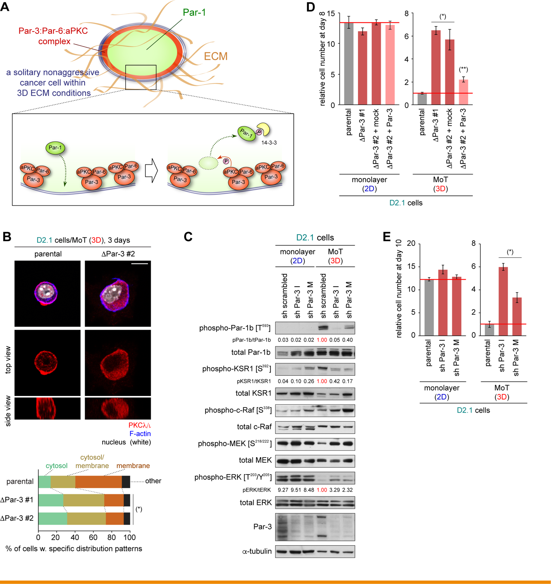

Supplementary Figure S11. Restoration of ERK activation and proliferation by genetic depletion of Par-3, related to Figure 5

(A) Model of the behaviors of the aPKC complex and Par-1 on the plasma membrane of nonaggressive cancer cells growing under the 3D ECM conditions. When nonaggressive carcinoma cells are growing under the 3D ECM conditions, i.e., under the 3D MoT conditions of culture in vitro or following extravasation into the parenchyma of the lungs in vivo, the entire inner surface of the plasma membrane appears to be occupied by the components of the aPKC complex, including Par-3, Par-6 and atypical PKC (see Figs. 4C-4E, Supplementary Figs. S10A, S10C, S10D). This results in the aPKC-dependent phosphorylation of the Par-1 kinase (T593 of Par-1b and presumably T564 [a threonine residue on Par-1a equivalent to T593 of Par-1b] of Par-1a) and resulting eviction of Par-1 from the plasma membrane into the cytosol (see Supplementary Fig. S9B). Ultimately, the continuous eviction of Par-1 into the cytosol from the plasma membrane results in the accumulation of this kinase in the cytosol.
(B) Effects of Par-3 knockout on the subcellular localization of PKCλ/ι. Parental D2.1 cells and the two independent clones of Par-3 knockout (ΔPar-3 #1, 2) D2.1 cells were propagated under the 3D MoT conditions of culture for 3 days and immunostained for PKCλ/ι (red). The actin cytoskeleton (F-actin; blue) and the nuclei (white) were also visualized (top; only the parental D2.1 cells and the D2.1-ΔPar-3 #2 cells are shown here). In addition, the localization patterns of PKCλ/ι were scored for individual cells as in Supplementary Fig. S10A (bottom). n ≒ 300. This observation, together with the result shown in Fig. 5B, revealed that Par-1b was dispersed throughout the cytosol without accumulating on the plasma membrane in the majority (> 68%) of the parental D2.1 cells, while this pattern of Par-1b localization was observed only in the minority (< 20%) of the Par-3 knockout D2.1 cells. In addition, PKCλ/ι was primarily distributed evenly on the plasma membrane without detectably accumulating in the cytosol in the parental D2.1 cells (> 50% of cells displayed this pattern), whereas this pattern of PKCλ/ι localization was observed in less than 22% of Par-3 knockout D2.1 cells. These results support the notion that Par-3 contributes critically to the control of subcellular localization of various cell polarity-regulating proteins when the nonaggressive D2.1 cells are propagated under the 3D MoT conditions of culture, and perhaps more broadly in many nonaggressive carcinoma cell types specifically when they are growing under the 3D ECM conditions. (*) p < 4 × 10⁻¹³ (vs parental; by Fisher’s exact test). Bar = 10 μm.
(C) Effect of short-hairpin RNA (shRNA)-mediated Par-3 knockdown on Par-1:KSR:Ras/ERK signaling. The nonaggressive D2.1 cells were engineered to express shRNA against Par-3 (sh Par-3 I and sh Par-3 M; two different shRNA sequences against Par-3 were tested). These and the control (sh scrambled) cells were propagated under either 2D monolayer or 3D MoT conditions of culture. Five days later, cells were harvested and their lysates were analyzed by IB.
(D) Effect of Par-3 knockout on the proliferation of the D2.1 cells. Parental D2.1 cells and two clones of Par-3-knockout (ΔPar-3 #1, 2) D2.1 cells, one of which (#2) was manipulated further to ectopically express either Par-3 or a mock vector, were propagated as indicated for 8 days before the measurement of cell numbers. Values = means ± SD (n = 3). (*) p < 0.02 (vs parental), (**) p < 0.02 (vs ΔPar-3 #2 + mock).
(E) Effect of short-hairpin RNA (shRNA)-mediated Par-3 knockdown on the proliferation of the D2.1 cells. The Par-3 knockdown (sh Par-3 I, M) and the control (sh scrambled) D2.1 cells described in C were propagated under either 2D monolayer or 3D MoT conditions of culture for 10 days before the measurement of cell numbers. These observations were consistent with the results obtained by CRISPR/Cas9-mediqated knockout of Par-3 (Fig. 5A, Supplementary Fig. S11D). Hence, multiple genetic manipulations to deplete Par-3 reduce the phosphorylation of Par-1b, KSR1, enhances the phosphorylation of ERK and ultimately enables rapid proliferation of the otherwise-nonaggressive D2.1 cells when these cells were growing under the 3D MoT conditions of culture. (*) p < 0.002 (vs sh scrambled). Values = means ± SD (n = 3: D, E).

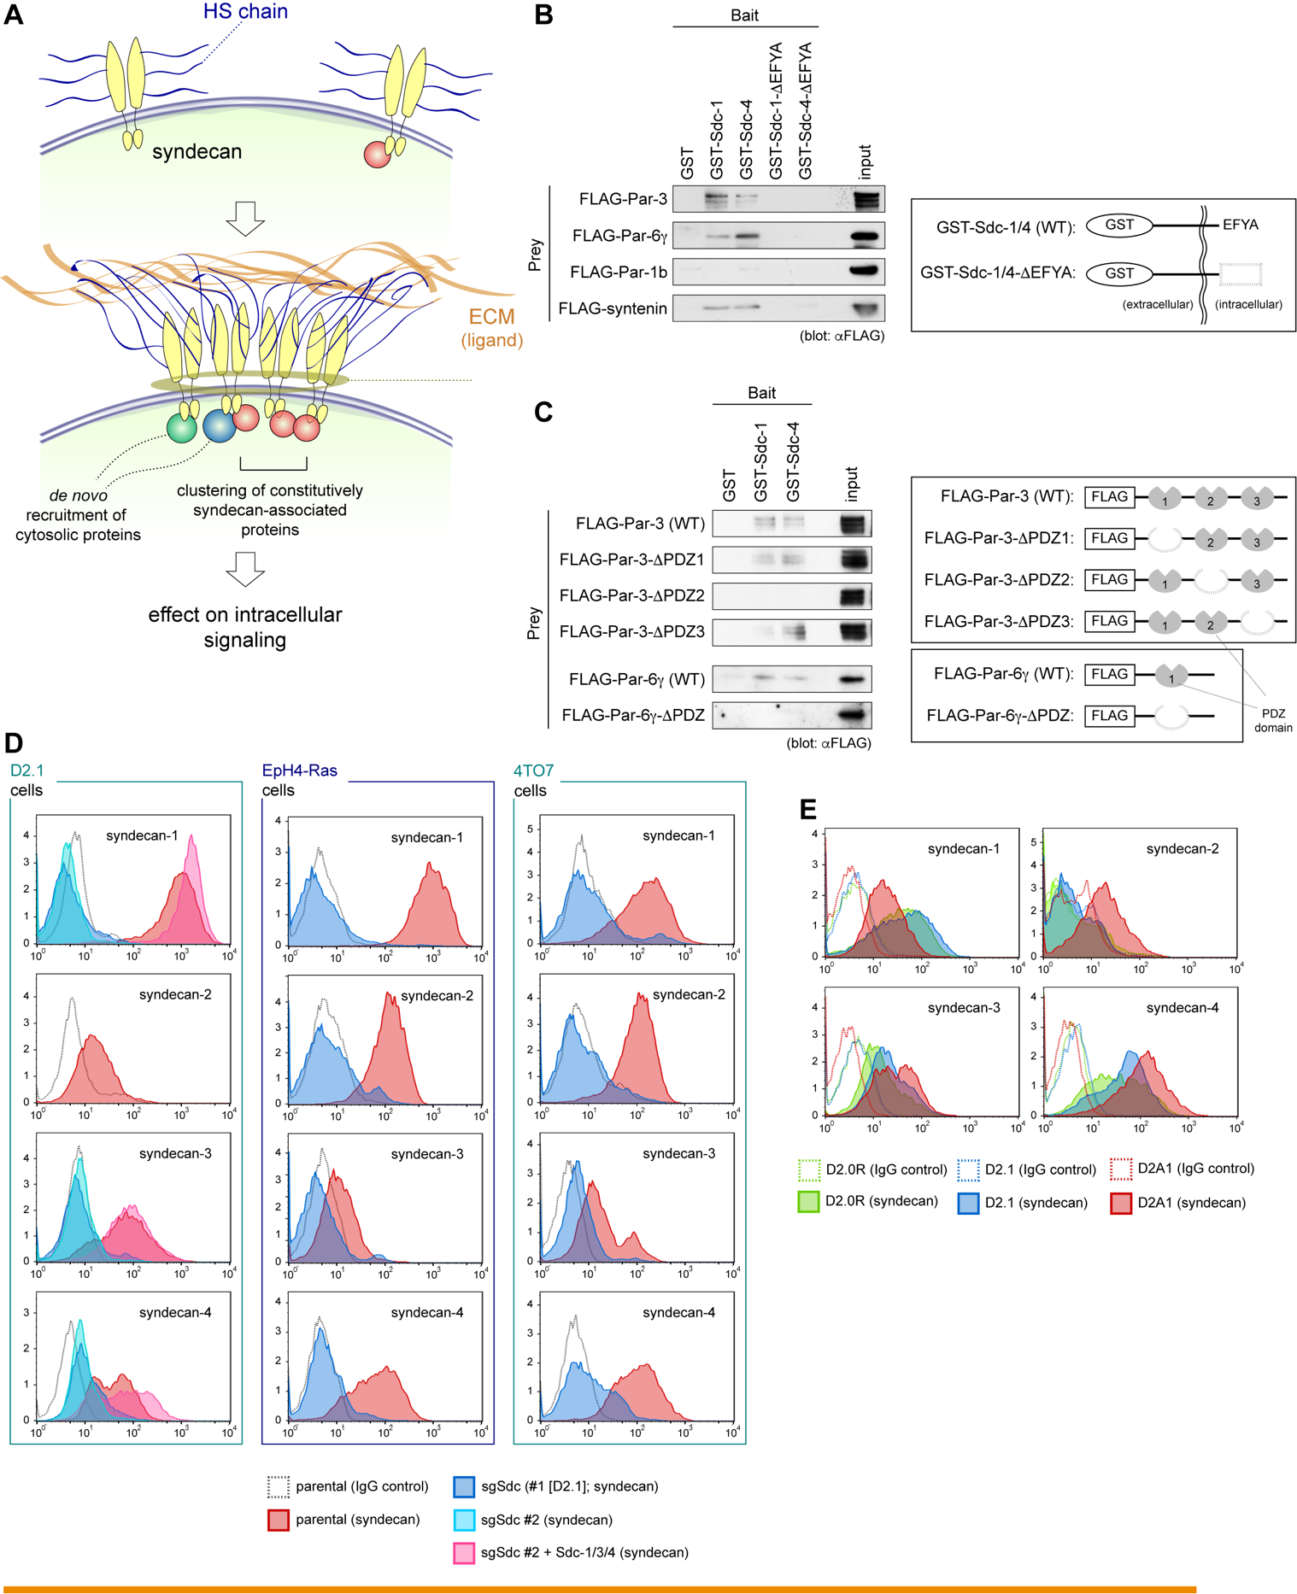

Supplementary Figure S12. Syndecans as crucial cell-surface sensors for the 3D ECM configuration, related to Figure 6

(A) Syndecans as cell-surface receptors for various ECM proteins. Syndecans recognize various extracellular proteins through the interactions mediated by the heparan sulfate (HS) chains that are covalently attached to their ectodomains. These extracellular ligands of syndecans include, among others, various ECM proteins such as collagen, fibronectin, laminin and tenascin. All the different syndecan isoforms possess the same tetrapeptide motif (E-F-Y-A) in their cytoplasmic tails, and through this motif, syndecans contribute to the recruitment of various PDZ domain-harboring cytosolic proteins to the plasma membrane. Ligand binding to the HS chains attached to syndecans appears to cause a high-order oligomerization of the syndecan core proteins, which in turn alters the patterns of syndecan-dependent (and EFYA:PDZ interaction-dependent) recruitment of cytosolic proteins to the plasma membrane, ultimately affecting intracellular signaling (Couchman [2010], Annu Rev Cell Dev Biol 26:89). However, the details of this syndecan-mediated signaling, in particular how the binding of ECM proteins to the HS chains attached to syndecans regulates signaling processes, remain largely obscure. Our present results indicate that when nonaggressive carcinoma cells are surrounded on all sides by the ECM proteins, syndecan-mediated ligation of ECM proteins results in the recruitment of the Par-3:Par-6:aPKC complex (or aPKC complex) to the entire inner surface of the plasma membrane that is caused, in part, by the EFYA:PDZ interaction-dependent association of syndecan-1/4 with Par-3/6γ (Figs. 4C-E, 5D, 6B, Supplementary Figs. S12B, S12C). This syndecan-dependent recruitment of the aPKC complex to the plasma membrane also appears to occur when the D2.1 cells are growing under the 2D monolayer culture condition (see Fig. 5D). This recruitment fails to cause, however, the accumulation of the aPKC complex to the entire inner surface of the plasma membrane in the 2D monolayer culture (Figs. 3E, 4B), which is likely due to the fact that these cells interact with ECM proteins only on their bottom/ventral surface under the monolayer culture condition. Hence, ECM-syndecan ligation – a potential prerequisite for syndecan-dependent recruitment of aPKC complex – is also likely to happen only on the bottom/ventral side of the cells.
(B, C) Physical interactions between Par-3/6γ and syndecan-1/4. In B, recombinant GST-tagged syndecan-1 and syndecan-4 (GST-Sdc1/4) fusion proteins and their respective mutants lacking the C-terminal EFYA tetrapeptide motif (GST-Sdc1/4-ΔEFYA), as well as control GST protein, were incubated with the lysates of 293FT cells expressing the indicated FLAG-tagged proteins. In C, GST-Sdc1/4 and the control GST protein were incubated with the lysates of 293FT cells expressing various versions of FLAG-tagged Par-3 or Par-6γ proteins (see right diagram). In both cases, the lysates were subsequently subjected to GST pull-down and analyzed by anti-FLAG IB. Input represents 5% of the amount of lysate used in the pull-down assay. This indicated the physical interactions between syndecan-1/4 and Par-3, Par-6γ, which is mediated largely by the direct binding of the EFYA motif in the cytoplasmic tails of syndecans to the second PDZ domain (PDZ2) and the only PDZ domain of Par-3 and Par-6γ, respectively.
(D) Syndecan knockout in various nonaggressive mouse mammary carcinoma cell types. The levels of cell-surface expression of the four syndecan isoforms were tested in the nonaggressive D2.1, EpH4-Ras and 4TO7 cells and their derivatives. Syndecan knockout cells (ΔSdc) were generated via the CRISPR/Cas9 system. Briefly, transient expression of both the Cas9 endonuclease and short-guide RNA (sgRNA) was used to generate syndecan triple-knockout (ΔSdc-1, -3, -4) D2.1 cells, while lentivirus-mediated expression of Cas9 and sgRNA was used to generate syndecan quadruple-knockout (ΔSdc-1, -2, -3, -4) EpH4-Ras and 4T07 cells (see ‘Supplementary Methods’). Given the naturally low level of syndecan-2 expression in the D2.1 cells, syndecan-2 was not knocked out from these cells. One of the two resulting syndecan triple-knockout clones (#2) of D2.1 cells was subsequently engineered further to ectopically express either mock vectors (ΔSdc #2 + mock) or syndecan-1, -3 and -4 (ΔSdc #2 + Sdc-1/3/4).
(E) Cell-surface expression of syndecans by the three different D2 cell types. The nonaggressive D2.0R and D2.1 cells as well as the aggressive D2A1 cells, all of which were growing under the 3D MoT conditions of culture, were tested by flow cytometry for the expression of four syndecan isoforms (syndecan-1 to -4) on their cell surface. The aggressive D2A1 cells exhibited slightly lower expression level of syndecan-1 (57% reduction in mean fluorescence intensity [MFI]), and slightly higher expression levels of the other three syndecan isoforms (syndecan-2, 3, and 4; 3.0, 2.6 and 1.3-fold increase, respectively, in MFI) on their cell surface than the expression levels of corresponding syndecan isoforms observed in the nonaggressive D2.1 cells. However, for all the four different syndecan isoforms, the MFIs measured in the nonaggressive D2.0R and D2.1 populations were both within one standard deviation of the corresponding fluorescence intensity gauged in the aggressive D2A1 population. Hence, the aggressive D2A1 cells exhibit a level of syndecan expression comparable with the levels expressed by their nonaggressive counterparts (i.e., D2.0R and D2.1 cells).

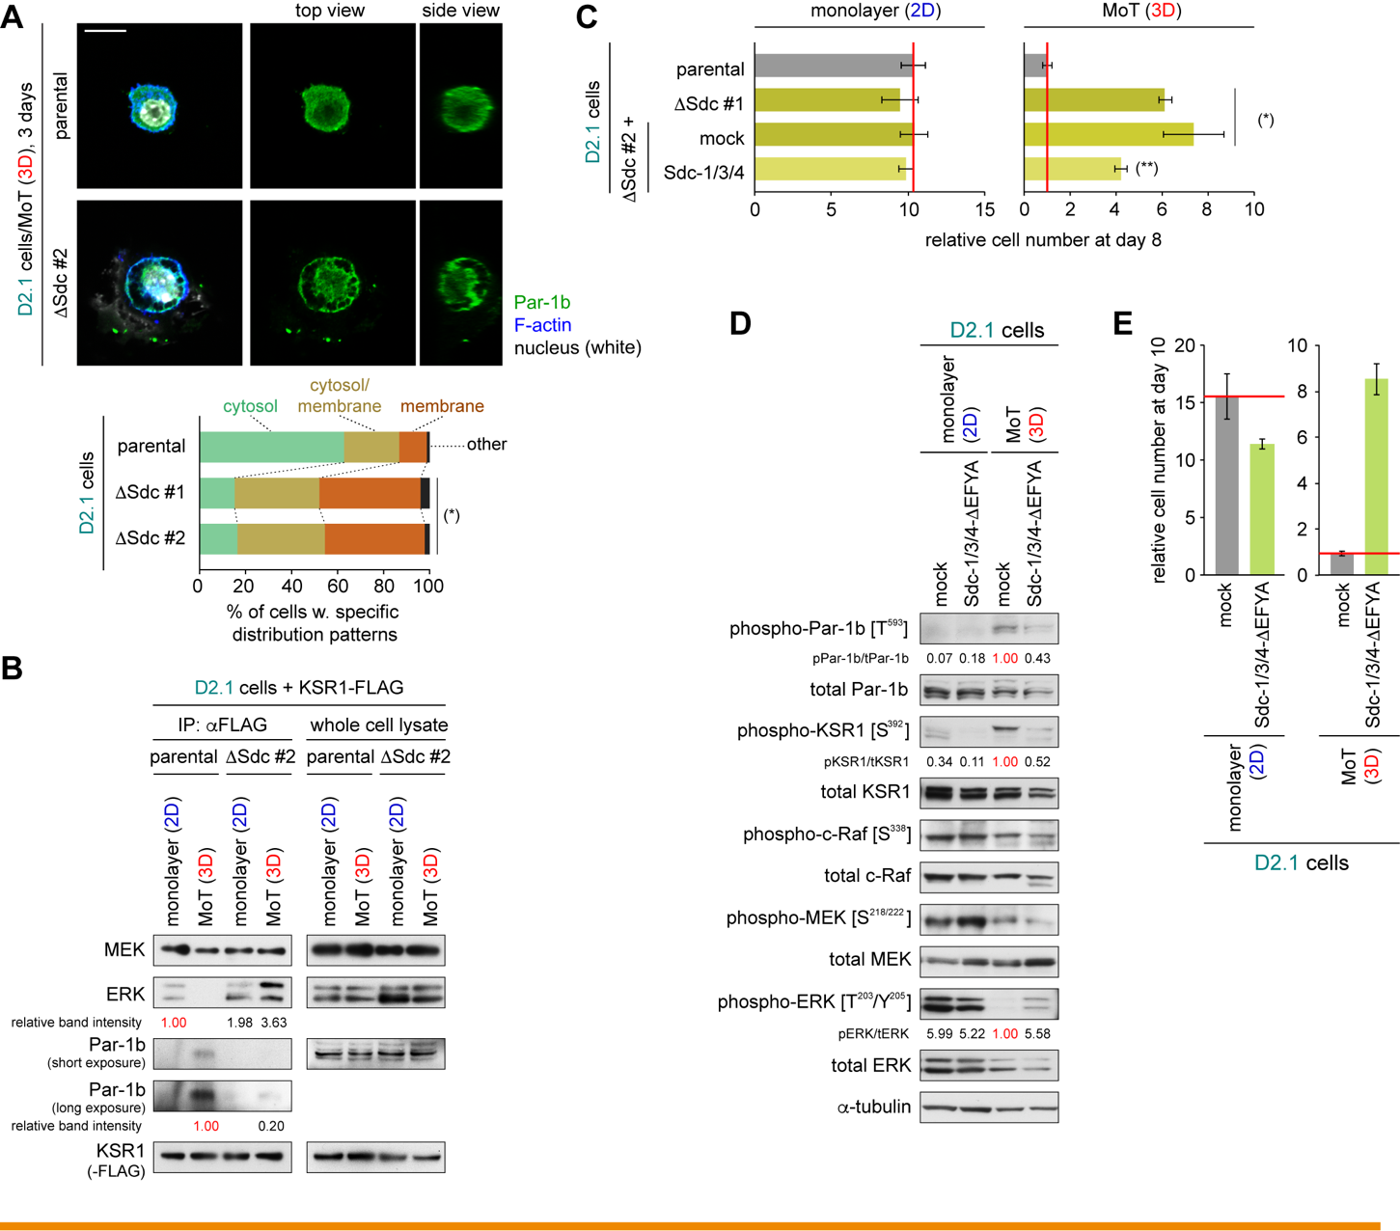

Supplementary Figure S13. Functional role of syndecans in regulating D2.1 cell behaviors in 3D conditions, related to Figure 6

(A) Effects of syndecan knockout on subcellular localization of Par-1b. The parental D2.1 cells and the two syndecan-1/3/4 knockout clones (ΔSdc #1, 2) of the D2.1 cells were propagated under the 3D MoT conditions of culture for 3 days and stained for Par-1b (green), F-actin (blue) and the nuclei (white) (top). Subsequently, the patterns of Par-1b localization were scored for individual cells (bottom). n ≒ 300. This revealed that Par-1b was dispersed throughout the cytosol without accumulating on the plasma membrane in the majority (> 62%) of the parental D2.1 cells, while this pattern of Par-1b localization was observed only in the minority (< 17%) of the syndecan knockout D2.1 cells. Bar = 10 μm. (*) p < 3 × 10⁻¹⁶ (vs parental; by Fisher’s exact test).
(B) Effects of syndecan knockout on KSR1:Par-1b interactions. The parental and a syndecan knockout (ΔSdc #2) versions of D2.1 cells were both engineered to express FLAG-tagged KSR1 (KSR1-FLAG) and propagated as indicated for 5 days. Lysates of these cells were subjected to anti-FLAG IP and then analyzed by IB. Par-1b coprecipitated with KSR1-FLAG far more abundantly (4.9-fold higher in band intensity) from the lysate of the parental D2.1 cells than it did from the lysate of the D2.1-ΔSdc #2 cells when both cells were growing under the 3D MoT conditions of culture. Hence, reduced cytosolic eviction of Par-1b and KSR1 observed in D2.1-ΔSdc #2 cells (relative to the evictions observed in the parental D2.1 cells; Fig. 6A, Supplementary Fig. S13A) is accompanied by impaired physical interactions between Par-1b and KSR1.
(C) Effects of syndecan knockout on cell proliferation. The parental and the ΔSdc #1, 2 versions of D2.1 cells, one of which (#2) was manipulated further to ectopically express either a set of three syndecan isoforms (syndecans 1, 3, and 4; ΔSdc #2 + Sdc-1/3/4) or mock vectors, were propagated as indicated for 8 days before the measurement of cell numbers. (*) p < 0.02 (vs parental), (**) p < 0.05 (vs ΔSdc #2 + mock).
(D, E) Effects of ectopically expressing dominant-negative syndecan mutants on Par-1:KSR:Ras/ERK signaling and cell proliferation. The nonaggressive D2.1 cells were engineered to triply express dominant-negative deletion mutants of syndecan-1, -3 and -4 (Sdc1-ΔEFYA, Sdc3-ΔEFYA, and Sdc4-ΔEFYA, respectively; see Supplementary Methods). These and the control (mock) cells were propagated under either 2D monolayer or 3D MoT conditions of culture. Five days later, cells were harvested and their lysates were analyzed by IB (D). The cell numbers were also measured after 10 days of culture (E). These observations were consistent with the results obtained by CRISPR/Cas9-mediqated knockout of these three syndecan isoforms (Fig. 6C, Supplementary Fig. S13C). Hence, multiple genetic manipulations to inactivate syndecans result in reduced phosphorylation of Par-1b, KSR1, enhanced phosphorylation of ERK, and increased proliferation rate of the otherwise-nonaggressive D2.1 cells specifically when these cells were growing under the 3D MoT culture conditions. Values = means ± SD (n = 3: C, E).

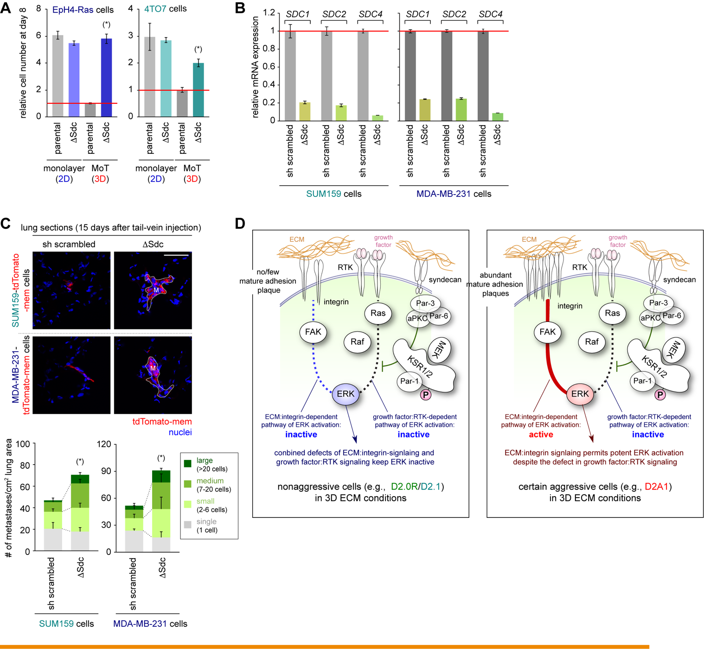

Supplementary Fig. S14. Genetic inactivation of syndecans and its effect on aggressive cell behaviors, related to Figure 7

(A) Effects of syndecan knockout on the proliferation of the nonaggressive EpH4-Ras and 4TO7 cells. The parental and syndecan knockout (ΔSdc) versions of the EpH4-Ras cells and the 4TO7 cells were propagated under either 2D monolayer or 3D MoT conditions for 8 days before the measurement of cell numbers. (*) p < 0.002 (vs parental). Values = means ± SD (n = 3).
(B, C) Effects of syndecan knockdown on metastasis formation by the SUM159 and MDA-MB-231 cells. The SUM159 and MDA-MB-231 human breast cancer cells were engineered to knock down the expression of syndecan-1, 2, and 4 (the resulting cells are referred to as SUM159-ΔSdc and MDA-MB-231-ΔSdc cells, respectively). The level of syndecan expression in these and the control (sh scrambled) cells were scored by RT-PCR (B). These various cell types were manipulated further to express tdTomato-mem and injected into the tail-vein of NOD scid mice. The numbers and sizes of lung metastases formed by these cells at day 15 were scored as in Supplementary Fig. S2A (C). Both SUM159-ΔSdc and MDA-MB-231-ΔSdc cells developed medium and large (≥ 7 cells) metastases more efficiently than did the corresponding control cells. (*) p < 0.002 (vs sh scrambled; for combined abundance of medium and large metastases). M, large colony. Bar = 50 μm.
(D) Schematic of the mechanisms governing ERK activation in the nonaggressive and aggressive cancer cell types. Left: The nonaggressive cells (e.g., D2.0R and D2.1 cells) fail to assemble abundant, mature forms of adhesion plaques when they were growing under the 3D ECM conditions, which results in an inability of these cells to stimulate ERK activation via integrin:FAK-dependent signaling pathway (blue dotted line). In addition, the operation in these cells of syndecan-mediated anti-proliferative signaling machinery blocks growth factor:RTK-dependent pathway of ERK activation via inactivating the KSR scaffolding proteins (black dotted line). The combined defects of these two signaling pathways accounts for the defective ERK activation in these nonaggressive cells. Right: The syndecan-mediated anti-proliferative signaling machinery is also operational and blocks growth factor:RTK-dependent pathway of ERK activation in some of the aggressive cell types (e.g., D2A1) when they are growing under the 3D ECM conditions. However, the ability of these cells to trigger integrin:FAK-dependent pathway of ERK activation enables them to have potent ERK activation and proliferate rapidly even under these conditions (red line). Note that other aggressive cancer cell types (e.g., B16F10 melanoma cells) have defects in syndecan-mediated anti-proliferative signaling machinery, which contribute functionally to their aggressive behaviors (see Supplementary Fig. S16). Values = means ± SD (n = 3: A, B) or means + SD (n = 5: C).

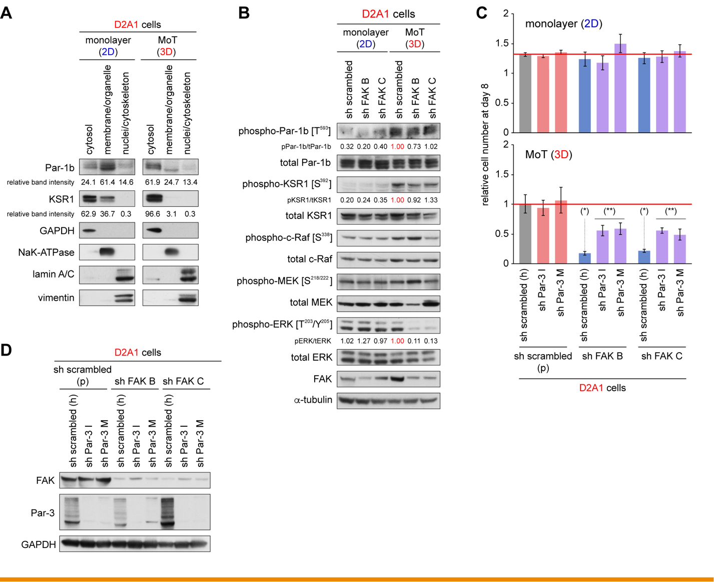

Supplementary Fig. S15. Concomitant operations of integrin:FAK-mediated pro-proliferative signaling and syndecan-mediated anti-proliferative signaling in the aggressive D2A1 cells, extended experimental results

(A) Subcellular localization of Par-1b and KSR1 in the aggressive D2A1 cells. The aggressive D2A1 cells were propagated under either 2D monolayer or 3D MoT conditions of culture for 5 days. These cells were subsequently subjected to subcellular fractionation as in Supplementary Fig. S5C. Both Par-1b and KSR1 were primarily distributed to the cytosol when these aggressive cells were propagated in 3D MoT culture, while significant proportion (> 35%) of both proteins were associated with the plasma membrane when these cells were growing in 2D monolayer culture. This mirrored the observations made in the nonaggressive D2.0R and D2.1 cells (Figs. 2E, 3E, Supplementary Fig. S5C).
(B) Effect of FAK knockdown on Par-1:KSR:Ras/ERK signaling. The aggressive D2A1 cells were engineered to express shRNA against FAK (sh FAK B and C; two different shRNA sequences against FAK were tested). These and the control (sh scrambled) cells were propagated under either 2D monolayer or 3D MoT conditions of culture. Five days later, cells were harvested and their lysates were subjected to analysis by IB. Both Par1-b and KSR1 exhibited elevated phosphorylation specifically when these cells were growing in the 3D MoT culture. This observation, together with the result shown in A, indicated that syndecan-mediated anti-proliferative signaling − which involves enhanced phosphorylation of Par-1 and KSR and resulting cytosolic eviction of these proteins − is active not only in the nonaggressive D2.0R and D2.1 cells, but also in the aggressive D2A1 cells specifically when these cells are growing in 3D ECM conditions. Of note, the levels of Par-1b and KSR1 phosphorylation were not noticeably affected by the knockdown of FAK expression in the D2A1 cells, while this knockdown strongly inhibited ERK phosphorylation when these cells were growing in 3D MoT conditions of culture. This supported the notion that integrin:FAK-mediated pro-proliferative signaling machinery and syndecan-mediated anti-proliferative signaling machinery are operating in mutually-independent manners, converging on the regulation of ERK activation (see Supplementary Fig. S14D)
(C, D) Effects of FAK and/or Par-3 knockdown on the proliferation of aggressive D2A1 cells. The control (sh scrambled [p; in a puromycin-resistance vector]), and FAK-knockdown (sh FAK B, C) D2A1 cells were engineered further to express shRNA against Par-3 (sh Par-3 I and M; two different shRNA sequences against Par-3 were tested) or control shRNA (sh scrambled [h; in a hygromycin-resistance vector]). These various cells were propagated under either 2D monolayer or 3D MoT conditions of culture for 8 days before the measurement of cell numbers (C). The levels of FAK- and Par-3-knockdown were also tested by IB (D). The knockdown of FAK expression strongly reduced (4.7- to 5.7-fold reduction in the abundance of cells after 8 days of culture) the proliferation of otherwise-aggressive D2A1 cells specifically when these cells were growing under the 3D MoT condition of culture. In contrast, the knockdown of Par-3 expression did not discernibly affect the proliferation of D2A1 cells under the same condition. Hence, while syndecan-mediated anti-proliferative signaling machinery was apparently active in the aggressive D2A1 cells when these cells were growing under the 3D MoT condition of culture, the blockade of this signaling machinery did not recognizably promote cell proliferation. Intriguingly, however, the concomitant knockdown of Par-3 expression in the FAK-knockdown D2A1 cells restored the proliferation of these cells (2.3- to 3.3-fold increase in the abundance of cells after 8 days of culture) in the 3D MoT culture. This indicated that the anti-proliferative effect of syndecan-mediated signaling machinery becomes exposed only after the blockade of concomitantly-operating integrin:FAK-mediated pro-proliferative signaling machinery in the D2A1 cells. Hence, while both integrin:FAK-mediated pro-proliferative signaling machinery and syndecan-mediated anti-proliferative signaling machinery are operating when the aggressive D2A1 cells are growing in the 3D MoT condition of culture, the effect of the former pathway appears to dominate the effect of the latter. Values = means ± SD (n = 3: C). (*) p < 0.02 (vs sh scrambled [p]/sh scrambled [h]); (**) p < 0.03 (vs corresponding sh scrambled [h]).

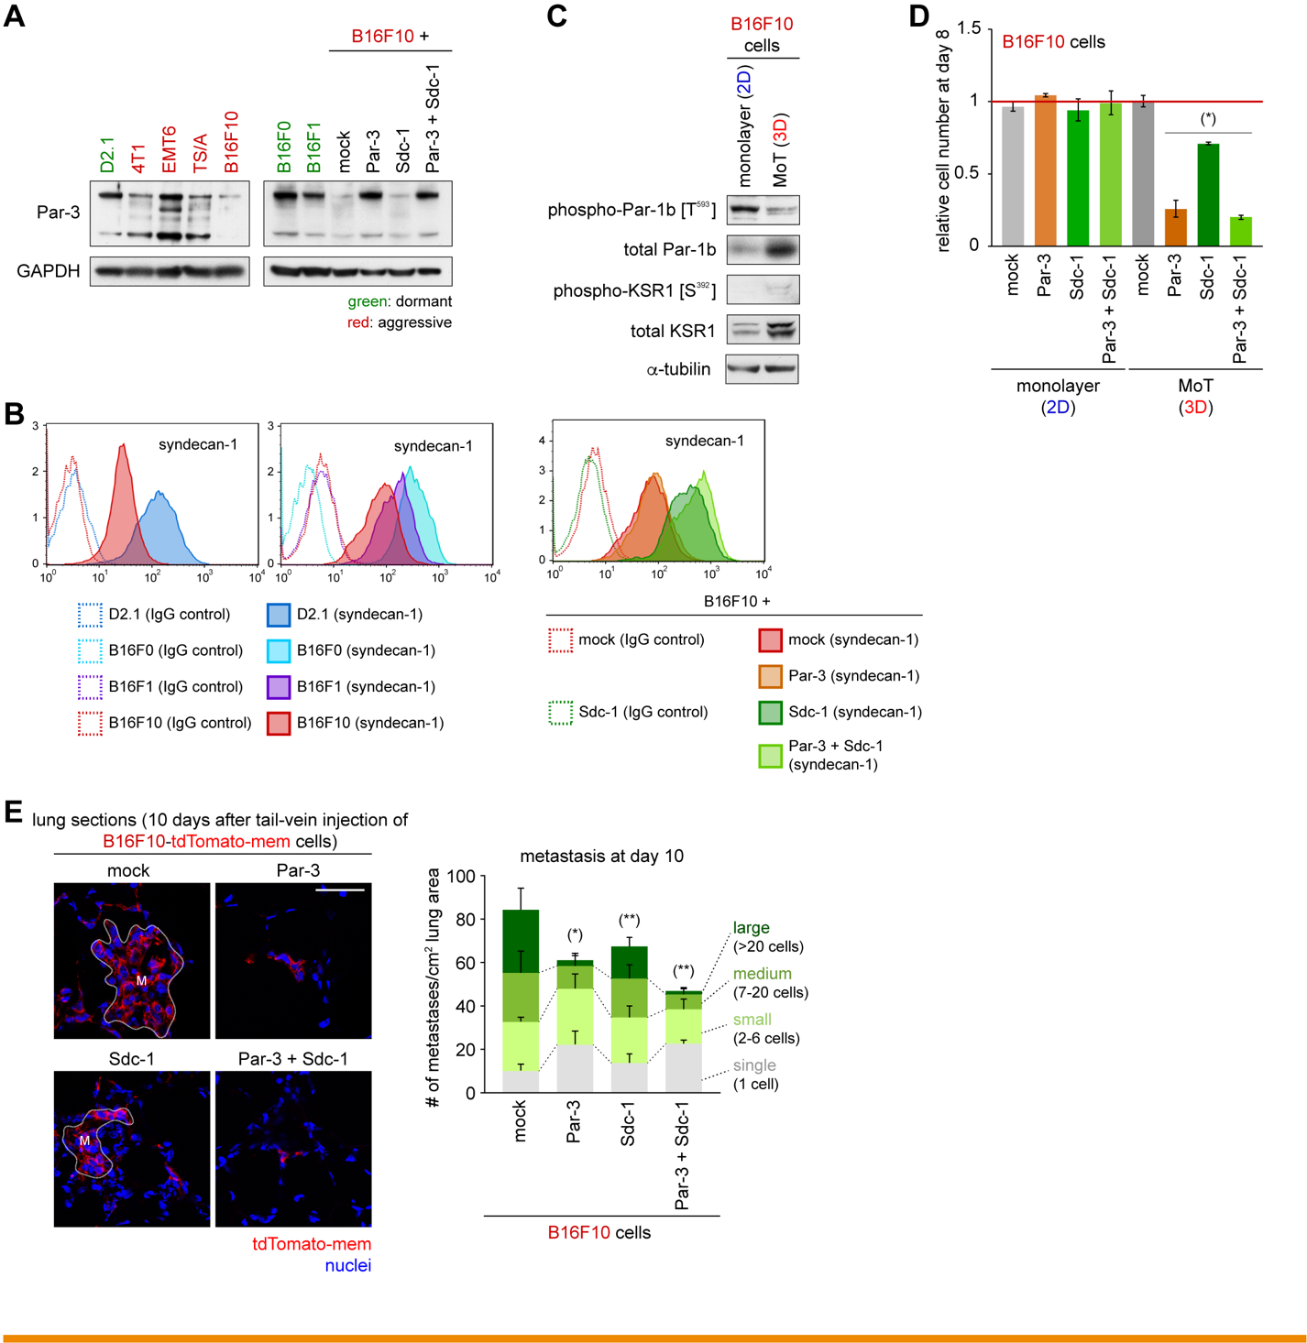

Supplementary Fig. S16. Restoration of Par-3 and syndecan-1 expression in the B16F10 melanoma cells, extended experimental results

(A) Expression of Par-3 in various mouse cancer cell types. The nonaggressive D2.1 cells and various aggressive mouse cancer cell lines were tested by IB for the expression of Par-3 (left). The aggressive B16F10 mouse melanoma cells, their several engineered versions, as well as the nonaggressive counterparts of the B16F10 cells (i.e., B16F0 and B16F1 cells), were also tested for Par-3 expression (right). The aggressive B16F10 cells exhibited a far lower level of Par-3 expression than the levels observed in the nonaggressive D2.1, B16F0, and B16F1 cells.
(B) Cell-surface expression of syndecan-1 on B16 mouse melanoma cells. The cell-surface expression of syndecan-1 on the D2.1 cells and the three different B16 melanoma cells was tested by flow cytometry (left). The expression levels of syndecan-1 in various engineered versions of B16F10 cells were also tested (right). The aggressive B16F10 cells exhibited a lower level of syndecan-1 expression on their cells surface than did the nonaggressive D2.1, B16F0, and B16F1 cells.
(C) Phosphorylation of Par-1b and KSR1 in the B16F10 cells. The B16F10 cells were propagated either under 2D monolayer or 3D MoT conditions of culture. Five days later, cells were harvested and their lysates were analyzed by IB. This revealed that neither Par-1b (on its T593 residue) nor KSR1 (on its S392 residue) exhibited noticeable elevation in the level of phosphorylation when the B16F10 cells were growing under the 3D MoT conditions of culture relative to the level of phosphorylation observed in the 2D monolayer culture of these cells.
(D) Effect of Par-3- and/or syndecan-1-overexpression on the in vitro proliferation of B16F10 melanoma cells. The aggressive B16F10 melanoma cells were engineered to overexpress Par-3 and/or syndecan-1 (Sdc-1). These and the control cells were propagated under either 2D monolayer or 3D MoT conditions for 8 days before the measurement of cell numbers. Restoration of Par-3 and/or syndecan-1 expression impaired the proliferation of the aggressive B16F10 cells specifically when these cells were growing under the 3D MoT conditions of culture. This supported the notion that the rapid proliferation of the 3D ECM conditions is enabled, in part, by the low expression levels in these cells of Par-3 and syndecan-1 and the resulting functional defect of the syndecan-mediated anti-proliferative signaling machinery. (*) p < 0.005 (vs mock).
(E) Effects of Par-3- and/or syndecan-1-overexpression on metastasis formation by naturally-aggressive B16F10 cells. The aggressive B16F10 melanoma cells were engineered to overexpress Par-3 and/or syndecan-1 (Sdc-1). These and the control cells, also expressing tdTomato-mem, were injected intravenously into syngeneic C57BL/6 mice. The numbers and sizes of lung metastases formed by these cells at day 10 were scored as in Supplementary Fig. S2A. (*) p < 0.002, (**) p = 0.03 (vs mock; for combined abundance of medium and large metastases). This indicated that the aggressive metastatic behaviors of the B16F10 cells are enabled, in part, by the reduced expression of Par-3 and syndecan-1 as well as the resulting functional defects of syndecan-mediated anti-proliferative signaling machinery in these cells. Bars = 50 μm. Values = means ± SD (n = 3: D), means + SD (n = 5: E).

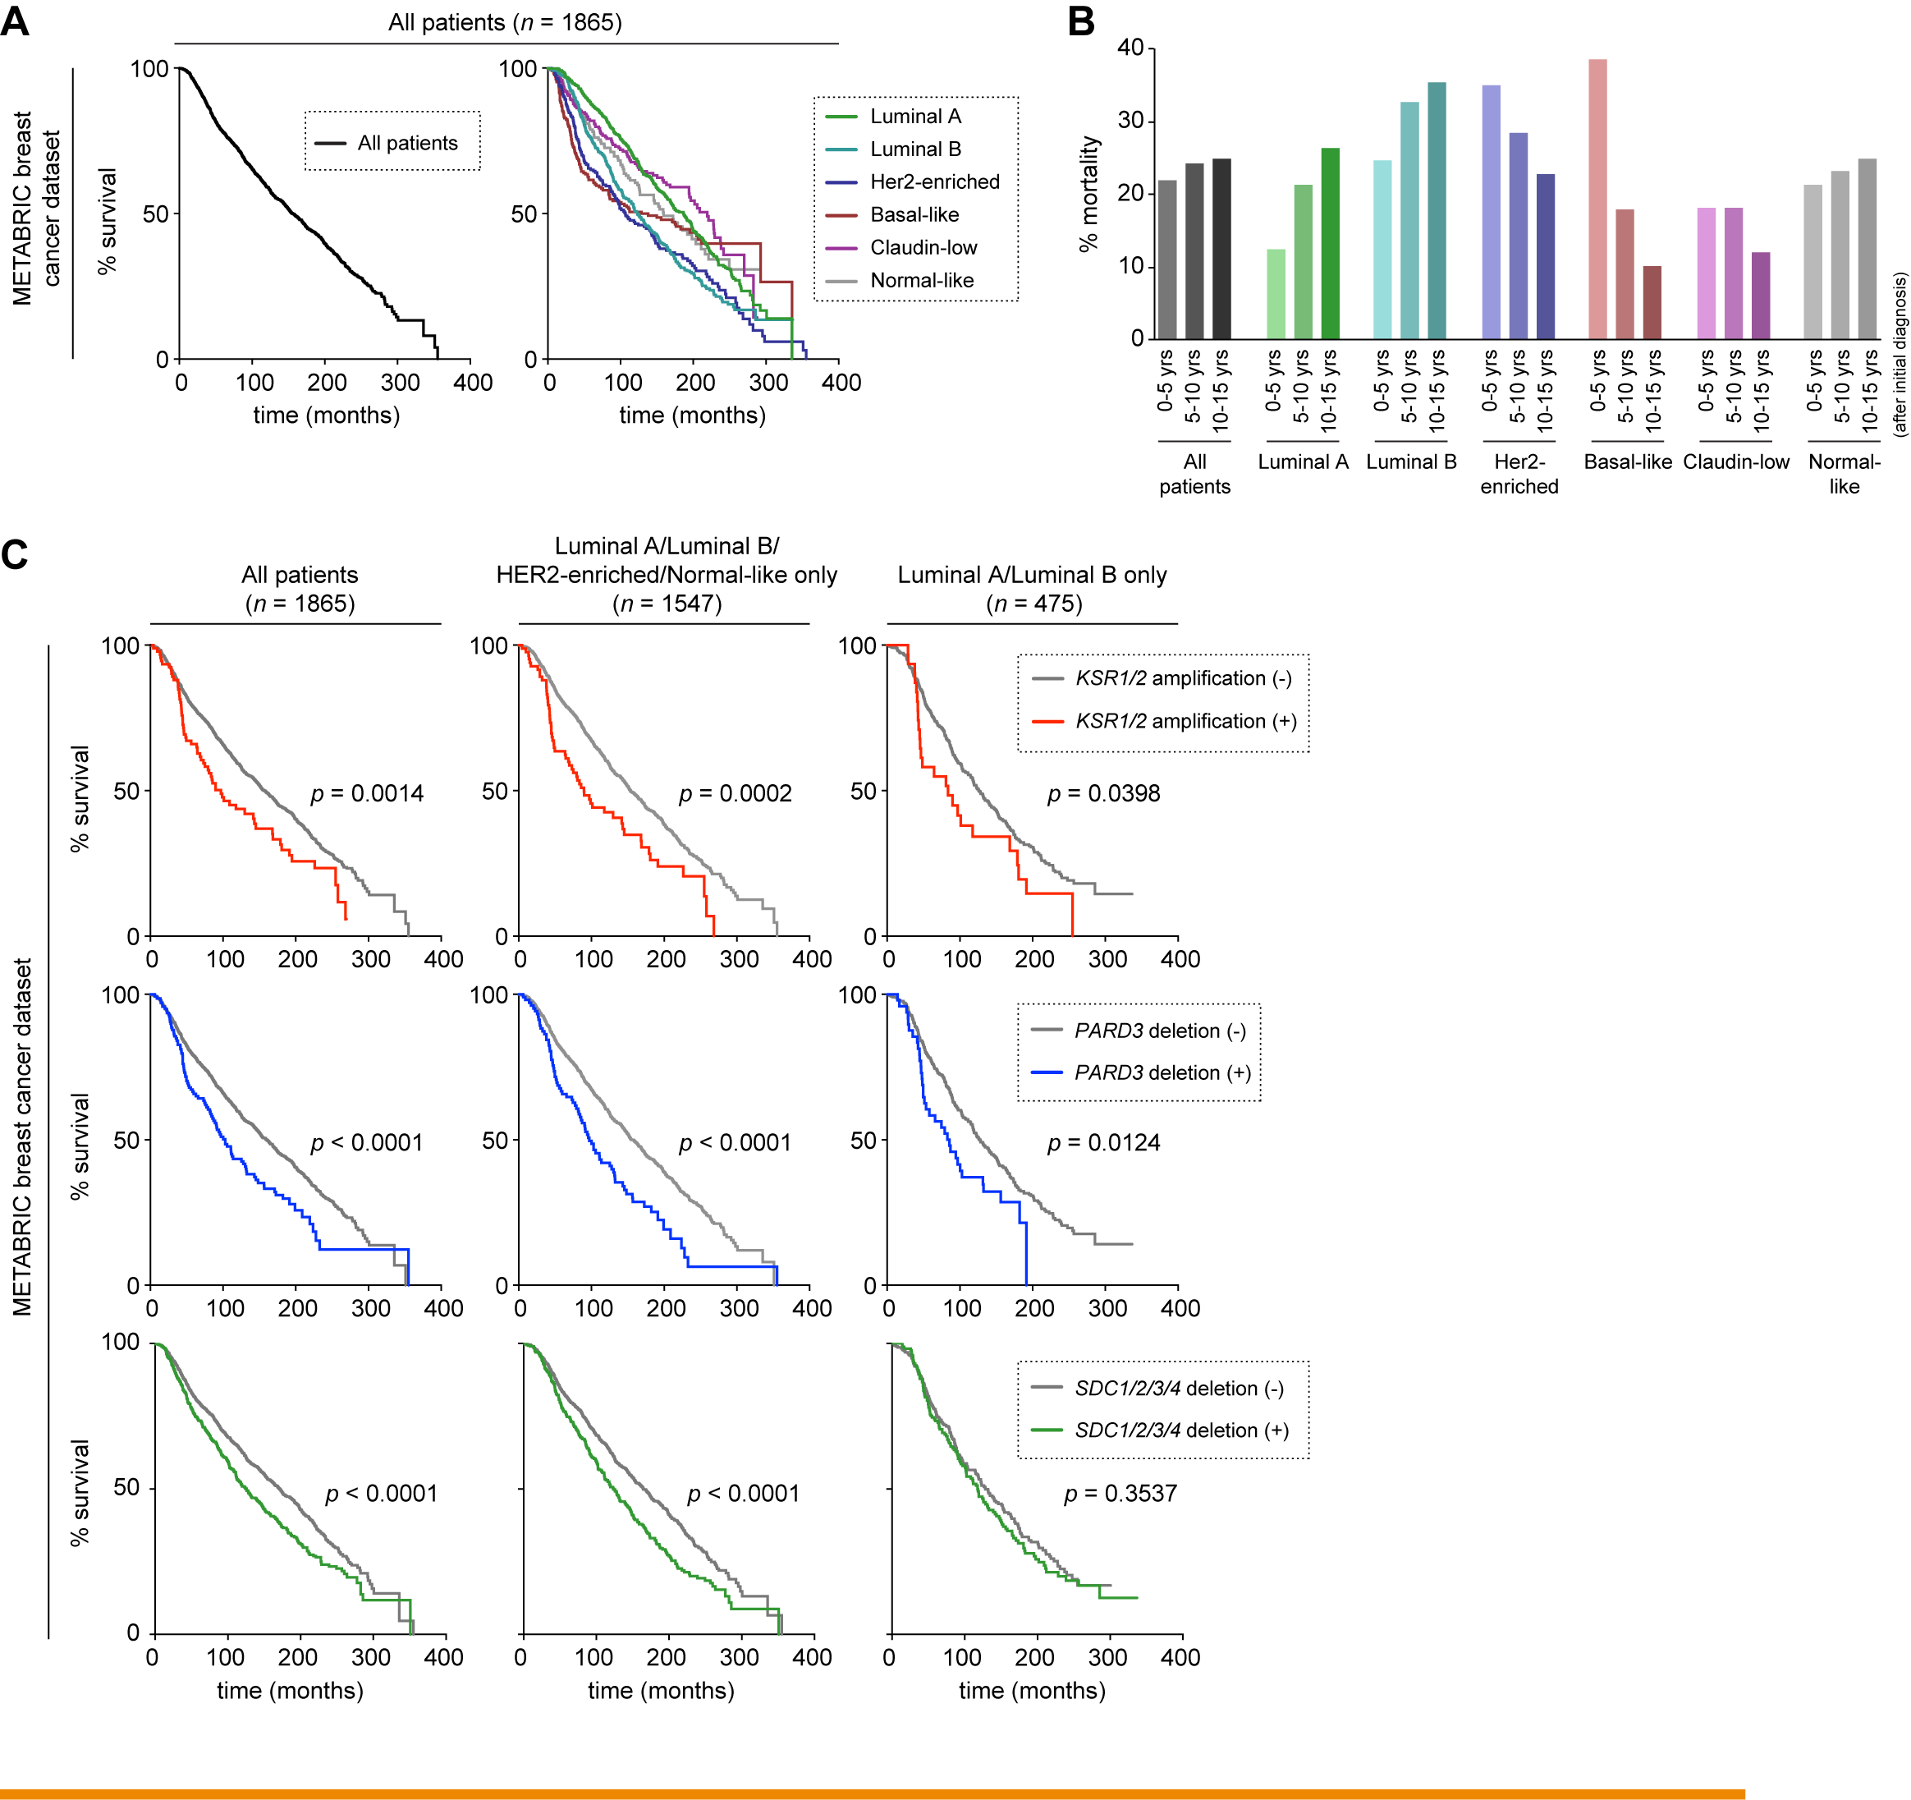

Supplementary Fig. S17. Evidence for genetic alterations to inactivate syndecan-mediated anti-proliferative signaling machinery in human cancers, extended analyses

Patient survival in the METABRIC breast cancer data set and KSR1/2 amplification/PARD3 deletion/SDC1-4 deletion. Overall survival of the patients in the METABRIC breast cancer dataset (n = 1980) (Curtis et al. [2012], Nature 486:346) was analyzed either altogether (A, left) or individually for each of the six breast cancer subtypes (A, right; Luminal A, Luminal B, Her2-enriched, Basal-like, Claudin-low and Normal-like) by plotting Kaplan-Meier survival curves. Patient mortality in every five year period following initial diagnosis was also plotted (B). As already reported in breast cancer (Cancer Genome Atlas Network [2012], Nature 490:61), patient mortality did not decrease over a long period of time (up to 15 years after diagnosis). This is thought to be attributable, at least in part, to the prolonged dormancy of DTCs and following delayed metastatic relapse caused by the awakening of previously-dormant DTCs, which is characteristically observed in breast cancer (Sosa et al. [2014], Nat Rev Cancer 14:611). Among the six breast cancer subtypes, Luminal A, Luminal B, Her2-enriched and Normal-like subtypes have relatively poor long-term prognosis (> 20% mortality in each period of 5-10 years and 10-15 years after diagnosis) with the Luminal B subtype showing the worst prognosis in these periods. This suggests that delayed metastatic relapse is more prominent in Luminal A, Luminal B, Her2-enriched and Normal-like breast cancer subtypes and thus the induction and maintenance of dormancy in DTCs play particularly important roles for disease progression in these breast cancer subtypes. Remarkably, genetic amplification of KSR1 and/or KSR2 (encoding KSR1 and KSR2 scaffolding proteins, respectively), homozygous or heterozygous deletion of PARD3 (encoding Par-3), homozygous or heterozygous deletion of SDC1, SDC2, SDC3 and/or SDC4, all of which are likely to result in the functional inactivation/impairment of syndecan-mediated anti-proliferative signaling machinery described in the present study (see Supplementary Fig. S18), are associated with shorter survival period of the patients (C, left). Even more intriguing, these genetic changes were still correlated significantly with poorer prognosis when analysis was limited to patients with i) Luminal A, Luminal B, HER2-enriched, or Normal-like subtype (C, center) or ii) only Luminal B-subtype of breast cancer (for KSR1/2 amplification and PARD3 deletion; C, right). These observations were in line with the notion that syndecan-mediated anti-proliferative signaling machinery critically controls the latency of metastatic disease, doing so presumably by regulating the induction and/or maintenance of quiescence in DTCs, thereby ultimately governing disease progression in the breast cancer subtypes where delayed metastatic relapse is frequently observed.

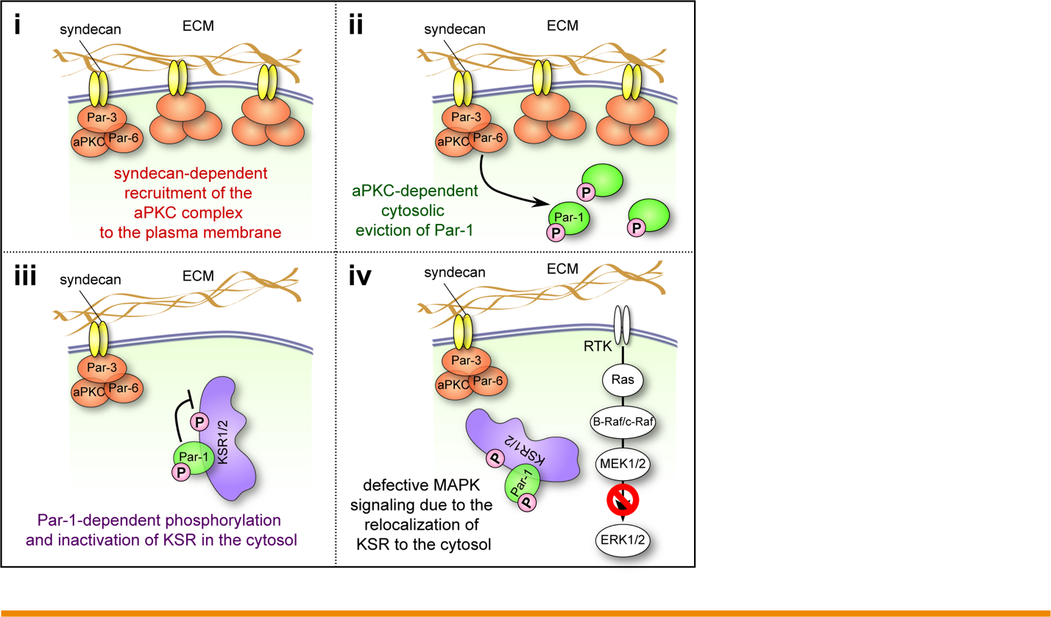
Supplementary Fig. S18. Syndecan-mediated anti-proliferative signaling machinery that prevents the outgrowth of solitary DTCs, a summary illustration

Schematic of the proposed anti-proliferative mechanism triggered by syndecan-mediated ECM ligation that operates in solitary DTCs. Upon extravasating into the parenchyma of foreign tissues as solitary cells, cancer cells should be surrounded on their all sides by the ECM components of the host tissue (see Supplementary Fig. S4). Engagement of these ECM proteins by the syndecan receptor expressed on the surface of cancer cells results in the recruitment of Par-3:Par-6:aPKC polarity complex (or aPKC complex) throughout the inner surface of their plasma membrane (i). This recruitment, in turn, causes the eviction of Par-1 kinase into the cytosol, because of the mutually exclusive localization patterns of aPKC complex and Par-1 kinase (ii). In the cytosol, the Par-1 kinase binds to, phosphorylates and thereby functionally inactivates the KSR scaffolding proteins (iii). The functional inactivation of KSR proteins prevents growth factors and their cognate receptors (receptor tyrosine kinases [RTKs]) from efficiently triggering Ras/ERK signaling, ultimately blocking the proliferation of these cancer cells (iv). This model is supported by our observation that the blockade of syndecan-mediated anti-proliferative signaling machinery, achieved by (1) simultaneous knockout of there syndecan isoforms (syndecan-1, -3, and -4; Fig. 6C); (2) knockout of Par-3 (Fig. 5A); (3) knockout of PKCι (Fig. 4A) ; and (4) the knockout of Par-1b (Fig. 3A) all resulted in the enhancement of ERK phosphorylation in the otherwise nonaggressive D2.1 cells specifically when these cell were growing under the 3D MoT conditions of culture, but not when they were growing in 2D monolayer culture. Hence, syndecans and the various regulators of cell polarity together contribute critically to the blockade of Ras/ERK signaling observed when the nonaggressive cells were growing in the 3D ECM conditions. Intriguingly, the effect of these proteins on Ras/ERK signaling are strongly influenced by the conditions of cell growth. Indeed, contrary to what we found in 3D MoT culture, we observed that the knockout of PKCι impaired the phosphorylation of ERK when the nonaggressive D2.1 cells were growing in 2D monolayer culture (Fig. 4A). This exemplifies the critical effect of the conditions of cell growth on the functions of the regulators of cell polarity.

