Supplementary material to

Tomoelastography distinguishes non-invasively between benign and malignant liver lesions
by
Mehrgan Shahryari¹, Heiko Tzschätzsch¹, Jing Guo¹, Stephan R. Marticorena Garcia¹, Georg Böning¹, Uli Fehrenbach¹, Lisa Stencel¹, Patrick Asbach¹, Bernd Hamm¹, Joseph A. Käs², Jürgen Braun³, Timm Denecke⁴, Ingolf Sack¹

¹ Department of Radiology, Charité - Universitätsmedizin Berlin, corporate member of Freie Universität Berlin, Humboldt-Universität zu Berlin, and Berlin Institute of Health, Berlin, Germany.
² Faculty of Physics and Earth Sciences, Peter Debye Institute, Leipzig University, Linnéstr. 5, 04103 Leipzig, Germany.
³ Institute of Medical Informatics, Charité - Universitätsmedizin Berlin, corporate member of Freie Universität Berlin, Humboldt-Universität zu Berlin, and Berlin Institute of Health, Berlin, Germany.
⁴ Department of Diagnostic and Interventional Radiology, University Hospital of Leipzig, 04103 Leipzig, Germany.

Figure S1: Study flowchart.
70 patients and 7 healthy volunteers underwent tomoelastography (no drop-out). All 54 patients with malignant tumors and 16 patients with benign tumors, with overall 141 liver lesions, were included. Twenty-seven patients had multiple intrahepatic lesions including two patients with different tumor entities: one with hepatic adenoma (HCA) and simultaneous focal nodular hyperplasia (FNH) and one with hepatocellular adenoma (HCA) and hepatic hemangioma (HEM). 7 different entities of metastasis were measured, including colorectal carcinoma (CRC), pancreatic carcinoma (PCa), breast cancer (BCa), neuroendocrine tumor (NET), urothelial carcinoma (UCa), malignant melanoma (MM) and ovarian carcinoma (OCa). All patients with malignant lesions and 7 of 16 patients with benign lesions (1 of 5 patients with HEM, 1 of 5 patients with FNH, and 5 of 8 patients with HCA) underwent either biopsy or surgical excision with histopathological diagnosis. The remaining 11 patients with benign lesions were diagnosed on the basis of typical MRI features by three experienced abdominal radiologists (TD,GB,UF) and unchanged imaging appearance of the lesions over a minimum period of 1 year according to the guidelines of the European Association for the Study of the Liver (EASL)(1). * Two patients had two different entities.
Figure S2: Tomoelastography setup.
The MRE sequence sends a trigger to a waveform generator in order to initiate the output of binary on-off signals of 30, 40, 50 or 60Hz frequency into a pneumatic control unit. The control unit comprises four magnetic valves which in turn control the flow of pressurized air into four 3D-printed pneumatic actuators at driving frequency. 4 pneumatic actuators are placed onto the body surface around the liver as indicated. 3D-wave fields are acquired using a single-shot, spin-echo echo-planar imaging sequence with flow-compensated motion-encoding gradients. (2) Maps of stiffness and fluidity are retrieved by the tomoelastography pipeline (3,4) based on multifrequency 3D-wave fields.
Figure S3: Representative MRI, tomoelastography maps and other clinical images of four malignant tumor cases.
Four tomoelastography, maps of shear-wave speed c (stiffness) and phase angle φ (fluidity) are shown along with T2-weighted MR images acquired during the same examination for anatomical orientation. Furthermore, positron-emission tomography (PET) fused with computed tomography (CT) is shown for (a), while contrast-enhanced CT is shown for (b, c and d). CT and PET images were acquired during clinical scans before tomoelastography. (a) 66-year-old woman with 24-mm liver metastasis (arrow) originating from pancreatic cancer. The lesion shows higher c and φ values compared with surrounding tissue overlapping with enhanced radionuclide uptake in PET. (b) 83-year-old man with 83-mm cholangiocarcinoma (CCA) (arrow) in the right liver lobe. CCA shows high c and φ values in tomoelastography and a hypodense lesion in CT. (c) 49-year-old woman with liver metastasis (arrow) of primary breast cancer. T2-weighted MRI shows a 20-mm hyperintense lesion with high c and φ values and hypodense CT contrast. (d) 66-year-old man with 9-mm urothelial metastasis (arrow) with elevated c and φ values, hypodense CT contrast and enhancement of CT-contrast agent during the arterial phase.

Figure S4: Representative tomoelastography maps of two cases of FNH with increased stiffness and fluidity.
(a) and (b): The figure shows maps of shear wave speed c (stiffness) and phase angle φ (fluidity) along with T2-weighted MR images for anatomical orientation. Both FNH cases present large masses with prominent hyperintense central scar (red arrow) visible in T2-weighted MRI. In tomoelastography, FNH lesions have elevated c- and φ-values. It is reported that FNH are hypervascularized masses due to the hyperplastic response to portal tract injury and resulting in marked vascular anomalies (5,6). The increased vascular density might be responsible for elevated φ values, while collagen deposition, as demonstrated here by the central scar, might result in higher c values (7-9).

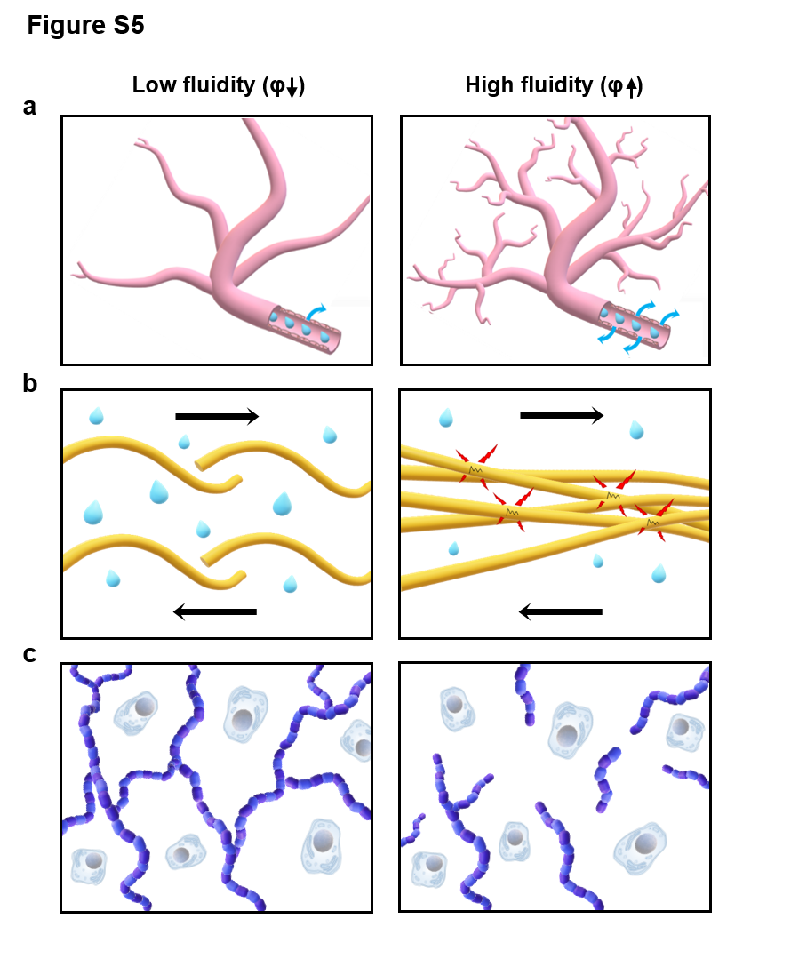
Figure S5: Microscopic mechanisms that potentially influence fluidity.
The figure shows hypothetical situations of micro-tissue interactions which are associated with an increase or decrease in fluidity φ. The left and right columns depict low-φ (elastic-solid) and high-φ (viscous-fluid) situations, respectively. (a) Tissue fluidity increases due to vascularization, leaky blood vessels and an overall increase of the amount of water in the tissue (9-11). (b) Since φ reflects the loss angle of the complex shear modulus, it is also associated with internal friction due to hydrophobic interactions of protein molecules. In materials with abundant proteins, such as soy milk curd, water acts as lubricant, reducing friction and leading to an overall reduction in fluidity (12). Similarly, protein–protein interactions due to the accumulation of dysmorphic collagen in malignant liver lesions (13) might cause the observed increase in φ. (c) Sparse crosslinked collagen networks (14) or polar molecules, such as long sugar chains or glycosaminoglycans, (GAGs) which bind large amounts of water can effectively turn a liquid material into a solid state (12,15). Conversely, chain cleavage or depletion of GAGs will increase φ (15-17).
Table S1: Generalized linear mixed-effect model for predicting the nature of tissue.
Generalized linear mixed-effect model (GLMM) for predicting tumor and liver tissue based on c or φ for patients with malignant and benign lesions for 70 patients. Fixed effects (β) are presented as non-standardized coefficients with 95% CI and as standardized coefficient with standard error. p values for fixed effects are shown. SE = standard error.

 |  |  | Non-standardized (95% CI) |  |  |  | Standardized
 | Fixed effect |  | Coefficient | Lower | Upper |  | Coefficient | SE | p value
Malignant
 | (Intercept) |  | –6.79 | –11.11 | –4.37
 | c |  | 3.62 | 2.41 | 5.73 |  | 5.29 | 1.2 | p<0.001
 | (Intercept) |  | –6.60 | –10.45 | –4.16
 | φ |  | 10.64 | 7.02 | 16.35 |  | 7.34 | 1.57 | p<0.001
Benign
 | (Intercept) |  | –4.06 | –8.81 | –0.51
 | c |  | 3.2 | 0.8 | 6.55 |  | 3.46 | 1.61 | 0.032
 | (Intercept) |  | –0.97 | –2.80 | 0.63
 | φ |  | 3.32 | 0.34 | 7.14 |  | 1.6 | 0.82 | 0.051

Table S2: Diagnostic accuracy for separation of tumor and liver based on GLMM predictions.
Diagnostic accuracy for separating tumor from non-tumorous liver based on GLMM predictions of mechanical parameters c and φ in 70 patients. AUC = area under the receiver-operating characteristics curve. c = shear wave speed (stiffness), φ = phase angle of complex shear modulus (fluidity). PPV = positive predictive value. NPV = negative predictive value. Unless otherwise specified, data in parentheses represent 95% confidence intervals.

 | Model parameter | AUC | (95% CI) | Cut-off value | Sensitivity | (95% CI) | Specificity | (95% CI) | PPV | (95% CI) | NPV | (95% CI)
Malignant
 | c | 0.88 | (0.83-0.94) | 0.43 | 0.91 | (0.86-0.96) | 0.70 | (0.59-0.81) | 0.86 | (0.81-0.91) | 0.81 | (0.71-0.91)
 | φ | 0.95 | (0.92-0.98) | 0.50 | 0.92 | (0.87-0.97) | 0.85 | (0.76-0.93) | 0.92 | (0.88-0.97) | 0.85 | (0.76-0.94)
Benign
 | c | 0.71 | (0.57-0.84) | 0.67 | 0.64 | (0.47-0.78) | 0.89 | (0.72-1.00) | 0.92 | (0.81-1.00) | 0.55 | (0.45-0.68)
 | φ | 0.66 | (0.51-0.80) | 0.67 | 0.61 | (0.44-0.78) | 0.94 | (0.83-1.00) | 0.96 | (0.87-1.00) | 0.55 | (0.46-0.67)

Table S3: Diagnostic accuracy for distinguishing malignant versus benign lesions based on mechanical tumor and liver properties.
Diagnostic accuracy for distinguishing patients (n=70) with malignant from those with benign tumors based on shear wave speed c (stiffness) and phase angle of complex shear modulus φ (fluidity). Area under the receiver-operating characteristics curve (AUC) analysis was conducted for tumor-c and tumor-φ including all patients and excluding patients with hepatic hemangioma (HEM), as well as liver (non-tumoral) c- and φ-values. c = shear wave speed, φ = phase angle of complex shear modulus (fluidity). PPV = positive predictive value. NPV = negative predictive value. Unless otherwise specified, data in parentheses represent 95% confidence intervals.

Subjects | Mechanical parameter | AUC | (95% CI) | Cutoff value | Sensitivity | (95% CI) | Specificity | (95% CI) | PPV | (95% CI) | NPV | (95% CI)
All patients
 | c | 0.85 | (0.72-0.98) | 1.75 m/s | 0.94 | (0.87-1.00) | 0.78 | (0.56-0.94) | 0.93 | (0.87-0.98) | 0.82 | (0.67-1.00)
 | φ | 0.86 | (0.77-0.96) | 0.91 rad | 0.83 | (0.72-0.93) | 0.78 | (0.56-0.94) | 0.92 | (0.85-0.98) | 0.61 | (0.46-0.79)
Excl. patients with HEM
 | c | 0.88 | (0.73-1.00) | 1.75 m/s | 0.94 | (0.89-1.00) | 0.85 | (0.62-1.00) | 0.96 | (0.91-1.00) | 0.80 | (0.62-1.00)
 | φ | 0.92 | (0.85-0.99) | 0.91 rad | 0.83 | (0.72-0.93) | 0.92 | (0.77-1.00) | 0.98 | (0.93-1.00) | 0.57 | (0.44-0.76)
Based on viscoelasticity of liver
 | c | 0.84 | (0.74-0.94) | 1.5 m/s | 0.72 | (0.59-0.83) | 0.88 | (0.69-1.00) | 0.95 | (0.88-1.00) | 0.48 | (0.38-0.62)
 | φ | 0.60 | (0.46-0.74) | 0.68 rad | 0.46 | (0.33-0.59) | 0.81 | (0.63-1.00) | 0.90 | (0.79-1.00) | 0.31 | (0.24-0.39)

References
1. European Association for the Study of the L. EASL Clinical Practice Guidelines on the management of benign liver tumours. J Hepatol 2016;65:386-98
2. Dittmann F, Hirsch S, Tzschatzsch H, Guo J, Braun J, Sack I. In Vivo Wideband Multifrequency MR Elastography of the Human Brain and Liver. Magnetic Resonance in Medicine 2016;76:1116-26
3. Tzschatzsch H, Guo J, Dittmann F, Hirsch S, Barnhill E, Johrens K, et al. Tomoelastography by multifrequency wave number recovery from time-harmonic propagating shear waves. Medical Image Analysis 2016;30:1-10
4. Hirsch S, Guo J, Reiter R, Papazoglou S, Kroencke T, Braun J, et al. MR Elastography of the Liver and the Spleen Using a Piezoelectric Driver, Single-Shot Wave-Field Acquisition, and Multifrequency Dual Parameter Reconstruction. Magn Reson Med 2014;71:267-77
5. Wanless IR, Mawdsley C, Adams R. On the pathogenesis of focal nodular hyperplasia of the liver. Hepatology 1985;5:1194-200
6. Nault JC, Bioulac-Sage P, Zucman-Rossi J. Hepatocellular benign tumors-from molecular classification to personalized clinical care. Gastroenterology 2013;144:888-902
7. Cox TR, Erler JT. Remodeling and homeostasis of the extracellular matrix: implications for fibrotic diseases and cancer. Dis Model Mech 2011;4:165-78
8. Lu P, Weaver VM, Werb Z. The extracellular matrix: a dynamic niche in cancer progression. J Cell Biol 2012;196:395-406
9. Jamin Y, Boult JK, Li J, Popov S, Garteiser P, Ulloa JL, et al. Exploring the biomechanical properties of brain malignancies and their pathologic determinants in vivo with magnetic resonance elastography. Cancer Res 2015;75:1216-24
10. Hashizume H, Baluk P, Morikawa S, McLean JW, Thurston G, Roberge S, et al. Openings between Defective Endothelial Cells Explain Tumor Vessel Leakiness. The American Journal of Pathology 2000;156:1363-80
11. Carmeliet P, Jain RK. Angiogenesis in cancer and other diseases. Nature 2000;407:249-57
12. Streitberger K, Lilaj L, Schrank F, Braun J, Käs J, Hoffmann K, et al. Detection of fluid/solid tissue behavior of neurotumors by magnetic resonance elastography [abstract]. In: Proceedings of the ISMRM 27th Annual Meeting & Exhibition. 2019 May 11-16; Montréal, QC, Canada. ISMRM; 2019. Abstract nr 0396
13. Levental KR, Yu H, Kass L, Lakins JN, Egeblad M, Erler JT, et al. Matrix crosslinking forces tumor progression by enhancing integrin signaling. Cell 2009;139:891-906
14. Sauer F, Oswald L, Ariza de Schellenberger A, Tzschatzsch H, Schrank F, Fischer T, et al. Collagen networks determine viscoelastic properties of connective tissues yet do not hinder diffusion of the aqueous solvent. Soft Matter 2019;15:3055-64
15. Netti PA, Berk DA, Swartz MA, Grodzinsky AJ, Jain RK. Role of Extracellular Matrix Assembly in Interstitial Transport in Solid Tumors. Cancer Research 2000;60:2497-503
16. de Schellenberger AA, Bergs J, Sack I, Taupitz M. The Extracellular Matrix as a Target for Biophysical and Molecular Magnetic Resonance Imaging. In: Sack I, Schaeffter T, editors. Quantification of Biophysical Parameters in Medical Imaging. Heidelberg: Springer; 2018. p.123-150.
17. Kohyama K, Sano Y, Doi E. Rheological Characteristics and Gelation Mechanism of Tofu (Soybean Curd). Journal of Agricultural and Food Chemistry 1995;43:1808-12

