SuppMENTAry Figures
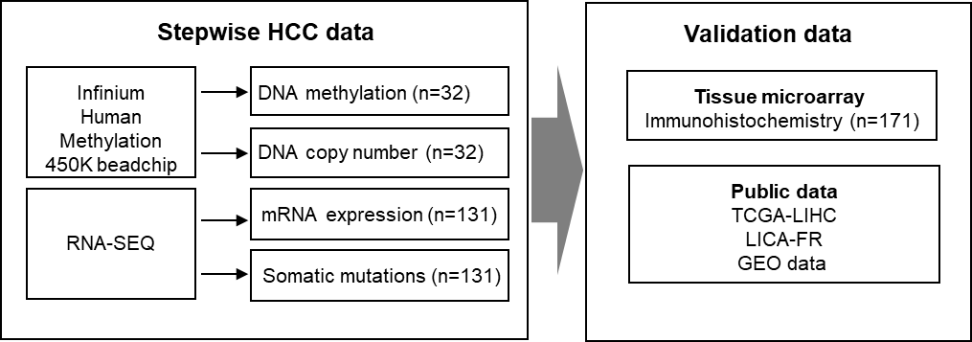

Supplementary Figure S1. Overall study design for multi-omic data analysis

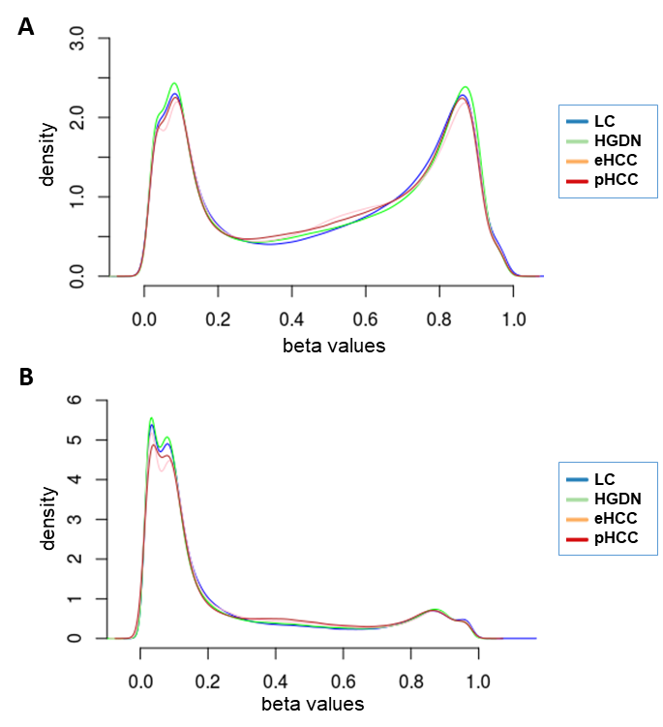

Supplementary Figure S2. The distribution of beta-values in DNA methylation data
Density plots show the distribution of overall beta-values for all the probes (A) or the probes for CpG sites (B) in each group of LC, HGDN, eHH, or pHCC.

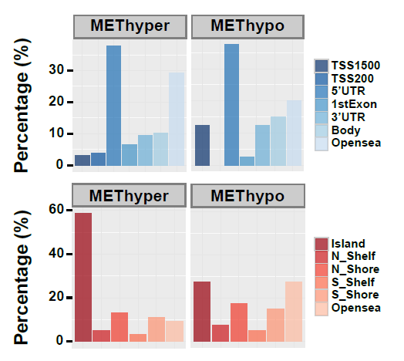

Supplementary Figure S3. The distribution of differentially methylated probes (DMPs)

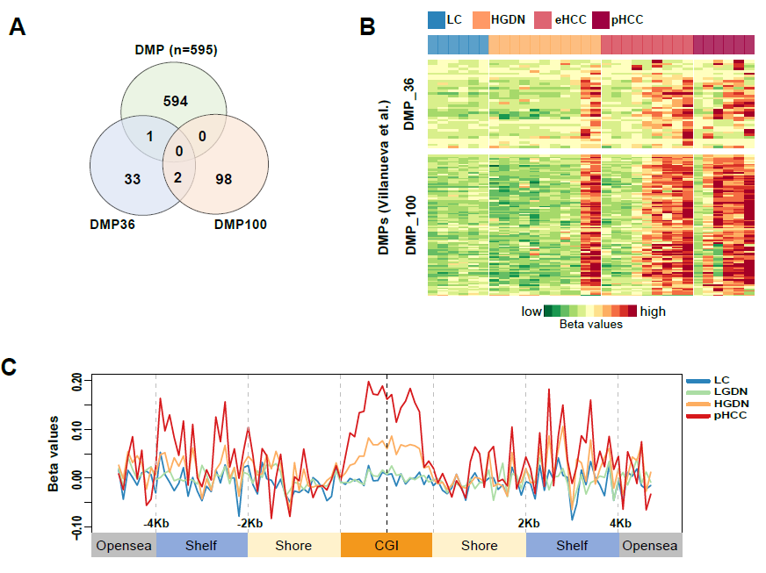

Supplementary Figure S4. Differentially methylated probes in the integrated data of GSE44970 and YSHCC
(A) A Venn-diagram shows the number of DMPs overlapped with the two DMP signatures of DMP100 and DMP36 which were obtained from a previous study (for details see Supplementary Materials and Methods). (B) A heatmap shows the DNA methylation levels of the DMP signatures in YSHCC data. (C) For each group in GSE44970, averaged DNA methylation levels in the genomic coordinates in relation to CGI are calculated and plotted as described in Supplementary Materials and Methods.

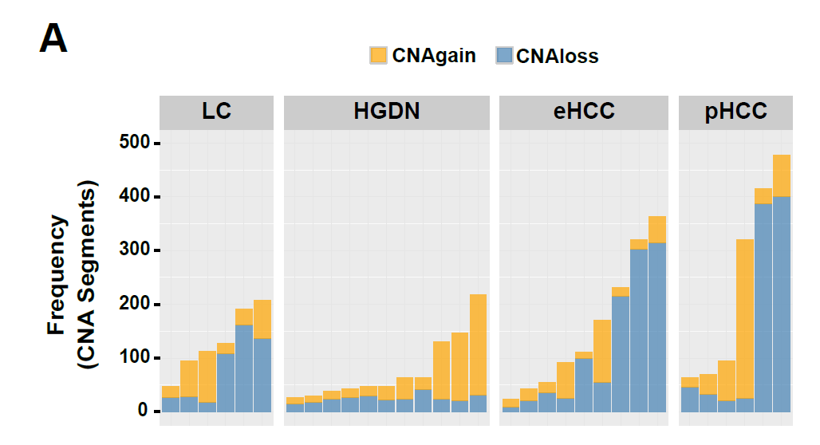
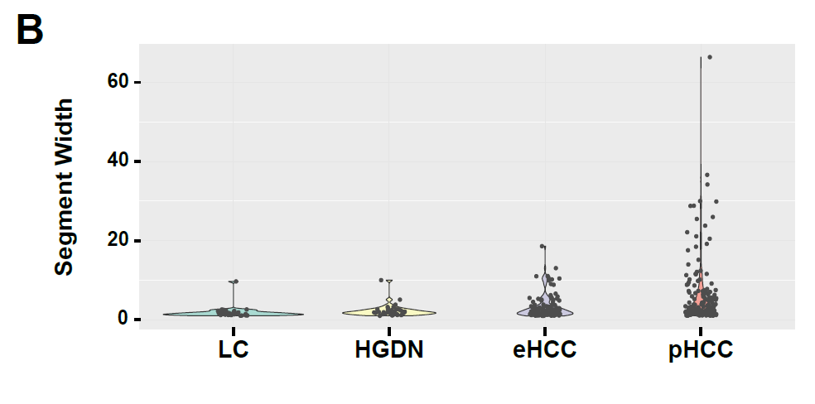

Supplementary Figure S5. Distribution of CNAs during stepwise hepatocarcinogenesis
Bar plots show the frequencies of CNA segments (A) and their lengths (B).
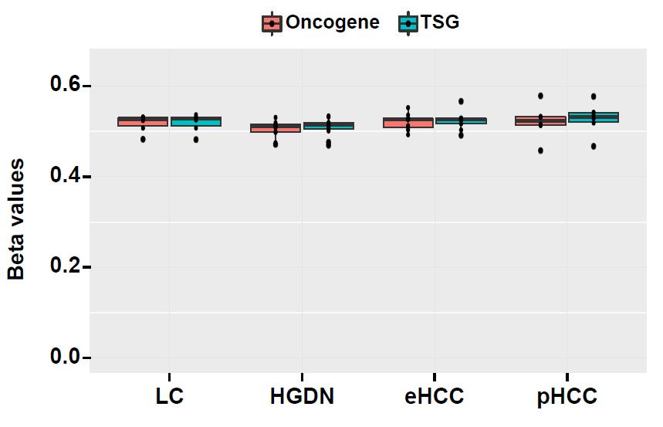

Supplementary Figure S6. DNA methylation of oncogenes and TSGs during multi-step hepatocarcinogenesis

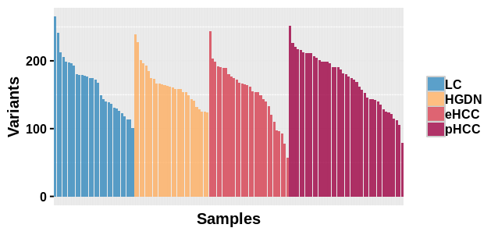

Supplementary Figure S7. Frequencies of nonsynonymous or missense mutations in each patient
Bar plot shows the frequency of nonsynonymous or missense mutations in each patient. Each group of the tissue specimen was indicated with different colors.

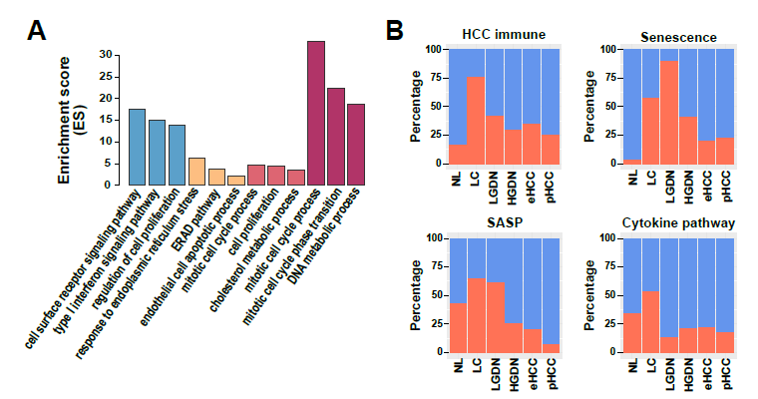

Supplementary Figure S8. Functionally enriched expression in each step of hepatocarcinogenesis
(A) A bar plot shows the enrichment scores (ES) of the genes in biological processes of gene ontology category in each group of hepatocarcinogenesis. Enrichment scores (ES) of each gene set are calculated by using DAVID software (https://david.ncifcrf.gov/). (B) Bar plots show the proportion of the samples with enriched expression (ES > 0.2, red bars) of HCC immune, Senescence, SASP, and cytokine pathways in each group.

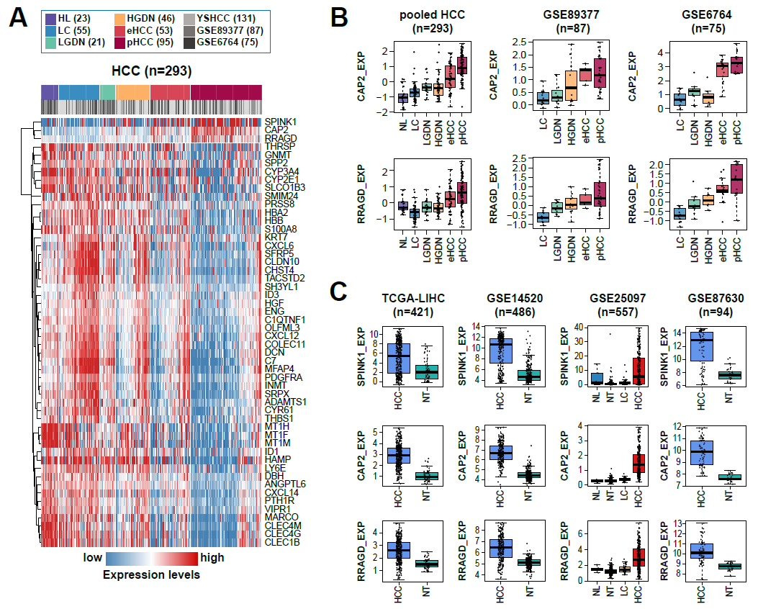

Supplementary Figure S9. Validation of the three genes including SPINK1, CAP2, and RRAGD
(A) A heatmap shows the differentially expressed genes during hepatocarcinogenesis (n=53) in the pooled HCC data set (n=293). (B) Box plots show the stepwise expression of CAP2 and RRAGD during hepatocarcinogenesis in the pool data (left), GSE89377 (middle), and GSE6764 (right), respectively. (C) Box plots show the expression levels of SPINK1, CAP2, and RRAGD in HCCs and non-tumor tissues form the data sets of TCGA-LIHC, GSE14520, GSE25097, and GSE87630, respectively.

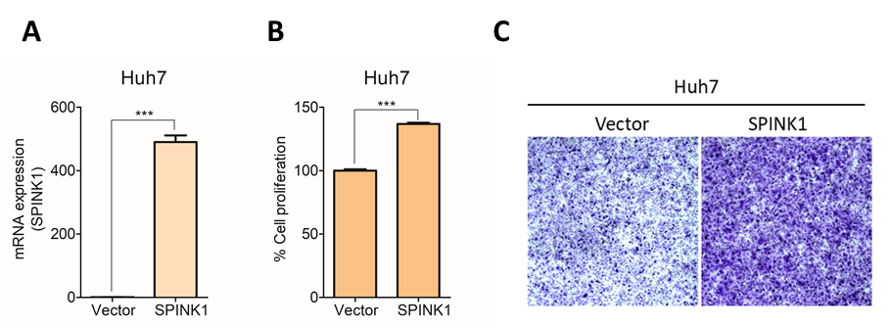

Supplementary Figure S10. SPINK1 overexpression increases proliferation and invasion of Huh7 cells
(A) SPINK1 mRNA expression levels measured by quantitative RT-PCR in Vector- or SPINK1- overexpressed Huh7 cells, respectively. Values are mean ± SEM of three replicates. (B) Cell proliferation is measured by WST-1 assay in Vector- or SPINK1-overexpressed Huh7 cells, respectively. (***P<0.001). (C) Cell Invasion assay is performed in Vector- or SPINK1-overexpressed Huh7 cells, respectively.

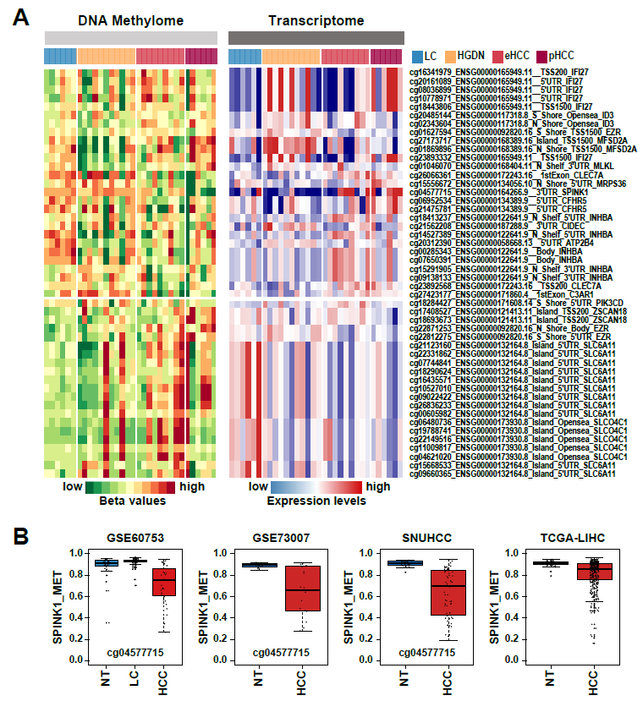

Supplementary Figure S11. Correlation between methylation and expression
(A) Heatmaps show the DNA methylation (left) and the mRNA expression (right) levels of METcor genes (n=48). (B) Box plots show the methylation level of SPINK1 in the data sets of GSE60753, GSE73003, SNUHCC (DNA methylation profile from Seoul National University)(1), and TCGA-LIHC, respectively.
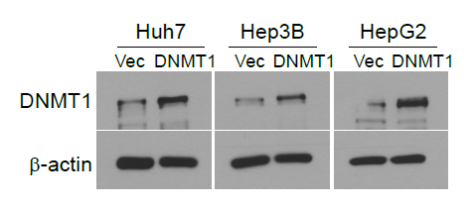

Supplementary Figure S12. Western blot of DNMT1 expression
Western blot analyses are performed to measure the DNMT1 protein level using HCC cell lines including Huh7 (left), Hep3B (middle), and HepG2 (right). Beta actin is used as a loading control.
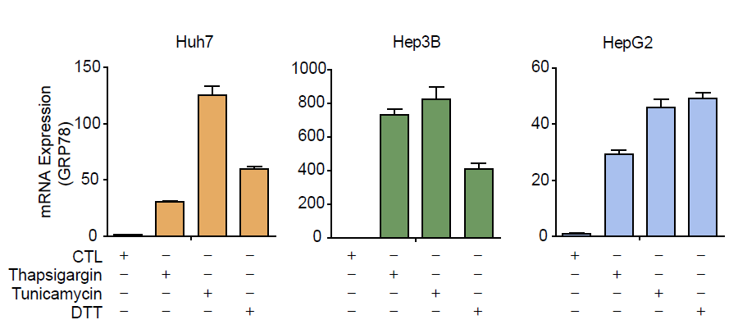

Supplementary Figure S13. GRP78 expression under ER stress
Liver cancer cell lines of Huh7 (left), Hep3B (middle), HepG2 (middle) are grown under serum-free conditions and are treated with ER stress inducers including Thapsigargin (Thap, 1 uM) for 72h, Tunicamycin (Tuni, 1 ug/ml) for 24h, and dithiothreitol (DTT, 1mM) for 24h, and the expression level of GRP78 mRNA is measured by quantitative RT-PCR. Values are mean ± SEM of three replicates.
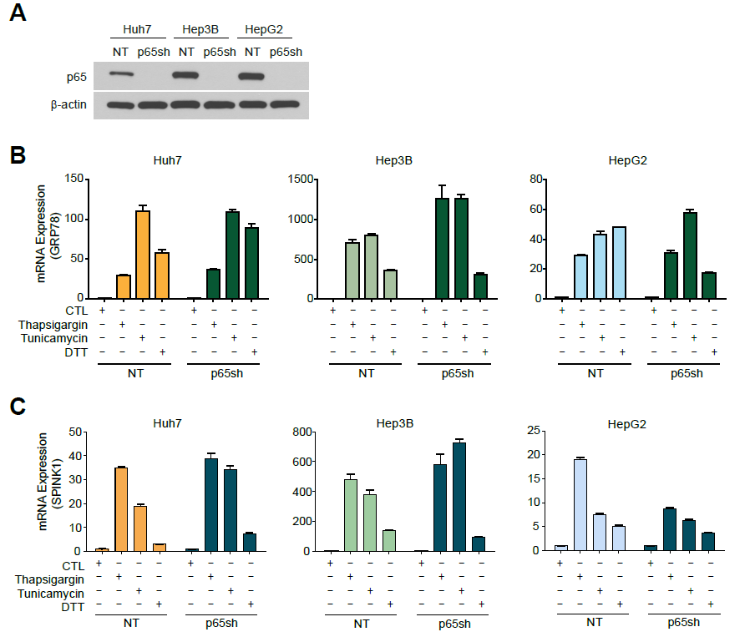

Supplementary Figure S14. Effects of knockdown of p65 expression in the expression of GRP78 and SPINK1
(A) Western blot analyses are performed to measure the p65 protein level using HCC cell lines including Huh7, Hep3B, and HepG2. Beta actin is used as a loading control. (B-C) Liver cancer cell lines and p65sh cell lines of Huh7 (left), Hep3B (middle), HepG2 (middle) are grown under serum-free conditions and are treated with ER stress inducers including Thapsigargin (Thap, 1 uM) for 72h, Tunicamycin (Tuni, 1 ug/ml) for 24h, and dithiothreitol (DTT, 1Mm) for 24h, and the expression levels of GRP78 mRNA (B) and SPINK1 mRNA (C) are measured by quantitative RT-PCR. Values are mean ± SEM of three replicates.

