Supplementary Table 1. Adjusted ORs and 95% CIs for the association between CRP and ovarian cancer risk overall and by study*
 | Invasive Epithelial Ovarian Cancer |  | CLUE |  | EPIC |  | NHS |  | NHSII |  | NYU WHS |  | PLCO
CRP | No. of Cases | OR  (95% CI)ª | No. of Cases | OR  (95% CI)ª | No. of Cases | OR  (95% CI)ª | No. of Cases | OR  (95% CI)ª | No. of Cases | OR  (95% CI)ª | No. of Cases | OR  (95% CI)ª | No. of Cases | OR  (95% CI)ª
Continuous, per 1mg/L^{b} | 1091 | 1.06  (0.99, 1.14) | 52 | 1.29  (0.83, 2.01) | 581 | 1.01  (0.91, 1.11) | 217 | 1.10  (0.94, 1.28) | 50 | 1.13  (0.79, 1.60) | 48 | 1.13  (0.76, 1.70) | 143 | 1.22  (1.00, 1.49)
Tertiles
T1 (<0.77 mg/L) | 333 | 1.00  (Referent) | 12 | 1.00  (Referent) | 181 | 1.00  (Referent) | 70 | 1.00  (Referent) | 21 | 1.00 (Referent) | 19 | 1.00  (Referent) | 30 | 1.00  (Referent)
T2 (≥0.77 to <2.25 mg/L) | 367 | 1.11  (0.92, 1.33) | 17 | 1.38  (0.51, 3.72) | 206 | 0.97  (0.76, 1.25) | 76 | 1.17  (0.77, 1.76) | 11 | 1.43  (0.58, 3.48) | 20 | 1.54  (0.63, 3.80) | 37 | 1.54  (0.79, 3.00)
T3 (≥2.25 mg/L) | 391 | 1.12  (0.93, 1.36) | 23 | 2.03  (0.67, 6.14) | 194 | 0.96  (0.74, 1.27) | 71 | 1.25  (0.79, 1.97) | 18 | 1.36  (0.45, 4.07) | 9 | 1.22  (0.39, 3.85) | 76 | 2.09  (1.08, 4.04)
P_{trend}^{c} |  | 0.34 |  | 0.23 |  | 0.83 |  | 0.40 |  | 0.57 |  | 0.80 |  | 0.04
Clinical cut-points
<1 mg/L | 407 | 1.00  (Referent) | 15 | 1.00  (Referent) | 224 | 1.00  (Referent) | 88 | 1.00  (Referent) | 22 | 1.00 (Referent) | 22 | 1.00  (Referent) | 36 | 1.00  (Referent)
1-10 mg/L | 625 | 1.11  (0.94, 1.32) | 36 | 1.40  (0.55, 3.58) | 325 | 0.98  (0.78, 1.22) | 118 | 1.15  (0.79, 1.68) | 26 | 1.33  (0.60, 2.94) | 25 | 1.65  (0.68, 4.00) | 95 | 1.69  (0.98, 2.94)
>10 mg/L | 59 | 1.67  (1.12, 2.48) | 1 | 1.36  (0.24, 7.63) | 32 | 1.87  (1.06, 3.28) | 11 | 1.81  (0.77, 4.27) | 2 | 2.78  (0.31, 24.80) | 1 | 1.05  (0.11, 10.23) | 12 | 1.28  (0.47, 3.45)
P_{trend}^{c} |  | 0.01 |  | 0.67 |  | 0.03 |  | 0.17 |  | 0.33 |  | 0.55 |  | 0.94
Abbreviations: OR: odds ratio, CI: confidence interval, CRP: C-reactive protein
ªResults were derived from random-effects meta-analysis of study-specific effect estimates from conditional logistic regression models, where cases were matched to one or two controls by age at blood collection, date of blood collection, fasting status for blood collection, menopausal status (including hormone therapy use for postmenopausal women), and day or phase of menstrual cycle at blood collection for premenopausal women. Models were additionally adjusted for the number of pregnancies, oral contraceptive use, tubal ligation, BMI, and smoking status.
^{b}Batch-corrected natural log values.
^{c}P-value for trend was determined using the median value of each category.
*P-values for heterogeneity across study were 0.53 (continuous), 0.40 (tertiles), and 0.86 (clinical cut-points).

Supplementary Table 2. ORs and 95% CIs for the association between CRP and ovarian cancer risk overall with exclusion of PLCO, exclusion of women diagnosed within 2 years of blood draw, additional adjustment for aspirin use, and exclusion of women with cardiovascular disease and diabetes
 | Invasive epithelial ovarian cancer |  | Exclusion of PLCO |  | Exclusion of women diagnosed within 2 years of blood draw |  | Restricted to studies with data on aspirin use (CLUE II, NHS, NHS II, PLCO) |  |  | Exclusion of women with cardiovascular disease and diabetes
CRP | No. of Cases | OR (95% CI)ª | No. of Cases | OR (95% CI)ª | No. of Cases | OR (95% CI)ª | No. of Cases | OR (95% CI)ª | OR (95% CI)^{b} | No. of Cases | OR (95% CI)ª
Continuous, per 1mg/L^{c} | 1091 | 1.06 (0.99, 1.14) | 948 | 1.04 (0.96, 1.12) | 967 | 1.03 (0.96, 1.12) | 462 | 1.13 (1.01, 1.25) | 1.13 (1.01, 1.25) | 672 | 1.05 (0.96, 1.15)
Tertiles, mg/L
T1 (<0.77) | 333 | 1.00 (Referent) | 301 | 1.00 (Referent) | 303 | 1.00 (Referent) | 133 | 1.00 (Referent) | 1.00 (Referent) | 225 | 1.00 (Referent)
T2 (≥0.77 to <2.25) | 367 | 1.10 (0.91, 1.33) | 317 | 1.05 (0.86, 1.28) | 326 | 1.06 (0.87, 1.28) | 141 | 1.23 (0.91, 1.67) | 1.23 (0.91, 1.67) | 218 | 1.03 (0.81, 1.31)
T3 (≥2.25) | 391 | 1.13 (0.92, 1.39) | 330 | 1.08 (0.87, 1.34) | 338 | 1.08 (0.86, 1.35) | 188 | 1.39 (1.01, 1.93) | 1.39 (1.00, 1.93) | 229 | 1.10 (0.84, 1.42)
P_{trend}^{d} |  | 0.33 |  | 0.55 |  | 0.56 |  | 0.07 | 0.07 |  | 0.50
Clinical cut-points
<1 mg/L | 407 | 1.00 (Referent) | 371 | 1.00 (Referent) | 369 | 1.00 (Referent) | 161 | 1.00 (Referent) | 1.00 (Referent) | 269 | 1.00 (Referent)
1-10 mg/L | 625 | 1.11 (0.94, 1.32) | 530 | 1.06 (0.89, 1.27) | 547 | 1.08 (0.90, 1.29) | 275 | 1.29 (0.99, 1.69) | 1.28 (0.98, 1.68) | 368 | 1.05 (0.85, 1.31)
>10 mg/L | 59 | 1.67 (1.12, 2.48) | 47 | 1.90 (1.22, 2.94) | 51 | 1.56 (1.03, 2.38) | 26 | 1.45 (0.80, 2.61) | 1.44 (0.80, 2.62) | 35 | 1.51 (0.88, 2.57)
P_{trend}^{d} |  | 0.01 |  | 0.004 |  | 0.04 |  | 0.27 | 0.27 |  | 0.14
Abbreviations: OR: odds ratio, CI: confidence interval, CRP: C-reactive protein
ªResults were derived from conditional logistic regression models, where cases were matched to one or two controls by age at blood collection, date of blood collection, fasting status for blood collection, menopausal status (including hormone therapy use for postmenopausal women), and day or phase of menstrual cycle at blood collection for premenopausal women. Models additionally adjusted for the number of pregnancies, oral contraceptive use, tubal ligation, BMI, and smoking status.
^{b}Models additionally adjusted for aspirin use.
^{c}Batch corrected natural log values.
^{d}P-value for trend was determined using the median value of each category.

Supplementary Table 3. ORs and 95% CIs for the association between CRP and ovarian cancer risk overall by time between blood draw and diagnosis
 | Time between blood draw and diagnosis
 | <4 yrs (n=255) |  | 4 to <7 yrs (n=241) |  | 7 to <10 yrs (n=270) |  | ≥10 yrs (n=325)
CRP | No. of Cases | OR (95% CI)ª | No. of Cases | OR (95% CI)ª | No. of Cases | OR (95% CI)ª | No. of Cases | OR (95% CI)ª
Continuous, per 1mg/L^{b} | 255 | 1.10 (0.97, 1.26) | 241 | 1.09 (0.94, 1.26) | 270 | 1.04 (0.91, 1.19) | 325 | 1.02 (0.90, 1.15)
Tertiles
T1 (<0.77 mg/L) | 73 | 1.00 (Referent) | 68 | 1.00 (Referent) | 79 | 1.00 (Referent) | 113 | 1.00 (Referent)
T2 (≥0.77 to <2.25 mg/L) | 85 | 1.28 (0.83, 1.95) | 78 | 1.06 (0.71, 1.60) | 97 | 1.31 (0.90, 1.91) | 107 | 0.92 (0.66, 1.27)
T3 (≥2.25 mg/L) | 97 | 1.17 (0.79, 1.74) | 95 | 1.32 (0.86, 2.02) | 94 | 1.05 (0.70, 1.57) | 105 | 1.07 (0.74, 1.53)
P_{trend}^{c} |  | 0.65 |  | 0.18 |  | 0.87 |  | 0.61
Clinical cut-points
<1 mg/L | 86 | 1.00 (Referent) | 82 | 1.00 (Referent) | 103 | 1.00 (Referent) | 136 | 1.00 (Referent)
1-10 mg/L | 154 | 1.22 (0.87, 1.71) | 145 | 1.21 (0.84, 1.74) | 150 | 1.13 (0.81, 1.58) | 176 | 0.97 (0.72, 1.30)
>10 mg/L | 15 | 2.79 (1.24, 6.26) | 14 | 2.85 (1.14, 7.11) | 17 | 1.44 (0.70, 2.98) | 13 | 0.93 (0.45, 1.93)
P_{trend}^{c} |  | 0.01 |  | 0.03 |  | 0.34 |  | 0.82
Abbreviations: OR: odds ratio, CI: confidence interval, CRP: C-reactive protein
ªResults were derived from conditional logistic regression models, where cases were matched to one or two controls by age at blood collection, date of blood collection, fasting status for blood collection, menopausal status (including hormone therapy use for postmenopausal women), and day or phase of menstrual cycle at blood collection for premenopausal women. Models additionally adjusted for the number of pregnancies, oral contraceptive use, tubal ligation, BMI, and smoking status.
^{b}Batch corrected natural log values.
^{c}P-value for trend was determined using the median value of each category.

Supplementary Figure 1. Restricted cubic splines of the association between CRP and ovarian cancer risk using the ESD approach (Panel A) and the 1st and 99th percentile (Panel B) approach to identify CRP outliers

A

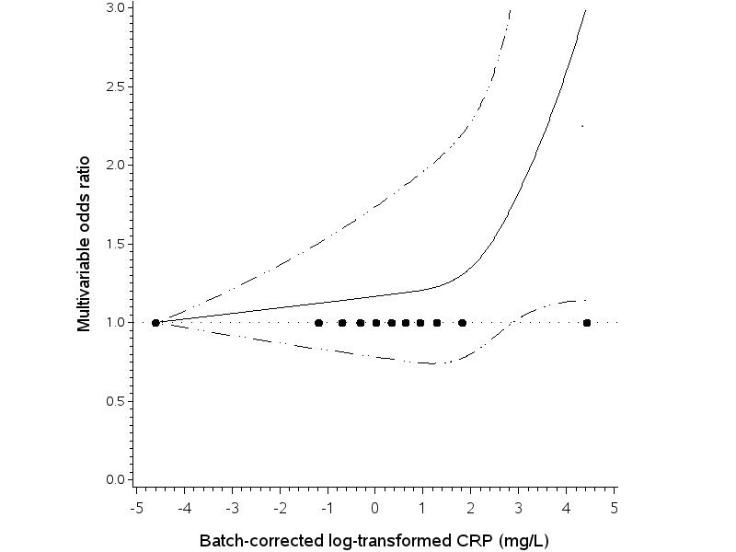

B
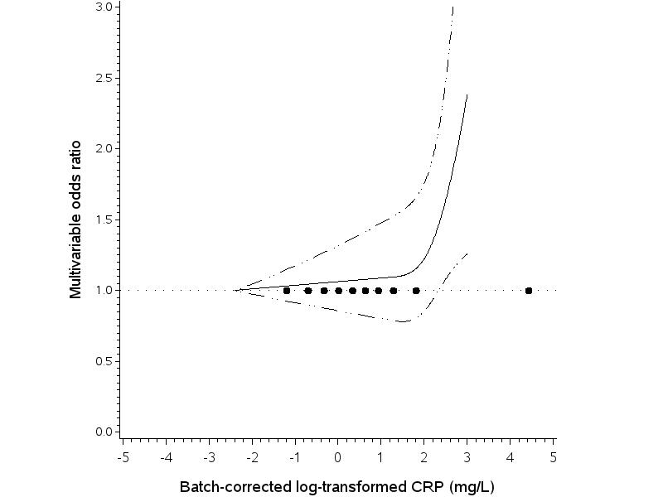

Supplementary Figure 2. Restricted cubic splines of the association between CRP and risk of serous (Panel A) and non-serous ovarian cancer (Panel B) using the 1st and 99th percentile approach to identify CRP outliers

A

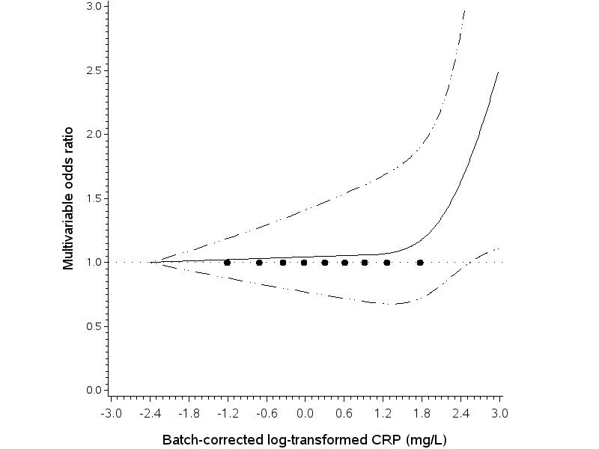

B

