**SUPPLEMENTARY DATA**

**S1: Mass spectrometry data of DTPA-labeled oligonucleotides**

All oligonucleotides were characterised by using a Waters Xevo G2-XS QT of mass spectrometer with an Acquity UPLC system, equipped with an Acquity UPLC oligonucleotide BEH C18 column (particle size: 1.7 μm; pore size: 130 Å; column dimensions: 2.1 x 50 mm). Data were analysed using Waters MassLynx software. All mass showed +63 which was due to unavoidable binding of DTPA to copper ions in the HPLC system (below). The labeled product is the main peak.

|  |  |  |
| --- | --- | --- |
| **Oligonucleotide** | **Calculated Mass** | **Found Mass** |
| DTPA-Match | 4917 | 4980 (M+63) |
| DTPA-Mismatch 1 | 4837 | 4900 (M+63) |
| DTPA-Mismatch 2 | 4860 | 4923 (M+63) |
| DTPA-Scramble | 4917 | 4981 (M+64) |



**Scramble**

**Mismatch 2**

**Mismatch 1**

**Match**

**S2: Site-specificity of oligonucleotide DTPA-conjugation and radiolabeling**

To confirm the site-specificity of radiolabeling, oligonucleotides lacking the 5’-amino-modification were incubated with DTPA. The reaction products were separated by SEC and fractions analysed by absorbance at 260 nm and gamma-counting following diagnostic radiolabeling. A peak eluting at 750 μL exhibited absorbance at 260 nm and a single peak eluting at 1400 μL was recorded in the radiotrace, indicating that oligonucleotide radiolabeling is dependent on the presence of the amino-linker and DTPA. CPM – counts per minute.

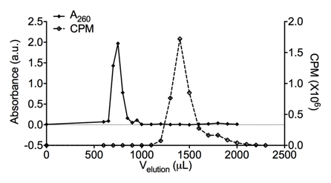

**S3: TRAP assay amplification of the control substrate TSR8**

The pre-elongated control substrate TSR8 (0.2 amoles) was added to the TRAP assay in combination with Match oligonucleotide (1 µM). Data were normalized to untreated control and groups compared by unpaired t-test. n=2, data from two independent repeat experiments.



**S4: Inhibitory activity of DTPA-conjugated oligonucleotide controls**

Telomerase activity of MDA-MB-435 cell lysate after treatment with increasing concentration of Match, Mismatch 1, Mismatch 2, and Scramble oligonucleotides following DTPA-conjugation. Data were fitted using fixed-slope non-linear regression.



**S5: Phosphorothioate DNA oligonucleotides inhibit telomerase in a sequence-independent manner**

A phosphorothioate (PS) DNA oligonucleotide of sequence complementary to hTR (PS Match) showed inhibitory activity in the TRAP assay. However, a PS oligonucleotide with mismatched bases (PS Mismatch) also led to telomerase inhibition, indicating a sequence-independent mechanism. n=2, data from at least two independent repeat experiments.



**S6: Fluorophore-labeling of oligonucleotide inhibitors of telomerase**

(**A**) Oligonucleotides were conjugated with a Cy3 fluorophore and subjected to size exclusion chromatography. Fractions were analysed using absorbance at 260 and 550 nm. (**B**) Unreacted Cy3 fluorophore was employed as a control. n=1, data from at least two independent repeat experiments.

B

A



**S7: Uptake of fluorophore-labeled oligonucleotide inhibitors of telomerase into MDA-MB-435 cells**

The Cy3 fluorescence signal was confirmed to depend on the transfection of fluorophore-labeled oligonucleotide. MDA-MB-435 cells were incubated with the indicated construct for 2.5 hours before fixation and imaging. Cells were counterstained for the Cajal body protein coilin, and DNA (DAPI). Cells stained with secondary antibodies-only confirmed the fluorescence signal depended upon presence of the anti-coilin antibody. Tfx, transfection reagent, Sec Ab, Secondary antibody. Scale bar 40µm.

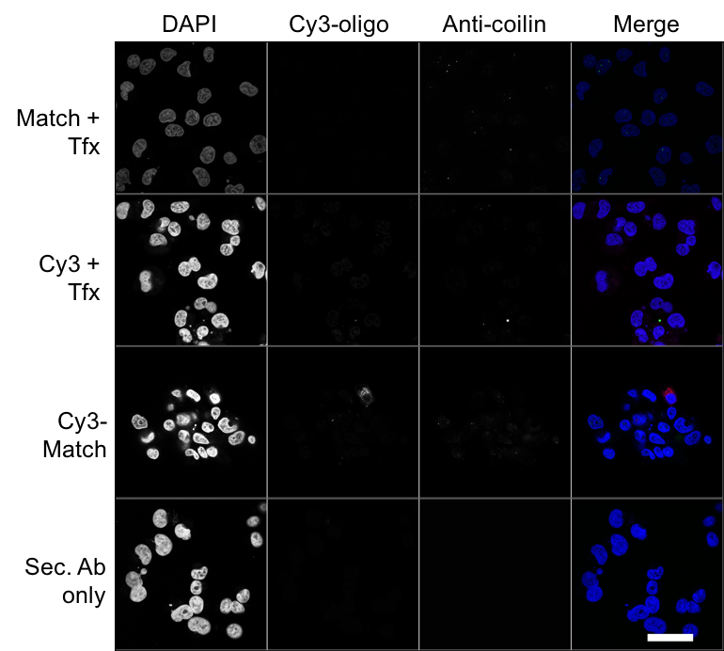

**S8: Quantification of nuclear Cy3-oligonucleotides in MDA-MB-435 cells**

The nuclear Cy3 signal (mean intensity) was quantified from > 50 cells for each condition per experiment. Line and box represent median and 25-75th percentile, respectively. Whiskers represent the 5-95th percentile. Samples were compared using a one-way ANOVA with post hoc Tukey test. *** P < 0.001



**S9: Uptake of fluorophore-labeled oligonucleotide inhibitors of telomerase into U2OS cells**

The uptake and localisation of fluorophore-labeled oligonucleotides into U2OS cells was assessed by confocal microscopy. (**A**) Cy3-labeled Match and Scramble oligonucleotides were transfected into U2OS cells for 2.5 or 24 hours before fixation. (**B**) The fluorescence signal associated with Cy3-oligonucleotides in U2OS cells was confirmed to depend on the presence of transfected fluorophore-labeled oligonucleotide. Cells were counterstained for the Cajal body protein coilin, and DNA (DAPI). Cells stained with secondary (Sec) antibodies-only confirmed the fluorescence signal depended upon presence of the anti-coilin antibody. Tfx – transfection reagent, Abs - antibodies. Images represent data from three independent repeat experiments. Scale bar 40µm.

A

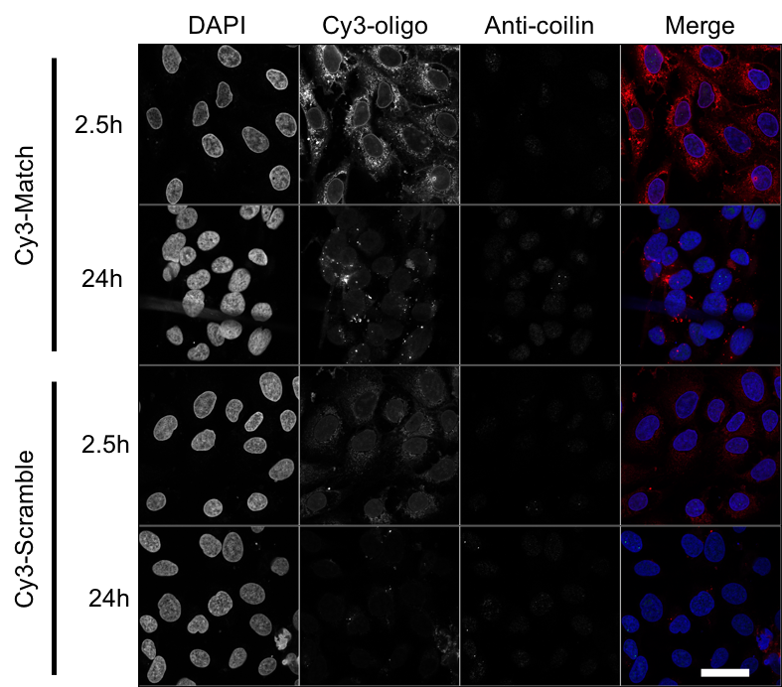

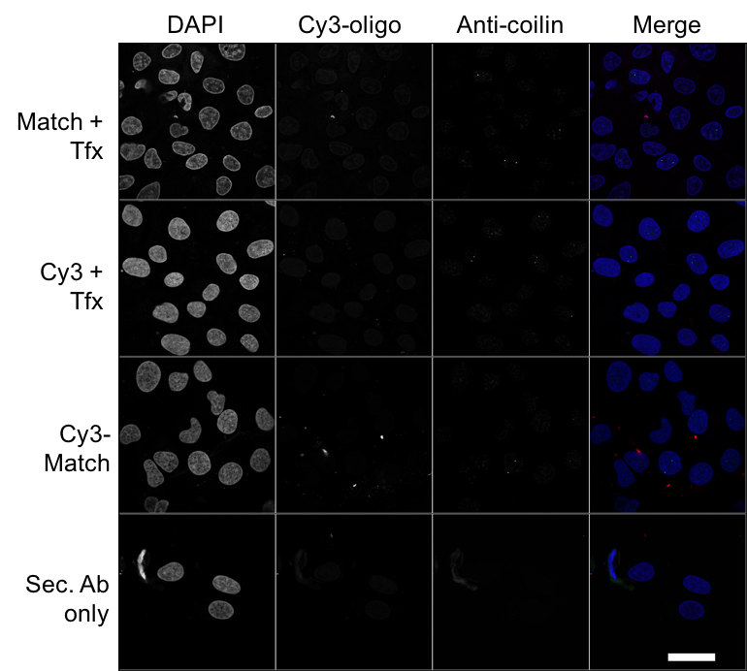

B

**S10: Clonogenic survival uptake optimisation**

Oligonucleotide transfection was optimised to facilitate radioactivity uptake levels between 5 and 10% after 2.5 hours. Required volume of transfectant per oligonucleotide mass: 111In-Match 12 μL/μg; 111In-Scramble 15 μL/μg; 111In-Mismatch 118 μL/μg; 111In-Mismatch 26 μL/μg.



**S11: Clonogenic survival following treatment with increasing oligonucleotide concentration**

Radiolabeled (27 MBq/nmol) and non-labeled oligonucleotides were transfected into MDA-MB-435 cells at the indicated concentration and survival assessed by clonogenic assay. Treatment groups were compared using two-way ANOVA and F-test of linear quadratic fitting. *** P < 0.001



**S12: Clonogenic survival controls**

Oligonucleotides (220 nM in 250 µL) radiolabeled to the indicated specific activity were added without transfection medium into (**A**) MDA-MB-435, (**B**) U2OS, (**C**) SKBR3 and (**D**) MDA-MB-231/H2N cells for 24 hours before plating for colony formation in the clonogenic assay. Colonies of > 50 cells were counted and the surviving fraction (SF) calculated. n=6, data from at least two independent repeat experiments. No effects were observed without transfection media. Treatment groups were compared using two-way ANOVA and F-test of linear quadratic fitting.



**S13: WI38 telomerase activity and radiolabeled oligonucleotide uptake**

WI38 normal fibroblasts were assayed for relative telomerase activity in comparison to MDA-MD-435 cells (**A**). U2OS acted as an additional telomerase-negative control. Oligonucleotides (220 nM in 250 µL) radiolabeled to 3.6 MBq/nmol were combined with transfection reagent and incubated with WI38 cells for the indicated time (**B**). Cells were washed and lysed, and the proportion of internalised radioactivity determined by gamma-counting.



**S14: hTERT expression is not altered following short-term treatment with radiolabeled oligonucleotides**

hTERT expression in MDA-MB-435 cell lysate following treatment with 111In-Match or 111In-Scramble (27 MBq/nmol, 220 nM oligonucleotide, 24 h), as assessed by immunoblotting. Lysates from cells treated in parallel with non-radiolabeled Match or Scramble oligonucleotides (220 nM) included for comparison. β-actin was used as loading control. Approximate molecular weight (in kDa) indicated. NT – not treated.

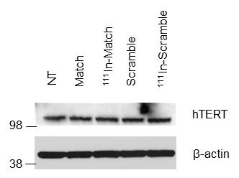

**Method**

After treatment with oligonucleotide for 24 hours, samples were washed with cold PBS and lysed in RIPA buffer containing protease inhibitors (10 μg/mL leupeptin, 2 μg/mL pepstatin, 50 μg/mL antipain, 2 μg /mL aprotinin, 20 μg/mL chyprostatin, 2 μg/mL benzamidine, 1 mM phenylmethanesulfonyl fluoride). Aliquots of cell lysates were prepared in standard Laemmli buffer, heated at 95 °C for 5 minutes and resolved by NuPAGE® 4–12% Bis-Tris gels and LDS-PAGE (20 μg total protein per well, Thermo Fisher Scientific). Proteins were transferred onto nitrocellulose membrane and probed with primary antibodies in 5 % bovine serum albumin. Primary antibodies were anti-hTERT (Abcam, ab3202, 1/1000) and anti-β-actin (Sigma, 1/5000). Reactions were visualised with a suitable secondary antibody conjugated with horseradish peroxidase (1/5000 dilution, Thermo Fisher Scientific). Pierce ECL (Thermo Fisher Scientific) or WesternSurePREMIUM (Li-Cor) chemiluminescent substrates (Fuji medical film and Optimax 2010 processor) were used to visualise protein expression.