Supplemental Figures
Supplemental Figure 1: FACS was utilized for the isolation of CD133-positive and –negative cell populations from the B16-F10 cell line. Representative panels depicting the gating strategy from the parental cell line (left, purple, BD Aria II) as well as the post-sort validation of CD133⁻ (red, top) and CD133⁺ (red, bottom) populations (BD FACSCelesta) are shown. Further validation by immunoblot analysis was used to assess the level of CD133 expression from sorted cells.

Supplemental Figure 2: SPADE trees from pooled data obtained from flow cytometry experiments representative of lung tissues derived from naïve and tumor bearing mice (Figure 5). Each SPADE tree represents a specific marker and its relative level of expression, which is used in the identification of immune cell phenotypes present within the TME. Scales in the lower right hand corner of each tree depict the mean fluorescence from lowly expressed (blue) to highly expressed (red) for each biomarker.

Supplemental Figure 3: Whole lysates isolated from CD133 positive and CD133 negative cells showed differential expression patterns in immunoblot analysis of integrins and TGF-β signaling molecules. Full membrane images following exposure to ECL substrate are provided for the bands referenced in Figure 3B.
Supplemental Figure 4: Spleens isolated from naïve and tumor bearing mice were isolated, dissociated, and subjected to flow cytometric analysis for myeloid cell (top) and lymphocyte (bottom) subsets. Statistical significance was determined by student’s t-test and is denoted by an asterisk. P-values are provided where appropriate.
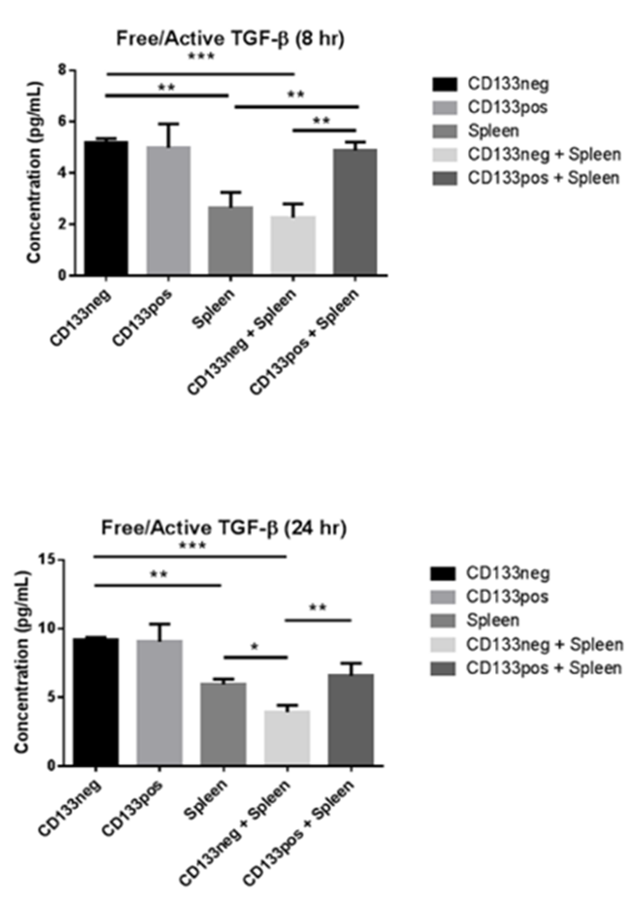

Supplemental Figure 5: ELISA was performed to analyze changes in TGF-β liberation and activation between CSCs and non-CSCs using an in vitro co-culture model. Active TGF-β was measured using CD133+ and CD133- B16-F10 melanoma cells in combination with freshly isolated splenocytes from C57Bl/6 mice after 8 hours and 24 hours. Groups consisting of cancer cells alone, splenocytes alone, and combinations of cancer cells and splenocytes (1:1 ratio) are shown. Asterisks denote statistical significance with * = p < 0.05, ** = p < 0.01, and *** = p < 0.001.
Supplemental Table 1: Primer Sequences for qRT-PCR

Gene | Primer | Sequence (5’ to 3’)
IL10 | Forward  Reverse | TGAATTCCCTGGGTGAGAAGC  ATCATCCTTCACCTGCTCCAC
TGFβ1 | Forward  Reverse | GAGAAGAACTGCTGTGTGCG GTGTCCAGGCTCCAAATATAGG
TGFβ2 | Forward  Reverse | CTTCGACGTGACAGACGCT GCAGGGGCAGTGTAAACTTATT
TGFβ3 | Forward  Reverse | AACAGCCACTCACGCACAGTG GCACAACGAACTGGCTGTCTG
SMAD2 | Forward  Reverse | ATTCCAGAAACGCCACCTCC GCTATTGAACACCAAAATGCAGG
ITGB1 | Forward  Reverse | GTGAAGACATGGACGCTTACT  CTCTTCCTACACACACACTGT
ITGB3 | Forward  Reverse | GTAGCTCTTCCCAGGAGATTT  AGTCTCAGCACATAGCACAAG
ITGA5 | Forward  Reverse | CCGAAGAGCCAGTCCAATAC  TGTCTCTGGGCTAGGAAGAA
ITGAV | Forward  Reverse | CCTCAAGGAGAAGGAAAGGAAG  GTACAAGCTAGCCACGAGTAAG
Β-Actin | Forward  Reverse | GGCTGTATTCCCCTCCG CCAGTTGGTAACAATGCCATGT

Supplemental Table 1: Commercially available and validated primers (IDT) were used for amplification and quantitation of genes of interests by qRT-PCR. The sequences for the forward and reverse primers and their targeted genes are provided above.
Supplemental Table 2: Microarray Results ( > 2-fold change)
 | Negative |  |  | Negative (contd) |  |  |  |  |  |  | Positive
Transcript ID | Fold Change (CD133+ vs CD133-) |  | Transcript ID |  | Fold Change (CD133+ vs CD133-) |  |  |  |  | Transcript ID |  | Fold Change (CD133+ vs CD133-)
mmu-miR-669l-5p |  | -23.35 | mmu-miR-542-5p |  |  | -2.59 |  |  |  | mmu-miR-34b-5p |  | 2.01
mmu-miR-466h-5p |  | -19.62 | mmu-miR-193b-5p |  |  |  | -2.55 |  |  | mmu-mir-6516 |  | 2.03
mmu-miR-8095 |  | -15.58 | mmu-miR-6378 |  |  |  | -2.55 |  |  | mmu-miR-501-3p |  | 2.04
mmu-miR-467h |  | -15.42 | mmu-miR-6988-5p |  |  |  | -2.55 |  |  | mmu-miR-1903 |  | 2.04
mmu-miR-669a-5p |  | -12.93 | mmu-miR-672-5p |  |  |  | -2.54 |  |  | mmu-miR-93-3p |  | 2.05
mmu-miR-669p-5p |  | -12.93 | mmu-miR-7083-5p |  |  |  | -2.54 |  |  | mmu-miR-1981-5p |  | 2.05
mmu-miR-669k-5p |  | -11.37 | mmu-miR-297b-5p |  |  |  | -2.51 |  |  | mmu-miR-3064-3p |  | 2.05
mmu-miR-669o-5p |  | -9.56 | mmu-miR-7039-5p |  |  |  | -2.51 |  |  | mmu-mir-500 |  | 2.05
mmu-miR-669m-5p |  | -9.18 | mmu-miR-670-5p |  |  |  | -2.48 |  |  | mmu-miR-7211-3p |  | 2.06
mmu-miR-466m-5p |  | -9.18 | mmu-miR-6979-5p |  |  |  | -2.48 |  |  | mmu-miR-7222-3p |  | 2.07
mmu-miR-6238 |  | -9.09 | mmu-miR-150-3p |  |  |  | -2.47 |  |  | mmu-miR-291b-5p |  | 2.08
mmu-miR-669d-5p |  | -8.28 | mmu-miR-5129-3p |  |  |  | -2.47 |  |  | mmu-let-7a-1 |  | 2.08
mmu-miR-669e-5p |  | -7.5 | mmu-miR-6944-5p |  |  |  | -2.47 |  |  | mmu-miR-125a-3p |  | 2.1
mmu-miR-7002-5p |  | -7.45 | mmu-miR-6905-5p |  |  |  | -2.46 |  |  | mmu-mir-188 |  | 2.12
mmu-miR-5620-3p |  | -6.29 | mmu-miR-7003-5p |  |  |  | -2.45 |  |  | mmu-miR-324-5p |  | 2.13
mmu-miR-297a-5p |  | -5.98 | mmu-miR-7654-3p |  |  |  | -2.45 |  |  | mmu-miR-378a-5p |  | 2.13
mmu-miR-466j |  | -5.74 | mmu-miR-7242-5p |  |  |  | -2.43 |  |  | mmu-miR-326-3p |  | 2.14
mmu-miR-669b-5p |  | -5.69 | mmu-miR-743a-5p |  |  |  | -2.42 |  |  | mmu-miR-491-5p |  | 2.17
mmu-mir-467h |  | -5.24 | mmu-miR-6963-3p |  |  |  | -2.41 |  |  | mmu-miR-362-5p |  | 2.18
mmu-miR-3100-5p |  | -5.01 | mmu-mir-467e |  |  |  | -2.4 |  |  | mmu-miR-346-5p |  | 2.19
mmu-miR-7684-3p |  | -4.87 | mmu-miR-7658-5p |  |  |  | -2.39 |  |  | mmu-miR-7018-5p |  | 2.2
mmu-mir-7017 |  | -4.79 | mmu-mir-6979 |  |  |  | -2.39 |  |  | mmu-miR-1291 |  | 2.23
mmu-mir-467h |  | -4.78 | mmu-miR-6991-5p |  |  |  | -2.37 |  |  | mmu-miR-7080-5p |  | 2.26
mmu-miR-297c-5p |  | -4.71 | mmu-miR-6909-5p |  |  |  | -2.36 |  |  | mmu-mir-465d |  | 2.27
mmu-miR-7076-5p |  | -4.67 | mmu-miR-200c-3p |  |  |  | -2.35 |  |  | mmu-miR-3068-5p |  | 2.29
mmu-miR-680 |  | -4.3 | mmu-miR-669n |  |  |  | -2.35 |  |  | mmu-miR-1981-3p |  | 2.32
mmu-miR-7024-5p |  | -4.3 | mmu-miR-7087-5p |  |  |  | -2.35 |  |  | mmu-mir-138-1 |  | 2.33
mmu-miR-1956 |  | -4.23 | mmu-miR-7665-5p |  |  |  | -2.35 |  |  | mmu-miR-3065-5p |  | 2.34
mmu-miR-7036-5p |  | -4.21 | mmu-miR-7009-5p |  |  |  | -2.34 |  |  | mmu-miR-6984-5p |  | 2.34
mmu-miR-7014-5p |  | -4.15 | mmu-miR-871-5p |  |  |  | -2.33 |  |  | mmu-miR-652-5p |  | 2.36
mmu-miR-762 |  | -4.05 | mmu-miR-32-3p |  |  |  | -2.32 |  |  | mmu-miR-574-3p |  | 2.36
mmu-miR-5620-5p |  | -4.01 | mmu-miR-6953-5p |  |  |  | -2.32 |  |  | mmu-miR-1306-3p |  | 2.36
mmu-miR-696 |  | -3.95 | mmu-miR-7031-5p |  |  |  | -2.32 |  |  | mmu-miR-7677-5p |  | 2.37
mmu-miR-6337 |  | -3.9 | mmu-mir-7082 |  |  |  | -2.32 |  |  | mmu-miR-211-3p |  | 2.4
mmu-miR-669f-5p |  | -3.87 | mmu-miR-7084-3p |  |  |  | -2.29 |  |  | mmu-miR-199b-5p |  | 2.4
mmu-miR-7115-5p |  | -3.85 | mmu-miR-365-1-5p |  |  |  | -2.27 |  |  | mmu-miR-7684-5p |  | 2.4
mmu-miR-326-5p |  | -3.78 | mmu-miR-7045-5p |  |  |  | -2.27 |  |  | mmu-miR-1894-5p |  | 2.42
mmu-miR-92a-3p |  | -3.57 | mmu-miR-6911-5p |  |  |  | -2.26 |  |  | mmu-miR-1933-3p |  | 2.43
mmu-mir-1194 |  | -3.5 | mmu-miR-7221-3p |  |  |  | -2.25 |  |  | mmu-miR-6907-5p |  | 2.48
mmu-miR-3090-5p |  | -3.45 | mmu-mir-150 |  |  |  | -2.24 |  |  | mmu-miR-455-3p |  | 2.49
mmu-miR-346-3p |  | -3.41 | mmu-mir-301b |  |  |  | -2.24 |  |  | mmu-miR-532-3p |  | 2.54
mmu-mir-466f-4 |  | -3.41 | mmu-mir-466j |  |  |  | -2.24 |  |  | mmu-miR-505-5p |  | 2.57
mmu-miR-7662-5p |  | -3.37 | mmu-mir-466j |  |  |  | -2.24 |  |  | mmu-miR-5622-3p |  | 2.58
mmu-miR-7648-3p |  | -3.36 | mmu-miR-7036b-3p |  |  |  | -2.21 |  |  | mmu-miR-181a-1-3p |  |  | 2.59
mmu-miR-6921-5p |  | -3.3 | mmu-mir-101c |  |  |  | -2.21 |  |  | mmu-miR-219a-1-3p |  |  | 2.63
mmu-miR-6958-3p |  | -3.3 | mmu-miR-872-5p |  |  |  | -2.2 |  |  | mmu-miR-671-5p |  | 2.7
mmu-miR-7212-5p |  | -3.28 | mmu-miR-28c |  |  |  | -2.2 |  |  | mmu-miR-501-5p |  | 2.81
mmu-miR-7682-3p |  | -3.19 | mmu-mir-6930 |  |  |  | -2.19 |  |  | mmu-miR-330-5p |  | 2.84
mmu-miR-6935-5p |  | -3.18 | mmu-mir-3113 |  |  |  | -2.14 |  |  | mmu-let-7a-1 |  | 2.88
mmu-miR-3620-5p |  | -3.06 | mmu-mir-1956 |  |  |  | -2.13 |  |  | mmu-miR-1968-5p |  | 2.96
mmu-miR-7030-5p |  | -3.05 | mmu-miR-6391 |  |  |  | -2.12 |  |  | mmu-miR-7116-5p |  | 3.01
mmu-miR-669c-5p |  | -3.04 | mmu-miR-7047-5p |  |  |  | -2.12 |  |  | mmu-miR-29b-2-5p |  | 3.02
mmu-miR-128-2-5p |  | -3.01 | mmu-miR-194-2-3p |  |  |  | -2.09 |  |  | mmu-miR-188-5p |  | 3.18
mmu-miR-6970-5p |  | -3 | mmu-mir-466f-1 |  |  |  | -2.09 |  |  | mmu-miR-1843a-5p |  | 3.22
mmu-miR-711 |  | -2.99 | mmu-miR-7063-5p |  |  |  | -2.08 |  |  | mmu-miR-7034-5p |  | 3.28
mmu-miR-1893 |  | -2.98 | mmu-miR-7075-5p |  |  |  | -2.08 |  |  | mmu-miR-301b-5p |  | 4.33
mmu-miR-6980-5p |  | -2.98 | mmu-miR-7082-3p |  |  |  | -2.08
mmu-miR-1247-3p |  | -2.93 | mmu-miR-6952-5p |  |  |  | -2.06
mmu-miR-195a-3p |  | -2.91 | mmu-miR-7085-5p |  |  |  | -2.06
mmu-miR-16-1-3p |  | -2.91 | mmu-miR-7235-5p |  |  |  | -2.06
mmu-miR-7001-5p |  | -2.87 | mmu-miR-7668-3p |  |  |  | -2.06
mmu-miR-7067-5p |  | -2.87 | mmu-mir-297c |  |  |  | -2.06
mmu-miR-466c-5p |  | -2.82 | mmu-miR-466p-5p |  |  |  | -2.05
mmu-miR-466f-5p |  | -2.82 | mmu-miR-5627-5p |  |  |  | -2.05
mmu-miR-6937-5p |  | -2.78 | mmu-miR-7066-3p |  |  |  | -2.05
mmu-miR-466f |  | -2.67 | mmu-miR-6244 |  |  |  | -2.04
mmu-miR-7038-3p |  | -2.66 | mmu-miR-22-5p |  |  |  | -2.03
mmu-miR-5135 |  | -2.64 | mmu-miR-770-5p |  |  |  | -2.02
mmu-miR-1934-3p |  | -2.63 | mmu-miR-6908-5p |  |  |  | -2.02
mmu-miR-6910-5p |  | -2.63 | mmu-mir-30e |  |  |  | -2.02
mmu-miR-6966-5p |  | -2.63 | mmu-miR-338-5p |  |  |  | -2
mmu-miR-21a-5p |  | -2.62 | mmu-mir-669m-2 |  |  |  | -2

Supplemental Table 2: TAC software reported several hundred microRNAs from our microarray comparing miR expression profiles of CD133+ and CD133- B16-F10 cells. The comprehensive list of miRs with < 2-fold and > 2-fold changes in expression are listed above. MicroRNA-92a has been highlighted in red, and miRNAs have been sorted by fold-change expression in ascending order.

