Supplementary Material
Supplementary Tables 2
Supplementary Table 2 2
Supplementary Table 4 5
Supplementary Table 6 16
Supplementary Figures 23
Supplementary Methods 30
Primers and sequences 33
References 34

Supplementary Tables
Supplementary Table 2. Genetic characterization of BL cell lines
Sample | EBV status | IG-MYC translocation | chr1q CNA | TP53 status | RNAi screen | POS | Gene | CDS | AA
BJAB | negative | MYC gain³ | 1q21 diploid³ | mut | yes | X:41205861 | DDX3X | c.1601G>A | p.R534H
 |  |  |  |  |  | 17:7578271 | TP53 | c.578A>G | p.H194R
BL2 | negative | t(8;22)  (q24.2;q11.2)^{1,2} | +1q21.1q31.3^{1,2} | wt | yes | X:41205625 | DDX3X | c.1459T>C | p.F487L
 |  |  |  |  |  | 13:41240288 | FOXO1 | c.62G>A | p.R21H
 |  |  |  |  |  | 1:23885617 | ID3 | splice site | p.?
 |  |  |  |  |  | 8:128748565 | MYC | . | UTR
 |  |  |  |  |  | 8:128748640 | MYC | . | UTR
 |  |  |  |  |  | 8:128748661 | MYC | . | UTR
 |  |  |  |  |  | 8:128748680 | MYC | . | UTR
 |  |  |  |  |  | 8:128748697 | MYC | . | UTR
 |  |  |  |  |  | 8:128748731 | MYC | . | UTR
 |  |  |  |  |  | 8:128750938 | MYC | c.475C>T | p.L159F
 |  |  |  |  |  | 8:128751032 | MYC | c.569G>A | p.S190N
 |  |  |  |  |  | 8;128750613 | MYC | c.180G>C | p.Q60H
 |  |  |  |  |  | 3:38182032 | MYD88 | c.656C>G | p.S219C
 |  |  |  |  |  | 19:1611800 | TCF3 | c.1862A>G | p.E621G
 |  |  |  |  |  | 19:1611850 | TCF3 | splice site | p.?
BL60 | positive  (latency  phase III) | MYC break³ | 1q21 diploid³ | mut | yes | 13:41240349 | FOXO1 | c.1A>G | p.M1V
 |  |  |  |  |  | 1:23,885,667 | ID3 | c.251T>A | p.L84Q
 |  |  |  |  |  | 1:23,885,680 | ID3 | c.238C>G | p.L80V
 |  |  |  |  |  | 1:23,885,685 | ID3 | c.233T>G | p.L78R
 |  |  |  |  |  | 8:128748843 | MYC | c.4G>C | p.D2H
 |  |  |  |  |  | 8:128750681 | MYC | c.218C>T | p.T73I
 |  |  |  |  |  | 8:128750682 | MYC | c.140C>T | p.P47L
 |  |  |  |  |  | 8:128751113 | MYC | c.650G>C | p.S217T
 |  |  |  |  |  | 8:128751116 | MYC | c.653G>C | p.S218T
 |  |  |  |  |  | 19:1612356 | TCF3 | c.1663G>C | p.E555Q
 |  |  |  |  |  | 17:7577539 | TP53 | c.742C>T | p.R248W
LY47 | positive  (latency  phase III) | t(8;22)  (q24.2;q11.2)² | +1q43q44² | wt | yes | 8:128748866 | MYC | c.27C>G | p.N9K
Raji | positive  (latency  phase III) | t(8;14)  (q24;q32)¹ | diploid¹ | mut | yes | X:41203663 | DDX3X | splice site | p.?
 |  |  |  |  |  | 17:63052557 | GNA13 | c.155T>G | p.L52R
 |  |  |  |  |  | 8:128750639 | MYC | c.176C>T | p.A59V
 |  |  |  |  |  | 8:128750681 | MYC | c.218C>T | p.T73I
 |  |  |  |  |  | 17:7577581 | TP53 | c.700T>C | p.Y234H
 |  |  |  |  |  | 17:7578211 | TP53 | c.638G>A | p.R213Q
Ramos | negative | t(8;14)  (q24.2;q32.3)^{1,2} | diploid^{1,2} | mut | yes | X:41206952 | DDX3X | c.1969G>A | p.V657I
 |  |  |  |  |  | 17:63049625 | GNA13 | c.505C>T | p.Q169*
 |  |  |  |  |  | 8:128748157 | MYC | . | UTR5
 |  |  |  |  |  | 8:128748735 | MYC | . | UTR5
 |  |  |  |  |  | 8:128748837 | MYC | . | UTR5
 |  |  |  |  |  | 19:1612336 | TCF3 | c.1683T>G | p.D561E
 |  |  |  |  |  | 17:7577520-  17:7577521 | TP53 | c.761-762AT>GA | p.I254D
Salina | positive  (Wp-restricted) | t(8;14)  (q24.2;q32.3)² | +1q21.2q31.3² | wt | yes | X:41203603 | DDX3X | c.976C>T | p.R326C
 |  |  |  |  |  | 1:23885709 | ID3 | c.209T>C | p.L70P
 |  |  |  |  |  | 8:128750541 | MYC | c.78C>G | p.N26K
Seraphine | positive  (latency  phase III) | t(8;14)  (q24.2;q32.3)² | +1q21.1qter² | wt | yes | 8:128748843 | MYC | c.4G>A | p.D2N
 |  |  |  |  |  | 8:128748858 | MYC | c.19G>A | p.V7M
 |  |  |  |  |  | 8:128750542 | MYC | c.79T>C | p.Y27H
 |  |  |  |  |  | 8:128750683 | MYC | c.220C>G | p.P74A
 |  |  |  |  |  | 8:128750953 | MYC | c.490C>G | p.L164V
 |  |  |  |  |  | 8:128750959 | MYC | c.496T>G | p.S166A
BL7 | positive  (latency  phase III) | MYC break³ | 1q21 diploid³ | wt | no
BL41 | negative | t(8;14)  (q24.2;q31.3)^{1,2} | Multiple subclonal rearrangements and gains^{1,2} | mut | no | 17:7577538 | TP53 | c.743G>A | p.R248Q
CA46 | negative | t(8;14)  (q24;q32)¹ | dup(1)(q21q32)¹ | mut | no | 17:7577538 | TP53 | c.743G>A | p.R248Q
 |  |  |  |  |  |  | MYC |  | p.P72S
 |  |  |  |  |  |  | MYC |  | p.P75H
Cheptanges | subclone  positive  (latency  phase III) | MYC break³ | 1q21 diploid³ | wt | no |  | MYC |  | p.P75T
DG75 | negative | t(8;14)  (q24;q32)¹ | diploid¹ | mut | no | 17:7577548 | TP53 | c.733G>A | p.G245S
 |  |  |  |  |  | 17:7577090 | TP53 | c.848G>A | p.R283H
 |  |  |  |  |  |  | MYC |  | p.C148W
Namalwa | positive  (latency  phase III) | t(8;14)  (q24.2;q32.3)^{1,2} | +1q12q31.1;  +1q44(subclone);  dup(1)(pterp36.1);  dup(1)(q11q31.1)^{1,2} | mut | no | 17:7577538 | TP53 | c.743G>A | p.R248Q
DogKit | negative¹ | t(14;18)  (q32;q21)¹ | dup(1)(q21q42)¹ | wt | no
Gumbus | negative¹ | t(8;14)  (q24;q32)¹ | 1q21 diploid¹ | wt | no
¹DSMZ (https://www.dsmz.de/home.html)
²Toujani et al., 2009
³FISH analysis (MYC break probe or 1p32/1q21 probe)

Supplementary Table 4. Genetic aberrations in aggressive B-NHL patients from the MMML consortium
MPINR | class | MYC status | # MYC mutations | # MYC box 1 mutations | # MYC box 2 mutations | TP53 status | CNA data
MPI-001 | BL | IG-MYC | 0 | NA | NA | 0 | yes
MPI-003 | BL | IG-MYC | 3 | 0 | 1 | 0 | yes
MPI-016 | BL | IG-MYC | 0 | NA | NA | 0 | yes
MPI-043 | BL | IG-MYC | 0 | NA | NA | 0 | yes
MPI-049 | BL | IG-MYC | 3 | 1 | 0 | 0 | yes
MPI-055 | BL | IG-MYC | 1 | 0 | 0 | 0 | yes
MPI-066 | BL | IG-MYC | 3 | 1 | 0 | 0 | yes
MPI-067 | BL | IG-MYC | 0 | NA | NA | 0 | yes
MPI-075 | BL | IG-MYC | 3 | 1 | 0 | 0 | yes
MPI-079 | BL | IG-MYC | 4 | 1 | 0 | 0 | yes
MPI-080 | BL | IG-MYC | 4 | 1 | 0 | 0 | yes
MPI-081 | BL | IG-MYC | 1 | 0 | 0 | 0 | yes
MPI-082 | BL | IG-MYC | 2 | 1 | 0 | 0 | yes
MPI-084 | BL | IG-MYC | 0 | NA | NA | 0 | yes
MPI-091 | BL | IG-MYC | 2 | 2 | 0 | 0 | yes
MPI-095 | BL | IG-MYC | 2 | 1 | 0 | 0 | yes
MPI-114 | BL | IG-MYC | 0 | NA | NA | 0 | yes
MPI-138 | BL | IG-MYC | 2 | 0 | 0 | 0 | yes
MPI-139 | BL | IG-MYC | 2 | 0 | 1 | 0 | yes
MPI-156 | BL | IG-MYC | 0 | NA | NA | 0 | yes
MPI-171 | BL | IG-MYC | 0 | NA | NA | 0 | yes
MPI-172 | BL | IG-MYC | 6 | 0 | 1 | 0 | yes
MPI-211 | BL | IG-MYC | 0 | NA | NA | 0 | no
MPI-220 | BL | IG-MYC | NA | NA | NA | 0 | yes
MPI-527 | BL | IG-MYC | 0 | NA | NA | 0 | yes
MPI-528 | BL | IG-MYC | 0 | NA | NA | 0 | yes
MPI-529 | BL | IG-MYC | 0 | NA | NA | 0 | yes
MPI-576 | BL | IG-MYC | 1 | 0 | 0 | 0 | yes
MPI-586 | BL | IG-MYC | 5 | 1 | 2 | 0 | yes
MPI-591 | BL | IG-MYC | 0 | NA | NA | 0 | yes
MPI-622 | BL | IG-MYC | 2 | 0 | 0 | 0 | yes
MPI-623 | BL | IG-MYC | 3 | 1 | 0 | 0 | yes
MPI-697 | BL | IG-MYC | NA | NA | NA | 0 | no
MPI-004 | BL | IG-MYC | 2 | 2 | 0 | 1 | yes
MPI-005 | BL | IG-MYC | 1 | 0 | 0 | 1 | yes
MPI-017 | BL | IG-MYC | 2 | 2 | 0 | 1 | yes
MPI-018 | BL | IG-MYC | 3 | 1 | 2 | 1 | yes
MPI-033 | BL | IG-MYC | 2 | 0 | 1 | 1 | yes
MPI-044 | BL | IG-MYC | 1 | 1 | 0 | 1 | yes
MPI-048 | BL | IG-MYC | 2 | 1 | 0 | 1 | yes
MPI-071 | BL | IG-MYC | 0 | NA | NA | 1 | yes
MPI-077 | BL | IG-MYC | 3 | 1 | 1 | 1 | yes
MPI-085 | BL | IG-MYC | 0 | NA | NA | 1 | yes
MPI-087 | BL | IG-MYC | 6 | 0 | 4 | 1 | yes
MPI-101 | BL | IG-MYC | 3 | 1 | 0 | 1 | yes
MPI-123 | BL | IG-MYC | NA | NA | NA | 1 | no
MPI-144 | BL | IG-MYC | 1 | 1 | 0 | 1 | yes
MPI-323 | BL | IG-MYC | 7 | 0 | 4 | 1 | yes
MPI-417 | BL | IG-MYC | 1 | 0 | 0 | 1 | yes
MPI-532 | BL | IG-MYC | 1 | 0 | 0 | 1 | yes
MPI-568 | BL | IG-MYC | 0 | NA | NA | 1 | yes
MPI-579 | BL | IG-MYC | 0 | NA | NA | 1 | yes
MPI-580 | BL | IG-MYC | 1 | 0 | 0 | 1 | yes
MPI-588 | BL | IG-MYC | 2 | 0 | 2 | 1 | yes
MPI-589 | BL | IG-MYC | 4 | 2 | 0 | 1 | yes
MPI-590 | BL | IG-MYC | 1 | 0 | 0 | 1 | yes
MPI-618 | BL | IG-MYC | 0 | NA | NA | 1 | yes
MPI-621 | BL | IG-MYC | 3 | 1 | 1 | 1 | yes
MPI-625 | BL | IG-MYC | 0 | NA | NA | 1 | yes
MPI-680 | BL | IG-MYC | NA | NA | NA | 1 | no
MPI-747 | BL | IG-MYC | NA | NA | NA | 1 | no
MPI-008 | DLBCL | neg | 0 | NA | NA | 0 | yes
MPI-009 | DLBCL | neg | 0 | NA | NA | 0 | yes
MPI-010 | DLBCL | neg | 0 | NA | NA | 0 | yes
MPI-012 | DLBCL | neg | 0 | NA | NA | 0 | yes
MPI-014 | DLBCL | neg | 0 | NA | NA | 0 | yes
MPI-015 | DLBCL | neg | 0 | NA | NA | 0 | yes
MPI-030 | DLBCL | neg | NA | NA | NA | 0 | yes
MPI-036 | DLBCL | IG-MYC | 8 | 1 | 2 | 0 | yes
MPI-040 | DLBCL | neg | 0 | NA | NA | 0 | no
MPI-046 | DLBCL | non-IG-MYC | 0 | NA | NA | 0 | yes
MPI-047 | DLBCL | neg | 0 | NA | NA | 0 | yes
MPI-053 | DLBCL | neg | 0 | NA | NA | 0 | yes
MPI-073 | DLBCL | neg | 0 | NA | NA | 0 | yes
MPI-074 | DLBCL | non-IG-MYC | 11 | 0 | 0 | 0 | yes
MPI-076 | DLBCL | neg | 0 | NA | NA | 0 | yes
MPI-083 | DLBCL | neg | NA | NA | NA | 0 | no
MPI-096 | DLBCL | neg | 0 | NA | NA | 0 | no
MPI-105 | DLBCL | neg | 0 | NA | NA | 0 | yes
MPI-109 | DLBCL | neg | 0 | NA | NA | 0 | yes
MPI-110 | DLBCL | neg | 0 | NA | NA | 0 | yes
MPI-111 | DLBCL | neg | 0 | NA | NA | 0 | yes
MPI-113 | DLBCL | neg | 0 | NA | NA | 0 | yes
MPI-115 | DLBCL | neg | 0 | NA | NA | 0 | yes
MPI-118 | DLBCL | neg | NA | NA | NA | 0 | yes
MPI-127 | DLBCL | neg | 0 | NA | NA | 0 | yes
MPI-128 | DLBCL | neg | 0 | NA | NA | 0 | yes
MPI-130 | DLBCL | neg | 0 | NA | NA | 0 | yes
MPI-133 | DLBCL | neg | 0 | NA | NA | 0 | yes
MPI-136 | DLBCL | neg | 0 | NA | NA | 0 | yes
MPI-141 | DLBCL | neg | 0 | NA | NA | 0 | yes
MPI-145 | DLBCL | neg | 0 | NA | NA | 0 | yes
MPI-146 | DLBCL | neg | 0 | NA | NA | 0 | yes
MPI-149 | DLBCL | neg | 0 | NA | NA | 0 | yes
MPI-151 | DLBCL | neg | 0 | NA | NA | 0 | yes
MPI-154 | DLBCL | neg | 0 | NA | NA | 0 | yes
MPI-159 | DLBCL | neg | 0 | NA | NA | 0 | yes
MPI-163 | DLBCL | neg | 0 | NA | NA | 0 | yes
MPI-164 | DLBCL | neg | 0 | NA | NA | 0 | yes
MPI-165 | DLBCL | non-IG-MYC | 38 | 13 | 0 | 0 | no
MPI-168 | DLBCL | IG-MYC | 0 | NA | NA | 0 | yes
MPI-173 | DLBCL | neg | 0 | NA | NA | 0 | yes
MPI-176 | DLBCL | IG-MYC | 0 | NA | NA | 0 | yes
MPI-180 | DLBCL | NA | 0 | NA | NA | 0 | yes
MPI-183 | DLBCL | neg | 0 | NA | NA | 0 | no
MPI-184 | DLBCL | neg | 0 | NA | NA | 0 | yes
MPI-188 | DLBCL | neg | 0 | NA | NA | 0 | yes
MPI-189 | DLBCL | IG-MYC | 4 | 1 | 0 | 0 | yes
MPI-191 | DLBCL | neg | 0 | NA | NA | 0 | yes
MPI-193 | DLBCL | neg | 0 | NA | NA | 0 | no
MPI-194 | DLBCL | neg | 1 | 0 | 1 | 0 | yes
MPI-195 | DLBCL | neg | 0 | NA | NA | 0 | yes
MPI-199 | DLBCL | neg | 0 | NA | NA | 0 | yes
MPI-201 | DLBCL | neg | 0 | NA | NA | 0 | yes
MPI-203 | DLBCL | neg | 0 | NA | NA | 0 | yes
MPI-205 | DLBCL | neg | 0 | NA | NA | 0 | yes
MPI-206 | DLBCL | neg | 0 | NA | NA | 0 | yes
MPI-207 | DLBCL | neg | 0 | NA | NA | 0 | no
MPI-209 | DLBCL | neg | 0 | NA | NA | 0 | yes
MPI-210 | DLBCL | IG-MYC | 3 | 0 | 0 | 0 | no
MPI-223 | DLBCL | neg | NA | NA | NA | 0 | no
MPI-232 | DLBCL | neg | 0 | NA | NA | 0 | yes
MPI-236 | DLBCL | NA | 0 | NA | NA | 0 | no
MPI-237 | DLBCL | IG-MYC | 0 | NA | NA | 0 | yes
MPI-241 | DLBCL | neg | 0 | NA | NA | 0 | yes
MPI-244 | DLBCL | neg | 0 | NA | NA | 0 | yes
MPI-247 | DLBCL | neg | 0 | NA | NA | 0 | yes
MPI-248 | DLBCL | non-IG-MYC | 0 | NA | NA | 0 | no
MPI-261 | DLBCL | NA | NA | NA | NA | 0 | yes
MPI-269 | DLBCL | neg | NA | NA | NA | 0 | yes
MPI-270 | DLBCL | neg | NA | NA | NA | 0 | yes
MPI-271 | DLBCL | IG-MYC | NA | NA | NA | 0 | yes
MPI-272 | DLBCL | neg | NA | NA | NA | 0 | yes
MPI-273 | DLBCL | neg | NA | NA | NA | 0 | yes
MPI-274 | DLBCL | neg | NA | NA | NA | 0 | yes
MPI-277 | DLBCL | neg | NA | NA | NA | 0 | yes
MPI-278 | DLBCL | neg | NA | NA | NA | 0 | yes
MPI-279 | DLBCL | NA | NA | NA | NA | 0 | yes
MPI-281 | DLBCL | neg | NA | NA | NA | 0 | yes
MPI-282 | DLBCL | neg | NA | NA | NA | 0 | yes
MPI-285 | DLBCL | neg | NA | NA | NA | 0 | yes
MPI-286 | DLBCL | neg | NA | NA | NA | 0 | yes
MPI-287 | DLBCL | neg | 0 | NA | NA | 0 | yes
MPI-288 | DLBCL | neg | NA | NA | NA | 0 | yes
MPI-289 | DLBCL | neg | NA | NA | NA | 0 | yes
MPI-290 | DLBCL | neg | NA | NA | NA | 0 | yes
MPI-291 | DLBCL | non-IG-MYC | NA | NA | NA | 0 | yes
MPI-293 | DLBCL | neg | NA | NA | NA | 0 | yes
MPI-299 | DLBCL | neg | NA | NA | NA | 0 | yes
MPI-302 | DLBCL | non-IG-MYC | NA | NA | NA | 0 | yes
MPI-304 | DLBCL | IG-MYC | NA | NA | NA | 0 | yes
MPI-306 | DLBCL | neg | 1 | 0 | 0 | 0 | yes
MPI-308 | DLBCL | neg | NA | NA | NA | 0 | yes
MPI-309 | DLBCL | neg | NA | NA | NA | 0 | yes
MPI-312 | DLBCL | neg | NA | NA | NA | 0 | yes
MPI-318 | DLBCL | neg | NA | NA | NA | 0 | yes
MPI-319 | DLBCL | neg | NA | NA | NA | 0 | yes
MPI-321 | DLBCL | neg | NA | NA | NA | 0 | yes
MPI-324 | DLBCL | neg | NA | NA | NA | 0 | yes
MPI-326 | DLBCL | neg | NA | NA | NA | 0 | no
MPI-327 | DLBCL | neg | NA | NA | NA | 0 | yes
MPI-330 | DLBCL | neg | NA | NA | NA | 0 | yes
MPI-331 | DLBCL | non-IG-MYC | NA | NA | NA | 0 | yes
MPI-334 | DLBCL | IG-MYC | NA | NA | NA | 0 | yes
MPI-335 | DLBCL | neg | NA | NA | NA | 0 | yes
MPI-337 | DLBCL | neg | NA | NA | NA | 0 | yes
MPI-338 | DLBCL | neg | NA | NA | NA | 0 | yes
MPI-342 | DLBCL | neg | NA | NA | NA | 0 | yes
MPI-343 | DLBCL | neg | NA | NA | NA | 0 | yes
MPI-344 | DLBCL | neg | NA | NA | NA | 0 | yes
MPI-345 | DLBCL | neg | NA | NA | NA | 0 | yes
MPI-346 | DLBCL | neg | NA | NA | NA | 0 | yes
MPI-347 | DLBCL | neg | NA | NA | NA | 0 | yes
MPI-348 | DLBCL | neg | NA | NA | NA | 0 | yes
MPI-349 | DLBCL | neg | NA | NA | NA | 0 | yes
MPI-350 | DLBCL | neg | NA | NA | NA | 0 | yes
MPI-351 | DLBCL | neg | NA | NA | NA | 0 | yes
MPI-352 | DLBCL | neg | NA | NA | NA | 0 | yes
MPI-353 | DLBCL | neg | NA | NA | NA | 0 | yes
MPI-355 | DLBCL | neg | NA | NA | NA | 0 | yes
MPI-356 | DLBCL | non-IG-MYC | NA | NA | NA | 0 | yes
MPI-357 | DLBCL | neg | NA | NA | NA | 0 | yes
MPI-358 | DLBCL | neg | NA | NA | NA | 0 | yes
MPI-359 | DLBCL | neg | NA | NA | NA | 0 | no
MPI-360 | DLBCL | neg | NA | NA | NA | 0 | yes
MPI-363 | DLBCL | neg | NA | NA | NA | 0 | yes
MPI-364 | DLBCL | neg | NA | NA | NA | 0 | yes
MPI-365 | DLBCL | neg | NA | NA | NA | 0 | yes
MPI-366 | DLBCL | neg | NA | NA | NA | 0 | yes
MPI-367 | DLBCL | neg | NA | NA | NA | 0 | yes
MPI-369 | DLBCL | neg | NA | NA | NA | 0 | yes
MPI-370 | DLBCL | neg | NA | NA | NA | 0 | no
MPI-371 | DLBCL | neg | NA | NA | NA | 0 | yes
MPI-374 | DLBCL | neg | NA | NA | NA | 0 | yes
MPI-377 | DLBCL | neg | NA | NA | NA | 0 | yes
MPI-378 | DLBCL | neg | NA | NA | NA | 0 | yes
MPI-379 | DLBCL | neg | NA | NA | NA | 0 | yes
MPI-386 | DLBCL | neg | NA | NA | NA | 0 | yes
MPI-387 | DLBCL | IG-MYC | NA | NA | NA | 0 | yes
MPI-388 | DLBCL | neg | 0 | NA | NA | 0 | yes
MPI-389 | DLBCL | IG-MYC | 2 | 0 | 0 | 0 | yes
MPI-391 | DLBCL | neg | NA | NA | NA | 0 | yes
MPI-393 | DLBCL | neg | NA | NA | NA | 0 | yes
MPI-394 | DLBCL | neg | NA | NA | NA | 0 | no
MPI-395 | DLBCL | neg | NA | NA | NA | 0 | yes
MPI-396 | DLBCL | IG-MYC | 1 | 0 | 0 | 0 | yes
MPI-397 | DLBCL | neg | NA | NA | NA | 0 | yes
MPI-398 | DLBCL | neg | NA | NA | NA | 0 | no
MPI-399 | DLBCL | neg | NA | NA | NA | 0 | yes
MPI-401 | DLBCL | neg | NA | NA | NA | 0 | yes
MPI-402 | DLBCL | neg | NA | NA | NA | 0 | yes
MPI-403 | DLBCL | neg | NA | NA | NA | 0 | yes
MPI-406 | DLBCL | neg | NA | NA | NA | 0 | yes
MPI-407 | DLBCL | IG-MYC | NA | NA | NA | 0 | yes
MPI-411 | DLBCL | neg | NA | NA | NA | 0 | yes
MPI-412 | DLBCL | neg | NA | NA | NA | 0 | yes
MPI-413 | DLBCL | neg | NA | NA | NA | 0 | yes
MPI-414 | DLBCL | non-IG-MYC | NA | NA | NA | 0 | yes
MPI-415 | DLBCL | neg | 0 | NA | NA | 0 | yes
MPI-416 | DLBCL | neg | NA | NA | NA | 0 | yes
MPI-419 | DLBCL | neg | NA | NA | NA | 0 | yes
MPI-423 | DLBCL | non-IG-MYC | NA | NA | NA | 0 | yes
MPI-435 | DLBCL | neg | NA | NA | NA | 0 | yes
MPI-436 | DLBCL | neg | NA | NA | NA | 0 | yes
MPI-438 | DLBCL | neg | NA | NA | NA | 0 | yes
MPI-443 | DLBCL | neg | NA | NA | NA | 0 | no
MPI-475 | DLBCL | neg | NA | NA | NA | 0 | yes
MPI-531 | DLBCL | neg | 0 | NA | NA | 0 | yes
MPI-539 | DLBCL | neg | NA | NA | NA | 0 | no
MPI-541 | DLBCL | neg | NA | NA | NA | 0 | yes
MPI-543 | DLBCL | neg | NA | NA | NA | 0 | yes
MPI-546 | DLBCL | neg | NA | NA | NA | 0 | yes
MPI-547 | DLBCL | neg | NA | NA | NA | 0 | yes
MPI-548 | DLBCL | neg | NA | NA | NA | 0 | yes
MPI-552 | DLBCL | neg | NA | NA | NA | 0 | yes
MPI-555 | DLBCL | IG-MYC | NA | NA | NA | 0 | yes
MPI-565 | DLBCL | IG-MYC | NA | NA | NA | 0 | no
MPI-566 | DLBCL | neg | NA | NA | NA | 0 | yes
MPI-567 | DLBCL | neg | 1 | 0 | 0 | 0 | yes
MPI-578 | DLBCL | neg | 0 | NA | NA | 0 | yes
MPI-585 | DLBCL | neg | 0 | NA | NA | 0 | yes
MPI-594 | DLBCL | neg | 1 | 0 | 0 | 0 | yes
MPI-596 | DLBCL | IG-MYC | 0 | NA | NA | 0 | yes
MPI-597 | DLBCL | neg | NA | NA | NA | 0 | yes
MPI-598 | DLBCL | neg | NA | NA | NA | 0 | yes
MPI-624 | DLBCL | neg | 0 | NA | NA | 0 | yes
MPI-627 | DLBCL | neg | NA | NA | NA | 0 | no
MPI-628 | DLBCL | IG-MYC | 2 | 2 | 0 | 0 | yes
MPI-634 | DLBCL | neg | NA | NA | NA | 0 | no
MPI-635 | DLBCL | neg | NA | NA | NA | 0 | no
MPI-637 | DLBCL | neg | NA | NA | NA | 0 | no
MPI-638 | DLBCL | neg | NA | NA | NA | 0 | no
MPI-644 | DLBCL | neg | NA | NA | NA | 0 | no
MPI-648 | DLBCL | neg | NA | NA | NA | 0 | no
MPI-650 | DLBCL | neg | NA | NA | NA | 0 | no
MPI-652 | DLBCL | non-IG-MYC | NA | NA | NA | 0 | no
MPI-679 | DLBCL | neg | NA | NA | NA | 0 | no
MPI-686 | DLBCL | neg | NA | NA | NA | 0 | no
MPI-689 | DLBCL | neg | NA | NA | NA | 0 | no
MPI-690 | DLBCL | IG-MYC | NA | NA | NA | 0 | no
MPI-694 | DLBCL | neg | NA | NA | NA | 0 | no
MPI-698 | DLBCL | IG-MYC | NA | NA | NA | 0 | no
MPI-700 | DLBCL | IG-MYC | NA | NA | NA | 0 | no
MPI-701 | DLBCL | IG-MYC | NA | NA | NA | 0 | no
MPI-703 | DLBCL | neg | NA | NA | NA | 0 | no
MPI-704 | DLBCL | neg | NA | NA | NA | 0 | no
MPI-706 | DLBCL | neg | NA | NA | NA | 0 | no
MPI-713 | DLBCL | neg | NA | NA | NA | 0 | no
MPI-723 | DLBCL | neg | NA | NA | NA | 0 | no
MPI-724 | DLBCL | neg | NA | NA | NA | 0 | no
MPI-730 | DLBCL | neg | NA | NA | NA | 0 | no
MPI-731 | DLBCL | neg | NA | NA | NA | 0 | no
MPI-735 | DLBCL | neg | NA | NA | NA | 0 | no
MPI-745 | DLBCL | neg | NA | NA | NA | 0 | no
MPI-746 | DLBCL | neg | NA | NA | NA | 0 | no
MPI-748 | DLBCL | neg | NA | NA | NA | 0 | no
MPI-749 | DLBCL | neg | NA | NA | NA | 0 | no
MPI-769 | DLBCL | neg | NA | NA | NA | 0 | no
MPI-795 | DLBCL | neg | NA | NA | NA | 0 | no
MPI-796 | DLBCL | neg | NA | NA | NA | 0 | no
MPI-798 | DLBCL | neg | NA | NA | NA | 0 | no
MPI-799 | DLBCL | neg | NA | NA | NA | 0 | no
MPI-800 | DLBCL | neg | NA | NA | NA | 0 | no
MPI-801 | DLBCL | neg | NA | NA | NA | 0 | no
MPI-807 | DLBCL | neg | NA | NA | NA | 0 | no
MPI-810 | DLBCL | neg | NA | NA | NA | 0 | no
MPI-811 | DLBCL | NA | NA | NA | NA | 0 | no
MPI-813 | DLBCL | neg | NA | NA | NA | 0 | no
MPI-814 | DLBCL | neg | NA | NA | NA | 0 | no
MPI-815 | DLBCL | neg | NA | NA | NA | 0 | no
MPI-818 | DLBCL | NA | NA | NA | NA | 0 | no
MPI-821 | DLBCL | neg | NA | NA | NA | 0 | no
MPI-822 | DLBCL | neg | NA | NA | NA | 0 | no
MPI-826 | DLBCL | NA | NA | NA | NA | 0 | no
MPI-830 | DLBCL | neg | NA | NA | NA | 0 | no
MPI-839 | DLBCL | neg | NA | NA | NA | 0 | no
MPI-840 | DLBCL | neg | NA | NA | NA | 0 | no
MPI-841 | DLBCL | neg | NA | NA | NA | 0 | no
MPI-842 | DLBCL | neg | NA | NA | NA | 0 | no
MPI-031 | DLBCL | non-IG-MYC | 0 | NA | NA | 1 | yes
MPI-045 | DLBCL | neg | 0 | NA | NA | 1 | yes
MPI-062 | DLBCL | neg | 1 | 0 | 0 | 1 | no
MPI-063 | DLBCL | neg | 0 | NA | NA | 1 | yes
MPI-098 | DLBCL | neg | 0 | NA | NA | 1 | yes
MPI-108 | DLBCL | neg | 1 | 0 | 0 | 1 | yes
MPI-119 | DLBCL | neg | 0 | NA | NA | 1 | yes
MPI-120 | DLBCL | IG-MYC | 0 | NA | NA | 1 | yes
MPI-121 | DLBCL | non-IG-MYC | 0 | NA | NA | 1 | no
MPI-132 | DLBCL | neg | 0 | NA | NA | 1 | yes
MPI-135 | DLBCL | neg | 0 | NA | NA | 1 | yes
MPI-142 | DLBCL | neg | 0 | NA | NA | 1 | yes
MPI-162 | DLBCL | neg | 0 | NA | NA | 1 | yes
MPI-178 | DLBCL | neg | 0 | NA | NA | 1 | yes
MPI-182 | DLBCL | neg | 0 | NA | NA | 1 | yes
MPI-185 | DLBCL | neg | 0 | NA | NA | 1 | yes
MPI-186 | DLBCL | neg | 0 | NA | NA | 1 | yes
MPI-187 | DLBCL | IG-MYC | 1 | 0 | 0 | 1 | yes
MPI-190 | DLBCL | non-IG-MYC | 0 | NA | NA | 1 | yes
MPI-192 | DLBCL | neg | 0 | NA | NA | 1 | yes
MPI-202 | DLBCL | neg | 0 | NA | NA | 1 | yes
MPI-204 | DLBCL | neg | 0 | NA | NA | 1 | no
MPI-208 | DLBCL | neg | 0 | NA | NA | 1 | yes
MPI-224 | DLBCL | neg | NA | NA | NA | 1 | yes
MPI-235 | DLBCL | neg | 0 | NA | NA | 1 | yes
MPI-239 | DLBCL | neg | 0 | NA | NA | 1 | yes
MPI-243 | DLBCL | neg | 0 | NA | NA | 1 | yes
MPI-246 | DLBCL | neg | 0 | NA | NA | 1 | yes
MPI-295 | DLBCL | neg | NA | NA | NA | 1 | no
MPI-314 | DLBCL | neg | NA | NA | NA | 1 | yes
MPI-316 | DLBCL | neg | NA | NA | NA | 1 | yes
MPI-320 | DLBCL | non-IG-MYC | NA | NA | NA | 1 | yes
MPI-329 | DLBCL | neg | NA | NA | NA | 1 | yes
MPI-339 | DLBCL | neg | NA | NA | NA | 1 | yes
MPI-340 | DLBCL | neg | NA | NA | NA | 1 | yes
MPI-341 | DLBCL | neg | NA | NA | NA | 1 | yes
MPI-373 | DLBCL | neg | NA | NA | NA | 1 | yes
MPI-400 | DLBCL | neg | NA | NA | NA | 1 | yes
MPI-404 | DLBCL | neg | NA | NA | NA | 1 | yes
MPI-410 | DLBCL | neg | NA | NA | NA | 1 | yes
MPI-418 | DLBCL | neg | NA | NA | NA | 1 | yes
MPI-424 | DLBCL | neg | NA | NA | NA | 1 | yes
MPI-440 | DLBCL | neg | NA | NA | NA | 1 | no
MPI-441 | DLBCL | neg | NA | NA | NA | 1 | yes
MPI-550 | DLBCL | neg | NA | NA | NA | 1 | yes
MPI-554 | DLBCL | neg | NA | NA | NA | 1 | yes
MPI-556 | DLBCL | neg | NA | NA | NA | 1 | yes
MPI-557 | DLBCL | neg | NA | NA | NA | 1 | yes
MPI-558 | DLBCL | neg | NA | NA | NA | 1 | yes
MPI-559 | DLBCL | neg | NA | NA | NA | 1 | yes
MPI-646 | DLBCL | neg | NA | NA | NA | 1 | no
MPI-651 | DLBCL | neg | NA | NA | NA | 1 | no
MPI-655 | DLBCL | neg | NA | NA | NA | 1 | no
MPI-702 | DLBCL | neg | NA | NA | NA | 1 | no
MPI-708 | DLBCL | neg | NA | NA | NA | 1 | no
MPI-714 | DLBCL | IG-MYC | NA | NA | NA | 1 | no
MPI-737 | DLBCL | neg | NA | NA | NA | 1 | no
MPI-812 | DLBCL | neg | NA | NA | NA | 1 | no
MPI-820 | DLBCL | neg | NA | NA | NA | 1 | no
MPI-006 | intermediate | neg | 0 | NA | NA | 0 | yes
MPI-024 | intermediate | neg | 0 | NA | NA | 0 | yes
MPI-026 | intermediate | IG-MYC | 0 | NA | NA | 0 | yes
MPI-050 | intermediate | neg | 0 | NA | NA | 0 | yes
MPI-054 | intermediate | IG-MYC | 0 | NA | NA | 0 | yes
MPI-094 | intermediate | non-IG-MYC | 1 | 0 | 0 | 0 | yes
MPI-099 | intermediate | non-IG-MYC | 0 | NA | NA | 0 | yes
MPI-107 | intermediate | neg | 0 | NA | NA | 0 | yes
MPI-117 | intermediate | IG-MYC | 0 | NA | NA | 0 | yes
MPI-126 | intermediate | neg | 0 | NA | NA | 0 | yes
MPI-131 | intermediate | neg | 0 | NA | NA | 0 | yes
MPI-216 | intermediate | neg | NA | NA | NA | 0 | no
MPI-225 | intermediate | neg | 0 | NA | NA | 0 | yes
MPI-245 | intermediate | IG-MYC | 0 | NA | NA | 0 | yes
MPI-250 | intermediate | neg | 0 | NA | NA | 0 | yes
MPI-275 | intermediate | IG-MYC | NA | NA | NA | 0 | yes
MPI-284 | intermediate | neg | 0 | NA | NA | 0 | yes
MPI-292 | intermediate | neg | NA | NA | NA | 0 | yes
MPI-310 | intermediate | neg | NA | NA | NA | 0 | yes
MPI-317 | intermediate | neg | NA | NA | NA | 0 | yes
MPI-322 | intermediate | IG-MYC | NA | NA | NA | 0 | yes
MPI-325 | intermediate | neg | NA | NA | NA | 0 | yes
MPI-333 | intermediate | IG-MYC | NA | NA | NA | 0 | yes
MPI-336 | intermediate | neg | NA | NA | NA | 0 | yes
MPI-362 | intermediate | neg | NA | NA | NA | 0 | yes
MPI-372 | intermediate | neg | NA | NA | NA | 0 | yes
MPI-439 | intermediate | neg | NA | NA | NA | 0 | yes
MPI-530 | intermediate | neg | 0 | NA | NA | 0 | yes
MPI-569 | intermediate | IG-MYC | 0 | NA | NA | 0 | yes
MPI-574 | intermediate | IG-MYC | 3 | 0 | 0 | 0 | yes
MPI-582 | intermediate | neg | 0 | NA | NA | 0 | yes
MPI-583 | intermediate | IG-MYC | 2 | 1 | 0 | 0 | yes
MPI-592 | intermediate | neg | 1 | 0 | 0 | 0 | yes
MPI-593 | intermediate | IG-MYC | 6 | 2 | 1 | 0 | yes
MPI-691 | intermediate | neg | NA | NA | NA | 0 | no
MPI-808 | intermediate | neg | NA | NA | NA | 0 | no
MPI-843 | intermediate | neg | NA | NA | NA | 0 | no
MPI-007 | intermediate | neg | 0 | NA | NA | 1 | yes
MPI-037 | intermediate | non-IG-MYC | 0 | NA | NA | 1 | no
MPI-038 | intermediate | IG-MYC | 0 | NA | NA | 1 | yes
MPI-060 | intermediate | IG-MYC | 0 | NA | NA | 1 | yes
MPI-061 | intermediate | IG-MYC | 0 | NA | NA | 1 | yes
MPI-072 | intermediate | IG-MYC | 3 | 1 | 1 | 1 | yes
MPI-116 | intermediate | IG-MYC | 0 | NA | NA | 1 | yes
MPI-143 | intermediate | neg | 0 | NA | NA | 1 | no
MPI-161 | intermediate | IG-MYC | 0 | NA | NA | 1 | yes
MPI-175 | intermediate | neg | NA | NA | NA | 1 | yes
MPI-294 | intermediate | neg | NA | NA | NA | 1 | yes
MPI-311 | intermediate | neg | NA | NA | NA | 1 | yes
MPI-368 | intermediate | neg | NA | NA | NA | 1 | yes
MPI-587 | intermediate | IG-MYC | 0 | NA | NA | 1 | yes
MPI-619 | intermediate | IG-MYC | 4 | 0 | 1 | 1 | yes
MPI-654 | intermediate | neg | NA | NA | NA | 1 | no
MPI-661 | intermediate | neg | NA | NA | NA | 1 | no

Supplementary Table 5. Annotation of TP53 mutation and MDM4 gain in cell lines from the Achilles project.
Name | tumor type | subtype | TP53 status | MDM4 gain (CCLE)
CADOES1 | bone | Ewings | wt | gain
EW8 | bone | Ewings | NA | NA
EWS502 | bone | Ewings | NA | NA
A673 | bone | Ewings | mut | normal
TC71 | bone | Ewings | mut | normal
SJSA1 | bone | Osteosarcoma | wt | normal
CAL51 | breast | 0 | wt | normal
CAL120 | breast | 0 | mut | normal
MDAMB453 | breast | Adenocarcinoma | wt | gain
MCF7 | breast | Carcinoma | wt | gain
ZR7530 | breast | ductal Carcinoma | wt | gain
HCC1187 | breast | ductal Carcinoma | mut | gain
HCC2218 | breast | ductal Carcinoma | mut | gain
HCC70 | breast | ductal Carcinoma | mut | normal
BT20 | breast | ductal Carcinoma | mut | normal
BT474 | breast | ductal Carcinoma | mut | normal
EFM19 | breast | ductal Carcinoma | mut | normal
HCC1395 | breast | ductal Carcinoma | mut | normal
HCC1954 | breast | ductal Carcinoma | mut | normal
SF767 | central_nervous_system | 0 | wt | NA
LN319 | central_nervous_system | 0 | mut | NA
LN428 | central_nervous_system | 0 | mut | NA
CH157MN | central_nervous_system | 0 | NA | NA
IOMMLEE | central_nervous_system | 0 | NA | NA
LN215 | central_nervous_system | 0 | NA | NA
LN464 | central_nervous_system | 0 | NA | NA
A1207 | central_nervous_system | 0 | NA | NA
LN235 | central_nervous_system | 0 | NA | NA
LN340 | central_nervous_system | 0 | NA | NA
LN382 | central_nervous_system | 0 | NA | NA
LN443 | central_nervous_system | 0 | NA | NA
LNZ308 | central_nervous_system | 0 | NA | NA
SF172 | central_nervous_system | 0 | NA | NA
U178 | central_nervous_system | 0 | NA | NA
U343 | central_nervous_system | 0 | NA | NA
A172 | central_nervous_system | 0 | wt | normal
AM38 | central_nervous_system | 0 | wt | normal
DBTRG05MG | central_nervous_system | 0 | wt | normal
DKMG | central_nervous_system | 0 | wt | normal
KNS81 | central_nervous_system | 0 | wt | normal
U87MG | central_nervous_system | 0 | wt | normal
LN229 | central_nervous_system | 0 | mut | normal
U251MG | central_nervous_system | 0 | mut | normal
CAS1 | central_nervous_system | 0 | mut | normal
GB1 | central_nervous_system | 0 | mut | normal
HS683 | central_nervous_system | 0 | mut | normal
KALS1 | central_nervous_system | 0 | mut | normal
KNS60 | central_nervous_system | 0 | mut | normal
SF126 | central_nervous_system | 0 | mut | normal
SF295 | central_nervous_system | 0 | mut | normal
SNU1105 | central_nervous_system | 0 | mut | normal
SW1783 | central_nervous_system | 0 | mut | normal
T98G | central_nervous_system | 0 | mut | normal
YKG1 | central_nervous_system | 0 | mut | normal
HEC1A | endometrium | Adenocarcinoma; uterus | mut | normal
EFE184 | endometrium | Carcinoma | mut | normal
MM1S | haematopoietic_and_lymphoid_tissue | 0 | wt | gain
L363 | haematopoietic_and_lymphoid_tissue | plasma cell leukemia | mut | gain
OPM2 | haematopoietic_and_lymphoid_tissue | Multiple myeloma | mut | gain
JJN3 | haematopoietic_and_lymphoid_tissue | plasma cell leukemia | wt | NA
KMS12BM | haematopoietic_and_lymphoid_tissue | Multiple myeloma | mut | normal
SKMM2 | haematopoietic_and_lymphoid_tissue | plasma cell leukemia | mut | normal
MONOMAC6 | haematopoietic_and_lymphoid_tissue | AML | mut | normal
SKNO1 | haematopoietic_and_lymphoid_tissue | AML M2 | mut | NA
KASUMI1 | haematopoietic_and_lymphoid_tissue | AML M2 | mut | normal
HL60 | haematopoietic_and_lymphoid_tissue | AML M3 | mut | normal
NB4 | haematopoietic_and_lymphoid_tissue | AML M3 | mut | normal
OCIAML2 | haematopoietic_and_lymphoid_tissue | AML M4 | wt | gain
OCIAML3 | haematopoietic_and_lymphoid_tissue | AML M4 | wt | gain
OCIAML5 | haematopoietic_and_lymphoid_tissue | AML M4 | wt | gain
HNT34 | haematopoietic_and_lymphoid_tissue | AML M4 | wt | NA
PLB985 | haematopoietic_and_lymphoid_tissue | AML M4 | NA | NA
MV411 | haematopoietic_and_lymphoid_tissue | AML M5 | wt | normal
AML193 | haematopoietic_and_lymphoid_tissue | AML M5 | mut | normal
MONOMAC1 | haematopoietic_and_lymphoid_tissue | AML M5 | mut | normal
THP1 | haematopoietic_and_lymphoid_tissue | AML M5 (Monocytic) | mut | gain
MOLM13 | haematopoietic_and_lymphoid_tissue | AML M5a | wt | normal
NOMO1 | haematopoietic_and_lymphoid_tissue | AML M5a | mut | normal
F36P | haematopoietic_and_lymphoid_tissue | AML M6 | mut | normal
X697 | haematopoietic_and_lymphoid_tissue | B-ALL | wt | gain
NALM6 | haematopoietic_and_lymphoid_tissue | B-ALL | wt | normal
RS411 | haematopoietic_and_lymphoid_tissue | B-ALL | wt | normal
SEM | haematopoietic_and_lymphoid_tissue | B-ALL | mut | normal
REH | haematopoietic_and_lymphoid_tissue | B-ALL | NA | normal
LAMA84 | haematopoietic_and_  lymphoid_tissue | CML-BC (megakaryocytic) | mut | normal
K562 | haematopoietic_and_  lymphoid_tissue | CML-BC myeloid | mut | normal
SLR21 | kidney | 0 | NA | NA
SKRC20 | kidney | 0 | NA | NA
SLR20 | kidney | 0 | NA | NA
SLR23 | kidney | 0 | NA | NA
SLR24 | kidney | 0 | NA | NA
SLR25 | kidney | 0 | NA | NA
SLR26 | kidney | 0 | NA | NA
UOK101 | kidney | 0 | NA | NA
ACHN | kidney | 0 | wt | normal
X786O | kidney | Adenocarcinoma | mut | normal
HCT116 | large_intestine | 0 | wt | normal
SNUC1 | large_intestine | Adenocarcinoma | mut | loss
GP2D | large_intestine | Adenocarcinoma | wt | normal
LOVO | large_intestine | Adenocarcinoma | wt | normal
SKCO1 | large_intestine | Adenocarcinoma | wt | normal
SW48 | large_intestine | Adenocarcinoma | wt | normal
C2BBE1 | large_intestine | Adenocarcinoma | mut | normal
COLO205 | large_intestine | Adenocarcinoma | mut | normal
HT29 | large_intestine | Adenocarcinoma | mut | normal
HT55 | large_intestine | Adenocarcinoma | mut | normal
KM12 | large_intestine | Adenocarcinoma | mut | normal
RKO | large_intestine | Adenocarcinoma | mut | normal
SW480 | large_intestine | Adenocarcinoma | mut | normal
NCIH716 | large_intestine | Adenocarcinoma | mut | normal
SW1417 | large_intestine | Adenocarcinoma | mut | normal
DLD1 | large_intestine | Adenocarcinoma | NA | normal
NCIH508 | large_intestine | Adenocarcinoma; Cecum | mut | loss
LS513 | large_intestine | Adenocarcinoma; Cecum | wt | normal
LS411N | large_intestine | Adenocarcinoma; Cecum | mut | normal
SNUC2A | large_intestine | Carcinoma; Cecum | mut | normal
HLF | liver | Hepatoma | mut | normal
NCIH1299 | lung | 0 | mut | loss
HCC827GR5 | lung | 0 | NA | NA
A549 | lung | 0 | wt | normal
NCIH196 | lung | 0 | mut | normal
NCIH2171 | lung | 0 | mut | normal
HCC44 | lung | 0 | mut | normal
HCC364 | lung | Adenocarcinoma | NA | NA
HCC827 | lung | Adenocarcinoma | mut | normal
NCIH1975 | lung | Adenocarcinoma | mut | normal
NCIH2122 | lung | Adenocarcinoma | mut | normal
NCIH1437 | lung | Adenocarcinoma | mut | normal
NCIH1792 | lung | Adenocarcinoma | mut | normal
NCIH23 | lung | Adenocarcinoma | mut | normal
NCIH441 | lung | Adenocarcinoma | mut | normal
NCIH838 | lung | Adenocarcinoma | NA | normal
NCIH1650 | lung | Adenocarcinoma, BAC | mut | normal
CALU1 | lung | Carcinoma, Epidermoid | NA | normal
NCIH661 | lung | Large cell | mut | normal
CORL23 | lung | Large cell | mut | normal
HCC2814 | lung | Squamous | NA | NA
LK2 | lung | Squamous | mut | normal
JHESOAD1 | oesophagus | Adenocarcinoma | NA | NA
OE33 | oesophagus | Adenocarcinoma | mut | normal
KYSE150 | oesophagus | Squamous | mut | loss
KYSE30 | oesophagus | Squamous | mut | normal
KYSE450 | oesophagus | Squamous | mut | normal
KYSE510 | oesophagus | Squamous | mut | normal
TE15 | oesophagus | Squamous | mut | normal
TE9 | oesophagus | Squamous | mut | normal
TT | oesophagus | Squamous | mut | normal
TE10 | oesophagus | Squamous | mut | normal
JHOC5 | ovary | 0 | wt | gain
SNU840 | ovary | 0 | wt | gain
OELE | ovary | 0 | NA | NA
COV434 | ovary | 0 | wt | normal
COV644 | ovary | 0 | wt | normal
OAW42 | ovary | 0 | wt | normal
COV362 | ovary | 0 | mut | normal
TYKNU | ovary | 0 | mut | normal
JHOM1 | ovary | 0 | mut | normal
OV7 | ovary | 0 | mut | normal
RMUGS | ovary | 0 | mut | normal
SKOV3 | ovary | 0 | mut | normal
CAOV3 | ovary | Adenocarcinoma | mut | loss
OVISE | ovary | Adenocarcinoma | wt | normal
CAOV4 | ovary | Adenocarcinoma | mut | normal
IGROV1 | ovary | Adenocarcinoma | mut | normal
COLO704 | ovary | Carcinoma | wt | gain
HEYA8 | ovary | Carcinoma | wt | normal
OVCAR3 | ovary | Carcinoma | mut | normal
OVCAR4 | ovary | Carcinoma | mut | normal
RMGI | ovary | Clear cell carcinoma | wt | normal
TOV21G | ovary | Clear cell carcinoma | wt | normal
TOV112D | ovary | Endometrioid carcinoma | mut | normal
OVCAR8 | ovary | Mixed carcinoma | mut | normal
OV90 | ovary | Mixed carcinoma;  papillary serous adenocarcinoma | mut | normal
EFO27 | ovary | Mucinous carcinoma | mut | normal
EFO21 | ovary | Serous carcinoma | mut | loss
COV504 | ovary | Serous carcinoma | mut | normal
KURAMOCHI | ovary | Undifferentiated carcinoma | mut | gain
SU8686 | pancreas | 0 | mut | NA
KP4 | pancreas | 0 | wt | normal
L33 | pancreas | 0 | wt | normal
BXPC3 | pancreas | 0 | mut | normal
CFPAC1 | pancreas | 0 | mut | normal
HPAC | pancreas | 0 | mut | normal
MIAPACA2 | pancreas | 0 | mut | normal
PANC0327 | pancreas | 0 | mut | normal
PANC0813 | pancreas | 0 | mut | normal
PANC1005 | pancreas | 0 | mut | normal
QGP1 | pancreas | 0 | mut | normal
HPAFII | pancreas | 0 | mut | normal
PSN1 | pancreas | 0 | mut | normal
HS766T | pancreas | 0 | NA | normal
KP1NL | pancreas | Adenocarcinoma | wt | NA
ASPC1 | pancreas | ascites | mut | normal
KP2 | pancreas | Carcinoma | mut | normal
NCIH2052 | pleura | 0 | wt | normal
NCIH2452 | pleura | 0 | wt | normal
VCAP | prostate | 0 | mut | normal
X22RV1 | prostate | Carcinoma | mut | gain
NCIH660 | prostate | Neuroendocrine | wt | normal
C32 | skin | 0 | wt | gain
HS944T | skin | 0 | wt | normal
SKMEL5 | skin | 0 | wt | normal
A2058 | skin | 0 | mut | normal
IGR39 | skin | 0 | mut | normal
COLO783 | skin | 0 | mut | normal
COLO741 | skin | Carcinoma | mut | normal
HUTU80 | small_intestine | Adenocarcinoma; Duodenum | wt | normal
RKN | soft_tissue | Leiomyosarcoma | mut | normal
A204 | soft_tissue | Rhabdomyosarcoma | wt | normal
AGS | stomach | 0 | wt | normal
HUG1N | stomach | 0 | mut | normal
MKN7 | stomach | Adenocarcinoma | mut | normal
NCIN87 | stomach | Carcinoma | mut | normal
HT1197 | urinary_tract | Carcinoma | wt | loss
RT112 | urinary_tract | Carcinoma; transitional cell | mut | normal
TCCSUP | urinary_tract | Carcinoma; transitional cell | mut | normal

Supplementary Figures
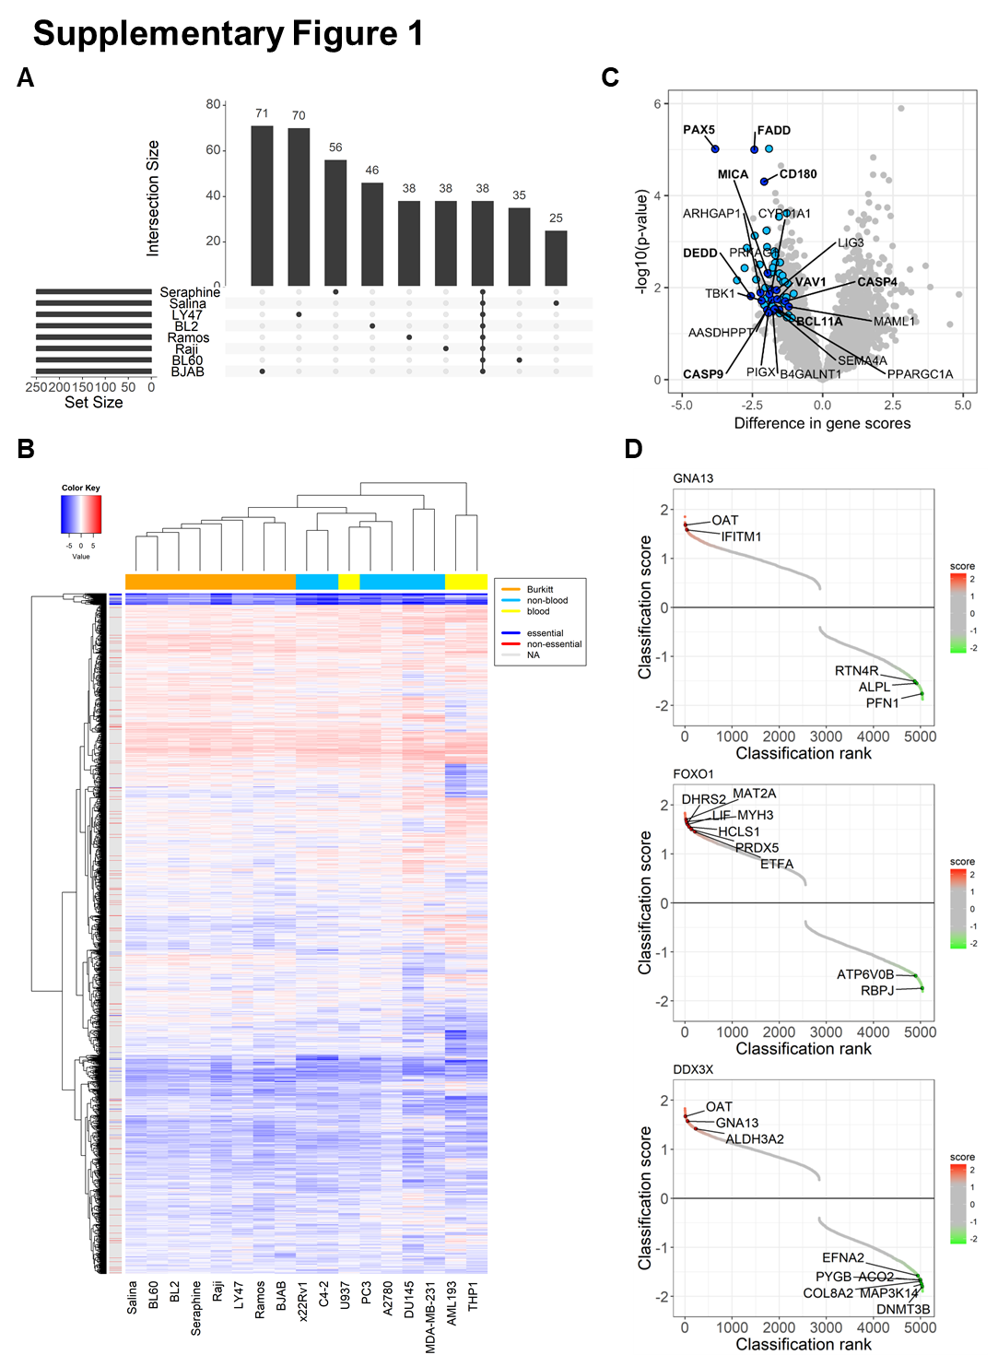

Supplementary Figure 1. RNAi screen identifies common and context-specific essential genes.
(A) Overlap of essential genes in eight BL cell lines. Genes were ranked based on their weighted z-score and the top 250 essential genes were selected for comparison between the cell lines. The barplot shows the number of genes that scored in one or multiple cell lines as indicated at the bottom. Many top-ranking genes were cell line-specific, followed by a set of core essential genes common to all cell lines. (B) Integration of multiple independent RNAi screens. The RNAi screen in eight BL cell lines was combined with three RNAi screens using the same shRNA library (performed by Cellecta Inc.). Weighted z-scores were normalized using peak median absolute deviation (PMAD) to account for differences in dispersion of the data. The heatmap represents data for 5,045 genes included in the RNAi library. Core essential and non-essential genes as defined by Hart et al., 2014 are indicated. (C) Comparison of essential genes in eight BL and two blood cancer (1 DLBCL, 2 AML) cell lines. Genes essential in BL are shown in light blue and genes that also scored as BL-essential in the comparison of BL and solid cancer cell lines are shown in dark blue. (D) Genotype-specific essential genes. shRNAs were ranked by their differential effects in cell lines with and without the indicated mutation. Candidate genes essential in mutant (red) or wild-type (green) cell lines are indicated.

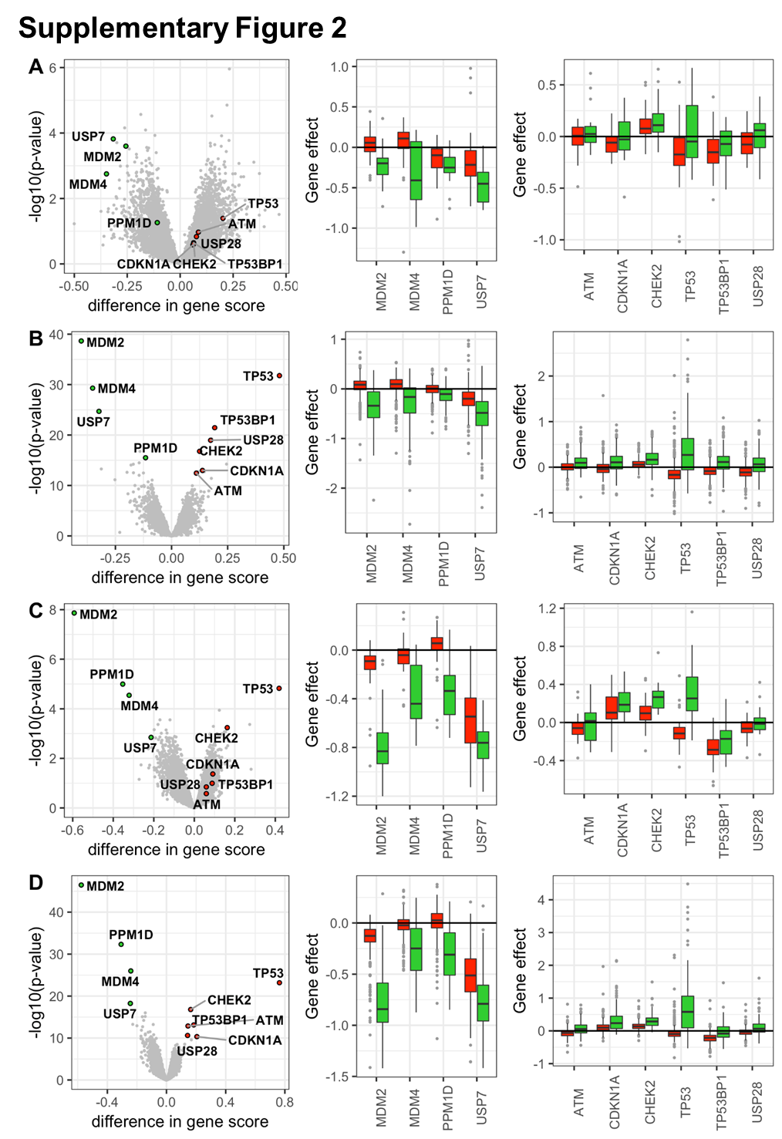
Supplementary Figure 2. Genes essential in the context of TP53 mutation.
Volcano plots show the differences in gene dependency scores with highlighted TP53wt (green) and TP53mut (red) candidate genes. Boxplots show genes with significantly (adjusted p-value < 0.01) higher or lower gene scores in TP53wt or TP53mut cell lines, respectively. All data is from the DepMap project (https://depmap.org/portal/) showing hematopoietic/lymphoid cell lines from (A) combined RNAi screens (TP53wt: n=19; TP53mut: n=42) or from (B) CRISPR screen (TP53wt: n=55; TP53mut: n=55), and cell lines of all origins from (C) combined RNAi screens (TP53wt: n=245; TP53mut: n=467) or from (D) the CRISPR screen (TP53wt: n=164; TP53mut: n=353).

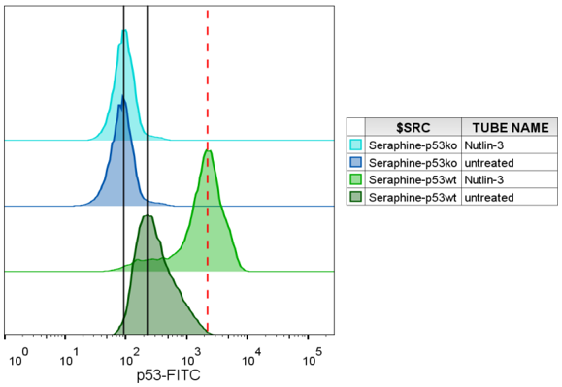
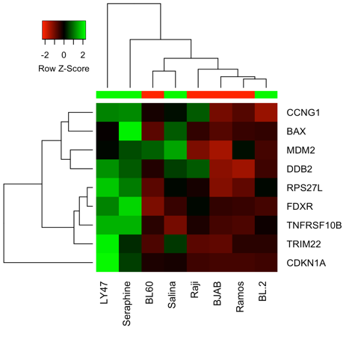
Supplementary Figure 3
A
D
LY47
BL60
BJAB
Ramos
Annexin-V-APC
30%
Nutlin-3
Nutlin-3
Seraphine-TP53ko
Seraphine-TP53wt
9%
7%
5%
DMSO
DMSO
7-AAD
C
p53wt
DMSO
p53wt
Nutlin-3
p53ko
DMSO
p53ko
Nutlin-3
p53-FITC
B

Supplementary Figure 3. p53 reactivation causes cytotoxic effects.
(A) Seraphine-TP53wt (green) and Seraphine-TP53ko (blue) were exposed to 10µM Nutlin-3 or DMSO for 12h and p53 levels were assayed in flow cytometry using intracellular staining. (B) Expression of p53 target genes in Burkitt lymphoma cell lines. The heatmap is showing row-normalized RPKM values from RNA sequencing. The genes were previously reported to be direct targets of p53 and were differentially expressed in aggressive B-cell lymphomas with p53 mutation (as shown in figure 6). TP53 status of the cell lines is indicated (green = TP53wt, red = TP53mut). (C) Cell lines LY47 (TP53wt), BJAB, BL60 and Ramos (TP53mut) were transduced with shRNAs targeting MDM4 or a non-targeting control (shNT) at >80% rate and the proportion of cycling cells was measured in flow cytometry using 7-AAD after 5 days. (D) Cells were treated with 10µM Nutlin-3 or DMSO for 48h and apoptotic cells were measured in flow cytometry using Annexin-V-APC and 7-AAD staining.
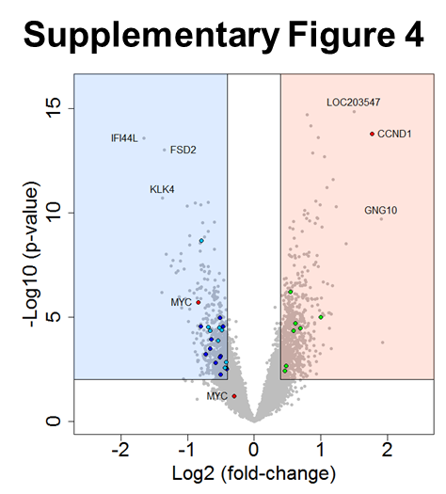
Supplementary Figure 4. Molecular impact of MDM2 or MDM4 knock-down.
Differential gene expression changes after MDM4 and MDM2 knock-down in the BL cell line Seraphine-TP53wt. Related to Figure 3C.
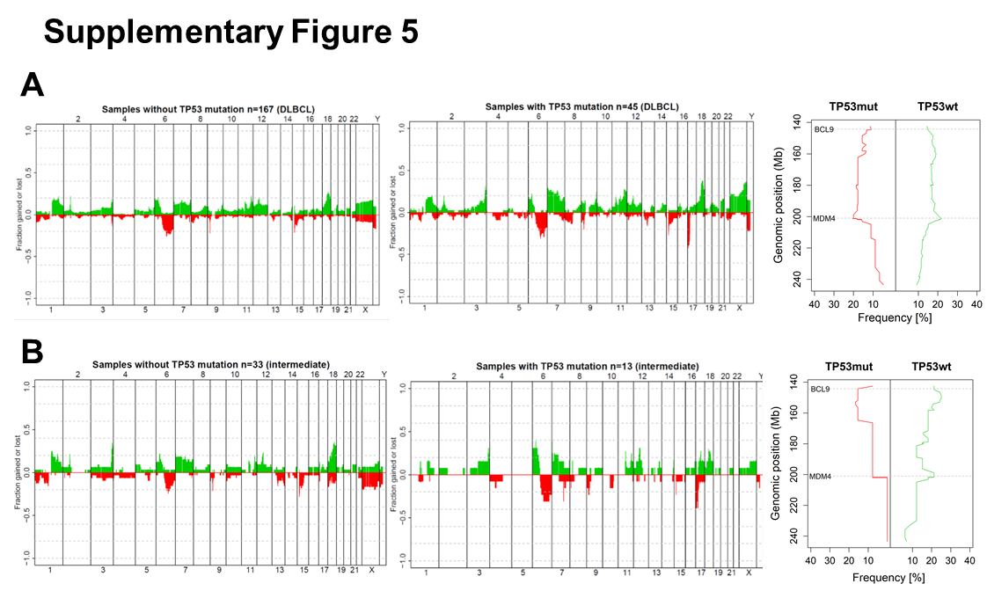
Supplementary Figure 5. Genetic profile in TP53wt and TP53mut aggressive B-NHL patients.
Chromosomal gains (green) and losses (red) in (A) DLBCL and (B) intermediate phenotype patients from the MMML consortium. The copy number profiles for TP53wt patients are shown on the left and for TP53mut patients in the middle. The mirror plot on the right shows the frequency of a gain on 1q.
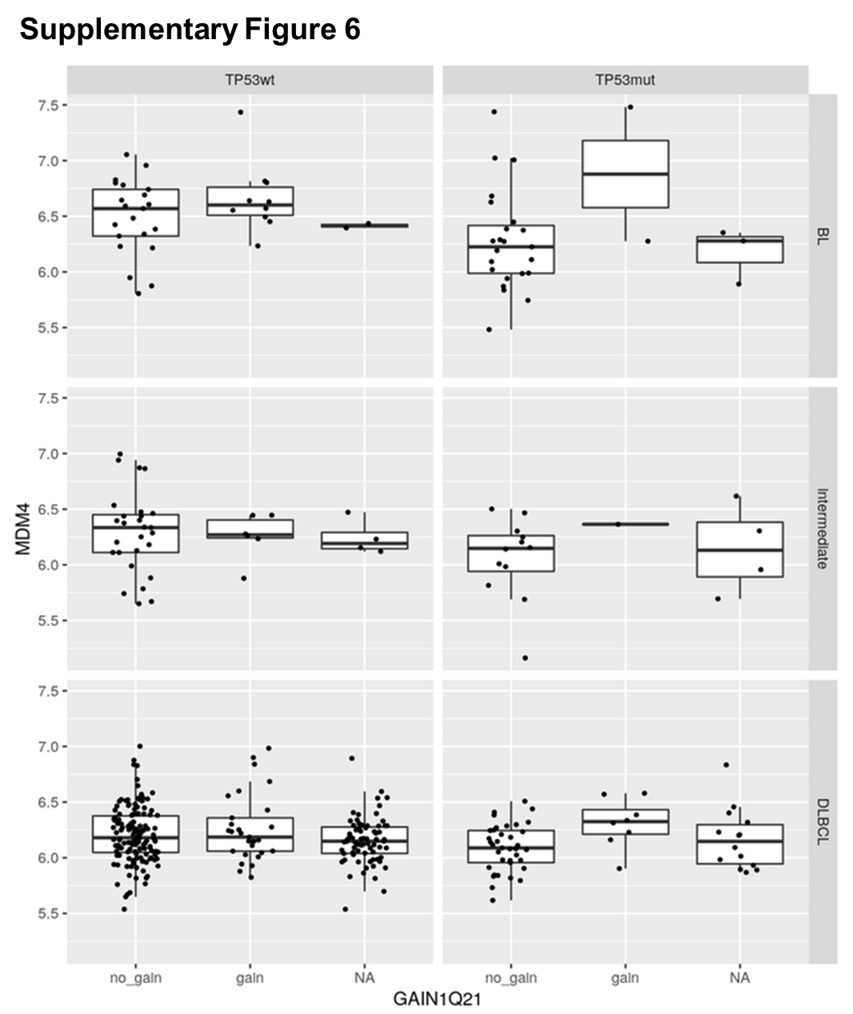
Supplementary Figure 6. Basal MDM4 mRNA in aggressive lymphomas stratified by TP53 mutation and 1q status.
Gene expression for 61 BL, 54 intermediate and 297 DLBCL patients from the MMML cohort were available from Gene Expression Omnibus (GSE43677).

Supplementary Methods
Genetic annotation of cell lines
Mutations in BL cell lines were identified from genomic DNA using a self-designed amplicon panel (1) or from RNA sequencing on the Illumina HiSeq2000. Sequences were mapped against the human reference genome hg19 using the STAR alignment tool. Mutations were called as described previously (2). Genetic information for non-BL cell lines was extracted from CCLE (https://portals.broadinstitute.org/ccle/home) and COSMIC (GDSC, http://www.cancerrxgene.org/).
RT-qPCR
Total RNA was isolated with RNeasy Mini Kit (Qiagen) and on-column DNase I (Qiagen) digestion. RNA was reverse-transcribed by Super-Script III First-Strand Synthesis Supermix (Invitrogen) and quantified using QuantiFast SYBR Green RT-PCR (Qiagen) or Power SYBR Green Master Mix (Applied Biosystems) on a LightCycler 480 Real-Time PCR System, software v1.5 (Roche Applied Sciences).

CRISPR/Cas9 gene knock-out
sgRNAs were co-expressed with Cas9 from lentiCRISPRv2 (Addgene, Cambridge, MA, USA, plasmid #52961). Seraphine cells with effective p53 knock-out were selected using puromycin and Nutlin-3.
RNAi screen. The DECIPHERTM Human Module 1 shRNA library (#DHPAC-M1-P) consisting of 27,500 targeting 5,045 genes in key signaling pathways was obtained from Cellecta Inc. (Mountain View, CA, USA). shRNAs were co-expressed with puromycin resistance gene and red fluorescence protein (RFP) from a barcoded pRSI12-U6-(sh)-UbiC-TagRFP-2A-Puro vector backbone. shRNA were infected 80 times (5.4x10⁶ cells) in three replicates aiming at 50% transduction efficiency. One replicate was harvested on day 2 post-transduction while remaining cells were treated with puromycin at the minimal lethal dose for 48h and harvested in two replicates on day 14 post-transduction. During sampling >1,000-fold representation of shRNAs was maintained. DNA extraction and shRNA barcode amplification were performed according to the Cellecta Manual for pooled barcoded lentiviral shRNA libraries “HT RNAi Genetic Screens with DECIPHER™ or Custom Pooled shRNA Libraries” (version v5e from 2013-09-06). Barcode sequences are listed in the Supplementary Methods section under Primers and Sequences. shRNA barcodes were sequenced at the DKFZ Genomics and Proteomics Core Facility (GPCF) using 50bp single-end sequencing on one lane of the Illumina HiSeq2000. 40% “random” PhiX sequences were added to avoid that the sequencer loses focus while reading the common identifier.
Multiplexed samples were deconvoluted by the DKFZ GPCF based on the index sequence. Raw sequencing reads were trimmed to 20bp reads using the python script “Gzim_Trim”. Barcode sequences were identified using the DECIPHER bar code deconvoluter software (version 2010-10-05) and the library reference file (BLIB). Settings of the software were changed to “Allow 1 error” and “Correct N symbol”. The 2bp module identifier (AT for module 1) was not needed, as we did not pool different modules. The software created a tab delimited file containing the counts for all identified barcodes.
Raw shRNA counts were divided by the mean read count in the respective samples. As replicate samples were highly correlated, the mean was taken in the following analysis. shRNA fold-changes between day 2 and day 14 were calculated for each cell line. After logarithmic transformation to the basis of 2, values were normalized between cell lines by peak median absolute deviation (PMAD) using the GenePattern module “NormLines” provided by the Broad Institute (3).
Analysis of differentially expressed shRNAs was performed using GENE-E software with RIGER extension provided by the Broad Institute (https://software.broadinstitute.org/GENE-E/) as described previously (4). shRNAs were scored and ranked for their ability to distinguish between two classes using „Weight of evidence“ (WoE) statistics. WoE scores for shRNAs targeting the same gene were combined into gene scores and ranks using Kolmogorov-Smirnov (KS) statistics.
Gene depletion scores were calculated using the edgeR package and Fisher z-transformation as described previously (5,6). Control shRNAs present in triplicates and shRNAs with low read counts in the day 2 control samples (5%) were removed. The edgeR package was used to calculate the dispersion of the data and fit a negative binomial model (7). P-values for shRNA distribution were calculated by carrying out a likelihood ratio test and adjusted for multiplicity of testing by FDR method. P-values for shRNAs targeting the same gene were combined into gene depletion scores using weighted z-transformation (wZ-scores) (5,6).
To remove shRNAs with overlapping target region, shRNA sequences were mapped against the human reference genome hg19 using the Tophat2 algorithm (kindly performed by Agnes Hotz-Wagenblatt, DKFZ).
Context-specific essential genes were prioritized based on the following criteria:
(1) Genes with significantly lower shRNA counts in one group by KS score (p-value < 0.05).
(2) Genes with significantly lower shRNA counts in one group by 2nd best shRNA (p-value < 0.05)
(3) Genes that cause a viability effect in one group (median wZ-score < -0.5)
(4) Genes expressed in BL cell lines (8)
(5) Removal of shRNAs with overlapping target region
(6) Significant difference in wZ-score (p<0.05). The difference was calculated using a t-test.

Single shRNA mediated knock-down. shRNA sequences from the pooled shRNA library and cloned into the pRSI12-U6-(sh)-UbiC-TagRFP-2A-Puro vector backbone according to the Cellecta manual “Cloning of shRNA Templates into shRNA Expression Vectors” (version v3a, 8-29-2013). Lentiviral packaging and transduction were performed according to the Cellecta manual “Packaging and Transduction of Lentiviral Constructs” (version v.8a, 7/17/12).
Immunoblot analysis. Cells were lysed in RIPA buffer (150mM NaCl, 0.5% Na-Desoxycholate, 1% NP-40, 0.1% SDS, 50mM Tris pH 7.5; Merck/Millipore) and protein was quantified using the Pierce BCA Protein Assay kit (Thermo Fisher Scientific), a colorimetric assay, according to the manuals. Light absorption at 562nm was measured with the Tecan plate reader. For immunoblotting 40µg protein containing 1x Laemmli buffer (4% SDS, 20% glycerol, 10% 2-mercaptoethanol, 0.004% bromphenol blue and 0.125 M Tris HCl, pH~6.8; Sigma-Aldrich) were separated by size on pre-casted TGX gradient gels (4-15%) and transferred to a low-fluorescent PVDF membrane using the Trans-Blot Turbo Transfer system (Biorad). The membrane was incubated for at least 2h in TBS-T (137mM NaCl, 2.7mM KCl, 19mM Tris pH 7.4, 0.1% Tween 20) with 5% skim milk to reduce unspecific antibody binding. Primary antibodies were diluted in TBS-T with 5% BSA to increase specificity of binding and incubated over night at 4°C while shaking. Fluorochrome-conjugated DyLight® (CST, Danvers, MA, USA) secondary antibody targeting mouse or rabbit proteins were used at a 1:15,000 dilution. Protein bands were detected using the Odyssey fluorescent scanner (Li-cor, Lincoln, NE, USA), analyzed using the ImageStudio software provided by Li-cor and quantified using ImageJ software.

Primers and sequences
RNAi screen
Name | Sequence [5'-3'] | Reaction
FwdHTS | TTCTCTGGCAAGCAAAAGACGGCATA | 1st Round PCR
RevHTS1 | TAGCCAACGCATCGCACAAGCCA | 1st Round PCR
FwdGex | CAAGCAGAAGACGGCATACGAGA | 2nd Round PCR
RevGex | AATGATACGGCGACCACCGAGA | 2nd Round PCR
IndA | AATGATACGGCGACCACCGAGATCTACACGCAATGCGCACAACCGCAA | Multiplexing
IndB | AATGATACGGCGACCACCGAGATCTACACGCAGACTGCACAACCGCAA | Multiplexing
IndC | AATGATACGGCGACCACCGAGATCTACACGCATCAGGCACAACCGCAA | Multiplexing
IndD | AATGATACGGCGACCACCGAGATCTACACGCACGTAGCACAACCGCAA | Multiplexing
IndE | AATGATACGGCGACCACCGAGATCTACACGCAAGCGGCACAACCGCAA | Multiplexing
IndF | AATGATACGGCGACCACCGAGATCTACACGCAGATGGCACAACCGCAA | Multiplexing
IndG | AATGATACGGCGACCACCGAGATCTACACGCAGGACGCACAACCGCAA | Multiplexing
IndH | AATGATACGGCGACCACCGAGATCTACACGCAGCGAGCACAACCGCAA | Multiplexing
GexSeqS | AGAGGTTCAGAGTTCTACAGTCCGAA | Barcode sequencing
GexSeqIND | ACGACCACCGAGATCTACACGCA | Indexing
RT-qPCR
Name | Sequence [5'-3'] | Source
qMDM4_fwd | TGAAAGACCCAAGCCCTCT | Self-designed
qMDM4_rev | CGAGAGTCTGAGCAGCATCTG | Self-designed
qTP53_fwd | GGAGCACTAAGCGAGCACTG | Self-designed
qTP53_rev | CACGGATCTGAAGGGTGAAA | Self-designed
qMDM2_fwd | CAGTAGCAGTGAATCTACAGGGA | RT-Primer Bank
qMDM2_rev | CTGATCCAACCAATCACCTGAAT | RT-Primer Bank
qBAX_fwd | CCCGAGAGGTCTTTTTCCGAG | RT-Primer Bank
qBAX_rev | CCAGCCCATGATGGTTCTGAT | RT-Primer Bank
qRRM2B_fwd | AGAGGCTCGCTGTTTCTATGG | RT-Primer Bank
qRRM2B_rev | GCAAGGCCCAATCTGCTTTTT | RT-Primer Bank
qCDKN1A_fwd | GACTCTCAGGGTCGAAAACG | self-designed
qCDKN1A_rev | TAGGGCTTCCTCTTGGAGAA | self-designed
qMCM7_fwd | CCTACCAGCCGATCCAGTCT | RT-Primer Bank
qMCM7_rev | CCTCCTGAGCGGTTGGTTT | RT-Primer Bank
qMCM6_fwd | ACCTGCCTACCAGACACAAGA | RT-Primer Bank
qMCM6_rev | ACAGAAAAGTTCCGCTCACAAG | RT-Primer Bank
qMCM10_fwd | TGTCCCTGCGCTACCAAGA | RT-Primer Bank
qMCM10_rev | GATGAGCTTTTGGGATCTGGAG | RT-Primer Bank
qCDKN3_fwd | TCCGGGGCAATACAGACCAT | RT-Primer Bank
qCDKN3_rev | GCAGCTAATTTGTCCCGAAACTC | RT-Primer Bank
qGAPDH_fwd | GGAGCGAGATCCCTCCAAAAT | RT-Primer Bank
qGAPDH_rev | GGCTGTTGTCATACTTCTCATGG | RT-Primer Bank
shRNA target sequences
Name | Sequence [5'-3'] | Cellecta ID
MDM2_1 | CTTTGGTAGTGGAATAGTGAA | CLL-H-016687
MDM4_1 | GTTCACTGTTAAAGAGGTCAT | CLL-H-016693
MDM4_2 | CACCTAGAAGTAATGGCTCAA | CLL-H-016692
MDM4_3 | ACAGTCCTTCAGCTATTTCAT | CLL-H-016695
MDM4_4 | CTCAACTGATTTACAGACAAA | CLL-H-016696
MDM4_5 | CCCTGATTGTCGAAGAACCAT | CLL-H-016694
shNT | CAACAAGATGAAGAGCACCAA
sgRNA target sequences
Name | Sequence [5'-3'] | Source
TP53_8 | CCCCTTGCCGTCCCAAGCAA | HGLibB_51985

References
1. Hullein J, Jethwa A, Stolz T, Blume C, Sellner L, Sill M, et al. Next-generation sequencing of cancer consensus genes in lymphoma. Leuk Lymphoma 2013;54:1831-5
2. International Cancer Genome Consortium PedBrain Tumor P. Recurrent MET fusion genes represent a drug target in pediatric glioblastoma. Nature medicine 2016;22:1314-20
3. Reich M, Liefeld T, Gould J, Lerner J, Tamayo P, Mesirov JP. GenePattern 2.0. Nature genetics 2006;38:500-1
4. Cheung HW, Cowley GS, Weir BA, Boehm JS, Rusin S, Scott JA, et al. Systematic investigation of genetic vulnerabilities across cancer cell lines reveals lineage-specific dependencies in ovarian cancer. Proceedings of the National Academy of Sciences of the United States of America 2011;108:12372-7
5. Dai Z, Sheridan JM, Gearing LJ, Moore DL, Su S, Dickins RA, et al. shRNA-seq data analysis with edgeR. F1000Res 2014;3:95
6. Kim J, Tan AC. BiNGS!SL-seq: A Bioinformatics Pipeline for the Analysis and Interpretation of Deep Sequencing Genome-Wide Synthetic Lethal Screen. Next Generation Microarray Bioinformatics: Methods and Protocols 2012;802:389-98
7. Robinson MD, McCarthy DJ, Smyth GK. edgeR: a Bioconductor package for differential expression analysis of digital gene expression data. Bioinformatics 2010;26:139-40
8. Klijn C, Durinck S, Stawiski EW, Haverty PM, Jiang Z, Liu H, et al. A comprehensive transcriptional portrait of human cancer cell lines. Nat Biotechnol 2015;33:306-12

