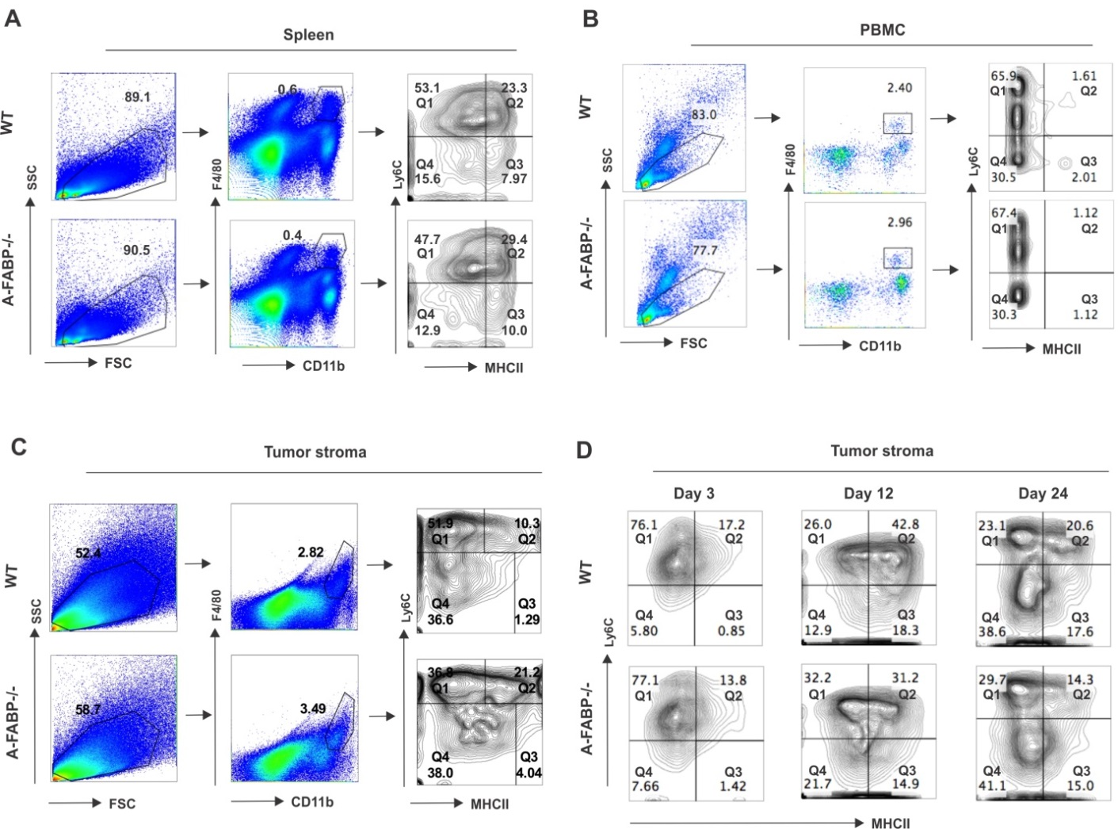

Supplementary Figure 5 Analysis of distinct subsets of macrophages in WT and A-FABP^{-/-} mice. (A) Flow cytometric analysis of distinct macrophage subsets in the spleen of naïve WT and A-FABP^{-/-} mice. (B) Flow cytometric analysis of distinct macrophage subsets in the peripheral blood of naïve WT and A-FABP^{-/-} mice. (C) Flow cytometric analysis of distinct macrophage subsets in the E0771 tumor stroma from WT and A-FABP^{-/-} mice. (D) Dynamic analysis of distinct subsets of TAM in the tumor stroma of WT and A-FABP^{-/-} mice after E0771 cell implantation at the indicated time points.

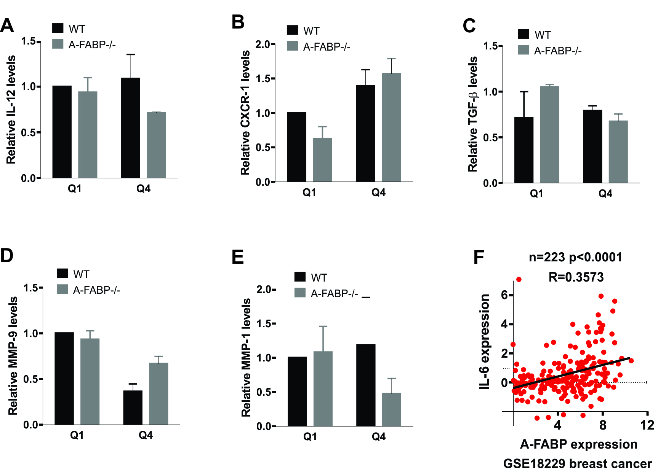

Supplementary Figure 6 Analyses of the impact of A-FABP on cytokine expression
(A-E) Analyses of the expression of IL-12 (A), CXCR-1 (B), TGF-β (C), MMP-9 (D) and MMP-1 (E) in the major subset of TAM separated from the tumor stroma of WT and A-FABP^{-/-} mice by real-time PCR. (F) Correlation analysis of A-FABP with IL-6 in the breast cancer dataset GSE18229 (n=223, p<0.0001).

