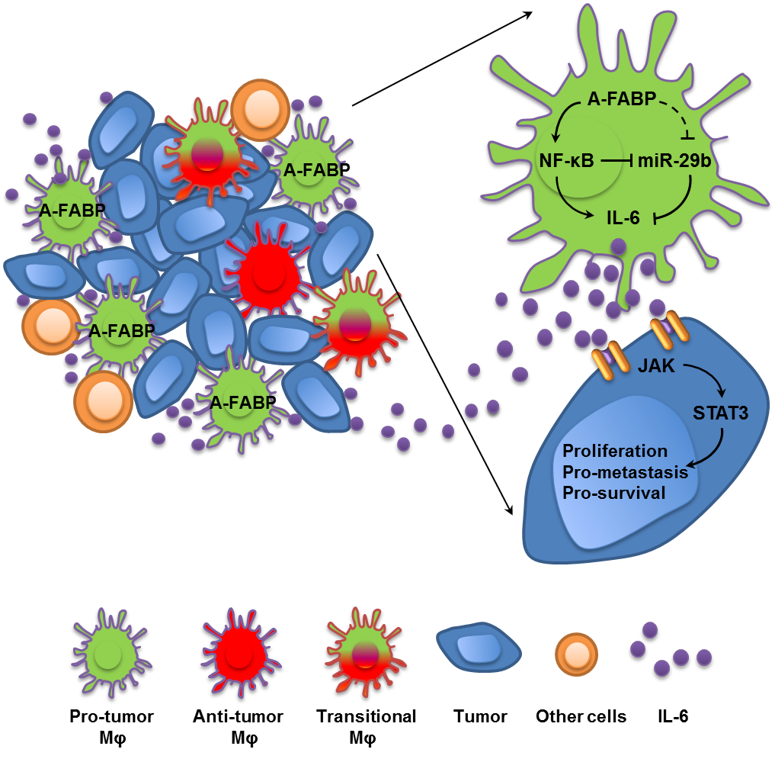

Supplementary Figure 9 A-FABP is a new functional maker for pro-tumor macrophages
Tumor stroma contains heterogeneous macrophages with different phenotype and function, among which A-FABP is highly expressed in the subset of CD11b⁺F4/80⁺MHCII⁻Ly6C⁻ promoting mammary tumor growth and metastasis through NFκB/miR-29b/IL-6 pathway. Thus, A-FABP represents a new functional marker for pro-tumor macrophages and a novel target for macrophage-based tumor immunotherapy.

