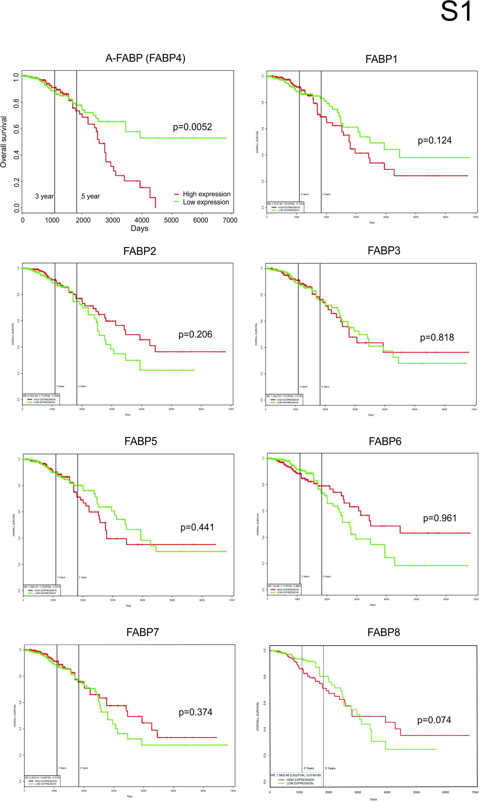

Supplementary Figure 1 PROGgene analysis of association of FABP family members with overall survival of breast cancer patients using TCGA breast cancer dataset. Samples in the top 50% of FABP expression were defined as high expressers (red line). Low expressers were shown in green line.

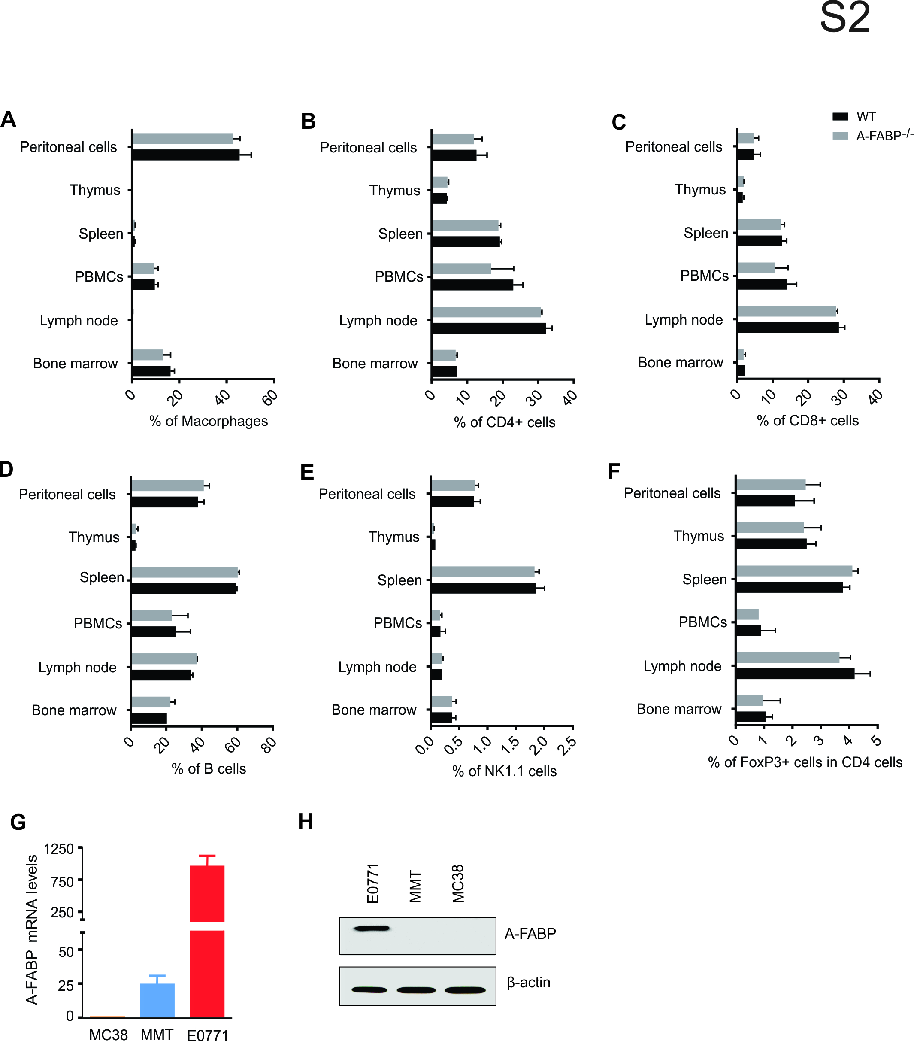

Supplementary Figure 2 Analyses of immunophenotype of naïve WT and A-FABP-/- mice and A-FABP expression in different tumor cells. (A-F) Comparison of the percentage of different immune cells in naïve WT and A-FABP-/- mice by flow cytometric surface staining. (G-H) Analysis of A-FABP expression by real-time PCR (G) and Western blotting (H) in the indicated tumor cells. β-actin was used as a loading control.

