Supplemental Figure 7: Expression of CSC markers in multinucleated cells at protein and RNA levels
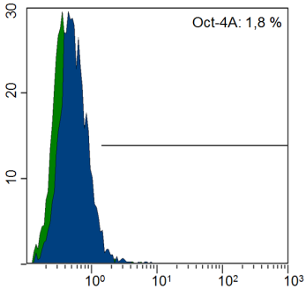
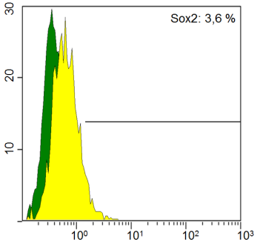
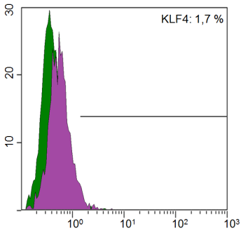
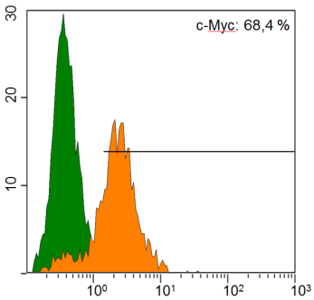
A
B
C
D

Panel A: Expression of Yamanaka stem cell transcription factors. Expression of Oct4A, Sox2, KLF4 is around 2% at the protein level as assayed by FACS. The abundance of c-Myc in several tumors is widely known, which is substantiated by our observations.
E
F

Panel B: Expression of stem cell transcription factors, CSC-related markers, HERVK-ISD and the immune checkpoint PDL-1 in SKOV3 wildtype and chemotherapy resistant cells as measured by qPCR. E: Relative gene expression in adherent cells. In Carboplatin resistant cells c-Myc, Nanog and Sox2 stem cell transcriptions factors are up regulated. In MDR1⁺ cells, Nanog was down-regulated. EpCAM CSC marker was down-regulated in both resistant cells. Both, the ISD of HERV-K and the immuno checkpoint PDL-1 were upregulated in resistant cells. F: Relative gene expression in 3D cultured cells. Both MDR⁺ and CP resistant cells depict a different gene expression for which KLF4, Nanog, Oct4 are overexpressed. c-Myc was down-regulated and Sox2 was upregulated in CP cells. EpCAM was up-regulated in opposition to adherent cells and both, the ISD of HERV-K and the immuno checkpoint PDL-1 were upregulated in resistant cells as seen in adherent cells.

