Supplemental Figure 6: Resistance profile and spherogenicity of SKOV3 ovarian carcinoma models
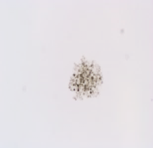
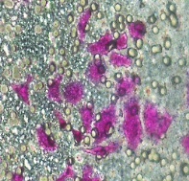
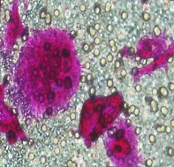
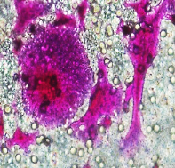
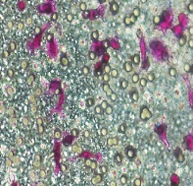
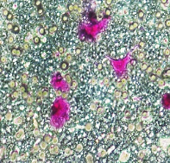
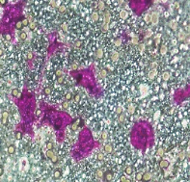
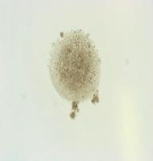
WT
C
CP
E
Up
F
Up
G
Up
H
Down
I
Down
J
Down
K
MDR1⁺
D
A
B

Morphology of SKOV3 ovarian carcinoma cells in 3D cultures and their migration patterns. Resistance status of SKOV3 cells against paclitaxel and cisplatin can be visualised from A and B respectively. Morphologic pictures of hanging drop 3D cultures (C-E) in wildtype and resistant SKOV3 ovarian carcinoma cells. Chemotherapy refractory MDR1⁺ (cross-resistant to etoposide, doxorubicin, vinblastine and paclitaxel) and carboplatin cells are not able to form spheres in 3D hanging drops cultures (D &E). Wildtype cells effectively build spheres when cultured in hanging drops (C). The frequency to localize multinucleated cells in chemotherapy refractory cells (G & H) is higher in resistant models in comparison to the wiltype parental (F). The ability to migrate in a Transwell 8 µm pore system is higher for the small cells (down, I-K) than the multinucleated cells (G & H). Visualization was conducted by Sulforhodamine B staining. Experiment repetitions n>3.

