Supplemental Figure 1: Occurrence and morphology of multinucleated cells in different tumors
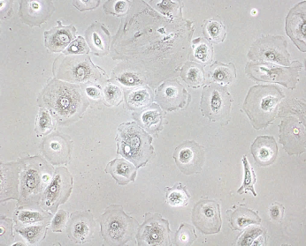
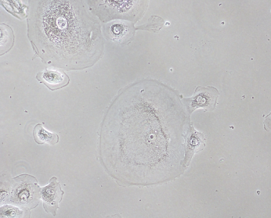
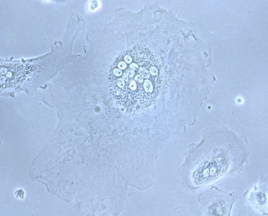
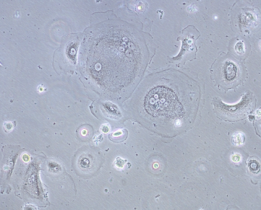
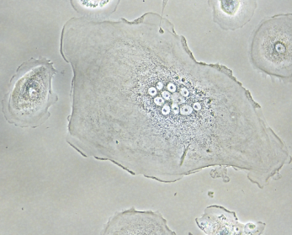
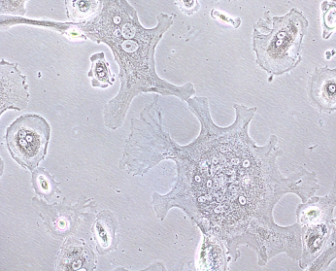
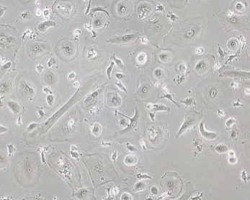
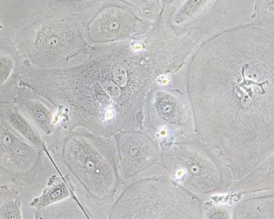
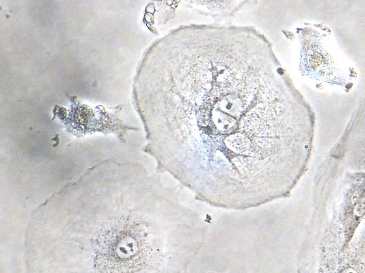
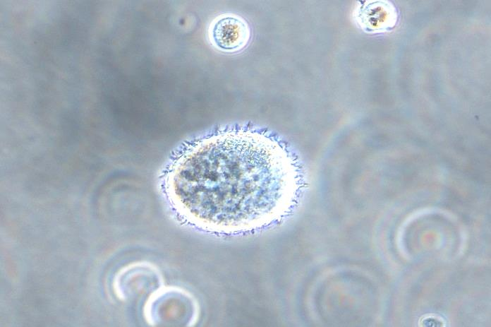
MaCa 137
25 µm
MaCa 192
50 µm
MaCa 331
50 µm
OvCa246
50 µm
OvCa331
50 µm
OvCa239
50 µm
PaCa 1
25 µm
PaCa 2
50 µm
PaCa 3
50 µm
50 µm
50 µm
50 µm
T-Cell Leukaemia
T-Cell Leukaemia
T-Cell Leukaemia
A
B
C
D
E
F
G
H
I
J
K
L

Panel A: Morphology of primary cell cultures from diverse tumors. P1 and G1-Gn are present in several tumors. OvCa, ovarian carcinoma; MaCa, breast carcinoma; PaCa, pancreas carcinoma; T-cell leukemia (here Jurkat cell line).
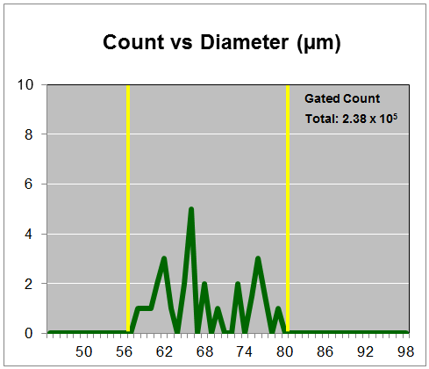
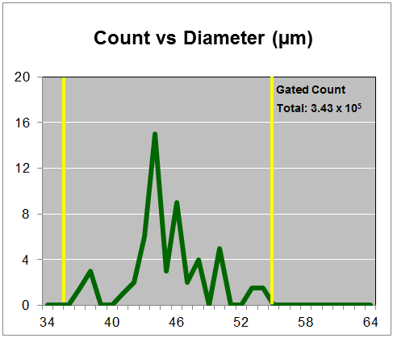
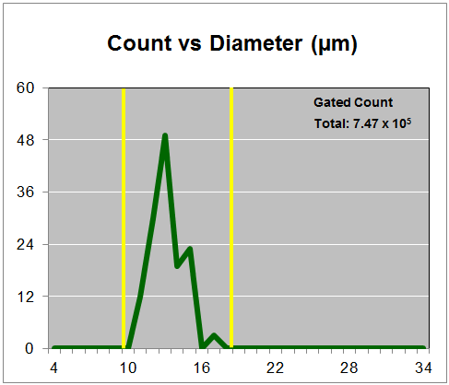
M
N
O

Panel B: Presence of multinucleated cells in ovarian ascites cells. Size distribution of cell population in ascites from ovarian carcinomas. M, cells isolated from untreated patients (Wildtype). N and O, cells from poly-chemotherapy experienced patients.

