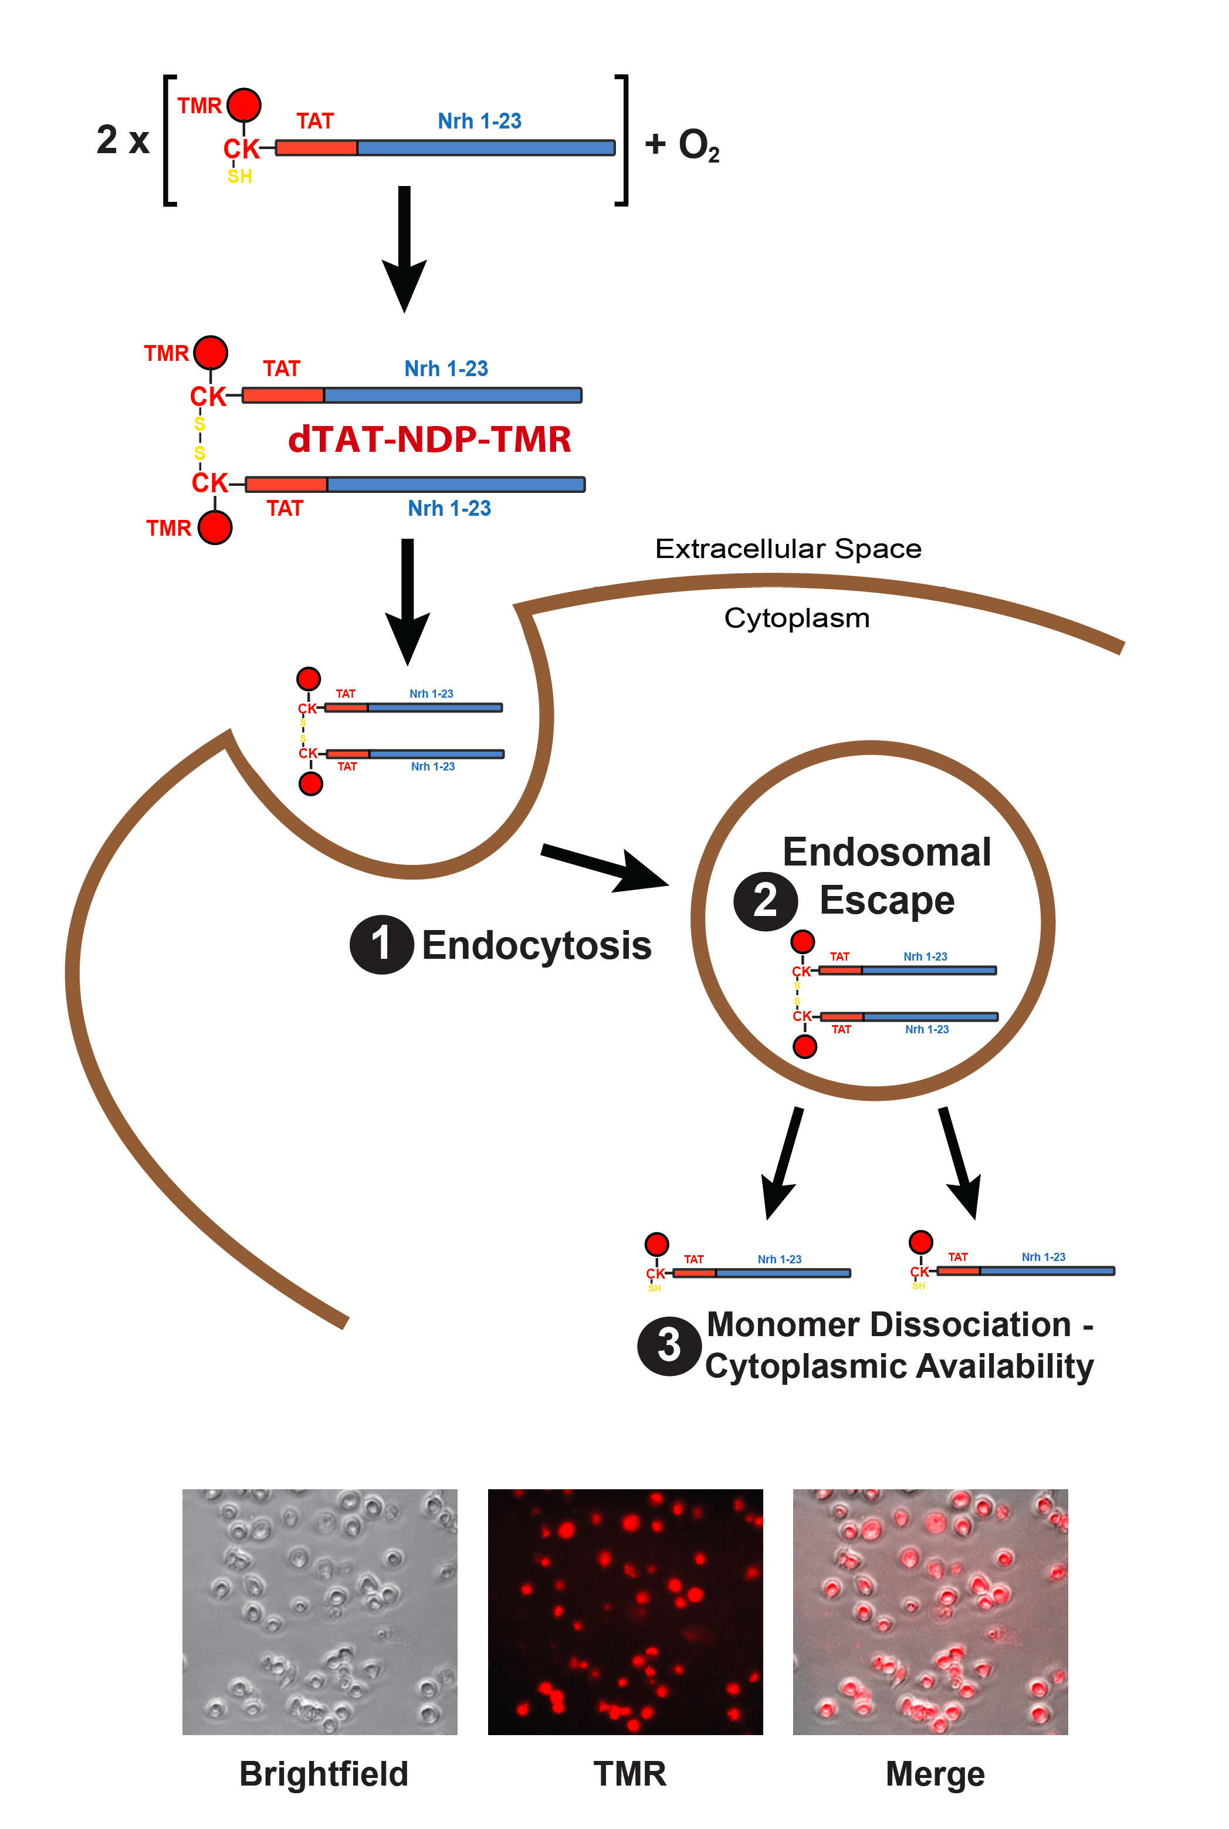

Supplementary Figure 8 – Mechanism for irradiation-free dTAT peptide internalization
Diagram presenting the protocol used to internalize dTAT peptide without the help of physical agents, such as light irradiation. For treatment with dTAT-NDP-TMR or dTAT-NDP-CTRL, cells were first seeded onto regular 6-well, 24-well or 96-well plates (Corning). Corresponding peptides were diluted to 10 μM in Ca²⁺-free balanced salt solution (BSS), from a 100 μM peptide stock solution in water prepared 24h prior experiment. Cells were incubated for 1h in the 10 μM peptide/BSS solution, and then washed and placed in regular medium before subsequent experiments.
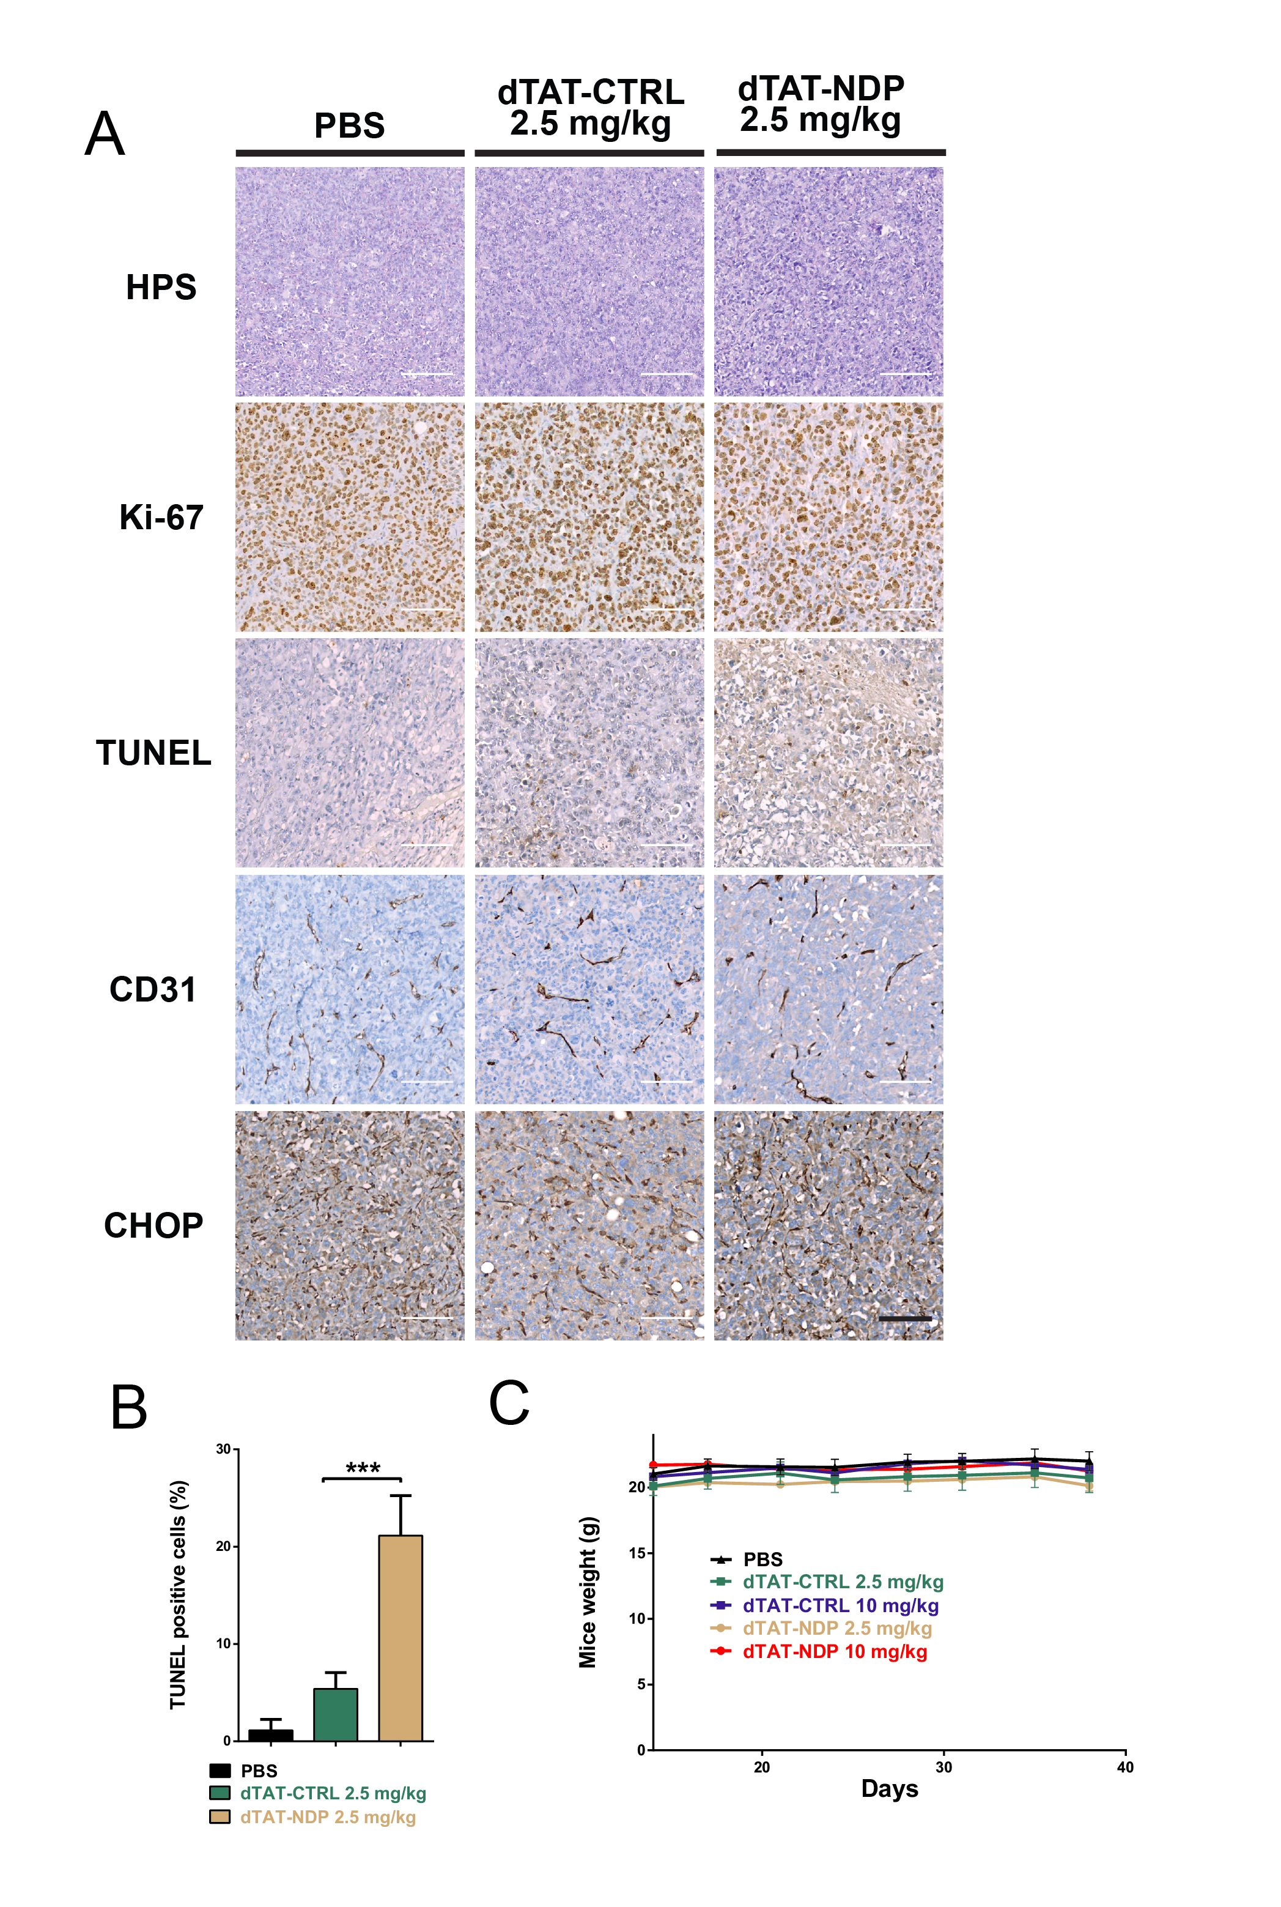

Supplementary Figure 9 – dTAT peptide treatment increases apoptosis of tumor cells in vivo

(A) Expression of Ki-67, TUNEL-positive apoptotic bodies, CD31-positive blood vessels and CHOP in representative tumor sections of mouse group treated by PBS, dTAT-CTRL or dTAT-NDP at 2.5 mg/kg. Hematoxylin staining is shown on top panels (HPS). Representative tumor sections in non-necrotic area were processed for immunohistochemical detection of Ki-67 and CHOP to assess cell proliferation and UPR, respectively. Blood vessels were visualized via CD31. Cell death was detected by TUNEL assays. At least five randomly selected non-overlapping fields were examined. TUNEL signal was increased upon nrh silencing and Doxorubicin treatment. Mitotic index (Ki-67) and vessel density quantification (CD31/PECAM) showed no significant differences between groups. Scale bars: 100 μm. (B) Quantification of TUNEL positive cells in two different mouse tumors per conditions processed as described in (A), representing cell death levels (mean ± SD; n = 8 microscopic field, at least 100 cells per field; ***, P < 0.001). (C) Measurement of mouse weight over the course of the experiments shown in Figure 7C. Mice were weighted twice a week using a precision scale (mean ± SEM; n = 5 mice per condition) and did not show significative weight change at different dTAT peptide concentrations.

