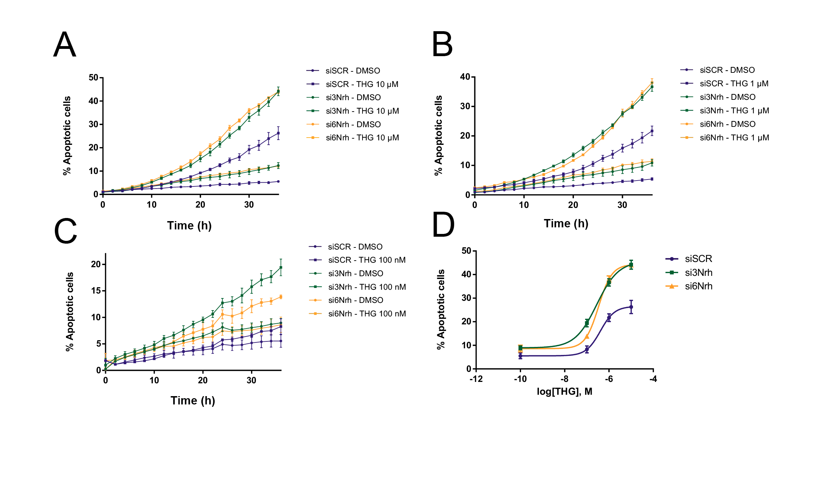 Supplementary Figure 2 - Nrh knock-down potentiates Thapsigargin dose-dependent effect in the
MDA-MB-231 cell line
(A) Kinetic apoptosis assay (% of cells displaying Caspases 3/7 activity) in MDA-MB-231 cells
transfected with corresponding siRNAs and treated with 10 μM Thapsigargin (THG) for 36 hours, (B)
1μM Thapsigargin or (C) 100 nM Thapsigargin (mean ± SD; n = 3). (D) Percentage (%) of cells
displaying Caspases 3/7 activity as a function of log[THG] concentration using two nrh siRNA at 36
hours.
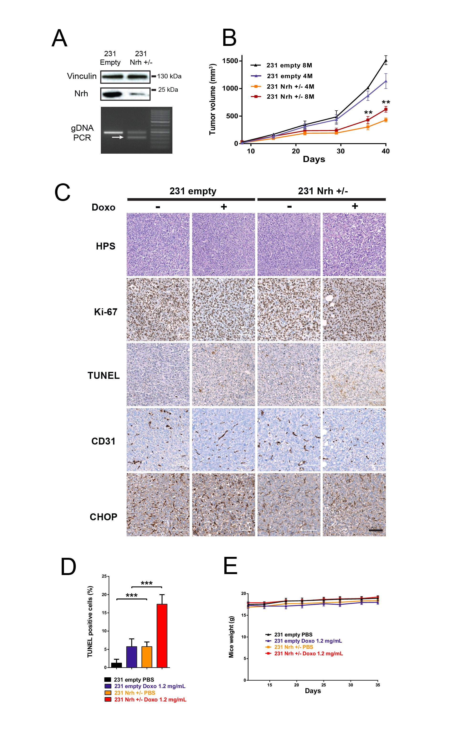 Supplementary Figure 3 – Nrh knock-down is sufficient to impair tumor progression
(A) Characterization of the MDA-MB-231 nrh+/- cell line, bearing a mutant nrh allele; Top endogenous Nrh expression levels in 231 nrh +/- and containing pLentiCRISPRv2 empty vector (231 empty) cell lines (50 μg lysate), detected by Western blot analysis; Bottom: gel electrophoresis validation of the CRISPR-CAS9 engineered genomic DNA deletion in one allele. (B) Evaluation of the tumorigenic capacity of MDA-MB-231 heterozygous cells (231 nrh +/-), injected into the mammary fat pad of nude mice. MDA-MB-231 containing pLentiCRISPRv2 empty vector were used as a control (231 empty). Four (4M) or eight million (8M) cells from 231 nrh +/- or 231 empty cell lines were injected into nude mice. Tumor volume was assessed using calipers (mean ± SEM; n = 3 mice per condition; **, P < 0.01). (C) Expression of Ki-67, TUNEL-positive apoptotic bodies, CD31- positive blood vessels and CHOP in representative tumor sections of MDA-MB-231 (231 empty) or MDA-MB-231 nrh +/- (231 nrh +/-) mouse group, with or without chemotherapy treatment (PBS control or Doxorubicin at 1.2 mg/kg). Hematoxylin staining is shown on top panels (HPS). Representative tumor sections in non-necrotic area were processed for immunohistochemical detection of Ki-67 and CHOP to assess cell proliferation and UPR, respectively. Blood vessels were visualized via CD31. Cell death was detected by TUNEL assays. At least five randomly selected non-overlapping fields were examined. TUNEL signal was increased upon nrh silencing and Doxorubicin treatment. Mitotic index (Ki-67) and vessel density quantification (CD31/PECAM) showed no significant differences between groups. Scale bars: 100 μm. (D) Quantification of TUNEL positive cells in two different mouse tumors per conditions processed as described in (C), representing cell death levels (mean ± SD; n = 8 microscopic field, at least 100 cells per field; ***, P < 0.001) (E) Measurement of mouse weight over the course of the experiments (see also Figures 1H and I). Mice were weighted twice a week using a precision scale (mean ± SEM; n = 8 mice per condition) and did not show significative weight change upon doxorubicin treatment.

