Table of contents
Supplemental Regulons Comparison 1
Supplemental Methods 3
Cell lines and primary tumors data (extension) 3
RNA-seq data processing 3
CTFR sources 4
Benchmark data 5
CTFR+CpG activities 5
Inferred regulons activities 5
Management of TCGA samples 6
Analysis of sensitivity to the sample size of the background population 6
Functional annotation of driver mutations and classification 6
Supplemental Tables 8
Supplemental Figures 9
Supplemental References 20

Supplemental Regulons Comparison

TF activities derived from the CTFRs were evaluated on a benchmark data in the cell lines (Figure S3; Supplementary methods). Moreover, we compared these to other TF activities obtained using two alternative regulon definitions. The first alternative refines the CTFRs with promoter CpG methylation data (that we called “CTFRs+CpG”). Here, for each sample, we remove from the CTFRs the genes whose promoters are hypermethylated to capture the TF-target binding specificities of each cell line. The second alternative considers regulons inferred from transcriptional data (that we called “inferred regulons”, also known as reverse-engineered regulons). These regulons were inferred by Alvarez et al(1) using ARACNe(2), a data-driven approach based on the assumption that mRNA levels correlate with protein activity and does not rely on prior knowledge. Similarly, TF regulons inferred from tumor type-specific expression data are expected to capture regulatory specificities characteristic of the disease. Moreover, since is not restricted by prior knowledge, the resulting regulatory networks have larger resolution and coverage.

Next, we compared the TF activities from the different regulons definitions (CTFR, CTFR+CpG and inferred regulons) using a benchmark dataset for which there was evidence of the activity status of the TFs. Specifically, we used homozygous genomic deletions affecting TFs as a proxy of TF inactivation (negative controls), whereas essentially scores from the Achilles project(3) were used as a proxy of TF activation (positive control). To ensure the comparability of the estimates, the comparison was restricted to the TFs and samples covered by the CTFRs, the inferred regulons and the benchmark data, comprising 264 TF/cell-line pairs (111 negative controls and 153 positive controls; Figure S3). We also defined a subgroup of 25 TF/cell-line pairs out of the 153 positive controls with higher evidence of TF activity (Figure S3C).

Using the less stringent group of positive controls, analysis of the Receiver Operating Characteristic (ROC) curves revealed similar performances between the different networks, with CTFRs, with or without the inclusion of methylation refinements performing slightly better (AUC of 0.68) than the regulons extracted from inferred regulons (AUC=0.667), (Figure S4A). Comparison of TF rank’s position across samples revealed better ability for CTFRs to discriminate positive and negative controls (Figure S4B). Using a more stringent criterion to define essential TFs showed similar results with ROC curves of 0.803, 0.802 and 0.787 for CTFRs, CTFRs+CpG and inferred regulons respectively (Figure S4C-D). Comparison of TF rank’s position across samples revealed again a better separation of the positive and negative controls groups using CTFRs (Figure S4D-E).

Pearson correlation between activities derived from CTFRs and inferred regulons was significant (FDR<0.05) and positive for 82 TFs (67%), negative for 26 (21%) and nonsignificant for 15 (12%). TP53, the most commonly mutated gene in cancer, is among the non-correlating TFs (R=-0.06). We reasoned that the presence of loss-of-function mutations in TP53 would generate transcripts encoding nonfunctional TP53 that would confound network inference methods (i.e. mutant TP53 may fail to regulate their targets). To test this hypothesis, we compared TP53 mRNA levels between mutant and wild-type samples. In both primary tumors and cell lines, the TP53 mRNA levels in TP53 mutants were higher (p=3.08×10⁻³⁴, and p=0.00112 respectively, Figure S6A-B), in agreement with previous experimental studies(4,5). Also, the correlation at the mRNA level between TP53 and the canonical targets(6) is significantly lower in TP53 mutants than in wild-type samples (p=0.00915 and p=3.67×10⁻⁶, respectively, Figure S6C-D). Finally, TP53 mRNA and protein levels correlate in mutant, but not in wild-type samples (p=1.1×10⁻⁹ and p=0.14 respectively, Figure S6E), indicating significant post-translational regulation of TP53 protein abundance in wild-type samples, which may confound network inference methods. Since some TFs are known to accumulate genomic alterations in cancer, and consistent with our attempt to explore their activities as markers of drug response, we chose to use CTFR (without promoter methylation refinement) to define TF-targets in the downstream analysis.

Supplemental Methods

Cell lines and primary tumors data (extension)
WES data: For cancer cell lines, we used the list of genomic variants assembled from the COSMIC database available through the GDSC1000 (www.cancerrxgene.org)(7). For TCGA primary tumors, we downloaded WES data from the cBioportal(8). To maintain consistency in the annotations between both datasets, genomic coordinates of WES variants were re-annotated with ANNOVAR version 2.4(9) and mapped to Ensembl gene coordinates under the genome build version hg19.
CNA data: For cancer cell lines, we downloaded PICNIC processed data from the GDSC1000. For TCGA primary tumors, CNA GISTIC scores were downloaded from the cBioportal. A gene was considered to be homozygously depleted if the maximum copy number of any genomic segment containing coding sequence of the gene from PICNIC was 0, in the case of the cell lines, or the GISTIC score was equal to -2, for the primary tumors.
Drug response data: Effects on cell viability for 265 compounds in the cancer cell lines were downloaded from the GDSC1000. Viability reduction in response to drug treatment was expressed in terms of IC₅₀ (drug concentration needed to achieve the half-maximal viability reduction).
Clinical data: For cell lines, annotation on cancer types (GDSC.description_1 and GDSC.description_2), TCGA identifier, microsatellite instability status, growth properties and media was downloaded from the GDSC1000. For primary tumors, information on TCGA cancer type identifier and clinical variables was downloaded from cBioportal.
Gene essentiality data: We downloaded ATARiS phenotype values from the Achilles portal(10) (v2.4.3) reflecting the relative effects of gene suppression across 216 cell lines.

RNA-seq data processing
The iRAP pipeline(11) was used to filter low-quality reads, alignment and raw counts quantification of the three cancer cell lines RNA-seq datasets (GDSC, CCLE and Klijn et al(12)). Annotation and genome reference was based on Ensembl release 79. Raw counts from cell lines and TCGA samples (together tumors and normal samples) were processed independently (Figure 1A) but using a common pipeline to maintain consistency. We followed limma protocol to process and normalise of RNA-seq data(13). Briefly, 1) samples which proportion of genes with 0 raw counts(14) exceed 40% were discarded; 2) lowly expressed genes, defined as those with an average CPM lower than 1, were discarded; 3) data was TMM normalised using calcNormFactors function described in limma and edgeR packages; 4) a limma-voom transformation was applied to the data and fitted log2 counts per million with associated precision weights were extracted. Finally, for cell lines, data was batch corrected using ComBat from sva R package(15) to account for the possible bias effects introduced by different platforms (GDSC, CCLE and Klijn et al), keeping the tissue of origin as a covariate (data available at www.synapse.org as syn10463688).

CTFR sources
Consensus TF Regulons (CTFR) were derived by selecting TF-target interactions found in at least two of the following publicly available resources.
- Chromatin immunoprecipitation coupled with high-throughput data (ChIP-X).
  - ENCODE(16). We downloaded sif interaction files for both proximal and distal estimates from http://encodenets.gersteinlab.org/ (v2015).
  - ChEA (17). We downloaded human Chip-X experiments (v2015) from http://amp.pharm.mssm.edu/Enrichr/. Data was provided as a geneset collection in a “.gmt” file that was read using the GSA R package.
  - HTRIdb (18). We downloaded the TF-target network from http://www.lbbc.ibb.unesp.br/htri (v2015).
- Curated regulatory annotations:
  - ORegAnno (19). We downloaded the “ORegAnno_Combined” file (v2015) and selected human TF-target gene interactions which “outcome type” was labelled as “POSITIVE OUTCOME”.
  - Signalink2.0 (20). We downloaded the “Transcriptional regulators” file (v2015), filtered out PAZAR interactions (which we considered as an independent source below) and selected those interactions where the source gene was a TF.
  - PAZAR (21)data curated via Signalink2.0 was derived from the “Transcriptional regulators” file in database Signalink2.0 (v2015) by selecting PAZAR interactions where the source gene was a TF.
  - KEGG(22) via KEGGREST R package (v1.12.3; May 2016). For each TF, we retrieved the edges labelled as “GErel”.
  - Riley et al. 2008 (6). We downloaded the Supplementary information S2 and retrieved the targets labelled as “activator”.
- Literature text-mining annotations.
  - TRRUST(24). We downloaded the human TF-target interactions from http://www.grnpedia.org/trrust/ (v2016) and selected those with an “activation” effect. TRRUST only includes text-mining interactions with evidence that the TF binds to the promoter region of the target gene.
- TF binding site (TFBS) based predictions.
  - TRANSFAC. We downloaded TRANSFAC (v7.4) TF-target interactions derived by MSigDB (23). Data was provided as a geneset collection in a “.gmt” file that was loaded using the GSA R package.
  - JASPAR. High confidence vertebrate PWMs (v2009) were used to scan human promoters following the transcription factor affinity prediction (TRAP) algorithm proposed in (24,25). Human promoters were defined for GRCh37. To give priority to matches near the TSS (Transcription Starting Site), 3 promoter lengths were scanned: 1000bp upstream-200bp downstream the TSS; 800bp upstream-200bp downstream; and 300bp upstream-100bp downstream. For each TF, top 200 scoring targets in each scan were retrieved and aggregated.
  - ITFP. TF-target processed data was downloaded from http://itfp.biosino.org/itfp (v2012).

When CTFRs are used to estimate TF activities, targets in more than 10 TFs or TFs with less than 3 targets in the expression matrix are discarded to ensure a minimum signal.

Benchmark data
We utilised Copy Number Alterations (CNA) and Whole Exome Sequencing (WES) data derived from the GDSC project data portal(26) to identify samples carrying homozygous depletion or truncating mutations (i. e. naturally occurring knockouts) affecting the studied TFs (total of 111 TF-sample pairs), which were defined as negative controls (Figure S3B). Next, we queried the Achilles essentiality screen data (v2.4.3)(10) to identify cancer cell lines with high sensitivity to the depletion of specific TFs. We reasoned that essentiality could be used as indirect evidence of protein activity and, therefore, used as positive controls in our benchmark. We defined two classes of positive controls: one less stringent, with TFs with an ATARiS essentiality zscore(3) below -2; and more stringent group, with TFs with ATARiS zscore below -3 (total 153 and 25 TF-sample pairs respectively, Figure S3C).

CTFR+CpG activities

We retrieved information on the methylation status of the promoter regions of coding genes in cancer cell lines from the GDSC1000. Specifically, the downloaded data represents binary events referring to low and high methylation status of CpG islands derived from per gene averaged beta values in gene promoters. Next, we derived sample-specific CTFR+CpG by excluding from the CTFRs target genes whose CpG islands in their promoters are hypermethylated in the sample. Finally, activities for CTFR+CpG are estimated in the same way as for the CTFRs.

Inferred regulons activities
For comparison purpose, we downloaded a second type of TF regulons proposed in (1), that we called “inferred TF regulons”. These regulons, available through the aracne.networks R package, are tumor-type specific and were derived from TCGA expression data using ARACNe tool (2) by Alvarez and colleagues in (1). We downloaded 16 versions of the inferred regulon, one per tumor-type. Each TF-target interaction in the inferred regulons has an associated weight, estimated by ARACNe. We followed the strategy used by Alvarez and colleagues to assign a sign to each TF-target interaction using the aracne2regulon function in the VIPER R package. The aREA method was used to estimate TF activities from the resulting signed and weighted inferred regulons. For each sample, we used the corresponding tumor-type regulon. The downloaded inferred regulons covered 16 out of the 26 tumor types (505 out of the 1,058 samples) represented in the cell lines panel and 123 out of 127 TFs in the CTFRs (Figure S3A). For comparison purpose, only the 123 inferred TF regulons overlapping with the CTFRs were used.

Management of TCGA samples
The percentage of patients with more than one sample was 0.66% (61 out of 9153 patients) and thus we considered each TCGA tumor sample as an independent observation, without collapsing the data at the patient level in the downstream analysis.

Analysis of sensitivity to the sample size of the background population
To evaluate the sensitivity of the TF activity estimates to the background population sample size, we have re-computed the relative activities by downsampling 100 times the cell lines for n = {5, 10, 20, 50, 100, 200, 500}, with no replacement and every sample in the population having the same likelihood of been selected. For each permutation, we have re-normalised (gene-wise) the expression distribution by using a kernel estimation of the cumulative density function (kcdf) and run the aREA algorithm to estimate the relative activity profiles. Next, we have computed the Pearson correlation with the activity profiles using the whole population.

Functional annotation of driver mutations and classification
We classified WES variants in driver genes by estimating the biological implications of each alteration on the protein. Consequences of short deletions, insertions, and nonsense mutations were classified as protein truncating. In contrast, consequences of missense mutations can be broader. To estimate possible consequences of missense mutations, we applied the following existing tools:
- Kinase/Phosphosite/PTMs rewiring: Missense mutations changing residues acceptors of a PTM were classified as PTM disrupting mutations. For the cases where the missense mutations fall in resides around a conserved kinase phosphosite (-/+ 7 adjacent to the acceptor), we used MIMP R package(27) to quantitatively score the likelihood of the new sequence to be phosphorylated by a kinase and retrieve missense rewiring mutations with probability higher than 99%. In order to limit the study to likely functional regulatory sites, PTM residues were extracted from the “Post-translational modification” fields in Uniprot (version 2016_12)(28), “Regulatory sites” table from phosphoSitePlus™ (version 3.0)(29) and Omnipath(30) signalling network (version 2016_12). Rekinect(31) was used to identify missense mutation possibly inducing constitutive activation of kinases, affecting the activity/recognition ability of kinase and SH2 domains and phospho mimicking alterations. Finally, mutations described to impact phosphorylation in Uniprot “natural variant” or “mutagenesis” fields or in the mutation census from Intact database(32) were labelled as protein-protein binding affecting mutations.
- Protein interfaces and interaction rewiring: dSysMap(33) (version 2016_06) web service was used to map missense mutation to protein structures (surface, interface and buried regions) and to retrieve the corresponding partners of the mutated interfaces. Predicted changes in protein interaction affinities we computed with Mechismo setting the stringency set to high. Mechismo(34) predicts whether a missense mutation enables or disables the interaction with a giving DNA or protein partner. Also, mutations described to impact binding abilities to a specific partner in Uniprot “natural variant” or “mutagenesis” fields or in the mutation census from Intact database (version 2016_12) were labelled as protein-protein binding affecting mutations.
- Mutational cancer hotspots: eDriver(35), a gene-centric approach, was used to identify mutation hotspots in protein interacting interfaces. ActiveDriver R package(36), another gene-centric approach, was used to identify mutation hotspots in phosphosites (adj. p<0.01). Both eDriver and ActiveDriver were run on the cell lines and primary tumor datasets independently. By these approaches we were able to annotate rare mutations that would go unnoticed by gene-based methods.
- Stability effect: As for the previous cases, mutations described to impact protein stability in Uniprot “natural variant” or “mutagenesis” fields were labelled as stability impacting mutations.
- Activity effect: We parsed description fields in “natural variant” or “mutagenesis” sections of the Uniprot database to search for mutations that cause an effect on the activity of the carrier protein.
- Cancer driver genes: Vogelstein et al(37) and IntoGen(38) census were used to define genes that are cancer drivers. Moreover, we added in the analysis potentially new driver genes identified by eDriver and ActivDriver and the TFs under study.
Overlapping mutation classes (i.e. containing the same samples) were merged to avoid redundant groups.

Supplemental Tables

Table S1. Summary of number of samples per dataset used in this study. (A-B) Sample information for cell lines and TCGA patients. (C) Samples overlap between the used datasets. (D) TCGA Study Abbreviations. (E) AR dependencies in Prostate cell lines.

Table S2. TF-target interactions in the CTFRs.

Table S3. TF activities using CTFRs. Sample-level activities in (A) primary tumors and (B) cell lines. Summaries of cancer type-level activities in (C) primary tumors and (D) cell lines.

Table S4. Functional characterization of TF mutations. (A) Manual classification of TP53 mutations. (B-C) Full list of ANOVA pan-cancer interactions between TP53 mutation classes and TP53 activity in primary tumors and cell lines, respectively. (D-E) Full list of ANOVA pan-cancer interactions between TF mutation classes and their corresponding activity in primary tumors and cell lines, respectively.

Table S5. Functional characterization of driver mutations. (A) Full list of ANOVA pan-cancer interactions between mutation classes in driver genes and TF activities in primary tumors and (B) cell lines, respectively.

Table S6. TF-drug association analysis. (A) Full list of pan-cancer interactions between TF activities and drug response. (B) Frequency of each TF in the significant associations. (C) Frequency of each drug in the significant associations. (D) Enrichment of drug classes among the significant hits. (E) Full list of cancer-specific interactions between TF activities and drug response.

Table S7. Refinement of pharmacogenomic interactions analysis. Full list of pan-cancer interactions between TF and strong effect pharmacogenomic interactions identified in Iorio et al 2016.

Supplemental Figures

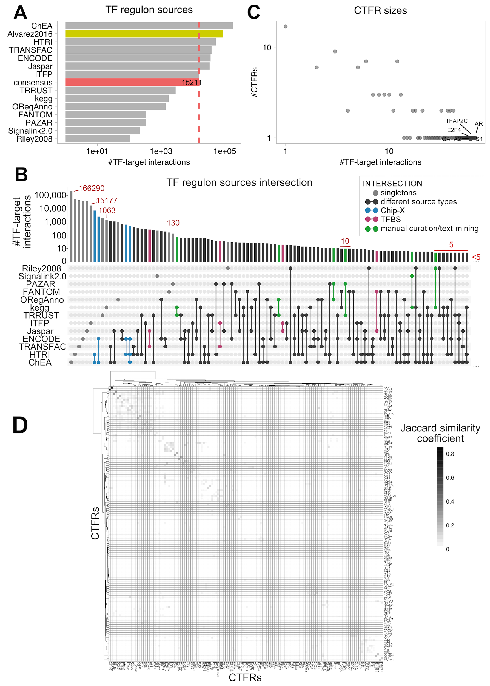
Figure S1. Regulons sources overview. A) Number of TF-target interactions per source. Red indicates CTFRs. Green indicates average from tumor-specific inferred regulons. B) Matrix layout for all intersections between the sources used to derive CTFRs, sorted by size. Colored circles in the matrix indicate the sources in the intersection: light grey for singletons (TF-target interactions not included in the CTFRs), green for overlaps between manual curation/text-mining sources, red for overlap between TFBS sources, blue for Chip-X overlaps and dark grey for overlaps between different source types). Only intersections with more than 5 TF-target interactions are shown. C) Scatterplot (log-log scale) representing the size distribution of the final 127 CTFRs. Top 5 largest regulons are highlighted. D) Targets overlap between individual TFs in CTFRs quantified by the Jaccard Index.

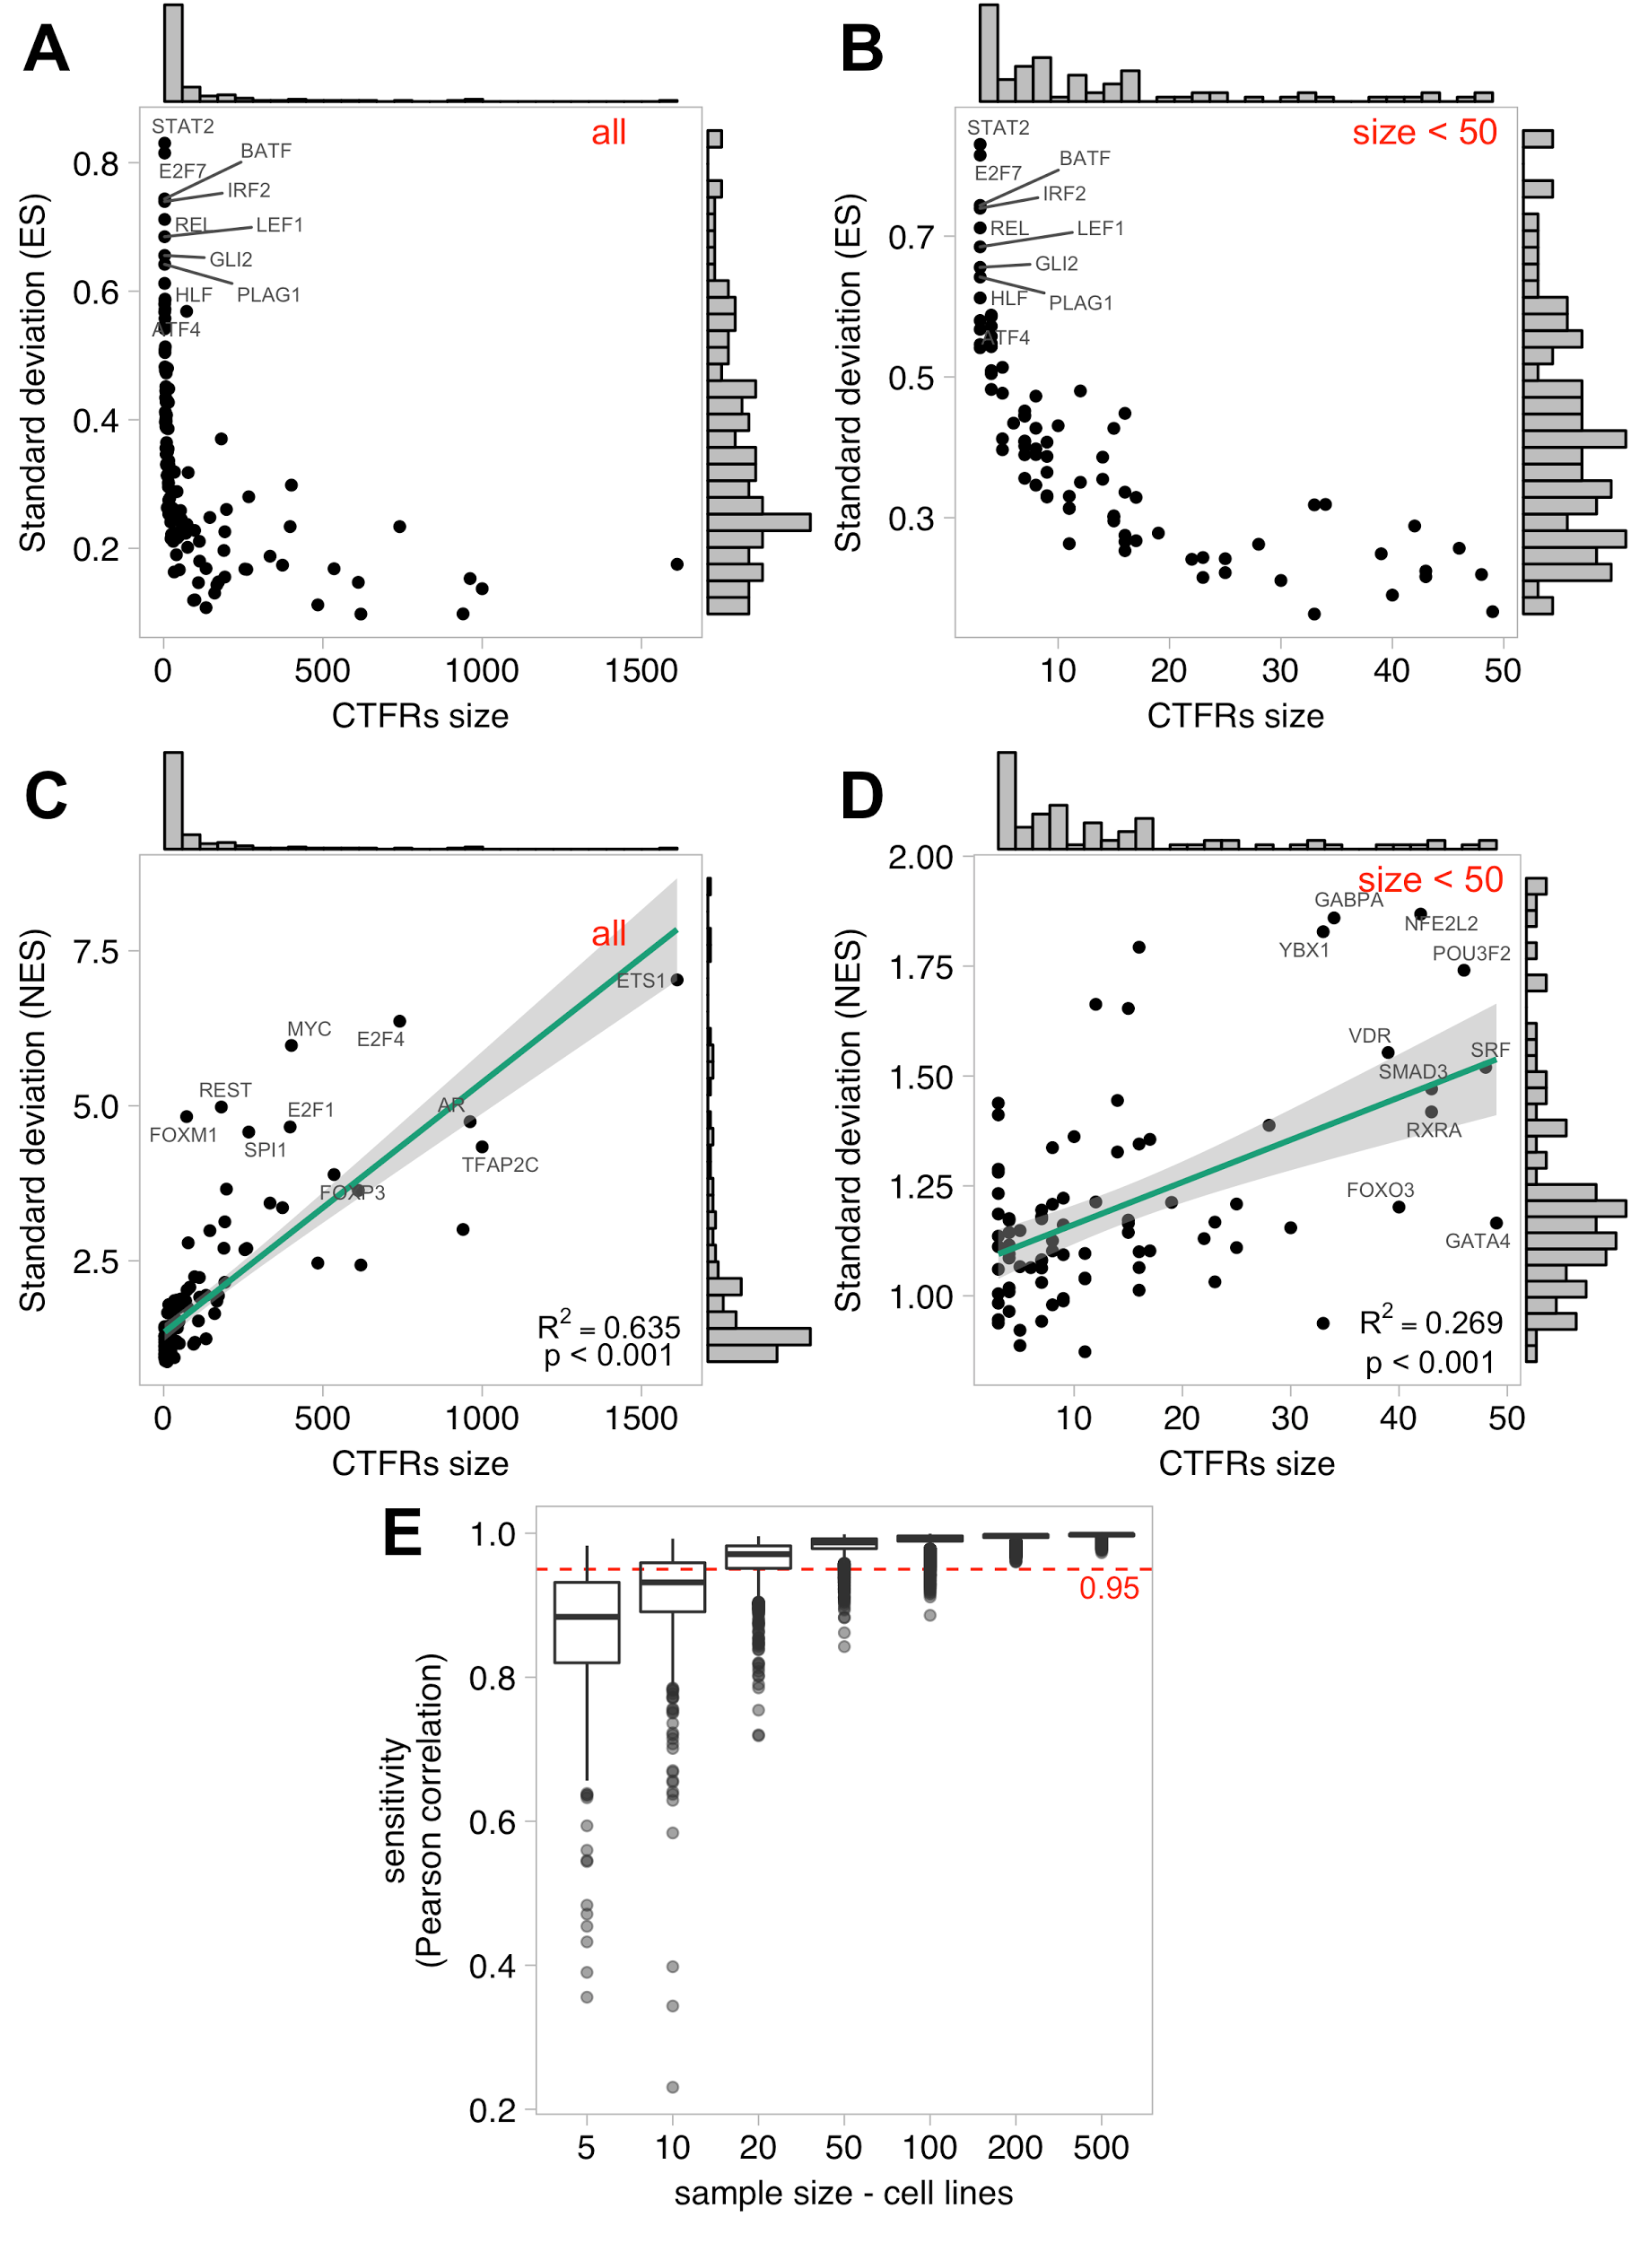
Figure S2. Effect of regulon size and sample size on the TF activity estimation: A) Effect of regulon size on the standard deviation in the Enrichment scores (ES); B) ES in regulons with size < 50; C) normalised enrichment scores (NES); and D) NES in regulons with size < 50. E) Effect of sample size of the background population on the sensitivity. Each dot represents a permutation for sample sizes n={5, 10, 20, 50, 100, 200, 500}. 100 permutations were computed per sample size. Sensitivity is computed as the pearson correlation between the NES obtained using all the cell lines and the NES obtained in the permuted population. All plots refer to estimations on the cell lines and the 127 CTFRs.

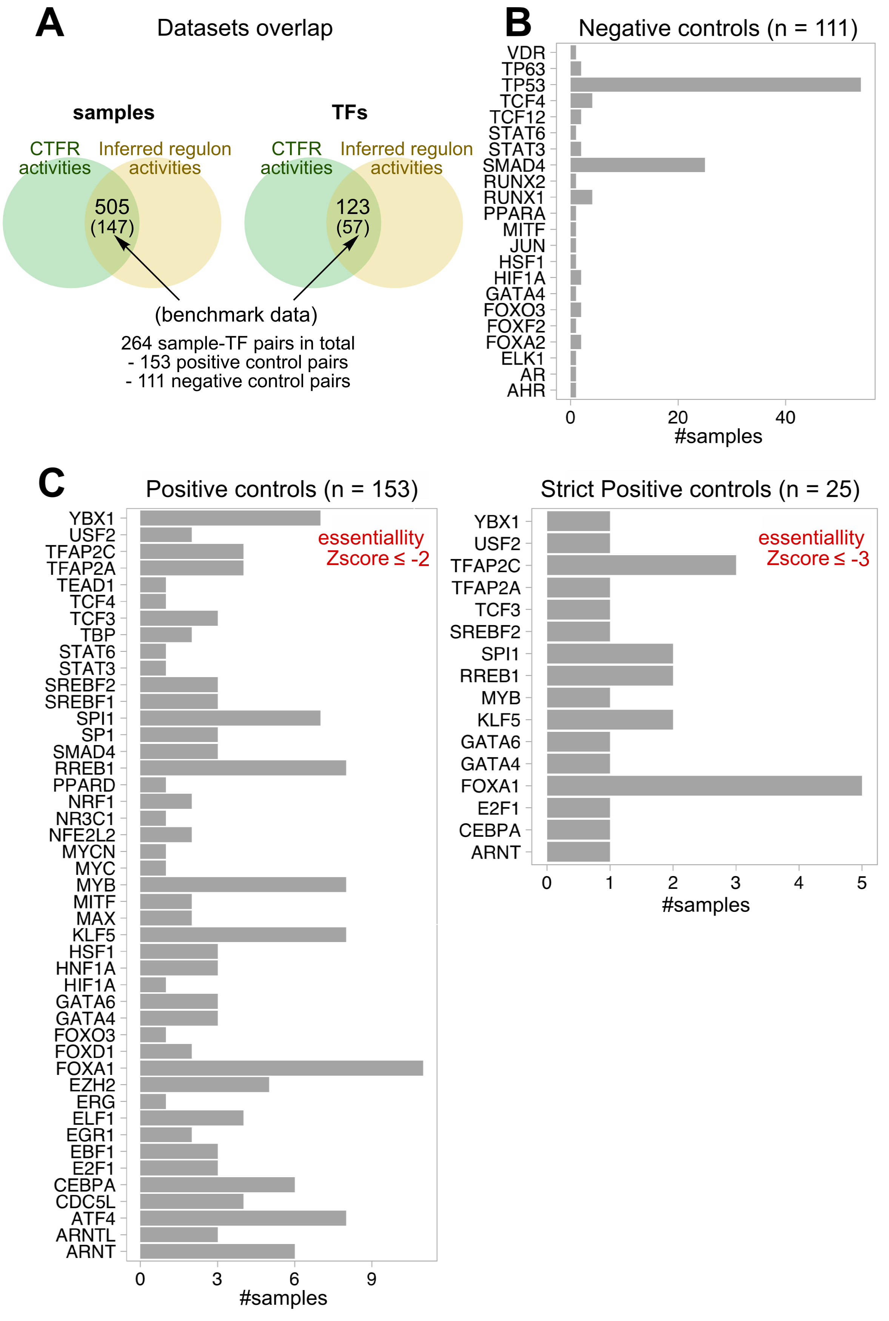
Figure S3. Positive and negative controls used in the benchmark data. A) TFs (y) and number of samples (x) in the negative controls. B) TFs (y) and number of samples (x) in the positive controls considering an ATARiS essentiality zscore < -2 (less stringent, left) and zscore < -3 (more stringent, right), respectively.
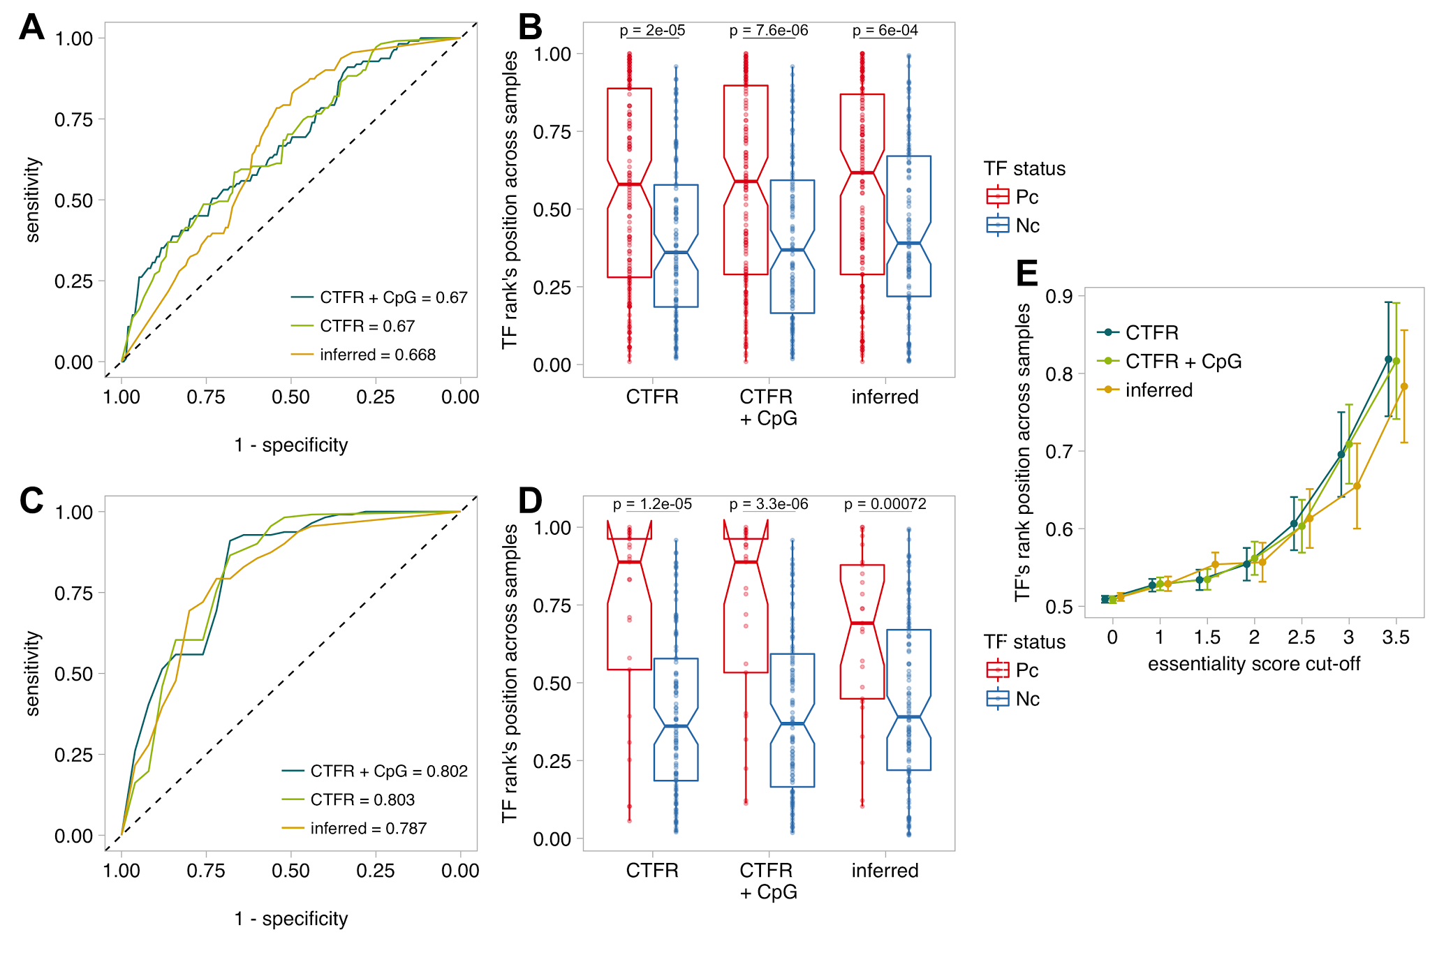Figure S4. Comparison of TF activities derived from the 3 regulon types on the benchmark data. A) ROC curves derived for 153 positive controls (Pc; Achilles ATARiS zscore < -2) and 111 negatives controls (Nc; homozygous gene deletions). B) Boxplots depicting the sample-wise rank position of positive (red) and negative controls (blue) from a given regulon source. Lower rank indicates lower TF activity across cell lines. C and D) Same as A and B using a more stringent threshold to define positive controls (n=25; Achilles ATARiS zscore < -3; red). E) Boxplots depicting the sample-wise rank position of positive controls according different ATARiS zscore thresholds.

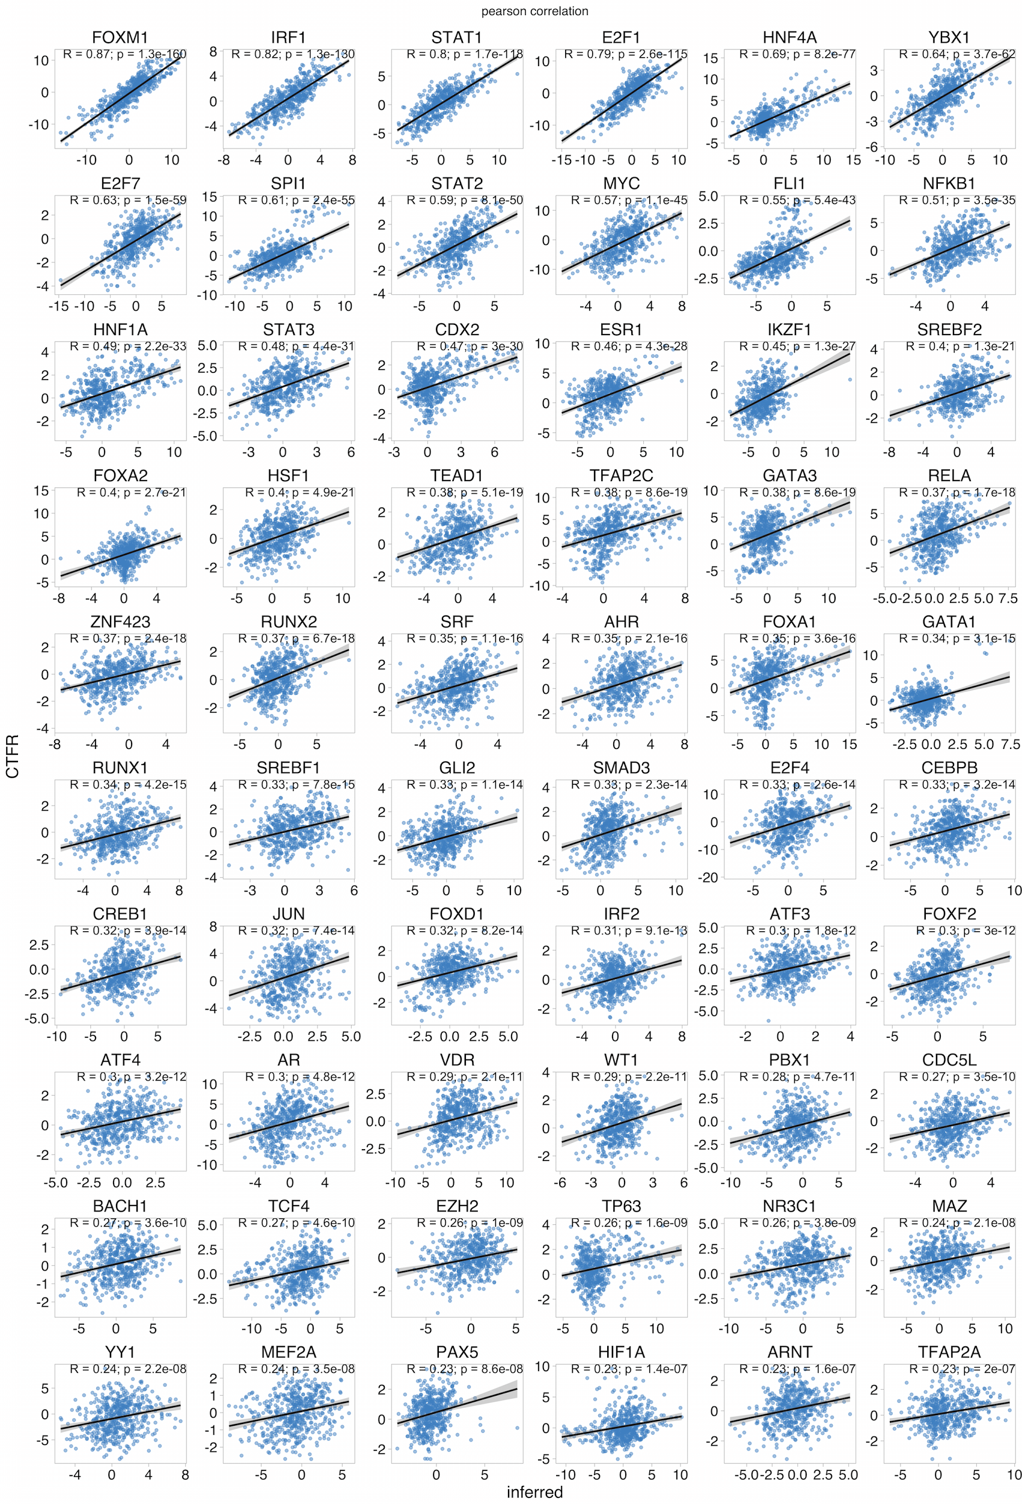
Figure S5A. Pearson correlation in TF activities between CTFRs and inferred regulons. Each scatterplot represents the TF activities across cell lines estimated using inferred regulons (x) and CTFRs (y). R represents the correlation coefficient and p the adjusted p-values (FDR).

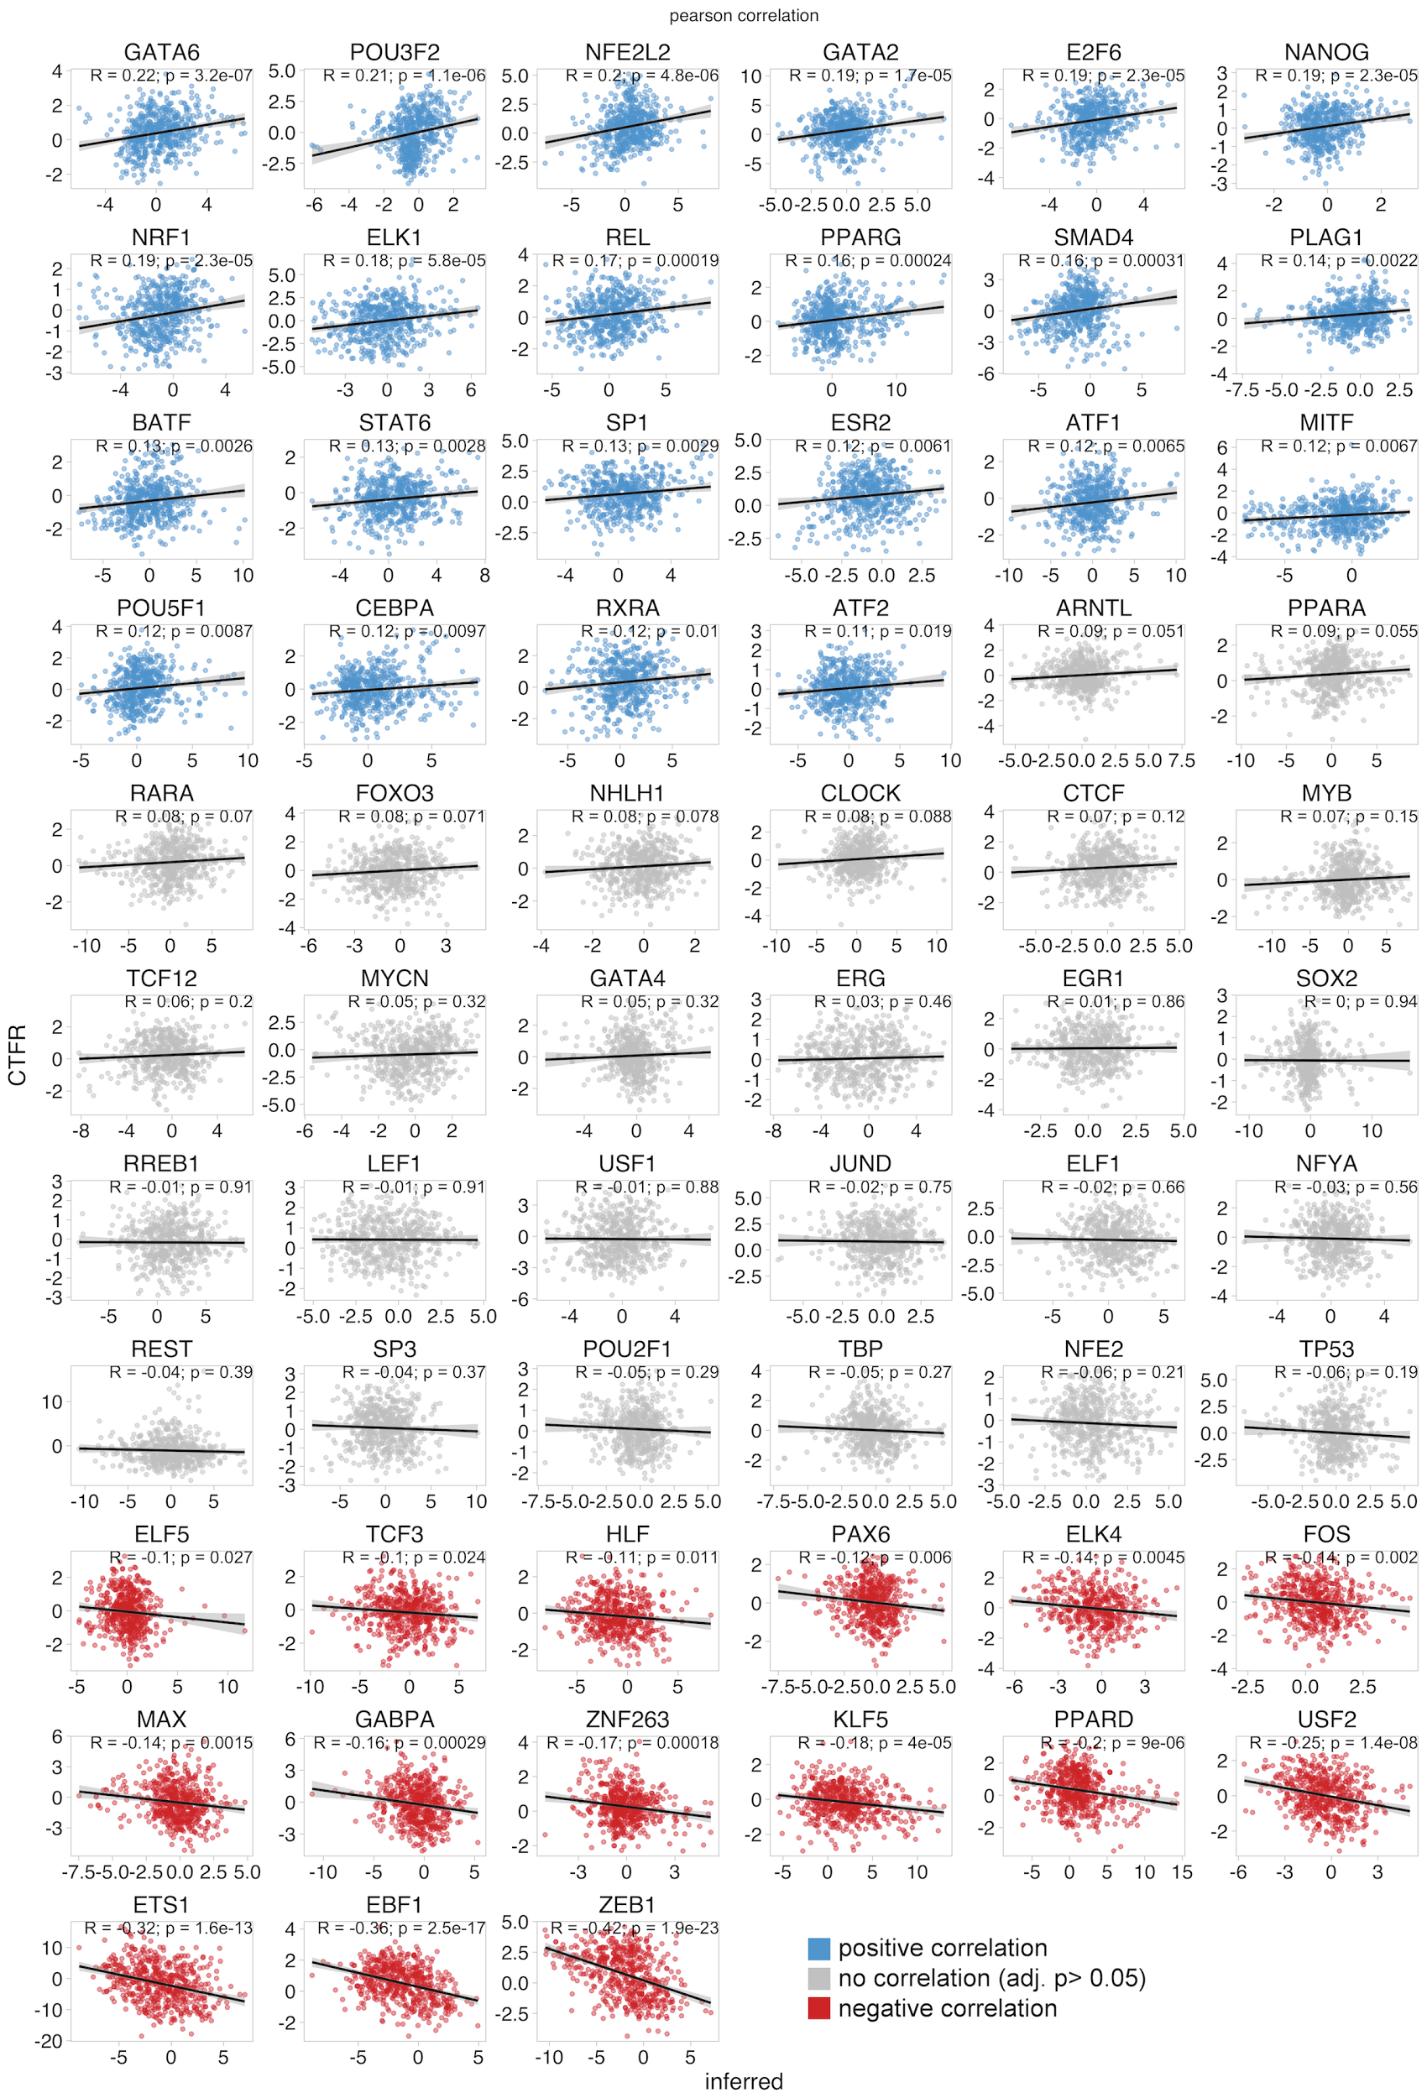
Figure S5B. Pearson correlation in TF activities between CTFRs and inferred regulons (continuation Figure S5A).
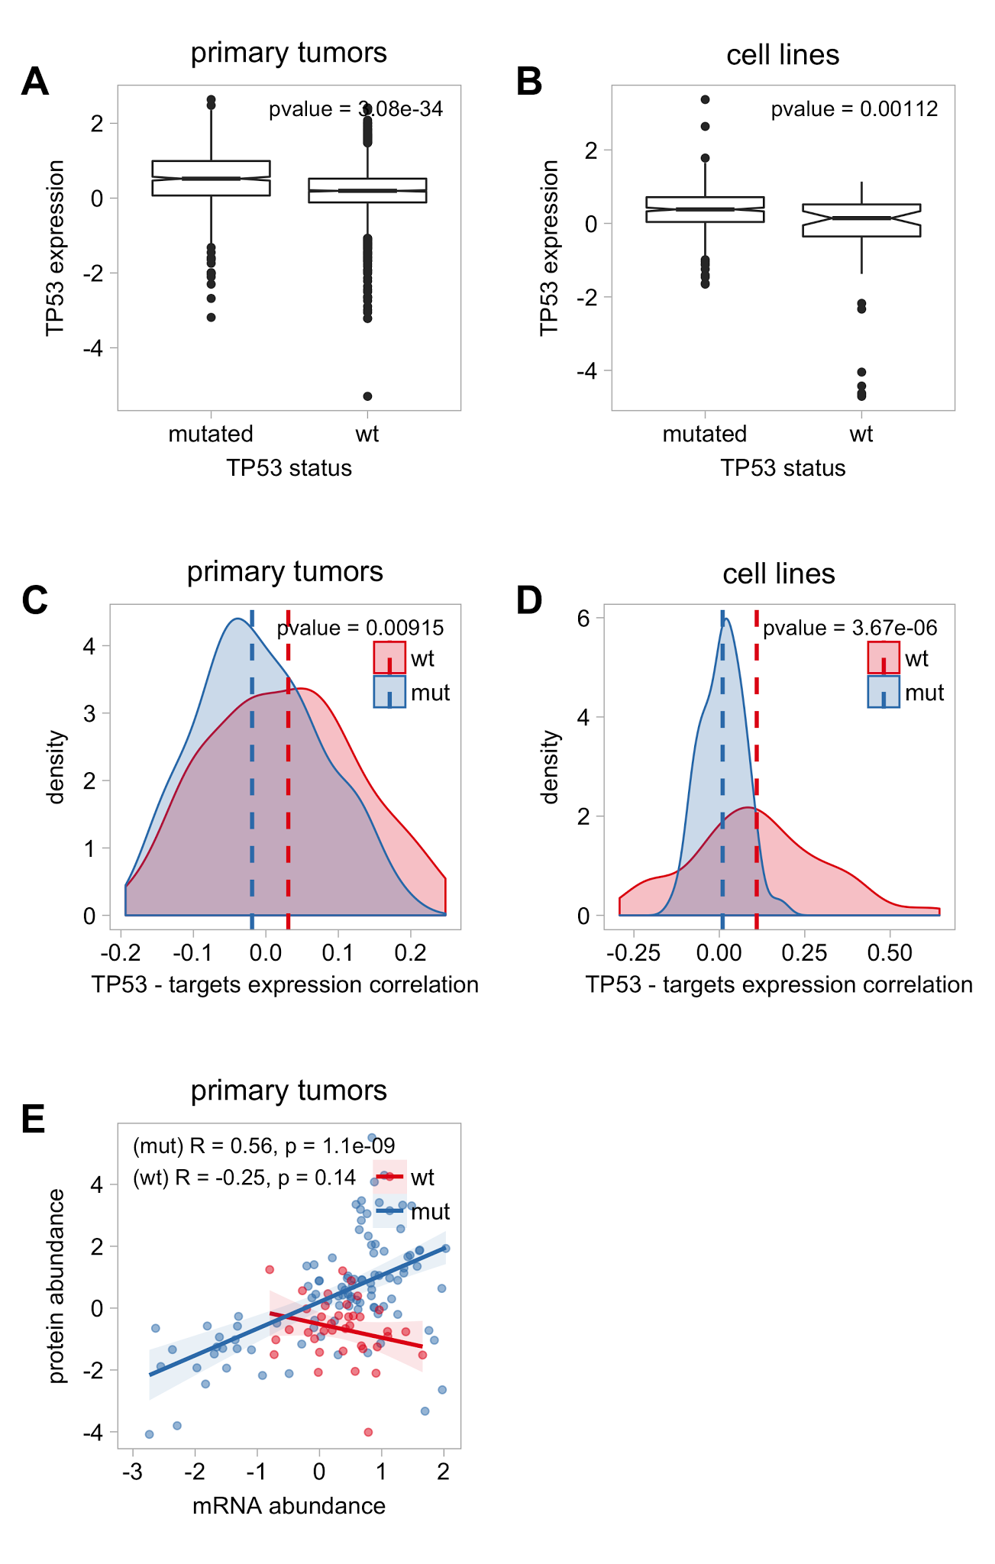

Figure S6. Differential expression between wild-type and TP53 missense mutant samples. A-B) Comparison of mRNA abundances (y) between wild-type and TP53 missense mutant samples (x) in primary tutors and cell lines, respectively. C-D) Comparison of mRNA TP53-canonical target pairwise correlations (x) between wild-type (red) and TP53 missense mutant (blue) samples in primary tutors and cell lines, respectively. E) Correlation between mRNA (x) and protein abundances (y) in wild-type (red) and TP53 missense mutant (blue) primary tumors.

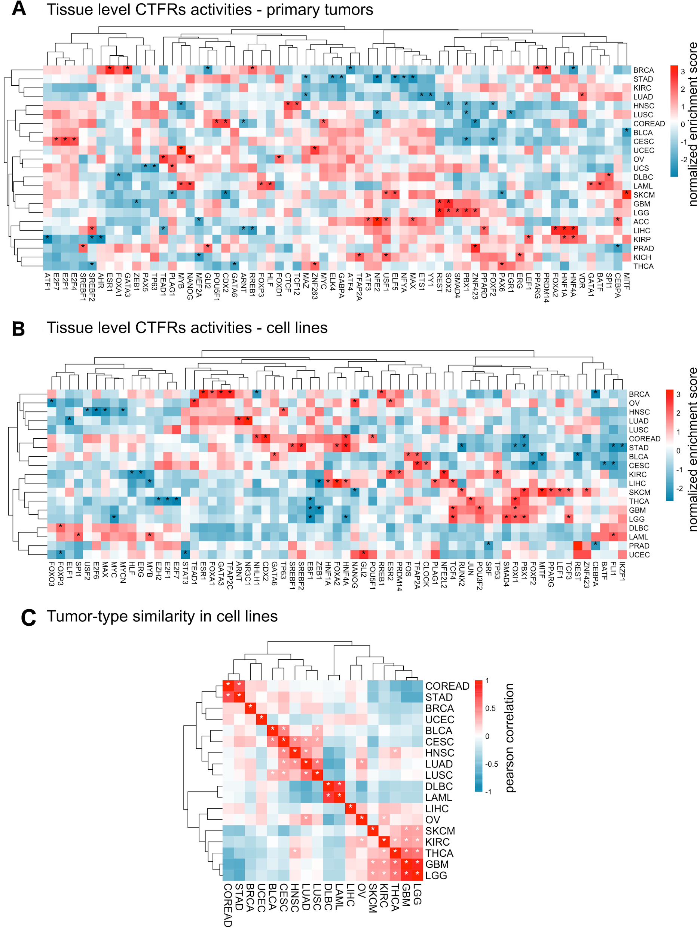
Figure S7. Tumor-level TF activities overview. A-B) Heatmap depicting the tumor-level activity summaries across tumor types in primary tumors (23 tumor types) and cell lines (18 tumor types), respectively. Values represent the normalised enrichment score derived from VIPER, where red and blue indicate higher and lower activities. Dashed boxes indicate TFs which activities deviates 2 standard deviations away from the mean. Only TFs with at least one dash are shown. C) Tumor type similarity in cell lines. Hierarchical clustering of pearson correlation coefficients between tumor type-level TF activities for 18 tumors-types.
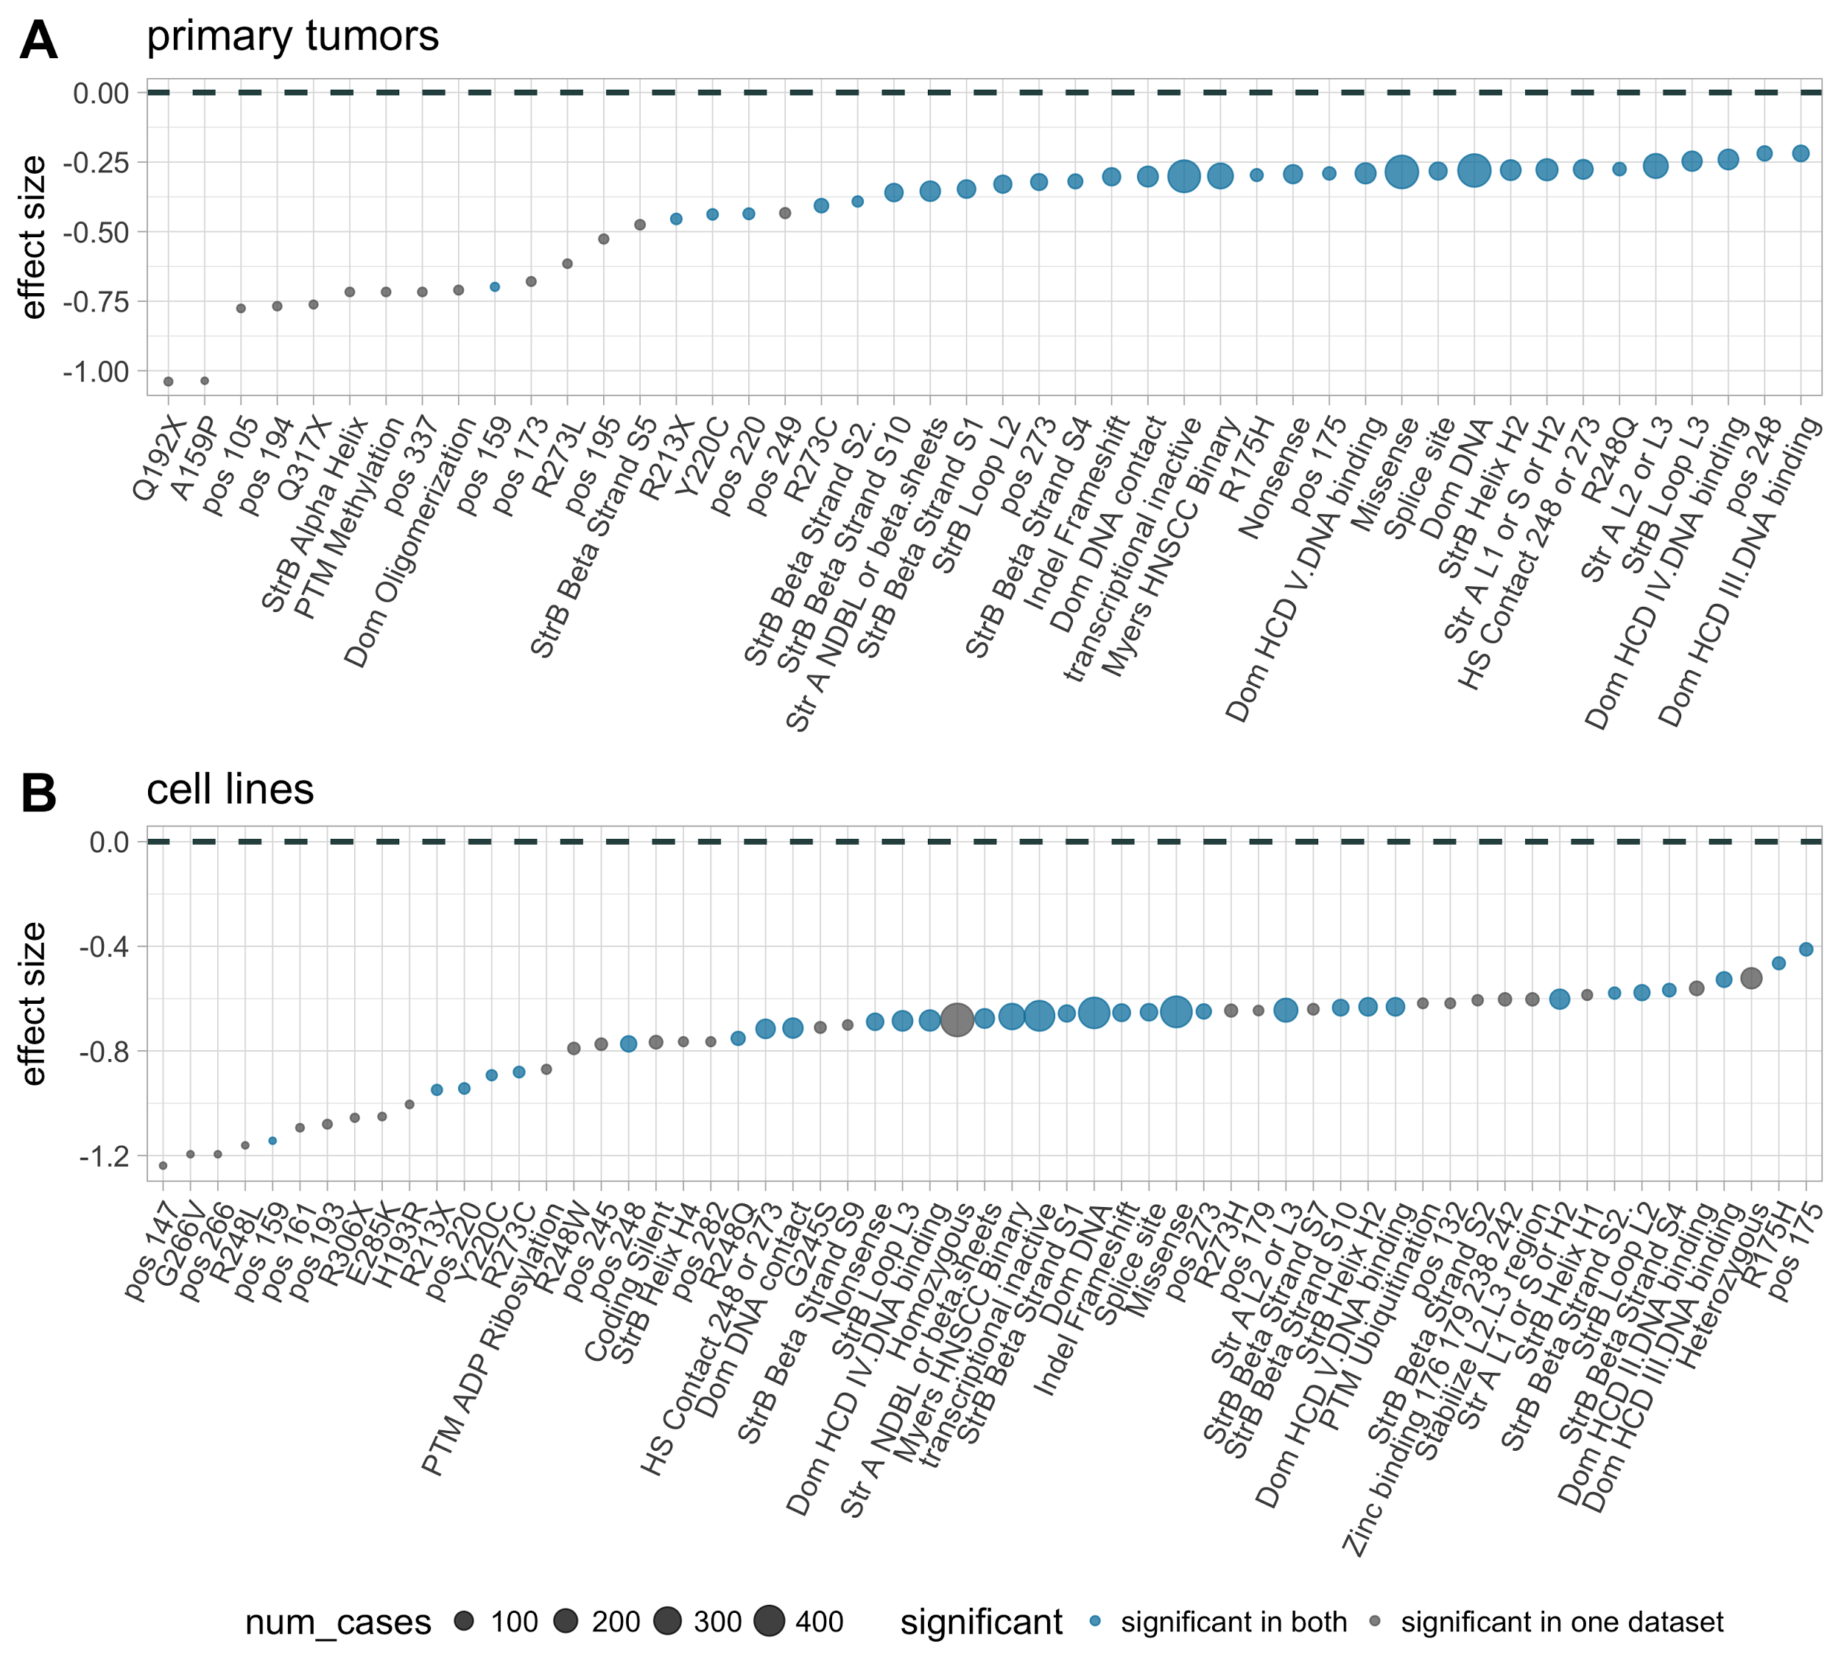
Figure S8. Functional characterisation of TP53 mutants on TP53 activity. Effect of TP53 mutation groups (x) on TP53 activity (y) in patients (A) and cell lines (B). Y-axis indicates the effect size after comparing mutant against wild-type samples. Negative values indicate lower TF activities in mutants.
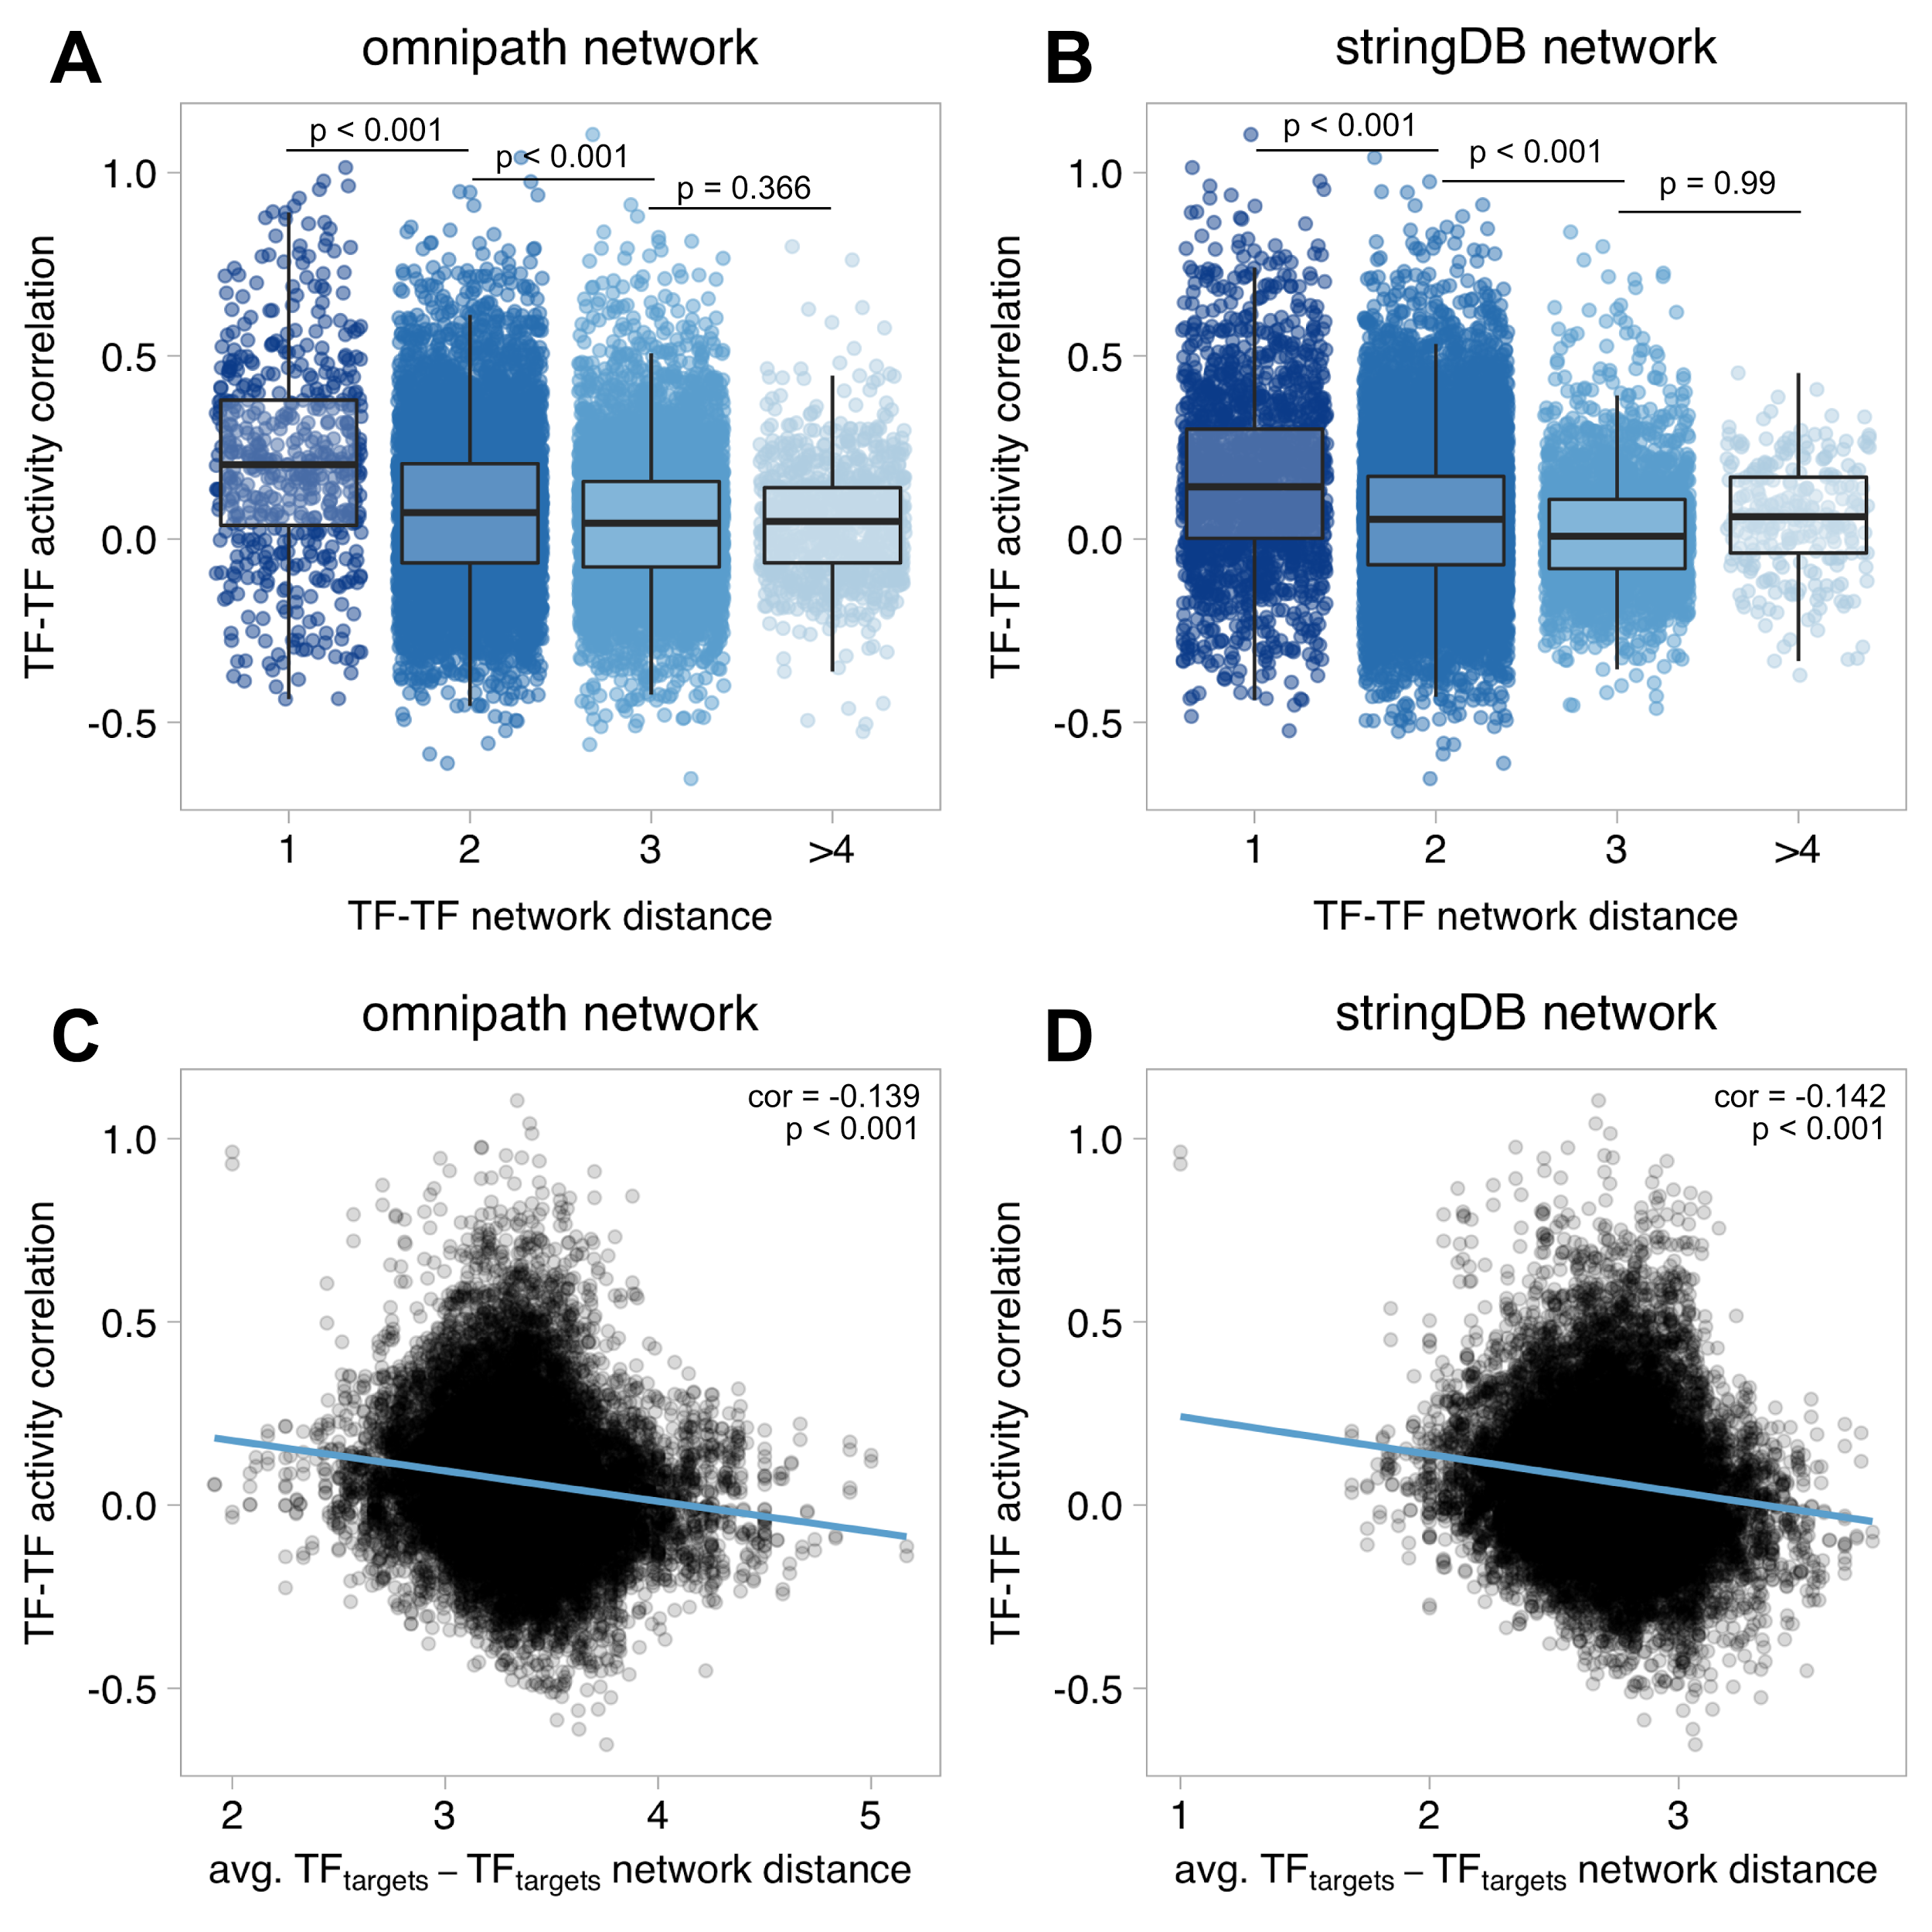
Figure S9. Relationship between similarity in TF activity and proximity in signaling networks. A-B) Boxplots representing the TF-TF pairwise activity Pearson correlation (y), defined as the regression coefficient in a linear regression model, and their network distance (x), defined as shortest path lengths connecting both TFs in Omnipath (A) and StringDB networks (score>700; B). C-D) Scatterplots representing TF-TF pairwise activity similarity (y) and the average network distance between the targets in the TF pair in Omnipath (C) and StringDB (D) networks.

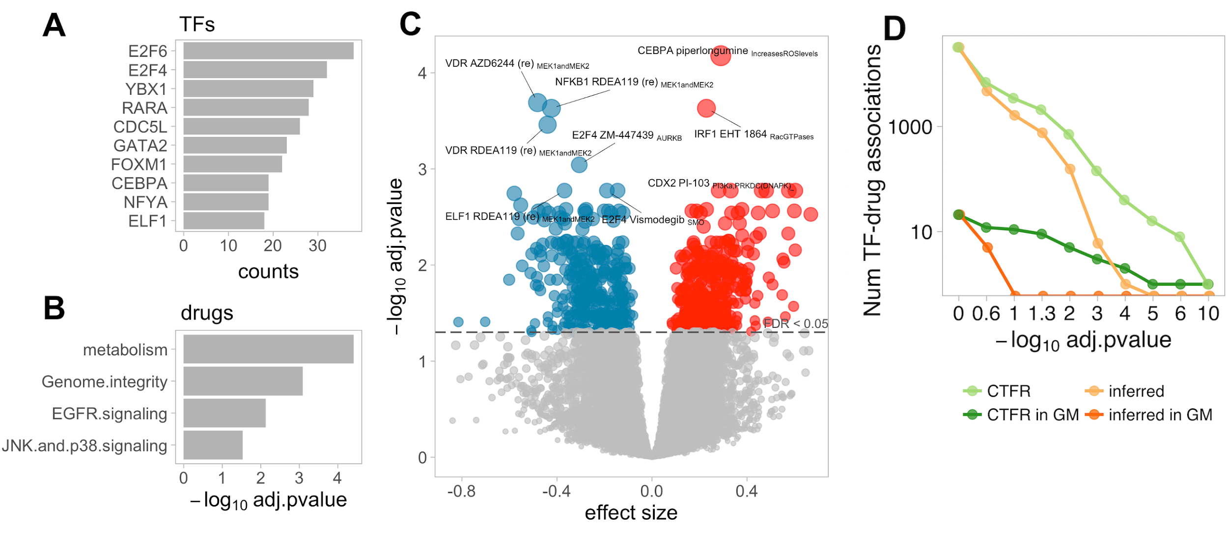
Figure S10. Modelling of the effect of TF activities from inferred regions on drug sensitivity. A) Frequency of TFs in significant pancancer TF-drug associations. B) Drug types overrepresented among significant pancancer associations. C) Volcano plot representing the effect size (x) and adjusted p-value of all tested pancancer TF-drug associations. Red and blue indicate positive (resistance) and negative (sensitivity) effects, respectively. D) Number of significant pancancer associations (y) after applying different FDR cut offs (x) using CTFRs (green) and inferred (blue) regulons on the 123 shared TFs. Light lines represent all tested TF-drug associations. Dark lines represent tests involving TF-drug pairs previously defined as pharmacogenomic markers (GM).

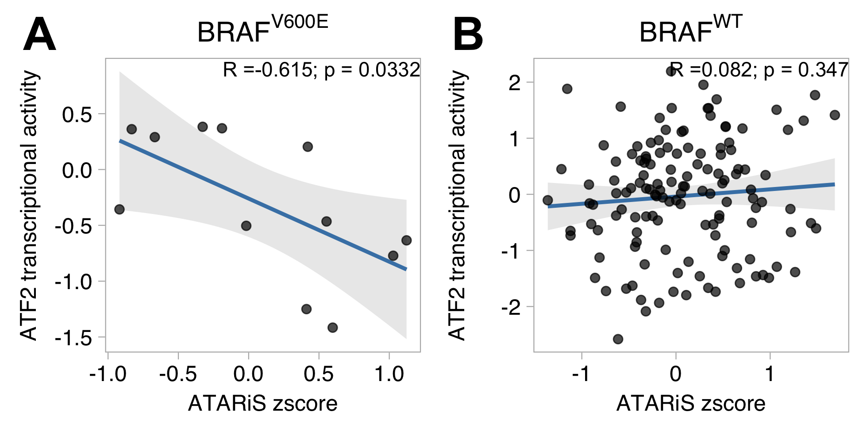
Figure S11. Correlation between ATF2 TF activity and essentiality in BRAF^{wt} and BRAF^{V6000E} samples. A) Scatterplot representing the TF activity and gene-level ATARIs essentiality score in ATF2 for BRAFwt samples. B) Scatterplot representing the TF activity and gene-level ATARIs essentiality score in ATF2 for BRAFV600E samples. R indicates Pearson’s correlation estimates. Red dots indicate melanoma samples.

Supplemental References

1. Alvarez MJ, Shen Y, Giorgi FM, Lachmann A, Ding BB, Ye BH, et al. Functional characterization of somatic mutations in cancer using network-based inference of protein activity. Nat Genet. 2016;48:838–47.
2. Margolin AA, Wang K, Lim WK, Kustagi M, Nemenman I, Califano A. Reverse engineering cellular networks. Nat Protoc. 2006;1:662–71.
3. Shao DD, Tsherniak A, Gopal S, Weir BA, Tamayo P, Stransky N, et al. ATARiS: computational quantification of gene suppression phenotypes from multisample RNAi screens. Genome Res. 2013;23:665–78.
4. Bártek J, Bártková J, Vojtĕsek B, Stasková Z, Lukás J, Rejthar A, et al. Aberrant expression of the p53 oncoprotein is a common feature of a wide spectrum of human malignancies. Oncogene. 1991;6:1699–703.
5. Kupryjańczyk J, Thor AD, Beauchamp R, Merritt V, Edgerton SM, Bell DA, et al. p53 gene mutations and protein accumulation in human ovarian cancer. Proc Natl Acad Sci U S A. 1993;90:4961–5.
6. Riley T, Sontag E, Chen P, Levine A. Transcriptional control of human p53-regulated genes. Nat Rev Mol Cell Biol. 2008;9:402–12.
7. Yang W, Soares J, Greninger P, Edelman EJ, Lightfoot H, Forbes S, et al. Genomics of Drug Sensitivity in Cancer (GDSC): a resource for therapeutic biomarker discovery in cancer cells. Nucleic Acids Res. 2013;41:D955–61.
8. Gao J, Aksoy BA, Dogrusoz U, Dresdner G, Gross B, Sumer SO, et al. Integrative analysis of complex cancer genomics and clinical profiles using the cBioPortal. Sci Signal. 2013;6:l1.
9. Wang K, Li M, Hakonarson H. ANNOVAR: functional annotation of genetic variants from high-throughput sequencing data. Nucleic Acids Res. 2010;38:e164.
10. Cowley GS, Weir BA, Vazquez F, Tamayo P, Scott JA, Rusin S, et al. Parallel genome-scale loss of function screens in 216 cancer cell lines for the identification of context-specific genetic dependencies. Sci Data. 2014;1:140035.
11. Fonseca NA, Petryszak R, Marioni J, Brazma A. iRAP - an integrated RNA-seq Analysis Pipeline [Internet]. bioRxiv. 2014 [cited 2017 Feb 27]. page 005991. Available from: http://biorxiv.org/content/early/2014/06/06/005991
12. Klijn C, Durinck S, Stawiski EW, Haverty PM, Jiang Z, Liu H, et al. A comprehensive transcriptional portrait of human cancer cell lines. Nat Biotechnol. Nature Research; 2014;33:306–12.
13. Ritchie ME, Phipson B, Wu D, Hu Y, Law CW, Shi W, et al. limma powers differential expression analyses for RNA-sequencing and microarray studies. Nucleic Acids Res. 2015;43:e47.
14. Conesa A, Madrigal P, Tarazona S, Gomez-Cabrero D, Cervera A, McPherson A, et al. A survey of best practices for RNA-seq data analysis. Genome Biol. 2016;17:13.
15. Leek JT, Johnson WE, Parker HS, Jaffe AE, Storey JD. The sva package for removing batch effects and other unwanted variation in high-throughput experiments. Bioinformatics. 2012;28:882–3.
16. Gerstein MB, Kundaje A, Hariharan M, Landt SG, Yan K-K, Cheng C, et al. Architecture of the human regulatory network derived from ENCODE data. Nature. 2012;489:91–100.
17. Lachmann A, Xu H, Krishnan J, Berger SI, Mazloom AR, Ma’ayan A. ChEA: transcription factor regulation inferred from integrating genome-wide ChIP-X experiments. Bioinformatics. 2010;26:2438–44.
18. Bovolenta LA, Acencio ML, Lemke N. HTRIdb: an open-access database for experimentally verified human transcriptional regulation interactions. BMC Genomics. 2012;13:405.
19. Lesurf R, Cotto KC, Wang G, Griffith M, Kasaian K, Jones SJM, et al. ORegAnno 3.0: a community-driven resource for curated regulatory annotation. Nucleic Acids Res. 2016;44:D126–32.
20. Fazekas D, Koltai M, Türei D. SignaLink 2–a signaling pathway resource with multi-layered regulatory networks. BMC Syst Biol [Internet]. bmcsystbiol.biomedcentral.com; 2013; Available from: https://bmcsystbiol.biomedcentral.com/articles/10.1186/1752-0509-7-7
21. Portales-Casamar E, Arenillas D, Lim J, Swanson MI, Jiang S, McCallum A, et al. The PAZAR database of gene regulatory information coupled to the ORCA toolkit for the study of regulatory sequences. Nucleic Acids Res. 2009;37:D54–60.
22. Kanehisa M, Goto S, Sato Y, Furumichi M, Tanabe M. KEGG for integration and interpretation of large-scale molecular data sets. Nucleic Acids Res. 2012;40:D109–14.
23. Liberzon A, Subramanian A, Pinchback R, Thorvaldsdóttir H, Tamayo P, Mesirov JP. Molecular signatures database (MSigDB) 3.0. Bioinformatics. 2011;27:1739–40.
24. Manke T, Roider HG, Vingron M. Statistical modeling of transcription factor binding affinities predicts regulatory interactions. PLoS Comput Biol. 2008;4:e1000039.
25. Thomas-Chollier M, Hufton A, Heinig M, O’Keeffe S, Masri NE, Roider HG, et al. Transcription factor binding predictions using TRAP for the analysis of ChIP-seq data and regulatory SNPs. Nat Protoc. 2011;6:1860–9.
26. Iorio F, Knijnenburg TA, Vis DJ, Bignell GR, Menden MP, Schubert M, et al. A Landscape of Pharmacogenomic Interactions in Cancer. Cell. 2016;166:740–54.
27. Wagih O, Reimand J, Bader GD. MIMP: predicting the impact of mutations on kinase-substrate phosphorylation. Nat Methods. 2015;12:531–3.
28. Breuza L, Poux S, Estreicher A, Famiglietti ML, Magrane M, Tognolli M, et al. The UniProtKB guide to the human proteome. Database [Internet]. 2016;2016. Available from: http://dx.doi.org/10.1093/database/bav120
29. Hornbeck PV, Zhang B, Murray B, Kornhauser JM, Latham V, Skrzypek E. PhosphoSitePlus, 2014: mutations, PTMs and recalibrations. Nucleic Acids Res. 2015;43:D512–20.
30. Türei D, Korcsmáros T, Saez-Rodriguez J. OmniPath: guidelines and gateway for literature-curated signaling pathway resources. Nat Methods. 2016;13:966–7.
31. Creixell P, Schoof EM, Simpson CD, Longden J, Miller CJ, Lou HJ, et al. Kinome-wide decoding of network-attacking mutations rewiring cancer signaling. Cell. 2015;163:202–17.
32. Orchard S, Ammari M, Aranda B, Breuza L, Briganti L, Broackes-Carter F, et al. The MIntAct project--IntAct as a common curation platform for 11 molecular interaction databases. Nucleic Acids Res. 2014;42:D358–63.
33. Mosca R, Tenorio-Laranga J, Olivella R, Alcalde V, Céol A, Soler-López M, et al. dSysMap: exploring the edgetic role of disease mutations. Nat Methods. 2015;12:167–8.
34. Betts MJ, Lu Q, Jiang Y, Drusko A, Wichmann O, Utz M, et al. Mechismo: predicting the mechanistic impact of mutations and modifications on molecular interactions. Nucleic Acids Res. 2015;43:e10.
35. Porta-Pardo E, Garcia-Alonso L, Hrabe T, Dopazo J, Godzik A. A Pan-Cancer Catalogue of Cancer Driver Protein Interaction Interfaces. PLoS Comput Biol. 2015;11:e1004518.
36. Reimand J, Bader GD. Systematic analysis of somatic mutations in phosphorylation signaling predicts novel cancer drivers. Mol Syst Biol. 2013;9:637.
37. Vogelstein B, Papadopoulos N, Velculescu VE, Zhou S, Diaz LA Jr, Kinzler KW. Cancer genome landscapes. Science. 2013;339:1546–58.
38. Gonzalez-Perez A, Perez-Llamas C, Deu-Pons J, Tamborero D, Schroeder MP, Jene-Sanz A, et al. IntOGen-mutations identifies cancer drivers across tumor types. Nat Methods. 2013;10:1081–2.

