Supplementary materials

Co-mutations in DNA Damage Response Pathways as a Potential Biomarker for Immune Checkpoint Blockades

Contents:
Table S1-S6
Figure S1-S8

Table S1. Data source.
Data source | Tumor | N | WGS | WES | RNAseq | Neoantigen | Clinical outcome
TCGA | 29 cohorts | 11186 | － | 8552 | 8482 | 5935 | －
ICGC | － | － | 2638 | － | － | － | －
Rizvi cohort | Non-small cell lung cancer with anti-PD-1 therapy | 34 | － | 34 | － | 34 | ORR  DCB  PFS
Allen cohort | Melanoma with anti-CTLA-4 therapy | 110 | － | 110 | － | 110 | ORR  OS
Snyder cohort | Melanoma with anti-CTLA-4 therapy | 64 | － | 64 | － | － | OS
Hugo cohort | Melanoma with anti-PD-1 therapy | 38 | － | 38 | － | － | ORR  OS
TCGA, The Cancer Genome Altlas; ICGC, The Interantional Cancer Genome Consortium; WGS, whole-genome sequencing; WES, whole-exome sequencing; ORR, Objective response rate; DCB, durable clinical benefit; PFS, progression-free survival; OS, Overall survival.

Table S2. Gene list for DNA repair response pathways.
Pathway | Genes
BER (n = 37) | APEX1, APLF, APTX, CCNO, FEN1, HMGB1, LIG1, LIG3, MBD4, MPG, MUTYH, NEIL1, NEIL2, NEIL3, NTHL1, OGG1, PARP1, PARP2, PARP3, PARP4, PCNA, PNKP, POLB, POLD1, POLD2, POLD3, POLD4, POLE, POLE2, POLE3, POLE4, POLL, SMUG1, TDG, TDP1, UNG, XRCC1
CPF (n = 22) | AEN, ATM, ATR, ATRIP, CHEK1, CHEK2, HUS1, HUS1B, PER1, PER2, PER3, RAD1, RAD17, RAD9A, RAD9B, RFC2, RFC3, RFC4, RFC5, TIMELESS, TIPIN, TP53
FA (n = 30) | CENPS, BLM, BRCA1, BRCA2, BRIP1, FAAP100, FAAP24, FAN1, FANCA, FANCC, FANCD2, FANCE, FANCF, FANCG, FANCI, FANCL, FANCM, HES1, PALB2, RAD51, RAD51C, RMI1, RMI2, CENPX, TELO2, TOP3A, TOP3B, UBE2T, USP1, WDR48
HRR (n = 44) | BLM, BRCA1, BRCA2, DMC1, EME1, EME2, GEN1, HFM1, MRE11, MUS81, NBN, PPP4C, PPP4R1, PPP4R2, PPP4R4, RAD50, RAD51, RAD51B, RAD51C, RAD51D, RAD52, RAD54B, RAD54L, RAD54L2, RDM1, RECQL, RECQL4, RECQL5, RMI1, RMI2, RPA1, RPA2, RPA3, SEM1, SLX1A, SLX4, PPP4R3A, PPP4R3B, SPO11, TOP3A, TOP3B, WRN, XRCC2, XRCC3
MMR (n = 25) | EXO1, HMGB1, LIG1, MLH1, MLH3, MSH2, MSH3, MSH4, MSH5, MSH6, PCNA, PMS1, PMS2, POLD1, POLD2, POLD3, POLD4, RFC1, RFC2, RFC3, RFC4, RFC5, RPA1, RPA2, RPA3
NER (n = 47) | BIVM-ERCC5, CCNH, CDK7, CUL3, CUL4A, CUL5, DDB1, DDB2, ERCC1, ERCC2, ERCC3, ERCC4, ERCC6, ERCC8, GTF2H1, GTF2H3, GTF2H4, GTF2H5, LIG1, MMS19, MNAT1, POLR2A, POLR2B, POLR2C, POLR2D, POLR2E, POLR2F, POLR2G, POLR2H, POLR2I, POLR2J, POLR2J2, POLR2K, POLR2L, RAD23A, RAD23B, RBX1, RPA1, RPA2, RPA3, ELOC, ELOB, ELOA, ELOA2, ELOA3B, XPA, XPC
NHEJ (n = 15) | APLF, APTX, DCLRE1C, DNTT, LIG4, MRE11A, NHEJ1, POLB, POLL, POLM, PRKDC, RAD50, XRCC4, XRCC5, XRCC6
TLS (n = 13) | HLTF, POLH, POLI, POLK, POLN, RAD18, REV1, REV3L, TMEM189, UBE2B, UBE2N, UBE2V1, UBE2V2
BER, base excision repair; CPF, checkpoint factors; FA, Fanconi anemia; HRR, homologous recombination repair; MMR, mismatch repair; NER, nucleotide excision repair; NHEJ, non-homologous end-joining; TLS, translesion DNA synthesis.

Table S3. Gene list of immune gene signature.
Classification | Genes
Immune checkpoint | PD-1, PD-L1, PD-L2, LAG3, CTLA4, TIM3, VTCN1
T-effector and INFγ pathway | GBP1, IFI16, IFI30, IFNG, IRF1, STAT1, TAP1, TAP2, FAS, PSMB9, IL15RA, GZMA, GZMB, EOMES, CXCL10, CXCL9, CXCL11, TBX21, PRF1
T cell receptor | CD27, GRAP2, LCK, PTPRCAP, CCL5, IL2RB, IKZF3, CD3G, CD74, CD3D, CD8A, CD4, TIGIT
Tumor microenvironment | IDO1, PTGS2, IL1B, IL18, IL6, IL12A, TNF, CD73

Table S4. Correlations of co-mut status with tumor mutational burden.
Tumor | Co-mut- |  |  |  | Co-mut+ |  |  | P
 | N | mean | SD |  | N | mean | SD
ACC | 81 | 104.16 | 83.43 |  | 9 | 558.56 | 626.37 | 0.0002
BLCA | 92 | 211.96 | 152.30 |  | 38 | 510.03 | 341.12 | 0.0000
BRCA | 952 | 49.56 | 77.15 |  | 30 | 595.03 | 1015.89 | 0.0000
CESC | 176 | 95.57 | 99.54 |  | 18 | 718.39 | 540.16 | 0.0000
CHOL | 30 | 109.27 | 32.06 |  | 5 | 251.40 | 278.39 | 0.0208
CRAC | 188 | 84.57 | 79.20 |  | 35 | 1375.37 | 1967.28 | 0.0000
ESCA | 162 | 181.92 | 77.70 |  | 23 | 434.26 | 506.33 | 0.0005
GBM | 284 | 55.12 | 18.82 |  | 6 | 89.00 | 46.91 | 0.0233
HNSC | 455 | 138.81 | 110.13 |  | 57 | 392.86 | 503.25 | 0.0000
KICH | 65 | 69.82 | 26.49 |  | 1 | 816.00 | NA | -
KIRC | 427 | 57.15 | 82.99 |  | 24 | 507.38 | 417.87 | 0.0000
KIRP | 273 | 51.27 | 24.28 |  | 9 | 63.89 | 10.42 | 0.0475
LGG | 283 | 24.47 | 12.75 |  | 3 | 170.00 | 207.12 | 0.0055
LIHC | 347 | 80.80 | 61.86 |  | 26 | 508.73 | 400.66 | 0.0000
MESO | 80 | 29.20 | 10.71 |  | 2 | 156.50 | 171.83 | 0.1075
NSCLC | 954 | 212.92 | 174.34 |  | 190 | 521.55 | 385.54 | 0.0000
OV | 306 | 48.38 | 27.13 |  | 10 | 69.00 | 31.07 | 0.0251
PAAD | 144 | 49.51 | 24.24 |  | 6 | 2490.83 | 5960.69 | 0.0759
PRAD | 490 | 39.93 | 33.72 |  | 9 | 918.00 | 2125.63 | 0.0002
SARC | 242 | 50.80 | 123.19 |  | 5 | 87.60 | 89.82 | 0.2937
SKCM | 272 | 279.61 | 302.20 |  | 96 | 1352.70 | 3283.76 | 0.0000
STAD | 316 | 128.72 | 128.25 |  | 79 | 1407.06 | 1192.82 | 0.0000
TGCT | 151 | 56.13 | 14.25 |  | 4 | 149.00 | 192.95 | 0.2759
THCA | 404 | 13.45 | 9.12 |  | 1 | 10.00 | NA | -
THYM | 122 | 11.63 | 10.76 |  | 1 | 646.00 | NA | -
UCEC | 198 | 97.20 | 115.45 |  | 50 | 2331.74 | 3090.05 | 0.0000
UCS | 54 | 59.19 | 18.55 |  | 3 | 1631.67 | 1955.56 | 0.0040

Abbreviation: NA, not available.

Table S5. Correlations of co-mut status with neoantigen load.
Tumor | Co-mut- |  |  |  | Co-mut+ |  |  | P
 | N | mean | SD |  | N | mean | SD
BLCA | 91 | 176.88 | 195.76 |  | 38 | 406.13 | 297.04 | 0.0000
BRCA | 939 | 50.40 | 83.34 |  | 30 | 538.80 | 867.55 | 0.0000
CESC | 169 | 90.27 | 113.75 |  | 18 | 841.83 | 665.79 | 0.0000
CRAC | 73 | 61.60 | 70.20 |  | 12 | 1118.67 | 2055.12 | 0.0000
GBM | 143 | 53.09 | 27.16 |  | 4 | 119.00 | 63.48 | 0.0289
HNSC | 428 | 110.49 | 86.05 |  | 55 | 357.33 | 515.73 | 0.0000
KICH | 65 | 49.46 | 25.88 |  | 1 | 1030.00 | NA | -
KIRC | 397 | 54.07 | 30.99 |  | 18 | 78.00 | 39.91 | 0.0047
KIRP | 156 | 73.30 | 46.18 |  | 5 | 95.00 | 40.78 | 0.1740
LIHC | 177 | 84.05 | 58.11 |  | 17 | 175.24 | 173.38 | 0.0037
NSCLC | 553 | 197.12 | 188.56 |  | 99 | 508.15 | 424.42 | 0.0000
OV | 266 | 47.41 | 31.85 |  | 8 | 67.75 | 56.37 | 0.5041
PAAD | 139 | 75.10 | 61.46 |  | 6 | 2594.50 | 6094.63 | 0.0059
PRAD | 414 | 34.44 | 32.79 |  | 6 | 336.83 | 467.86 | 0.0036
SKCM | 250 | 212.33 | 219.53 |  | 90 | 756.76 | 702.47 | 0.0000
STAD | 73 | 98.45 | 65.54 |  | 12 | 1439.42 | 2812.43 | 0.0005
THCA | 378 | 15.71 | 15.46 |  | 1 | 2.00 | NA | -
UCEC | 196 | 107.73 | 158.43 |  | 50 | 2302.48 | 3117.23 | 0.0000
Abbreviation: NA, not available.
Table S6. Correlations between clinical prognosis and co-mut status or TMB
 | Rizvi cohort |  |  |  | Allen & Synder cohort |  |  |  | Hugo cohort
 | N | mPFS | P |  | N | mOS | P |  | N | mOS | P
Co-mut
Co-mut– | 23 | 4.1 (2.1-8.3) | 0.006 |  | 124 | 10.6 (8.4-17.7) | 0.04 |  | 23 | 27.9 (14.6-NR) | 0.20
Co-mut+ | 11 | NR (8.3-NR) |  |  | 50 | 32.4 (20.1-NA) |  |  | 14 | NR (23.0-NR)
TMB
TMB<75th percentile | 25 | 6.3 (3.3-8.3) | 0.07 |  | 131 | 13.2 (9.6-19.2) | 0.20 |  | 28 | 31.5 (14.6-NR) | 0.53
TMB≥75th percentile | 9 | 14.5 (8.3-NR) |  |  | 43 | 27.0 (14.4-49.3) |  |  | 9 | 31.8 (22.1-NR)
TMB<median | 17 | 3.4 (1.9-6.5) | <0.001 |  | 87 | 12.0 (9.6-20.9) | 0.26 |  | 19 | 27.9 (14.6-NR) | 0.13
TMB≥median | 17 | NR (8.3-NR) |  |  | 87 | 20.4 (12.0-34.9) |  |  | 18 | 32.7 (22.1-NR)
Abbreviations: TMB, tumor mutational burden. NR, not reached.

Figure S1-S8
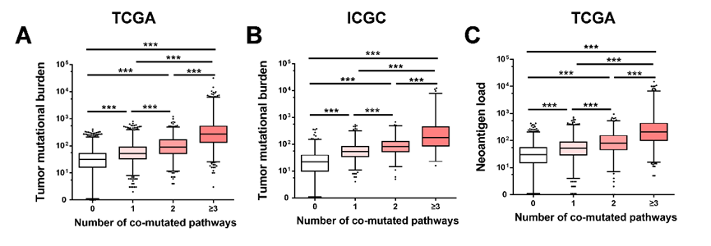
Figure S1. Correlations between DDR pathways and tumor mutational burden, neoantigen load. A, Comparison of tumor mutational burden between different numbers of mutated DDR pathways (0, 1, 2, vs ≥2) from TCGA database. B, Comparison of tumor mutational burden between different numbers of mutated DDR pathways (0, 1, 2, vs ≥2) from ICGC database. C, Comparison of neoantigen load between different numbers of mutated DDR pathways (0, 1, 2, vs ≥2) from TCGA database. DDR, DNA damage response; TCGA, The Cancer Genome Atlas; ICGC, the International Cancer Genome Consortium.
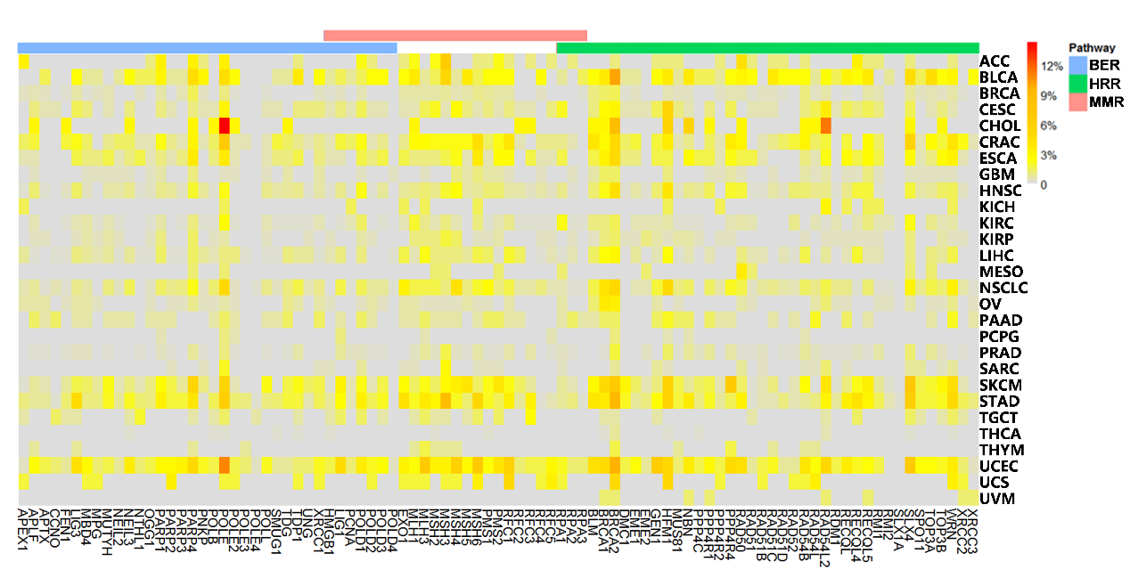
Figure S2. Mutation frequency of DDR genes in HRR, BER and MMR pathways.
BER, base excision repair; HRR, homologous recombination repair; MMR, mismatch repair; ACC, adrenocortical carcinoma; BLCA, bladder urothelial carcinoma; LGG, brain lower grade glioma; BRCA, breast invasive carcinoma; CESC, cervical squamous cell carcinoma and endocervical adenocarcinoma; CHOL, cholangiocarcinoma; CRAC, colorectal adenocarcinoma; ESCA, esophageal carcinoma; GBM, glioblastoma multiforme; HNSC, head and neck squamous cell carcinoma; KICH, kidney chromophobe; KIRC, kidney renal clear cell carcinoma; KIRP, kidney renal papillary cell carcinoma; LIHC, liver hepatocellular carcinoma; NSCLC, non-small cell lung cancer; MESO, mesothelioma; OV, ovarian serous cystadenocarcinoma; PAAD, pancreatic adenocarcinoma; PCPG, pheochromocytoma and paraganglioma; PRAD, prostate adenocarcinoma; SARC, sarcoma; SKCM, skin cutaneous melanoma; STAD, stomach adenocarcinoma; TGCT, testicular germ cell tumors; THYM, thymoma; THCA, thyroid carcinoma; UCS, uterine carcinosarcoma; UCEC, uterine corpus endometrial carcinoma; UVM, uveal melanoma.

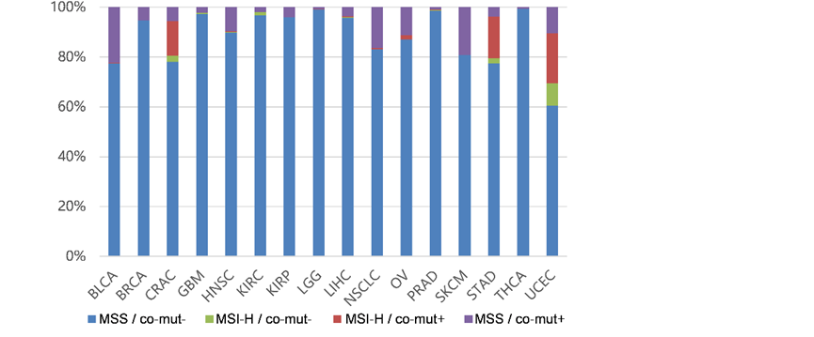
Figure S3. Correlations between DDR pathways and MSI-H. The proportion of patients with co-mut+ or MSI-H in different tumor. DDR, DNA damage response; BLCA, bladder urothelial carcinoma; BRCA, breast invasive carcinoma; CRAC, colorectal adenocarcinoma; GBM, glioblastoma multiforme; HNSC, head and neck squamous cell carcinoma; KIRC, kidney renal clear cell carcinoma; KIRP, kidney renal papillary cell carcinoma; LIHC, liver hepatocellular carcinoma; LGG, brain lower grade glioma; NSCLC, non-small cell lung cancer; OV, ovarian serous cystadenocarcinoma; SKCM, skin cutaneous melanoma; STAD, stomach adenocarcinoma; TGCT, testicular germ cell tumors; THCA, thyroid carcinoma; UCEC, uterine corpus endometrial carcinoma.
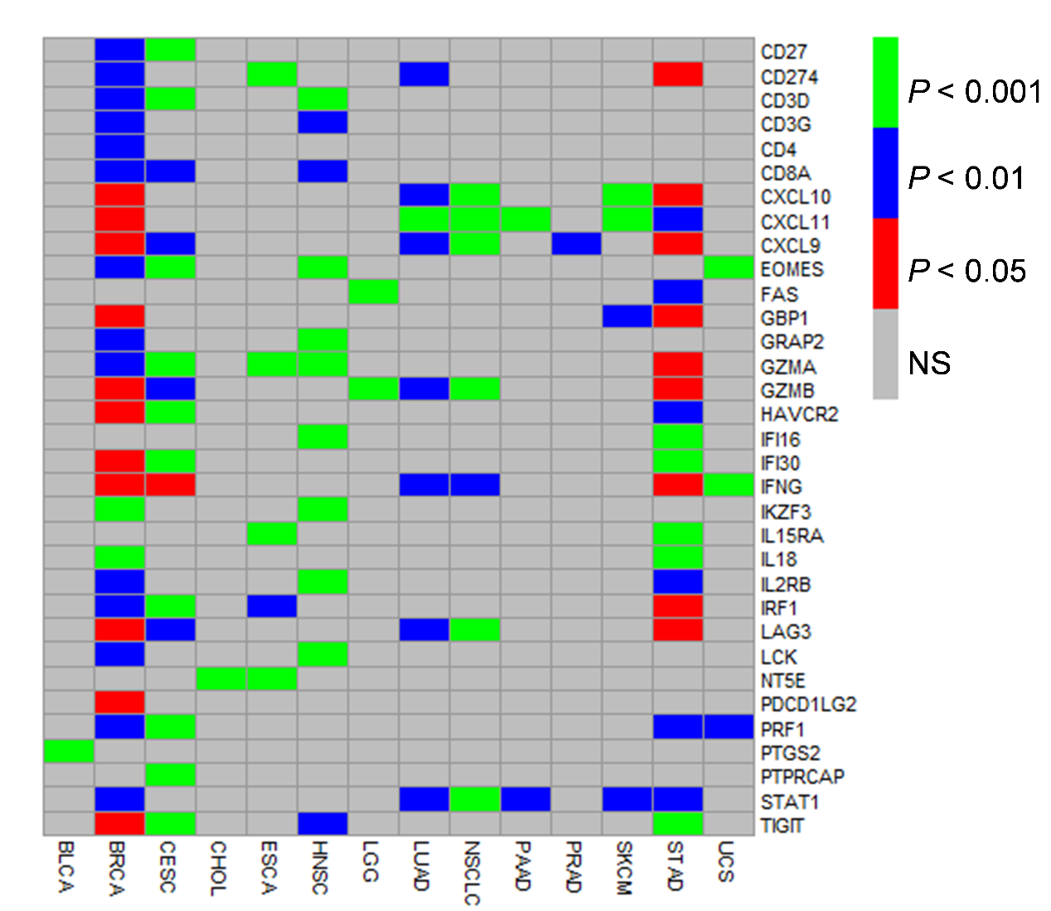
Figure S4. Association between co-mut status and immune genes expression. Heatmap depicting Mann-Whitney U test P values of associations between co-mut status and immune genes expression in 14 cancer types with at least one gene whose expression is significantly higher in co-mut+ group. NS, not significant.

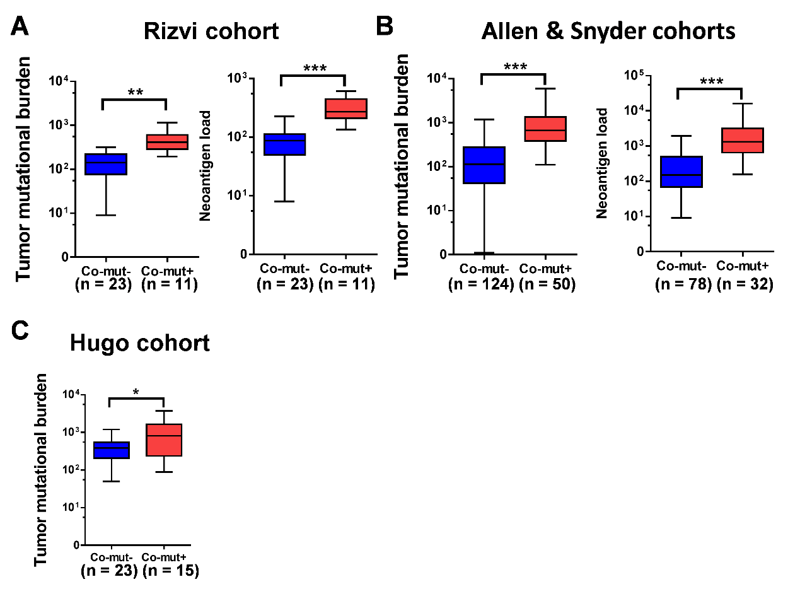
Figure S5. Correlations between co-mut status and Tumor mutational burden or neoantigen load. A-C, Comparisons of TMB and neoantigen load in co-mut+ and co-mut– group from Rizvi cohort (A), Allen cohort & Snyder cohort (B) or Hugo cohort (C). *P<0.05, **P<0.01, ***P<0.001.

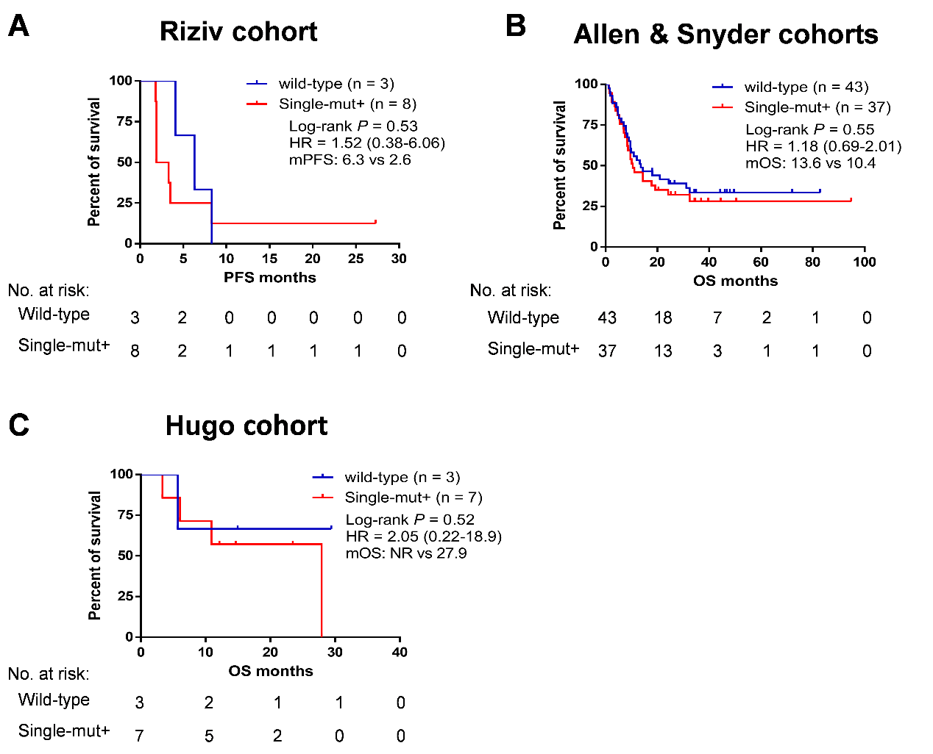
Figure S6. Comparison of clinical prognosis in DDR wild-type and single mutated DDR pathway. A, Kaplan-Meier survival curves of PFS comparing DDR wild-type and single DDR pathway mutated groups from the Rizvi cohort. B, Kaplan-Meier survival curves of OS comparing DDR wild-type and single DDR pathway mutated groups from the Allen and Snyder cohorts. C, Kaplan-Meier survival curves of OS comparing DDR wild-type and single DDR pathway mutated group from the Hugo cohort. PFS, progression-free survival; OS, overall survival; HR, hazard’s ratio.

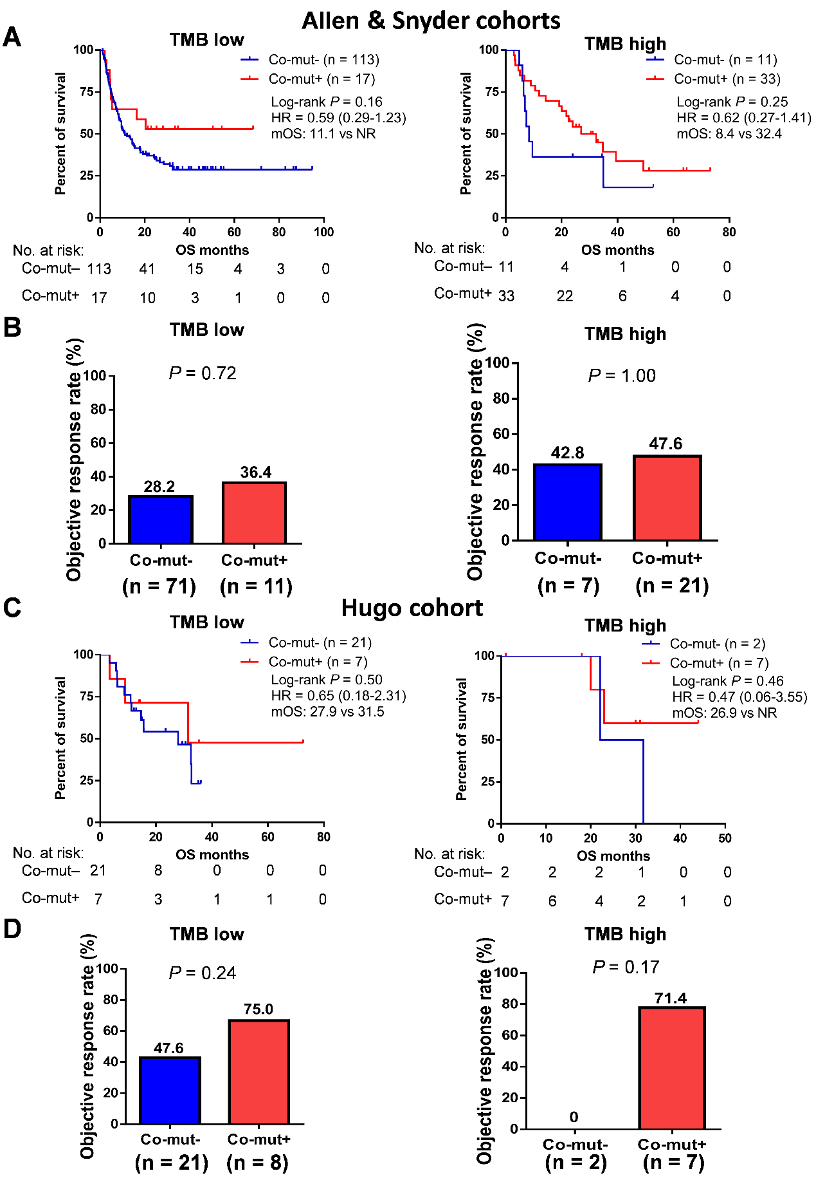
Figure S7. Associations between co-mut status and clinical prognosis by subgroup analysis in melanoma. A, Kaplan-Meier survival curves of OS comparing co-mut+ with co-mut– groups from the Allen and Snyder cohorts stratified by TMB. B, Comparison of the objective response rate between co-mut+ and co-mut– groups from the Allen and Snyder cohorts stratified by TMB. C, Kaplan-Meier survival curves of OS comparing co-mut+ with co-mut– groups from the Hugo cohort stratified by TMB. D, Comparison of the objective response rate in co-mut+ and co-mut– groups from the Hugo cohort stratified by TMB. Abbreviations: TMB, tumor mutational burden; OS, overall survival; NR, not reached.

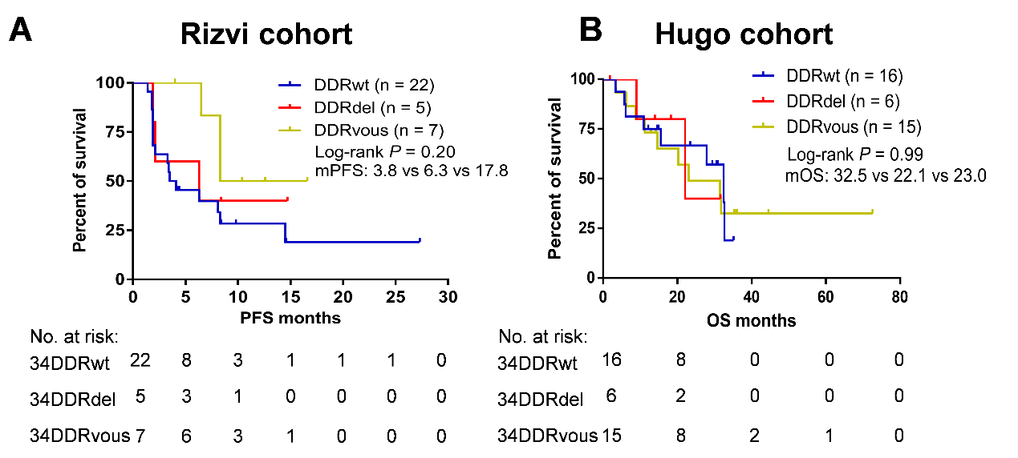
Figure S8. Associations between 34 DDR genes mutations and clinical prognosis of PD-1 blockade treatment. A, Kaplan-Meier survival curves of PFS comparing DDR genes mutations with wild-type groups from Rizvi cohort. B, Kaplan-Meier survival curves of OS comparing DDR genes mutations with wild-type groups from Hugo cohort. Thirty-four gene list was cited from Teo MY et al. J Clin Oncol, 2018. DDRwt, no any mutation in 34 DDR genes. DDRdel, at least one gene with known or likely deleterious DDR mutations including nonsense mutations, and frameshift or splice site alterations. For missense mutations, deleterious status was determined by manual review for their documentation in the Catalogue of Somatic Mutations in Cancer algorithmically determined recurrent hot spot mutations and annotation of oncogenicity by related publications. DDRvous, at least one gene with unknown deleterious DDR mutations.

