Supplementary Figures

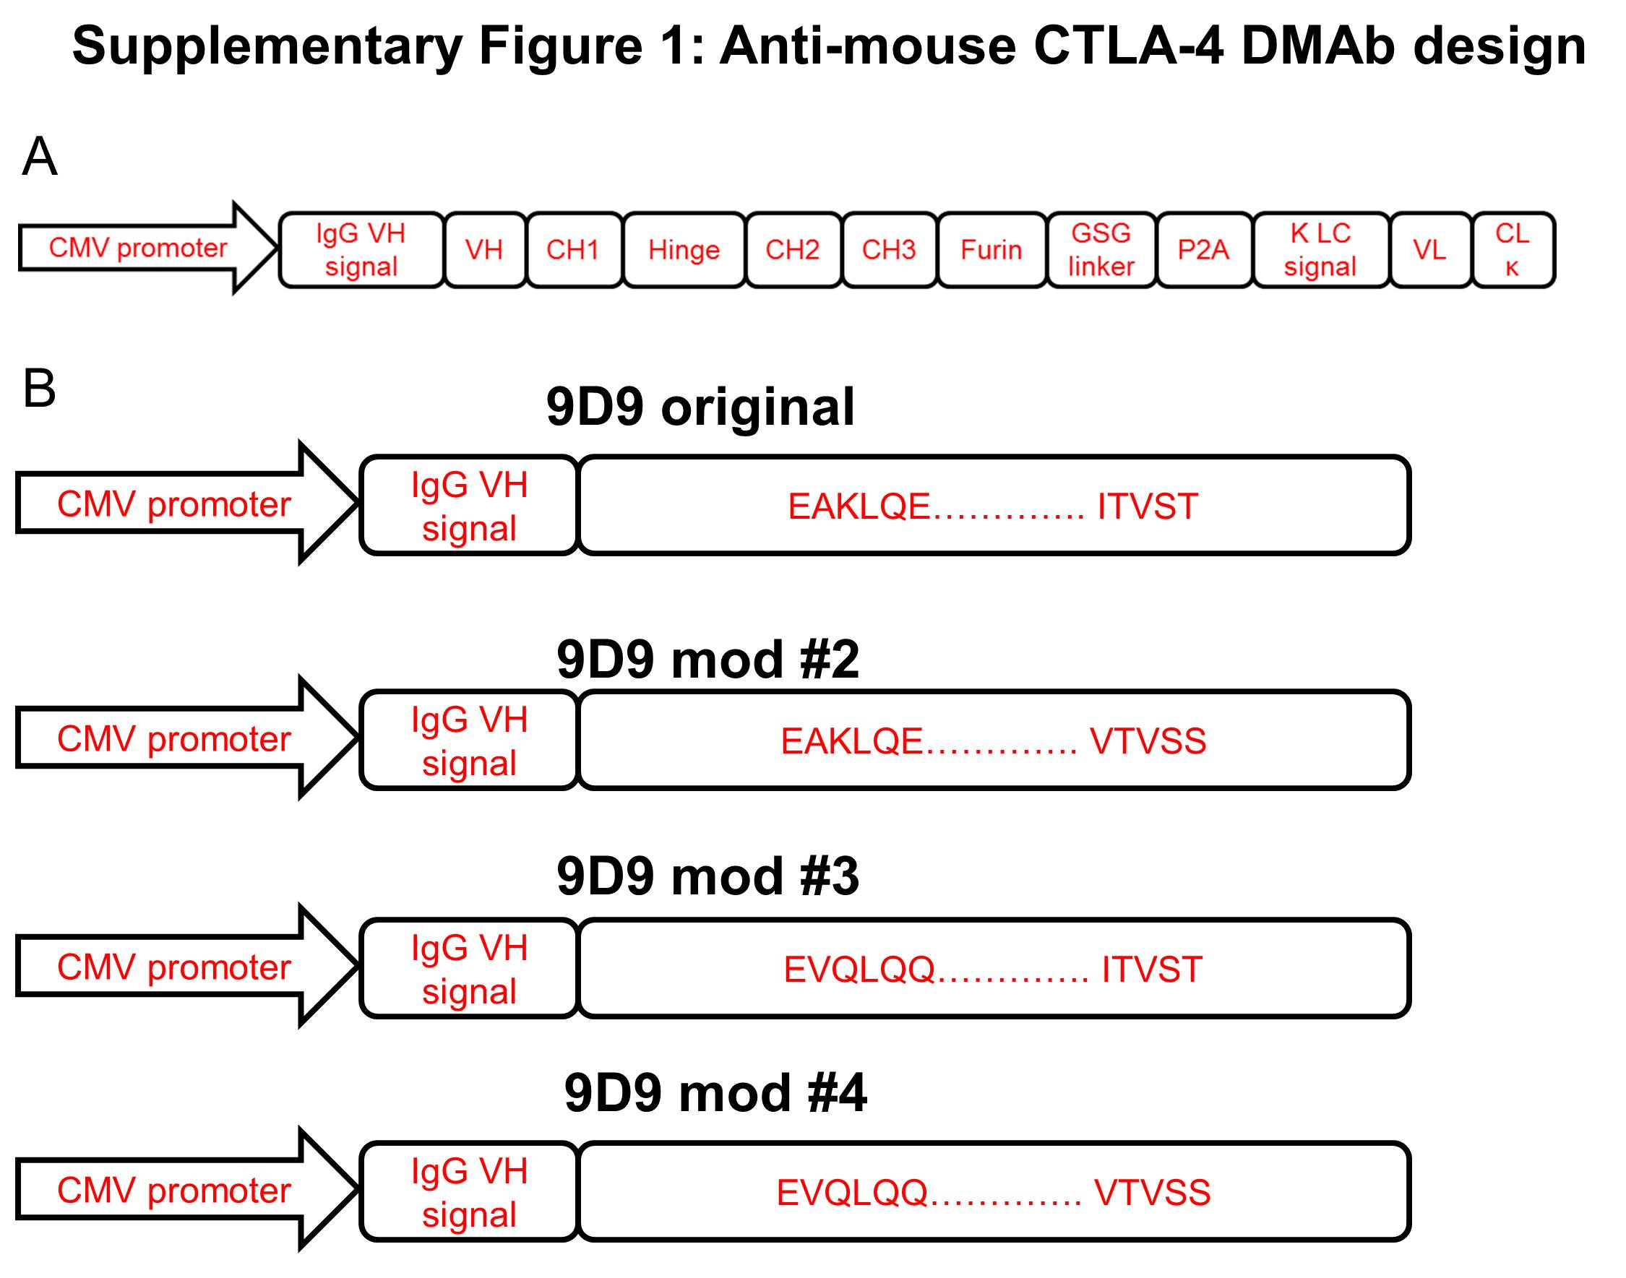
Supplementary Figure 1. Anti-mouse CTLA-4 DMAb design. A) Illustration of DMAb construct design. B) Modifications that were made to the heavy chain framework regions.

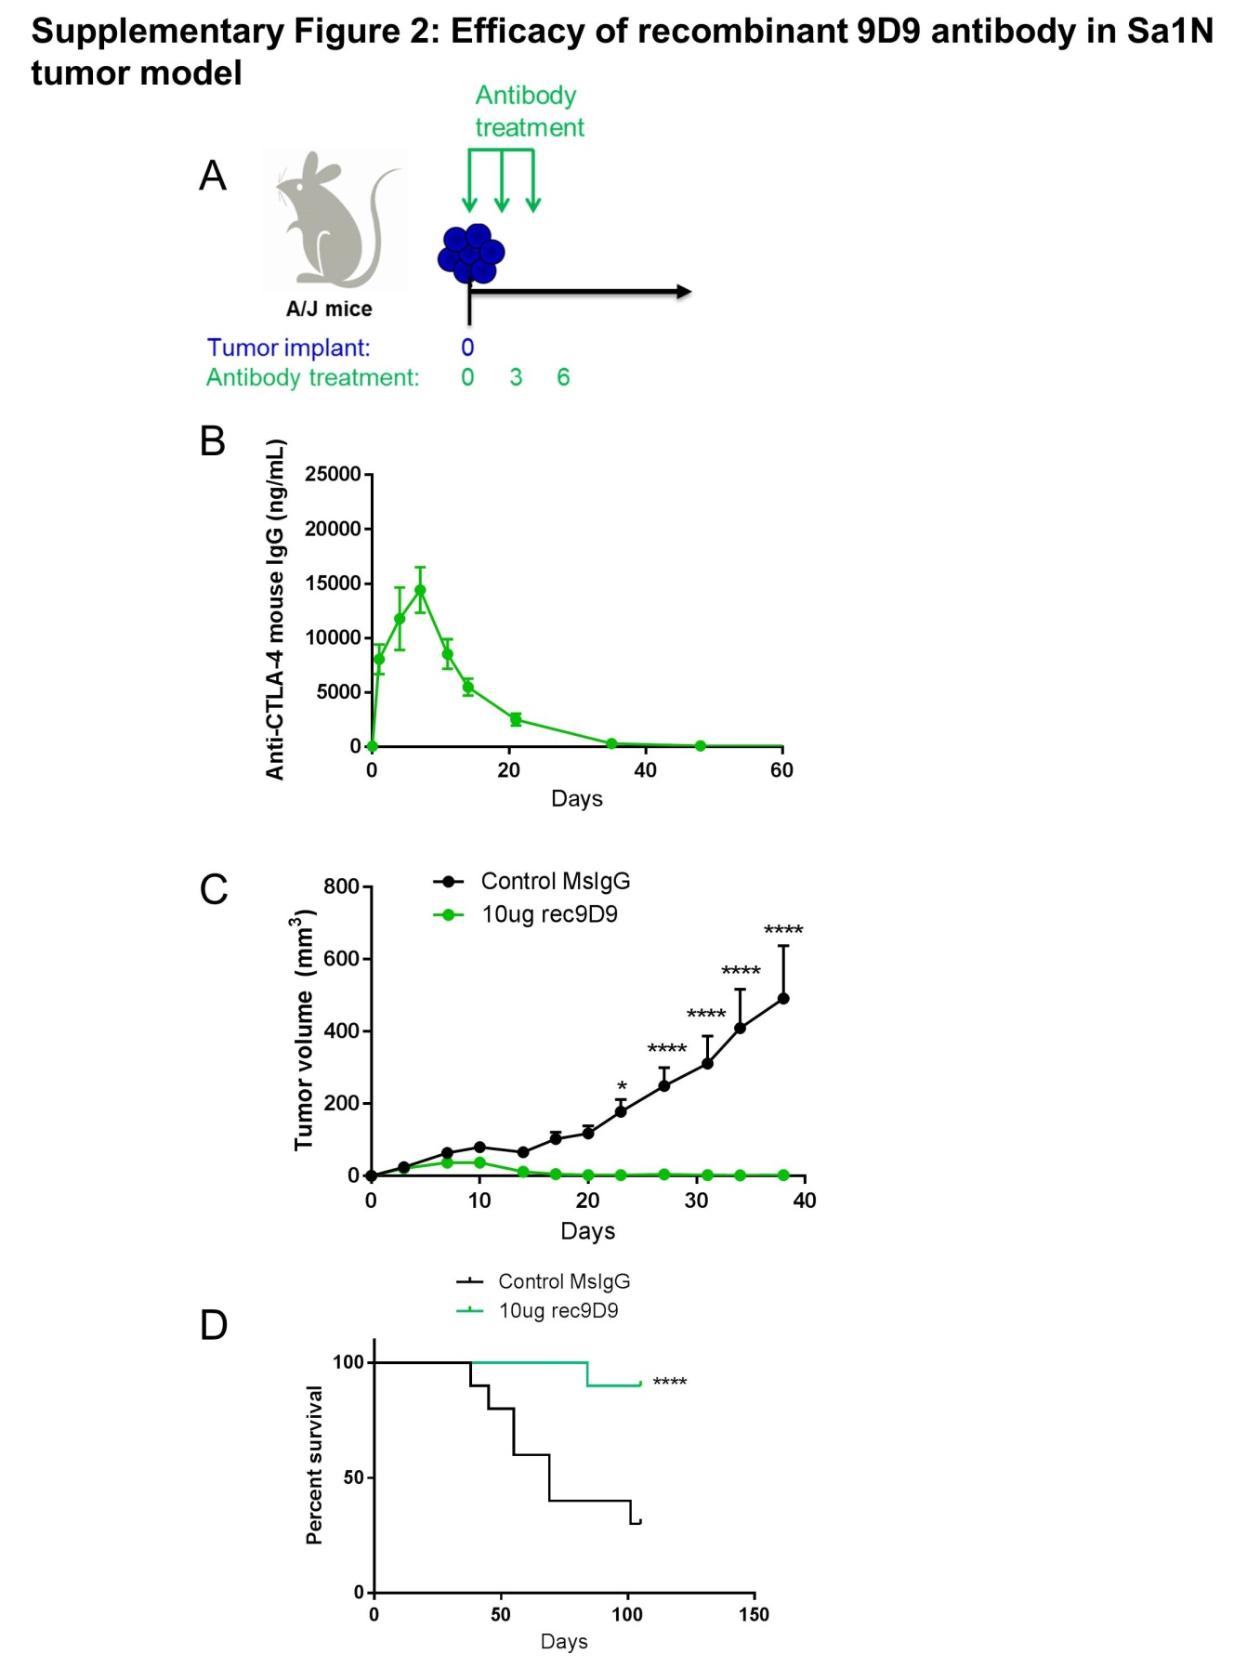
Supplementary Figure 2. Efficacy of recombinant 9D9 antibody in Sa1N tumor model. A) Tumor study outline for antibody delivery. Mice were administered monoclonal antibodies (either control mouse IgG or 10µg of recombinant 9D9) at days 0, 3 and 6. Tumors were implanted on day 0, at the start of antibody treatment. B) Serum levels of anti-CTLA-4 mouse IgG from the mice receiving recombinant 9D9 described in A. C) Tumor volume measurements for the mice described in A. D) Survival analysis for the mice described in A. For C and D, mice were euthanized when tumors reached 1.5cm in diameter. All mice still alive at the end of study cleared their tumors completely. Significance for tumor volume measurements over time was determined by multiple t-tests for each time point. Significance for mouse survival was determined by the Gehan-Breslow-Wilcoxon test. *p<0.05, **p<0.01, ***p<0.001, ****p<0.0001. Error bars indicate mean ±SEM. N=10 mice per group.
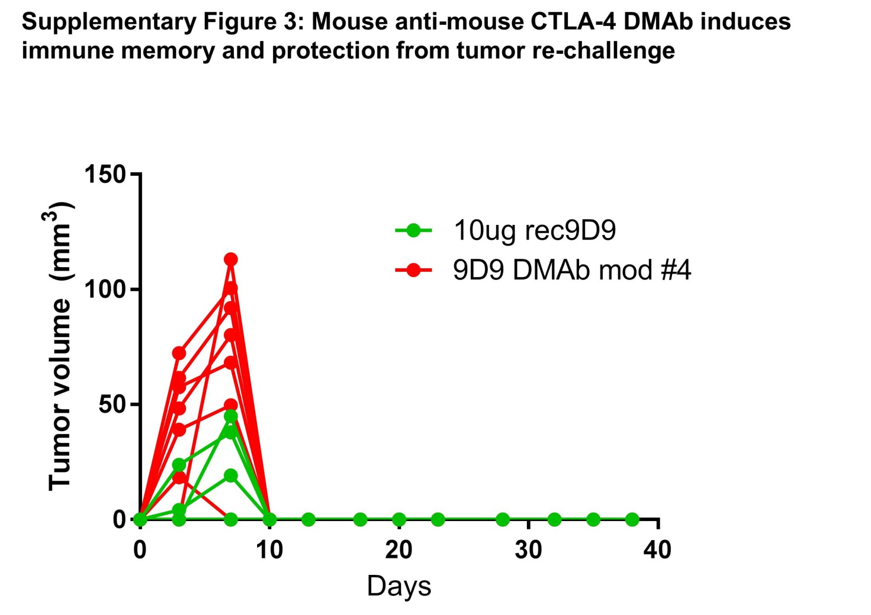

Supplementary Figure 3. Mouse anti-mouse CTLA-4 DMAb induces immune memory and protection from tumor re-challenge. Mice that survived the initial tumor challenge in Figure 2, from the 9D9 DMAb mod #4 treated group (8 mice) or the recombinant 9D9 treated group (9 mice) were re-challenged 6 months after the initial tumor challenge with 10 million Sa1N tumor cells per mouse. Shown are the individual tumor volume measurements from these mice over time.

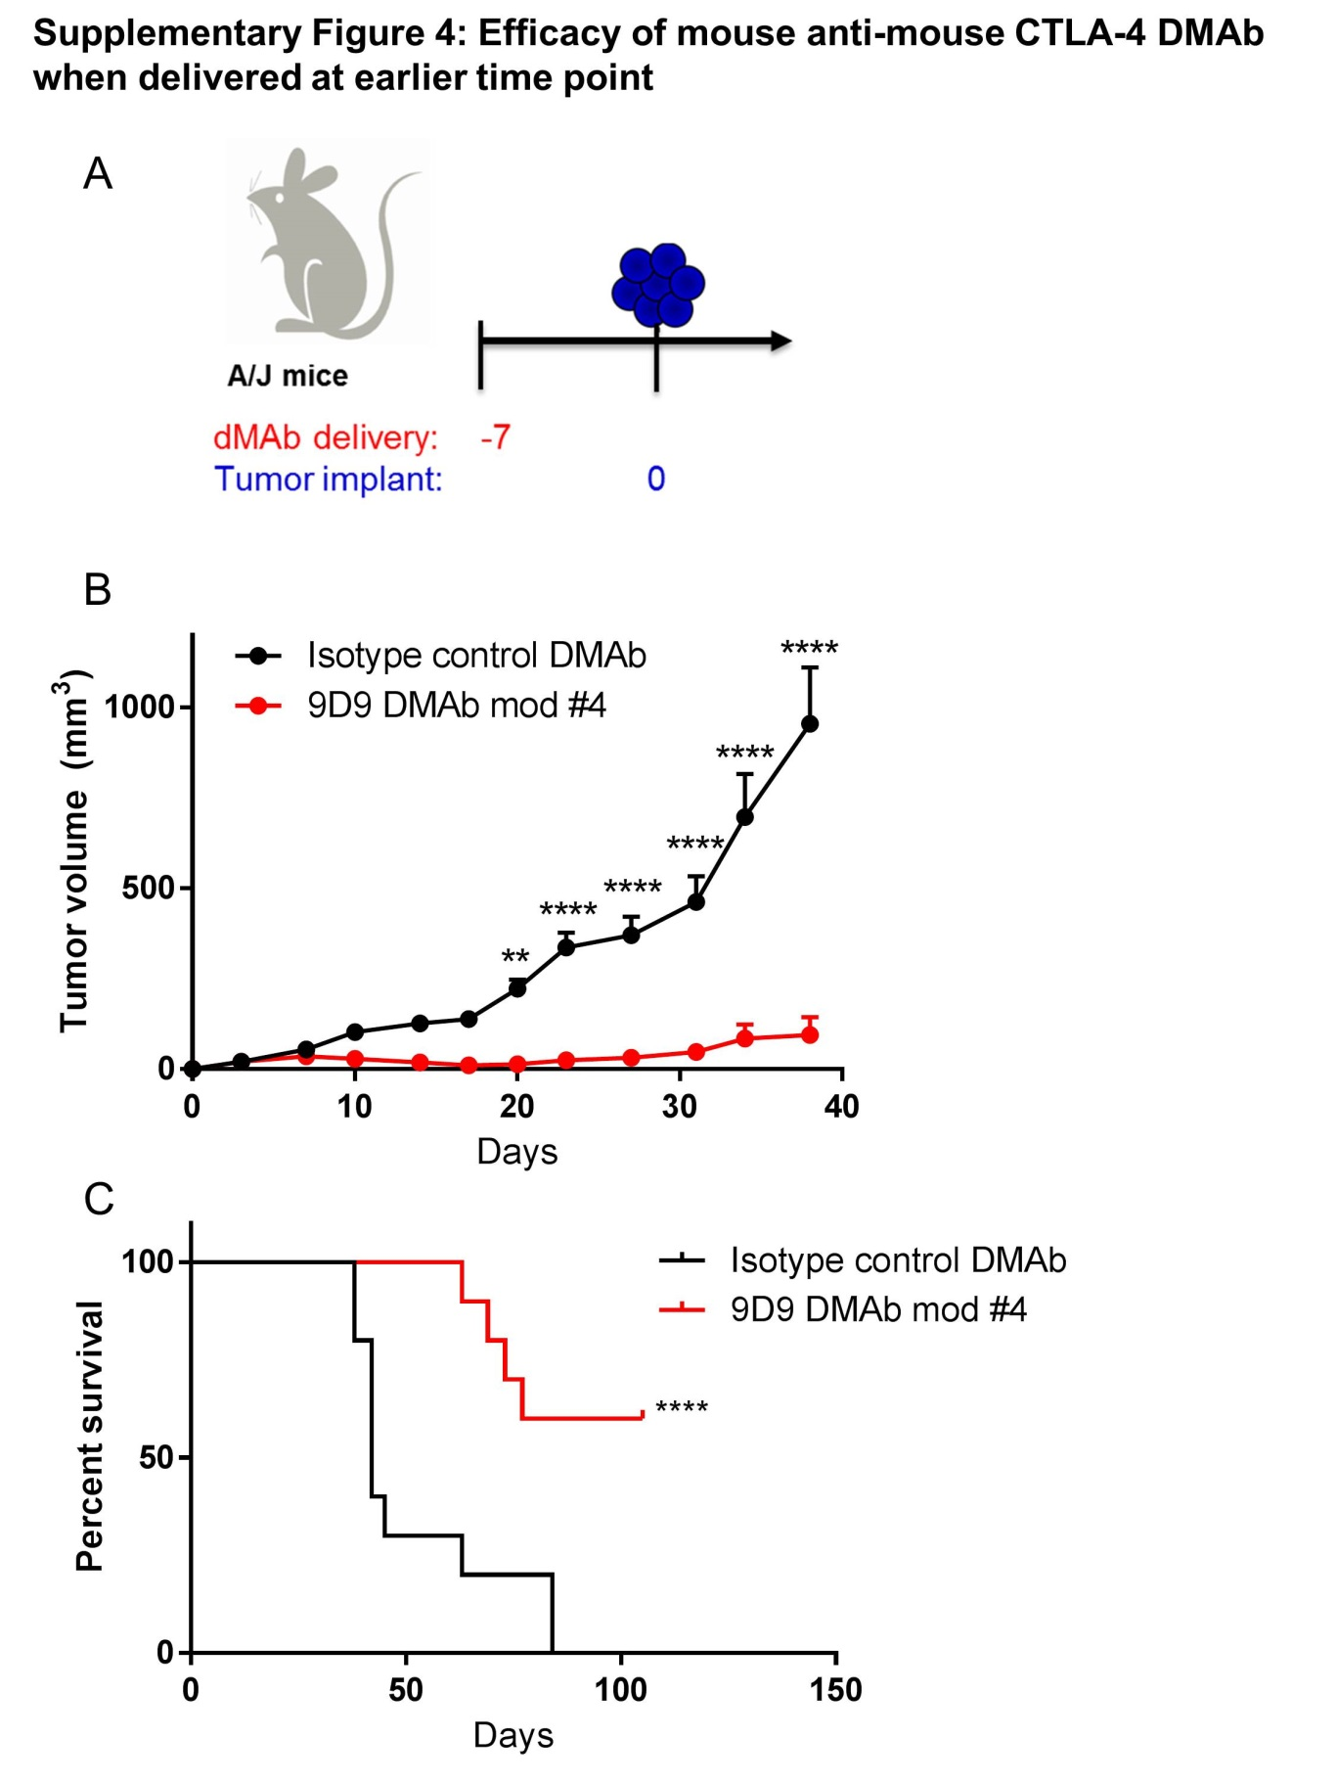
Supplementary Figure 4. Efficacy of mouse anti-mouse CTLA-4 DMAb when delivered at earlier time point. A) Tumor study outline for DMAb delivery. 400µg DMAb (either isotype control DMAb or 9D9 DMAb mod #4) was delivered by IM-EP to A/J mice 7 days prior to implantation of Sa1N tumor cells. B) Tumor volume measurements for the mice described in A. C) Survival analysis for the mice described in A. Mice were euthanized when tumors reached 1.5cm in diameter. All mice still alive at the end of the study cleared their tumors completely. Significance for tumor volume measurements over time was determined by multiple t-tests for each time point. Significance for mouse survival was determined by the Gehan-Breslow-Wilcoxon test. *p<0.05, **p<0.01, ***p<0.001, ****p<0.0001. Error bars indicate mean ±SEM. N=10 mice per group.

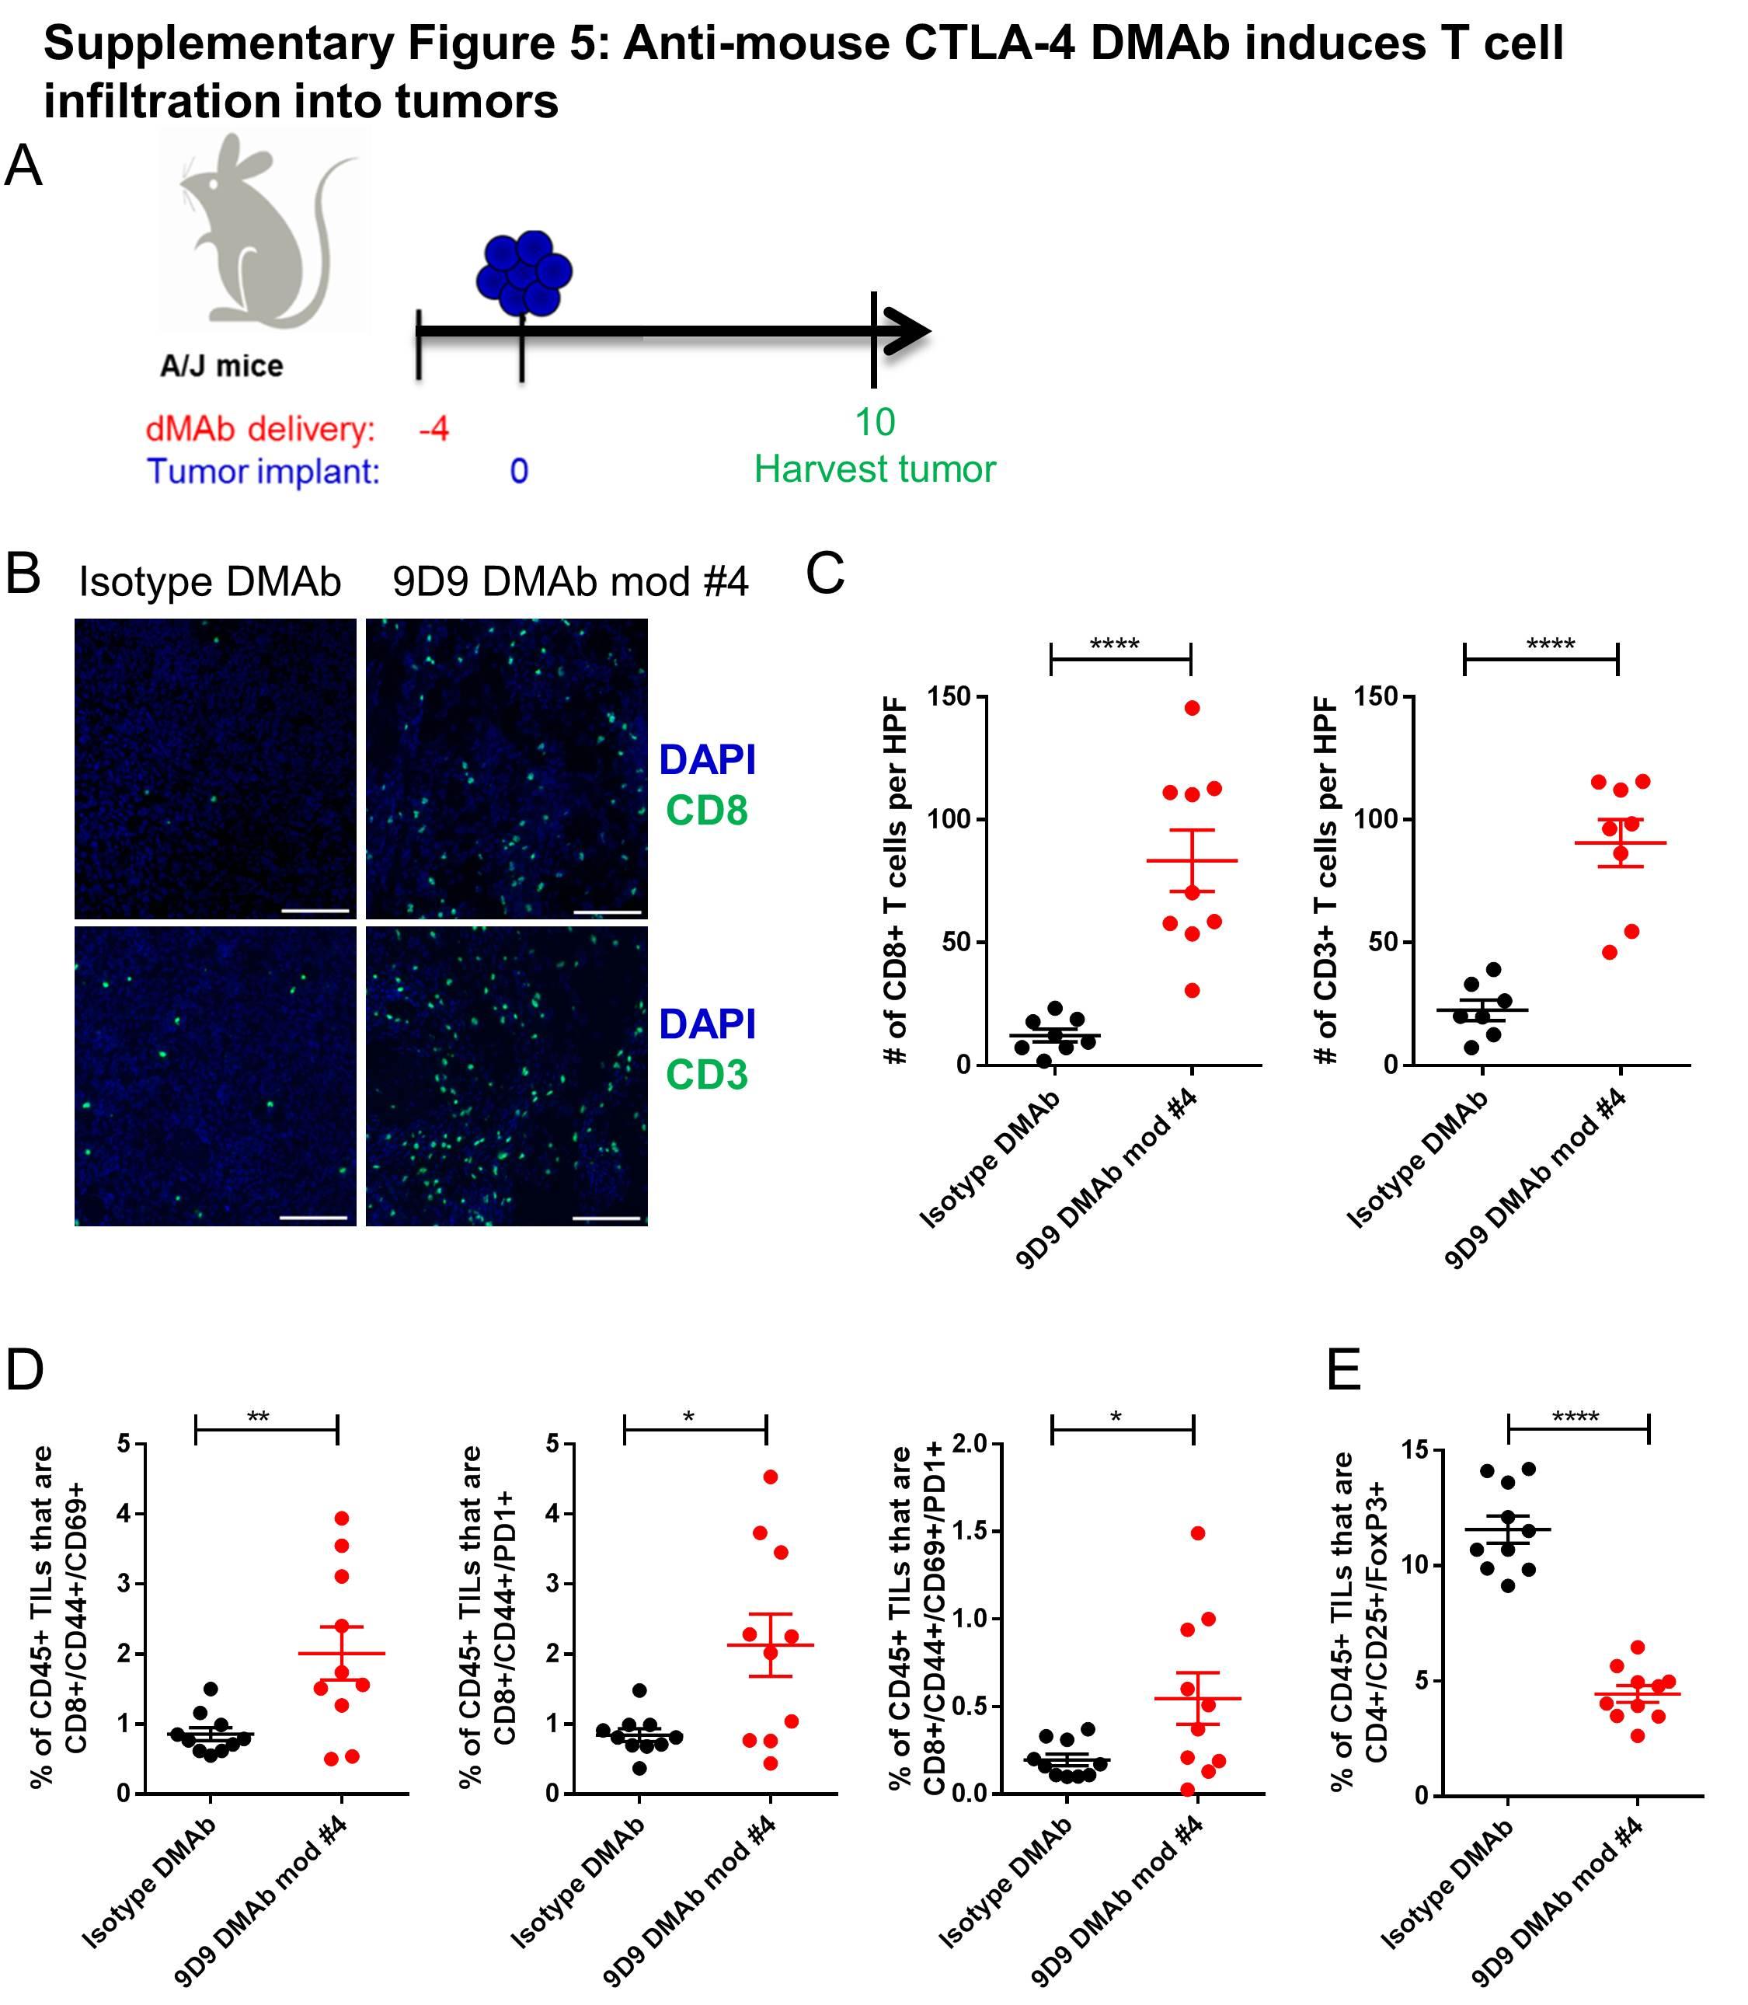

Supplementary Figure 5. Anti-CTLA-4 DMAb induces T cell infiltration into tumors. A) Tumor study outline for DMAb delivery. 400µg DMAb (either isotype control DMAb or 9D9 DMAb mod #4) was delivered by IM-EP to A/J mice 4 days prior to implantation of Sa1N tumor cells. Mice were euthanized at day 10 after tumor implant, prior to tumor clearance. B) Representative images of immunofluorescence staining of Sa1N tumors for CD8+ T cells, CD3+ T cells, or nuclei (DAPI). C) Quantification of images in B, in terms of CD8+ T cells per high powered field (HPF), or CD3+ T cells per HPF. D) Surface staining of tumor infiltrating lymphocytes (TILs) for CD45, CD8, CD44, CD69, and/or PD1, analyzed by flow cytometry. E) Surface and intracellular staining of TILs for CD45, CD4, CD25 and FoxP3, analyzed by flow cytometry. Significance was determined by a two-tailed student’s t-test. *p<0.05, **p<0.01, ***p<0.001, ****p<0.0001. Error bars indicate ± SEM. Scale bar= 50µm. N=8-10 mice per group.
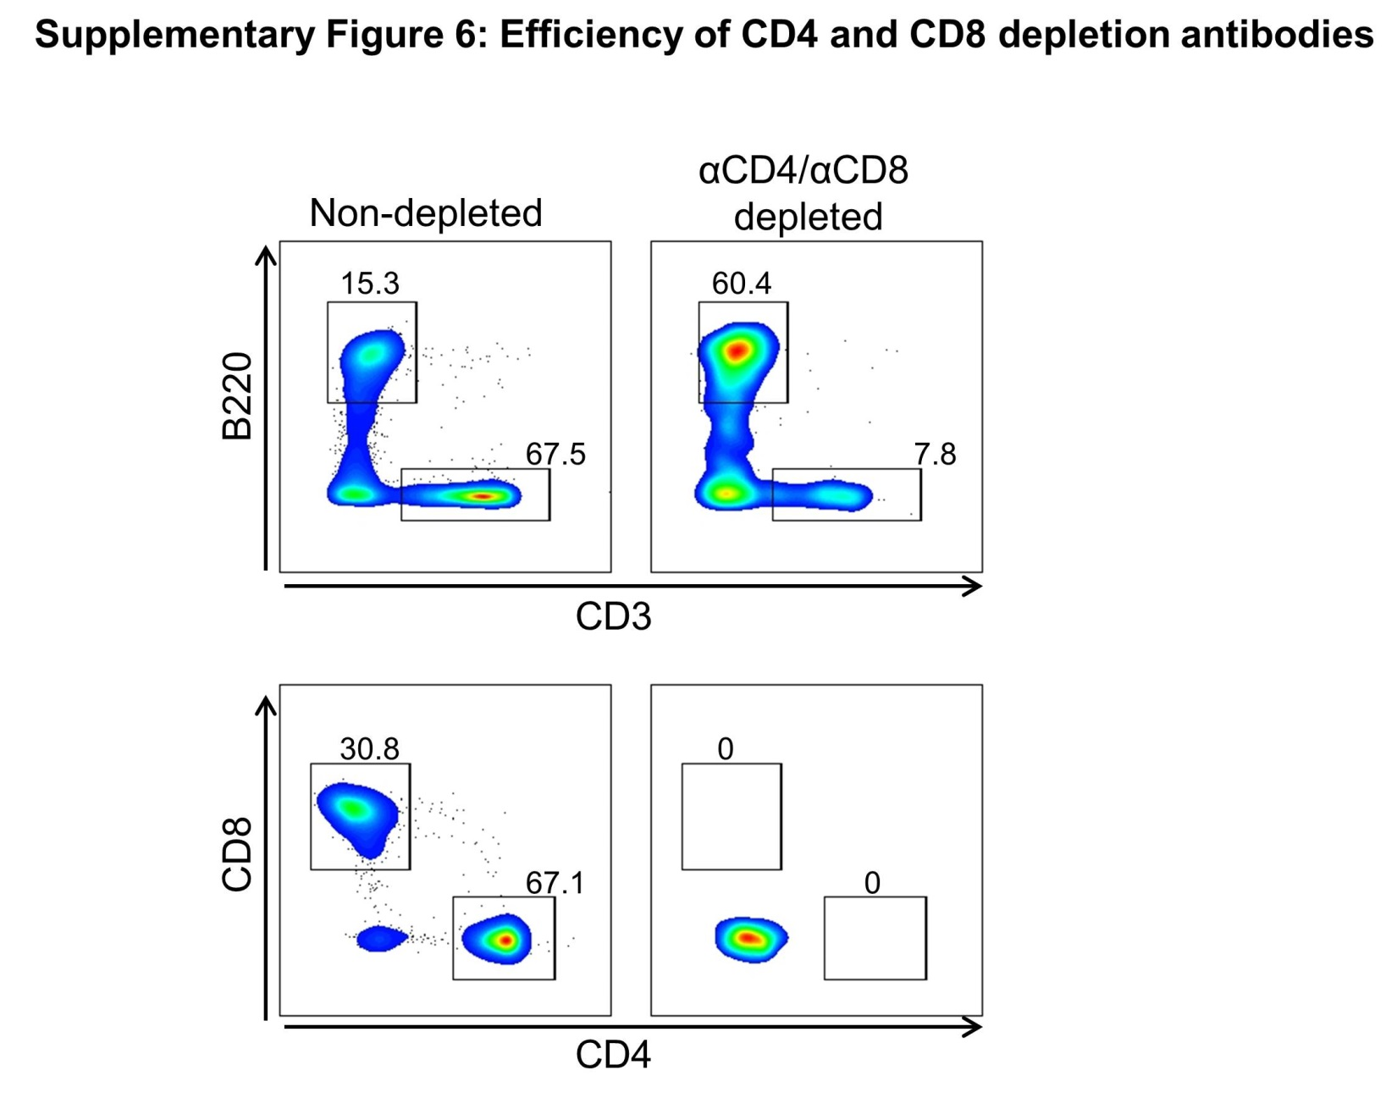

Supplementary Figure 6. Efficiency of CD4 and CD8 depletion antibodies. The efficiency of CD4 and CD8 depletion in peripheral blood was measured by surface staining of PBMCs isolated from mice 2 days after antibody delivery (200µg intraperitoneal injection of clone GK1.5 and clone YTS 169.4 from BioXCell). Mouse PBMCs were stained for B220, CD3, CD8 and CD4. Shown is a representative flow plot from mice that did not receive depletion antibodies, compared to mice that received CD4 and CD8 depletion antibodies. Shown is a representative of 5 individual mice per group.

