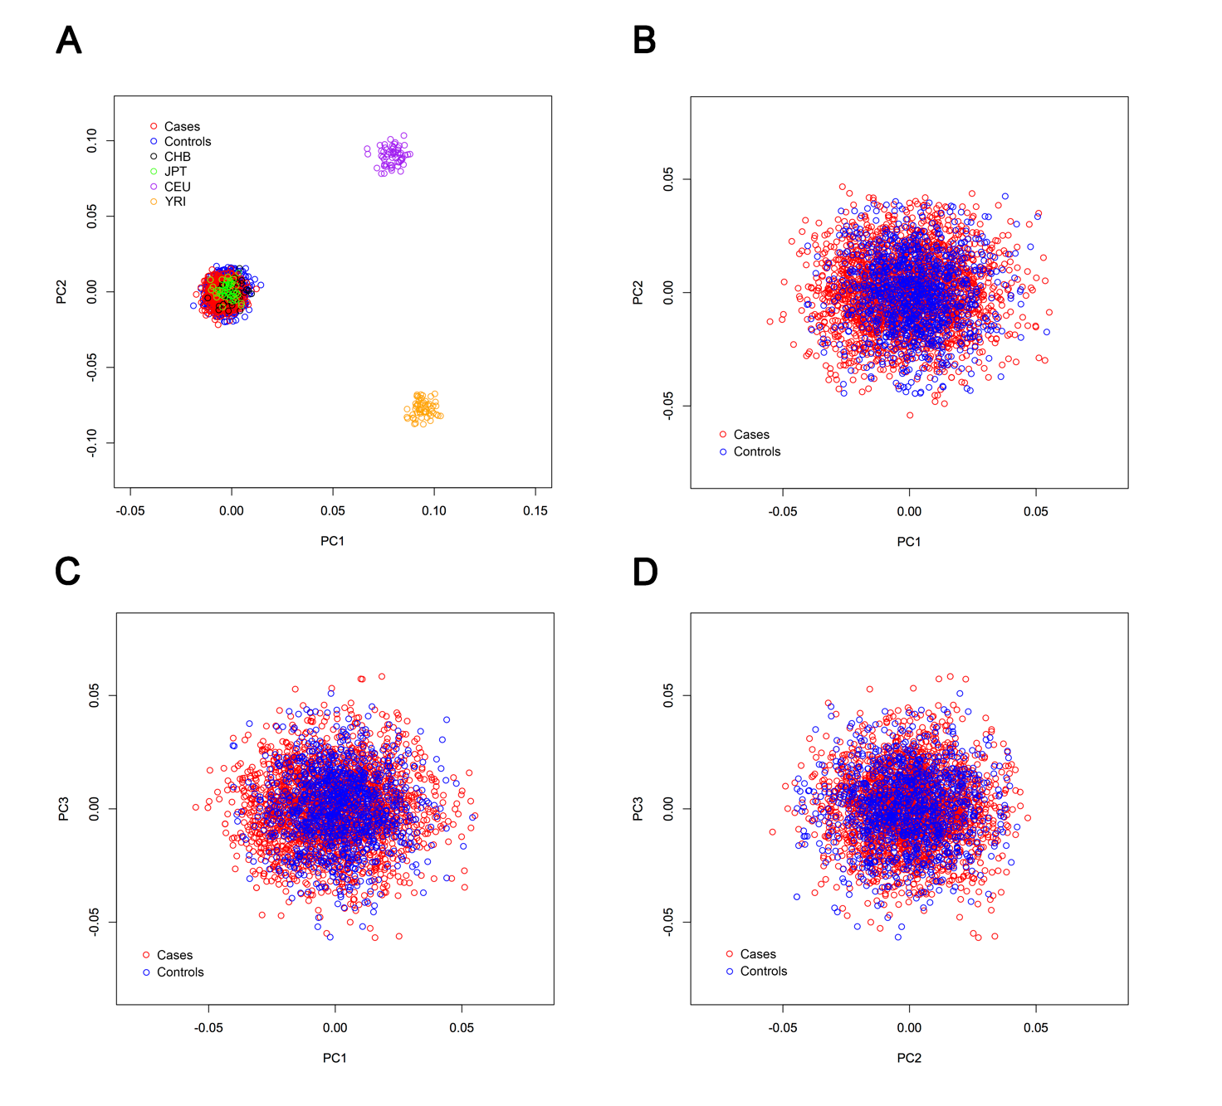
Supplementary Figure 1. Plots for genetic matching of three principal components (PCs) derived from the PC analysis of 1,066 cases with CRC and 2,203 controls. (A) Plots of the first two PCs from the CRC of all samples and 270 HapMap individuals were shown with different colors, (B) PC1 versus PC2 for cases and controls, (C) PC1 versus PC3 for cases and controls and (D) PC2 versus PC3 for cases and controls.

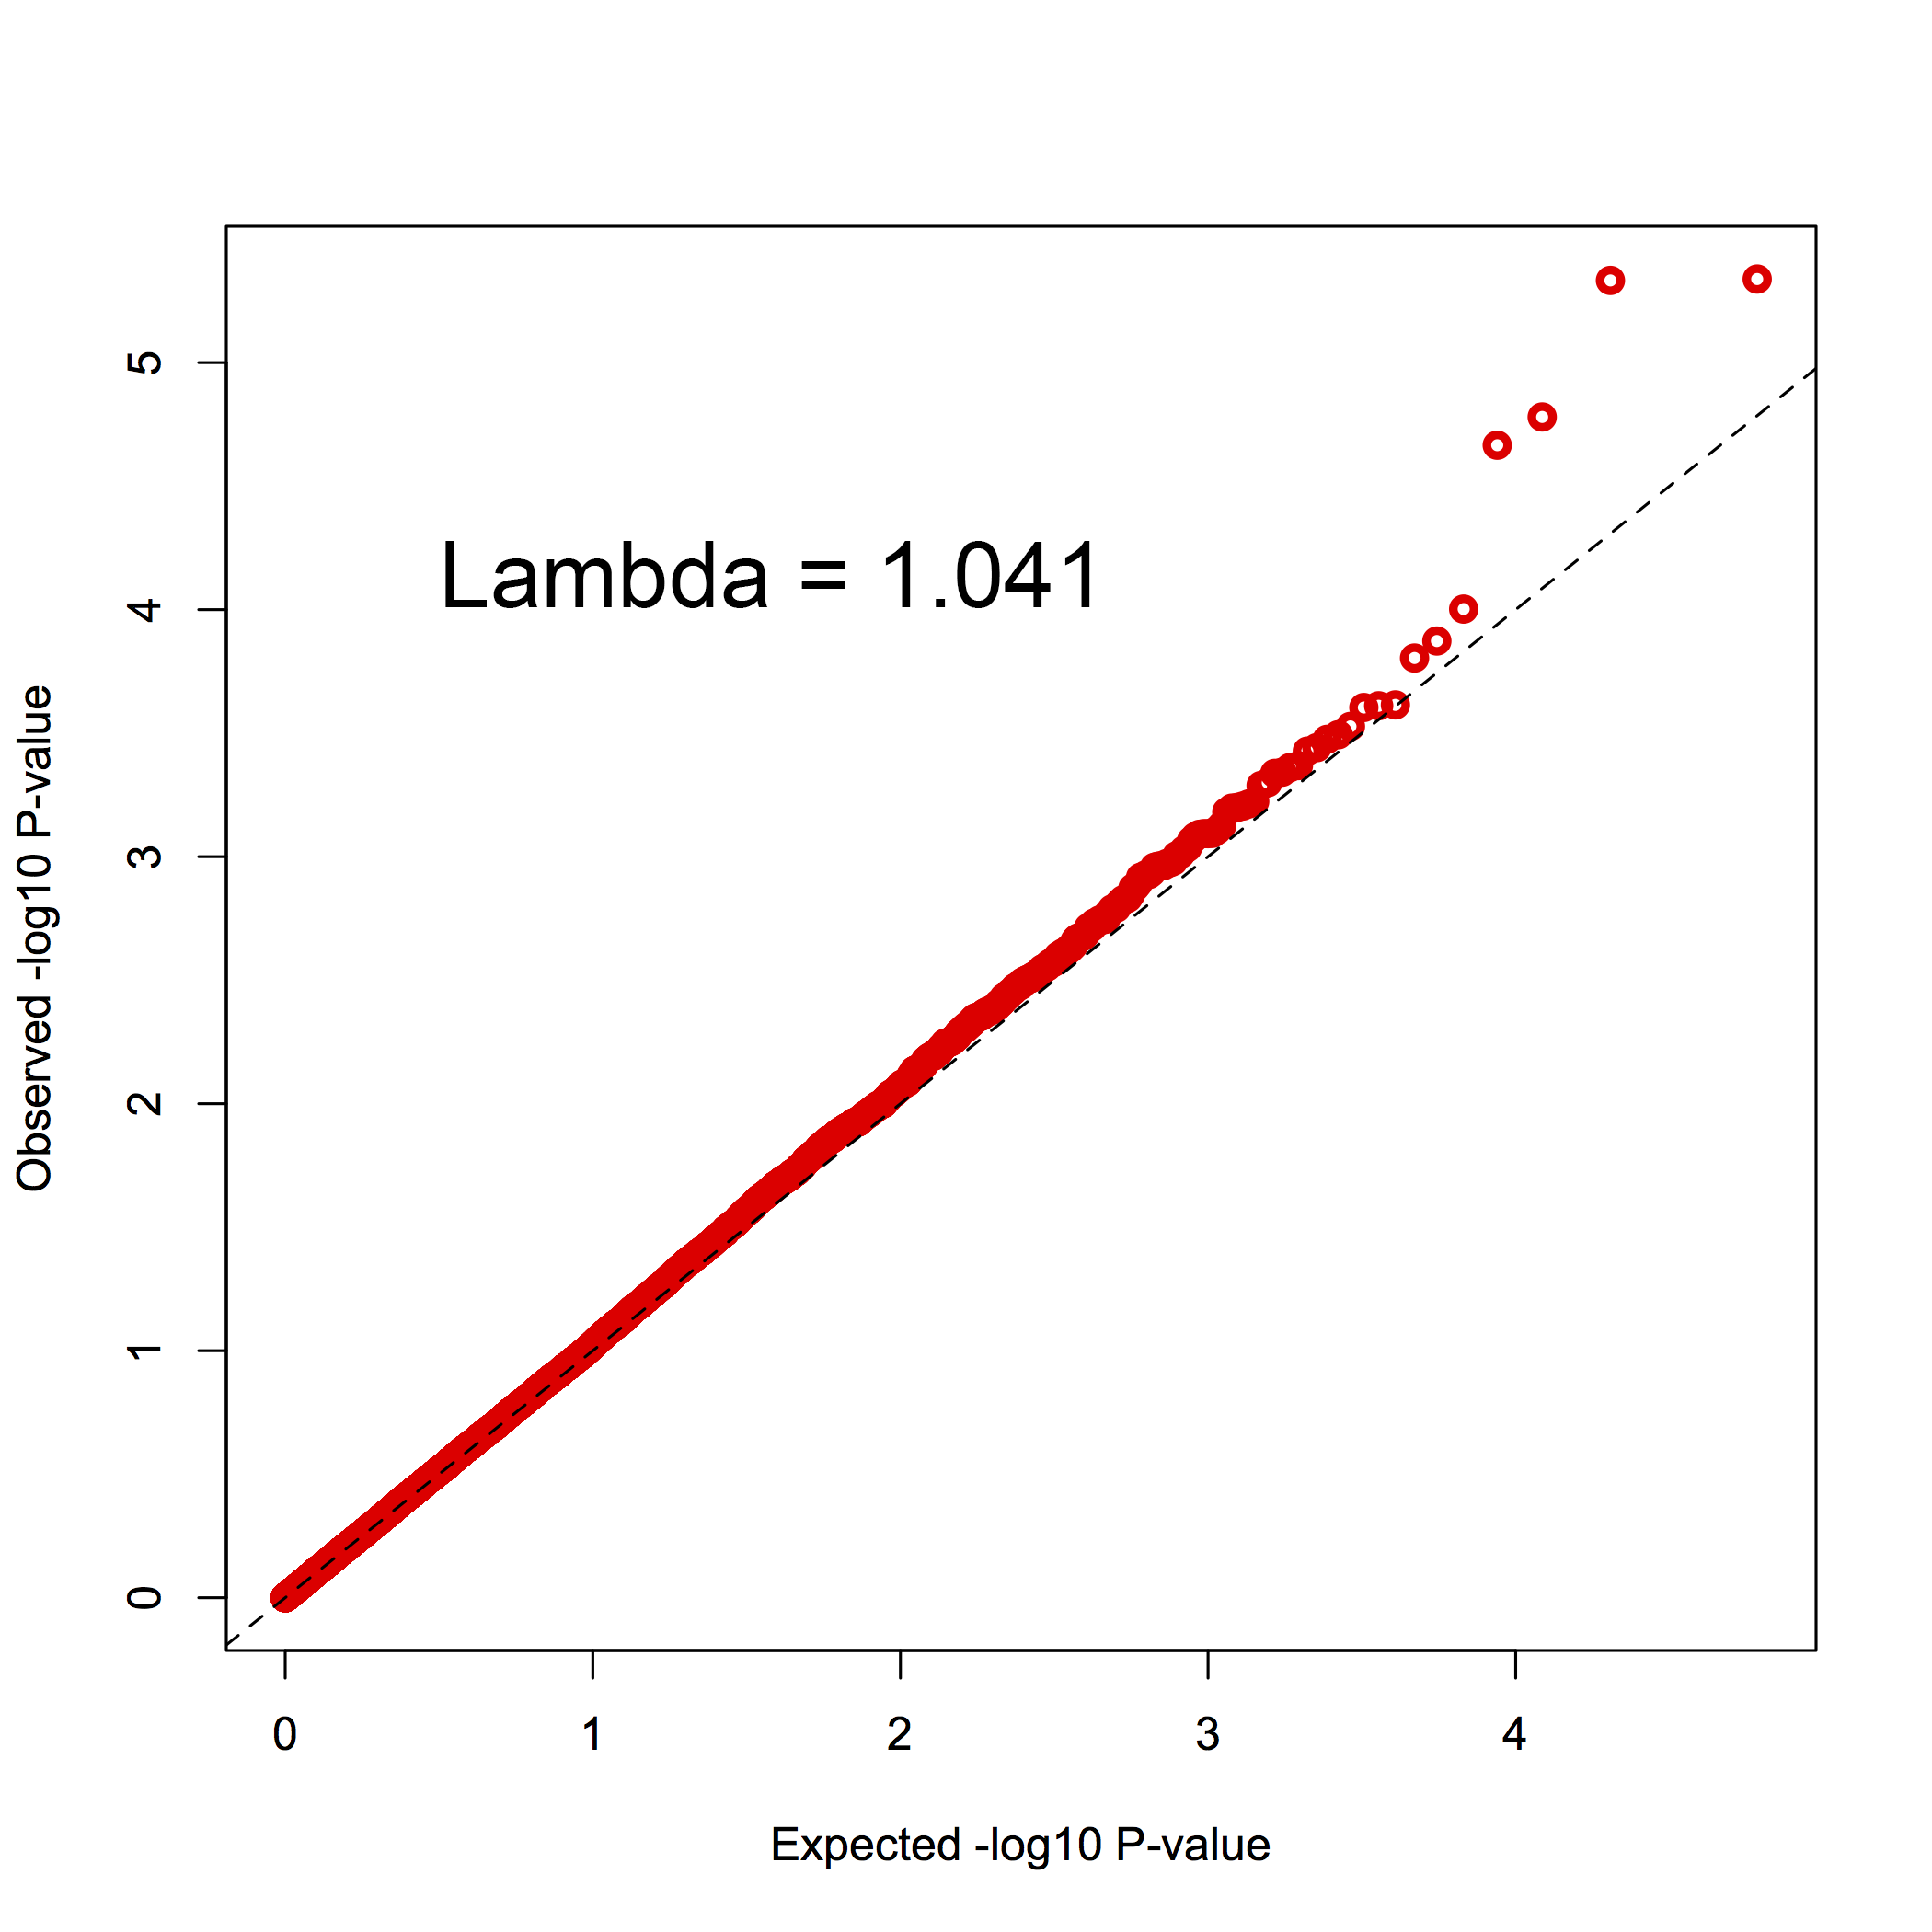
Supplementary Figure 2. Quantile-quantile plot and genomic inflation factor lambda for associations. The red circles represent the distribution of P values for the association of variants in 1,062 cases with colorectal cancer and 2,184 controls with adjustment of sex, age and the top 3 principal components.
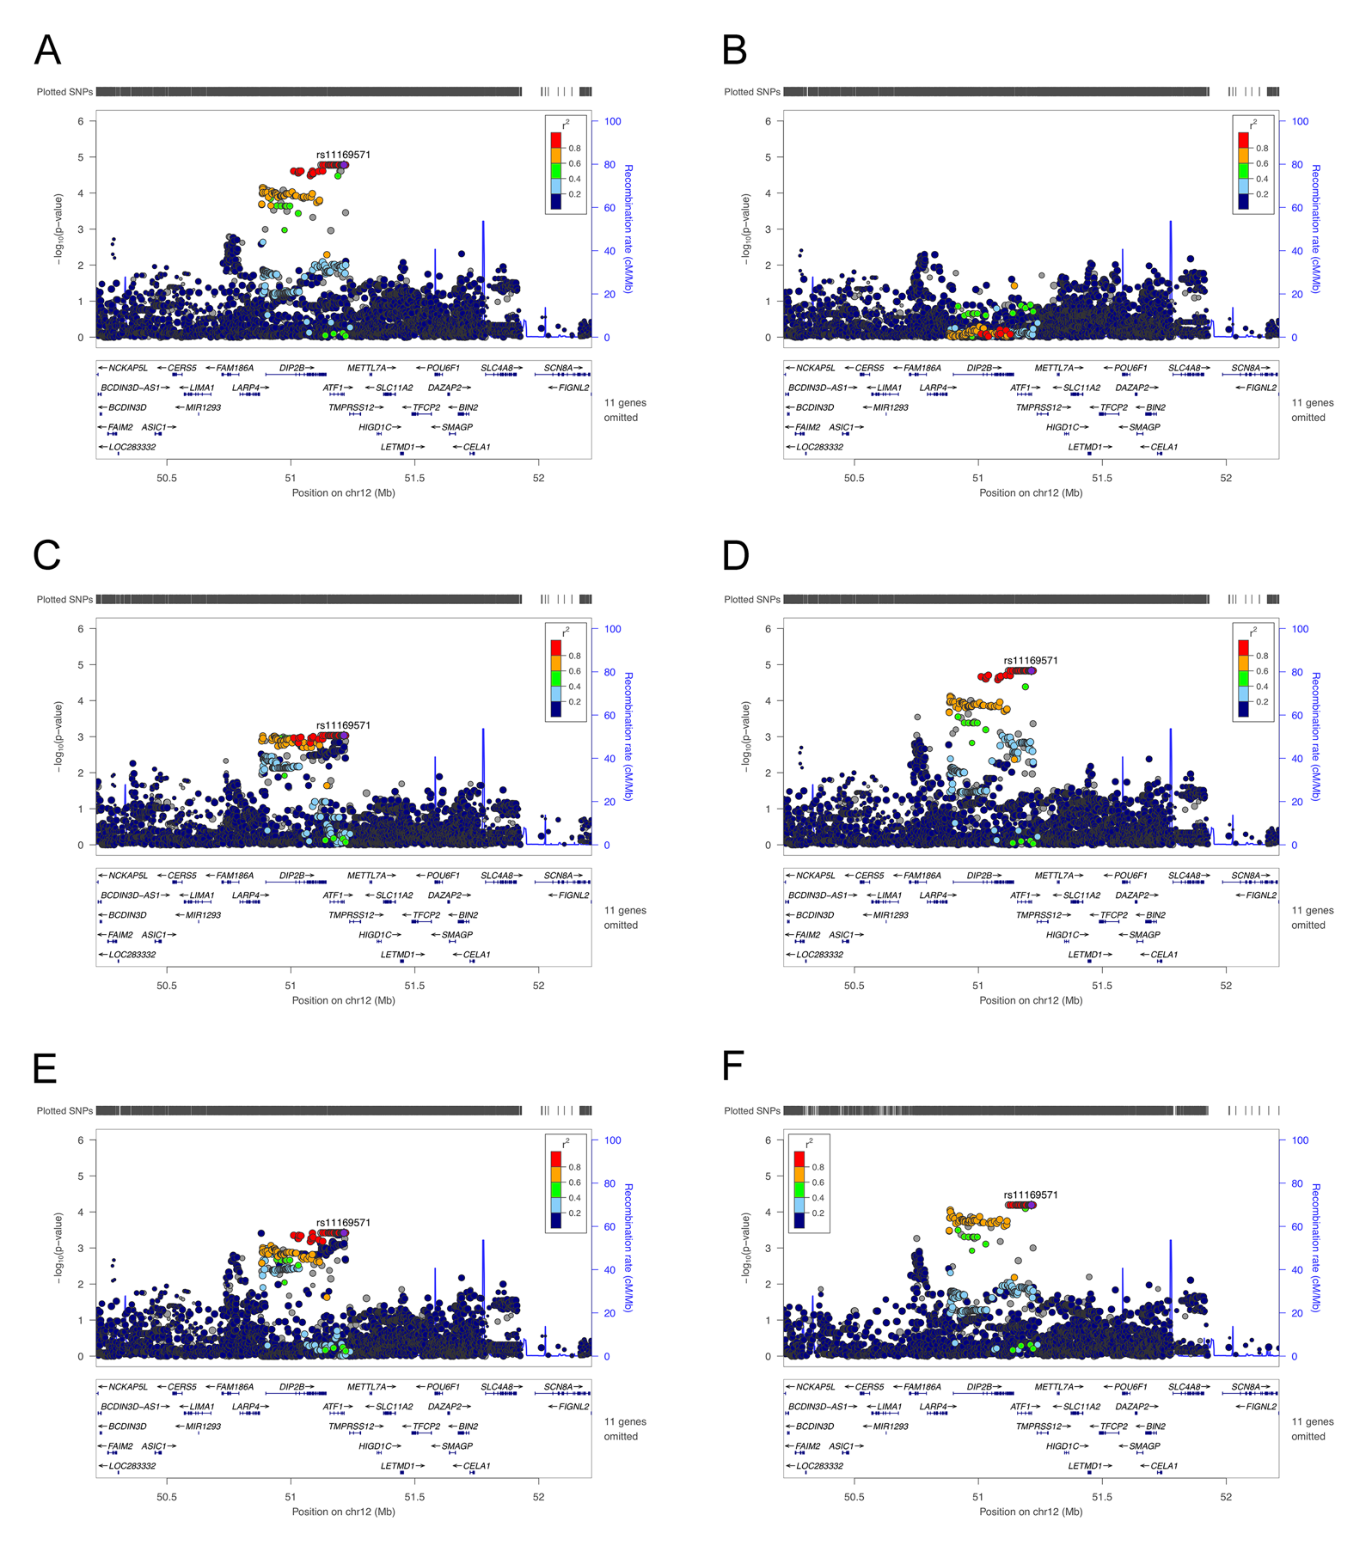
Supplementary Figure 3. The rs11169571 signal was the only one in the Chinses population. The logistic regressions were performed without conditioning any variant (A) and conditioning on the rs11169571 (B), rs4768903 (C), rs7136702 (D), rs11169552 (E) or rs34245511 (F). The −log10 P values (y axis) of the SNPs are presented according to their chromosomal positions (x axis). The genetic recombination rates (cM/Mb) estimated using the 1000 Genomes June 2014 ASN samples are shown with a blue line; we annotated the genes within the interested region and these genes are shown as arrows. The top genotyped SNP is labeled by rs ID and the r² values of the rest of the SNPs with the top genotyped SNP are indicated by different colors.
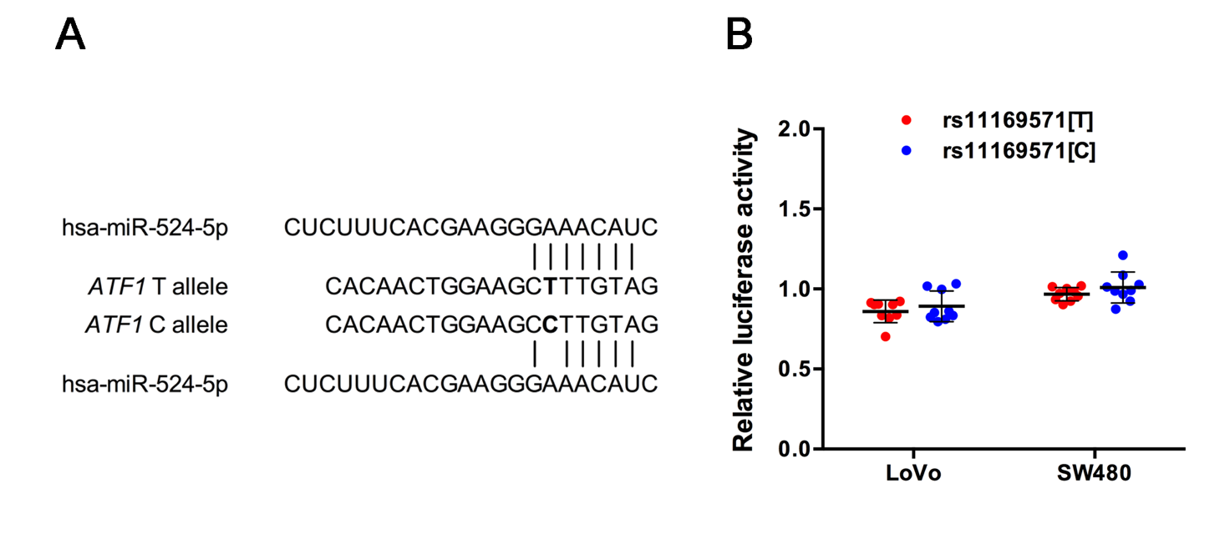
Supplementary Figure 4. Luciferase reporter assays to measure T or C allele difference at rs11169571 with the presence of hsa-miR-524-5p in LoVo and SW480 cells. (A) Predicted effect of allelic variation at rs11169571 on hsa-miR-524-5p recognition and the construct containing full-length 3’-UTR of ATF1 gene with different alleles of rs11169571. SNP rs11169571 occurs in the 8-bp seed sequence of complementarity at hsa-miR-524-5p 5’ end. Base pairing is indicated by a solid (Watson–Crick) vertical line. (B) Cells were transiently cotransfected with constructs and 80 nmol/L hsa-miR-524-5p mimic or negative control (NC). Results are shown as relative luciferase activity versus NC. Data are from 3 independent transfection experiments with assays conducted in 3 replications.

Supplementary Table 1. Summary of characteristics of study subjects participated in this study
 | Discovery stage |  |  | Replication stage I |  |  | Replication stage II |  |  | Combined
 | Cases  (N = 1,062) | Controls  (N = 2,184) |  | Cases  (N = 2,478) | Controls  (N = 3,880) |  | Cases  (N = 3,761) | Controls  (N = 4,058) |  | Cases  (N = 7,301) | Controls  (N = 10,122)
Age (years), mean±S.D. | 60.52±12.83 | 63.37±9.72 |  | 58.31±12.05 | 63.66±10.24 |  | 57.72±11.85 | 58.10±12.22 |  | 58.33±12.10 | 61.37±11.30
Gender, n (%)
Male | 711 (66.9) | 1,448 (66.3) |  | 1,537 (62.0) | 2,439 (62.9) |  | 2,269 (60.3) | 2,522 (62.1) |  | 4,517 (61.9) | 6,409 (63.3)
Female | 351(33.1) | 736 (33.7) |  | 941 (38.0) | 1,441 (37.1) |  | 1,492 (39.7) | 1,536 (37.9) |  | 2,784 (38.1) | 3,713 (36.7)

Supplementary Table 2. The results of variants that were found to be potentially associated with risk of CRC at the

discovery stage and were selected for further replication
Chr | SNP | Gene | Location | Effect Allele | MAF |  | OR (95% CI)† | P† | OR (95% CI)‡ | P‡
 |  |  |  |  | Cases | Controls
12 | rs671 | ALDH2 | Missense | A | 0.250 | 0.193 | 1.37 (1.21-1.55) | 5.14×10⁻⁷ | 1.34 (1.18-1.52) | 4.59×10⁻⁶
12 | rs3782886 | BRAP | Synonymous | G | 0.254 | 0.196 | 1.37 (1.21-1.55) | 5.25×10⁻⁷ | 1.34 (1.18-1.51) | 4.65×10⁻⁶
12 | rs11169571 | ATF1 | 3'-UTR | G | 0.349 | 0.297 | 1.27 (1.13-1.42) | 3.91×10⁻⁵ | 1.28 (1.15-1.44) | 1.66×10⁻⁵
12 | rs1129406 | ATF1 | Synonymous | A | 0.349 | 0.297 | 1.27 (1.13-1.42) | 3.91×10⁻⁵ | 1.28 (1.15-1.44) | 1.66×10⁻⁵
10 | rs138649767 | TCF7L2 | Missense | A | 0.022 | 0.009 | 2.35 (1.53-3.60) | 9.95×10⁻⁵ | 2.44 (1.59-3.76) | 4.90×10⁻⁵
6 | rs2395269 | TAP1 | Intron | C | 0.274 | 0.214 | 1.26 (1.12-1.43) | 1.63×10⁻⁴ | 1.27 (1.12-1.43) | 1.34×10⁻⁴
17 | rs2304977 | KIAA0753 | Missense | A | 0.356 | 0.309 | 1.24 (1.11-1.38) | 1.66×10⁻⁴ | 1.24 (1.11-1.38) | 1.57×10⁻⁴
3 | rs145045076 | CNTN6 | Missense | G | 0.036 | 0.019 | 1.84 (1.33-2.54) | 2.03×10⁻⁴ | 1.83 (1.32-2.52) | 2.43×10⁻⁴
6 | rs406113 | GPX6 | Missense | A | 0.439 | 0.488 | 0.82 (0.74-0.91) | 1.68×10⁻⁴ | 0.82 (0.74-0.91) | 2.45×10⁻⁴
2 | rs1377656 | LOC105376755 | Intron | A | 0.416 | 0.366 | 1.22 (1.10-1.36) | 2.13×10⁻⁴ | 1.22 (1.10-1.35) | 2.49×10⁻⁴
6 | rs2270190 | C6orf15 | Upstream | G | 0.109 | 0.083 | 1.36 (1.14-1.62) | 5.00×10⁻⁴ | 1.38 (1.16-1.65) | 2.97×10⁻⁴
8 | rs13257322 | LOC102724623 | Intron | A | 0.452 | 0.500 | 0.82 (0.74-0.91) | 2.76×10⁻⁴ | 0.82 (0.74-0.92) | 3.21×10⁻⁴
1 | rs2840532 | RER1 | Intron | A | 0.414 | 0.462 | 0.83 (0.75-0.92) | 5.42×10⁻⁴ | 0.82 (0.74-0.92) | 3.35×10⁻⁴
10 | rs2489392 | DOCK1 | Intron | G | 0.217 | 0.256 | 0.79 (0.70-0.89) | 1.96×10⁻⁴ | 0.80 (0.70-0.90) | 3.62×10⁻⁴
15 | rs74505897 | ACAN | Missense | A | 0.046 | 0.070 | 0.65 (0.51-0.82) | 3.43×10⁻⁴ | 0.65 (0.51-0.82) | 3.74×10⁻⁴
1 | rs61744267 | TPR | Missense | A | 0.094 | 0.067 | 1.41 (1.17-1.70) | 3.15×10⁻⁴ | 1.40 (1.16-1.69) | 4.28×10⁻⁴
4 | rs3733197 | BANK1 | Missense | A | 0.179 | 0.218 | 0.78 (0.69-0.89) | 2.84×10⁻⁴ | 0.79 (0.69-0.90) | 4.36×10⁻⁴
2 | rs75011196 | XIRP2 | Missense | G | 0.036 | 0.020 | 1.76 (1.29-2.41) | 3.95×10⁻⁴ | 1.75 (1.28-2.40) | 4.55×10⁻⁴
3 | rs2271077 | GALNTL2 | Missense | A | 0.219 | 0.182 | 1.26 (1.11-1.44) | 4.37×10⁻⁴ | 1.26 (1.11-1.44) | 4.60×10⁻⁴

Note: Chr, chromosome; EAF, effect allele frequency; OR, odds ratio; CI, confidence interval. †P values are two sided and were calculated by an additive model in logistic regression analysis adjusted for sex and age. ‡P values are two sided and were calculated by an additive model in logistic regression analysis adjusted for sex, age and the first three principle components.

Supplementary Table 3. The results of variants that were found to be potentially associated with risk of CRC at the replication stage
SNP | Replication stage I |  |  |  |  | Replication stage II |  |  |  |  | Combined replication samples
 | EAF |  | OR (95% CI) | P |  | EAF |  | OR (95% CI) | P |  | EAF |  | OR (95% CI) | P
 | Cases | Controls |  |  |  | Cases | Controls |  |  |  | Cases | Controls
rs671 | 0.196 | 0.199 | 0.98 (0.89-1.08) | 0.6816
rs3782886 | 0.207 | 0.202 | 1.03 (0.94-1.13) | 0.5266
rs11169571 | 0.333 | 0.303 | 1.14 (1.05-1.24) | 0.0011 |  | 0.337 | 0.302 | 1.18 (1.10-1.27) | 2.07×10⁻⁶ |  | 0.335 | 0.303 | 1.17 (1.11-1.23) | 4.06×10⁻⁹
rs138649767 | 0.015 | 0.008 | 2.12 (1.49-3.02) | 3.16×10⁻⁵ |  | 0.014 | 0.007 | 2.09 (1.50-2.92) | 1.37×10⁻⁵ |  | 0.014 | 0.007 | 2.07 (1.63-2.63) | 2.51×10⁻⁹
rs2395269 | 0.216 | 0.216 | 1.01 (0.92-1.10) | 0.8853
rs2304977 | 0.313 | 0.324 | 0.94 (0.87-1.02) | 0.1503
rs145045076 | 0.020 | 0.024 | 0.82 (0.63-1.05) | 0.1148
rs406113 | 0.455 | 0.455 | 1.00 (0.93-1.07) | 0.9961
rs1377656 | 0.372 | 0.363 | 1.04 (0.97-1.13) | 0.2694
rs2270190 | 0.084 | 0.089 | 0.93 (0.82-1.06) | 0.3051
rs13257322 | 0.492 | 0.475 | 1.05 (0.98-1.13) | 0.1556
rs2840532 | 0.446 | 0.457 | 0.96 (0.89-1.03) | 0.2492
rs2489392 | 0.243 | 0.236 | 1.04 (0.96-1.13) | 0.3526
rs74505897 | 0.067 | 0.070 | 0.95 (0.82-1.10) | 0.5094
rs61744267 | 0.065 | 0.072 | 0.90 (0.78-1.04) | 0.1555
rs3733197 | 0.208 | 0.217 | 0.94 (0.86-1.03) | 0.1927
rs75011196 | 0.022 | 0.023 | 0.97 (0.76-1.25) | 0.8348
rs2271077 | 0.181 | 0.190 | 0.92 (0.84-1.01) | 0.0974

Note: Chr, chromosome; EAF, effect allele frequency; OR, odds ratio; CI, confidence interval. P values are two sided and were calculated by an additive model in logistic regression analysis adjusted for sex and age. Two SNPs with P < 0.0028 (0.05/18) in replication stage I were selected for further genotyping in replication stage II. Variants passed the significant threshold were in bold.

