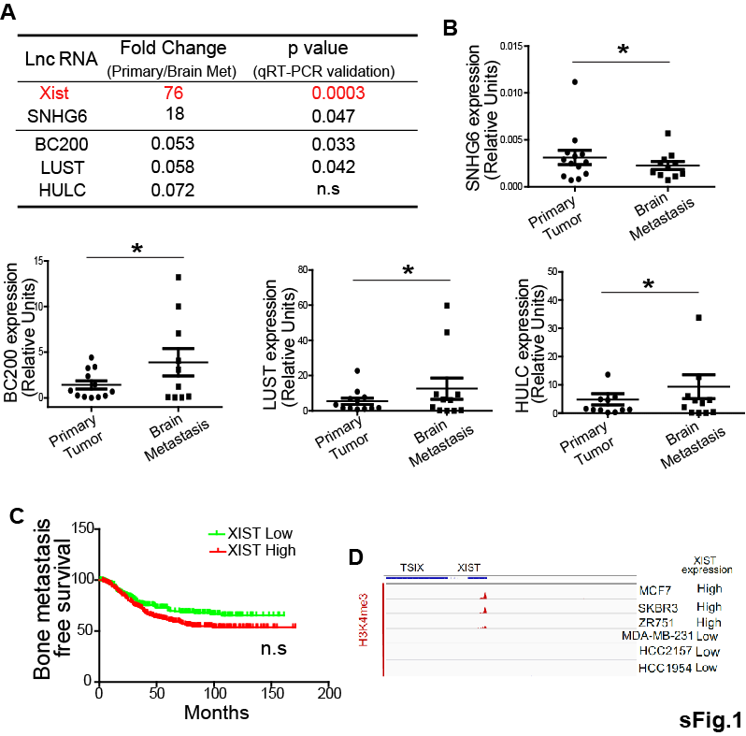
Fig. S1. XIST expression is preferentially correlated with brain metastasis in breast cancer.
(A) Results of the lnc-RNA array analysis as described in Fig.1a. Table indicates the list of most significantly up- or down-regulated lncRNAs. (B) Validation of selected lncRNAs by qRT-pcr (C) Kaplan-Meier analysis was performed for the relationship of XIST expression and bone metastasis-free survival using a combined GEO cohort database which includes a total of 710 breast cancer patients. (D) Analysis of H3K4me3 ChIP-seq data in breast cancer cell lines express high or low XIST based on GSE69017.
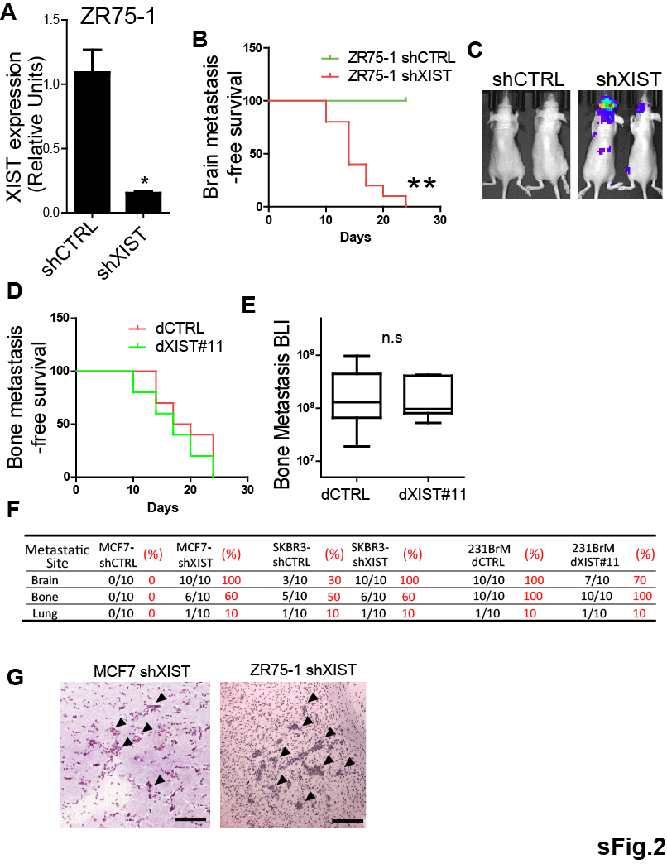
Fig. S2. Knockout of XIST preferentially promotes brain metastases
(A) Knockdown of XIST was verified by qRT-PCR in ZR-75-1 cells. (B) Brain metastasis-free survival of mice inoculated with ZR-75-1 with or without knockdown of XIST. (C) Representative BLI image of mice at end point. (D) Bone metastasis-free survival of mice inoculated with 231BrM/dCTRL and 231BrM/dXIST#11. (E) Quantification of bone metastasis. (F) Distant metastasis rate of the indicated cell lines. (G) Representative H&E staining of spontaneous metastatic lesions in the brain of a mouse implanted with MCF7-shXIST and ZR75-1-shXIST were shown. Scale bar represents 200 µm.

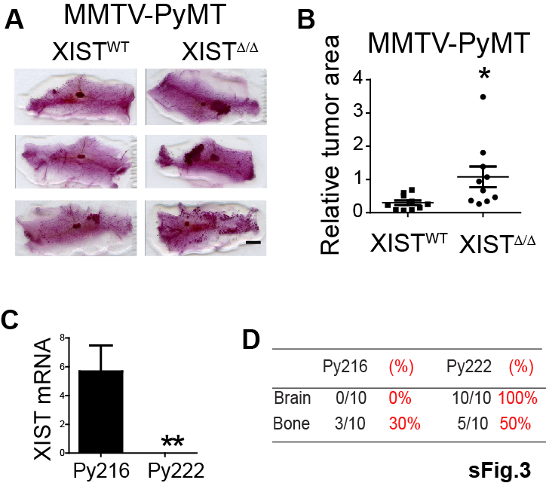
Fig. S3. Knockout of XIST enhances tumor growth and distant metastases
(A) PyMT-XIST^{WT} and PyMT-XIST^{Δ/Δ} were sacrificed at Day 56. Mammary gland was removed and whole mount slides were prepared. Scale bar represents 2 mm. (B) Relative tumor areas in (A) were measured by ImageJ. (C) XIST expression in Py216 and Py222 were measured by qRT-PCR. (D) Distant metastasis incidence of mice inoculated with Py216 and Py222.

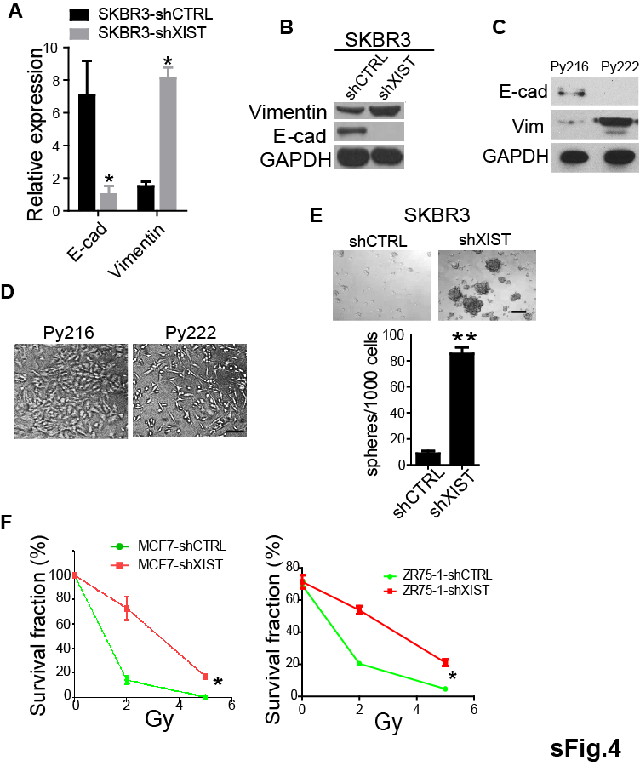
Fig.S4. Knockdown of XIST promotes EMT and stemness.
(A-B) The expression of EMT markers (E-cadherin and vimentin) were examined in SKBR3 and SKBR3-shXIST by qRT-PCR (A), and by western blot (B). (C) Expression of E-cadherin and Vimentin were examined by Western blot in Py216 and Py222. (D) Morphology of Py216 and Py222 were examined under microscope. Scale bar represents 20 μm. (E) SKBR3-shXIST and control cells were cultured in the mammosphere medium for 7 days, and the numbers of spheres were counted under a microscope. Upper panels show representative photos of spheres. Scale bar represents 100 μm. (F) MCF7-shXIST (left panel), ZR-75-1-shXIST (right panel) and control cells were treated with 2 Gy or 5 Gy of radiation followed by conducting a clonogenic assay.

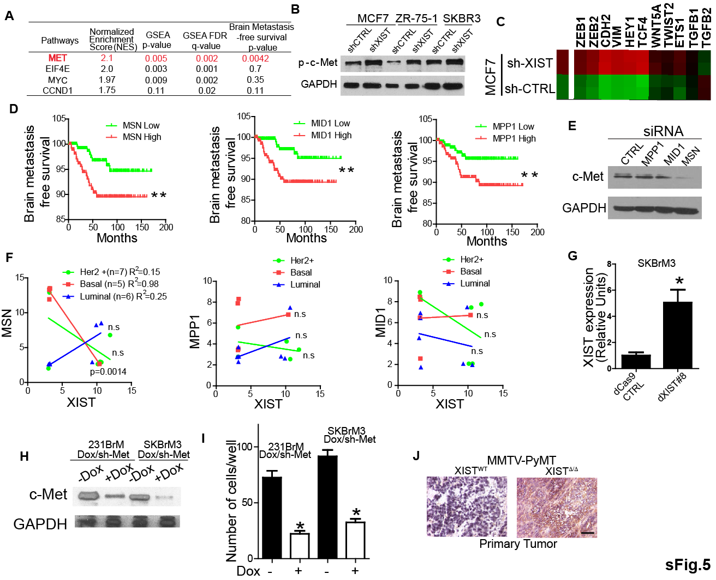
Fig. S5. c-Met is regulated by X-chromosome gene, MSN.
(A) List of most upregulated pathways in XIST^{low} patients by GSEA analysis as described in Fig 5A. (B) Phospho-c-Met expression in cells with or without knock down of XIST was examined by Western blot. (C) Heatmap analysis of EMT genes from microarray experiment in Fig 3d. (D) Brain metastasis-free survival of breast cancer patients was examined for MSN, MPP1 and MID1 by Kaplan-Meier analysis using the cohort data of 710 patients. (E) c-Met expression was examined after knock down of MPP1, MID1 and MSN by treating the cells with 50μM siRNA for 72 hours. (F) Correlations of gene expression between XIST, MSN, MPP1 and MID1 were examined in different subtype of breast cancer patients using GSE10843. (G) Endogenous XIST levels of dCas9 expressing 231BrM and SKBrM3 were examined by qRT-PCR (H) Western blot analysis of c-Met in 231BrM/Dox/sh-Met and SKBrM3/Dox/sh-Met cells with or without addition of doxycycline. (I) Transmigration assay of 231BrM/Dox/sh-Met and SKBrM3/Dox/sh-Met cells with or without treatment of doxycycline. (J) c-Met IHC of primary tumor sections from MMTV-PyMT mice with or without knock out of XIST.

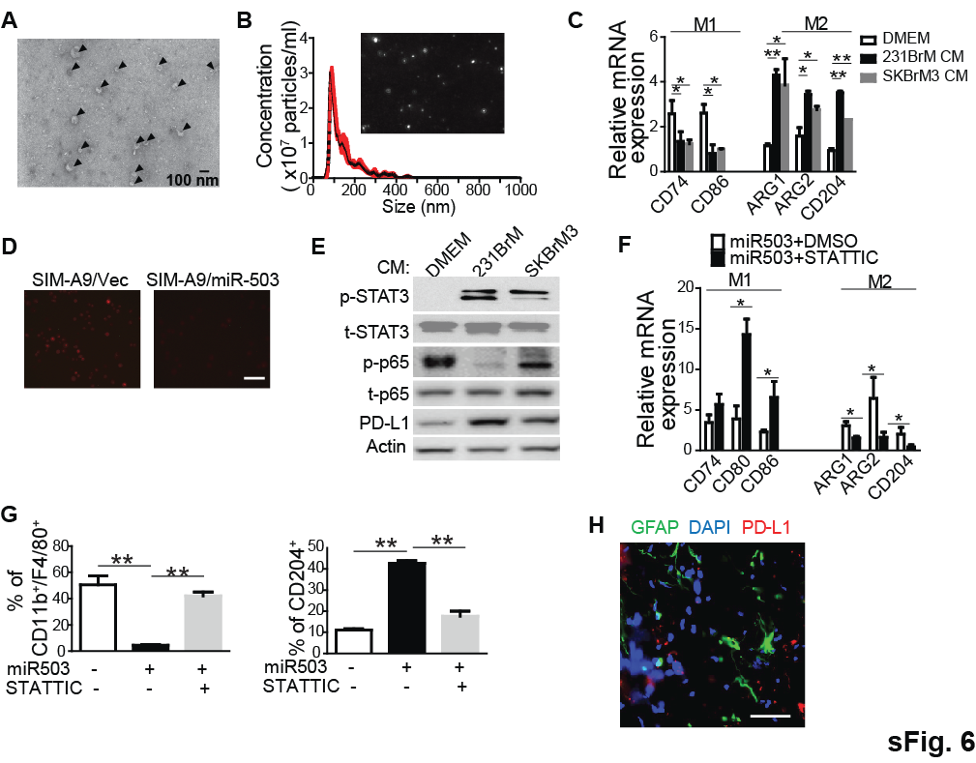
Fig. S6. miR-503 promotes the conversion of M1 to M2 phenotype of microglia.
(A) Isolated exosomes were visualized by electron microscope. The inserted bar indicates 100nm. Arrows indicate exosomes. (B) The size distribution of prepared exosomes was examined by the nano particle tracking analysis using Nanosight NS50. (C) SIM-A9 cells were treated with conditioned medium prepared from 231BrM or SKBrM cells for 24 hours, and the expressions of M1 and M2 markers were examined by qRT-PCR. (D) The level of ROS in SIM-A9/Vec and SIM-A9-mir503 cells was assayed by a cellular ROS detection assay kit. Scale bar represents 50 μm. (E) SIM-A9 cells were treated with conditioned medium prepared from 231BrM or SKBrM3 followed by Western blot analyses of PD-L1 and M1/M2 pathways. (F) SIM-A9 cells overexpressing miR-503 were treated with or without static (10 nM), and the expression of the M1 and M2 markers was examined by qRT-PCR. (G) SIM-A9 with or without express were examined for M1 or M2 population by Flow cytometry analysis. (H) Expressions of the astrocyte marker (GFAP) as well as PD-L1 expression were examined in brain metastatic lesion of patient with breast cancer, by immune-fluorescence analysis. Scale bar represents 50 μm.

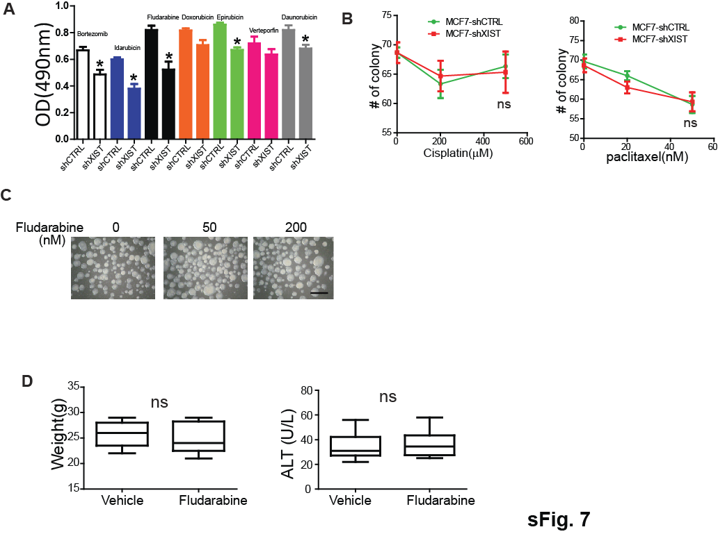
Fig. S7. Fludarabine selectively suppresses the growth of XIST^{low} cells.
(A) MCF7 with or without knockdown of XIST were treated with selected drugs from 1st round library screening followed by MTS assay. (B) Clonogenic assay of MCF7-shCTRL and MCF7-shXIST cells was performed after treating them with cisplatin at 0, 200 and 500 µM or with paclitaxel at 0, 20 and 50 nM. (C) Mouse neuron progenitor cells were cultured in special media and treated with fludarabine at 0, 50 and 200 nM for 96 hours to form neuron spheres. Scale bar represents 200 μm. (D) Fludatrabine treated mice were weighed at the end point (left panel). Serum was prepared from blood drawn from these mice at the end point, and the serum ALT level was measured (right panel).

Reagent and resource

REAGENT or RESOURCE | SOURCE | IDENTIFIER
Antibodies
Anti-p65 | Cell Signaling | Cat#8242
Anti-PD-L1 | Cell Signaling | Cat#13684
Anti-E-cadherin | Cell Signaling | Cat#3195
Anti-MSN | Cell Signaling | Cat#3150
Anti-Met | Cell Signaling | Cat#8189
Anti-p-p65 | Cell Signaling | Cat#3033
Anti-Akt | Cell Signaling | Cat#9272
Anti-Vimentin | Cell Signaling | Cat#5741
Anti-p-met | Cell Signaling | Cat#3077
Anti-p-Akt(s473) | Cell Signaling | Cat#4060
Anti-STAT3 | Cell Signaling | Cat#4904
Anti-α-Tubulin | Cell Signaling | Cat#2125
Anti-GAPDH | Cell Signaling | Cat#5174
GFAP | Cell signaling | Cat#12389
Anti-CD163 | eBioscience | Cat#12-1639-41
Anti-IBA-1 | Abcam | Cat#ab5076
Anti-CD11b | Biolegend | Cat#101208
Anti-F4/80+ | eBioscience | Cat#17-4801-80
Anti-CD204 | Miltenyibiotec | Cat#130-102-328
Anti-mouse-CK14 | Abcam | Cat#ab181595
Anti-mouse-CK8/18 | Abcam | Cat#Ab192467
Anti-PymT | Santa Cruz | Cat#SC-53481
Anti-CD44 | Biolegend | Cat#103012
Anti-ESA | eBioscience | Cat#12-9326-42
Bacterial and Virus Strains
lenti dCAS-VP64_Blast | Addgene | Cat#61425
lenti MS2-P65-HSF1_Hygro | Addgene | Cat#61426
lenti sgRNA (MS2)_zeo backbone | Addgene | Cat#61427
Biological Samples
Human primary and metastatic tumors | Cooperative Human Tissue Network, and Pathology Shared Resource at Wake Forest Baptist Comprehensive Cancer Center
Chemicals, Peptides, and Recombinant Proteins
Laemmli Sample Buffer | Bio-Rad | Cat#1610737
Script™ Reverse Transcription Supermix for RT-qPCR | Bio-Rad | Cat#1708841
iTaq™ Universal SYBR® Green Supermix | Bio-Rad | Cat#1725124
FDA-approved Drug Library | SelleckChem | Cat#L1300
Natural Product Library | SelleckChem | Cat#L1400
Fludarabine phosphate | Sigma-Aldrich | Cat#F9813
Cisplatin | Sigma-Aldrich | Cat#1134357
Paclitaxel | Sigma-Aldrich | Cat#T7402
D-Luciferin, Potassium Salt | Gold Biotechnology | Cat#LUCK-100
Stattic | Enzo Life Science | Cat#BML-EI368-0050
Critical Commercial Assays
Cellular Reactive Oxygen Species Detection Assay kit | Abcam | Cat#avb186029
Alanine Transaminase Activity Assay Kit | Abcam | Cat#ab105134
CellTiter 96® AQueous One Solution Cell Proliferation Assay | Promega | Cat# G3582
CellTrace™ CFSE Cell Proliferation Kit | ThermoFisher | Cat#C34554
Experimental Models: Cell Lines
MCF7 | ATCC | ATCC HTB-22
ZR-75-1 | ATCC | ATCC CRL-1500
SK-BR-3 | ATCC | ATCC HTB-30
MDA-MB-231 | ATCC | ATCC HTB-26
SIM-A9 | Laboratory of K. Nagamoto-Combs | https://www.kerafast.com/product/2118/microglial-cell-line-sim-a9
MDA-MB231BrM2a | Laboratory of J. Massague | Bos et al.,2009
Experimental Models: Organisms/Strains
129-Xisttm2Jae/Mmnc(XIST^{lox/lox}) | MMRRC | Cat#029172-UNC RRID:MMRRC_029172-UNC
Tg(MMTV-cre)4Mam/J | Jackson Laboratory | Cat#003553
B6.FVB-Tg(MMTV-PyVT)634Mul/LellJ | Jackson Laboratory | Cat#022974
Oligonucleotides
qRT-PCR Primers | This paper | Table S1
XIST shRNA target sequence 1  5’TCTCTGTCATTGCTTCTGTAGTCACAGTC3’ | ABM Inc. | Cat#i027305
XIST shRNA target sequence 2  5’ACTGTTAATGTGCATACTTATATTTGCTG3’ | ABM Inc. | Cat#i027305
XIST shRNA target sequence 3  5’ GGCCTGTTATGTGTGTGATTATATTTATC3’ | ABM Inc. | Cat#i027305
XIST shRNA target sequence 4  5’CACAACCATGCATCTTGGAAATTTATGTG3’ | ABM Inc. | Cat#i027305
MSN shRNA mature antisense sequence 1  5’TATAGCTGGAGAGGATTTG3’ | Dharmacon | Cat#V2LHS_151943
MSN shRNA mature antisense sequence 2  5’ TATAGTATATGCTTTCCAG3’ | Dharmacon | Cat#V2LHS_151944
MSN shRNA mature antisense sequence 3  5’ TCTTATTGAGTTTCAGCCA3’ | Dharmacon | Cat#V3LHS_342423
MSN shRNA mature antisense sequence 4  5’ TAGTCTGTCATTCTGCTCA3’ | Dharmacon | Cat#V3LHS_342424
XIST_sgRNA_11+  5’CACCgTGTCCGGCTTTCAATCTTCT3’ | This paper | N/A
XIST_sgRNA_11-  5’ AAACAGAAGATTGAAAGCCGGACAC3’ | This paper | N/A
XIST_sgRNA_8+  5’ CACCGCAGCGCTTTAAGAACTGAA3’ | This paper | N/A
XIST_sgRNA_8-  5’ AAACTTCAGTTCTTAAAGCGCTGC3’ | This paper | N/A
Software and Algorithms
Prism v6 | GraphPad | https://www.graphpad.com/scientific-software/prism/
GSEA v3.0 | Broad Institute | http://software.broadinstitute.org/gsea/downloads.jsp

