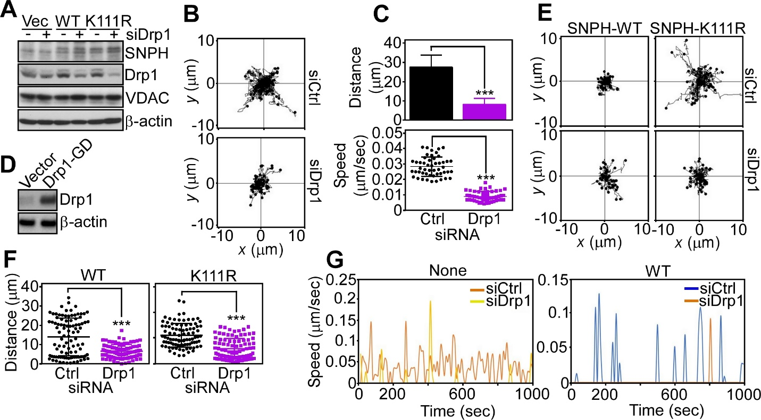
Fig. S5. Requirement of Drp1 for mitochondrial trafficking. A, PC3 cells were transfected with vector (Vec), WT SNPH or SNPH K111R mutant in the presence of absence of Drp1-directed siRNA and analyzed by Western blotting. B and C, Yumm 1.7 cells transfected with control non-targeted siRNA or Drp1-directed siRNA were analyzed for individual mitochondrial movements by time-lapse videomicroscopy (B) and the distance traveled by individual mitochondria (C, top) or the speed of mitochondrial movements (C, bottom) was quantified. Each tracing in B corresponds to an individual mitochondrial track. Data are the mean±SD (n=50). ***, p<0.0001. D, PC3 cells transfected with vector or Drp1 GTPase-mutant cDNA (Drp1-GD) were analyzed by Western blotting. E, Yumm 1.7 cells stably expressing SNPH mutant K111R were transfected with control non-targeting siRNA (Ctrl) or Drp1-directed siRNA and analyzed for individual mitochondrial movements at the indicated time intervals by time-lapse videomicroscopy. Each tracing corresponds to an individual mitochondrial track. F, The conditions are as in E, and the total distance traveled by individual mitochondria was calculated in Yumm 1.7 cells expressing WT SNPH or SNPH mutant K111R in the presence or absence of Drp1 silencing by siRNA. Data are the mean±SD (WT SNPH, n=95-97; SNPH K111R, n=91-93). ***, p<0.0001. G, The conditions are as in E, and the speed of individual mitochondrial movements was quantified in non-transfected cultures (None, left) or cells expressing WT SNPH (right) in the presence or absence of Drp1 siRNA silencing.

