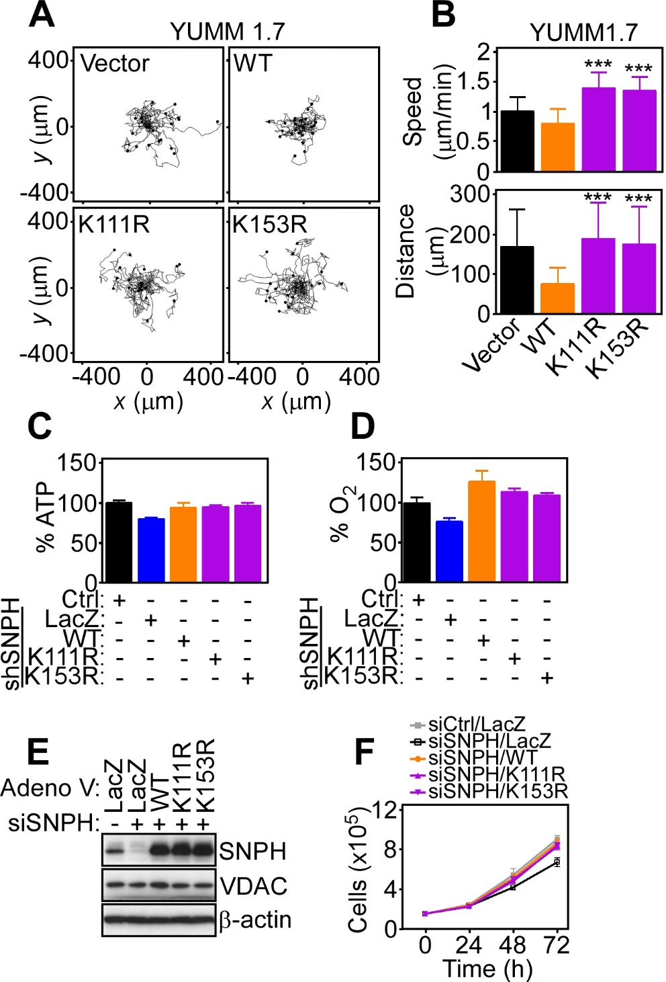
Fig. S3. SNPH ubiquitination in tumor chemotaxis and bioenergetics. A, Yumm 1.7 cells were transfected with vector, WT SNPH or SNPH mutant K111R or K153R and analyzed by 2D chemotaxis. Tracings correspond to the movement of an individual cell. B, The conditions are as in A, and transfected Yumm 1.7 cells were quantified for speed of cell migration (top, n=40-45) or total distance traveled (bottom, n=40-45). Data are the mean±SD. ***, p<0.0001 by two-tailed Student’s t test. C and D, PC3 cells were silenced for endogenous SNPH by siRNA, transfected with the indicated cDNA constructs as in A and analyzed for ATP production (C) or oxygen consumption rate (OCR, D). Data are the mean±SD (n=3). E and F. PC3 cells were transfected with control siRNA or SNPH-directed siRNA and reconstituted with adenoviral-encoded LacZ, WT SNPH or ubiquitination-defective SNPH K111R or K135R mutant and analyzed by Western blotting (E) or cell proliferation at the indicated time intervals by direct cell counting (F). Data are the mean±SD (n=4).

