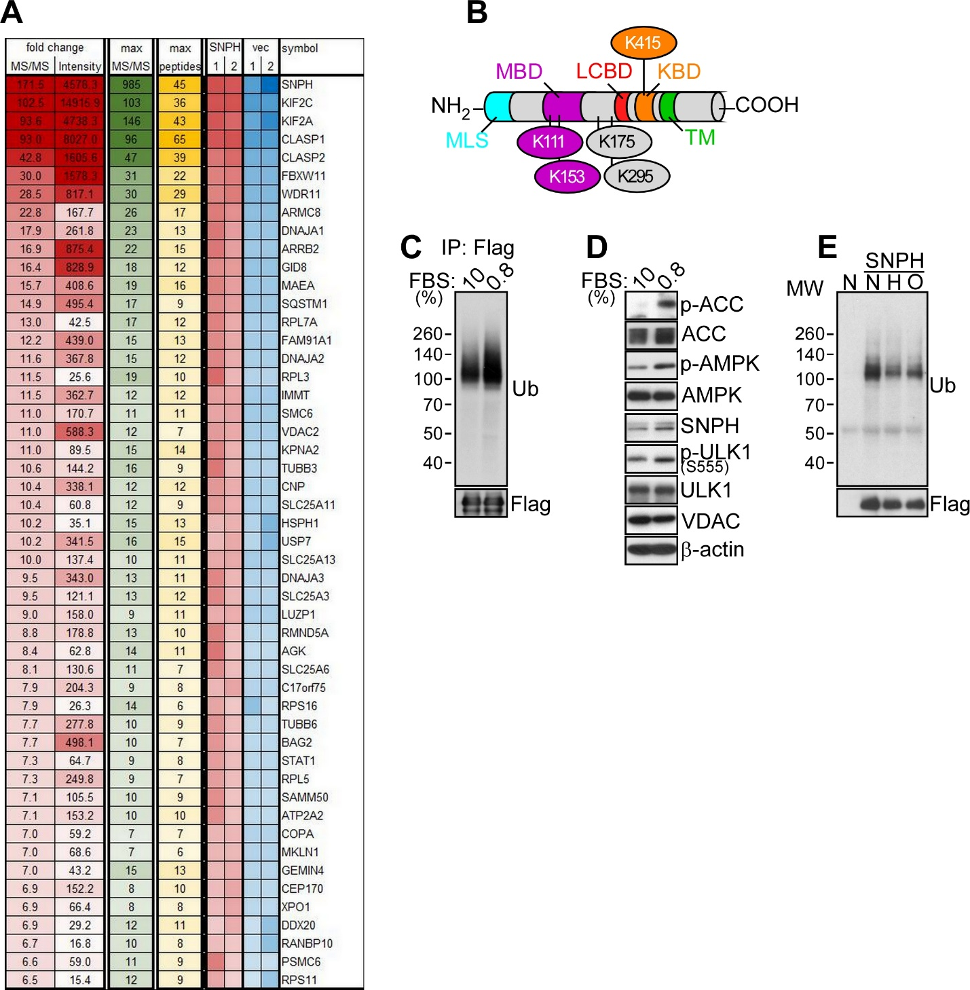
Fig. S1. Regulation of SNPH ubiquitination. A, Heat map of SNPH-associated proteins in PC3 cells. The MS/MS fold changes, intensity and peptides analyzed are reported for two independent experiments with vector control (vec) or SNPH transfectants. B, Schematic diagram of SNPH. The position of ubiquitinated residues identified by mass spectrometry is indicated. MBD, microtubule-binding domain; LCBD, LC8-binding domain; KBD, kinesin-binding domain; MLS, mitochondrial-localization sequence; TM, transmembrane domain. C, PC3 cells transfected with Flag-SNPH were maintained in 10% or 0.8% FBS for 16 h, immunoprecipitated with an antibody to Flag and analyzed by Western blotting. TCE, total cell extracts. D, PC3 cells were incubated in 10% or 0.8% FBS for 16 h and analyzed by Western blotting. p, phosphorylated. E, PC3 cells transfected with Flag-SNPH were cultured in normoxia (N), hypoxia (H, 1% O₂ for 24 h) or in the presence of an oxidative stress stimulus (O, 0.5 mM PQ for 16 h), and analyzed by Western blotting.

