Supplementary Figures
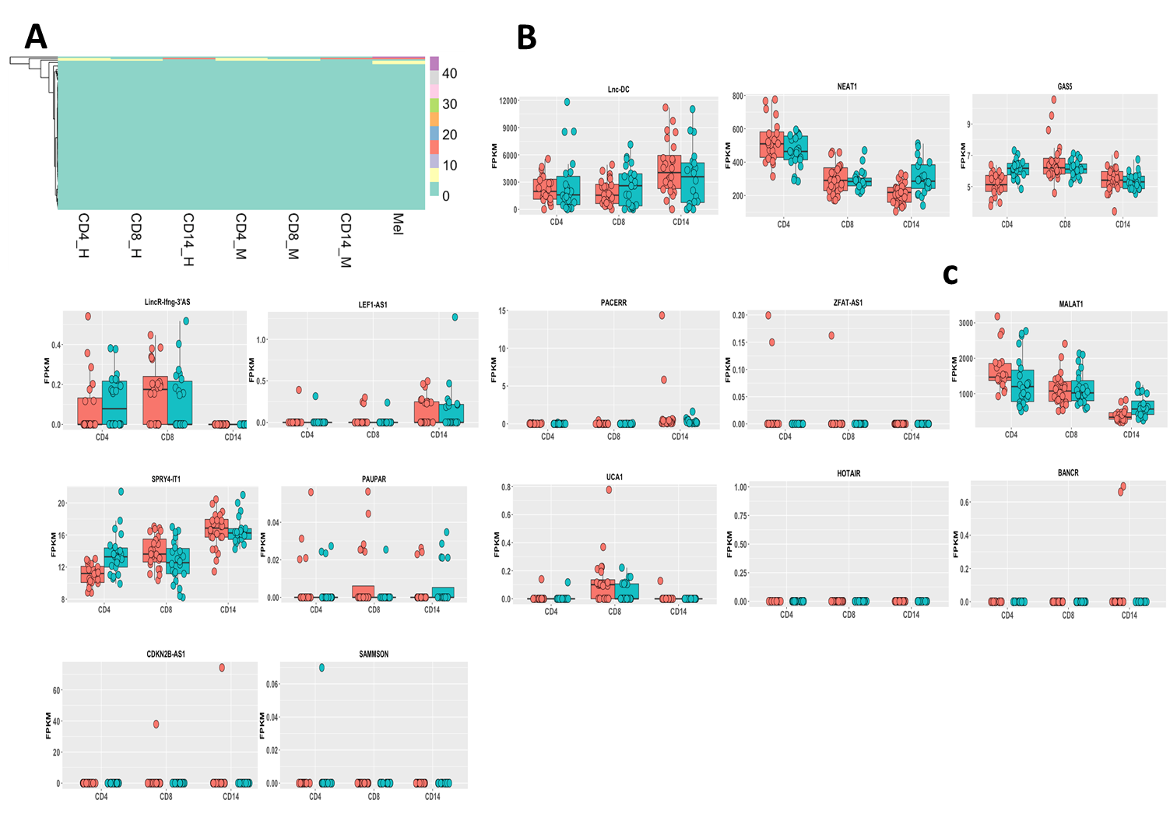
Supplementary Fig. S1. The cell-/tissue-specificity of lncRNA expression. (A) The heatmap of 63 differently expressed lncRNAs of melanoma from MiTranscriptome database in CD4+, CD8+, and CD14+ PBCs. Mean FPKM value is shown in this picture (CD4_H, CD4+ PBC from the healthy donors; CD8_H, CD8+ PBC from the healthy donors; CD14_H, CD14+ PBC from the healthy donors; CD4_M, CD4+ PBC from the stage IV melanoma patients; CD8_M, CD8+ PBC from the stage IV melanoma patients; CD14_M, CD14+ PBC from the stage IV melanoma patients; Mel, melanoma tissue from MiTranscriptome database.) (B) The expression of key immune-associated lncRNAs in CD4+, CD8+, and CD14+ PBCs (Red, the healthy donors; Turquoise, the stage IV melanoma patients). (C) The expression of key melanoma-associated lncRNAs in CD4+, CD8+, and CD14+ PBCs (Red, the healthy donors; Turquoise, the stage IV melanoma patients).

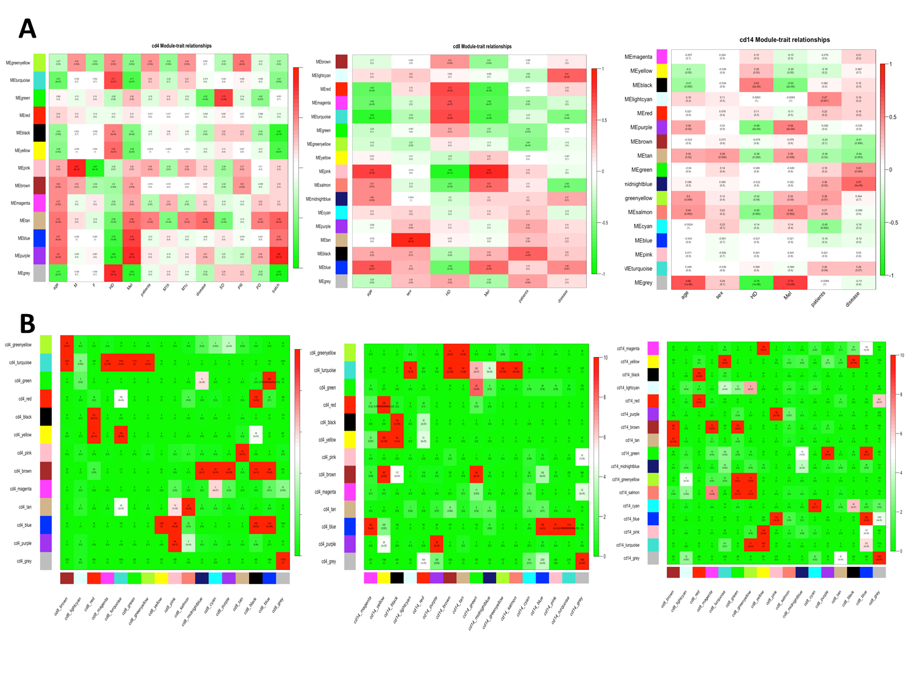
Supplementary Fig. S2. The co-expression modules analyses in CD4+, CD8+, and CD14+ PBCs. (A) co-expression modules and their correlation to multiple traits (HD, normal healthy subjects; Mel, stage IV melanoma patients). Numbers of each square represent the correlation of module and diverse traits as well as P-value of each correlation value. Color of each square is corresponded to correlation: Positive correlation (Red); Negative correlation (Green); No correlation (White). (B) Comparison of modules in CD4+, CD8+, and CD14+ PBCs. Heatmap showing the significance of transcripts overlaps among CD4+, CD8+, and CD14+ PBCs. The x axis or y axis shows all modules of one PBC. Each cell contains the number of intersecting transcripts and the P-value of the intersection. Color legend represents −log10–transformed P-values based on a hypergeometric test.

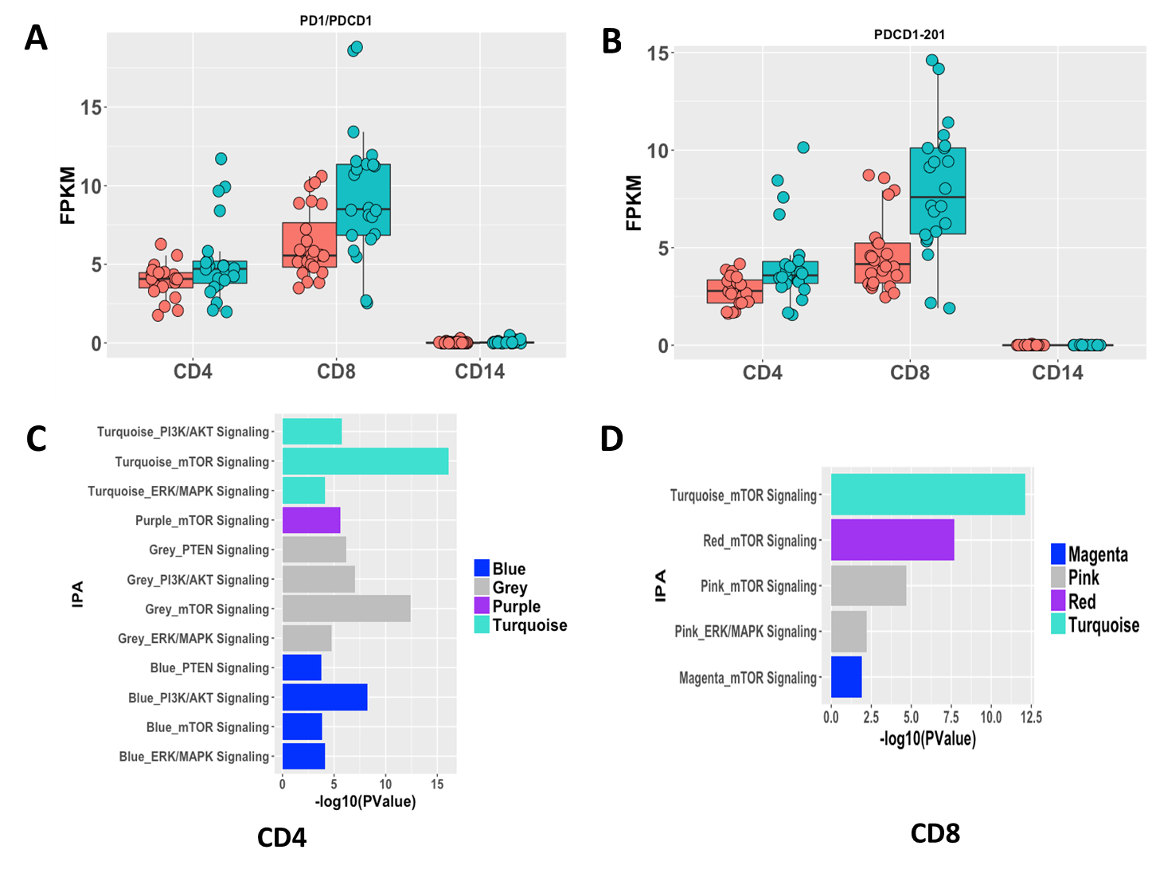
Supplementary Fig. S3. The lncRNAs associated with PD-1 checkpoint pathways. (A) The density distribution of PD1 gene in CD4+, CD8+, and CD14+ PBCs respectively. (B) The density distribution of PDCD1-201 transcript in CD4+, CD8+, and CD14+ PBCs respectively. (C, D) The PD-1 checkpoint pathways enriched in coexpression modules, in which the length of bars indicate the significance by IPA analyses (i.e., −log10(P-Value)).

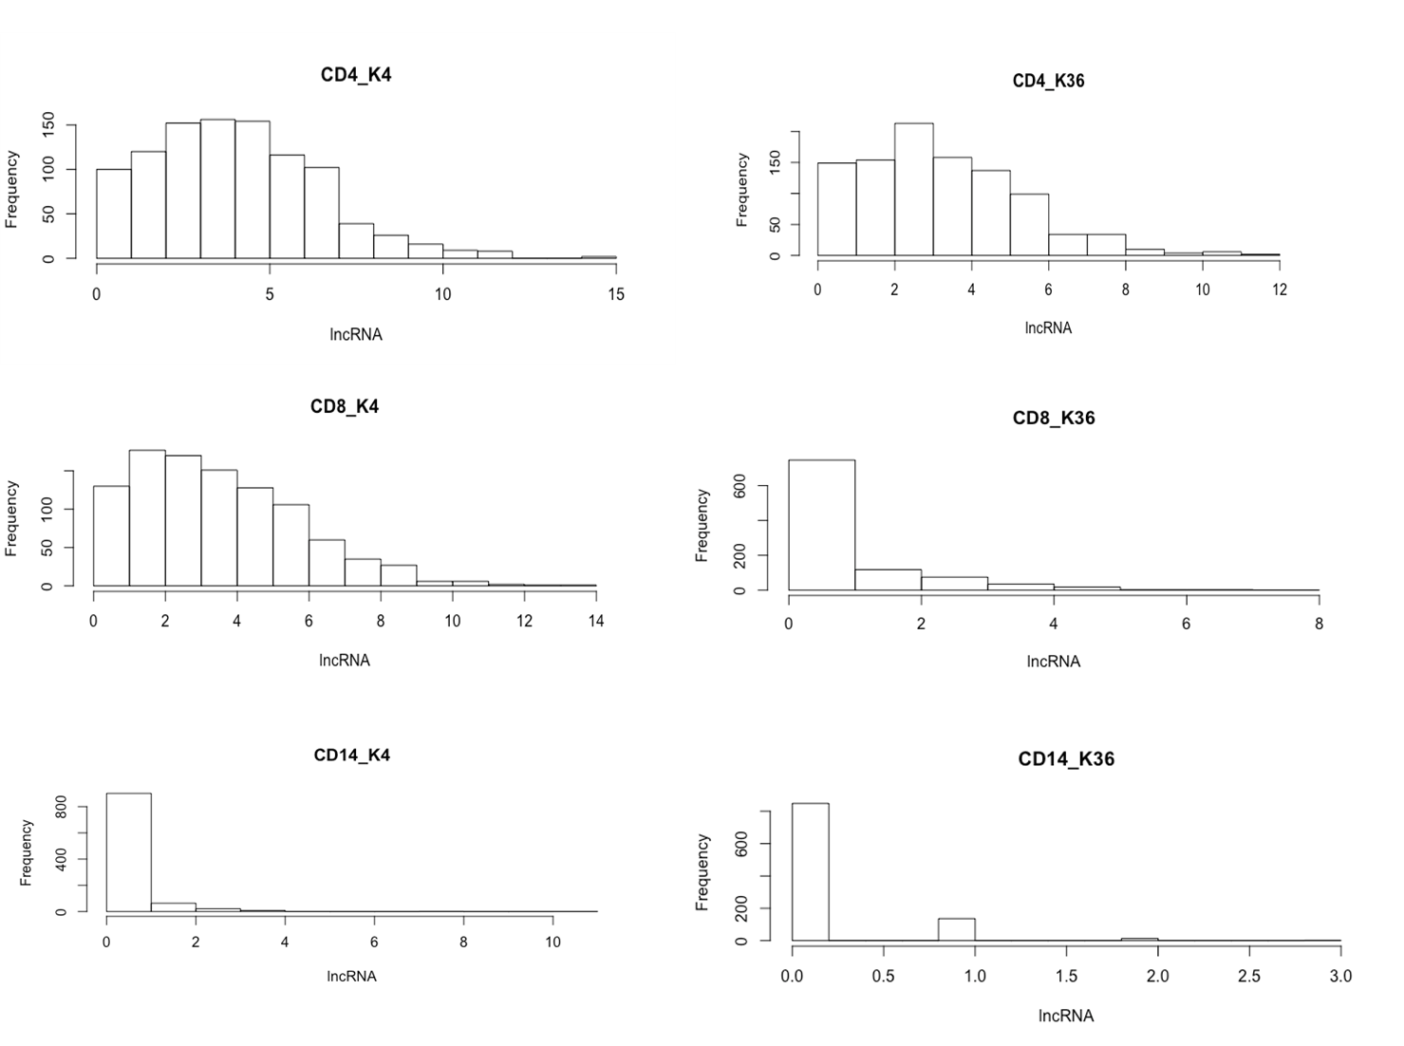
Supplementary Fig. S4. The histogram of the number of lncRNAs marked with same number of random chosen H3K4me3 and H3K36me3 marks (including immune-associated, translation-associated, and differentially expressed lncRNAs) by the permutation test, i.e., the frequency of the number of lncRNAs marked with H3K4me3 and H3K36me3 peaks in the region of +/- 3 kb from transcription start sites of lncRNAs in CD4+, CD8+, and CD14+ PBCs respectively.

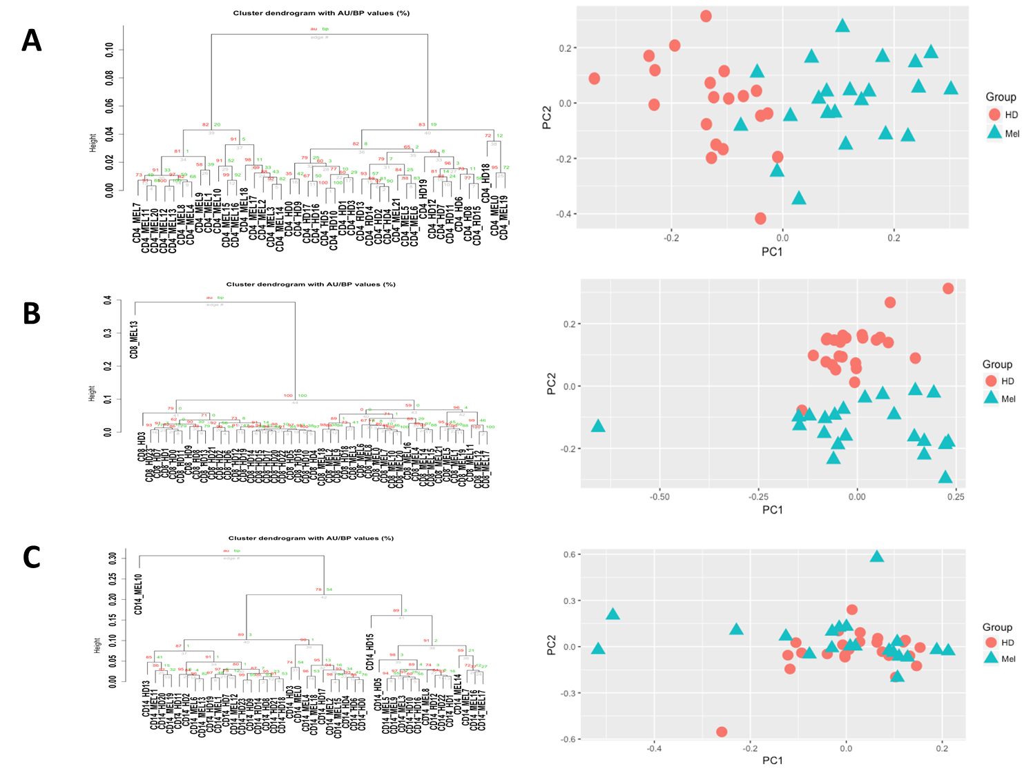
Supplementary Fig. S5. The hierarchical cluster analysis and the principal component analysis of mRNAs. (A) CD4+ PBC; (B) CD8+ PBC; and (C) CD14+ PBC.

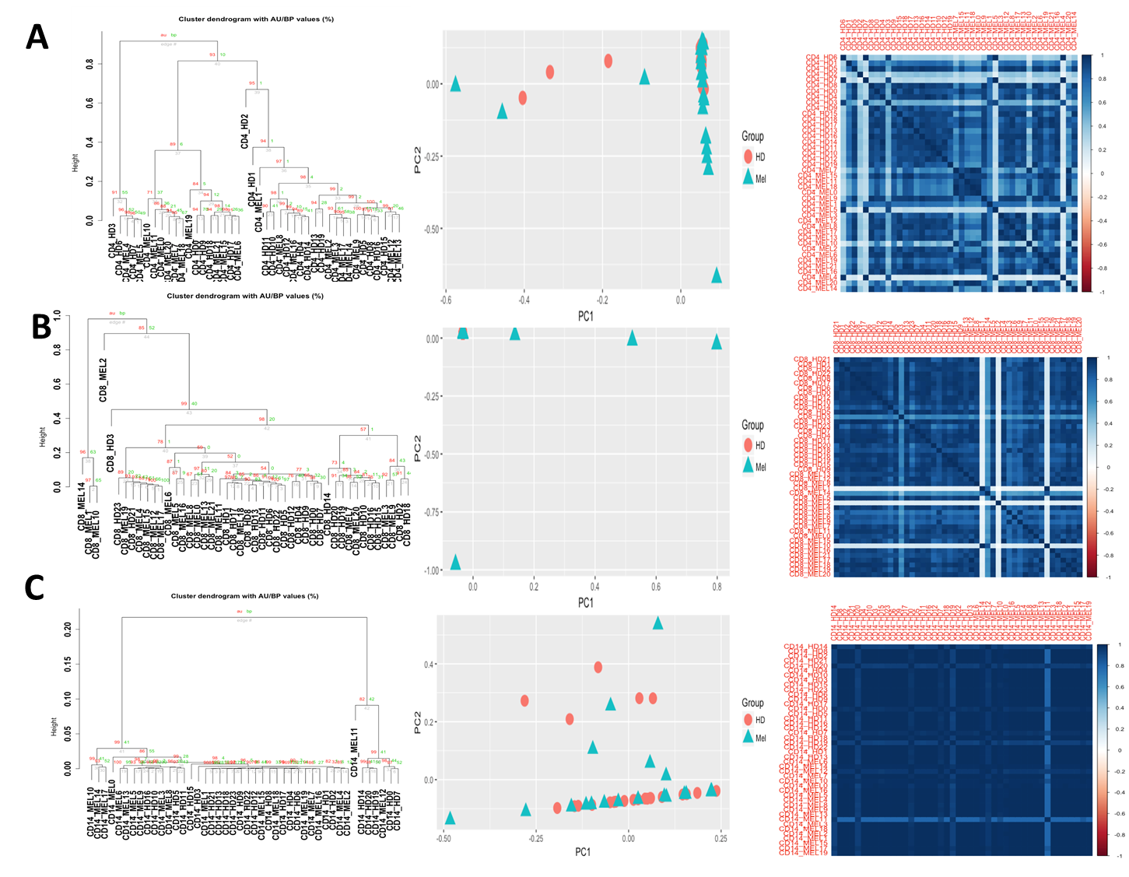
Supplementary Fig. S6. The hierarchical cluster analysis, the principal component analysis, and the correlation analysis of lncRNAs. (A) CD4+ PBC; (B) CD8+ PBC; and (C) CD14+ PBC.

