Rho Kinase Inhibition by AT13148 Blocks Pancreatic Ductal Adenocarcinoma Invasion and Tumor Growth

Supplemental Figures

Supplemental Figure S1. No effect of ROCK inhibitors on the expression of ROCK1 or ROCK2. Page 2
Supplemental Figure S2. ROCK1 and ROCK2 knockdown, dose-response relationships and IC₅₀ determinations for AT13148 on cell morphology parameters. Page 3
Supplemental Figure S3. Dose-response relationships for AT13148 on nuclear morphology parameters. Page 5
Supplemental Figure S4. No effect of ROCK inhibitor treatment on mouse weights. Page 6
Supplemental Figure S5. AT13148 blocks PDAC tumor growth in vivo. Page 7

Supplemental Figure S1. No effect of ROCK inhibitors on the expression of ROCK1 or ROCK2. Quantitative western blotting was used to determine whether treatment of KPC cells with AT13148, Y27632 or H1152 as indicated affected the protein levels of A, ROCK1 or B, ROCK2. Means ± SEM shown for n=3 independent experiments.
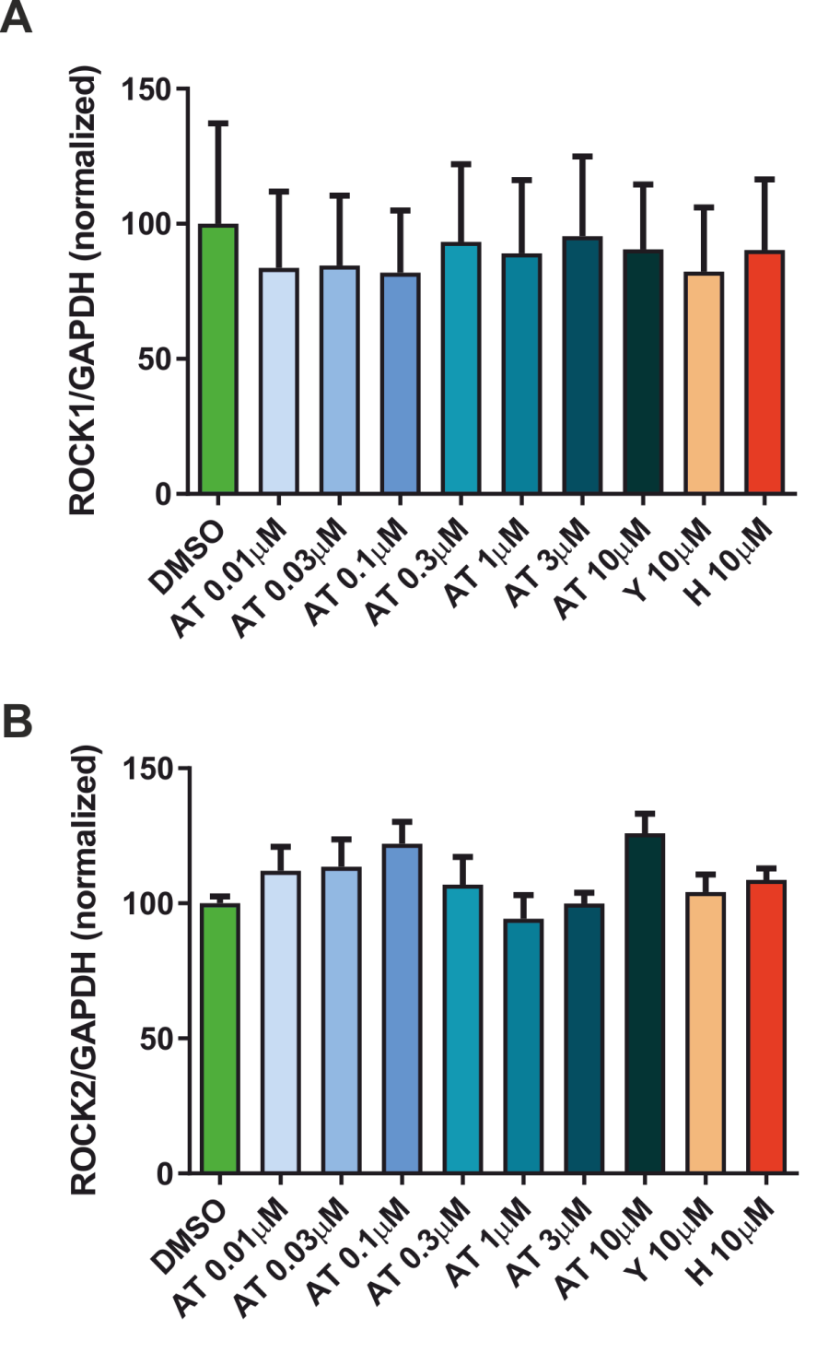

Supplemental Figure S2. ROCK1 and ROCK2 knockdown, dose-response relationships and IC₅₀ determinations for AT13148 on cell morphology parameters. A, Left panel; TKCC5 cells were transduced with lentiviral particles derived from pLKO TRCN0000000977 to TRCN0000000981 clones (abbreviated 977 to 981) to knockdown ROCK2. The pLKO 978 clone was selected for further use. Right panel; TKCC5 cells had undetectable ROCK1 expression, although Rock1 could be detected and successfully knocked down by siRNA transfection in KPC cells. TKCC5 cells were transduced with ROCK2-targeted pLKO 978 and ROCK1-targeted pLKO TRCN0000121093 (abbreviated 121093), which was reported to be the most efficient ROCK1 in the TRC collection, and which has been previously used in references (1,2). B, KPC cells were mock transfected, transfected with non-targeting control (NTC), or a mix of Rock1 and Rock2 siRNAs as indicated. The combined Rock1 + Rock2 knockdown reduced MLC2 phosphorylation by ~50% as determined by quantitative blotting. C-H, Cellular properties of KPC cells determined by high content analysis after 1 h treatment with a range of AT13148 concentrations, with means ± SEM shown for n=3 independent experiments. Four parameter variable slope non-linear curve fitting was used to determine IC₅₀ values.
1. Wang HL, Hu SH, Chou AH, Wang SS, Weng YH, Yeh TH. H1152 promotes the degradation of polyglutamine-expanded ataxin-3 or ataxin-7 independently of its ROCK-inhibiting effect and ameliorates mutant ataxin-3-induced neurodegeneration in the SCA3 transgenic mouse. Neuropharmacology 2013;70:1-11
2. Natkanski E, Lee WY, Mistry B, Casal A, Molloy JE, Tolar P. B cells use mechanical energy to discriminate antigen affinities. Science 2013;340:1587-90

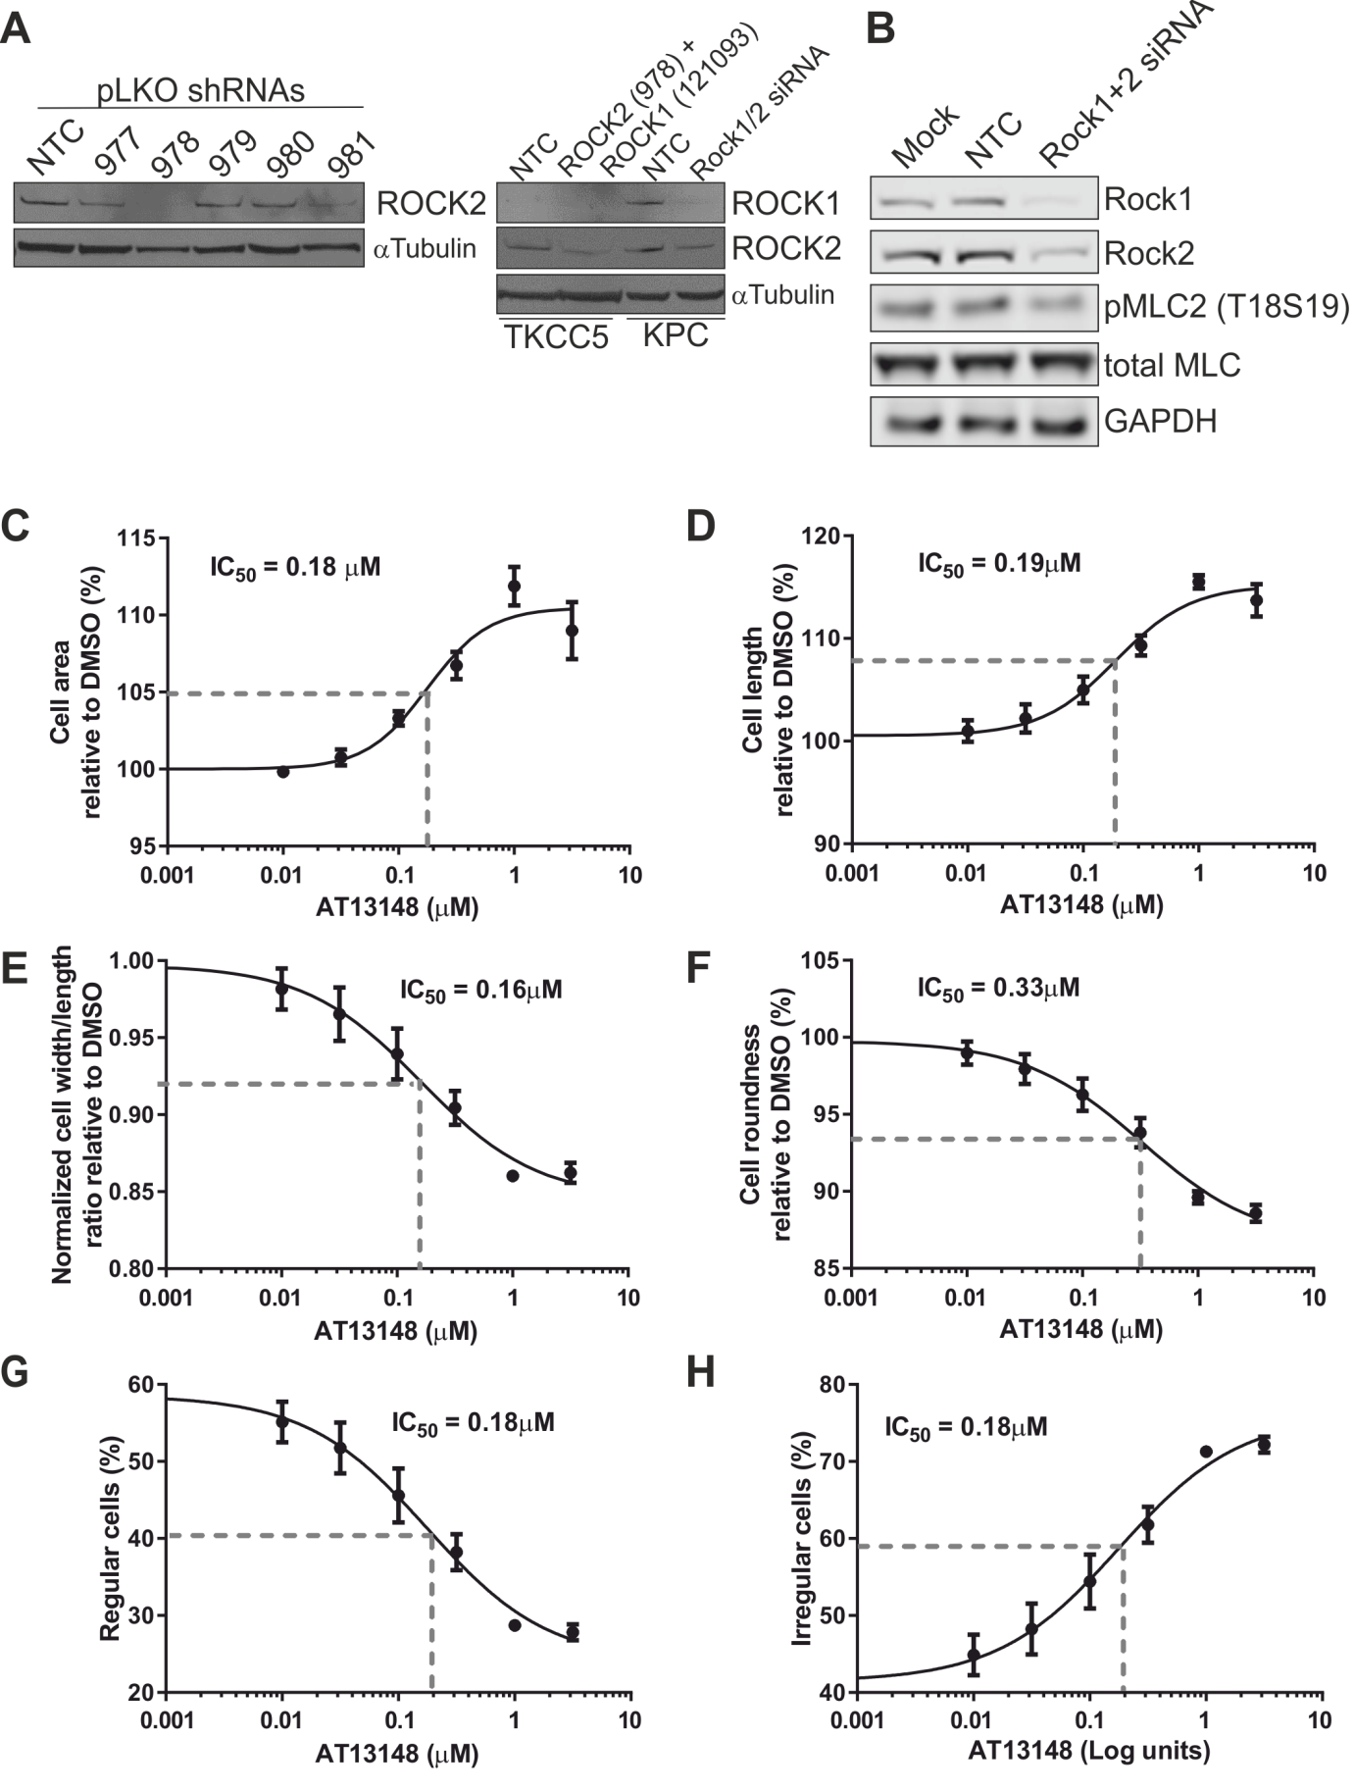

Supplemental Figure S3. Dose-response relationships for AT13148 on nuclear morphology parameters. Nuclear A, roundness and B, width/length ratio determined in KPC cells by high content analysis after 1 h treatment with a range of AT13148 concentrations, 10 µM Y27632, 10 µM H1152 or DMSO as indicated. Means ± SEM are shown from n = 3 independent experiments. Statistical significance was determined using one-way ANOVA and post-hoc Dunnett’s multiple comparison test. *, p<0.05; **, p<0.01; ***, p<0.001.
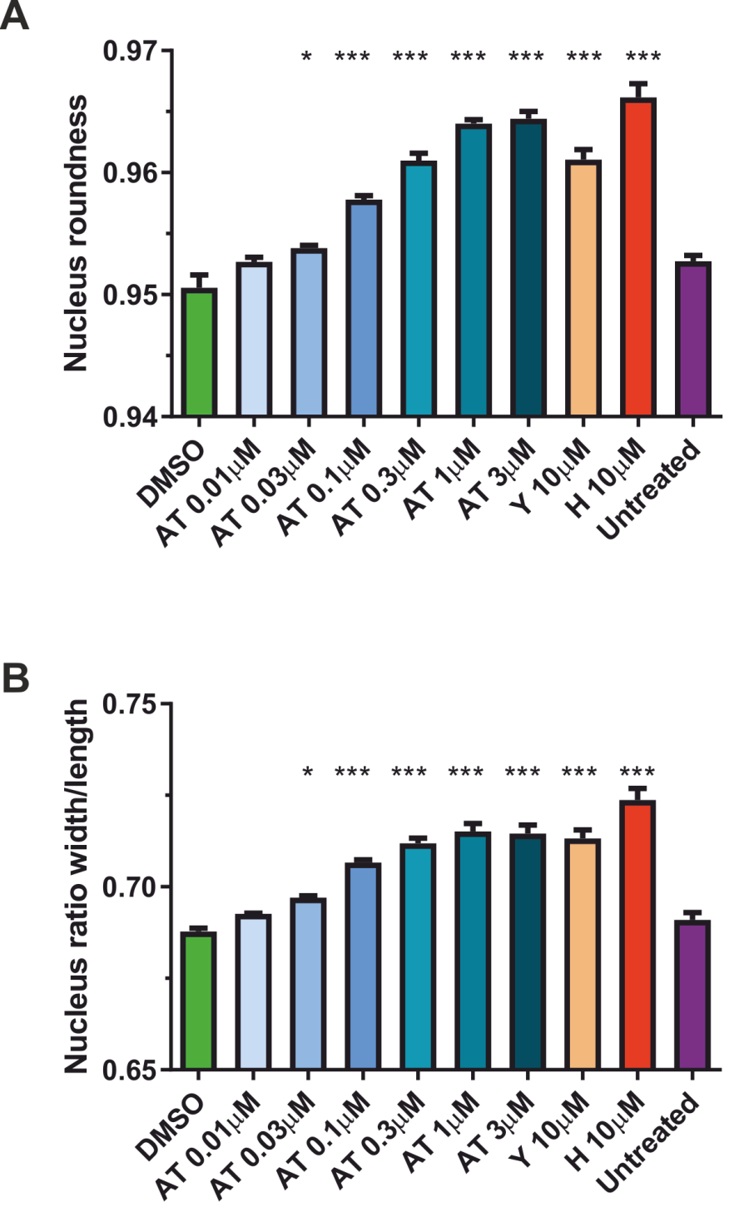
Supplemental Figure S4. No effect of ROCK inhibitor treatment on mouse weights. A, Relative weights of CD-1 mice with intraperitoneal KPC cell tumors treated with vehicle or AT13148. Means ± SEM for n=8 for vehicle-treated and n=8 for AT13148-treated mice. B, Relative weights of CD-1 mice with intraperitoneal KPC cell tumors treated with vehicle or fasudil. Means ± SEM for n=8 for vehicle-treated and n=8 for fasudil-treated mice. C, Relative weights of CD-1 mice with subcutaneous KPC cell tumors treated with vehicle or AT13148. Means ± SEM for n=8 for vehicle-treated and n=7 for AT13148-treated mice.
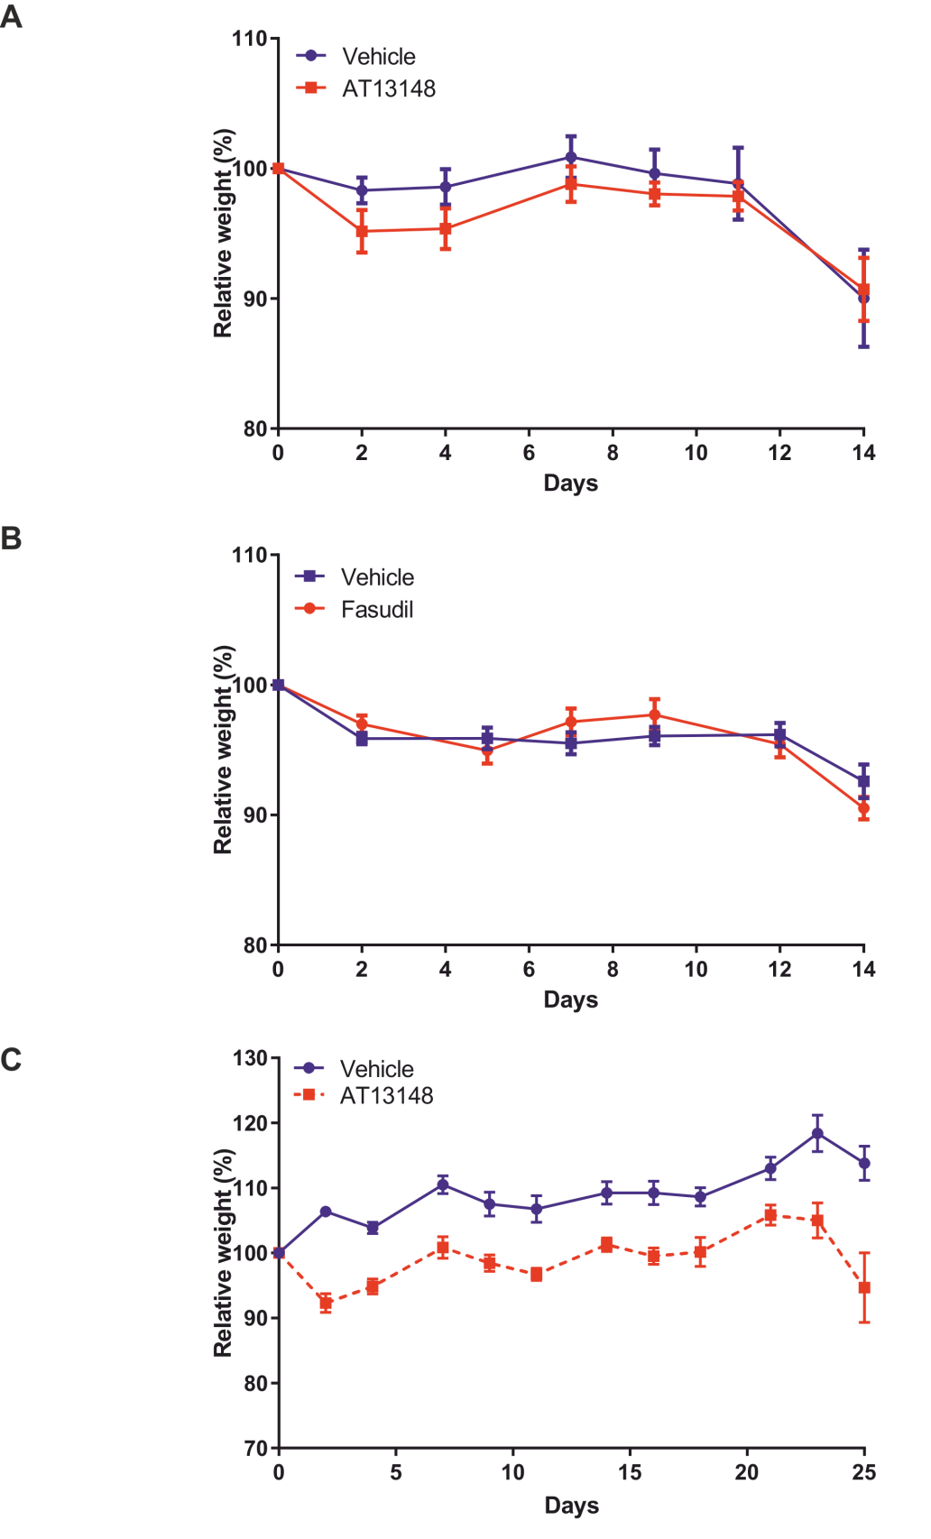
Supplemental Figure S5. AT13148 blocks PDAC tumor growth in vivo. Volumes (mm³) of subcutaneous KPC cell tumors in CD-1 mice treated with A, vehicle control or B, AT13148 (40 mg/kg, 3 x per week) for up to 25 days have been plotted for each individual mouse. Endpoints for each mouse were either reaching maximum permitted size or evidence of ulceration.
